Task 01: Install and Configure Nginx on Port 81 and Deploy a Sample Webpage
1. Objective
To install the Nginx web server on an AWS EC2 Linux instance, enable and start the Nginx service, configure it to listen on port 81, deploy a sample index.html webpage, and verify that the webpage is accessible.
2. Prerequisites
- AWS EC2 Linux instance.
- SSH access to the EC2 instance.
- Root or sudo privileges.
- Internet connectivity for package installation.
- Port 81 available for the Nginx service.
- Appropriate inbound security group rule if external browser access is required.
3. Step-by-Step Implementation
Step 1: Install Nginx
Installed the Nginx web server using the package manager.
Command:
sudo dnf install nginx -y
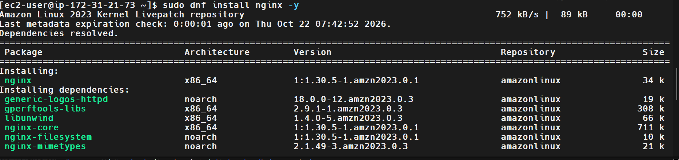
Explanation:
The dnf install command installs Nginx and its required dependencies. The -y option automatically confirms installation prompts.
Step 2: Enable and Start Nginx
Enabled Nginx to start automatically during system boot and started the service immediately.
Commands:
sudo systemctl enable nginx
sudo systemctl start nginx
Explanation:
- systemctl enable nginx enables automatic startup during system boot.
- systemctl start nginx starts the Nginx service immediately.
Step 3: Verify the Nginx Version
Checked the installed Nginx version.
Command:
nginx -v
Output:
nginx version: nginx/1.30.5
Explanation:
The command displays the installed Nginx version and confirms that the Nginx executable is available.
Step 4: Verify the Nginx Service Status
Checked whether the Nginx service was running successfully.
Command:
sudo systemctl status nginx --no-pager
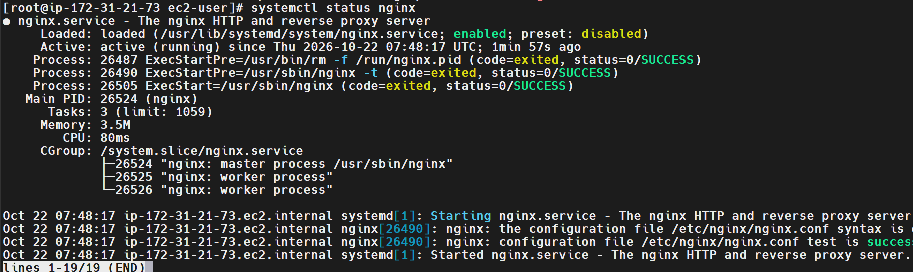
Output:
nginx.service - The nginx HTTP and reverse proxy server
Loaded: loaded (/usr/lib/systemd/system/nginx.service; enabled)
Active: active (running)
Explanation:
The output confirms that Nginx is enabled and running as a system service.
Step 5: Verify Nginx Processes
Checked the Nginx master and worker processes.
Command:
ps -ef | grep nginx
Observed output:
root 28372 1 0 08:48 ? 00:00:00 nginx: master process /usr/sbin/nginx
nginx 28373 28372 0 08:48 ? 00:00:00 nginx: worker process
nginx 28374 28372 0 08:48 ? 00:00:00 nginx: worker process
Explanation:
The master process manages the Nginx service, while the worker processes handle incoming client requests. Process IDs may vary between executions.
Step 6: Verify Port 81
Checked whether Nginx was listening on port 81.
Command:
netstat -na | grep 81
Observed output:
tcp 0 0 0.0.0.0:81 0.0.0.0:* LISTEN
tcp6 0 0 :::81 :::* LISTEN
Explanation:
The output confirms that port 81 is listening for incoming connections over IPv4 and IPv6.
Step 7: Create the Web Root Directory
The /var/www/html directory was missing, so it was created manually.
Command:
sudo mkdir -p /var/www/html
Explanation:
The mkdir -p command creates the specified directory if it does not already exist.
Step 8: Create the Sample HTML Page
Created a custom index.html file for the Nginx web server.
Command:
echo '<h1>Nginx Web Server is Working!</h1><p>Task: Nginx Setup on Port 81</p>' | sudo tee /var/www/html/index.html
Output:
<h1>Nginx Web Server is Working!</h1><p>Task: Nginx Setup on Port 81</p>
Explanation:
The echo command generates the HTML content, and sudo tee writes the content to the file with elevated privileges.
Step 9: Verify the HTML File
Verified that the sample HTML content was saved successfully.
Command:
cat /var/www/html/index.html
Output:
<h1>Nginx Web Server is Working!</h1><p>Task: Nginx Setup on Port 81</p>
Explanation:
The output confirms that the custom webpage content is present in the HTML file.
Step 10: Configure the Active Document Root
Initially, Nginx displayed its default welcome page instead of the custom webpage. The active document root was identified as /usr/share/nginx/html.
Copied the custom HTML file to the active document root.
Command:
sudo cp /var/www/html/index.html /usr/share/nginx/html/index.html
Explanation:
The command copies the custom webpage to the directory from which the active Nginx configuration serves the page.
Step 11: Test the Nginx Configuration
Validated the Nginx configuration before applying changes.
Command:
sudo nginx -t
Expected output:
nginx: the configuration file /etc/nginx/nginx.conf syntax is ok
nginx: configuration file /etc/nginx/nginx.conf test is successful
Explanation:
The nginx -t command checks the configuration for syntax errors. The configuration test should succeed before reloading the service.
Step 12: Reload Nginx
Reloaded Nginx to apply configuration changes.
Command:
sudo systemctl reload nginx
Explanation:
The reload operation applies configuration changes without unnecessarily stopping the running Nginx service.
Step 13: Verify the Deployed Webpage
Accessed the Nginx server locally on port 81.
Command:
curl -s http://localhost:81
Verified output:
<h1>Nginx Web Server is Working!</h1><p>Task: Nginx Setup on Port 81</p>
Explanation:
The output confirms that Nginx is serving the custom HTML webpage on port 81 instead of the default welcome page.
4. Validation and Testing
Validation | Command | Expected Result
Nginx installation | nginx -v | Version displayed
Service status | sudo systemctl status nginx --no-pager | Active and running
Process verification | ps -ef | grep nginx | Master and worker processes displayed
Port verification | netstat -na | grep 81 | Port 81 listening
HTML file verification | cat /var/www/html/index.html | Custom HTML content displayed
Configuration validation | sudo nginx -t | Syntax test successful
Webpage verification | curl -s http://localhost:81 | Custom HTML response returned
5. Screenshot Evidence
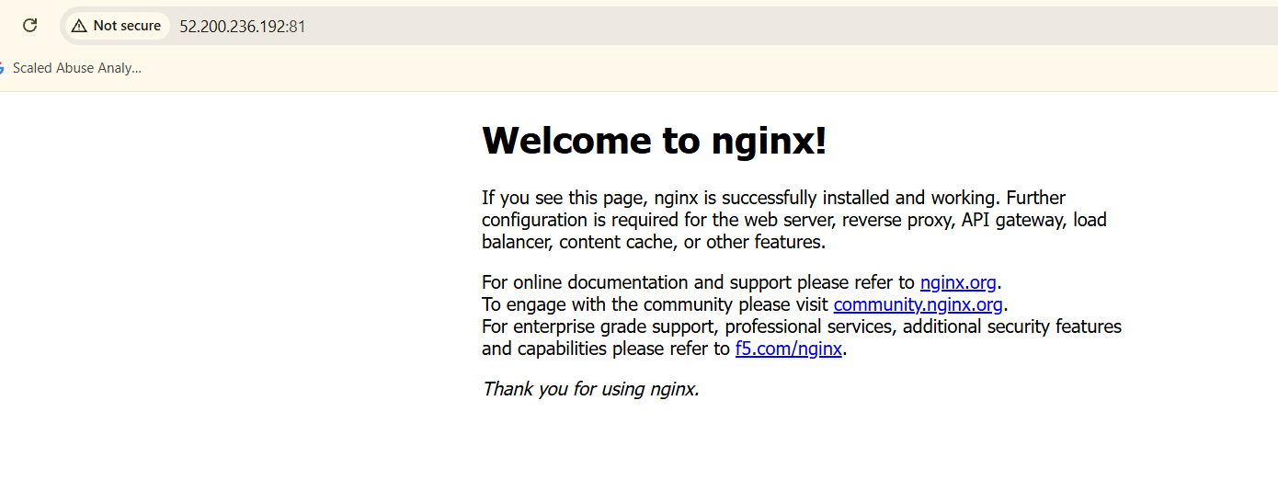
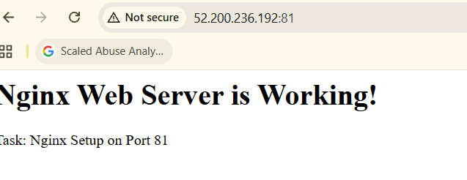
6. Explanation of Commands Used
- dnf install: Installs software packages on supported Linux distributions.
- systemctl enable: Configures a service to start automatically at boot.
- systemctl start: Starts a service immediately.
- systemctl status: Displays the current service status.
- nginx -v: Displays the installed Nginx version.
- ps -ef: Displays running processes.
- netstat -na: Displays network connections and listening ports.
- mkdir -p: Creates a directory if it does not exist.
- tee: Writes input to a file.
- nginx -t: Validates the Nginx configuration.
- systemctl reload: Applies configuration changes.
- curl: Sends an HTTP request and displays the server response.
7. Real-Time Use Case
Nginx is commonly used to host static websites, serve application assets, act as a reverse proxy, and distribute traffic across backend services.
Running Nginx on port 81 is useful when multiple web services need to operate on the same server using different ports. In this assignment, Nginx uses port 81, Apache will use port 82, and Tomcat will use port 8082. HAProxy can subsequently be configured to route incoming requests to the appropriate backend service.
8. Troubleshooting
Issue 1: Permission denied while creating the HTML file
Cause: Insufficient permissions to write to the web directory.
Solution:
echo '<h1>Nginx Web Server is Working!</h1>' | sudo tee /var/www/html/index.html
Issue 2: No such file or directory
Cause: The /var/www/html directory did not exist.
Solution:
sudo mkdir -p /var/www/html
Issue 3: Default Nginx welcome page displayed
Cause: Nginx was serving content from a different document root.
Solution:
Identify the active document root:
sudo nginx -T 2>/dev/null | grep -n -E 'listen|root|index'
Copy the custom webpage to the correct document root and test again:
curl -s http://localhost:81
Issue 4: Nginx configuration test fails
Cause: A syntax error or invalid directive exists in the configuration.
Solution:
sudo nginx -t
Review the reported error, correct the configuration, and validate it again before reloading Nginx.
9. Conclusion
Successfully installed Nginx, enabled and started the service, verified the installed version and running processes, confirmed that port 81 was listening, deployed a custom index.html webpage, and verified the webpage response using curl.
Task Status: Completed successfully.
Evidence Status: Attach the required screenshots to the final task completion document before submission.
Task 02: Install and Configure Apache on Port 82 and Deploy a Sample Webpage
1. Objective
To install the Apache HTTP Server on an AWS EC2 instance running Amazon Linux 2023, enable and start the service, configure Apache to listen on port 82, deploy a sample index.html webpage, and verify that the webpage is accessible.
2. Prerequisites
- AWS EC2 instance running Amazon Linux 2023.
- SSH access to the EC2 instance.
- Root or sudo privileges.
- Internet connectivity for package installation.
- Port 82 available for Apache.
- Appropriate inbound security group rules if external browser access is required.
3. Step-by-Step Implementation
Step 1: Check Port 82 Availability
Checked whether port 82 was already in use before configuring Apache.
Command:
netstat -na | grep 82
Result:
No TCP listener was found on port 82. The displayed entries were Unix socket entries, so port 82 appeared available for Apache.
Explanation:
Checking port availability helps avoid conflicts when running multiple web servers on the same EC2 instance.
Step 2: Install Apache
Installed the Apache HTTP Server package using the DNF package manager.
Command:
sudo dnf install httpd -y
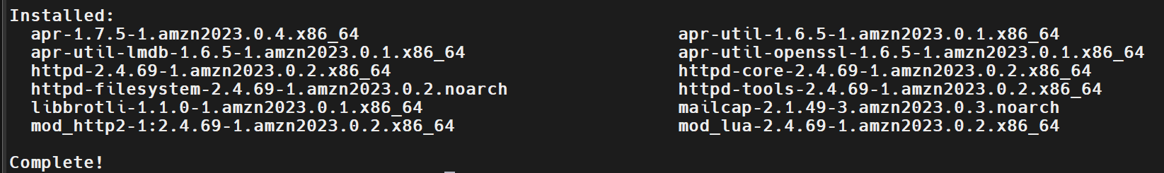
Explanation:
The dnf install command installs Apache and its required dependencies. On Amazon Linux 2023, the Apache package is named httpd.
Step 3: Enable and Start Apache
Enabled Apache to start automatically during system boot and started the service immediately.
Commands:
sudo systemctl enable httpd
sudo systemctl start httpd
Explanation:
- systemctl enable httpd enables automatic startup during boot.
- systemctl start httpd starts the Apache service immediately.
Step 4: Verify Apache Service Status
Checked whether Apache was running successfully.
Command:
sudo systemctl status httpd
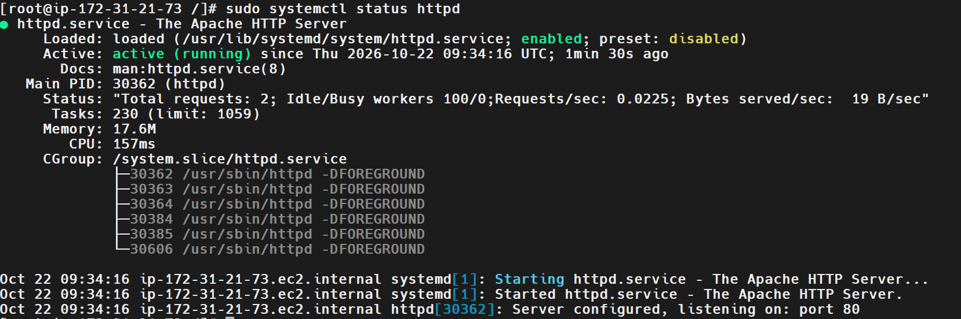
Observed output:
httpd.service - The Apache HTTP Server
Loaded: loaded (/usr/lib/systemd/system/httpd.service; enabled)
Active: active (running)
Main PID: 30362 (httpd)
Explanation:
The output confirmed that Apache was installed, enabled, and running successfully.
The service initially reported that it was listening on port 80. The configuration was subsequently changed to use the required port 82.
Step 5: Configure Apache to Listen on Port 82
Opened the Apache main configuration file.
Command:
sudo vi /etc/httpd/conf/httpd.conf
Located the following directive:
Listen 80
Changed it to:
Listen 82
Saved the file and exited the editor.
Explanation:
The Listen directive specifies the port on which Apache accepts incoming HTTP connections. Changing it from port 80 to port 82 allows Apache to run on the required port without conflicting with Nginx on port 81.
Step 6: Create the Apache Document Root
While validating the Apache configuration, the following error occurred:
AH00526: Syntax error on line 124 of /etc/httpd/conf/httpd.conf:
DocumentRoot '/var/www/html' is not a directory, or is not readable
Cause:
The configured document root /var/www/html did not exist or was not accessible to Apache.
Created the directory and set standard directory permissions.
Commands:
sudo mkdir -p /var/www/html
sudo chmod 755 /var/www/html
Explanation:
- mkdir -p creates the document root directory if it does not exist.
- chmod 755 grants the owner read, write, and execute permissions and grants other users read and execute permissions.
Step 7: Create the Sample HTML Webpage
Created a custom index.html file for Apache.
Command:
echo '<h1>Apache Web Server is Working!</h1><p>Task: Apache Setup on Port 82</p>' | sudo tee /var/www/html/index.html
Output:
<h1>Apache Web Server is Working!</h1><p>Task: Apache Setup on Port 82</p>
Explanation:
The echo command generates the HTML content, and sudo tee writes it to the file with elevated privileges.
Step 8: Validate the Apache Configuration
Checked the Apache configuration for syntax errors.
Command:
sudo httpd -t
Expected successful output:
Syntax OK
Explanation:
The httpd -t command validates the Apache configuration before restarting the service. The configuration must pass this check before proceeding.
Step 9: Restart Apache
Restarted Apache to apply the updated listening port and configuration.
Command:
sudo systemctl restart httpd
Verified the service status again:
sudo systemctl status httpd --no-pager
Expected result:
Active: active (running)
Explanation:
Restarting Apache applies the updated configuration and starts the service using port 82.
Step 10: Verify Port 82
Checked whether Apache was listening on port 82.
Command:
netstat -na | grep 82
Observed output:
tcp6 0 0 :::82 :::* LISTEN
tcp6 0 0 ::1:32914 ::1:82 TIME_WAIT
tcp6 0 0 172.31.21.73:82 124.123.154.200:55574 ESTABLISHED
tcp6 0 0 172.31.21.73:82 124.123.154.200:57274 FIN_WAIT2
Explanation:
The LISTEN entry confirms that Apache is listening on port 82. The other entries represent client connections or connection states associated with port 82.
Step 11: Verify the Deployed Webpage
Sent an HTTP request to Apache on port 82.
Command:
curl http://localhost:82
Verified output:
<h1>Apache Web Server is Working!</h1><p>Task: Apache Setup on Port 82</p>
Explanation:
The output confirms that Apache successfully serves the custom HTML webpage on port 82.
4. Validation and Testing
Validation | Command | Result
Port availability check | netstat -na | grep 82 | Checked before configuration
Apache installation | sudo dnf install httpd -y | Installation completed
Service verification | sudo systemctl status httpd | Active and running
Configuration test | sudo httpd -t | Verify Syntax OK in captured output
Port verification | netstat -na | grep 82 | Port 82 listening
Webpage verification | curl http://localhost:82 | Custom HTML response returned
5. Screenshot Evidence
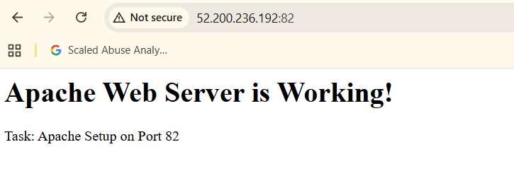
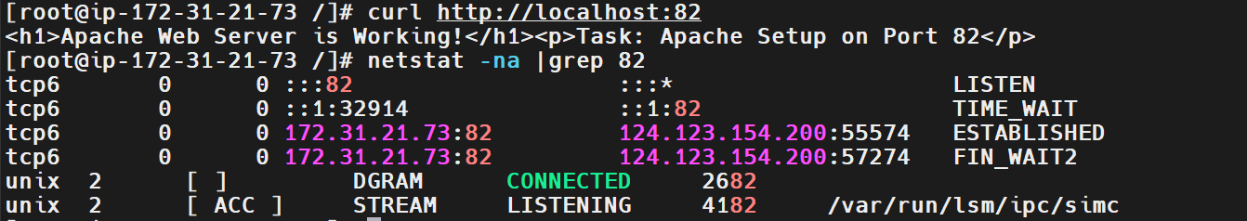
6. Explanation of Commands Used
- dnf install: Installs packages on Amazon Linux 2023.
- systemctl enable: Configures a service to start automatically at boot.
- systemctl start: Starts a service immediately.
- systemctl status: Displays the current service status.
- vi: Opens a file in the Vim text editor.
- mkdir -p: Creates a directory if it does not exist.
- chmod 755: Sets directory permissions.
- tee: Writes input to a file.
- httpd -t: Checks the Apache configuration syntax.
- systemctl restart: Restarts the service and applies configuration changes.
- netstat -na: Displays network connections and listening ports.
- curl: Sends an HTTP request and displays the response.
7. Real-Time Use Case
Apache is commonly used to host websites, serve static content, and handle HTTP requests.
Configuring Apache on port 82 is useful when multiple web servers need to run on the same machine using different ports. In this assignment:
- Nginx runs on port 81.
- Apache runs on port 82.
- Tomcat will run on port 8082.
- HAProxy can later be configured as a frontend load balancer or reverse proxy to route requests to the appropriate backend.
8. Troubleshooting
Issue 1: Document root does not exist
Error:
DocumentRoot '/var/www/html' is not a directory, or is not readable
Cause:
The Apache document root directory was missing or inaccessible.
Solution:
sudo mkdir -p /var/www/html
sudo chmod 755 /var/www/html
Issue 2: Apache still listens on port 80
Cause:
The Apache Listen directive may still be set to port 80, or the service may not have been restarted after the configuration change.
Solution:
Check the configuration:
sudo grep -n '^Listen' /etc/httpd/conf/httpd.conf
Confirm that it shows:
Listen 82
Validate and restart:
sudo httpd -t
sudo systemctl restart httpd
Issue 3: Apache configuration test fails
Cause:
The configuration file contains an invalid directive or an inaccessible document root.
Solution:
sudo httpd -t
Review the reported error, correct the configuration, and run the test again before restarting Apache.
Issue 4: The custom webpage is not displayed
Cause:
The sample HTML file may be missing, or the document root may not match the active Apache configuration.
Solution:
Check the file:
cat /var/www/html/index.html
Test the webpage:
curl http://localhost:82
9. Conclusion
Successfully installed Apache on Amazon Linux 2023, enabled and started the service, configured it to listen on port 82, created the document root and sample index.html file, and verified that the custom webpage was returned using curl.
Task Status: Completed successfully.
Evidence Status: Attach the required screenshots and ensure the successful Apache configuration test is captured before submitting the final document.
Task 45: Install and Configure Apache Tomcat on Port 8082, Deploy a Sample Application, and Create a Systemd Service
Date: 20261022
1. Objective
To install Apache Tomcat on an Amazon Linux 2023 EC2 instance, configure it to run on port 8082, deploy a sample web application in the webapps directory, create a custom tomcat.service systemd unit, and verify that the application is accessible through a web browser.
2. Prerequisites
- AWS EC2 instance running Amazon Linux 2023.
- SSH access to the EC2 instance.
- Root or sudo privileges.
- Internet connectivity for downloading packages and Tomcat.
- Java runtime environment.
- Port 8082 available for Tomcat.
- Appropriate EC2 security group rules for browser access.
3. Step-by-Step Implementation
Step 1: Verify Java Installation
Checked whether Java was installed on the server.
Command:
Sudo dnf install java-21-amazon-corretto-headless -y
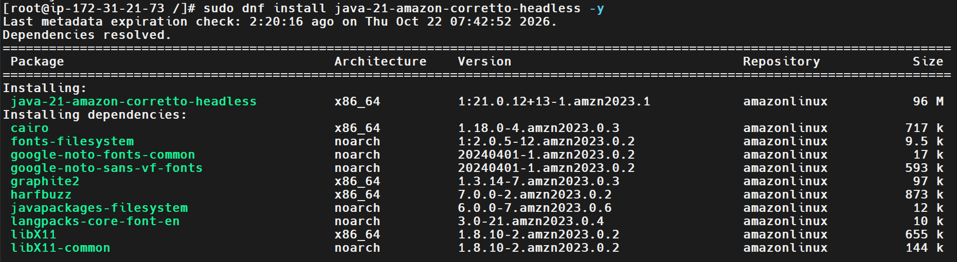
Output:
Installed java
Explanation:
Apache Tomcat requires Java to execute its Java-based web applications. Amazon Corretto 21 was available on the server.
Step 2: Identify the Java Installation Path
Located the Java executable.
Command:
readlink -f "$(which java)"
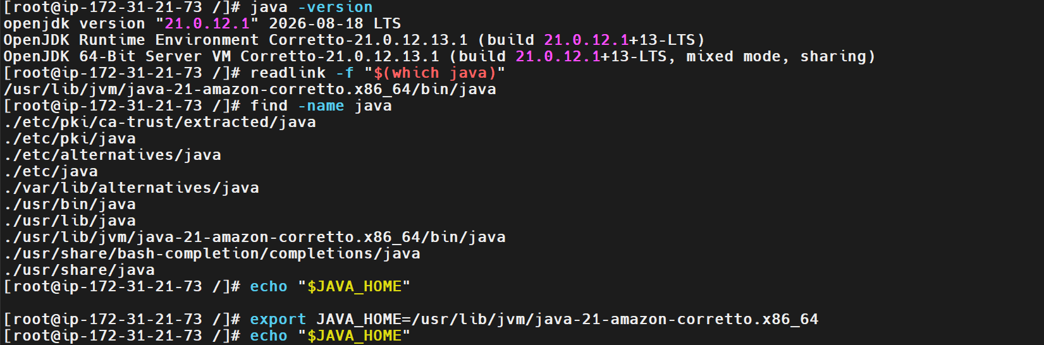
Output:
/usr/lib/jvm/java-21-amazon-corretto.x86_64/bin/java
Explanation:
The command displays the absolute path of the Java executable. The Java installation directory was used to configure the JAVA_HOME environment variable for Tomcat.
JAVA_HOME:
/usr/lib/jvm/java-21-amazon-corretto.x86_64
Step 3: Check for an Existing Tomcat Installation
Checked whether a Tomcat installation script or systemd service already existed.
Commands:
sudo find / -type f -name catalina.sh 2>/dev/null
sudo systemctl list-unit-files | grep -i tomcat
Result:
No output was returned by either command, so no existing Tomcat installation script or service unit was found.
Explanation:
This check helps prevent conflicts with an existing Tomcat installation.
Step 4: Verify Port 8082 Availability
Checked whether port 8082 was already in use.
Command:
netstat -na | grep 8082
Result:
No TCP listener was found on port 8082.
Explanation:
Port availability was checked before configuring Tomcat to listen on the required port.
Step 5: Create a Dedicated Tomcat User
Created a dedicated Linux group and user for running Tomcat.
Commands:
sudo groupadd --system tomcat
sudo useradd --system --gid tomcat --home-dir /opt/tomcat --shell /sbin/nologin tomcat
Explanation:
Running Tomcat under a dedicated non-login service account improves security by avoiding the need to run the application server as root.
Step 6: Download and Extract Apache Tomcat
Installed the required download utilities and downloaded the Tomcat archive.
Commands:
sudo dnf install wget tar -y
cd /tmp
wget https://downloads.apache.org/tomcat/tomcat-10/v10.1.60/bin/apache-tomcat-10.1.60.tar.gz
Extracted the archive and placed the installation under /opt/tomcat.
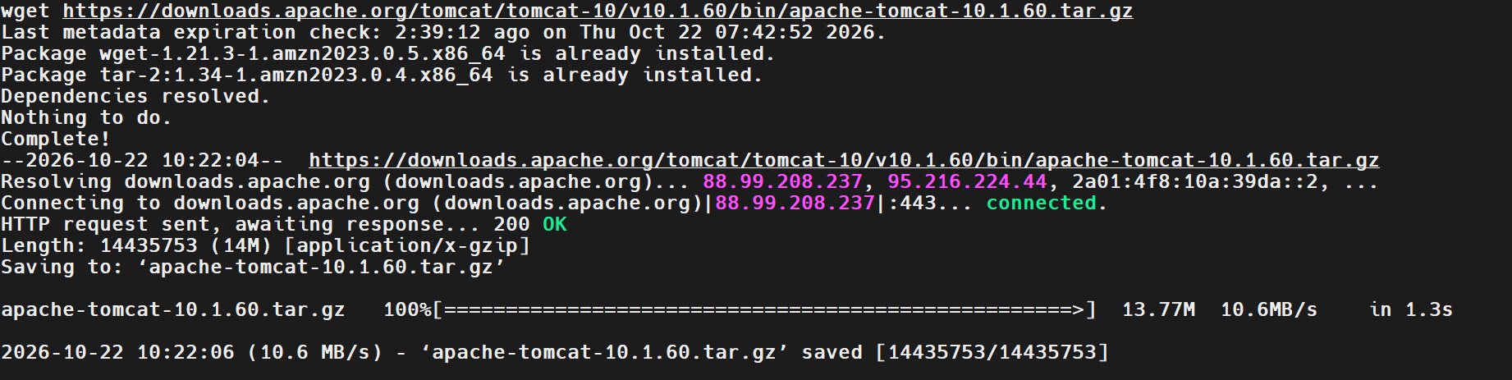
Commands:
sudo tar -xzf /tmp/apache-tomcat-10.1.60.tar.gz -C /opt/
sudo mv /opt/apache-tomcat-10.1.60 /opt/tomcat
Explanation:
Tomcat was extracted into /opt/tomcat, providing a consistent location for its executable scripts, configuration files, libraries, and web applications.
Step 7: Set Tomcat Ownership and Permissions
Assigned ownership of the Tomcat installation to the dedicated service account.
Commands:
sudo chown -R tomcat:tomcat /opt/tomcat
sudo chmod +x /opt/tomcat/bin/*.sh
Verified the Tomcat startup script.
Command:
ls -l /opt/tomcat/bin/catalina.sh
Observed output:
-rwxr-x--x. 1 tomcat tomcat 24049 Sep 9 22:35 /opt/tomcat/bin/catalina.sh
Explanation:
The output confirmed that the catalina.sh startup script existed and had executable permissions. Ownership was assigned to the Tomcat service user and group.
Step 8: Configure Tomcat to Use Port 8082
Backed up the Tomcat server configuration before modifying it.
Command:
sudo cp /opt/tomcat/conf/server.xml /opt/tomcat/conf/server.xml.bak
Opened the configuration file.
Command:
sudo vi /opt/tomcat/conf/server.xml
Changed the HTTP connector from port 8080 to port 8082.
Updated configuration:
<Connector port="8082" protocol="HTTP/1.1"
Verified the connector configuration.
Command:
grep -n 'Connector port=' /opt/tomcat/conf/server.xml
Observed output:
70: <Connector port="8082" protocol="HTTP/1.1"
92: <Connector port="8443" protocol="org.apache.coyote.http11.Http11NioProtocol"
Explanation:
The HTTP connector was changed to port 8082. The HTTPS connector remained configured on port 8443.
Step 9: Create the Sample Web Application
Created a directory for the sample application under Tomcat's webapps directory.
Command:
sudo mkdir -p /opt/tomcat/webapps/sampleapp
Created the application's index.html file.
Command:
sudo tee /opt/tomcat/webapps/sampleapp/index.html <<'EOF'
<!DOCTYPE html>
<html>
<head>
<title>Tomcat Sample Application</title>
</head>
<body>
<h1>Tomcat Server is Working!</h1>
<p>Sample application deployed successfully on port 8082.</p>
</body>
</html>
EOF
Set ownership of the application directory.
Command:
sudo chown -R tomcat:tomcat /opt/tomcat/webapps/sampleapp
Verified the application file.
Command:
cat /opt/tomcat/webapps/sampleapp/index.html
Output:
<!DOCTYPE html>
<html>
<head>
<title>Tomcat Sample Application</title>
</head>
<body>
<h1>Tomcat Server is Working!</h1>
<p>Sample application deployed successfully on port 8082.</p>
</body>
</html>
Explanation:
The sample application was created in the webapps directory. Tomcat serves the application under the /sampleapp/ context path.
Step 10: Create the Tomcat systemd Service File
Created a custom systemd unit to manage Tomcat using systemctl.
Command:
sudo vi /etc/systemd/system/tomcat.service
Added the following configuration:
[Unit]
Description=Apache Tomcat Web Application Server
After=network.target

[Service]
Type=forking
User=tomcat
Group=tomcat
Environment="JAVA_HOME=/usr/lib/jvm/java-21-amazon-corretto.x86_64"
Environment="CATALINA_HOME=/opt/tomcat"
Environment="CATALINA_BASE=/opt/tomcat"
Environment="CATALINA_PID=/opt/tomcat/temp/tomcat.pid"
ExecStart=/opt/tomcat/bin/startup.sh
ExecStop=/opt/tomcat/bin/shutdown.sh
Restart=on-failure
RestartSec=10

[Install]
WantedBy=multi-user.target
Explanation:
The systemd unit defines the Tomcat service, its execution user, Java environment, installation directory, startup command, shutdown command, and restart behavior.
Step 11: Reload systemd and Start Tomcat
Reloaded systemd so it could recognize the new service unit.
Command:
sudo systemctl daemon-reload
Enabled Tomcat to start automatically during system boot.
Command:
sudo systemctl enable tomcat
Started Tomcat.
Command:
sudo systemctl start tomcat
Verified the service status.
Command:
sudo systemctl status tomcat --no-pager
Observed result:
tomcat.service - Apache Tomcat Web Application Server
Loaded: loaded (/etc/systemd/system/tomcat.service; enabled)
Active: active (running)
Tomcat started.
Explanation:
The output confirmed that Tomcat started successfully and was running under systemd.
Step 12: Verify Tomcat Port 8082
Checked whether Tomcat was listening on the configured HTTP port.
Command:
netstat -na | grep 8082
Observed output:
tcp6 0 0 :::8082 :::* LISTEN
Explanation:
The LISTEN entry confirms that a TCP listener was available on port 8082.
Step 13: Verify Automatic Startup
Checked whether Tomcat was enabled to start automatically during system boot.
Command:
sudo systemctl is-enabled tomcat
Output:
enabled
Explanation:
The output confirms that the Tomcat service is enabled for automatic startup.
Step 14: Verify the Deployed Application
Accessed the sample application using the EC2 instance's public IP address in a web browser.
Application URL:
http://<EC2-PUBLIC-IP>:8082/sampleapp/
Observed result:
The sample webpage opened successfully in the browser and displayed the custom Tomcat application content.
Local verification command:
curl http://localhost:8082/sampleapp/
Expected content:
<h1>Tomcat Server is Working!</h1>
<p>Sample application deployed successfully on port 8082.</p>
Explanation:
The browser test confirmed that Tomcat was reachable externally and the sample application was deployed successfully.
4. Validation and Testing
Validation | Command | Result
Java installation | java -version | Java 21 verified
Java path | readlink -f "$(which java)" | Java executable identified
Existing installation check | sudo find / -type f -name catalina.sh 2>/dev/null | No previous installation found
Port availability | netstat -na | grep 8082 | Port initially available
Tomcat installation | ls -l /opt/tomcat/bin/catalina.sh | Startup script present
Connector configuration | grep -n 'Connector port=' /opt/tomcat/conf/server.xml | HTTP connector configured for 8082
Service status | sudo systemctl status tomcat --no-pager | Active and running
Port verification | netstat -na | grep 8082 | Port 8082 listening
Automatic startup | sudo systemctl is-enabled tomcat | Enabled
Browser verification | http://<EC2-PUBLIC-IP>:8082/sampleapp/ | Sample application opened successfully
5. Screenshot Evidence
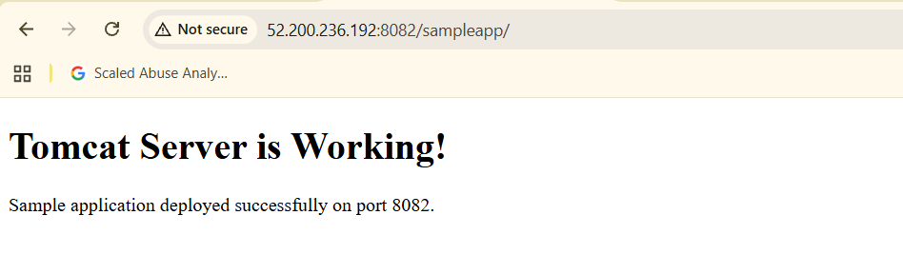
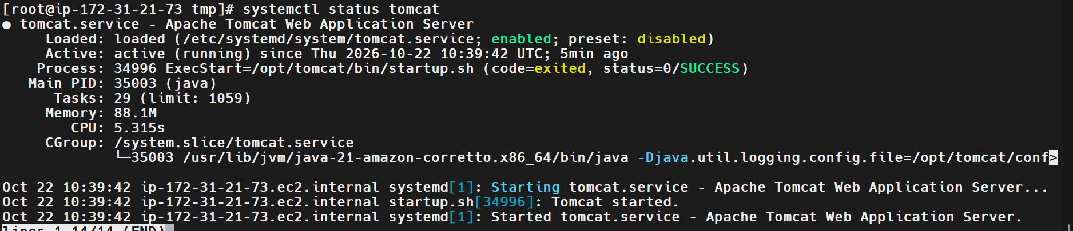
6. Explanation of Commands Used
- java -version: Displays the installed Java runtime version.
- readlink -f: Resolves a path to its absolute target.
- wget: Downloads files from a URL.
- tar -xzf: Extracts a gzip-compressed tar archive.
- chown: Changes file or directory ownership.
- chmod: Changes file permissions.
- vi: Opens a file in the Vim text editor.
- systemctl daemon-reload: Reloads systemd unit definitions.
- systemctl enable: Configures a service for automatic startup.
- systemctl start: Starts a service.
- systemctl status: Displays service status.
- systemctl is-enabled: Checks whether a service is enabled.
- netstat -na: Displays network connections and listening ports.
- curl: Sends an HTTP request and displays the response.
7. Real-Time Use Case
Apache Tomcat is a Java-based web application server commonly used to host Java web applications.
In a production environment, Tomcat can run behind a reverse proxy or load balancer. Nginx or Apache may handle incoming HTTP traffic, while Tomcat processes application requests.
For this assignment, the server uses three separate ports:
- Nginx: port 81.
- Apache HTTP Server: port 82.
- Apache Tomcat: port 8082.
HAProxy can subsequently be configured to route incoming traffic to one or more of these backend services.
8. Troubleshooting
Issue 1: Java command not found
Error:
sudo: java: command not found
Cause:
Java was not available in the environment at the time of the initial check.
Solution:
Install Java and verify it:
sudo dnf install java-21-amazon-corretto-headless -y
java -version
Issue 2: Tomcat HTTP connector uses the wrong port
Cause:
The default Tomcat HTTP connector was configured for port 8080.
Solution:
Edit the configuration file:
sudo vi /opt/tomcat/conf/server.xml
Change the HTTP connector port to 8082 and verify:
grep -n 'Connector port=' /opt/tomcat/conf/server.xml
Issue 3: Tomcat service fails to start
Cause:
Possible causes include incorrect Java paths, configuration errors, ownership problems, or port conflicts.
Troubleshooting commands:
sudo systemctl status tomcat --no-pager
sudo journalctl -u tomcat -n 50 --no-pager
These commands display service status and recent Tomcat service logs.
Issue 4: Sample application is inaccessible
Cause:
Possible causes include an incorrect application path, Tomcat startup problems, or blocked network access.
Solution:
Check the service and test the application locally:
sudo systemctl status tomcat --no-pager
curl http://localhost:8082/sampleapp/
If local access works but external browser access fails, check the EC2 security group inbound rule for TCP port 8082.
9. Conclusion
Successfully installed Apache Tomcat on Amazon Linux 2023, configured Java 21, changed the HTTP connector to port 8082, deployed a sample application under the webapps directory, and created a custom tomcat.service systemd unit.
Verified that Tomcat was active, listening on port 8082, enabled for automatic startup, and serving the sample application successfully in a web browser.
Task Status: Completed successfully.
Evidence Status: Attach the required screenshots to the final task completion document before submission.

Task 03: Configure HAProxy Load Balancer with Apache and Nginx
Outcome
HAProxy is configured on an AWS EC2 instance to distribute HTTP requests between two backend web servers: Apache HTTP Server and Nginx. Both backend servers return HTTP 200 OK responses, and both web pages are accessible through the HAProxy public IP address.
Objective
To configure HAProxy as a load balancer that distributes incoming HTTP requests across multiple backend web servers using the Round Robin algorithm. This improves traffic distribution and provides a foundation for building scalable web applications.
Prerequisites
- AWS account with permission to create and manage EC2 instances.
- Three EC2 instances running Amazon Linux 2023.
- MobaXterm installed on the local machine.
- SSH private key (.pem) file.
- Security groups configured for SSH and HTTP access.
- Apache HTTP Server and Nginx installed on the respective backend servers.
Environment Details
Component | Configuration
Cloud platform | AWS EC2
Operating system | Amazon Linux 2023
Server 1 | 172.31.21.73 — Apache
Server 2 | 172.31.21.244 — Nginx
HAProxy server | 172.31.22.124
HAProxy public IP | 52.207.242.88
Frontend port | TCP 80
Backend port | TCP 80
Load-balancing algorithm | Round Robin
SSH client | MobaXterm
Step-by-Step Implementation
Step 1: Create Three EC2 Instances
Logged in to the AWS Management Console and created three EC2 instances for the load-balancing setup.
The instances were assigned the following roles:
- Server 1: Apache HTTP Server.
- Server 2: Nginx Web Server.
- HAProxy Server: Receives incoming requests and distributes them to the backend servers.
Recorded the private IP addresses for backend communication and the public IP address of the HAProxy server for browser access.
Navigation path:
AWS Console → EC2 → Instances → Launch instances
Step 2: Connect to the Instances Using MobaXterm
Opened MobaXterm and configured SSH sessions for all three EC2 instances.
Steps followed:
- Selected Session → SSH.
- Entered the public IP address of the target instance.
- Enabled Specify username and entered ec2-user.
- Opened Advanced SSH settings.
- Enabled Use private key.
- Selected the private key file from the local machine.
- Clicked OK to connect.
The private key path visible in the screenshot was D:\devops2\linuxkey.
Step 3: Update Packages on Server 1
Connected to Server 1 and switched to the root user:
sudo -i
Updated the package repository:
dnf update -y
Installed Apache HTTP Server:
dnf install httpd -y
The package manager resolved dependencies and installed Apache and its required packages.
Screenshot Evidence
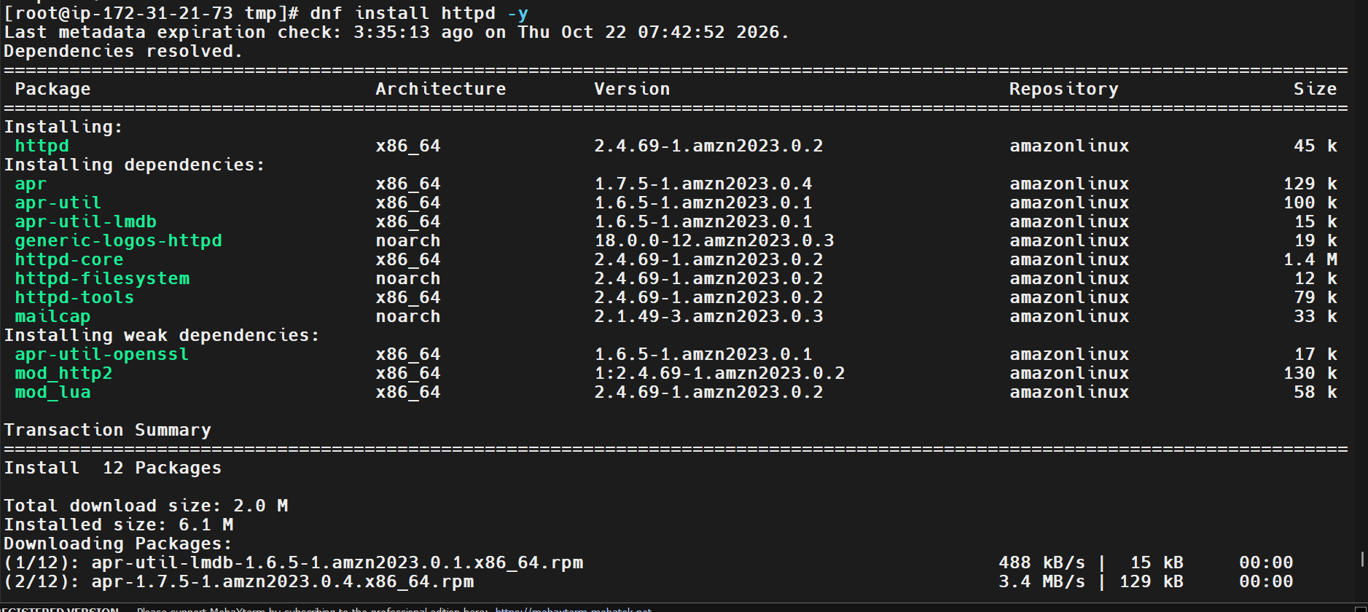
Step 4: Configure /etc/hosts on Server 1
Opened the hosts file:
vi /etc/hosts
Added the HAProxy server's public IP address with the hostname load_balancer.
Parameter | Value
File | /etc/hosts
Hostname | load_balancer
IP address | 52.207.242.88
The entry added was:
52.207.242.88 load_balancer
Saved the file and verified the entry:
cat /etc/hosts
Tested hostname resolution and connectivity:
ping load_balancer
The hostname resolved to 52.207.242.88, and the captured ping output showed replies with zero packet loss.
Screenshot Evidence
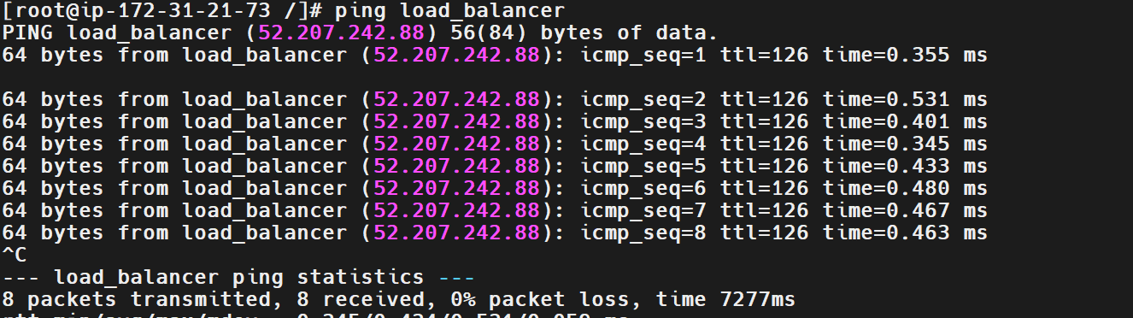
Step 5: Start and Verify Apache on Server 1
Started Apache:
systemctl start httpd
Checked the service status:
systemctl status httpd
The output showed:
Active: active (running)
The service logs also confirmed that Apache was listening on port 80.
Screenshot Evidence
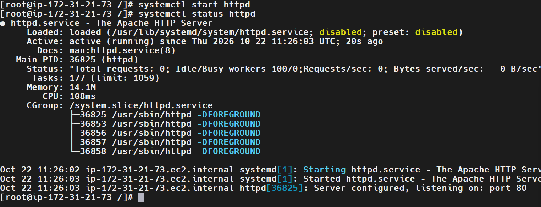
Step 6: Update Packages on Server 2
Connected to Server 2 through MobaXterm and switched to the root user:
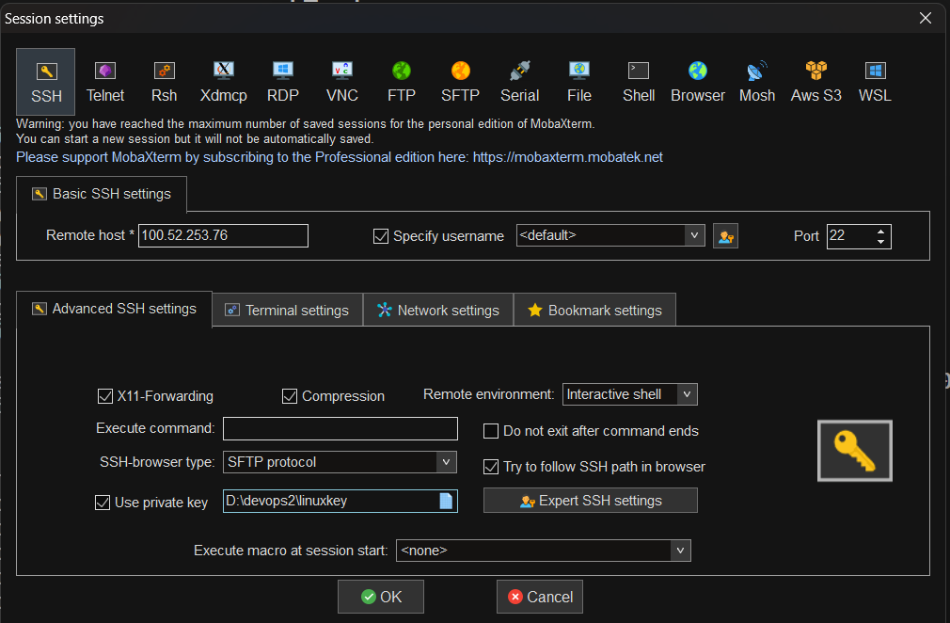
sudo -i
Updated the packages:
dnf update -y
The command completed successfully and reported that no updates were required.
Screenshot Evidence
Step 7: Install Nginx on Server 2
Installed Nginx:
dnf install nginx -y
The package manager installed Nginx and its dependencies successfully.
Started Nginx:
systemctl start nginx
Verified the service status:
systemctl status nginx
The output showed:
Active: active (running)
The Nginx configuration test also completed successfully.
Screenshot Evidence
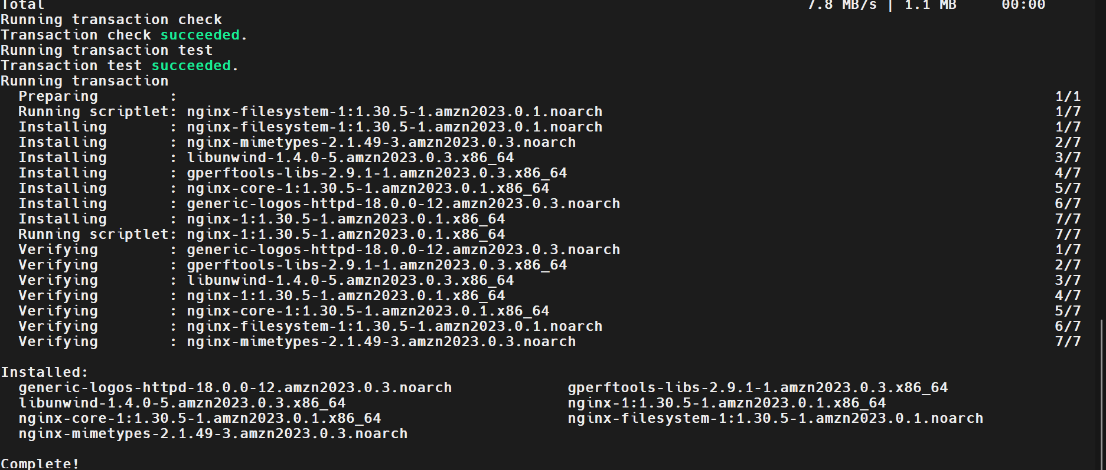

Step 8: Configure /etc/hosts on Server 2
Opened the hosts file:
vi /etc/hosts
Added the HAProxy server's public IP address:
52.207.242.88 load_balancer
Verified the entry:
cat /etc/hosts
Tested hostname connectivity:
ping load_balancer
The hostname resolved correctly, and the captured output showed four packets received with zero packet loss.
Screenshot Evidence
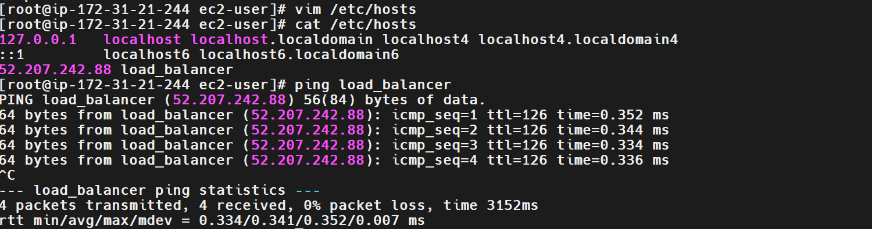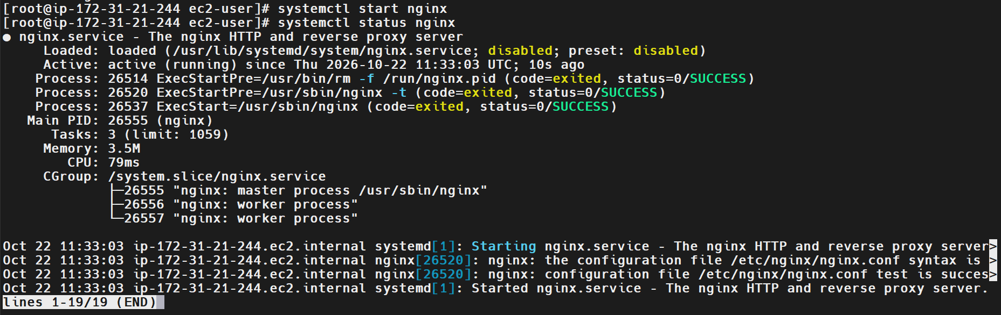
Step 9: Install HAProxy on the Load Balancer Server
Connected to the HAProxy instance and switched to the root user:
sudo su
Updated the package repository:
dnf update -y
Installed HAProxy:
dnf install haproxy -y
Verified the installation:
haproxy -v
The installed version shown in the service output was HAProxy 3.0.23.
Screenshot Evidence
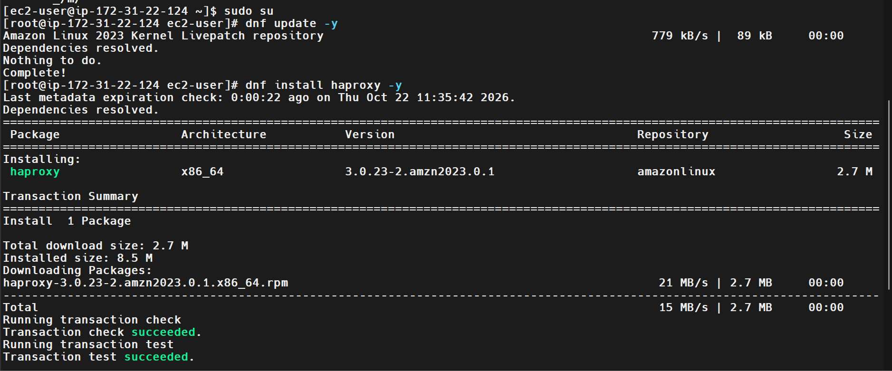
Step 10: Configure Backend Host Entries on the HAProxy Server
Opened the hosts file:
vi /etc/hosts
Added the private IP addresses of the backend servers:
172.31.21.73 server1
172.31.21.244 server2
Saved the file and verified the entries:
cat /etc/hosts
These entries allow the HAProxy instance to resolve the backend server hostnames locally.
Screenshot Evidence
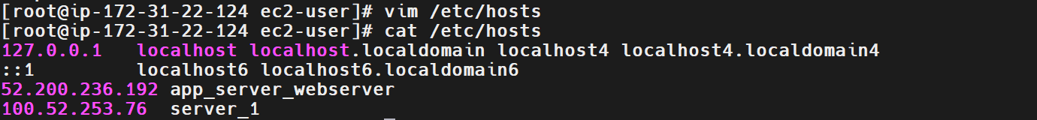
Step 11: Configure HAProxy Frontend and Backend
Opened the HAProxy configuration file:
vi /etc/haproxy/haproxy.cfg
The default configuration contained sample static and app backends pointing to local ports that were not in use. These sections were replaced with the actual backend configuration.
The final frontend and backend configuration was:
frontend main
bind *:80
mode http
default_backend web_servers

backend web_servers
mode http
balance roundrobin
option httpchk GET /
server server1 172.31.21.73:80 check
server server2 172.31.21.244:80 check
The existing global and defaults sections were retained.
Configuration Table
Parameter | Value
Frontend name | Main
Listening address | *:80
Mode | http
Backend name | web_servers
Balancing algorithm | Roundrobin
Health check | GET /
Backend 1 | 172.31.21.73:80
Backend 2 | 172.31.21.244:80
Screenshot Evidence
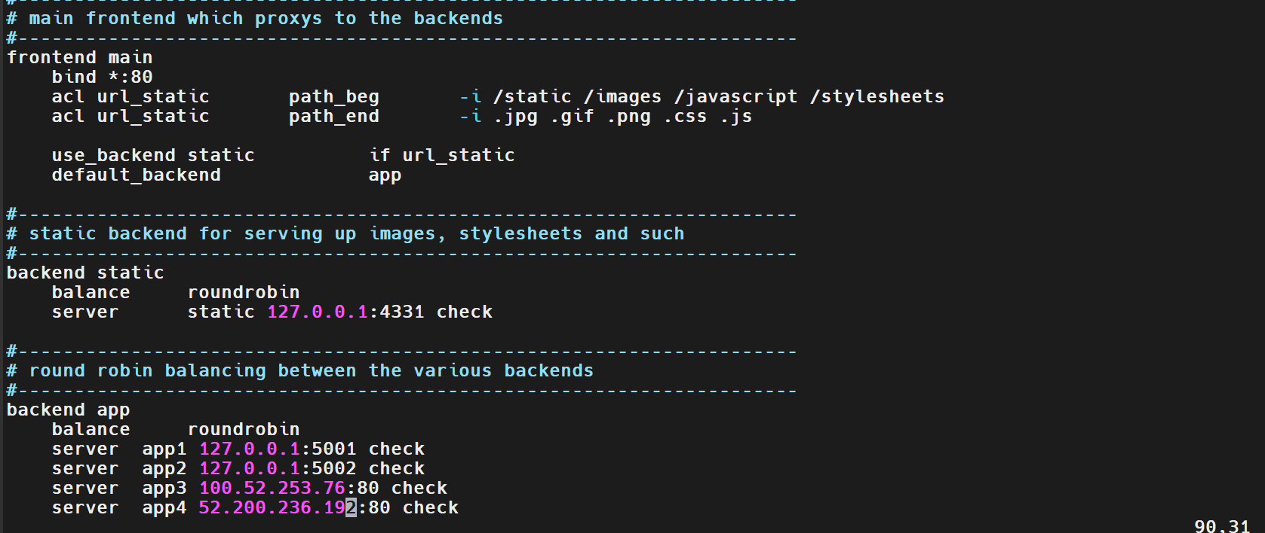
Step 12: Validate and Start HAProxy
Enabled HAProxy to start automatically after a system reboot:
systemctl enable haproxy
Started the service:
systemctl start haproxy
Checked the service status:
systemctl status haproxy
The output showed:
Active: active (running)
Status: "Ready."
The service startup checks succeeded, and HAProxy loaded its configuration.
Screenshot Evidence
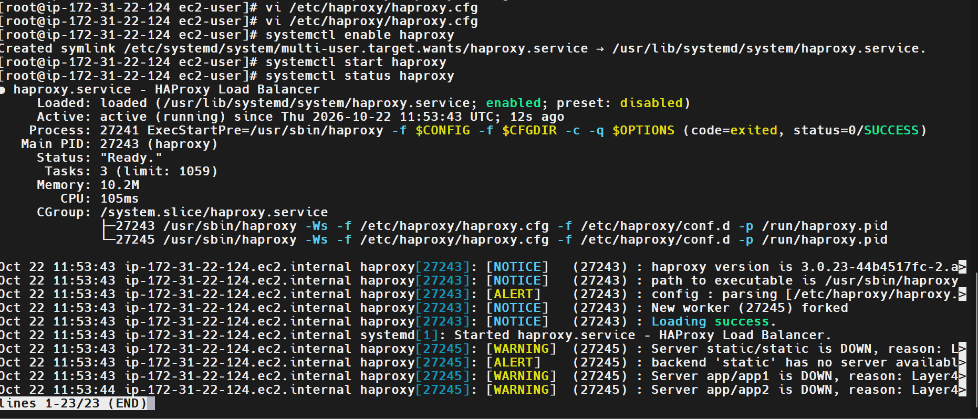
Step 13: Validate Backend Connectivity
From the HAProxy server, tested the Apache backend:
curl -I --connect-timeout 3 http://172.31.21.73:80/
Tested the Nginx backend:
curl -I --connect-timeout 3 http://172.31.21.244:80/
Both commands returned successful HTTP responses.
Backend | Observed response
Server 1 — Apache | HTTP/1.1 200 OK
Server 2 — Nginx | HTTP/1.1 200 OK
The response headers identified Apache on Server 1 and Nginx on Server 2.
Screenshot Evidence
Step 14: Access the HAProxy Website
Opened a web browser and entered the HAProxy public IP address:
http://52.207.242.88/
Refreshed the page multiple times. The browser displayed content from both Apache and Nginx through the same HAProxy address.
This demonstrated that requests were being distributed between the backend servers.
Screenshot Evidence
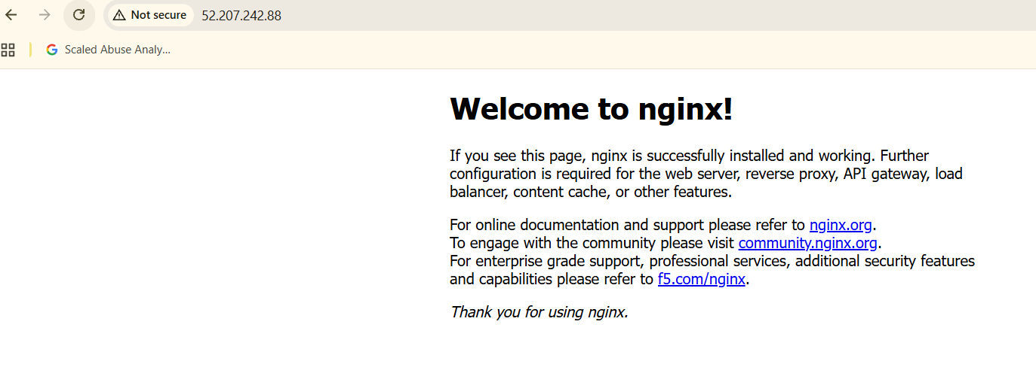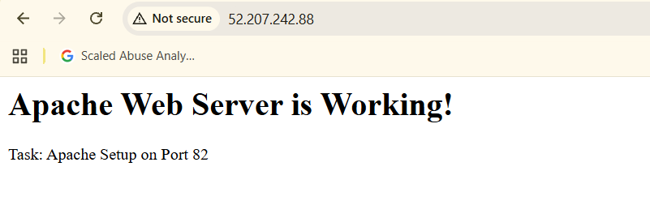
Validation Steps
The following checks were completed:
Validation | Expected result | Observed result
Apache service status | Active and running | Verified
Nginx service status | Active and running | Verified
HAProxy service status | Active and running | Verified
Backend 1 connectivity | HTTP 200 OK | Verified
Backend 2 connectivity | HTTP 200 OK | Verified
HAProxy website access | Web page loads through public IP | Verified
Backend page distribution | Apache and Nginx pages appear | Verified
Validation Summary
The HAProxy service was active and running. Both backend servers responded successfully on port 80, and both web pages were accessible through the HAProxy public IP address.
Explanation
HAProxy is a high-performance load balancer and reverse proxy that receives client requests and forwards them to backend servers. In this task, the frontend listens on port 80, while the backend pool contains an Apache server and an Nginx server. The Round Robin algorithm distributes requests across the available backend servers.
The check option enables health checks, and option httpchk GET / checks whether each backend responds to an HTTP request. This helps HAProxy identify unavailable backends and avoid sending traffic to servers that fail the configured health check.
Real-Time Use Case
Organizations use load balancers to distribute traffic across multiple web servers rather than directing all requests to one machine. For example, an e-commerce application can use HAProxy to distribute requests between several application servers during high traffic periods.
This approach helps improve traffic distribution, availability, and scalability. If one backend becomes unavailable and health checks detect the failure, HAProxy can continue routing requests to healthy backends.
Common Errors and Troubleshooting
Error or issue | Possible cause | Resolution
SSH connection fails | Incorrect public IP, username, key, or security group | Verify SSH settings and inbound TCP 22 rules
dnf install fails | Repository or network connectivity issue | Check network access and repository configuration
Apache or Nginx is inactive | Service not started or configuration error | Use systemctl status and inspect service logs
Backend connection refused | Service not listening on the configured port | Verify service status and listening port
Backend request times out | Security group or network connectivity issue | Check backend inbound rules and routing
HAProxy fails to start | Invalid configuration syntax | Validate using haproxy -c -f /etc/haproxy/haproxy.cfg
Old backend warnings appear in logs | Default sample backend entries remain in the loaded configuration | Check haproxy.cfg and files under /etc/haproxy/conf.d/
Only one backend page appears | Backend health, browser caching, or request distribution | Test both backends directly and repeat requests through HAProxy
Conclusion
Task 03 was completed successfully. Three EC2 instances were used to configure Apache, Nginx, and HAProxy. Both backend servers returned HTTP 200 OK responses, and the HAProxy public IP displayed content from both web servers, demonstrating successful load balancing.

