Task : Compare a Variable with a Numeric Value
Outcome
The script checks whether the variable count is equal to 100.
Expected output:
count is 100
Objective
To understand how to use variables and if-else conditional statements in Bash.
Prerequisites
- Access to an Amazon Linux EC2 instance.
- Basic knowledge of Linux commands and Bash scripting.
- Access to the working directory.
Step-by-Step Implementation
Step 1: Create the script
vim variable.bash
Step 2: Add the following script
#!/bin/bash

count=100

if [ "$count" -eq 100 ]
then
echo "count is 100"
else
echo "count is not 100"
fi
Step 3: Save the file and provide execute permissions
chmod 755 variable.bash
Step 4: Execute the script
./variable.bash
Validation Steps
Verify that the output is:
count is 100
The initial attempt displayed the error [: missing ]. After correcting the conditional syntax, the script executed successfully.
Evidence:
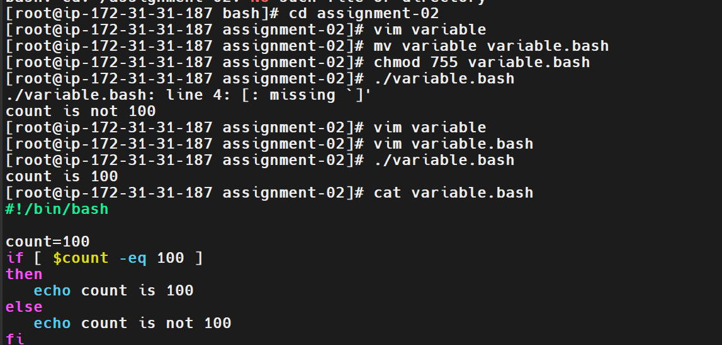
Explanation
- #!/bin/bash specifies the Bash interpreter.
- count=100 assigns the value 100 to the variable.
- if checks the condition.
- -eq compares two numeric values.
- then executes the commands when the condition is true.
- else executes when the condition is false.
- fi ends the conditional statement.
- echo displays the message.
Important: Spaces are required inside the test brackets.
Real-Time Use Case
Conditional statements are useful for validating configuration values, checking deployment conditions, and automating administrative tasks.
Common Errors and Troubleshooting
Error | Solution
[: missing ] | Add spaces before the closing bracket.
Unexpected output | Verify the variable value and numeric comparison operator.
Permission denied | Run chmod 755 variable.bash.
Task 2: Check Whether a File Exists
Outcome
The script checks whether /home/iafzal/error.txt exists.
Expected output depends on the file:
File exists
or
File does not exist
Objective
To understand file-existence testing using conditional statements.
Prerequisites
- Access to a Linux terminal.
- A Bash interpreter.
- Knowledge of Linux file paths.
Step-by-Step Implementation
Step 1: Create the script
vim error.bash
Step 2: Add the script
#!/bin/bash

if [ -e /home/iafzal/error.txt ]
then
echo "File exists"
else
echo "File does not exist"
fi
Step 3: Provide execute permissions
chmod 755 error.bash
Step 4: Execute the script
./error.bash
Validation Steps
The screenshot shows the following output:
File does not exist
This indicates that the specified path was not found at the time of execution.
You can verify the path with:
ls -l /home/iafzal/error.txt
Evidence:
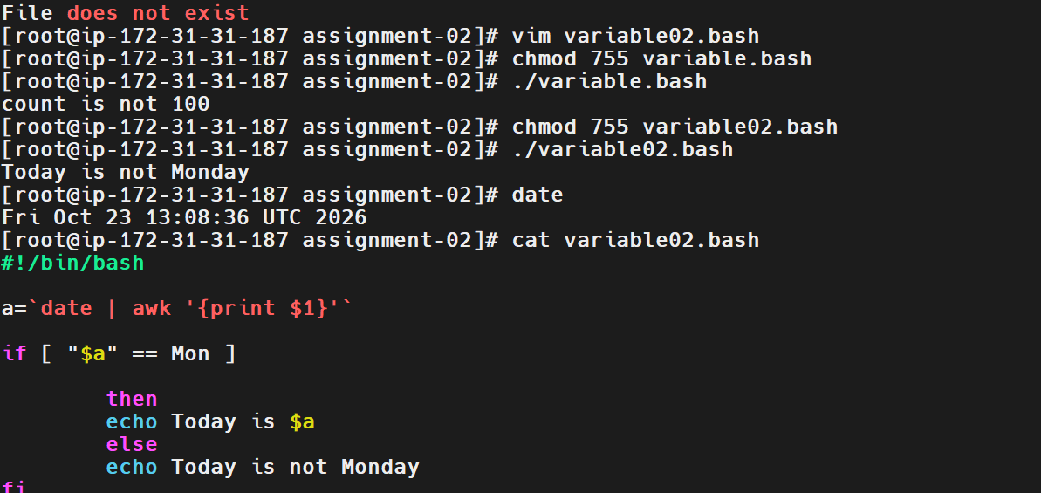

Explanation
- -e checks whether a filesystem path exists.
- if evaluates the condition.
- echo prints the appropriate message.
- else handles the case where the path does not exist.
To check specifically for a regular file, use -f instead of -e.
Real-Time Use Case
A deployment script can check whether a required configuration file exists before starting an application.
Common Errors and Troubleshooting
Error | Solution
File does not exist | Verify the file path using ls -l.
Incorrect path | Update the script with the correct absolute path.
Need to check a regular file | Replace -e with -f.
Task 3: Check Whether Today Is Monday
Outcome
The script checks the current weekday and displays an appropriate message.
The screenshot shows:
Today is not Monday
Objective
To understand command substitution, extracting date information, and using conditional statements.
Prerequisites
- Linux terminal access.
- Bash interpreter.
- System date and time configured correctly.
Step-by-Step Implementation
Step 1: Create the script
vim variable02.bash
Step 2: Add the script
#!/bin/bash

a=$(date +%a)

if [ "$a" = "Mon" ]
then
echo "Today is $a"
else
echo "Today is not Monday"
fi
Step 3: Provide execute permissions
chmod 755 variable02.bash
Step 4: Execute the script
./variable02.bash
Step 5: Verify the system date
date
Validation Steps
The screenshot shows the server date as Friday, October 23, 2026, and the script prints:
Today is not Monday
Explanation
- date +%a returns the abbreviated weekday, such as Mon, Tue, or Fri.
- $(...) captures the output of a command and stores it in a variable.
- a stores the weekday.
- = compares two strings.
- The script prints a different message depending on the weekday.
The original script used date | awk '{print $1}'. Using date +%a is simpler and avoids depending on the default output format of date.
Real-Time Use Case
This type of script can be used to run maintenance activities only on specific days of the week.
Common Errors and Troubleshooting
Error | Solution
Incorrect weekday output | Verify the server date using date.
Conditional syntax error | Ensure spaces exist around [ and ].
Variable contains unexpected text | Use date +%a to extract the weekday directly.
Task 4: Read User Input and Respond
Outcome
The script asks for the user's name and whether they like working in IT.
Example output:
What is your name?

naveen

Hello naveen sir

Do you like working in IT? [y/n]
y

You are cool
Objective
To understand how to accept user input and use that input in a conditional statement.
Prerequisites
- Access to an interactive Linux terminal.
- Bash interpreter.
Step-by-Step Implementation
Step 1: Create the script
vim input.bash
Step 2: Add the script
#!/bin/bash

read -r -p "What is your name? " name

echo
echo "Hello $name sir"

read -r -p "Do you like working in IT? [y/n] " answer

if [[ "$answer" =~ ^[Yy]$ ]]
then
echo "You are cool"
else
echo "Thanks for your answer"
fi
Step 3: Save and execute the script
bash input.bash
Alternatively, make the script executable:
chmod 755 input.bash
./input.bash
Validation Steps
Enter a name such as naveen and answer y when prompted. Confirm that the script displays the greeting and You are cool.
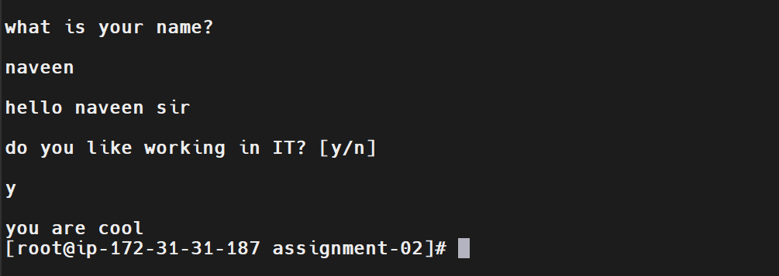
Explanation
- read accepts input from the user.
- -p displays a prompt.
- name stores the user's name.
- answer stores the yes/no response.
- [[ ... ]] evaluates the condition.
- =~ checks the response against a pattern.
- echo displays the result.
The pattern ^[Yy]$ accepts either uppercase Y or lowercase y.
Real-Time Use Case
Interactive scripts can collect deployment parameters or ask an administrator for confirmation before performing an operation.
Common Errors and Troubleshooting
Error | Solution
Empty name | Enter a name when prompted.
Unexpected response | Check the input and the conditional expression.
Script does not prompt | Run it from an interactive terminal.
Task 5: Create and delete Multiple Files Using a for Loop
Outcome
The script creates five files named 1, 2, 3, 4, and 5.
Expected output when confirmation messages are included:
File 1 created
File 2 created
File 3 created
File 4 created
File 5 created
Objective
To understand the for loop and create multiple files automatically.
Prerequisites
- Bash interpreter.
- Write permission in the working directory.
Step-by-Step Implementation
Step 1: Create the script
vim for-loop.bash
Step 2: Add the script
#!/bin/bash

for i in {1..5}
do
touch "$i"
echo "File $i created"
done
Step 3: Provide execute permissions
chmod 755 for-loop.bash
Step 4: Execute the script
./for-loop.bash
Step 5: Verify the created files
ls -l 1 2 3 4 5
Delete the file
Step 1: Create the script
vim for-loopdlt.bash
Step 2: Add the script

#!/bin/bash
for i in {1..5}
do
rm $i
done
Step 3: Provide execute permissions
chmod 755 for-loopdlt.bash
Step 4: Execute the script
./for-loopdlt.bash
Step 5: Verify the deleted files
ls -l
Validation Steps
The screenshot confirms that files 1 through 5 were created and deleted in the working directory.
The original script did not display any output because touch is silent by default. Adding echo displays a confirmation message for each file.
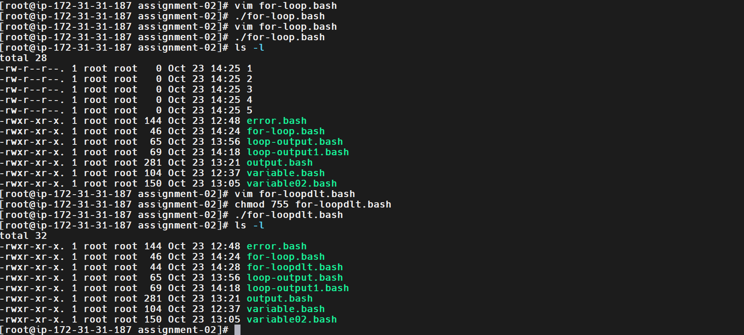
Explanation
- for starts the loop.
- i is the loop variable.
- {1..5} generates the numbers 1 to 5.
- do starts the loop body.
- touch "$i" creates an empty file if it does not exist.
- echo displays a confirmation message.
- done ends the loop.
Note: If a file already exists, touch updates its timestamp. It does not delete or replace the file's contents.
Real-Time Use Case
Loops are useful for creating multiple files, directories, or test resources during automation.
Common Errors and Troubleshooting
Error | Solution
No output appears | touch is silent; add echo or verify using ls -l.
Permission denied | Check the current directory and write permissions.
Files are created in the wrong location | Run pwd to verify the working directory.
Task 6: Print a Message Repeatedly Using a for Loop
Outcome
The script prints a welcome message five times.
Expected output:
welcome 1 times
welcome 2 times
welcome 3 times
welcome 4 times
welcome 5 times
Objective
To understand how a for loop executes a command repeatedly.
Prerequisites
- Linux terminal access.
- Bash interpreter.
Step-by-Step Implementation
Step 1: Create the script
vim loop-output.bash
Step 2: Add the script
#!/bin/bash

for i in {1..5}
do
echo "welcome $i times"
done
Step 3: Provide execute permissions
chmod 755 loop-output.bash
Step 4: Execute the script
./loop-output.bash
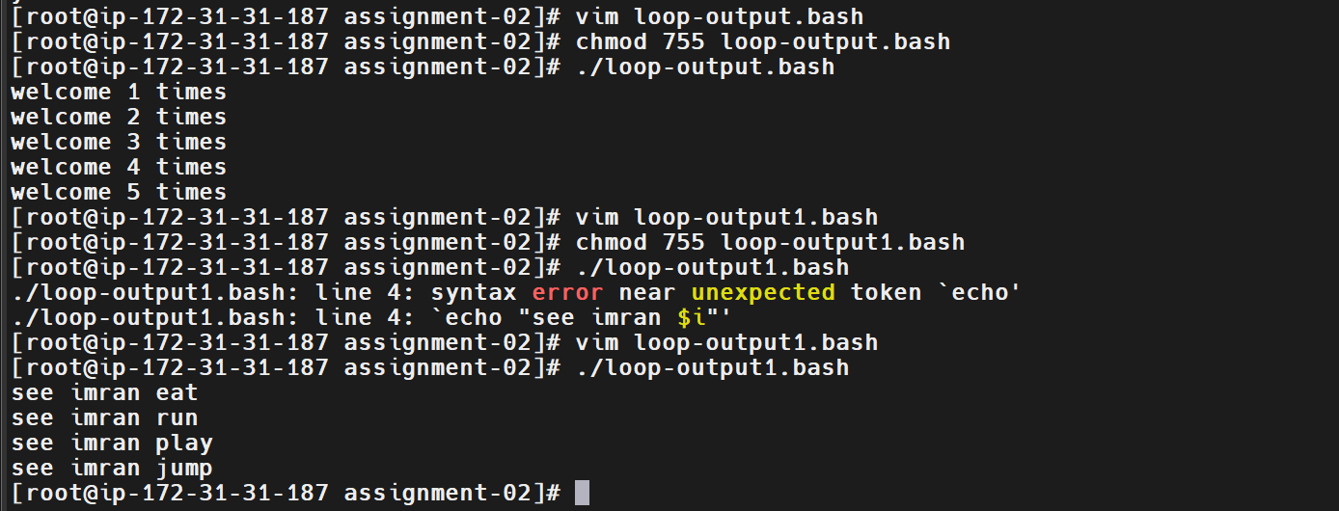
Validation Steps
Confirm that five lines appear, numbered from 1 to 5. The screenshot shows the expected output.
Explanation
The loop iterates through numbers 1 to 5. During each iteration, the value of i changes and is displayed in the message.
Real-Time Use Case
Repeated loops can be used in testing, batch operations, and executing the same command against several resources.
Common Errors and Troubleshooting
Error | Solution
Syntax error near echo | Ensure do appears before the loop commands.
Loop does not finish correctly | Verify that done is present at the end.
Output appears only once | Check the loop range {1..5}.
Task 7: Loop Through a List of Words
Outcome
The script prints a message for each word in the list.
Expected output:
see imran eat
see imran run
see imran play
see imran jump
Objective
To understand how a for loop processes a list of values.
Prerequisites
- Bash interpreter.
- Linux terminal access.
Step-by-Step Implementation
Step 1: Create the script
vim loop-output1.bash
Step 2: Add the script
#!/bin/bash

for i in eat run play jump
do
echo "see imran $i"
done
Step 3: Provide execute permissions
chmod 755 loop-output1.bash
Step 4: Execute the script
./loop-output1.bash
Validation Steps
The initial attempt displayed a syntax error near echo. After correcting the script structure, the screenshot shows all four expected lines.
Explanation
- The for loop processes each word in the list.
- The variable i holds the current word.
- echo prints the message.
- done ends the loop.
Real-Time Use Case
A list-based loop can execute commands for multiple service names, environments, or application components.
Common Errors and Troubleshooting
Error | Solution
Syntax error near echo | Check the placement of do and done.
A word is missing | Verify the list in the for statement.
Unexpected output | Check how the variable is used in the message.
Task 8: Print Weekdays Using a for Loop
Outcome
The script prints five weekday labels with their sequence numbers.
Expected output:
weekday 1 : mon
weekday 2 : tue
weekday 3 : wed
weekday 4 : thu
weekday 5 : fri
Objective
To understand Bash arrays, loops, and counters.
Prerequisites
- Bash interpreter.
- Linux terminal access.
Step-by-Step Implementation
Step 1: Create the script
vim days-loop.bash
Step 2: Add the script
#!/bin/bash

days=(mon tue wed thu fri)
i=1

for day in "${days[@]}"
do
echo "weekday $i : $day"
((i++))
done
Step 3: Provide execute permissions
chmod 755 days-loop.bash
Step 4: Execute the script
./days-loop.bash
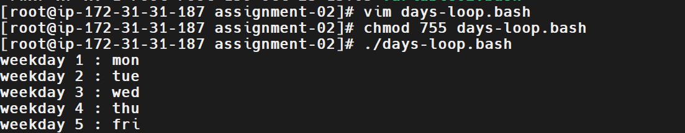
Validation Steps
The screenshot shows all five weekdays in sequence, from Monday to Friday.
Explanation
- days=(...) creates an array.
- "${days[@]}" accesses all array elements.
- day stores the current weekday.
- i=1 initializes the counter.
- ((i++)) increments the counter.
- done ends the loop.
Real-Time Use Case
Arrays and loops can be used to process a list of scheduled workdays or perform operations across multiple environments.
Common Errors and Troubleshooting
Error | Solution
Only one array element appears | Use "${days[@]}" to iterate through all elements.
Counter does not increment | Ensure ((i++)) is inside the loop.
Incorrect sequence | Initialize the counter before the loop.
Task 9: Display System Usernames from /etc/passwd
Outcome
The script displays usernames from the Linux account file with a sequence number.
Example output:
Username 1 : root
Username 2 : bin
Username 3 : daemon
Username 4 : adm
Username 5 : lp
The screenshot shows additional system accounts continuing in the same format.
Objective
To understand reading a Linux system file and processing its contents using a loop.
Prerequisites
- Linux system with /etc/passwd.
- Read access to /etc/passwd.
- Bash interpreter.
Step-by-Step Implementation
Step 1: Create the script
vim user-loop.bash
Step 2: Add the script
#!/bin/bash

i=1

while IFS=: read -r username _
do
echo "Username $i : $username"
((i++))
done < /etc/passwd
Step 3: Provide execute permissions
chmod 755 user-loop.bash
Step 4: Execute the script
./user-loop.bash
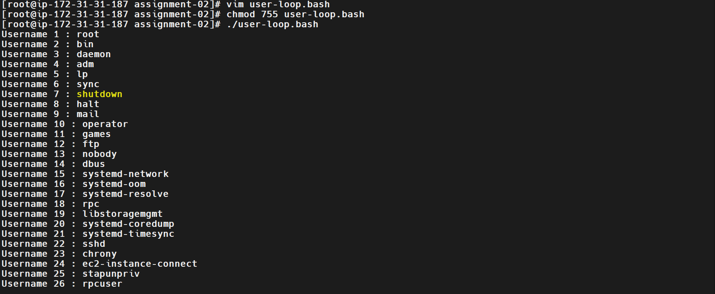
Validation Steps
Verify that the script displays usernames such as root, bin, and daemon, followed by other accounts listed in /etc/passwd.
Explanation
- /etc/passwd contains local Linux account information.
- while reads the file line by line.
- IFS=: sets the field separator to a colon.
- read -r username _ stores the first field in username.
- i tracks the number of entries processed.
- ((i++)) increments the counter.
- < /etc/passwd redirects the file contents into the loop.
The output includes system and service accounts, not only accounts used by human users.
Real-Time Use Case
Linux administrators can use scripts like this to review local account names during system administration and account audits.
Common Errors and Troubleshooting
Error | Solution
No output appears | Check that /etc/passwd exists and the redirection is correct.
Fields are parsed incorrectly | Use IFS=: with the read command.
Only one line is processed | Check the while loop and the placement of done.
Task 10: Run a Countdown Using a while Loop
Outcome
The script displays a countdown and then prints a final message.
Expected output:
10 seconds left to stop this process
9 seconds left to stop this process
8 seconds left to stop this process
...
2 seconds left to stop this process
1 seconds left to stop this process
process is stopped!!!
Objective
To understand loops, counters, and delays using the sleep command.
Prerequisites
- Bash interpreter.
- Linux terminal access.
- sleep utility available on the system.
Step-by-Step Implementation
Step 1: Create the script
vim do-while.bash
Step 2: Add the script
#!/bin/bash

count=10

while [ "$count" -gt 0 ]
do
echo "$count seconds left to stop this process"
sleep 1
((count--))
done

echo "process is stopped!!!"
Step 3: Execute the script
bash do-while.bash
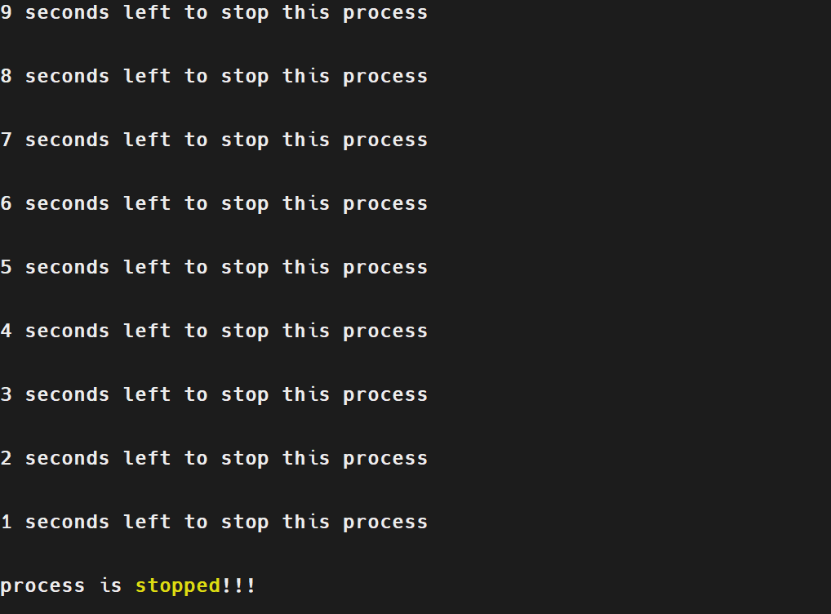
Validation Steps
The screenshot shows the countdown decreasing once per second and then displays:
process is stopped!!!
Explanation
- count=10 initializes the countdown.
- while [ "$count" -gt 0 ] continues while the counter is greater than zero.
- echo prints the current count.
- sleep 1 pauses execution for approximately one second.
- ((count--)) decreases the counter by one.
- done ends the loop.
- The final echo runs after the loop finishes.
Note: Bash does not have a native do-while keyword. This example uses a while loop to implement a countdown. Also, grammatically, 1 second would be more appropriate than 1 seconds.
Real-Time Use Case
A countdown can introduce a short delay before a controlled operation. It should not replace proper process supervision or safe shutdown procedures.
Common Errors and Troubleshooting
Error | Solution
Countdown does not end | Ensure the counter decreases inside the loop.
Final message does not appear | Check that the final echo is outside the loop.
sleep command fails | Verify that the command is available in the system's PATH.
Overall Validation Steps
- Verify the working directory:
pwd
Expected directory:
/bash/assignment-02
- List the scripts and generated files:
ls -l
- Run each script individually and verify its output.
- For the file-creation exercise, confirm the files exist:
ls -l 1 2 3 4 5
- Capture screenshots showing the script execution and successful output.
- Retain screenshots of initial errors and corrected executions as troubleshooting evidence.
- Review the script files before pushing them to GitHub.
Conclusion
This document demonstrate Bash scripting practice involving variables, conditional statements, file-existence checks, date commands, user input, loops, arrays, reading Linux account records, and countdowns. Several initial syntax errors were corrected during practice. The screenshots provide evidence of successful execution for the corrected examples.

Task 1: Check Whether a Directory Exists Using a Bash Script
1. Outcome
Successfully created and executed a Bash script named directory.bash on an Amazon Linux EC2 instance to check whether a specified directory exists. Verified both conditions: when the directory exists and when it does not exist.
2. Objective
To understand how to use conditional statements and the -d test operator in Bash scripting to check whether a directory exists. This is useful in DevOps automation to validate directory paths before performing operations such as creating files, storing backups, deploying applications, or processing logs.
3. Prerequisites
- Access to an Amazon Linux EC2 instance.
- Root access or a Linux user with appropriate permissions.
- Access to the terminal through SSH.
- Basic knowledge of Linux commands and Bash scripting.
- The Bash shell installed on the system.
4. Step-by-Step Implementation
Step 1: Open the Terminal and Navigate to the Working Directory
The script was created in the assignment-02 directory on the Amazon Linux EC2 instance.
Command:
cd /path/to/assignment-02
Note: Replace the example path with the actual path of your working directory. In the submitted screenshot, the terminal prompt shows assignment-02.
Screenshot Evidence:
[Paste the screenshot showing the working directory and terminal here.]
Step 2: Create the Bash Script
Create a file named directory.bash using the Vim editor.
Command:
vim directory.bash
Enter the following script:
#!/bin/bash

DIR="/home/ec2-user/nov"

if [ -d "$DIR" ]
then
echo "directory exists"
else
echo "directory doesnot exist"
fi
Save and exit the editor by pressing Esc, typing :wq, and pressing Enter.
Explanation:
- #!/bin/bash specifies Bash as the script interpreter.
- DIR stores the directory path to check.
- if starts the conditional statement.
- [ -d "$DIR" ] checks whether the specified path exists and is a directory.
- then executes the command when the condition is true.
- else executes the command when the condition is false.
- fi marks the end of the conditional statement.
Step 3: Provide Execute Permission
Execute the following command to make the script executable.
chmod 755 directory.bash
The 755 permission allows the file owner to read, write, and execute the script, while group members and others can read and execute it.
Step 4: Execute the Script When the Directory Exists
Run the script:
./directory.bash
Observed Output:
directory exists
The output confirms that /home/ec2-user/nov existed when the script was executed.
Explanation: When the directory exists, the -d condition evaluates to true and the then block executes.
Step 5: Execute the Script When the Directory Does Not Exist
Modify the script using Vim:
vim directory.bash
Change the directory path to a path that does not exist:
DIR="/home/ec2-user/nov"
For this test, ensure that /home/ec2-user/nov does not exist. Your submitted screenshot shows the script printing the negative result for this configured path.
Save the file and execute it again:
./directory.bash
Observed Output:
directory doesnot exist
Explanation: When the specified directory is absent, the -d condition evaluates to false and the else block executes.
Screenshot Evidence:
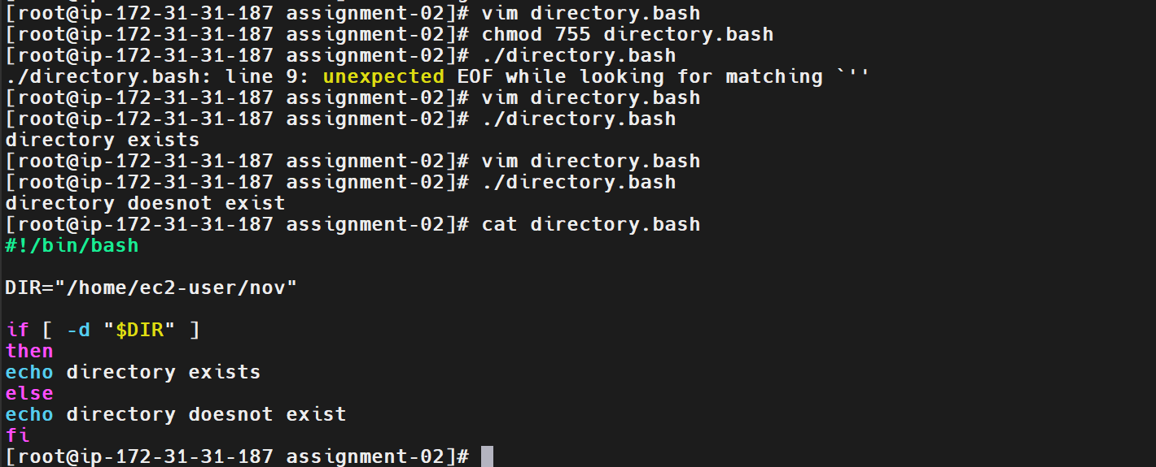
5. Validation Steps
Validate the task by confirming that:
- The directory.bash file was created successfully.
- The script contains the correct Bash interpreter declaration.
- The chmod 755 directory.bash command was executed.
- Running ./directory.bash displays directory exists when the configured directory exists.
- Running ./directory.bash displays directory doesnot exist when the configured directory is absent.
Validation Screenshot:
The submitted screenshot shows the script execution, both output messages, and the final script contents. It also shows an initial syntax error that was corrected before successful execution.
6. Explanation
Command or syntax | Description
#!/bin/bash | Specifies Bash as the interpreter.
DIR="..." | Assigns the directory path to a variable.
if | Starts a conditional statement.
-d | Tests whether a path exists and is a directory.
then | Runs commands when the condition is true.
else | Runs commands when the condition is false.
fi | Ends the conditional statement.
echo | Prints a message to the terminal.
chmod 755 | Sets read, write, and execute permissions for the owner and read/execute permissions for group and others.
./directory.bash | Executes the script from the current directory.
7. Real-Time Use Case
DevOps engineers use directory checks in deployment and backup scripts to ensure that the required directory is available before performing an operation.
For example, a script can check whether an application directory exists before deploying files:
#!/bin/bash

DIR="/var/www/html"

if [ -d "$DIR" ]
then
echo "Application directory exists"
else
echo "Application directory does not exist"
fi
This helps prevent scripts from proceeding under the assumption that a required directory is available.
8. Common Errors and Troubleshooting
Error or issue | Cause | Resolution
unexpected EOF while looking for matching ... | A quote or other syntax element was left unclosed. | Check the script for missing quotes, brackets, or other closing syntax.
Permission denied | The script does not have execute permission or the user lacks access. | Run chmod 755 directory.bash and verify file permissions.
No such file or directory | The script or configured path does not exist. | Verify the file name and directory path.
Incorrect directory result | The path in DIR does not match the intended directory. | Verify the path using ls -ld /home/ec2-user/nov.
Script does not execute | The script may have syntax errors or an incorrect interpreter declaration. | Review the script and run bash -n directory.bash to check syntax.
Actual error encountered and resolution:
During the initial execution, the script displayed the error:
./directory.bash: line 9: unexpected EOF while looking for matching ...
The script was reopened in Vim and corrected. After the correction, it executed successfully and displayed both the directory-exists and directory-does-not-exist messages during testing.
Conclusion: The task demonstrated how to use Bash conditional statements and the -d operator to check whether a directory exists. This technique is useful for validating paths and making Linux automation scripts more reliable.
Task 2: Create Multiple Files Using a Bash Script
1. Outcome
Successfully created and executed a Bash script named multiple_files.bash on an Amazon Linux EC2 instance to create multiple files automatically. The script created five files (file1.txt to file5.txt) inside /tmp/devops-files using a for loop and the touch command.
2. Objective
To understand how to use Bash scripting, variables, loops, and Linux file-management commands to automate the creation of multiple files. This is useful in DevOps workflows for generating configuration files, log files, test files, and application-specific files.
3. Prerequisites
- Access to an Amazon Linux EC2 instance.
- Root access or a Linux user with appropriate permissions.
- Access to the terminal through SSH.
- Basic knowledge of Bash scripting and Linux commands.
- The Bash shell installed on the system.
4. Step-by-Step Implementation
Step 1: Create the Bash Script
Create a script named multiple_files.bash using Vim.
Command:
vim multiple_files.bash
Enter the following script:
#!/bin/bash
clear
DIR="/tmp/devops-files"
mkdir -p "$DIR"
for i in 1 2 3 4 5
do
touch "$DIR/file$i.txt"
echo "Created file$i.txt"
done
echo "All files created successfully"
Save and exit Vim by pressing Esc, typing :wq, and pressing Enter.
Explanation:
- #!/bin/bash specifies Bash as the script interpreter.
- clear clears the terminal screen.
- DIR="/tmp/devops-files" stores the target directory path in a variable.
- mkdir -p "$DIR" creates the directory if it does not already exist.
- for i in 1 2 3 4 5 iterates through five numbers.
- touch "$DIR/file$i.txt" creates a file for each iteration.
- echo displays a message for each file created.
- done marks the end of the loop.
Step 2: Provide Execute Permission
Execute the following command to make the script executable:
chmod 755 multiple_files.bash
This grants the file owner read, write, and execute permissions, while group members and others receive read and execute permissions.
Screenshot Evidence: Paste the screenshot showing the permission command here.
Step 3: Execute the Script
Run the script from the current directory:
./multiple_files.bash
Observed Output:
Created file1.txt
Created file2.txt
Created file3.txt
Created file4.txt
Created file5.txt
All files created successfully
Explanation: The script iterates through the five values and creates a corresponding file during each iteration. The final message indicates that the loop has finished.
Step 4: Verify the Created Files
Run the following command to list the files:
ls -l /tmp/devops-files
The output should contain these five filenames:
file1.txt
file2.txt
file3.txt
file4.txt
file5.txt
To count the files in the directory, run:
find /tmp/devops-files -maxdepth 1 -type f | wc -l
Expected output:
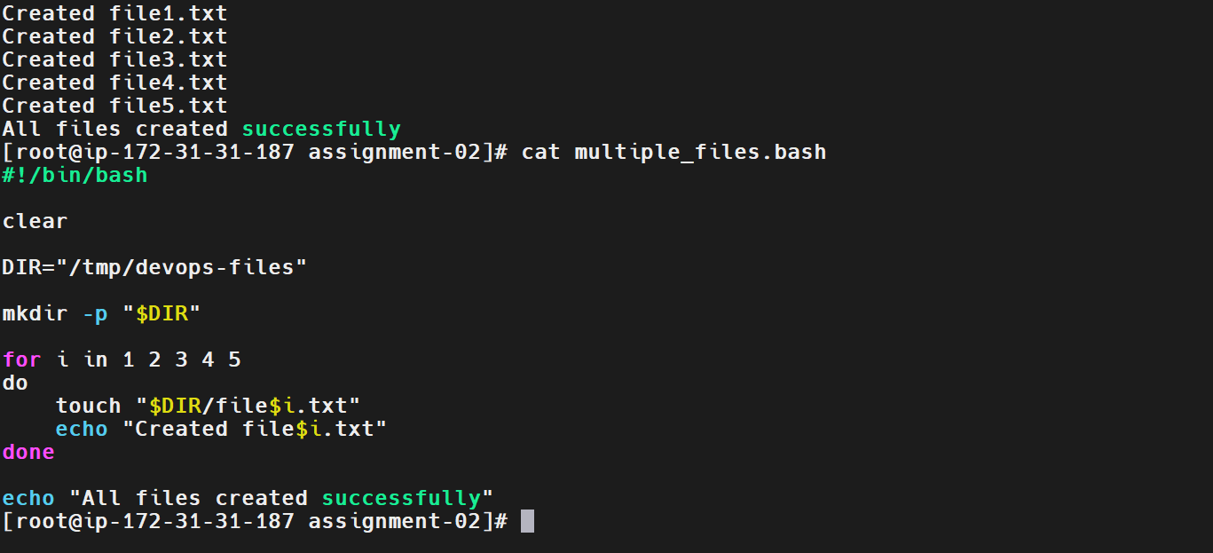
Note: The submitted screenshot confirms the creation messages and displays the script contents. The file listing and count are additional validation steps; capture them after executing the commands.
5. Validation Steps
Validate the task by confirming that:
- The multiple_files.bash script was created successfully.
- The script contains the correct Bash interpreter declaration.
- The chmod 755 multiple_files.bash command was executed.
- Running ./multiple_files.bash displays five file creation messages.
- The final message All files created successfully appears.
- The ls -l /tmp/devops-files command lists all five files.
- The find and wc -l commands confirm that five regular files exist in the target directory.
6. Explanation
Command or syntax | Description
#!/bin/bash | Specifies Bash as the script interpreter.
Clear | Clears the terminal screen.
DIR="/tmp/devops-files" | Defines the target directory using a variable.
mkdir -p | Creates the directory if it does not already exist.
for i in 1 2 3 4 5 | Repeats the commands for five values.
do | Marks the beginning of the loop body.
touch | Creates empty files if they do not exist.
"$DIR/file$i.txt" | Builds each filename using the directory and loop variable.
echo | Displays messages on the terminal.
done | Ends the loop.
chmod 755 | Sets executable permissions on the script.
ls -l | Displays detailed file information.
wc -l | Counts lines; here, it counts the file paths returned by find.
7. Real-Time Use Case
DevOps engineers often automate the creation of multiple files during application setup, testing, and deployment. For example, files for different environments can be created using a loop.
#!/bin/bash

for env in dev test prod
do
touch "${env}.conf"
echo "Created ${env}.conf"
done
This script creates three configuration files:
- dev.conf
- test.conf
- prod.conf
Using loops reduces repetitive manual work and makes scripts easier to maintain.
8. Common Errors and Troubleshooting
Error or issue | Cause | Resolution
Permission denied | Insufficient permissions on the target directory. | Select a writable directory or use appropriate authorized permissions.
No such file or directory | The target path is incorrect or missing. | Check the path and use mkdir -p to create the directory.
./multiple_files.bash: Permission denied | Execute permission is missing. | Run chmod 755 multiple_files.bash.
Files are not visible | The wrong directory is being checked. | Run ls -l /tmp/devops-files.
Only some files are created | The loop or command inside it may be incorrect. | Check the loop syntax and execute the script again.
Script runs but files are empty | touch creates empty files by design. | Use echo or another command to write content if required.
Actual error encountered / resolution: No execution errors were visible in the submitted screenshot. The script displayed all five creation messages and the final success message.
Conclusion: The task demonstrated how to use Bash loops, variables, mkdir, and touch to automate file creation. This technique is useful for repetitive file-management operations in Linux administration and DevOps automation.

Task 3: Take a Backup of a Directory Using a Bash Script
1. Outcome
Successfully created and executed a Bash script named backup_directory.bash on an Amazon Linux EC2 instance to create a compressed backup of a directory. Verified the backup file and practiced extracting the archive into a separate directory.
2. Objective
To understand how to automate directory backups using Bash scripting and the tar command. This is useful in DevOps for protecting application files, configuration files, and other important data before deployments, maintenance, or system changes.
3. Prerequisites
- Access to an Amazon Linux EC2 instance.
- Root access or appropriate directory permissions.
- Basic knowledge of Bash scripting and Linux commands.
- The tar utility installed on the system.
- Sufficient disk space to store the backup.
4. Step-by-Step Implementation
Step 1: Create a Sample Directory and Files
Create a directory to store sample application files.
Commands:
mkdir -p /tmp/devops-backup-source
echo "Application configuration" > /tmp/devops-backup-source/app.conf
echo "Backup practice file" > /tmp/devops-backup-source/readme.txt
Verify the files:
ls -l /tmp/devops-backup-source
Expected files:
app.conf
readme.txt
Step 2: Create the Bash Script
Create a file named backup_directory.bash.
Command:
vim backup_directory.bash
Enter the following script:
#!/bin/bash

SOURCE_DIR="/tmp/devops-backup-source"
BACKUP_DIR="/tmp/devops-backups"
DATE=$(date +%Y%m%d_%H%M%S)

if [ ! -d "$SOURCE_DIR" ]; then
echo "Source directory does not exist: $SOURCE_DIR"
exit 1
fi

mkdir -p "$BACKUP_DIR"

BACKUP_FILE="$BACKUP_DIR/backup_$DATE.tar.gz"

if tar -czf "$BACKUP_FILE" -C "$SOURCE_DIR" .; then
echo "Backup created successfully: $BACKUP_FILE"
else
echo "Backup failed"
exit 1
fi

if [ -s "$BACKUP_FILE" ]; then
echo "Backup verification successful"
ls -lh "$BACKUP_FILE"
else
echo "Backup file is missing or empty"
exit 1
fi
Save and exit Vim by pressing Esc, typing :wq, and pressing Enter.
Explanation:
- SOURCE_DIR specifies the directory to back up.
- BACKUP_DIR specifies the directory where the backup will be stored.
- date generates a timestamp for the backup filename.
- if [ ! -d "$SOURCE_DIR" ] checks whether the source directory is missing.
- mkdir -p creates the backup directory if it does not exist.
- tar -czf creates a compressed archive.
- if [ -s "$BACKUP_FILE" ] checks whether the backup file exists and is non-empty.
Step 3: Provide Execute Permission
Command:
chmod 755 backup_directory.bash
This makes the script executable by the owner, group, and other users, subject to their permissions.
Step 4: Execute the Script
Command:
./backup_directory.bash
Example output:
Backup created successfully: /tmp/devops-backups/backup_20261025_085522.tar.gz
Backup verification successful
The timestamp in the filename depends on the actual execution time. Your script should display the actual filename it creates.
Step 5: Verify the Backup File
Command:
ls -lh /tmp/devops-backups/
This displays the backup archive and its size.
To inspect the archive contents, use:
tar -tzf /tmp/devops-backups/backup_20261025_085522.tar.gz
Replace the example filename with the actual filename printed by your script if it differs.
Expected entries include:
./
./app.conf
./readme.txt
Step 6: Create a Restore Directory
Command:
mkdir -p /tmp/devops-backup-restore
This creates a separate directory for testing the backup extraction.
Step 7: Extract the Backup
Use the full path to the backup archive. Execute the entire command on one line.
Command:
tar -xzf /tmp/devops-backups/backup_20261025_085522.tar.gz -C /tmp/devops-backup-restore
Replace the example filename with the actual archive filename if necessary.
Explanation:
- -x extracts files from an archive.
- -z handles gzip compression.
- -f specifies the archive filename.
- -C changes to the specified destination directory before extracting.
During testing, an initial extraction attempt failed because the archive filename was not found in the current directory and the -C option was entered on a separate line. The command was corrected by using the full archive path and keeping all options in the same command.
Step 8: Verify the Restored Files
Commands:
ls -l /tmp/devops-backup-restore
cat /tmp/devops-backup-restore/app.conf
Expected content of app.conf:
Application configuration
The restored files confirm that the archive can be extracted and its contents accessed.
5. Validation Steps
Validate the task by confirming that:
- The sample source directory was created successfully.
- The backup_directory.bash script was created and made executable.
- The script checks whether the source directory exists.
- The tar command creates a compressed backup with a timestamp.
- The backup file exists and is non-empty.
- The tar -tzf command displays the archived files.
- The backup is extracted into /tmp/devops-backup-restore.
- The restored app.conf file contains Application configuration.
Screenshot Evidence:
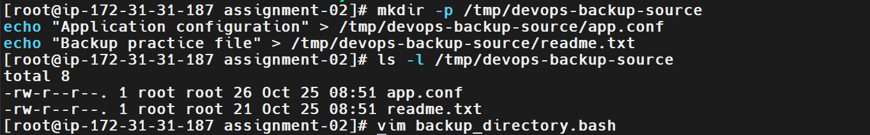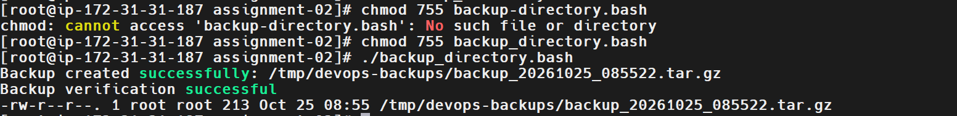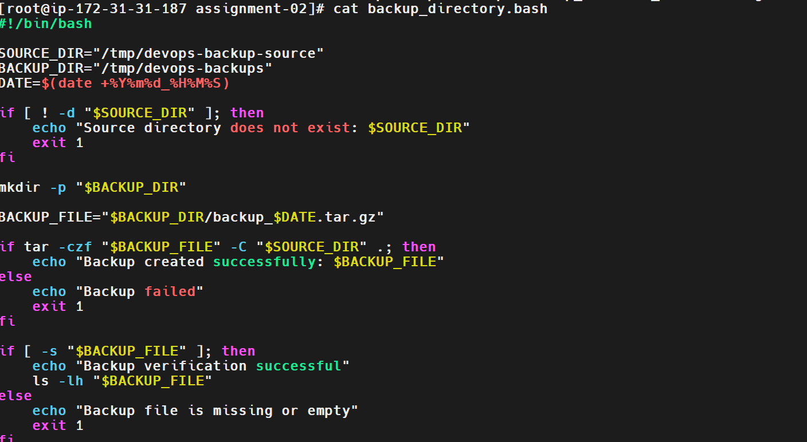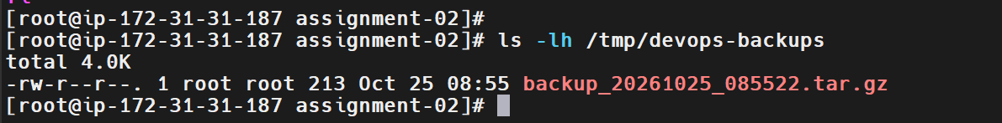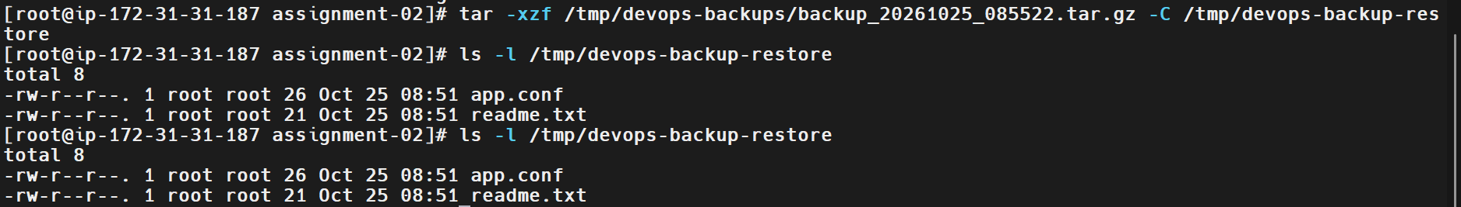
6. Explanation
Command or option | Description
mkdir -p | Creates a directory and any missing parent directories.
date +%Y%m%d_%H%M%S | Generates a timestamp for a unique filename.
tar -czf | Creates a gzip-compressed archive.
-C | Specifies the directory in which to operate during archive creation or extraction.
tar -tzf | Lists the contents of a compressed archive.
tar -xzf | Extracts a gzip-compressed archive.
[ ! -d "$SOURCE_DIR" ] | Checks whether the source directory does not exist.
[ -s "$BACKUP_FILE" ] | Checks whether the file exists and has a size greater than zero.
ls -lh | Displays file details and human-readable sizes.
exit 1 | Exits the script with a non-zero status to indicate failure.
7. Real-Time Use Case
DevOps engineers can create backups before deploying a new application version or modifying configuration files. If a deployment fails, the backup can help restore the previous files.
For example, an automated backup can be created before a maintenance operation:
tar -czf app_backup_$(date +%Y%m%d_%H%M%S).tar.gz /var/www/html
This command archives the application directory into a timestamped compressed file.
Important: A backup stored only on the same EC2 instance does not protect against instance or disk loss. For production environments, consider storing backups in Amazon S3, applying retention policies, and testing restoration regularly.
8. Common Errors and Troubleshooting
Error or issue | Cause | Solution
Source directory does not exist | Incorrect source path | Verify the path using ls -ld.
Cannot open: No such file or directory | The archive filename or path is incorrect | Use the full archive path and verify it with ls -lh.
bash: -C: command not found | The -C option was entered as a separate command | Keep the complete tar command on one line.
Permission denied | Insufficient directory permissions | Check permissions and use authorized privileges.
No space left on device | Insufficient disk space | Check filesystem usage using df -h.
Backup file is empty | Archive creation failed or source data was unavailable | Check the tar command's exit status and inspect the source directory.
Cannot extract archive | Incorrect filename or damaged archive | Verify the filename and test the archive with tar -tzf.
Actual error encountered and resolution:
The initial extraction command failed because the backup archive was not found in the current working directory. The -C option was also entered on a separate line, causing Bash to interpret it as a command. The resolution was to use the full archive path and execute the complete tar -xzf ... -C ... command on one line.
Conclusion: This task demonstrated how to automate directory backups using Bash scripting and tar, verify compressed archives, and restore files into a separate directory. These practices support safer deployments, recovery procedures, and routine DevOps maintenance.
Task 4: Install Nginx on an Amazon Linux EC2 Instance Using a Bash Script
1. Outcome
Successfully created and executed a Bash script named install_nginx.bash on an Amazon Linux EC2 instance to automate the installation of Nginx. Verified that the Nginx service was started, enabled to start automatically at boot, and responding to HTTP requests locally.
2. Objective
To understand how to automate software installation and service management using Bash scripting on an Amazon Linux EC2 instance. Nginx is a web server commonly used to serve web applications, reverse-proxy requests, and distribute traffic to backend services.
3. Prerequisites
- Access to an Amazon Linux EC2 instance.
- Root access or a user with appropriate sudo privileges.
- SSH or terminal access to the instance.
- Internet connectivity to access configured package repositories.
- The dnf or yum package manager.
- An EC2 security group configured appropriately if external HTTP access is required.
4. Step-by-Step Implementation
Step 1: Verify the Operating System
Run the following command to confirm the Linux distribution:
cat /etc/os-release
This confirms the operating system and helps determine the appropriate package manager.
Step 2: Create the Bash Script
Create a script named install_nginx.bash:
vim install_nginx.bash
Enter the following script:
#!/bin/bash

set -e

echo "Installing Nginx..."

if command -v dnf >/dev/null 2>&1; then
dnf install -y nginx
elif command -v yum >/dev/null 2>&1; then
yum install -y nginx
else
echo "No supported package manager found"
exit 1
fi

systemctl enable --now nginx

echo "Checking Nginx service status..."
systemctl status nginx --no-pager

echo "Nginx installation completed successfully"
Save and exit Vim by pressing Esc, typing :wq, and pressing Enter.
Explanation:
- #!/bin/bash specifies Bash as the script interpreter.
- set -e causes the script to exit if a command fails, subject to Bash's set -e behavior.
- command -v dnf checks whether the dnf package manager is available.
- dnf install -y nginx installs Nginx without interactive confirmation.
- yum install -y nginx provides an alternative for systems using yum.
- systemctl enable --now nginx enables Nginx at boot and starts it immediately.
- systemctl status nginx --no-pager displays the service status without opening a pager.
Step 3: Provide Execute Permission
Run:
chmod 755 install_nginx.bash
This makes the script executable according to the configured permissions.
Step 4: Execute the Script
Run:
./install_nginx.bash
The script installs Nginx, starts the service, enables it at boot, and displays its status.
Expected result: The output indicates that Nginx has been installed and that the service is active.
Step 5: Verify the Nginx Service
Check whether the service is running:
systemctl is-active nginx
Expected output:
active
Check whether it is enabled at boot:
systemctl is-enabled nginx
Expected output:
enabled
Step 6: Verify the HTTP Response
Run:
curl -I http://localhost
A typical successful response begins with:
HTTP/1.1 200 OK
The exact response headers may differ. A successful HTTP response confirms that the local web server is responding.
Step 7: Access Nginx from a Browser (Optional)
To access Nginx using your EC2 public IPv4 address:
- Open the AWS Management Console.
- Navigate to EC2 → Instances.
- Select your instance and copy its public IPv4 address.
- Open the instance's associated security group.
- Add an inbound rule for HTTP traffic on TCP port 80, restricted to an appropriate source.
- Open http://YOUR_EC2_PUBLIC_IP in your browser.
Do not open port 80 to the entire internet unless that access is appropriate for your environment.
5. Validation Steps and Screenshot
Validate the task by confirming that:
- The install_nginx.bash script was created successfully.
- Execute permissions were applied using chmod 755.
- The script installed Nginx using the available package manager.
- systemctl is-active nginx returns active.
- systemctl is-enabled nginx returns enabled.
- curl -I http://localhost returns a successful HTTP response.
- If external browser access was tested, the Nginx welcome page loads successfully.
Screenshot Evidence:
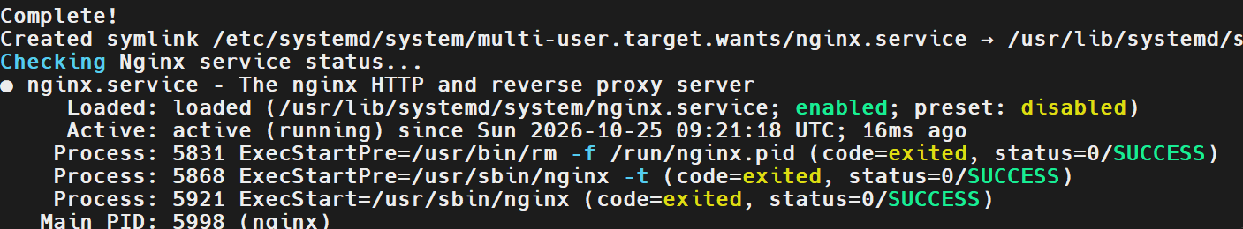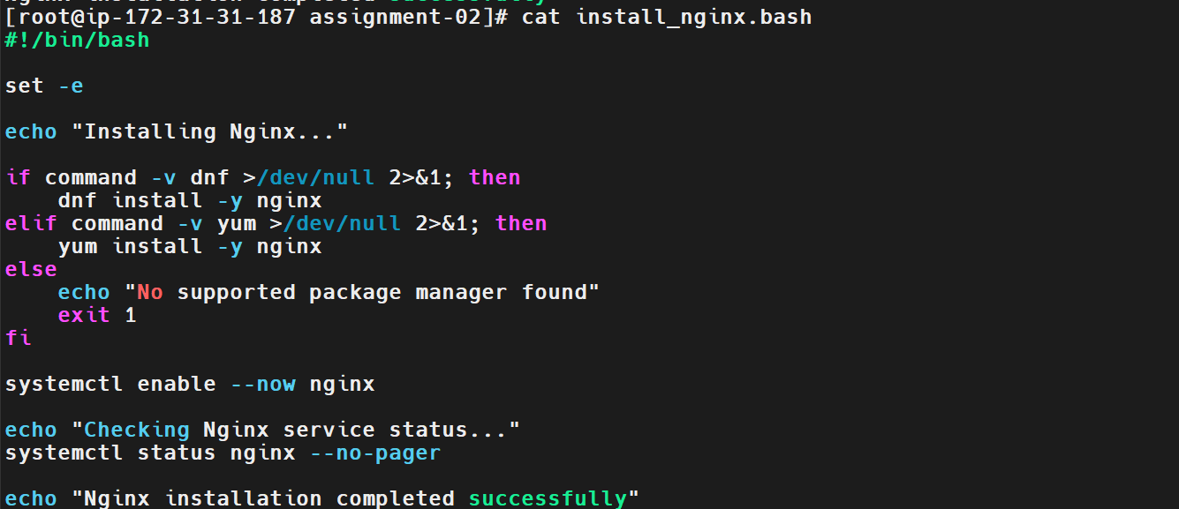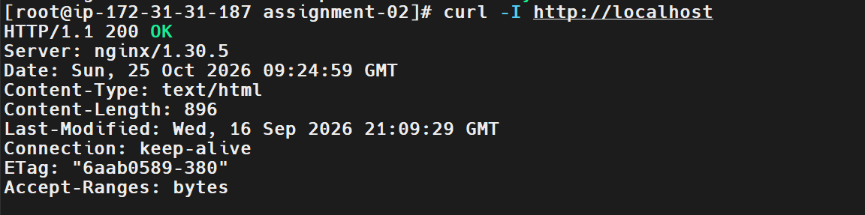
6. Explanation
Command or option | Description
#!/bin/bash | Specifies Bash as the script interpreter.
set -e | Exits the script when an eligible command fails.
command -v dnf | Checks whether dnf is available.
dnf install -y nginx | Installs Nginx using dnf.
yum install -y nginx | Installs Nginx using yum.
systemctl enable --now nginx | Enables Nginx at boot and starts it immediately.
systemctl status nginx | Displays detailed service status.
systemctl is-active nginx | Checks whether Nginx is active.
systemctl is-enabled nginx | Checks whether Nginx is enabled at boot.
curl -I http://localhost | Sends an HTTP request and displays response headers.
chmod 755 | Sets the script's file permissions.
7. Real-Time Use Case
DevOps engineers use Bash scripts to automate web-server installation during server provisioning and application deployment.
For example, Nginx may serve static website content or act as a reverse proxy that forwards incoming HTTP requests to backend application services.
Automating installation and service startup helps standardize server configuration and reduces repetitive manual work.
8. Common Errors and Troubleshooting
Error or issue | Cause | Solution
dnf: command not found | The package manager is unavailable. | Check whether yum is available and verify the OS.
Unable to download packages | Repository or network connectivity issue. | Check network access and configured package repositories.
Permission denied | Insufficient privileges. | Run the script as root or with authorized sudo privileges.
Unit nginx.service could not be found | Nginx is not installed or the installation failed. | Check the installation output and verify with rpm -q nginx.
Nginx service fails to start | Configuration error or port conflict. | Inspect systemctl status nginx and journalctl -u nginx.
curl: (7) Failed to connect | Nginx is stopped or not listening on the expected port. | Check systemctl status nginx and ss -lntp.
Local access works but external access fails | Security group, network ACL, or routing restriction. | Verify inbound TCP port 80 and network configuration.
Actual error encountered / resolution: Record any errors that occurred during your EC2 installation and the steps you used to resolve them. If no errors occurred, document that the installation completed successfully without errors.
Conclusion: This task demonstrated how to automate Nginx installation on Amazon Linux using Bash scripting, manage its service with systemctl, and validate the web server using curl. These skills are useful for automated server provisioning and DevOps deployment workflows.

Task 5: Install Apache Tomcat on Amazon Linux EC2 Using a Bash Script
Date: 20261025
1. Outcome
Successfully installed and configured Apache Tomcat on an Amazon Linux 2023 EC2 instance using a Bash script. Installed Java 17 (Amazon Corretto), configured Tomcat as a systemd service, and verified that Tomcat is working.
2. Objective
To automate the installation and configuration of Apache Tomcat on an Amazon Linux EC2 instance using Bash scripting.
The script performs the following operations:
- Checks and installs required utilities.
- Verifies the Java installation.
- Creates a dedicated Tomcat system user.
- Downloads and extracts the Apache Tomcat archive.
- Configures permissions and ownership.
- Creates a systemd service.
- Starts and enables Tomcat.
- Verifies the service and HTTP response.
3. Prerequisites
- An active AWS account.
- A running Amazon Linux 2023 EC2 instance.
- SSH access to the EC2 instance.
- Root privileges or sudo access.
- Java 17 installed.
- Internet connectivity to download Apache Tomcat.
- Security group access configured if Tomcat needs to be accessed externally.
4. Step-by-Step Implementation
Step 1: Verify the operating system
Command:
cat /etc/os-release
The instance was running Amazon Linux 2023.
Step 2: Install Java
Java was installed separately after encountering a package conflict during the initial script execution.
Command:
java -version
Observed output confirmed Java 17:
openjdk version "17.0.20.1" 2026-08-18 LTS
OpenJDK Runtime Environment Corretto-17.0.20.13.1
64-Bit Server VM
Explanation: Apache Tomcat requires a compatible Java runtime to execute Java-based web applications.
Step 3: Create the Bash script
Command:
vim install_tomcat.bash
Script content:
#!/bin/bash

set -e

TOMCAT_VERSION="10.1.52"
TOMCAT_USER="tomcat"
INSTALL_DIR="/opt/tomcat"

echo "Step 1: Checking required utilities..."

if ! command -v curl >/dev/null 2>&1 || \
! command -v tar >/dev/null 2>&1; then
dnf install -y curl tar
fi

echo "Java version:"
java -version

echo "Step 2: Creating Tomcat user..."

if ! id "$TOMCAT_USER" >/dev/null 2>&1; then
useradd --system --home-dir "$INSTALL_DIR" \
--shell /sbin/nologin "$TOMCAT_USER"
fi

echo "Step 3: Downloading Apache Tomcat..."

TMP_DIR=$(mktemp -d)
trap 'rm -rf "$TMP_DIR"' EXIT

curl -fL \
"https://archive.apache.org/dist/tomcat/tomcat-10/v${TOMCAT_VERSION}/bin/apache-tomcat-${TOMCAT_VERSION}.tar.gz" \
-o "$TMP_DIR/tomcat.tar.gz"

echo "Step 4: Installing Tomcat..."

mkdir -p "$INSTALL_DIR"

tar -xzf "$TMP_DIR/tomcat.tar.gz" \
--strip-components=1 -C "$INSTALL_DIR"

chown -R "$TOMCAT_USER":"$TOMCAT_USER" "$INSTALL_DIR"
chmod +x "$INSTALL_DIR/bin/"*.sh

echo "Step 5: Creating systemd service..."

cat > /etc/systemd/system/tomcat.service <<EOF
[Unit]
Description=Apache Tomcat Web Application Server
After=network.target

[Service]
Type=forking
User=$TOMCAT_USER
Group=$TOMCAT_USER
Environment="JAVA_HOME=/usr/lib/jvm/java-17-amazon-corretto"
Environment="CATALINA_HOME=$INSTALL_DIR"
Environment="CATALINA_BASE=$INSTALL_DIR"
ExecStart=$INSTALL_DIR/bin/startup.sh
ExecStop=$INSTALL_DIR/bin/shutdown.sh
Restart=on-failure

[Install]
WantedBy=multi-user.target
EOF

echo "Step 6: Starting Tomcat..."

systemctl daemon-reload
systemctl enable --now tomcat

echo "Step 7: Checking Tomcat service..."

systemctl --no-pager --full status tomcat

echo "Step 8: Testing Tomcat locally..."

curl -I http://localhost:8080

echo "Tomcat installation completed successfully!"
Note: The script uses Tomcat version 10.1.52 as configured for this task. For a new deployment, use a currently supported, patched release and verify the JAVA_HOME path on the instance.
Step 4: Save and grant execution permission
Save the script in Vim using Esc, then :wq, and press Enter.
Grant execution permission:
chmod 755 install_tomcat.bash
Explanation: The chmod command makes the script executable by the owner and readable/executable by other users.
Step 5: Execute the script
Command:
./install_tomcat.bash
The script checks the required utilities, verifies Java, creates the Tomcat user, downloads and extracts Tomcat, configures the service, and starts it.
Step 6: Verify the Tomcat service
Command:
systemctl status tomcat --no-pager
Check whether the service is active:
systemctl is-active tomcat
Expected output:
active
Check whether the service is enabled at startup:
systemctl is-enabled tomcat
Expected output:
enabled
Step 7: Verify HTTP connectivity
Command:
curl -I http://localhost:8080
Expected result:
HTTP/1.1 200
A successful HTTP response confirms that Tomcat is responding locally on port 8080. The exact response headers can vary by Tomcat version and configuration.
5. Validation Steps and Screenshot Evidence
Use the following commands to validate the installation.
Validation | Command | Expected result
Java version | java -version | Java 17 displayed
Tomcat service | systemctl status tomcat | Service running
Active state | systemctl is-active tomcat | active
Startup configuration | systemctl is-enabled tomcat | enabled
HTTP response | curl -I http://localhost:8080 | Successful HTTP response
Installation directory | ls -l /opt/tomcat | Tomcat files and directories listed
Screenshot evidence to include in your documentation:
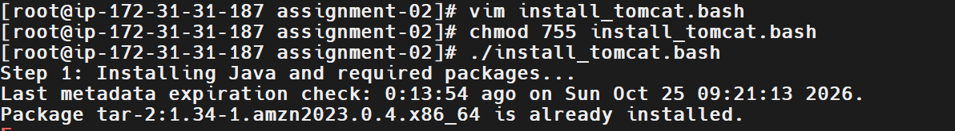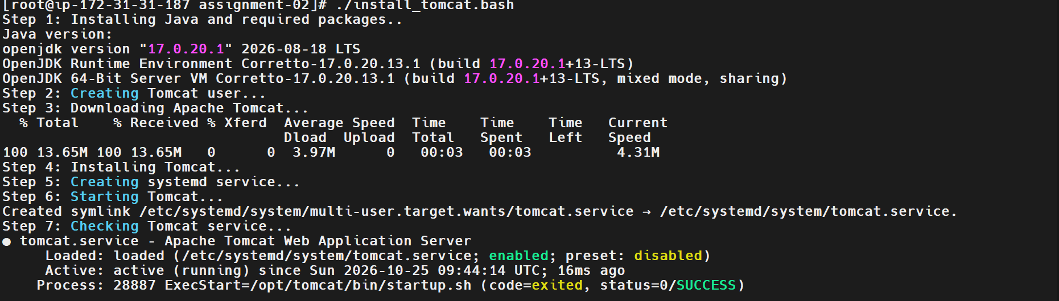
6. Explanation of Commands
Command or option | Description
#!/bin/bash | Specifies Bash as the script interpreter.
set -e | Stops the script when a command fails.
command -v | Checks whether a command is available.
dnf install -y | Installs packages without an interactive confirmation prompt.
java -version | Displays the installed Java version.
id tomcat | Checks whether the Tomcat user exists.
useradd --system | Creates a system user.
mktemp -d | Creates a temporary directory.
curl -fL | Downloads a file, follows redirects, and fails on HTTP error responses.
tar -xzf | Extracts a gzip-compressed tar archive.
--strip-components=1 | Removes the top-level directory from archive paths during extraction.
chown -R | Changes ownership recursively.
chmod +x | Adds executable permission.
cat > file <<EOF | Writes a multi-line configuration file using a here-document.
systemctl daemon-reload | Reloads systemd service definitions.
systemctl enable --now | Enables a service at startup and starts it immediately.
curl -I | Requests HTTP headers to test connectivity.
7. Real-Time Use Case
Apache Tomcat is used to host Java web applications in development, testing, and production environments.
For example, a DevOps engineer can automate Tomcat installation on EC2 instances using Bash scripting. This reduces repetitive manual work and helps standardize application server configuration across environments.
The script can be incorporated into server provisioning workflows alongside configuration management and deployment automation tools.
8. Common Errors and Troubleshooting
Error | Possible cause | Troubleshooting
Java package conflict | Conflicting package dependencies | Install Java separately and inspect the DNF error before changing packages.
Tomcat archive download fails | Invalid or unavailable version URL | Verify the Tomcat version and official download archive.
curl: command not found | Curl is not installed | Install it using dnf install -y curl.
Permission denied | Insufficient privileges or incorrect file permissions | Use an authorized account and check script permissions.
Tomcat service fails | Incorrect Java path, permissions, or service configuration | Run journalctl -u tomcat -n 50 --no-pager.
Port 8080 is unavailable | Another process is using the port | Run ss -lntp \| grep ':8080'.
Browser cannot reach Tomcat | Security group or network configuration issue | Check the EC2 security group, public IP, and network connectivity.
Conclusion
Apache Tomcat was installed and configured on Amazon Linux 2023 using a Bash script. Java 17 was installed separately to resolve the initial package conflict. The script automates Tomcat setup, creates a dedicated service user, configures systemd, and starts the service.
The successful service and HTTP checks confirm that the Tomcat server is working. This task demonstrates how Bash scripting can automate application server installation and service management on AWS EC2.
Task 6: Check Nginx Service Status and Start It If Stopped
Outcome
A Bash script named check_nginx.bash was created to check whether the Nginx service is running. If the service is stopped, the script attempts to start it and verifies its final status.
Nginx service status checked successfully.
If Nginx was stopped, the script attempted to start it.
The final service status was verified.
Objective
To automate Nginx service monitoring and basic recovery using a Bash script. This helps DevOps engineers identify a stopped service and attempt to restore it without manually executing service management commands.
Prerequisites
- An AWS account and a running EC2 instance.
- Amazon Linux 2023 operating system.
- SSH access to the EC2 instance.
- Root privileges or sudo permissions.
- Nginx installed on the EC2 instance.
- Basic knowledge of Bash scripting and Linux service management.
Step-by-Step Implementation
Step 1: Connect to the EC2 Instance
Connect to the Amazon Linux EC2 instance through SSH or your preferred SSH client.
Verify the operating system:
cat /etc/os-release
Check whether Nginx is installed:
nginx -v
If Nginx is not installed, execute:
dnf install -y nginx
Screenshot Evidence
Step 2: Create the Bash Script
Create a file named check_nginx.bash:
vim check_nginx.bash
Add the following script:
#!/bin/bash

SERVICE="nginx"

echo "Checking Nginx service status..."

if ! systemctl list-unit-files nginx.service --no-legend | grep -q nginx; then
echo "Nginx service is not installed."
exit 1
fi

if systemctl is-active --quiet "$SERVICE"; then
echo "Nginx is already running."
else
echo "Nginx is not running. Starting Nginx..."

if systemctl start "$SERVICE"; then
echo "Nginx start command executed."
else
echo "Failed to start Nginx."
systemctl status "$SERVICE" --no-pager
exit 1
fi
fi

echo "Verifying Nginx service..."

if systemctl is-active --quiet "$SERVICE"; then
echo "SUCCESS: Nginx is running."
else
echo "ERROR: Nginx is not running."
systemctl status "$SERVICE" --no-pager
exit 1
fi
Save and exit Vim by pressing Esc, typing :wq, and pressing Enter.
Screenshot Evidence
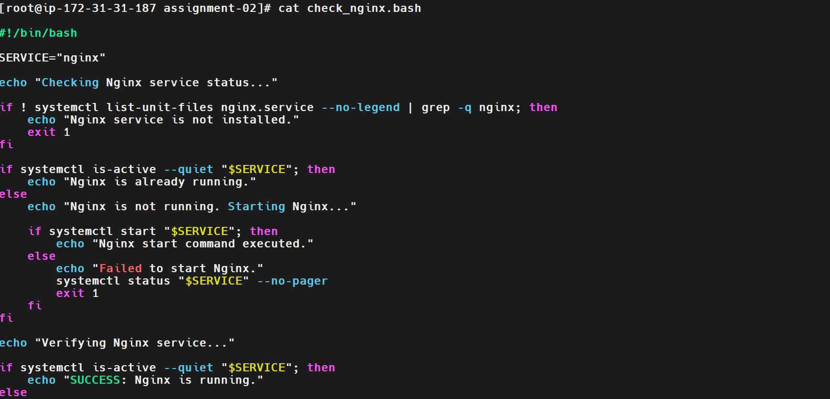
Step 3: Grant Execution Permission
Execute:
chmod 755 check_nginx.bash
This command makes the script executable.
Screenshot Evidence
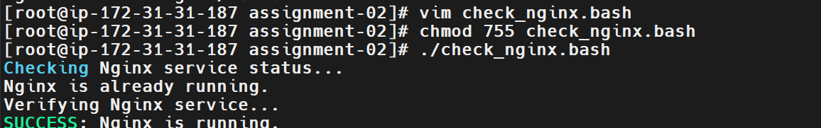
Step 4: Execute the Script
Run:
./check_nginx.bash
When Nginx is already running, the expected output is:
Checking Nginx service status...
Nginx is already running.
Verifying Nginx service...
SUCCESS: Nginx is running.
When Nginx is stopped, the script attempts to start it and checks the final status.
Screenshot Evidence
Step 5: Test the Stopped-Service Scenario
For testing purposes, stop Nginx:
systemctl stop nginx
Run the script again:
./check_nginx.bash
The script should detect that Nginx is stopped, attempt to start it, and verify whether it is running.
Note: Stopping Nginx interrupts websites served by the service. Perform this test only in your practice environment.
Screenshot Evidence
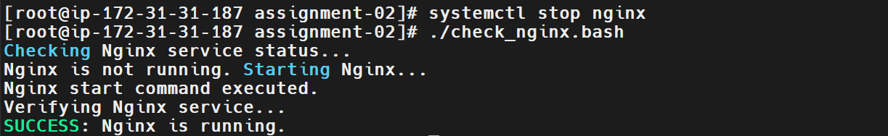
Validation Steps
Step 1: Check the Service Status
Execute:
systemctl status nginx --no-pager
The output should show that the service is active and running.
Step 2: Verify the Active State
Execute:
systemctl is-active nginx
Expected output:
active
Step 3: Test the HTTP Response
Execute:
curl -I http://localhost
A successful response commonly begins with:
HTTP/1.1 200 OK
The exact response can vary depending on the server configuration.
Validation Screenshot
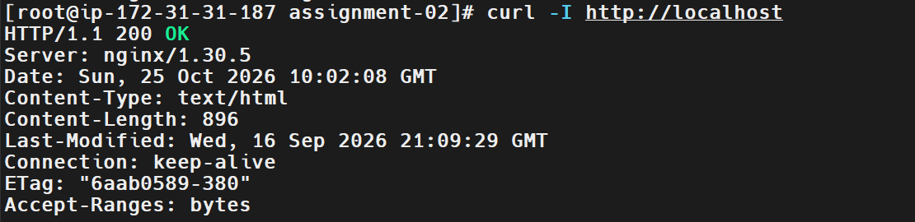
Explanation
The script uses systemctl to check and manage the Nginx service. The systemctl is-active --quiet command checks whether Nginx is running without displaying its status directly. If the service is inactive, the script attempts to start it using systemctl start nginx.
After attempting to start the service, the script checks the status again. If Nginx is still inactive, it displays diagnostic information and exits with an error status. This approach helps automate basic service recovery while providing useful troubleshooting information when the service cannot start.
Real-Time Use Case
In real-world DevOps environments, Nginx is commonly used as a web server and reverse proxy. If the service stops unexpectedly, a recovery script can attempt to restart it and verify its status.
Such scripts can be integrated into administrative workflows and monitoring systems. For production environments, monitoring and alerting should also be configured to detect repeated failures and notify the responsible team.
Common Errors and Troubleshooting
Error | Cause | Resolution
Unit nginx.service could not be found | Nginx is not installed or its service unit is unavailable. | Install Nginx using dnf install -y nginx.
Permission denied | The current user lacks permission to manage services. | Run the script as root or use an authorized account with sudo.
Nginx fails to start | Configuration errors or missing dependencies. | Run nginx -t to validate the configuration.
Port 80 is already in use | Another process is listening on port 80. | Run ss -lntp | grep ':80' to identify the process.
HTTP request fails | Nginx is stopped, misconfigured, or not listening correctly. | Check systemctl status nginx and run curl -I http://localhost.
Website is inaccessible externally | Security group or network configuration prevents access. | Check the EC2 security group's inbound rules and network connectivity.
Conclusion
The check_nginx.bash script automates checking the Nginx service status, attempting to start the service when it is stopped, and validating the final state. This task demonstrates conditional logic, service management, error handling, and basic troubleshooting using Bash scripting on Amazon Linux 2023.
Task 7: Create a Bash Script for a Calculator
Outcome
A Bash script named calculator.bash is created to perform basic arithmetic operations: addition, subtraction, multiplication, and division. The script accepts two numbers and an operator from the user, calculates the result, and displays the output.
Calculator script created and executed successfully.
Basic arithmetic operations can be performed through user input.
Objective
To understand Bash scripting concepts such as variables, user input, conditional statements, arithmetic operations, and error handling by developing a simple command-line calculator.
This task demonstrates how Bash scripts can accept input, process data, and display results based on user-selected operations.
Prerequisites
- A running Amazon Linux 2023 EC2 instance.
- SSH access to the EC2 instance.
- Root privileges or a user account with appropriate permissions.
- Basic knowledge of Linux commands and Bash scripting.
Step-by-Step Implementation
Step 1: Connect to the EC2 Instance
Connect to the Amazon Linux EC2 instance through SSH.
Verify the Bash version:
bash --version
Screenshot Evidence
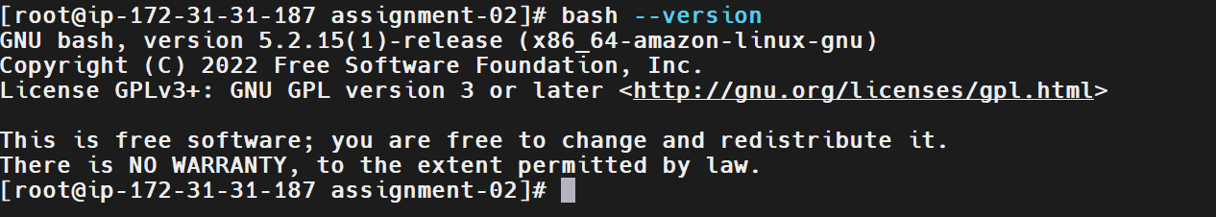
Step 2: Create the Calculator Script
Create a file named calculator.bash:
vim calculator.bash
Press i and enter the following script:
#!/bin/bash

echo "===== Bash Calculator ====="

read -p "Enter the first number: " num1
read -p "Enter an operator (+, -, *, /): " operator
read -p "Enter the second number: " num2

# Validate numeric inputs
if ! [[ "$num1" =~ ^-?[0-9]+([.][0-9]+)?$ ]] ||
! [[ "$num2" =~ ^-?[0-9]+([.][0-9]+)?$ ]]; then
echo "Error: Please enter valid numbers."
exit 1
fi

# Perform the calculation
case "$operator" in
+)
result=$(awk -v a="$num1" -v b="$num2" 'BEGIN {print a+b}')
;;
-)
result=$(awk -v a="$num1" -v b="$num2" 'BEGIN {print a-b}')
;;
\*)
result=$(awk -v a="$num1" -v b="$num2" 'BEGIN {print a*b}')
;;
/)
if awk -v b="$num2" 'BEGIN {exit (b==0 ? 0 : 1)}'; then
echo "Error: Division by zero is not allowed."
exit 1
fi
result=$(awk -v a="$num1" -v b="$num2" 'BEGIN {print a/b}')
;;
*)
echo "Error: Invalid operator."
echo "Please use +, -, *, or /."
exit 1
;;
esac

echo "Result: $num1 $operator $num2 = $result"
Save and exit Vim:
- Press Esc.
- Type :wq.
- Press Enter.
Screenshot Evidence
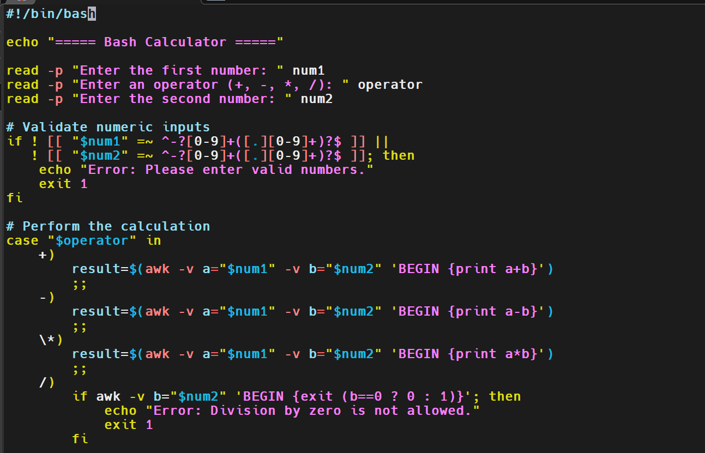
Step 3: Grant Execution Permission
Execute:
chmod 755 calculator.bash
This command grants the file owner read, write, and execute permissions and grants other users read and execute permissions.
Screenshot Evidence
Step 4: Execute the Calculator
Run the script:
./calculator.bash
Enter the requested values when prompted.
Example 1: Addition
Input:
Enter the first number: 10
Enter an operator (+, -, *, /): +
Enter the second number: 9
Expected output:
Result: 10 + 9 = 19
Example 2: Subtraction
Input:
Enter the first number: 5
Enter an operator (+, -, *, /): -
Enter the second number: 4
Expected output:
Result: 5-4 = 1
Example 3: Multiplication
Input:
Enter the first number: 10
Enter an operator (+, -, *, /): *
Enter the second number: 5
Expected output:
Result: 10 * 5 = 50
Example 4: Division
Input:
Enter the first number: 10
Enter an operator (+, -, *, /): /
Enter the second number: 5
Expected output:
Result: 10 / 5 = 2
Screenshot Evidence
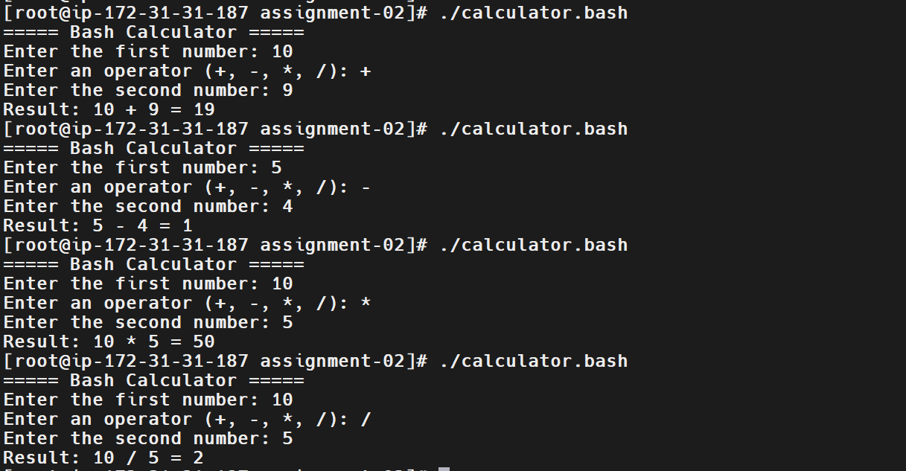
Step 5: Test Error Handling
Test division by zero:
Enter the first number: 10
Enter an operator (+, -, *, /): /
Enter the second number: 0
Expected output:
Error: Division by zero is not allowed.
Test an invalid operator:
Enter the first number: 10
Enter an operator (+, -, *, /): %
Enter the second number: 5
Expected output:
Error: Invalid operator.
Please use +, -, *, or /.
Test invalid numeric input:
Enter the first number: abc
Expected output:
Error: Please enter valid numbers.
Screenshot Evidence
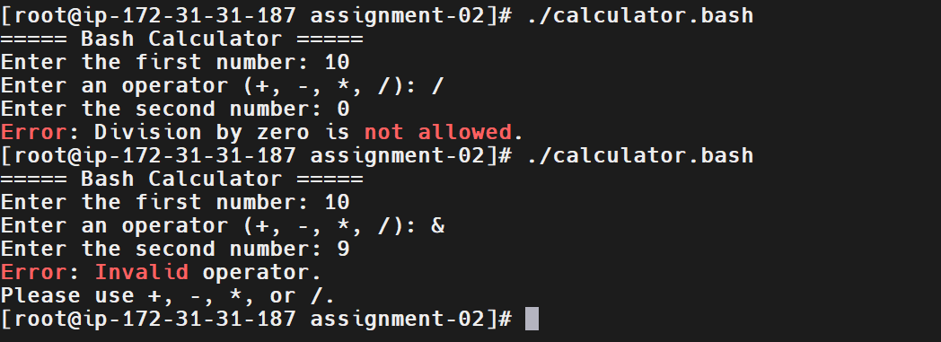
Validation Steps
Verify that the calculator performs all four arithmetic operations correctly.
Test case | Input | Expected result
Addition | 10 + 5 | 15
Subtraction | 10 - 5 | 5
Multiplication | 10 * 5 | 50
Division | 10 / 5 | 2
Division by zero | 10 / 0 | Error message
Invalid operator | 10 % 5 | Error message
Explanation
The calculator uses the read command to collect two numbers and an operator from the user. The case statement selects the appropriate arithmetic operation based on the operator entered. The awk command performs the calculations, allowing the script to support decimal as well as integer values.
The script also validates the input numbers, checks for division by zero, and rejects unsupported operators. These checks help prevent incorrect calculations and demonstrate the importance of input validation and error handling in Bash scripting.
Real-Time Use Case
Bash calculators can be useful for simple administrative calculations within shell scripts, such as calculating storage differences, converting numeric values, or performing arithmetic during automation tasks.
Although this example is intended for learning, the same concepts—user input, conditional logic, validation, and calculation—are used in more complex DevOps automation scripts.
Common Errors and Troubleshooting
Error | Cause | Resolution
Permission denied | The script does not have execution permission. | Run chmod 755 calculator.bash.
awk: command not found | The required utility is unavailable. | Install the appropriate gawk package if needed using dnf install -y gawk.
Invalid operator error | An unsupported operator was entered. | Use +, -, *, or /.
Division by zero error | The second number is zero during division. | Enter a non-zero second number.
Invalid number error | The input contains non-numeric characters. | Enter valid integer or decimal values.
Script not found | The command was executed from a different directory. | Run pwd and ls -l calculator.bash to locate the file.
Conclusion
The calculator.bash script demonstrates how Bash can accept user input, perform arithmetic operations, and handle common errors. The task provides practical experience with variables, read, case, regular-expression input validation, and the awk command.
The calculator can be extended in the future to support additional operations, repeated calculations, and a menu-driven interface.
Task 8: Check If a Directory Exists and Create It If Not
Outcome
A Bash script named check_create_directory.bash is created to check whether a specified directory exists. If the directory exists, the script displays a confirmation message. If the directory does not exist, the script creates it and verifies successful creation.
Directory existence checked successfully.
If the directory was missing, it was created automatically.
Objective
To automate directory management using Bash scripting. This task helps develop practical knowledge of conditional statements, directory checks, and filesystem operations in Linux.
Checking for a directory before creating it prevents unnecessary creation attempts and helps scripts manage required directories reliably.
Prerequisites
- An AWS account with a running EC2 instance.
- Amazon Linux 2023 operating system.
- SSH access to the EC2 instance.
- Root privileges or appropriate directory permissions.
- Basic knowledge of Linux commands and Bash scripting.
Step-by-Step Implementation
Step 1: Connect to the EC2 Instance
Connect to the Amazon Linux EC2 instance using SSH.
Verify the current working directory:
pwd
Check the current user:
whoami
Screenshot Evidence
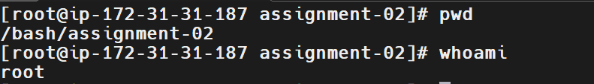
Step 2: Create the Bash Script
Create a file named check_create_directory.bash:
vim check_create_directory.bash
Press i and enter the following script:
#!/bin/bash

DIR="/tmp/devops-directory"

echo "Checking directory: $DIR"

if [ -d "$DIR" ]; then
echo "Directory already exists: $DIR"
else
echo "Directory does not exist. Creating it..."

if mkdir -p "$DIR"; then
echo "Directory created successfully: $DIR"
else
echo "Error: Failed to create directory."
exit 1
fi
fi

if [ -d "$DIR" ]; then
echo "Validation successful: Directory exists."
else
echo "Validation failed: Directory does not exist."
exit 1
fi
Save and exit Vim by pressing Esc, typing :wq, and pressing Enter.
Step 3: Grant Execution Permission
Execute:
chmod 755 check_create_directory.bash
This command grants execution permission to the script.
Screenshot Evidence
Step 4: Execute the Script When the Directory Does Not Exist
First, remove the practice directory if it already exists:
rm -rf /tmp/devops-directory
Caution: This command permanently removes the specified directory and its contents. Use it only for this disposable practice directory.
Run the script:
./check_create_directory.bash
Expected output:
Checking directory: /tmp/devops-directory
Directory does not exist. Creating it...
Directory created successfully: /tmp/devops-directory
Validation successful: Directory exists.
Screenshot Evidence
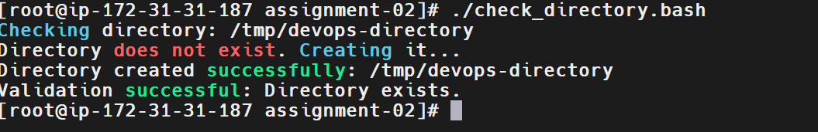
Step 5: Execute the Script When the Directory Already Exists
Run the script again:
./check_create_directory.bash
Expected output:
Checking directory: /tmp/devops-directory
Directory already exists: /tmp/devops-directory
Validation successful: Directory exists.
This confirms that the script detects an existing directory without attempting to create it again.
Screenshot Evidence
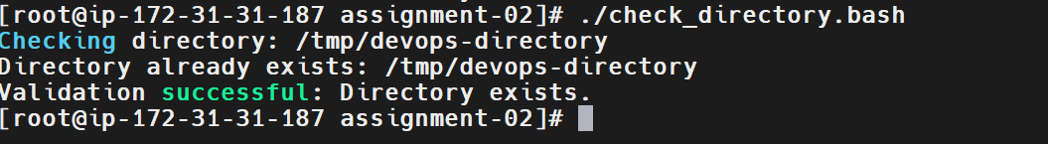
Validation Steps
Step 1: Verify the Directory
Execute:
ls -ld /tmp/devops-directory
The output should display the directory's permissions, ownership, and name.
Step 2: Check the Directory Using a Conditional Statement
Execute:
if [ -d /tmp/devops-directory ]; then
echo "Directory exists"
else
echo "Directory does not exist"
fi
Expected output:
Directory exists
Step 3: Verify the Script File
Execute:
ls -l check_create_directory.bash
Confirm that the script has execute permissions.
Validation Screenshot
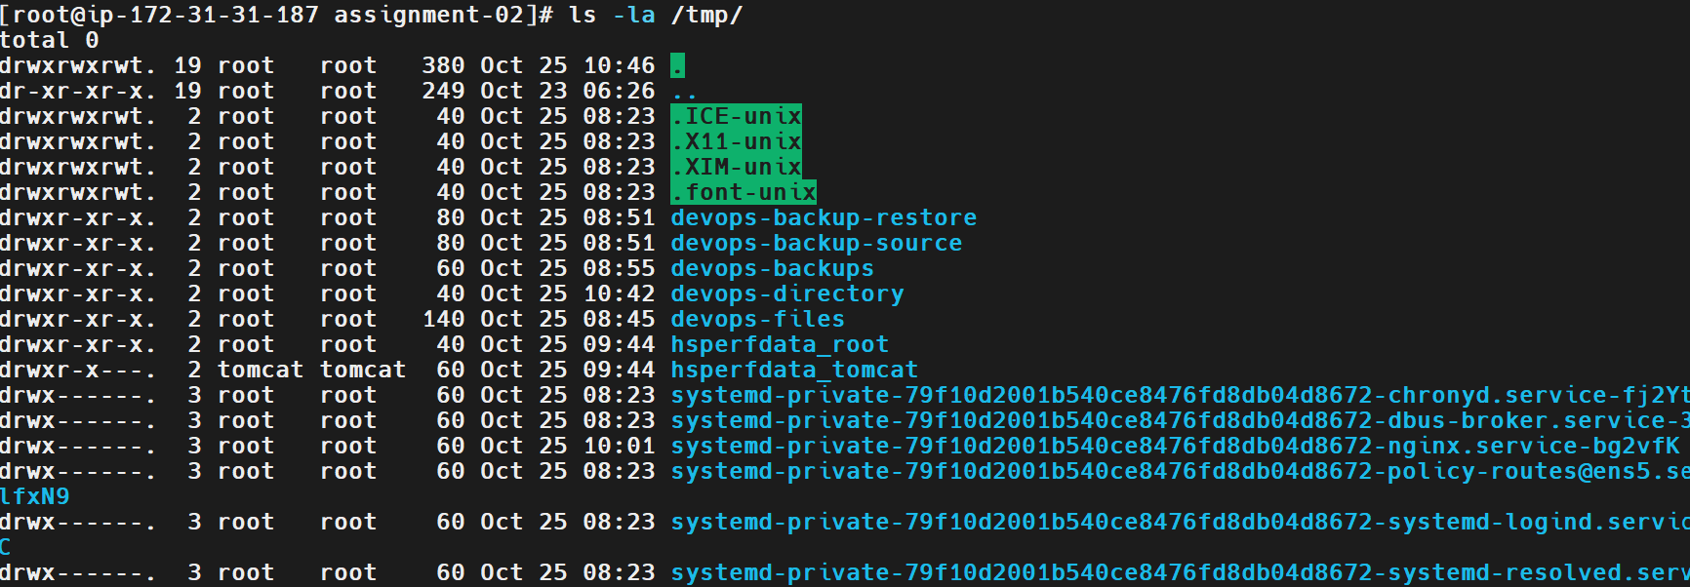
Explanation
The script uses the -d conditional test to determine whether the specified path exists and is a directory. If the condition is true, the script displays a message confirming that the directory already exists. Otherwise, it executes mkdir -p to create the directory.
The script then checks the directory again to confirm that the operation succeeded. The if statement provides decision-making logic, while mkdir -p safely creates the specified directory and any missing parent directories without reporting an error merely because the directory already exists.
Real-Time Use Case
DevOps engineers frequently need to ensure that directories exist before running automation tasks. For example, a backup script may need a destination directory, a deployment script may require an application directory, and a logging script may need a directory for storing log files.
By checking and creating directories automatically, Bash scripts reduce manual intervention and help make automation more reliable and repeatable.
Common Errors and Troubleshooting
Error | Cause | Resolution
Permission denied | The user lacks permission to create a directory at the specified path. | Use a directory you own or an authorized account with appropriate permissions.
No such file or directory | A parent directory is missing or the specified path is incorrect. | Verify the path and use mkdir -p to create missing parent directories.
command not found | A command was typed incorrectly or is unavailable. | Check the spelling and command availability.
Script does not execute | Execution permission is missing. | Run chmod 755 check_create_directory.bash.
Directory already exists | The target directory was created during an earlier run. | This is expected; the script should display the existing-directory message.
Directory creation fails | Filesystem permissions or storage limitations prevent creation. | Check directory permissions, disk space, and the exact error message.
Conclusion
The check_create_directory.bash script demonstrates how to check directory existence, create a missing directory, and validate the result using Bash scripting on Amazon Linux 2023.
This task provides practical experience with conditional statements, filesystem checks, directory creation, and error handling. These techniques are useful in backup automation, application deployments, and other DevOps workflows.
Task 9: Create a Bash Script to Delete the Last 3 Lines of a File
Outcome
A Bash script named delete_last3_lines.bash is created to remove the last three lines from a specified file. The script validates the input file, creates a backup before modifying it, removes the last three lines, and displays the updated file content.
The last three lines of the specified file are removed successfully.
A backup of the original file is retained for recovery.
Objective
To learn how to manipulate text files using Bash scripting and Linux command-line utilities. This task demonstrates file validation, backup creation, temporary files, and the use of sed to remove specific lines from a file.
This technique is useful when automating log cleanup, editing configuration files, and processing text files.
Prerequisites
- An AWS account with a running EC2 instance.
- Amazon Linux 2023 operating system.
- SSH access to the EC2 instance.
- Root privileges or appropriate file permissions.
- Basic knowledge of Bash scripting and Linux commands.
Step-by-Step Implementation
Step 1: Connect to the EC2 Instance
Connect to the Amazon Linux EC2 instance using SSH.
Verify the working directory:
pwd
Check the available files:
ls -l
Step 2: Create a Sample File
Create a sample file named sample.txt:
cat > sample.txt <<'EOF'
Line 1: Introduction
Line 2: Linux
Line 3: Bash scripting
Line 4: File handling
Line 5: Backup
Line 6: Automation
Line 7: DevOps
Line 8: Conclusion
EOF
Display the original file:
cat -n sample.txt
Expected output:
1 Line 1: Introduction
2 Line 2: Linux
3 Line 3: Bash scripting
4 Line 4: File handling
5 Line 5: Backup
6 Line 6: Automation
7 Line 7: DevOps
8 Line 8: Conclusion
Screenshot Evidence
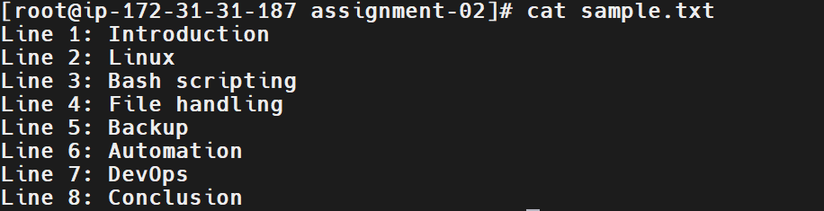
Step 3: Create the Bash Script
Create a script named delete_last3_lines.bash:
vim delete_last3_lines.bash
Enter the following code:
#!/bin/bash

FILE="${1:-sample.txt}"

echo "Checking file: $FILE"

if [ ! -f "$FILE" ]; then
echo "Error: File does not exist."
exit 1
fi

if [ ! -r "$FILE" ] || [ ! -w "$FILE" ]; then
echo "Error: File must be readable and writable."
exit 1
fi

BACKUP="${FILE}.bak"
TEMP_FILE=$(mktemp) || {
echo "Error: Unable to create temporary file."
exit 1
}

trap 'rm -f "$TEMP_FILE"' EXIT

if ! cp -p -- "$FILE" "$BACKUP"; then
echo "Error: Backup creation failed."
exit 1
fi

if ! sed '$d' "$FILE" | sed '$d' | sed '$d' > "$TEMP_FILE"; then
echo "Error: Failed to process the file."
exit 1
fi

if ! cat "$TEMP_FILE" > "$FILE"; then
echo "Error: Failed to update the file."
exit 1
fi

echo "Last three lines deleted successfully."
echo "Backup created: $BACKUP"
echo "Updated file content:"
cat -n "$FILE"
Save and exit Vim by pressing Esc, typing :wq, and pressing Enter.
Step 4: Grant Execution Permission
Run:
chmod 755 delete_last3_lines.bash
This grants the file owner read, write, and execute permissions, while other users receive read and execute permissions.
Screenshot Evidence
Step 5: Execute the Script
Run:
./delete_last3_lines.bash sample.txt
The script creates a backup named sample.txt.bak and removes the last three lines from sample.txt.
Expected output:
Checking file: sample.txt
Last three lines deleted successfully.
Backup created: sample.txt.bak
Updated file content:
1 Line 1: Introduction
2 Line 2: Linux
3 Line 3: Bash scripting
4 Line 4: File handling
5 Line 5: Backup
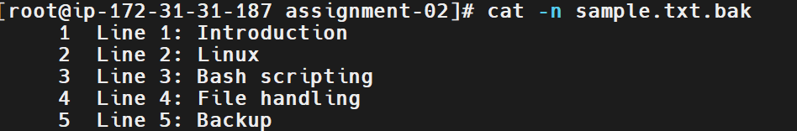
Step 6: Verify the Backup
Run:
cat -n sample.txt.bak
The backup should contain all eight original lines.
Verify the updated file:
cat -n sample.txt
The updated file should contain only the first five lines.
Screenshot Evidence
Validation Steps
Step 1: Count the Remaining Lines
Run:
wc -l sample.txt
Expected output:
5 sample.txt
Step 2: Confirm the Backup Exists
Run:
ls -l sample.txt.bak
Verify that the backup file exists.
Validation Screenshot
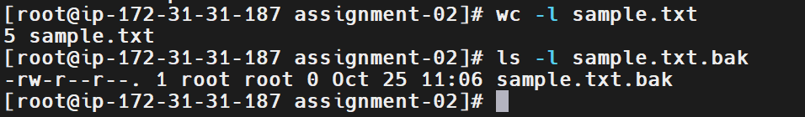
Explanation
The script checks whether the specified file exists and is readable and writable before modifying it. It creates a backup using cp -p, preserving the original file's contents and basic file attributes. It then uses three successive sed '$d' operations to remove the final line three times. The resulting content is written to a temporary file before replacing the original file's contents.
The script accepts a filename as a command-line argument. For example, ./delete_last3_lines.bash sample.txt processes sample.txt. If no filename is supplied, it defaults to sample.txt. This makes the script reusable for different files while retaining a backup of the original content.
Real-Time Use Case
DevOps engineers regularly automate text-file processing, configuration management, and log maintenance. Removing unwanted trailing lines can be useful when cleaning generated files or preparing text data for further processing.
In production environments, files should be backed up before modification, and critical configuration files should be validated after changes. For large or important files, a safer production implementation would also use atomic replacement and preserve ownership, permissions, and metadata.
Common Errors and Troubleshooting
Error | Cause | Resolution
File does not exist | Incorrect filename or file path. | Check the path using ls -l and pass the correct filename.
Permission denied | The current user lacks the required file permissions. | Check ownership and permissions; use an authorized account.
Script does not execute | Execute permission is missing. | Run chmod 755 delete_last3_lines.bash.
Backup creation failed | Insufficient permissions or disk space. | Check directory permissions and available space.
File becomes empty | The file originally contained three or fewer lines. | Verify the backup before restoring if needed.
Unexpected file contents | Incorrect filename or repeated execution. | Inspect the backup and use a fresh sample file for testing.
Conclusion
The delete_last3_lines.bash script demonstrates file validation, backup creation, text processing with sed, and temporary-file handling. It removes the last three lines from a specified file and retains a backup of the original content.
This task provides practical experience with Bash scripting and Linux file manipulation, which are useful skills for DevOps automation and routine system administration.
Task 10: Monitor CPU Usage and Send an Email Notification if It Exceeds 80%
Outcome
A Bash script named monitor_cpu.bash is created to monitor CPU utilization on an Amazon Linux 2023 EC2 instance. If CPU usage exceeds 80%, the script attempts to send an email notification to the configured recipient.
CPU utilization is monitored using a Bash script.
When CPU usage exceeds 80%, an email alert is triggered.
Note: Actual email delivery requires a configured email-sending method and valid SMTP or mail relay settings. Executing the script alone does not guarantee that an email will be delivered.
Objective
To automate CPU monitoring and alerting using Bash scripting. High CPU utilization can affect application response times, server performance, and service availability. An automated alert helps administrators identify potential performance issues and investigate them before they affect users.
This task demonstrates CPU metric collection, conditional statements, threshold comparison, and email notification integration on Linux.
Prerequisites
- An AWS account with a running EC2 instance.
- Amazon Linux 2023 operating system.
- SSH access to the EC2 instance.
- Root privileges or appropriate permissions.
- Basic knowledge of Bash scripting.
- The top or mpstat utility for collecting CPU utilization.
- A working email-sending method, such as a configured SMTP relay or an approved email service.
- A valid recipient email address.
- Network access to the configured email service.
Step-by-Step Implementation
Step 1: Connect to the EC2 Instance
Connect to the Amazon Linux 2023 EC2 instance through SSH.
Verify the operating system:
cat /etc/os-release
Check the CPU information:
lscpu
Screenshot Evidence
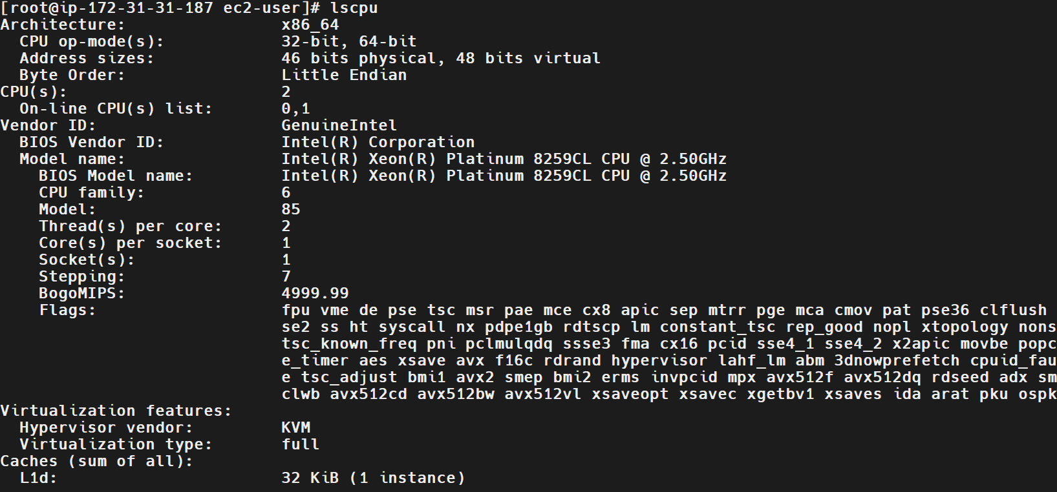
Step 2: Install the Required Utilities
Update the package metadata:
dnf makecache
Install the sysstat package, which provides the mpstat command:
dnf install -y sysstat
Verify the installation:
mpstat -V
Screenshot Evidence
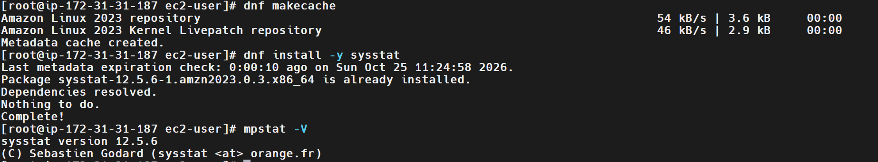
Step 3: Check CPU Utilization Manually
Run:
mpstat 1 1
Look for the %idle column in the output.
CPU utilization can be calculated as:
CPU Usage (%) = 100 - %idle
For example, if %idle is 15.00, CPU usage is:
100 - 15 = 85%
Screenshot Evidence
Step 4: Configure an Email Notification Method
Before running the monitoring script, configure an approved email-sending method.
For example, an organization may use an SMTP relay or Amazon Simple Email Service (Amazon SES). The sending method must be configured with valid credentials, an authorized sender address, and an approved recipient where required.
Do not put SMTP passwords or access keys directly in the Bash script.
For this task, the script will use a local mail command supplied by a configured mail-transfer service or relay.
Check whether the command is available:
command -v mail
If the command is missing, install an appropriate mail client and configure its sending service according to your organization's environment. Installing a mail client alone does not configure email delivery.
Test the configured email method before proceeding.
Installed mail client by using command dnf install -y mailx
Screenshot Evidence
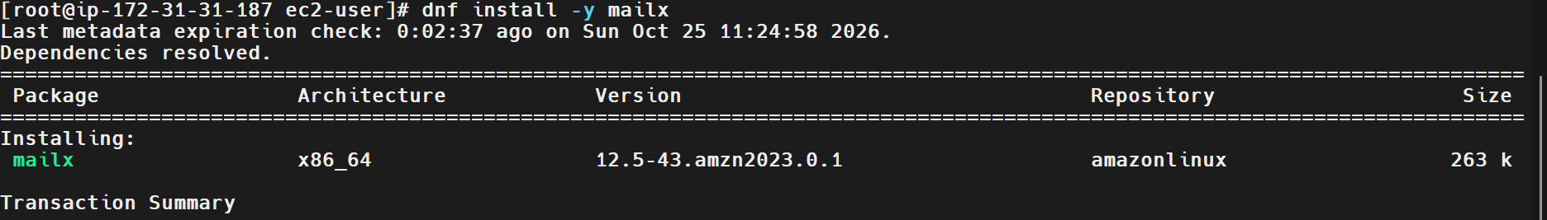
Step 5: Create the Bash Script
Create a file named monitor_cpu.bash:
vim monitor_cpu.bash
Press i and enter the following script:
#!/bin/bash

THRESHOLD=80
EMAIL="admin@example.com"

# Collect CPU utilization
IDLE=$(mpstat 1 1 | awk '/Average:/ && $NF ~ /^[0-9.]+$/ {print $NF}')

if ! [[ "$IDLE" =~ ^[0-9]+([.][0-9]+)?$ ]]; then
echo "Error: Unable to determine CPU idle percentage."
exit 1
fi

# Calculate CPU usage
CPU_USAGE=$(awk -v idle="$IDLE" 'BEGIN {
printf "%.2f", 100 - idle
}')

echo "Current CPU Usage: ${CPU_USAGE}%"
echo "CPU Threshold: ${THRESHOLD}%"

# Compare CPU usage with the threshold
if awk -v usage="$CPU_USAGE" -v threshold="$THRESHOLD" \
'BEGIN {exit !(usage > threshold)}'; then

SUBJECT="High CPU Usage Alert"
BODY="Warning: CPU usage on $(hostname) is ${CPU_USAGE}%, exceeding the threshold of ${THRESHOLD}%."

echo "$BODY" | mail -s "$SUBJECT" "$EMAIL"

if [ $? -eq 0 ]; then
echo "CPU usage exceeded the threshold. Email command completed."
else
echo "Error: Email notification command failed."
exit 1
fi
else
echo "CPU usage is within the configured threshold."
fi
Replace admin@example.com with your actual recipient email address.
Save the file by pressing Esc, typing :wq, and pressing Enter.
Screenshot Evidence
Insert a screenshot showing the completed script in Vim.
Step 6: Grant Execution Permission
Run:
chmod 755 monitor_cpu.bash
This grants execute permission to the script.
Screenshot Evidence
Step 7: Execute the Script
Run:
./monitor_cpu.bash
If CPU usage is below or equal to 80%, the output should resemble:
Current CPU Usage: 25.00%
CPU Threshold: 80%
CPU usage is within the configured threshold.
If CPU usage exceeds 80%, the script attempts to send an email notification.
Example output:
Current CPU Usage: 85.00%
CPU Threshold: 80%
CPU usage exceeded the threshold. Email command completed.
The example percentages are illustrative; actual CPU utilization depends on the workload at execution time.
Important: The message Email command completed means the local mail command returned success. It does not independently confirm that the recipient received the email.
Screenshot Evidence
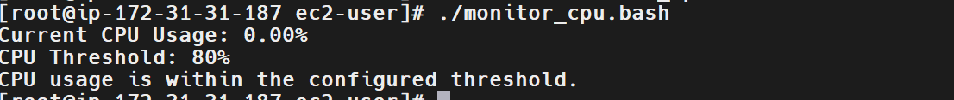
Step 8: Test the High-CPU Alert
CPU usage on a lightly loaded EC2 instance may never exceed 80%. If you need to test the alert, use a controlled test environment and a temporary CPU workload.
For example, install the stress-ng utility if it is available from your approved repositories:
dnf install -y stress-ng
Check available CPU cores:
nproc
Generate a temporary CPU workload for a limited period:
stress-ng --cpu 1 --timeout 60s
While the workload is running, execute the monitoring script in another terminal:
./monitor_cpu.bash
The workload may not push total CPU usage above 80%, especially on an instance with multiple vCPUs. Adjust the workload carefully in the lab and stop it when testing is complete.
Screenshot Evidence

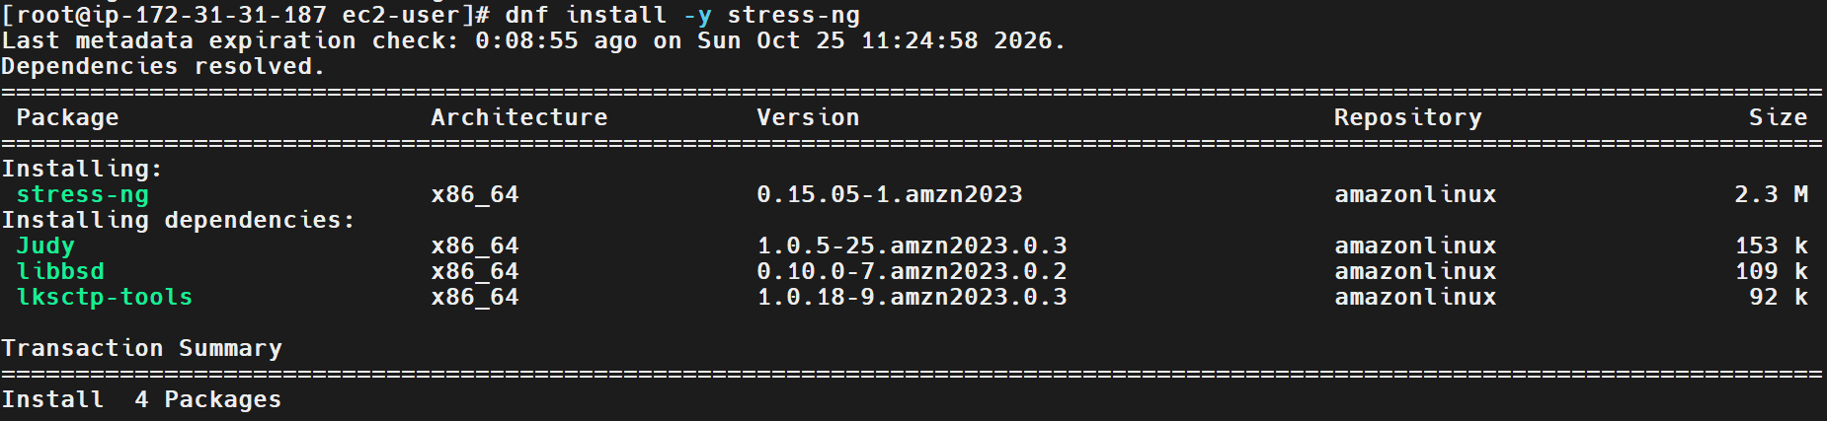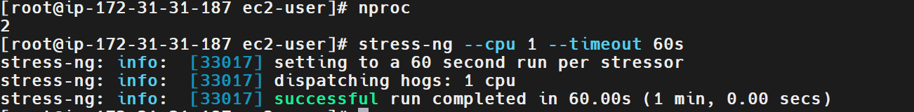
Validation Steps
Step 1: Verify CPU Metrics
Run:
mpstat 1 1
Confirm that the script is able to read the CPU idle percentage and calculate CPU usage.
Step 2: Verify the Threshold Logic
Confirm that the script sends an alert only when CPU usage is strictly greater than 80%.
CPU usage | Expected behavior
45% | No alert
80% | No alert
85% | Email notification attempted
Step 3: Verify Email Delivery
Check the configured mail service's logs or delivery status, and confirm that the recipient received the test email.
A successful script execution alone is not sufficient to verify email delivery.
Validation Screenshot
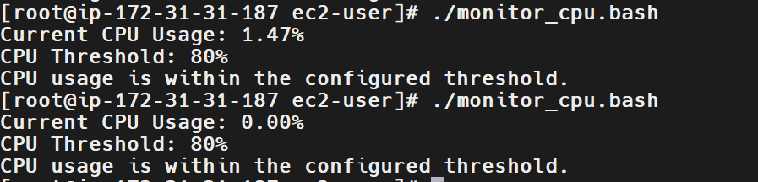
Explanation
The script uses mpstat to collect CPU statistics. The %idle value indicates the percentage of time the CPU was idle, so subtracting it from 100 provides an estimate of CPU utilization. The script then compares the calculated utilization with the configured threshold of 80%.
When CPU utilization is greater than 80%, the script constructs an alert message containing the server hostname and current CPU usage. It then invokes the configured mail command to send the message. If utilization does not exceed the threshold, no email is attempted. This provides a basic monitoring and notification workflow using Bash.
Real-Time Use Case
DevOps and system administration teams monitor CPU utilization on application servers, database servers, and cloud instances to detect performance bottlenecks. High CPU utilization can result from heavy traffic, inefficient application code, runaway processes, or background jobs.
A monitoring script can provide an additional alerting mechanism for small environments or learning labs. In production environments, continuous monitoring should generally use a dedicated monitoring platform, such as Amazon CloudWatch, Prometheus, or another observability solution, with configured notification channels.
Common Errors and Troubleshooting
Error | Cause | Resolution
mpstat: command not found | The sysstat package is missing. | Install it using dnf install -y sysstat.
CPU utilization cannot be calculated | The mpstat output differs from what the script expects. | Run mpstat 1 1 manually and inspect its output.
mail: command not found | A mail client is not installed. | Install an appropriate mail client and configure a mail relay.
Email is not received | SMTP settings, sender authorization, or network connectivity is incorrect. | Check the email service configuration and delivery logs.
CPU usage never exceeds 80% | The EC2 instance has a light workload. | Test with a controlled, temporary CPU workload.
Email command succeeds but no message arrives | Local acceptance does not guarantee final delivery. | Verify relay logs and recipient delivery status.
Script permission denied | The script is not executable or the user lacks permission. | Run chmod 755 monitor_cpu.bash and use an authorized account.
Conclusion
The monitor_cpu.bash script demonstrates how to collect CPU utilization, calculate usage, compare it against an 80% threshold, and attempt an email notification when the threshold is exceeded.
This task provides practical experience with Bash scripting, system monitoring, conditional logic, and alerting. For reliable production monitoring, the script should be combined with a properly configured email service, delivery verification, and a dedicated monitoring and alerting platform.
Task 11: Monitor Disk Space and Send an Email Notification if Usage Exceeds 80%
Outcome
A Bash script named monitor_disk.bash is created to monitor disk space utilization on an Amazon Linux 2023 EC2 instance. If the usage of a monitored filesystem exceeds 80%, the script attempts to send an email notification to the configured recipient.
Disk space utilization is monitored using a Bash script.
If a monitored filesystem exceeds 80% usage, an email alert is triggered.
Note: Email delivery requires a configured mail-transfer service or SMTP relay. The mail command being installed does not guarantee that an email will be delivered.
Objective
To automate disk space monitoring and email alerting using Bash scripting. When a filesystem becomes nearly full, applications may fail to write files, logs may stop recording events, and services may become unstable. Monitoring disk utilization helps administrators identify storage problems before they affect system availability.
Prerequisites
- An AWS account with a running EC2 instance.
- Amazon Linux 2023 operating system.
- SSH access to the EC2 instance.
- Root privileges or appropriate permissions.
- Basic knowledge of Bash scripting and Linux commands.
- The df utility for checking filesystem usage.
- The mail command installed.
- A configured SMTP relay or mail-transfer service.
- A valid recipient email address.
Step-by-Step Implementation
Step 1: Connect to the EC2 Instance
Connect to the Amazon Linux EC2 instance using SSH.
Verify the operating system:
cat /etc/os-release
Check available disk space:
df -h
The df -h command displays filesystem capacity, used space, available space, and utilization percentage in a human-readable format.
Screenshot Evidence
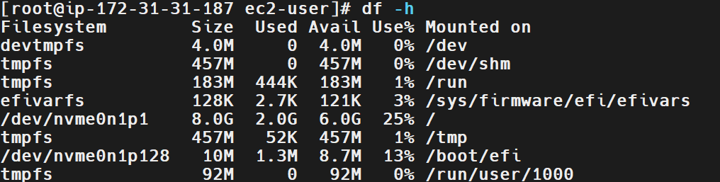
Step 2: Verify the Email Command
Check whether the mail command is available:
command -v mail
Expected output:
/usr/bin/mail
This confirms that the command is available. Actual email delivery still requires a properly configured mail service or SMTP relay.
Screenshot Evidence
Step 3: Create the Bash Script
Create a file named monitor_disk.bash:
vim monitor_disk.bash
Press i and enter the following script:
#!/bin/bash

THRESHOLD=80
EMAIL="admin@example.com"

echo "Checking disk space utilization..."

df -P -x tmpfs -x devtmpfs | awk 'NR > 1 {print $1, $6, $5}' |
while read -r FILESYSTEM MOUNTPOINT USAGE; do

USAGE=${USAGE%\%}

# Ignore entries without a numeric usage value
if ! [[ "$USAGE" =~ ^[0-9]+$ ]]; then
continue
fi

echo "Filesystem: $FILESYSTEM"
echo "Mount Point: $MOUNTPOINT"
echo "Usage: ${USAGE}%"

if [ "$USAGE" -gt "$THRESHOLD" ]; then

SUBJECT="High Disk Usage Alert: $MOUNTPOINT"

BODY="Warning: Disk usage on $(hostname) has exceeded ${THRESHOLD}%.

Filesystem: $FILESYSTEM
Mount Point: $MOUNTPOINT
Current Usage: ${USAGE}%

Please investigate disk usage."

if echo "$BODY" | mail -s "$SUBJECT" "$EMAIL"; then
echo "Email command completed for $MOUNTPOINT."
else
echo "Error: Failed to submit email for $MOUNTPOINT."
fi
else
echo "Disk usage is within the configured threshold."
fi

echo "-----------------------------"

done
Replace admin@example.com with your actual recipient email address.
Save and exit Vim:
- Press Esc.
- Type :wq.
- Press Enter.
Screenshot Evidence
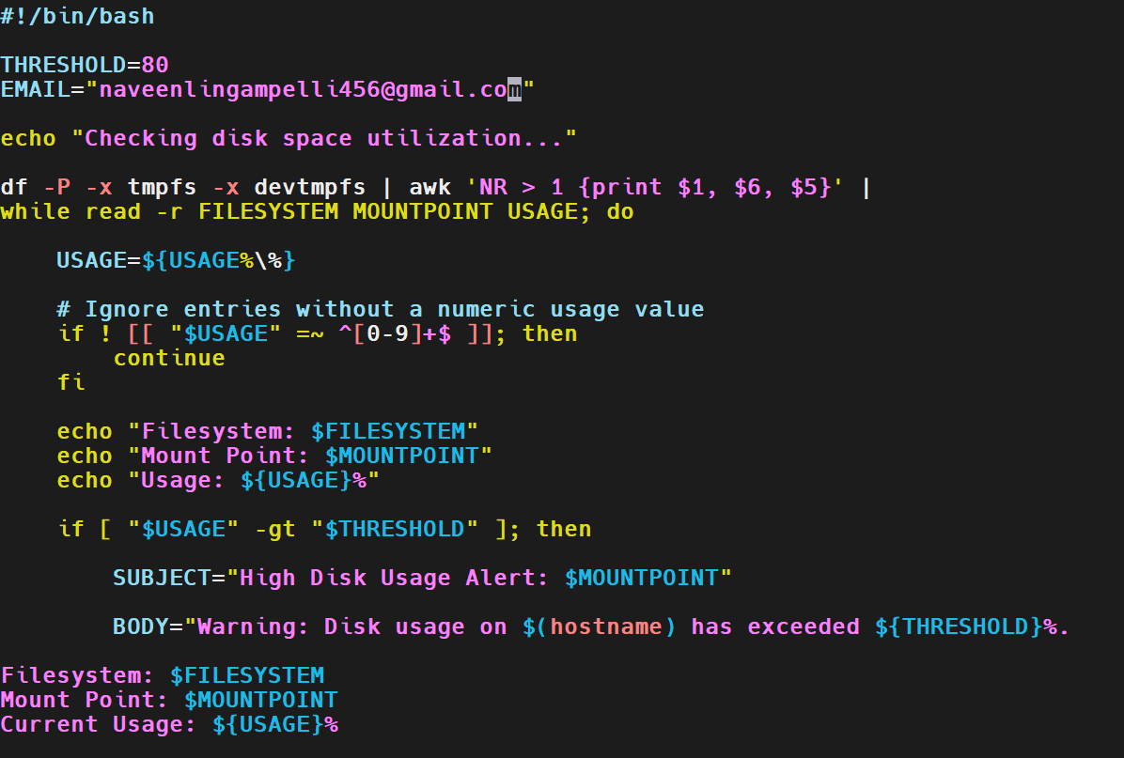Step 4: Grant Execution Permission
Run:
chmod 755 monitor_disk.bash
This grants the owner read, write, and execute permissions, and other users read and execute permissions.
Screenshot Evidence
Step 5: Execute the Script
Run:
./monitor_disk.bash
Example output when disk utilization is below the threshold:
Checking disk space utilization...
Filesystem: /dev/nvme0n1p1
Mount Point: /
Usage: 45%
Disk usage is within the configured threshold.
-----------------------------
The filesystem name and utilization percentage above are illustrative. Your actual output will depend on your EC2 instance.
If a filesystem exceeds 80%, the script attempts to send an email notification containing the filesystem name, mount point, and current utilization.
Screenshot Evidence
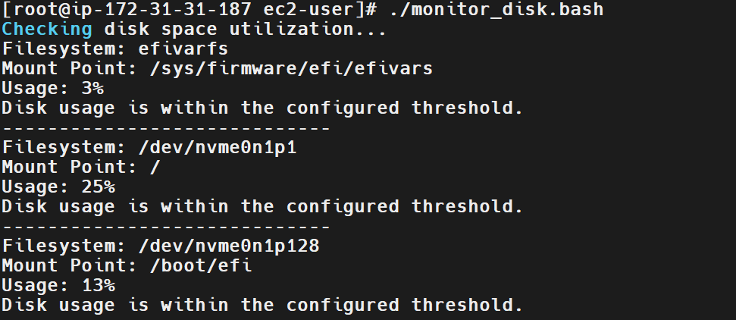
Step 6: Test the Email Notification
First, ensure that your email-sending service is configured and working.
You can test the mail command with:
echo "Disk monitoring test email" | mail -s "Disk Alert Test" your-email@example.com
Replace your-email@example.com with the recipient address.
To test the alert condition without filling the disk, you can temporarily change the threshold in the script to a lower value, such as THRESHOLD=1, and run it again. This should trigger alerts for filesystems whose usage exceeds 1%.
After testing, restore the threshold to:
THRESHOLD=80
Important: The script's message that an email command completed does not confirm that the recipient received the email. Verify delivery through the inbox or the configured mail service's logs.
Screenshot Evidence
Validation Steps
Step 1: Verify Disk Usage
Run:
df -h
Confirm the utilization percentage for each filesystem.
Step 2: Verify the Script
Run:
bash -n monitor_disk.bash
If the command produces no output, the script has passed Bash syntax checking.
Step 3: Verify the Alert Condition
Confirm that the script attempts to send an email only when filesystem usage is strictly greater than 80%.
Disk usage | Expected behavior
40% | No email alert
80% | No email alert
85% | Email notification attempted
Step 4: Verify Email Delivery
Check the recipient's inbox or the configured mail service's delivery logs. A successful local command alone is not sufficient proof of delivery.
Validation Screenshot
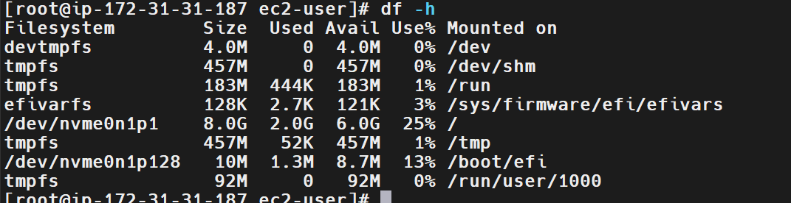Explanation
The script uses the df command to collect filesystem usage information. The -P option requests a predictable output format, while -x tmpfs -x devtmpfs excludes temporary memory-backed filesystems from monitoring. The awk command extracts the filesystem name, mount point, and percentage used.
The script removes the percent sign from the usage value and compares the resulting integer with the configured threshold of 80%. When utilization is greater than 80%, the script constructs an alert message and submits it using the mail command. Otherwise, it reports that disk usage is within the threshold.
Real-Time Use Case
DevOps engineers monitor disk utilization on application servers, database servers, and cloud instances to prevent storage exhaustion. High disk usage may result from growing application logs, backup files, temporary files, or large application data.
An automated disk monitoring script can help identify potential storage issues before applications fail. In production environments, this monitoring can be integrated with Amazon CloudWatch, Prometheus, or another monitoring platform to provide centralized dashboards and reliable alerting.
Common Errors and Troubleshooting
Error | Cause | Resolution
df: command not found | The required utility is unavailable or the environment is misconfigured. | Verify the command path and operating system utilities.
mail: command not found | The mail client is not installed. | Install an appropriate mail client and configure a delivery service.
Email is not received | SMTP settings, sender authorization, or network connectivity is incorrect. | Check relay configuration and delivery logs.
No alert is triggered | Disk usage has not exceeded 80%. | Check actual utilization using df -h; use a lower temporary threshold for testing.
Incorrect filesystem output | Filesystem types or mount points differ from expectations. | Review the output of df -P and adjust exclusions if necessary.
Script permission denied | Execution permission is missing. | Run chmod 755 monitor_disk.bash.
Disk is nearly full | Logs, backups, or application data consume available space. | Identify large files and directories, then clean up safely or expand storage.

Conclusion
The monitor_disk.bash script demonstrates how to monitor filesystem utilization, compare usage against an 80% threshold, and attempt email notification when the threshold is exceeded.
This task provides practical experience with Bash scripting, filesystem monitoring, conditional logic, and email alert integration. Reliable production alerting requires a configured email delivery service and should ideally be combined with a dedicated monitoring platform.
Task 12: Monitor Memory Usage and Send an Email Notification if Usage Exceeds 80%
Outcome
A Bash script named monitor_memory.bash is created to monitor memory utilization on an Amazon Linux 2023 EC2 instance. If memory usage exceeds 80%, the script attempts to send an email notification to a configured recipient.
Memory utilization is monitored using a Bash script.
If memory usage exceeds 80%, an email notification is attempted.
Note: Email delivery requires a working mail-transfer service or SMTP relay. In the previous task, Postfix could not deliver directly to Gmail because the connection to port 25 timed out. Unless an SMTP relay is configured, the script may detect high memory usage without successfully delivering the email.
Objective
To automate memory monitoring and email alerting using Bash scripting. High memory utilization can cause applications to slow down, processes to be terminated by the Linux out-of-memory (OOM) mechanism, and services to become unstable.
This task demonstrates how to collect memory statistics, calculate memory utilization, compare it against a defined threshold, and trigger an email notification when the threshold is exceeded.
Prerequisites
- An AWS account with a running EC2 instance.
- Amazon Linux 2023 operating system.
- SSH access to the EC2 instance.
- Root privileges or appropriate permissions.
- Basic knowledge of Bash scripting and Linux commands.
- The free utility, usually provided by procps-ng.
- The mail command installed.
- A configured SMTP relay or working email delivery service.
- A valid recipient email address.
Step-by-Step Implementation
Step 1: Connect to the EC2 Instance
Connect to the Amazon Linux 2023 EC2 instance using SSH.
Verify the operating system:
cat /etc/os-release
Check the system memory:
free -h
Example output:
total used free shared buff/cache available
Mem: 900Mi 250Mi 120Mi 10Mi 530Mi 500Mi
Swap: 0B 0B 0B
The values above are illustrative. Your EC2 instance may show different values.
Screenshot Evidence
Step 2: Verify the Required Commands
Check whether the free command is available:
command -v free
Check whether the mail command is available:
command -v mail
The free command is used to retrieve memory statistics. The mail command is used to submit an email notification.
Important: A path returned by command -v mail confirms only that the command is installed. It does not confirm that external email delivery is configured.
Screenshot Evidence
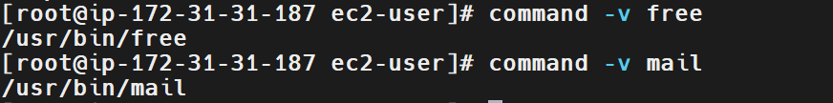
Step 3: Create the Bash Script
Create a file named monitor_memory.bash:
vim monitor_memory.bash
Press i and enter the following script:
#!/bin/bash

THRESHOLD=80
EMAIL="admin@example.com"

echo "Checking memory utilization..."

# Calculate memory usage percentage
MEMORY_USAGE=$(free | awk '/^Mem:/ {
if ($2 > 0) {
printf "%.2f", (($2 - $7) / $2) * 100
}
}')

# Validate the calculated value
if ! [[ "$MEMORY_USAGE" =~ ^[0-9]+([.][0-9]+)?$ ]]; then
echo "Error: Unable to determine memory usage."
exit 1
fi

echo "Current Memory Usage: ${MEMORY_USAGE}%"
echo "Memory Threshold: ${THRESHOLD}%"

# Compare memory usage with the threshold
if awk -v usage="$MEMORY_USAGE" -v threshold="$THRESHOLD" \
'BEGIN {exit !(usage > threshold)}'; then

SUBJECT="High Memory Usage Alert"

BODY="Warning: Memory usage on $(hostname) is ${MEMORY_USAGE}%, exceeding the threshold of ${THRESHOLD}%."

if echo "$BODY" | mail -s "$SUBJECT" "$EMAIL"; then
echo "High memory usage detected. Email command completed."
else
echo "Error: Email notification command failed."
exit 1
fi
else
echo "Memory usage is within the configured threshold."
fi
Replace admin@example.com with your actual recipient email address.
Save and exit Vim by pressing Esc, typing :wq, and pressing Enter.
Calculation used:
Memory Usage (%) = (Total Memory - Available Memory) / Total Memory × 100
This script uses the available-memory field reported by free to estimate memory utilization. This is generally more useful than simply subtracting the completely free memory from total memory because Linux also uses memory for buffers and cache.
Screenshot Evidence
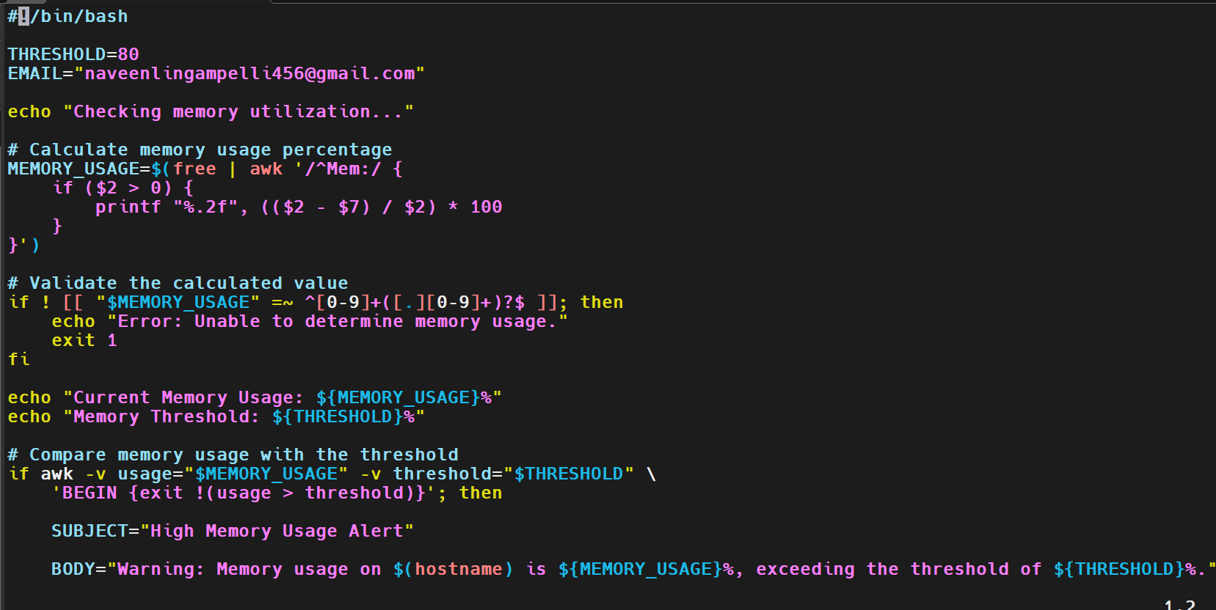
Step 4: Grant Execution Permission
Execute:
chmod 755 monitor_memory.bash
This grants the file owner read, write, and execute permissions, and other users read and execute permissions.
Screenshot Evidence
Step 5: Execute the Script
Run:
./monitor_memory.bash
If memory utilization is below or equal to 80%, the output should resemble:
Checking memory utilization...
Current Memory Usage: 45.00%
Memory Threshold: 80%
Memory usage is within the configured threshold.
If memory utilization exceeds 80%, the script attempts to submit an email notification.
Example output:
Checking memory utilization...
Current Memory Usage: 85.00%
Memory Threshold: 80%
High memory usage detected. Email command completed.
The percentages are illustrative. Actual utilization depends on the current workload.
Note: The message Email command completed indicates that the local mail command returned success; it does not guarantee delivery to the recipient.
Screenshot Evidence
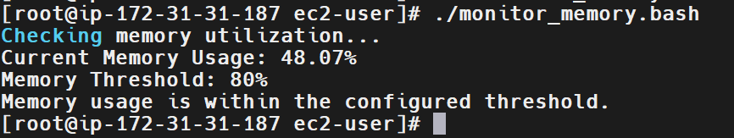Step 6: Test the Alert Condition
On a lightly loaded EC2 instance, memory usage may never exceed 80%. You can test the alert logic by temporarily changing the threshold in the script to a low value, such as:
THRESHOLD=1
Run the script:
./monitor_memory.bash
If actual memory utilization exceeds 1%, the script attempts to send an email.
After testing, restore the intended threshold:
THRESHOLD=80
Important: Changing the threshold tests the conditional logic; it does not prove that the actual 80% alert has been triggered. To test high memory utilization, use a controlled workload in a practice environment and monitor the system carefully. Avoid exhausting memory on a production server.
Screenshot Evidence
Insert a screenshot showing the temporary test threshold and resulting output.
Step 7: Verify Email Delivery
If email delivery is configured, send a test message:
echo "Memory monitoring test email" | mail -s "Memory Alert Test" YOUR_EMAIL_ADDRESS
Replace YOUR_EMAIL_ADDRESS with the actual recipient address.
Check the inbox and the configured mail service's delivery logs.
If using Postfix, inspect recent logs:
journalctl -u postfix -n 50 --no-pager
If direct delivery to an external provider fails, configure an authenticated SMTP relay, such as Amazon SES. Installing Postfix and the mail command alone does not guarantee external email delivery.
Screenshot Evidence
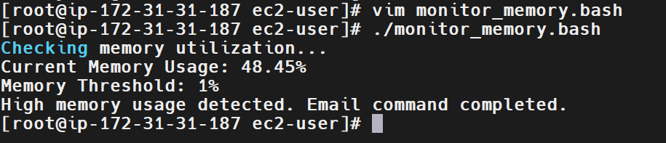Validation Steps
Step 1: Verify Memory Statistics
Execute:
free -h
Confirm that the system reports total, used, free, and available memory.
Step 2: Validate the Script Syntax
Run:
bash -n monitor_memory.bash
If no output appears, the script has passed Bash syntax checking.
Step 3: Verify the Threshold Logic
Confirm that the script attempts to send an email only when memory utilization is strictly greater than 80%.
Memory utilization | Expected behavior
40% | No email alert
80% | No email alert
85% | Email notification attempted
Step 4: Verify Email Delivery
Check the recipient's inbox or the configured email service's delivery logs. A successful local command alone is not sufficient proof of delivery.
Validation Screenshot
Insert screenshots showing the memory statistics, script execution, and email delivery evidence if available.
Explanation
The script uses the free command to retrieve memory statistics and awk to calculate memory utilization. It estimates used memory as total memory minus available memory, divides this value by total memory, and converts the result into a percentage.
The script compares the calculated percentage with the configured threshold of 80%. If memory utilization is greater than the threshold, it constructs an alert containing the hostname and current memory usage and submits it using the mail command. Otherwise, it reports that memory usage is within the configured limit.
Real-Time Use Case
DevOps engineers monitor memory utilization on application servers, database servers, and cloud instances to detect resource pressure. High memory usage may result from memory leaks, large workloads, excessive processes, or insufficient instance capacity.
Automated memory alerts help teams investigate performance problems before they lead to application failures. In production, this monitoring can be implemented through Amazon CloudWatch, Prometheus, or another observability platform with reliable alert delivery and dashboards.
Common Errors and Troubleshooting
Error | Cause | Resolution
free: command not found | The required utility is unavailable. | Verify the installation of procps-ng and the command path.
Memory usage cannot be calculated | Unexpected command output or invalid memory statistics. | Run free manually and inspect its output.
mail: command not found | The mail client is not installed. | Install an appropriate mail client and configure delivery.
/usr/sbin/sendmail: No such file or directory | A compatible mail-transfer agent is missing. | Install and configure an MTA or SMTP client.
Email is not received | SMTP relay, sender verification, or network connectivity is incorrect. | Check the mail service configuration and delivery logs.
Memory usage never exceeds 80% | The server is lightly loaded. | Use a controlled test threshold or a limited test workload.
Script permission denied | Execution permission is missing. | Run chmod 755 monitor_memory.bash.
Memory usage appears higher than expected | Linux memory accounting includes caches and buffers. | Use the available-memory-based calculation and inspect free -h.
Conclusion
The monitor_memory.bash script demonstrates how to collect memory statistics, calculate utilization, compare it against an 80% threshold, and attempt an email notification when the threshold is exceeded.
This task provides practical experience with Bash scripting, system monitoring, arithmetic calculations, conditional logic, and email alert integration. Reliable production monitoring requires a properly configured email delivery service and should ideally be combined with a dedicated monitoring platform.
Task 13: Configure Crontab Entries in Linux
Outcome
Successfully configure and verify seven different cron scheduling expressions on an Amazon Linux EC2 instance to automate tasks at specific dates, times, weekdays, and system reboot events.
Objective
To understand and implement cron scheduling in Linux using crontab. This exercise covers scheduling jobs for specific dates, particular weekdays, multiple times per day, daily execution, weekends, and system reboots.
Prerequisites
- An Amazon Linux EC2 instance.
- SSH access to the EC2 instance.
- A Linux user with permission to configure cron jobs.
- The cronie package installed.
- The crond service enabled and running.
Step-by-Step Implementation
Step 1: Verify Cron Installation and Service Status
Check whether the cron package is installed.
rpm -q cronie
If it is not installed, run:
sudo dnf install cronie -y
Start the cron service and enable it at boot:
sudo systemctl enable --now crond
Verify the service status:
sudo systemctl status crond
Expected Result: The crond service should show active (running).
Screenshot Evidence:
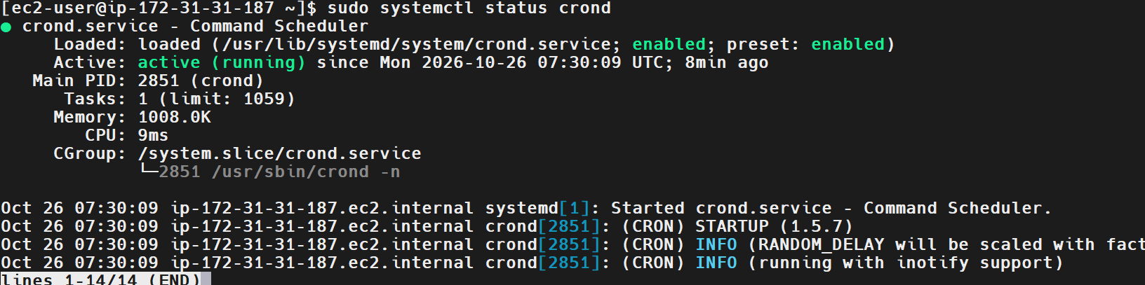
Step 2: Open the Crontab Editor
Open the current user's crontab:
crontab -e
If prompted, select your preferred text editor. Add the required cron entries in the following steps.
Note: Cron jobs execute with the permissions and environment of the user whose crontab contains the entry. Use sudo crontab -e only when the jobs must run as root.
Step 3: Schedule a Job for April 5th at Midnight
Requirement: Run a job at 12:00 AM on April 5th every year.
Cron expression:
0 0 5 4 *
Example entry:
0 0 5 4 * echo "April 5 midnight job executed" >> /tmp/cron_task13.log
Explanation:
- 0 — minute 0.
- 0 — hour 0, or midnight.
- 5 — fifth day of the month.
- 4 — April.
- * — every day of the week.
Screenshot Evidence: Capture the crontab entry and its output when displayed with crontab -l.
Step 4: Schedule a Job on the 5th of November, January, and June Only When It Is Thursday
Requirement: Run a job on the 5th day of November, January, and June when the date falls on Thursday.
Cron expression:
0 0 5 11,1,6 4
Example entry:
0 0 5 11,1,6 4 echo "Thursday date-specific job executed" >> /tmp/cron_task13.log
Important: Standard cron implementations generally treat the day-of-month and day-of-week fields as an OR when both are restricted. Therefore, the expression above does not reliably mean “the 5th of these months only if it is Thursday”; it can run on every Thursday in the listed months as well as on the 5th of those months.
To enforce the exact requirement, use a daily check and test both the date and weekday:
0 0 * 11,1,6 * [ "$(date +\%d)" = "05" ] && [ "$(date +\%u)" = "4" ] && echo "Thursday date-specific job executed" >> /tmp/cron_task13.log
Here, date +%u returns 4 for Thursday. The backslashes before % are required in crontab commands.
Screenshot Evidence: Capture the cron entry and a terminal showing the date/weekday condition used.
Step 5: Schedule a Job at the 5th and 27th Minutes of Hours 9, 10, and 11 Every Day
Requirement: Run the job at 9:05 AM, 9:27 AM, 10:05 AM, 10:27 AM, 11:05 AM, and 11:27 AM every day.
Cron expression:
5,27 9,10,11 * * *
Example entry:
5,27 9,10,11 * * * echo "Scheduled time job executed" >> /tmp/cron_task13.log
Explanation:
- 5,27 — at minutes 5 and 27.
- 9,10,11 — during the 9th, 10th, and 11th hours.
- The remaining * fields mean every day, every month, and every weekday.
Screenshot Evidence: Capture the expression and verify it appears in crontab -l.
Step 6: Schedule a Job at 9:34 AM on August 15th
Requirement: Run the job at 9:34 AM on August 15th every year.
Cron expression:
34 9 15 8 *
Example entry:
34 9 15 8 * echo "August 15 job executed" >> /tmp/cron_task13.log
Explanation:
- 34 — minute 34.
- 9 — 9 AM.
- 15 — the 15th day of the month.
- 8 — August.
- * — any day of the week.
Screenshot Evidence: Capture the cron expression in the crontab.
Step 7: Schedule a Job Every Midnight
Requirement: Run a job every day at 12:00 AM.
Cron expression:
0 0 * * *
Example entry:
0 0 * * * echo "Daily midnight job executed" >> /tmp/cron_task13.log
Explanation: The job runs at minute 0 of hour 0 every day.
Screenshot Evidence: Capture the cron entry and its presence in the crontab listing.
Step 8: Schedule a Job Every Saturday at 11:59 PM
Requirement: Run the job every Saturday night at 11:59 PM.
Cron expression:
59 23 * * 6
Example entry:
59 23 * * 6 echo "Saturday night job executed" >> /tmp/cron_task13.log
Explanation:
- 59 — minute 59.
- 23 — hour 23, or 11 PM.
- * * — every day of the month and every month.
- 6 — Saturday on standard Linux cron implementations.
Screenshot Evidence: Capture the Saturday scheduling expression.
Step 9: Schedule a Job After Every Reboot
Requirement: Execute a command whenever the system reboots.
Cron expression:
@reboot
Example entry:
@reboot echo "System reboot job executed" >> /tmp/cron_task13.log
Explanation: The @reboot special string tells cron to run the command when the cron service starts during system startup. It does not run at a recurring clock time.
Screenshot Evidence: Capture the @reboot entry. If you test it, rebooting the EC2 instance can interrupt your SSH session; reconnect afterward and inspect the log.
Step 10: Save and Verify All Entries
After adding the entries, save and exit the editor. List the configured jobs:
crontab -l
For easier verification, the seven example entries can be placed in the same user's crontab. Each entry appends to /tmp/cron_task13.log.
Check the log file if it exists:
cat /tmp/cron_task13.log
Note: The log file is created only after an entry executes or you manually create it. Listing a cron entry does not prove that its scheduled time has occurred.
Screenshot Evidence: Capture the complete output of crontab -l.
Validation Steps
- Confirm that the cron package is installed:
rpm -q cronie
- Confirm that the cron service is running:
systemctl is-active crond
Expected output:
active
- Verify the current user's configured cron jobs:
crontab -l
- Inspect the log file after jobs have executed:
cat /tmp/cron_task13.log
- Check cron service logs for execution or scheduling issues:
sudo journalctl -u crond --since today --no-pager
Validation Screenshot: 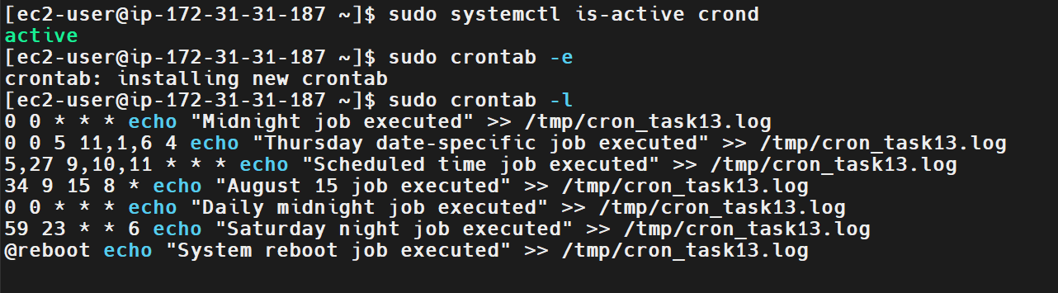
Explanation
Cron is a time-based job scheduler available on Linux systems. A cron expression consists of five fields: minute, hour, day of the month, month, and day of the week. These fields allow administrators to automate recurring maintenance activities, backups, monitoring scripts, log cleanup, and other routine operations without manually running commands.
The @reboot directive is a special cron scheduling string that runs a command when the cron service starts during system startup. Cron jobs should be tested carefully because they run with the configured user's permissions and may have a more limited environment than an interactive shell. Absolute paths are recommended for commands and scripts. In addition, cron uses the server's configured timezone, so verify the timezone when the schedule depends on a specific local time.
Real-Time Use Case
In a production environment, cron can automate daily database backups, periodic log rotation, cleanup of temporary files, scheduled health checks, and recurring monitoring scripts. For example, a disk-monitoring script can be scheduled to run every day and write its findings to a log or send an alert when a threshold is exceeded. An @reboot entry can start a lightweight initialization script after system startup.
Common Errors and Troubleshooting
Issue | Possible Cause | Solution
Cron jobs do not execute | crond is stopped | Run sudo systemctl enable --now crond.
No crontab exists | No jobs have been saved for the current user | Run crontab -e and add the required entries.
Job runs under the wrong permissions | Entry is configured for a different user | Check whether the entry belongs in crontab -e or sudo crontab -e.
Job executes at an unexpected time | Server timezone differs from the expected timezone | Check with timedatectl and adjust the timezone or schedule.
A conditional date/weekday job runs unexpectedly | Both day-of-month and day-of-week fields are restricted | Use a command-level date/weekday check as shown in Step 4.
Log file is missing | The scheduled time has not occurred, or the command failed | Check the cron service logs and verify the command manually.
Command works manually but not in cron | Cron has a limited environment or cannot locate a command | Use absolute command paths and redirect errors to a log file.
@reboot command does not appear to run | Cron service startup or command timing issue | Inspect journalctl -u crond and use an absolute path for the command.
Conclusion
In this exercise, seven cron scheduling scenarios were covered: a specific date and time, a date restricted to a weekday, multiple minute/hour combinations, a yearly date-specific job, daily midnight execution, a Saturday-night schedule, and execution after reboot. These examples demonstrate how Linux cron can automate recurring administrative tasks and system operations.
Final Verification: Ensure all entries are saved, confirm crond is active, and retain screenshots of the configured crontab and validation commands. Remember that scheduled execution should be verified from actual logs when the relevant time occurs.

