Task 1: Bash Scripting – Assignment 01
Date: 20261023
Outcome
Successfully practiced Bash scripting on an Amazon Linux 2023 EC2 instance. Created and executed scripts for basic commands, system information, variables, user input, and file renaming. Also practiced shell identification, file permissions, and troubleshooting common Bash scripting errors.
Objective
To learn Bash scripting fundamentals and understand how to automate Linux administration tasks using shell commands, variables, user input, and file operations. These skills are useful for automating repetitive activities in DevOps workflows.
Prerequisites
- AWS account and an active EC2 instance.
- Amazon Linux 2023 operating system.
- SSH access using MobaXterm and a private key.
- Basic Linux command-line knowledge.
- Vim text editor.
- Bash shell.
Environment Details
Parameter | Value
Cloud platform | AWS EC2
Operating system | Amazon Linux 2023
Hostname | ip-172-31-31-187
User | Root
Working directory | /bash/scripts
Shell | Bash
Editor | Vim
Assignment | Bash-Scripting Assignment 01
Step-by-Step Implementation
Step 1: Access the EC2 Instance and Switch to Root
Connected to the EC2 instance through SSH using MobaXterm.
Command:
sudo su
Verified access to the root shell.
Explanation: The sudo su command switches the current session to the root user, allowing administrative operations.
Step 2: Create a Test File and Execute System Commands
Created a file named test using Vim:
vim test
Checked the file details:
ll
Changed permissions:
chmod 777 test
Executed the file:
./test
The output displayed system information, including memory usage, running processes, and filesystem details.
Explanation:
- vim test creates or opens a file for editing.
- ll displays file permissions, ownership, size, and modification time.
- chmod 777 test grants read, write, and execute permissions to everyone.
- ./test executes the file from the current directory.
Note: Avoid 777 permissions in production. Use only the permissions required by the script.
Screenshot Evidence
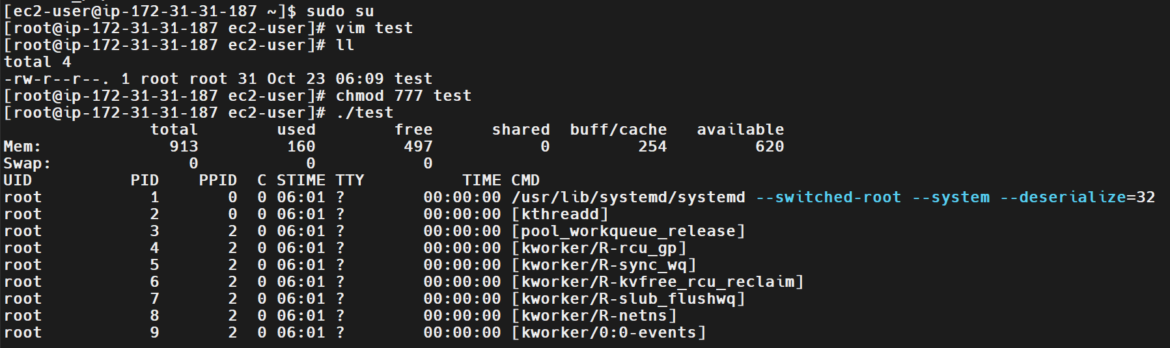
Step 3: Identify the Current Shell
Executed:
echo $0
Output:
bash
Explanation: The $0 variable displays the name used to invoke the current shell or script. In this example, the shell is Bash.
Step 4: List the Available Shells
Executed:
cat /etc/shells
The output included:
/bin/sh
/bin/bash
/usr/bin/sh
/usr/bin/bash
/bin/csh
/bin/tcsh
/usr/bin/csh
/usr/bin/tcsh
Explanation: The /etc/shells file lists shells recognized by the system as valid login shells.
Step 5: Test Different Shells
Tested the following shells individually:
sh
echo $0
exit
csh
echo $0
tcsh
echo $0
bash
echo $0
The outputs identified the respective shells as sh, csh, tcsh, and bash.
Explanation: A shell interprets commands entered by the user. Different shells provide different features and syntax. The exit command exits the current shell session and returns to the previous shell.
Screenshot Evidence
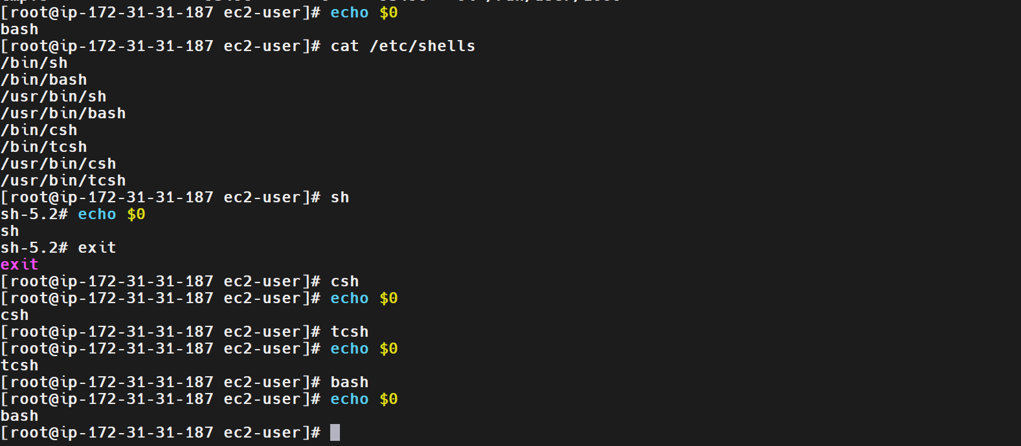
Step 6: Create the Bash Scripts Directory
Checked the current location:
pwd
Output:
/home/ec2-user
Created the directory:
mkdir -p /bash/scripts
An attempt to use the relative path failed:
cd bash/scripts
Error:
bash: cd: bash/scripts: No such file or directory
Corrected the path by using:
cd /bash/scripts
Verified the location:
pwd
Output:
/bash/scripts
Explanation: An absolute path starts from /, while a relative path is interpreted from the current working directory. Using /bash/scripts avoids ambiguity about the current location.
Screenshot Evidence
- 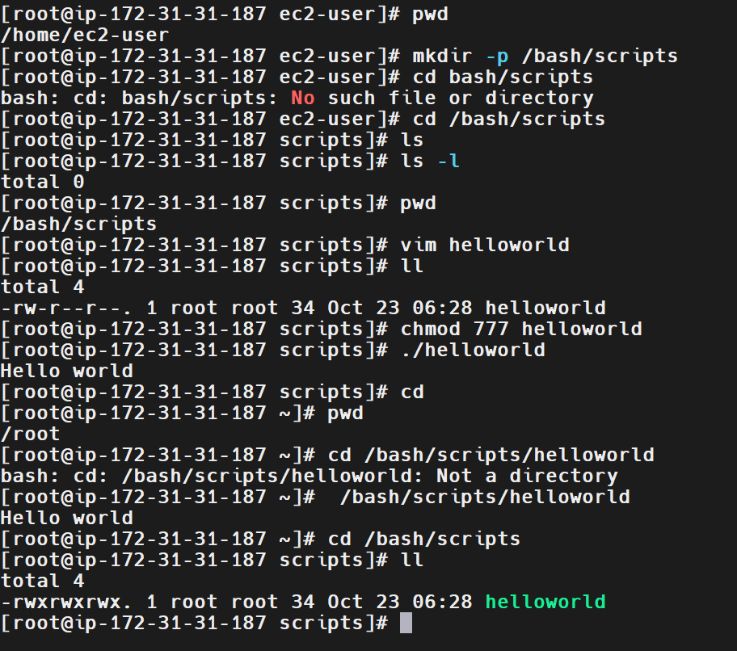
Step 7: Create and Execute a Hello World Script
Created a script:
vim helloworld
Added the following content:
#!/bin/bash

echo "Hello world"
Changed its permissions:
chmod 777 helloworld
Executed it:
./helloworld
Output:
Hello world
Renamed the script:
mv helloworld helloworld.bash
Verified the file:
ll
Explanation:
- #!/bin/bash is the shebang, specifying the Bash interpreter.
- echo displays text on the terminal.
- chmod changes file permissions.
- mv renames or moves a file.
- ./helloworld executes a script using its relative path.
Screenshot Evidence
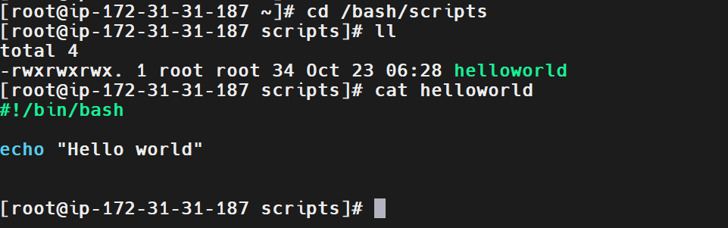
Step 8: Understand Script Permissions and Execution
Created another script:
vim abc.bash
Script content:
#!/bin/bash

echo "abc"
Attempted direct execution:
./abc.bash
Observed error:
bash: ./abc.bash: Permission denied
Executed the script through Bash:
bash abc.bash
Output:
abc
Added execute permission:
chmod 755 abc.bash
Executed it directly:
./abc.bash
Output:
abc
Explanation: Direct execution requires execute permission. Running bash abc.bash invokes the interpreter explicitly, so the script file itself does not need the execute bit. The 755 permission allows the owner to read, write, and execute the file, while others can read and execute it.
Screenshot Evidence
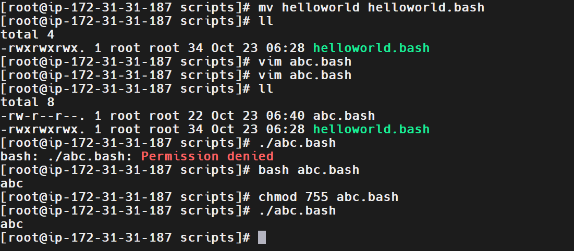
Step 9: Add Comments and Variables to a Script
Edited helloworld.bash:
vim helloworld.bash
Added the following content:
#!/bin/bash
#purpose: testing script format
#date: 23/10/2026
#modification: 23/10/2026

a="Hello world"

echo $a
Verified the content:
cat helloworld.bash
Explanation:
- Lines beginning with # are comments, except the shebang, which identifies the interpreter.
- a="Hello world" assigns a string to the variable a.
- echo $a displays the variable's value.
Initially, the assignment was entered with spaces around =, causing an error:
./helloworld.bash: line 6: a: command not found
Corrected it to:
a="Hello world"
Executed the script:
./helloworld.bash
Output:
Hello world
Updated the value to Hello devops and executed the script again:
Hello devops
Key learning: Bash variable assignments must not contain spaces around the equal sign.
Screenshot Evidence
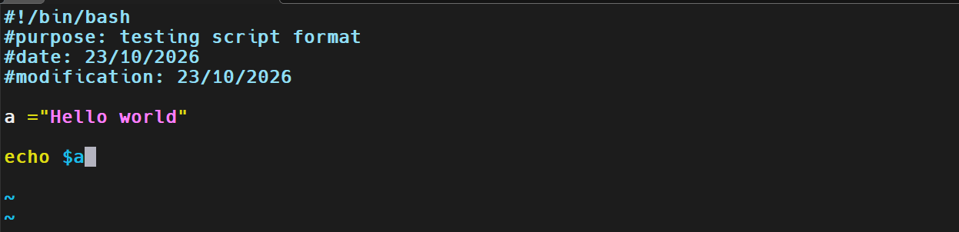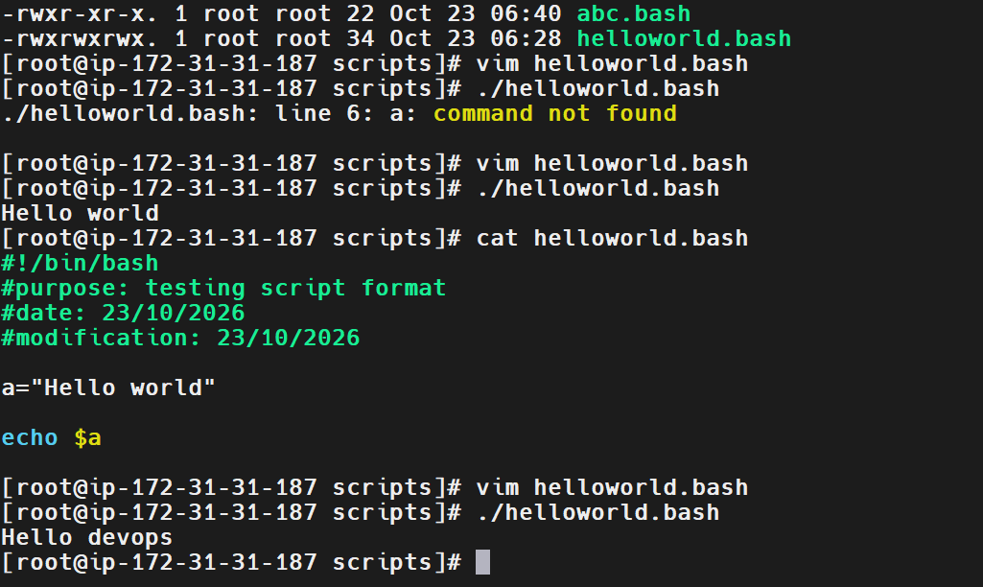

Step 10: Clean the Directory and Recreate the Hello World Script
Removed the existing files from the working directory:
rm -rf *
Verified the directory:
ll
Created the script again:
vim helloworld.bash
Added the following content:
#!/bin/bash

echo "helloworld"
Changed the permissions:
chmod 755 helloworld.bash
Executed the script:
./helloworld.bash
Output:
helloworld
Explanation: rm -rf * removes matching files and directories in the current directory without prompting. This command is destructive, especially when executed as root, so always verify the current directory before running it.
Screenshot Evidence
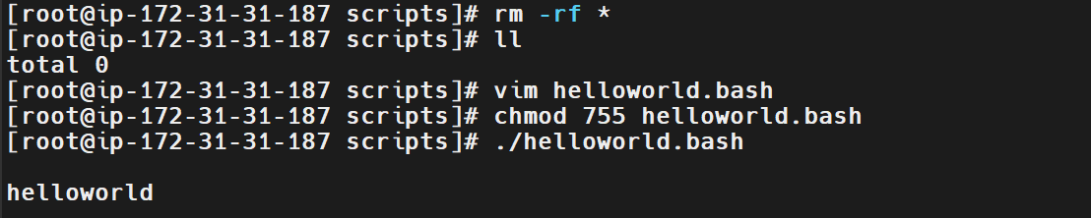
Step 11: Create a Script to Execute Basic Linux Commands
Created:
vim commands.bash
The script executed basic commands to display the current directory, list files, identify the current user, show the date, and display a calendar.
Changed permissions and executed the script:
chmod 755 commands.bash
./commands.bash
The output included:
/bash/scripts
commands.bash helloworld.bash
root
Fri Oct 23 07:11:45 UTC 2026
October 2026
The script also displayed the calendar for October 2026.
Explanation: Commands such as pwd, ls, whoami, date, and cal can be combined in a Bash script to collect system and environment information.
Screenshot Evidence
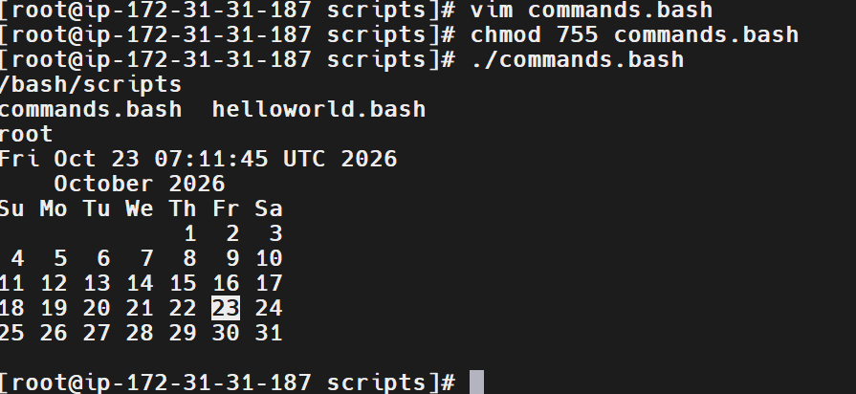
Step 12: Display System Resource Information
The system information script was executed to display information about processes, memory, CPU usage, and filesystem utilization.
The screenshot showed output from commands such as:
top
free -m
df -h
Explanation:
- top displays running processes and live resource utilization.
- free -m reports memory usage in megabytes.
- df -h displays filesystem capacity in human-readable units.
These commands are useful for troubleshooting performance issues on Linux servers.
Screenshot Evidence
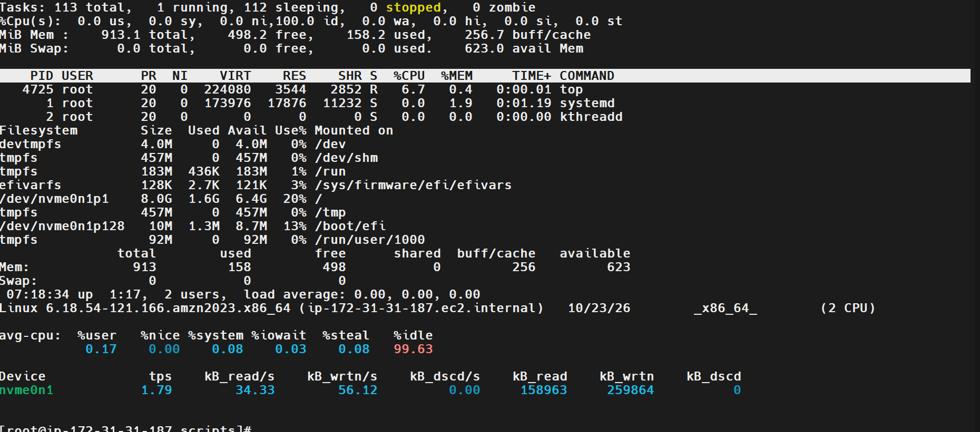
Step 13: Create a Script Using Command Variables
Created:
vim variables.bash
Script content:
#!/bin/bash
#define variables

p=pwd
l=ls
wi=whoami
d=date
c='cal 2023'

echo Run variable tasks
echo
$p
$l
$wi
$d
$c
Explanation: This example demonstrates storing command names in variables and expanding them to execute the corresponding commands.
Important note: Storing command names in variables works for simple commands, but it is generally clearer and safer to execute commands directly or use functions. For example, use pwd instead of assigning p=pwd and then running $p.
Screenshot Evidence
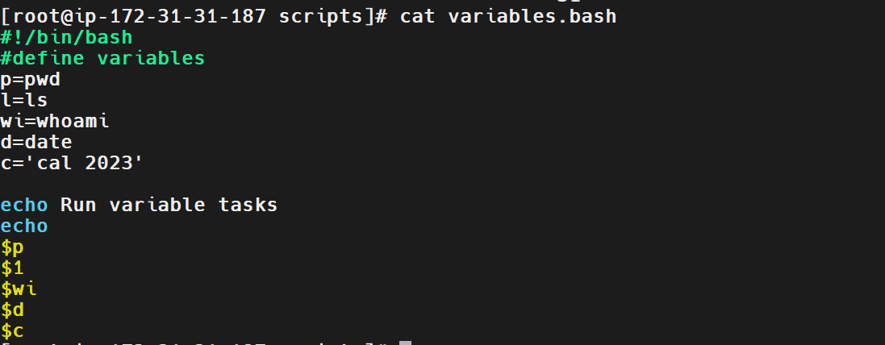
Step 14: Create a Script to Accept User Input
Created:
vim input.bash
Added:
#!/bin/bash

echo 'my name is naveen'
echo
echo 'what is your name'
echo
read name
echo hello $name
Changed permissions:
chmod 755 input.bash
Executed:
./input.bash
Example output:
my name is naveen

what is your name

ramu
hello ramu
Explanation:
- read name accepts input from the user and stores it in the variable name.
- $name retrieves the entered value.
- The script displays a personalized greeting using the input.
Screenshot Evidence
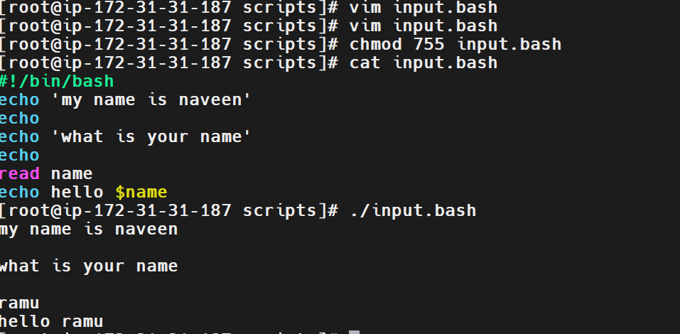
Step 15: Create a Script Using the Hostname and User Input
Created or edited:
vim output.bash
The script was designed to display the hostname, ask for a name, and print a greeting. The hostname was checked using:
hostname
Output:
ip-172-31-31-187.ec2.internal
The script was then executed:
./output.bash
The final output included:
hello my name is ip-172-31-31-187.ec2.internal

what is your name?
naveen

hello naveen
Explanation: The hostname command identifies the system's hostname. The script combines system information with interactive user input to generate output dynamically.
Screenshot Evidence
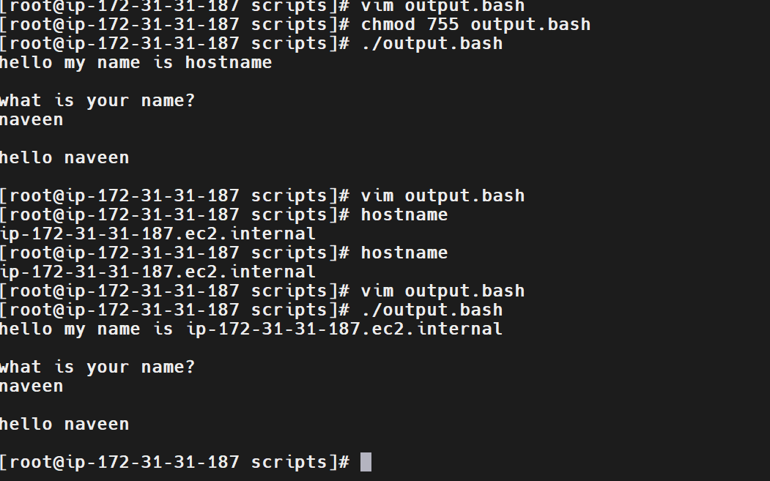
Step 16: Create a Script to Display User and System Information
Created:
vim tasks.bash
Executed:
bash tasks.bash
The output displayed information including:
root

/bash/scripts

ip-172-31-31-187.ec2.internal
The output also included a listing of files in the working directory.
Explanation: This task demonstrates combining multiple Linux commands within one script to display the current user, working directory, hostname, and file details.
Screenshot Evidence
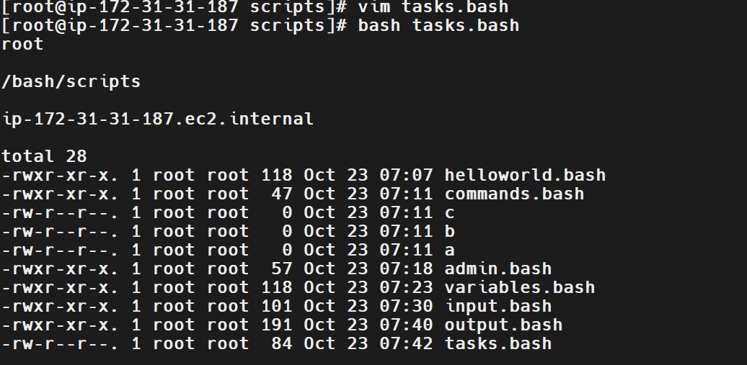
Step 17: Practice Variable Assignments
Created:
vim variables1.bash
Executed:
bash variables1.bash
Observed output:
My first name is Imran
My surname is Afzal
My surname is $c
Explanation: The script demonstrated variable usage and string output. The final line printed the literal $c, indicating that the variable was escaped or quoted in a way that prevented expansion, or that the script used a single-quoted string.
To print the value stored in c, use:
echo "My surname is $c"
Screenshot Evidence
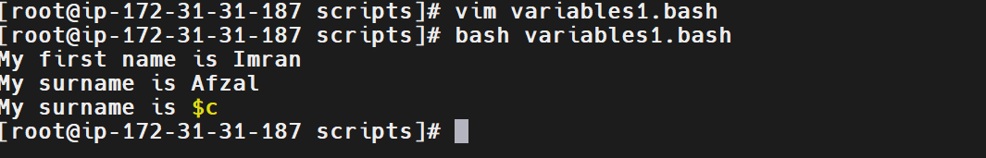
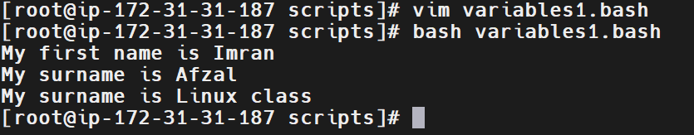
Step 18: Create a Script to Collect First and Last Name
Created a file using:
vim user input
The terminal showed:
2 files to edit
This happened because the filename contained a space and Vim interpreted user and input as two separate filenames.
Executed:
bash user input
The script prompted for a first name and a last name:
What is your first name?
naveen

What is your last name?
kumar

Hello naveen kumar
Explanation: The script collected two separate inputs and combined them in a greeting.
Important lesson: When creating or accessing a filename containing spaces, enclose the name in quotes, for example:
vim "user input"
To rename it to a filename without spaces, use:
mv "user input" userinput.bash
Screenshot Evidence
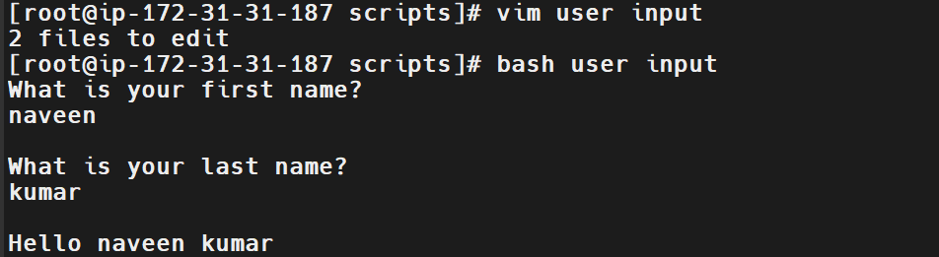
Step 19: Display User, Date, and Login Information
Executed a script that displayed the current user, date/time, and number of logged-in users.
Observed output:
Hello root

Today is Fri Oct 23 08:01:15 UTC 2026

Number of user login: 2
Explanation: This task demonstrates collecting system information from commands and printing it in a readable format. The date and login count can be useful for basic server monitoring.
Screenshot Evidence
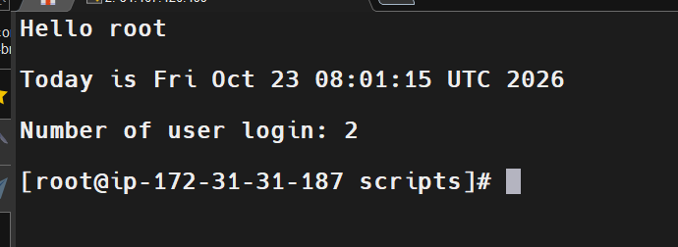
Step 20: Create a Script to Rename a File
Created the script:
vim ptask.bash
Executed it:
bash ptask.bash
The script prompted for the existing filename and the new filename.
Example interaction:
Enter the file name to be renamed
user

Enter the new file name
userinput.bash

The file has been renamed as userinput.bash
Explanation: The script accepts a source filename and a destination filename, then renames the file. The underlying Linux command for renaming is mv.
A basic implementation can be written as:
#!/bin/bash

read -p "Enter the file name to be renamed: " old_name
read -p "Enter the new file name: " new_name

if [ -f "$old_name" ]; then
mv -- "$old_name" "$new_name"
echo "The file has been renamed as $new_name"
else
echo "Error: File not found"
fi
The script checks that the original path is a regular file before attempting to rename it.
Screenshot Evidence
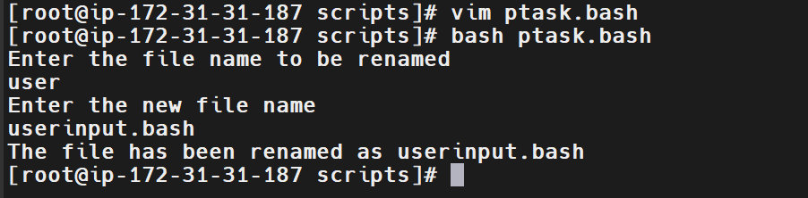
Validation Steps
The following results were visible in the provided screenshots.
Validation | Command or Script | Expected/Observed Result
Identify shell | echo $0 | bash
List shells | cat /etc/shells | Available shell paths displayed
Verify script directory | pwd | /bash/scripts
Execute basic script | ./helloworld.bash | helloworld
Test execute permissions | ./abc.bash | Permission error before chmod
Execute via interpreter | bash abc.bash | abc
Execute with permissions | ./abc.bash | abc
Display variable value | ./helloworld.bash | Hello world / Hello devops
Display command results | ./commands.bash | Directory, files, user, date, calendar
Accept user input | ./input.bash | Greeting using the entered name
Display hostname | hostname | ip-172-31-31-187.ec2.internal
Collect full name | bash user input | Greeting with first and last name
Rename a file | bash ptask.bash | Confirmation of the new filename
Validation Screenshot Evidence
Attach the screenshots listed under each step. The most important evidence includes:
- Shell identification and available shells.
- Successful Hello World script execution.
- Permission-denied error and correction.
- Variable assignment and output.
- User-input and full-name scripts.
- Hostname and system information output.
- Successful file-renaming output.
Explanation
Bash scripting provides a way to automate Linux operations by combining commands, variables, user input, and file operations into reusable scripts. A script commonly begins with #!/bin/bash, which specifies the interpreter. Commands such as pwd, ls, whoami, date, hostname, and df can be used to collect useful system information.
File permissions control whether a script can be executed directly. Variables allow data to be stored and reused, while the read command makes scripts interactive. File operations such as mv allow scripts to rename files automatically. Troubleshooting issues like incorrect paths, missing execute permissions, and spaces around variable assignments is an important part of developing reliable automation.
Real-Time Use Case
Bash scripts are commonly used by DevOps engineers to automate repetitive activities such as server health checks, log cleanup, backups, deployment preparation, and user management. For example, a script can collect hostname, memory, disk usage, and login information before a deployment. Interactive scripts can also collect filenames or environment values from an operator and perform tasks consistently.
Common Errors and Troubleshooting
Error | Cause | Resolution
No such file or directory | Incorrect relative directory path | Used the absolute path /bash/scripts
Permission denied | Execute permission missing | Used chmod 755 script_name
command not found for a variable name | Spaces around = in assignment | Used variable="value"
Vim reports 2 files to edit | Filename contains spaces but was not quoted | Used vim "user input"
Script cannot find the original file | Wrong filename or working directory | Checked pwd and verified the filename
Variable prints literally as $c | Variable expansion prevented by quoting or escaping | Used double quotes: echo "My surname is $c"
Accidental deletion of scripts | Used rm -rf * | Verify the current directory and review files before deleting
Conclusion
Successfully practiced Bash scripting fundamentals on Amazon Linux 2023, including shell identification, script creation, permissions, variables, user input, system information, and file renaming. The screenshots provide evidence of script execution and troubleshooting.

