Assignment 02

NAME.NAVEEN KUMAR MADDIPATI

SID-S550191

[EMAIL.ID-S550191@NWMISSOURI.EDU](mailto:EMAIL.ID-S550191@NWMISSOURI.EDU)

1.Link to the repo: <https://github.com/naveenmaddipati/assignment2-Maddipati.git>

2. Screen shot on GitHub showing ordered and unordered list.

3.Screen shot   in GitHub desktop showing the state of the repo with the changes for README

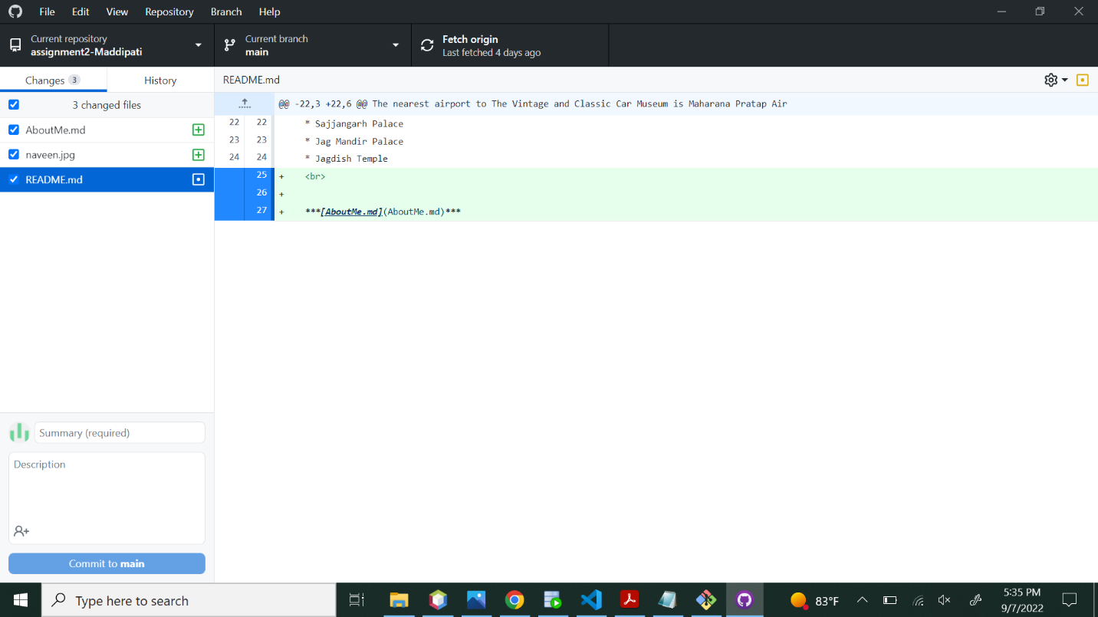

4.Screen shot in GitHub desktop showing the changes for AboutMe

5.Screen shot on GitHub showing the quote section.

7.Screen shot on GitHub showing code fencing section.

8.screen shot on GitHub showing updated profile.

