44-542 Object Oriented Programming
Casting

This worksheet uses the class hierarchy shown below.

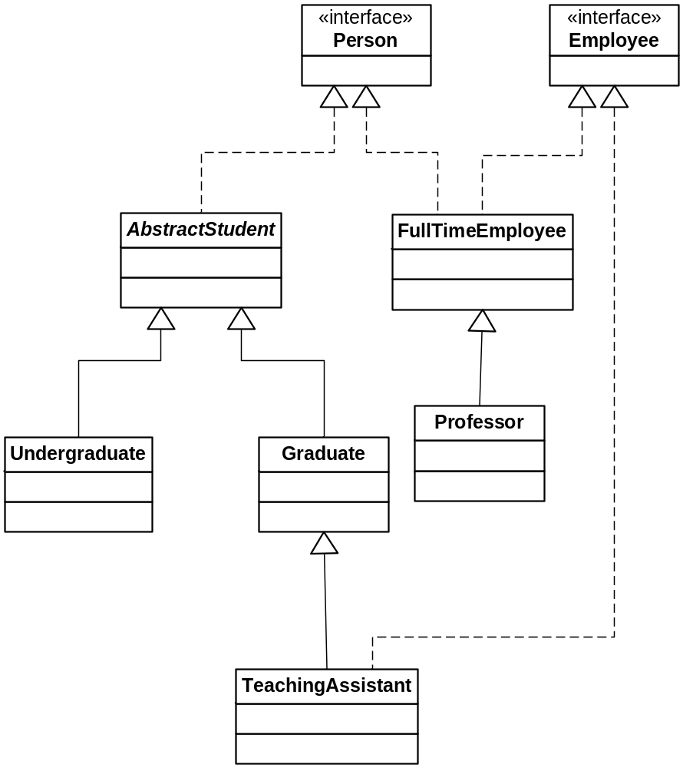

Casting enables us to make some reference assignments that might be illegal otherwise. Suppose we have the following definitions:
TeachingAssistant TA1;
TeachingAssistant TA2;
Graduate grad1;
TA1 = new TeachingAssistant(); //OK
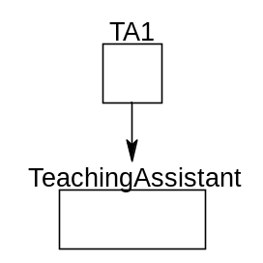
grad1 = TA1;//OK – a TeachingAssistant is a Graduate
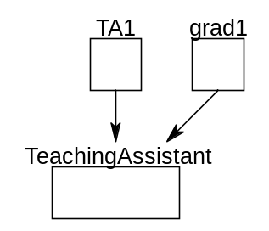
TA2 = grad1; // illegal – a Graduate is not a TeachingAssistant
However, in this instance note that grad1 actually references the same object that TA1 references, which is a TeachingAssistant.
If we know that grad1 references an object, which is indeed a TeachingAssistant, we can cast it to the correct type and then make the assignment:
TA2 = (TeachingAssistant) grad1; // This works!
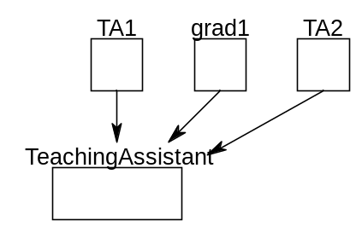

Without the cast, this statement is illegal. However, with the cast, the statement will compile. A runtime check will determine if the cast can actually be made – i.e., does grad1 actually reference a TeachingAssistant object? If not, a ClassCastException will be thrown at runtime.
Exercises
Assume we have the following declarations:
Person person1, person2;
Employee emp1;
AbstractStudent absStu1;
FullTimeEmployee ftEmp1, ftEmp2;
Undergraduate ug1, ug2;
Graduate grad1, grad2;
Professor prof1, prof2, prof3;
TeachingAssistant TA1, TA2;
Identify any illegal statements. Explain why each statement is either legal or illegal. Some statements are grouped together with no lines in between and should be treated as a code segment.

person1 = new Person();

emp1 = new Employee();

absStu1 = new AbstractStudent();

person1 = new TeachingAssistant();

emp1 = new TeachingAssistant();

emp1 = new Graduate();

prof1 = new Professor();
prof2 = new Professor();
prof3 = new Professor();
person1 = prof2;
emp1 = prof3;
prof1 = (Professor) emp1;
person1 = (Person) emp1;
emp1 = prof1;

emp1 = new Professor();
prof1 = new Professor();
person1 = prof1;
emp1 = (Employee) person1;
prof2 = (Professor) person1;

person1 = new TeachingAssistant();
emp1 = (Employee) person1;
prof2 = (Professor) person1;

