QA BUG REPORT
Angular RealWorld Example App (Conduit)

Prepared By | Naveen Mishra
Date | May 25, 2026
App URL | http://localhost:4200
App Name | Conduit (Angular RealWorld)
Test Type | Manual QA — Functional & UX Testing
Total Issues Found | 8 (1 Critical, 3 High, 2 Medium, 2 Low)

1. Executive Summary
This report documents the findings from manual QA testing performed on the Angular RealWorld Example App (Conduit) — a full-stack blogging platform. Testing was conducted by exercising all major user flows including Sign Up, Login, Article Creation, Article Editing, Commenting, Profile, and Settings.
A total of 8 issues were identified ranging from Critical to Low severity. The most impactful issue is a missing global CSS stylesheet which causes the entire application to render without any visual styling, making the app effectively unusable for end users despite all backend functionality working correctly.

Severity Breakdown
Severity | Count | Bugs
Critical | 1 | Bug #1
High | 3 | Bug #2, #3, #4
Medium | 2 | Bug #5, #6
Low | 2 | Bug #7, #8
Total | 8 | —

2. Detailed Bug Report

Bug #1 — Complete CSS Styling Missing — App Appears Entirely Unstyled
Severity | Critical
Steps to Reproduce | 1. Clone and run the app locally  2. Open http://localhost:4200  3. Observe homepage
Expected Result | App should display with proper colors, layout, typography, cards, and visual design
Actual Result | Entire app renders as plain black text on white background — no colors, no layout, no visual structure
Suspected Cause | angular.json references a non-existent npm package path 'realworld/assets/theme/styles.css'

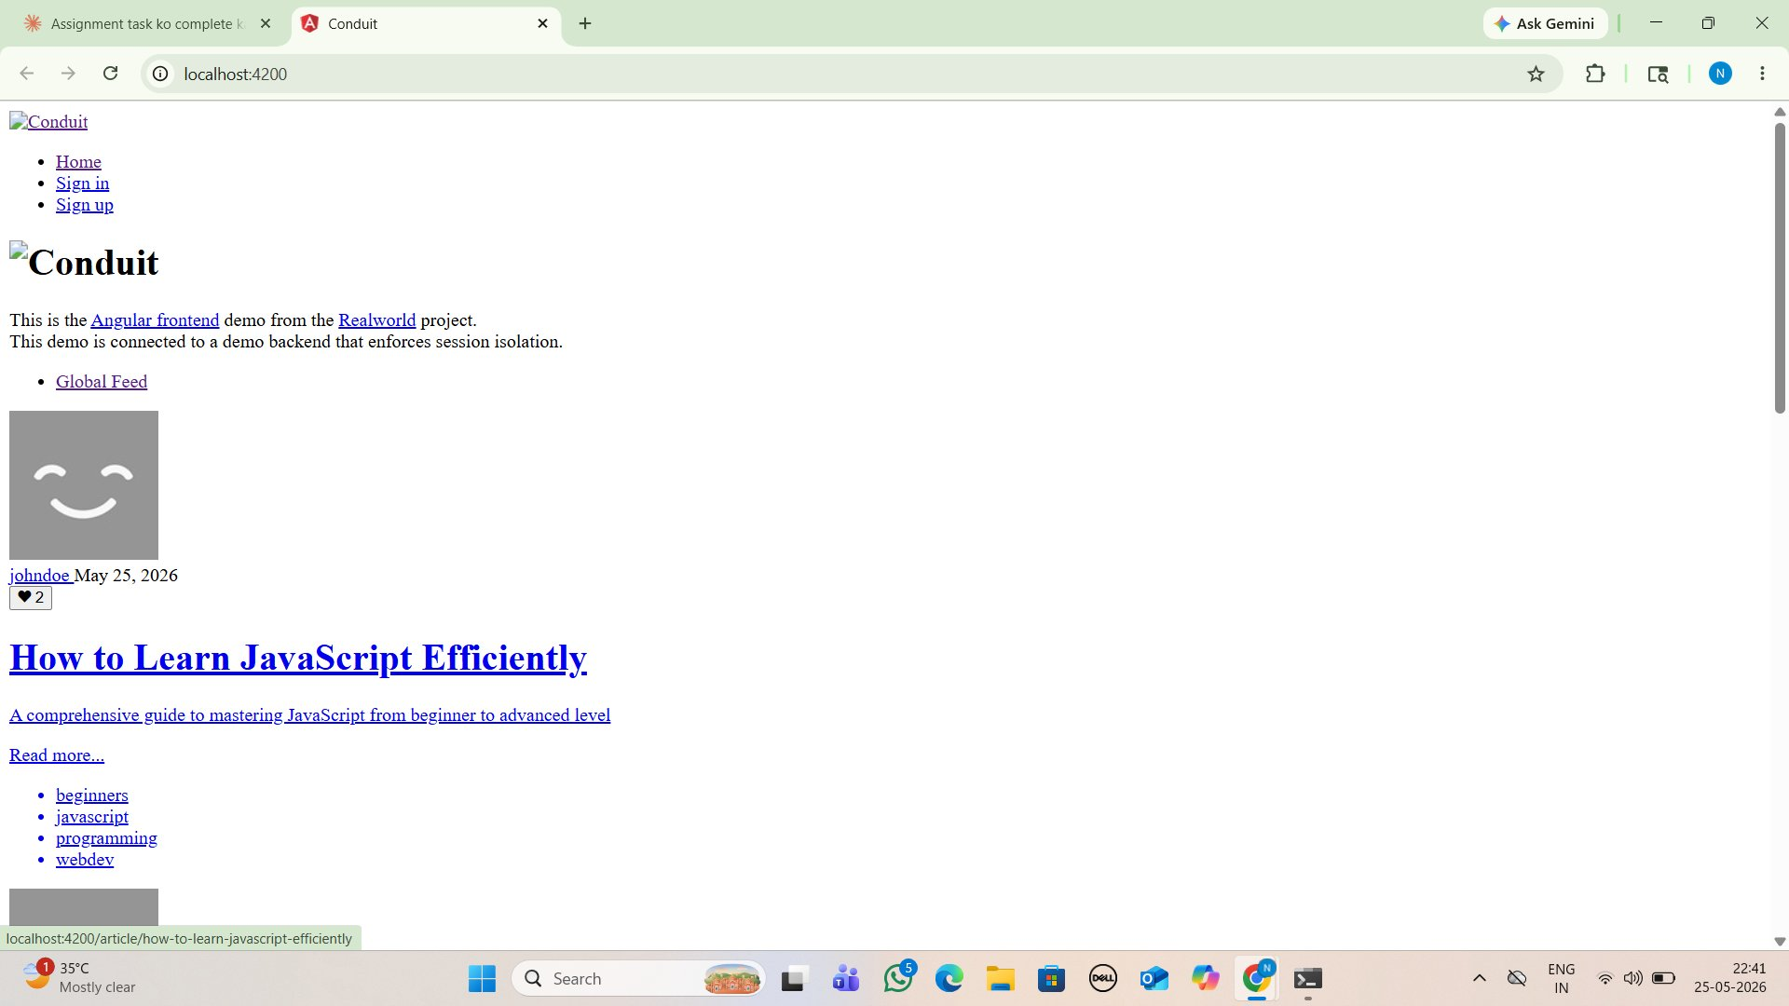
Screenshot — Bug #1

Bug #2 — Logo Image Broken on All Pages
Severity | High
Steps to Reproduce | 1. Open http://localhost:4200  2. Check navbar (top) and footer (bottom)
Expected Result | Conduit logo image should load and display correctly
Actual Result | Broken image placeholder icon shown in both navbar and footer
Suspected Cause | Logo image URL points to an external CDN that is unavailable; no fallback asset defined


Screenshot — Bug #2

Bug #3 — User Profile Avatar Not Loading
Severity | High
Steps to Reproduce | 1. Login with any account  2. Click on username to visit Profile page
Expected Result | User profile picture or a default avatar placeholder should display
Actual Result | Broken image icon shown instead of avatar — throughout the entire app
Suspected Cause | Default avatar URL is an external service that is unreachable; no fallback image is configured

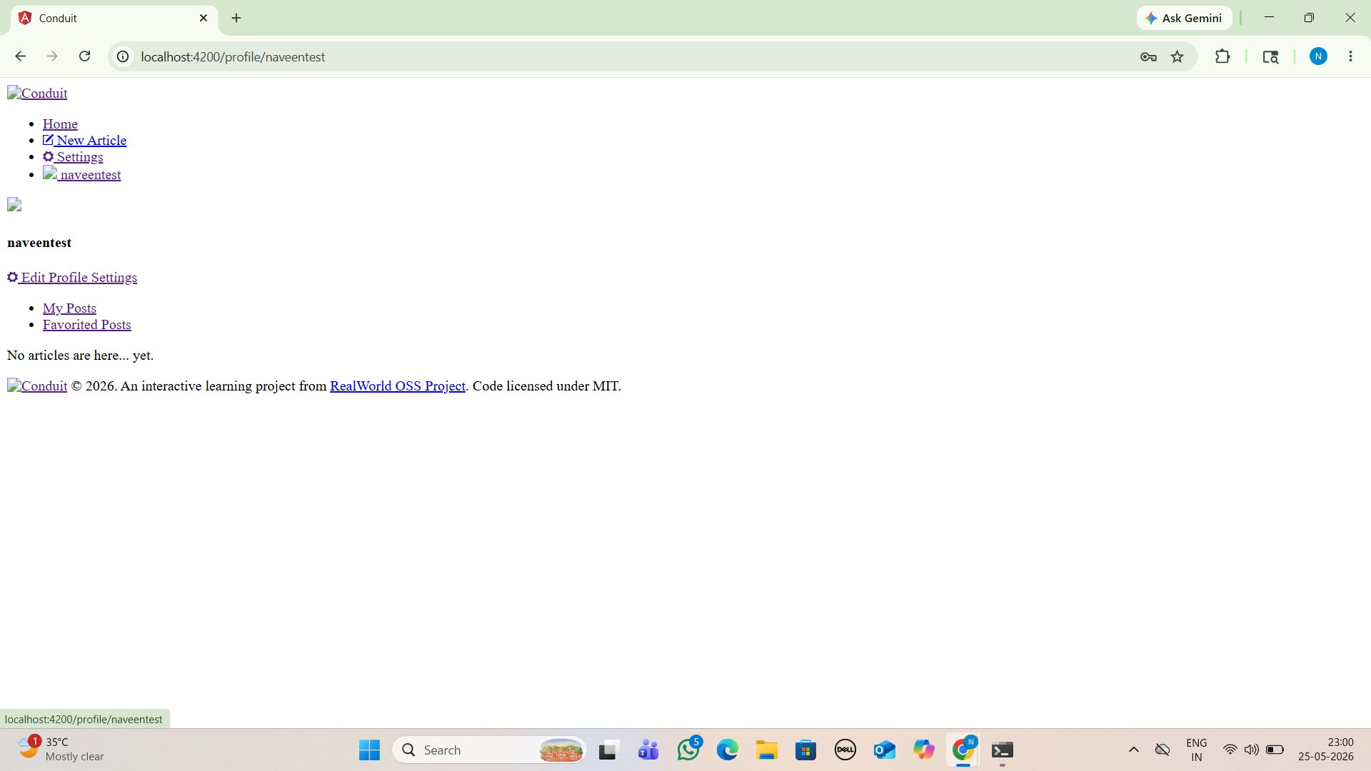
Screenshot — Bug #3

Bug #4 — Weak Password Accepted Without Any Validation
Severity | High
Steps to Reproduce | 1. Go to Sign Up page (/register)  2. Enter username: naveentest, email: naveentest@gmail.com, password: 123  3. Click Sign Up
Expected Result | App should reject weak passwords and show a minimum length or strength requirement
Actual Result | Password '123' (only 3 characters) is accepted — account created successfully with an extremely weak password
Suspected Cause | No client-side or server-side password strength validation implemented in the registration flow

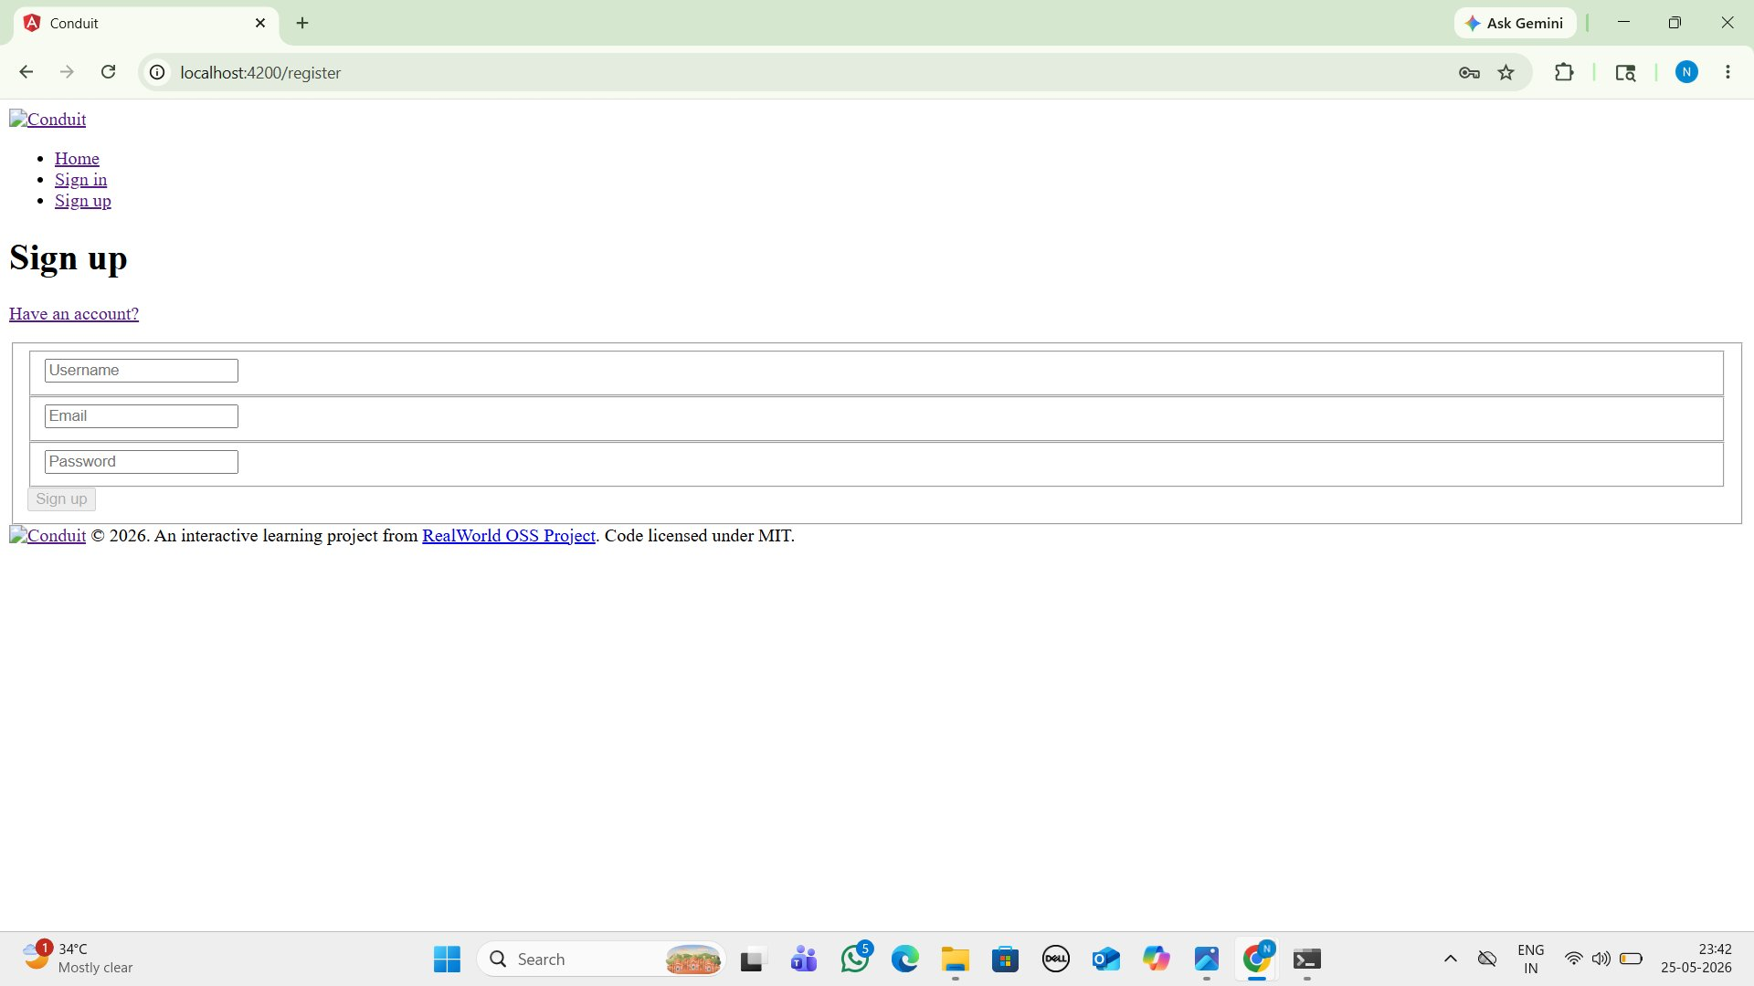
Screenshot — Bug #4

Bug #5 — Article Description Not Displayed on Article Detail Page
Severity | Medium
Steps to Reproduce | 1. Go to New Article (/editor)  2. Fill all fields including description: 'This is a test description'  3. Publish and view the article
Expected Result | Article description/subtitle should appear below the title on the article detail page
Actual Result | Description is completely absent from article view — only title and body are shown
Suspected Cause | Article detail component template does not render the 'description' field from the API response

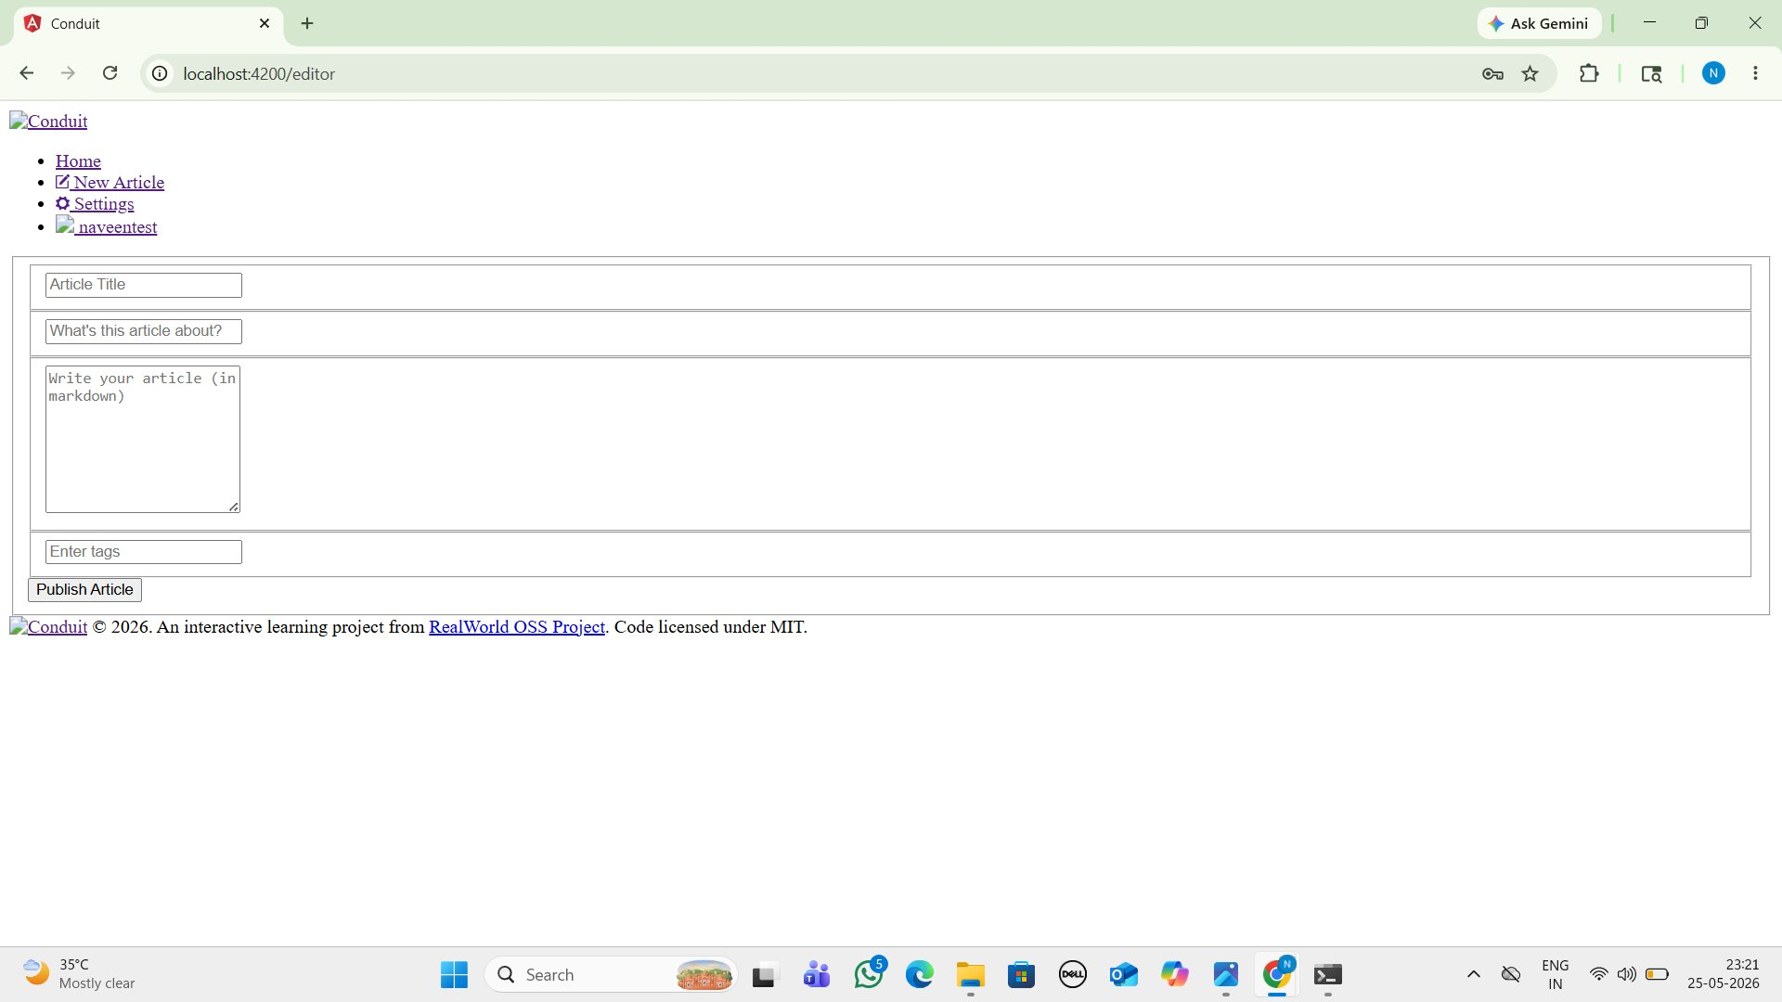
Screenshot — Bug #5

Bug #6 — Validation Error Messages Appear Unstyled
Severity | Medium
Steps to Reproduce | 1. Go to New Article (/editor)  2. Leave all fields empty  3. Click Publish Article
Expected Result | Error messages should appear in red, inside a styled error box, clearly visible to the user
Actual Result | Errors appear as plain bullet-point text with no color, no box, no visual prominence
Suspected Cause | CSS for error/alert components is missing due to the global stylesheet not loading

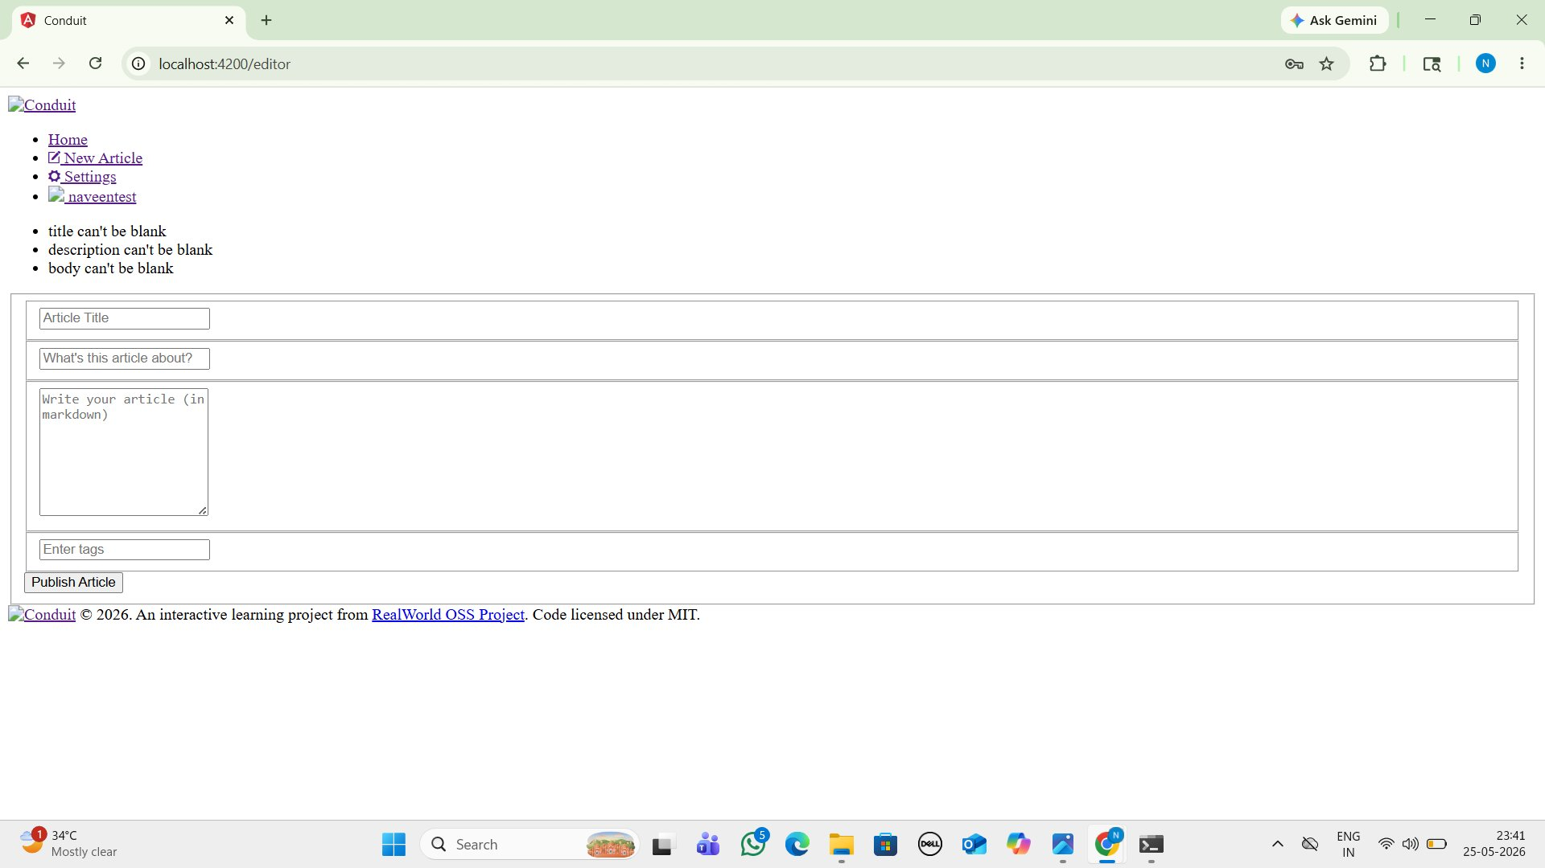
Screenshot — Bug #6

Bug #7 — Comment Section Avatar and Post Comment Button Image Broken
Severity | Low
Steps to Reproduce | 1. Open any article  2. Scroll to comment section  3. Observe the Post Comment button area and posted comments
Expected Result | User avatar should display next to comments and beside the Post Comment button
Actual Result | Broken image icon appears next to Post Comment button and in all comment entries
Suspected Cause | Same root cause as Bug #3 — avatar image URL broken with no fallback image handling

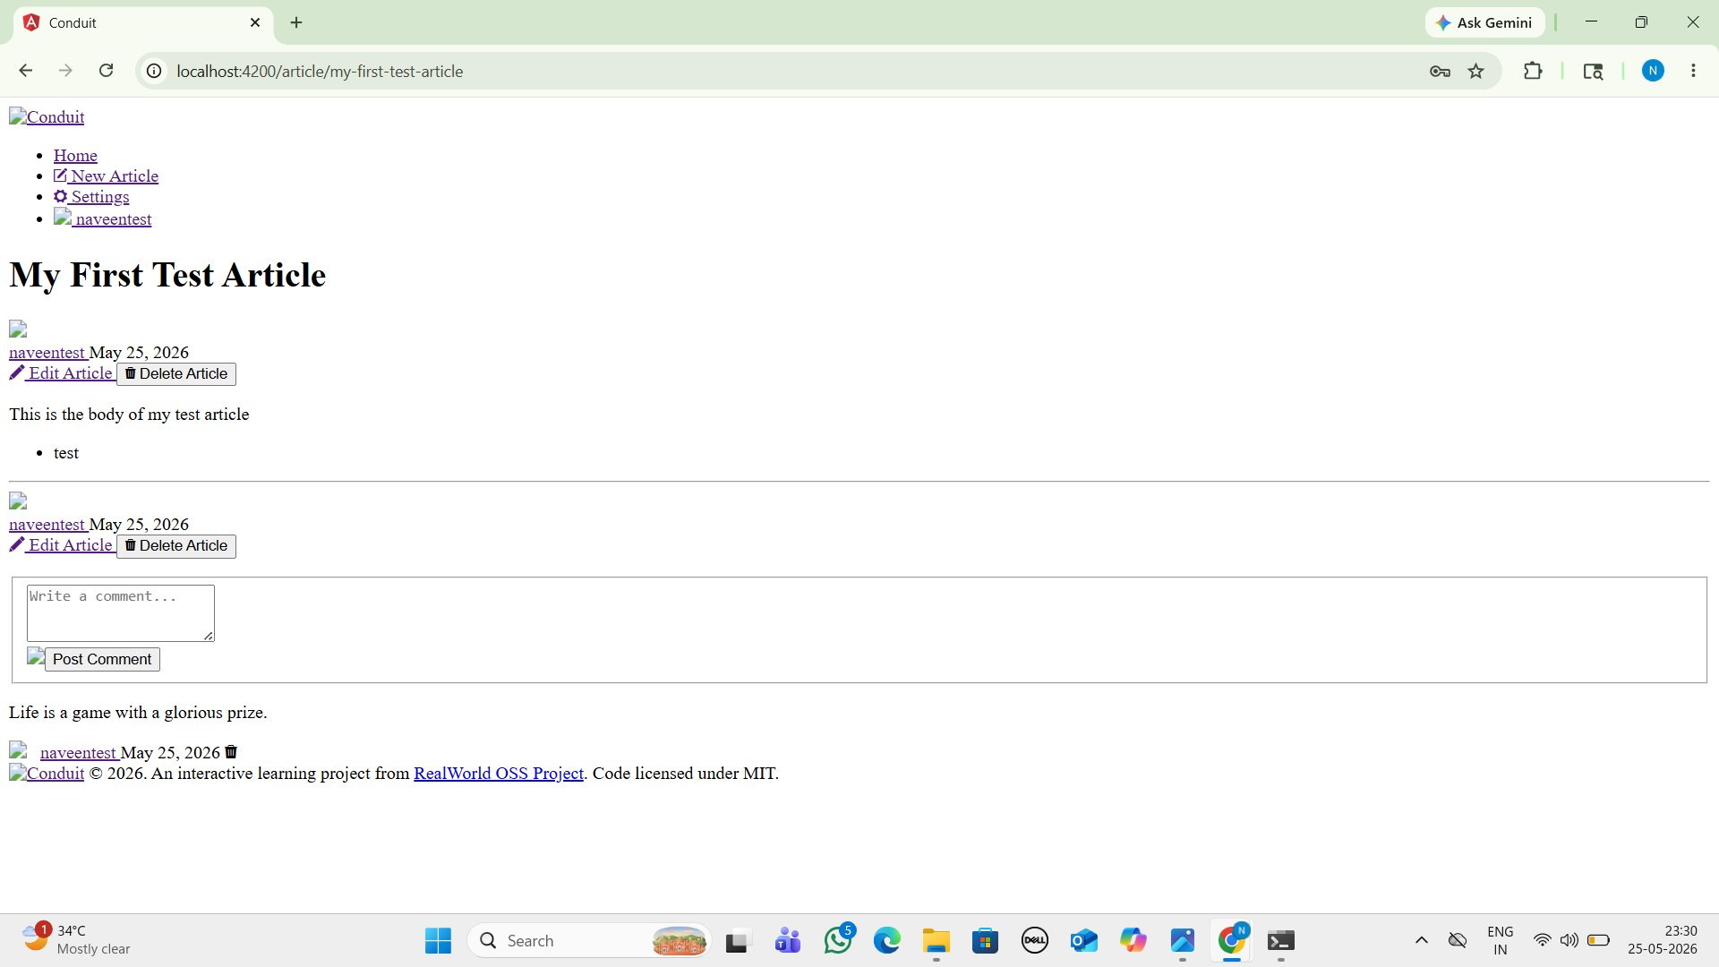
Screenshot — Bug #7

Bug #8 — Logout Button Completely Unstyled on Settings Page
Severity | Low
Steps to Reproduce | 1. Login and navigate to Settings (/settings)  2. Scroll to the bottom of the page
Expected Result | Logout should appear as a clearly styled danger button, visually distinct and easy to identify
Actual Result | Logout appears as a plain browser-default button — 'Or click here to logout' — easy to overlook
Suspected Cause | CSS for logout button is missing due to global stylesheet failure; no inline fallback styles defined

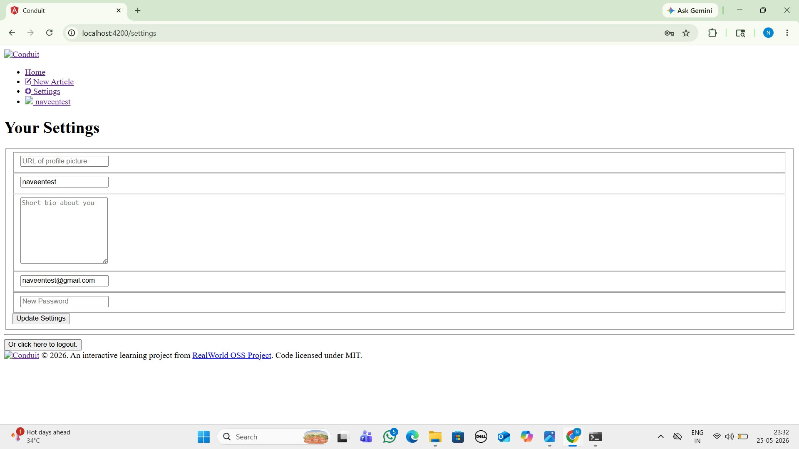
Screenshot — Bug #8

3. Root Cause Analysis — Bug #1: Missing CSS Stylesheet
Bug #1 is selected for detailed root cause analysis because it is the most critical issue and the root cause of multiple downstream visual bugs in the application.

What Is Happening
The entire Conduit application renders without any CSS styling — no colors, no layout, no typography, and no visual component design. All pages appear as plain black text on a white background. Despite this, all backend functionality (login, article creation, commenting) continues to work correctly because the issue is purely in the presentation layer.

Why It Happened
When the Angular build process runs, it reads the 'styles' array in angular.json and bundles all listed stylesheets. The original angular.json file referenced the path 'realworld/assets/theme/styles.css' — which points to an npm package called 'realworld' that does not exist in the project's node_modules. This package was either deprecated, never published to npm, or removed from the registry. As a result, when the project is freshly cloned, the CSS theme dependency is completely absent and the Angular compiler cannot resolve the stylesheet path, producing zero CSS output.

Root Cause (Technical)
File: angular.json — 'styles' array contained: "realworld/assets/theme/styles.css". This path resolves to node_modules/realworld/assets/theme/styles.css which does not exist. The Angular CLI's esbuild bundler throws a 'Could not resolve' error and skips the stylesheet, resulting in an unstyled application.

How to Fix It
Option 1 — Quick Fix: Update angular.json to reference a local stylesheet (src/styles.css) and import the RealWorld CSS theme from the official CDN: https://demo.productionready.io/main.css
Option 2 — Proper Fix: Install or recreate the required CSS theme package. Alternatively, replace it with a standard CSS framework such as Bootstrap or Tailwind CSS and re-implement the visual design system. The project README should clearly document this dependency to prevent recurrence.

Impact Assessment
This single bug is the direct root cause of at least 4 other reported issues (Bugs #2, #6, #7, #8) whose visual problems stem entirely from missing CSS. Fixing Bug #1 would resolve or significantly reduce the visual impact of these secondary issues. It also severely impacts first impressions for any user or evaluator of the application.


Screenshot — Bug #1 & #6: Missing CSS causes unstyled error messages in Article Editor

End of Report | Naveen Mishra | QA Assessment | May 2026

