API’s :

This which gives the overview of all the collections in postman.

It won’t run the scripts. It just looks like the overview of collections.

Creation:

Click on below “+” symbol.

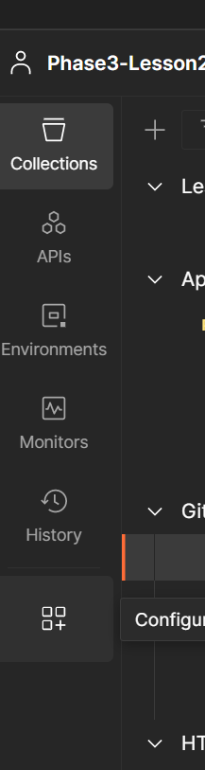

We can have multiple collections at a time to have a clear idea about that collections in one place.

