**Monitors:**

This is used to run the Requests at certain time by giving in monitors collections.

We can also run the requests default , but keeping these monitors makes the monitoring of requests running at exact time.

This Runs all Requests of Each Collection at a time.

I taken GitHub-API Collection and Runs All requests of these Collection at a time once.

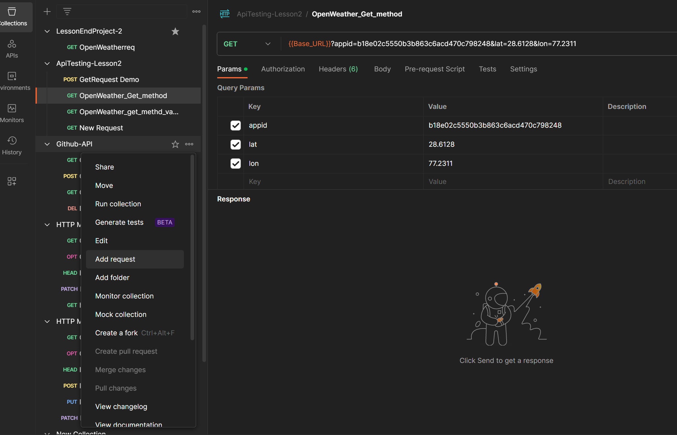

Time given 4:00pm everyday

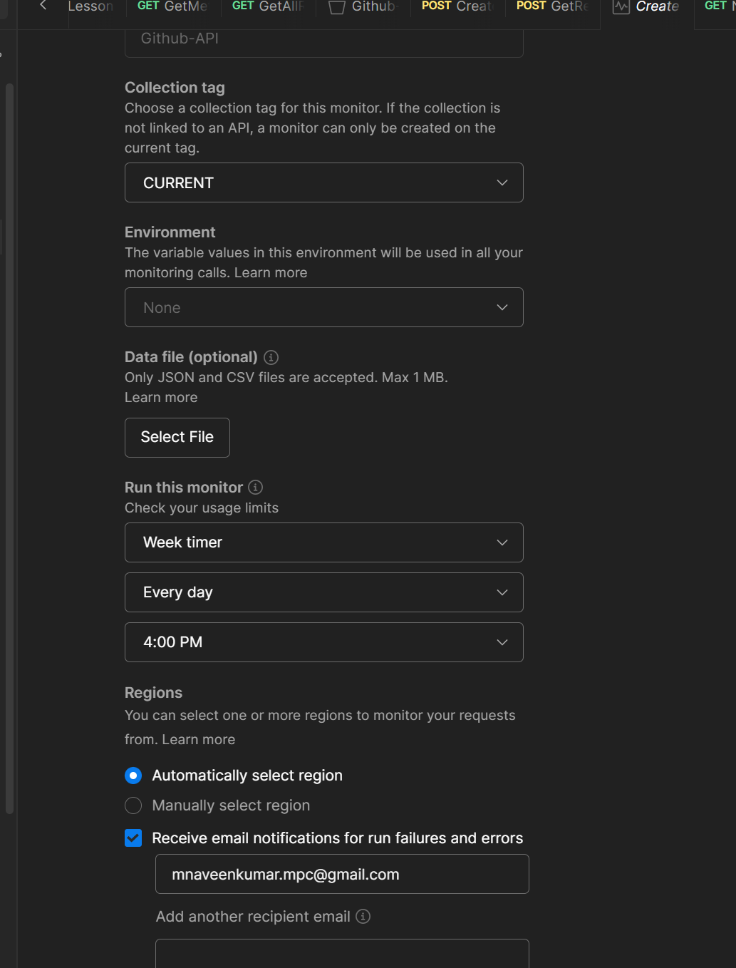

All requests of each Collection Runs at a time and Gives whether it is healthy execution or UnHealthy Execution.

