**SourceCode:**

Created a Get method for openweather page and given parameters are appid and q with certain values.

<https://github.com/naveenmpc/Postman-LessonEndProject/upload>

<https://github.com/naveenmpc/JavaCodes1/tree/master/src>

Here Given the City London with scope environment.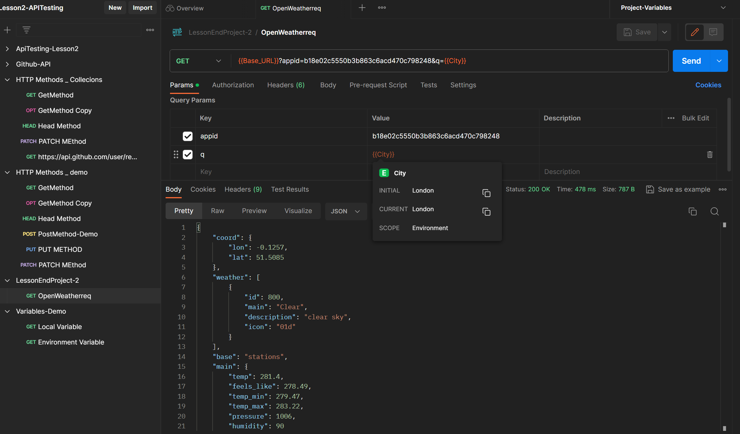

Base Url is initialised and scope is environment . output is given in JSON format.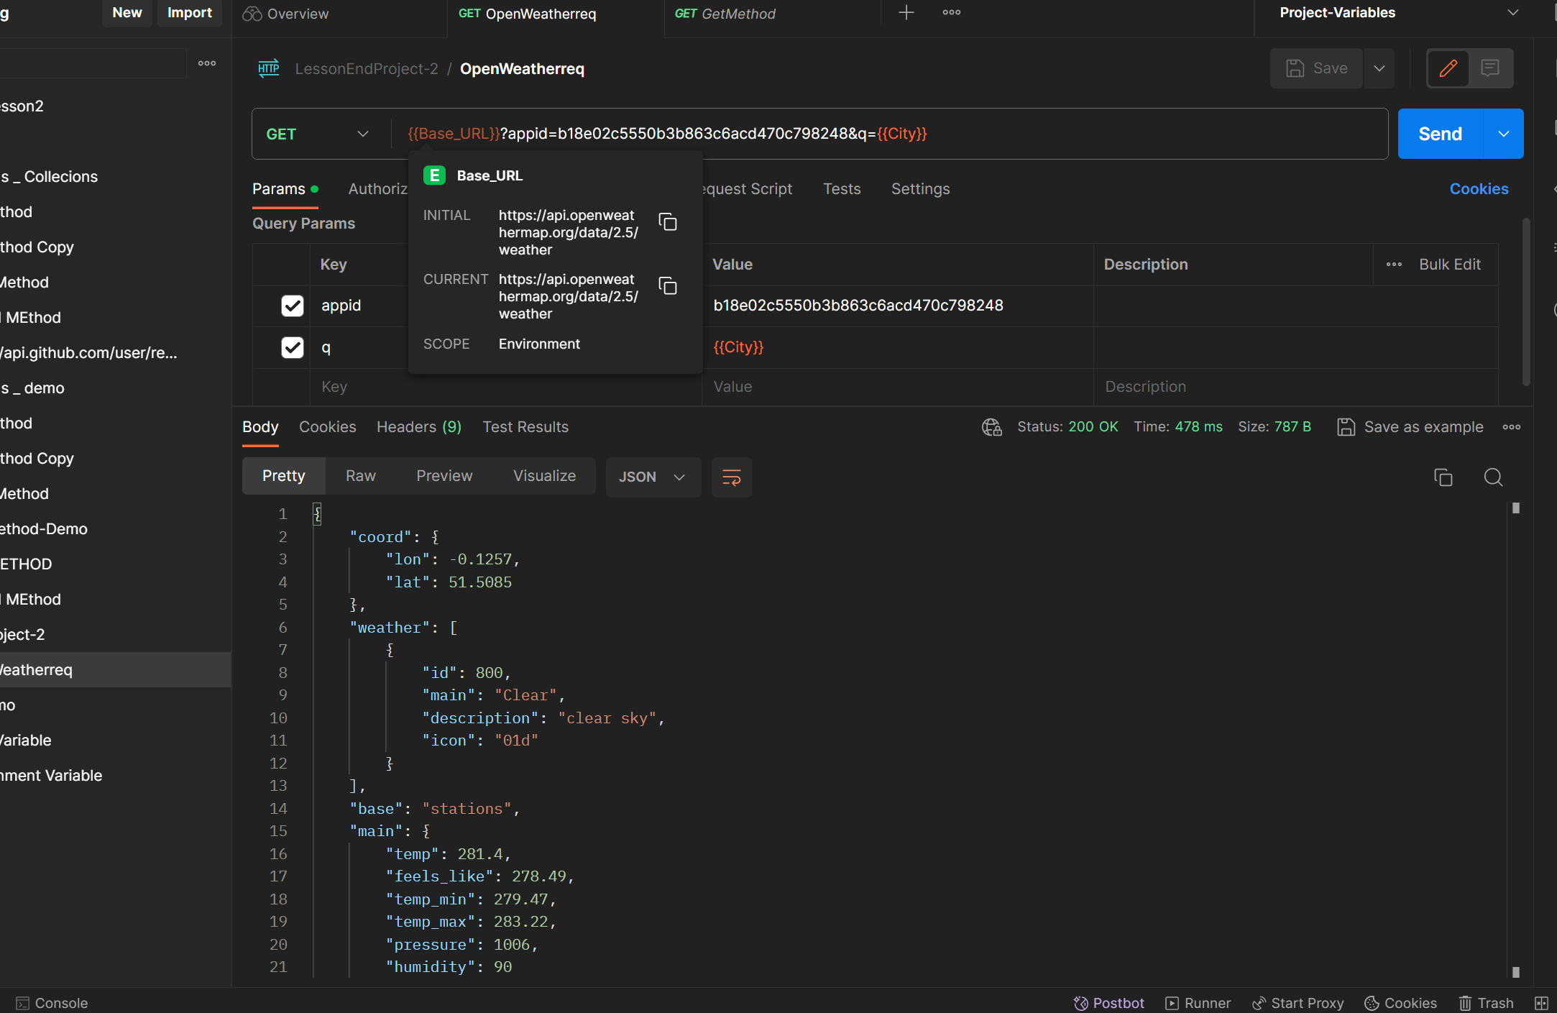

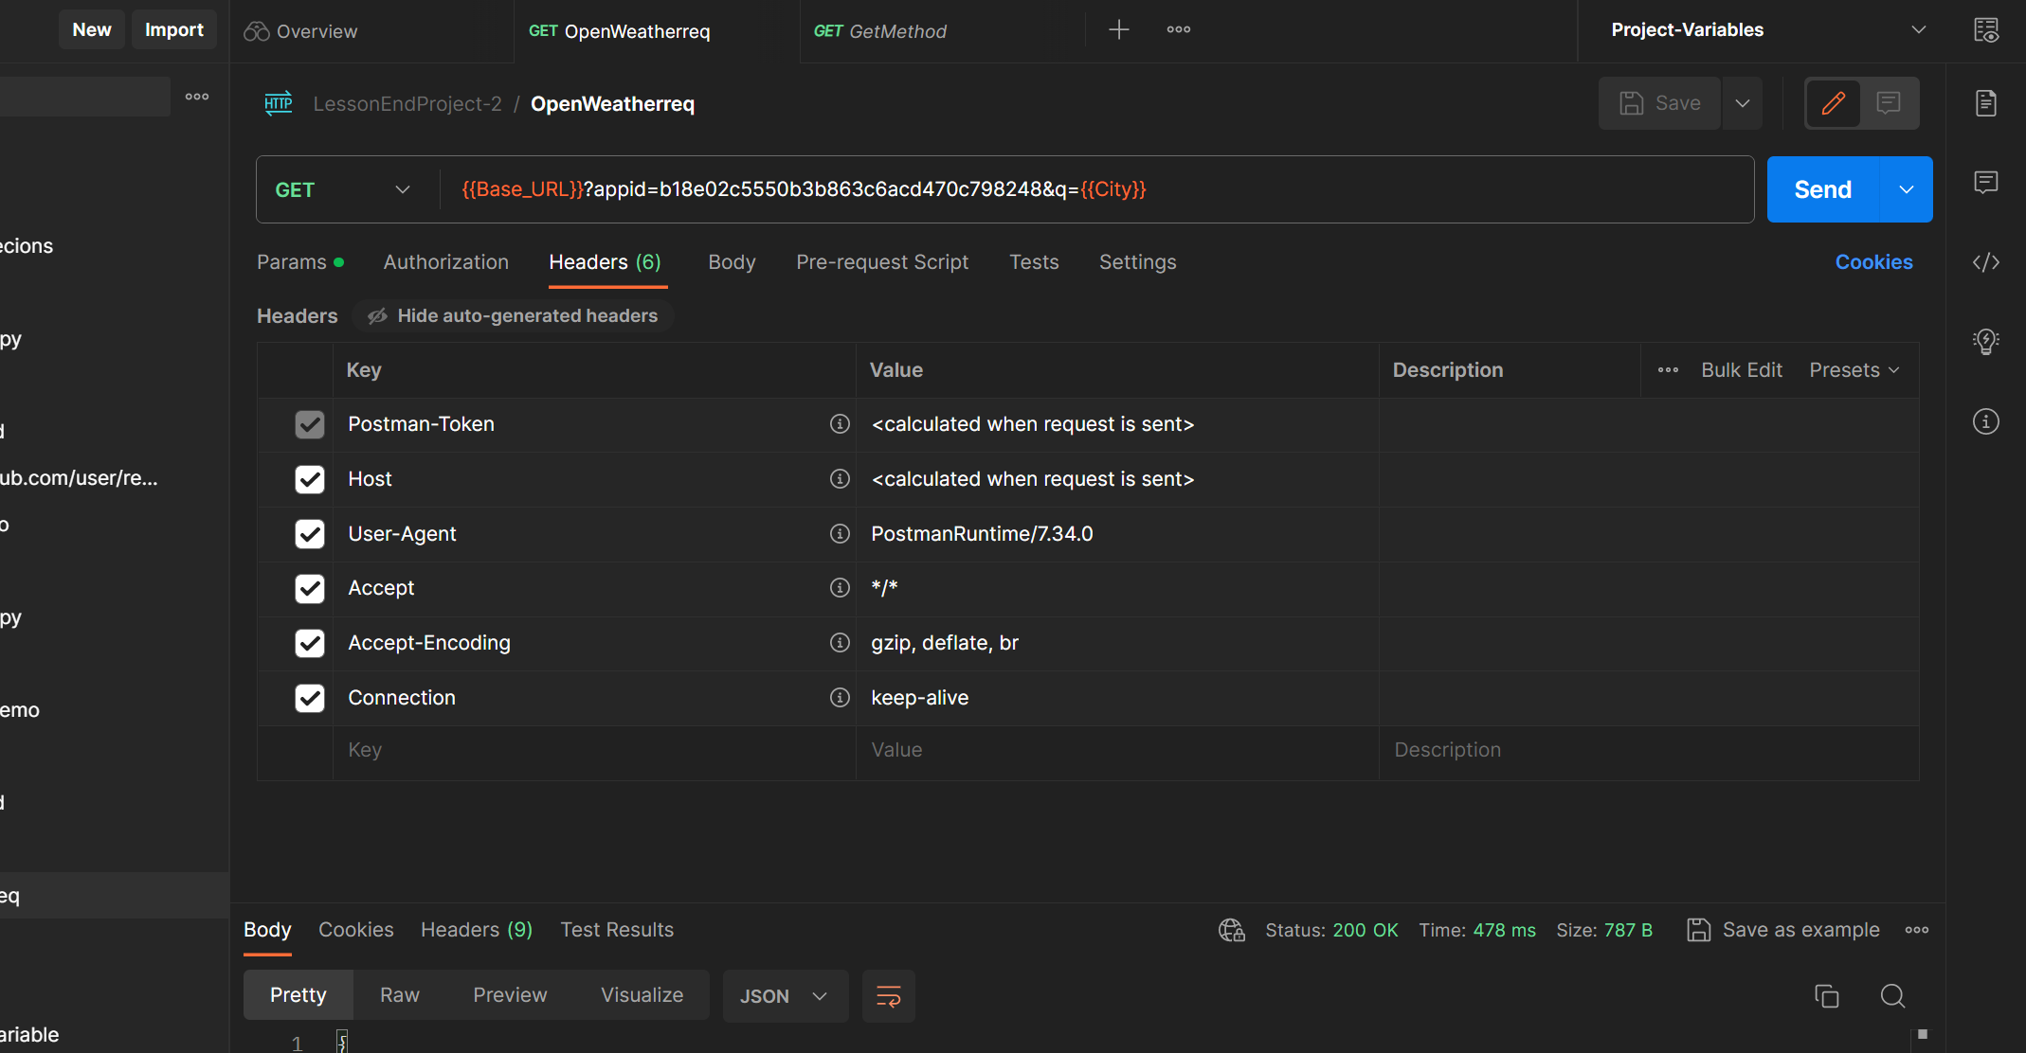

API’s which shows the no.of Collections in one place in detailed way. It doesn’t run the script . Its looks like Overall view of the things done in Postman Scripts.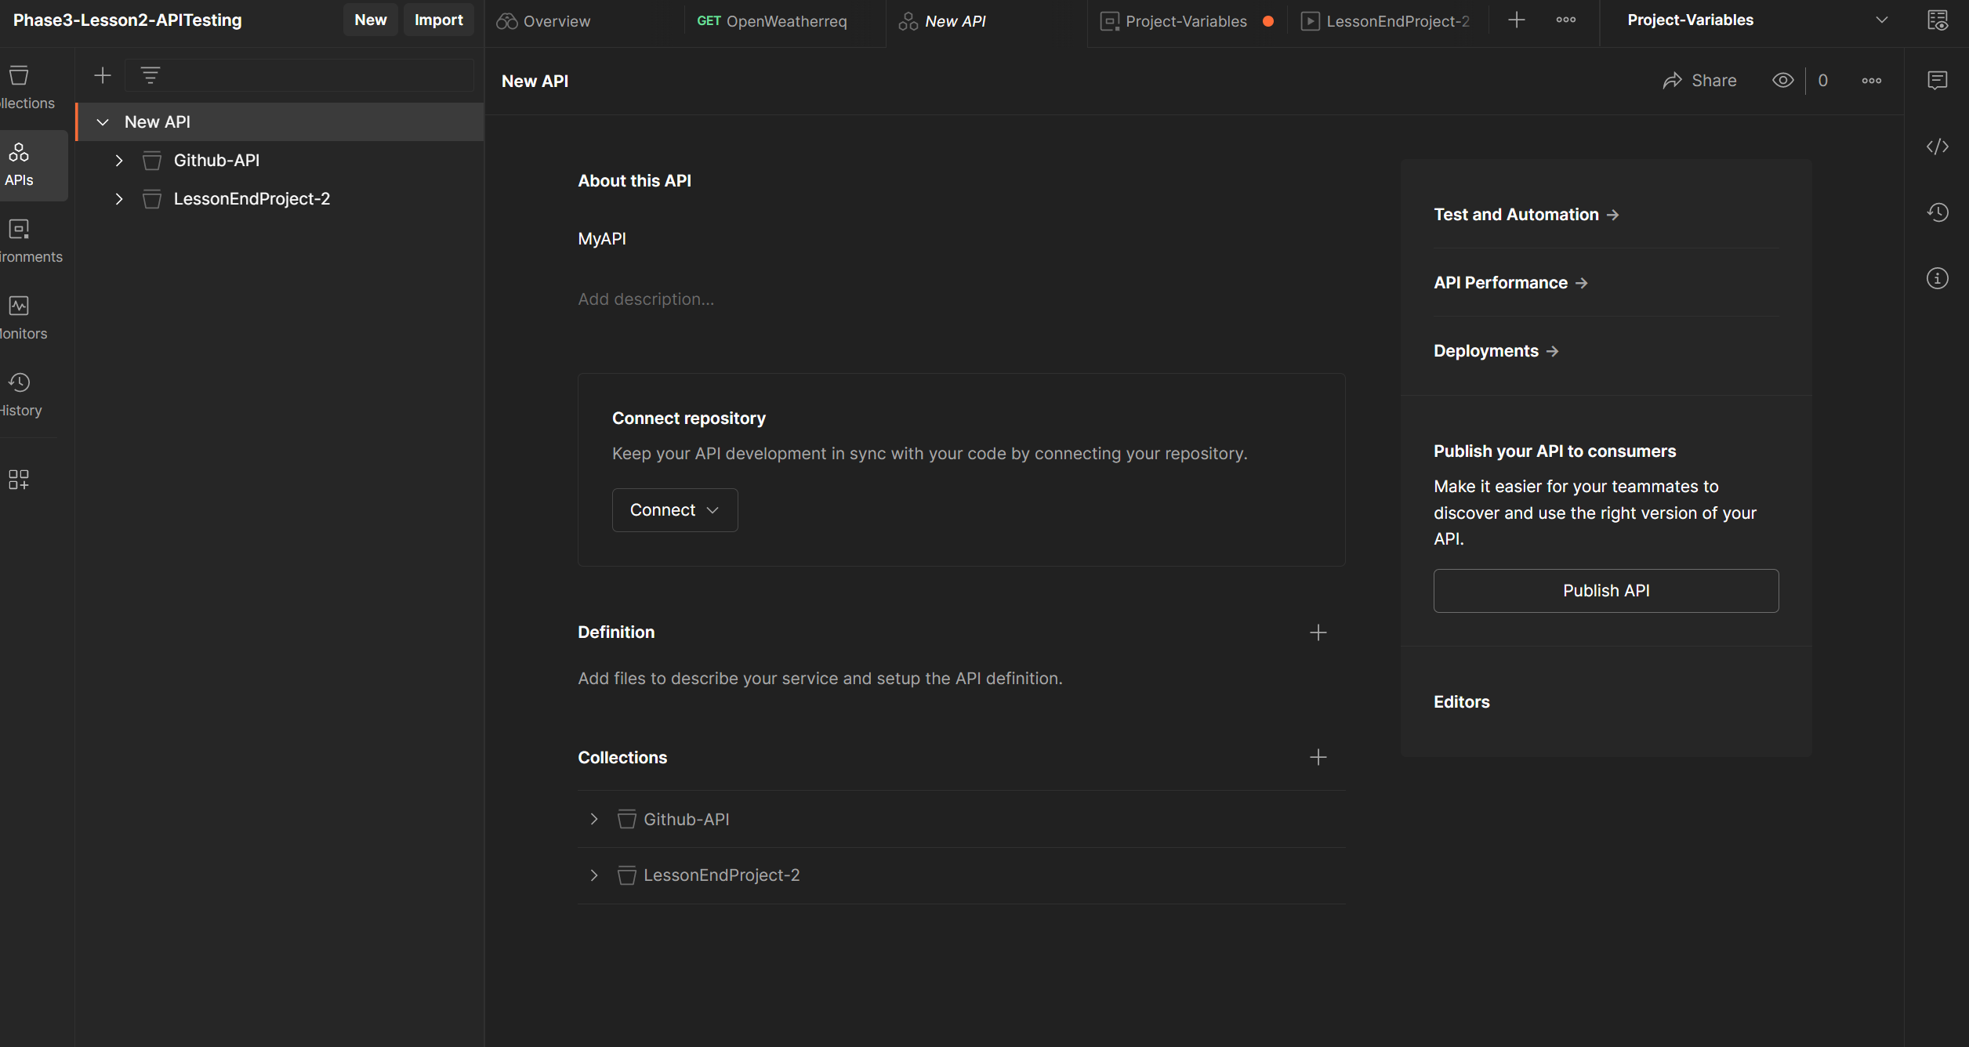

Below are the Variables of LessonEnd Project ..Base_Url and City which was initilised and persisted to the collections of lesson end project.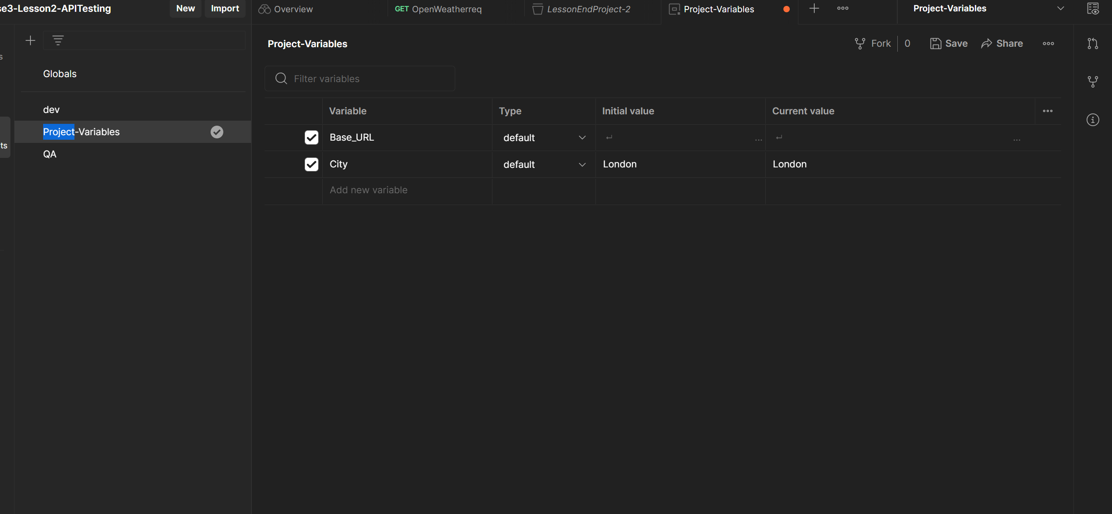

Below Image finds the Run Collection results of 5 Variables , That which are setted up via a excel format as .Csv extension….by running of 5 variables via excel . below is the output of 5 variables from excel.

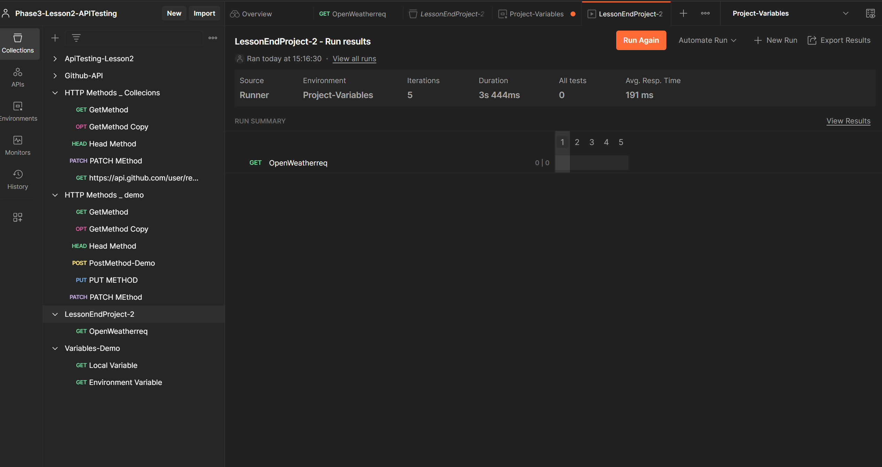

As we know that Monitor Collection that which says whether the tests are executed or not via Healthy or UnHealthy.

As Lessonend project has been Runned via Monitor Collection..That says These script is executed healthy with out errrors.