Data Types in Java

Data types specify the different sizes and values that can be stored in the variable. There are two types of data types in Java:

1. **Primitive data types:** The primitive data types include boolean, char, byte, short, int, long, float and double.
2. **Non-primitive data types:** The non-primitive data types include Classes, Interfaces, and Arrays.
3. 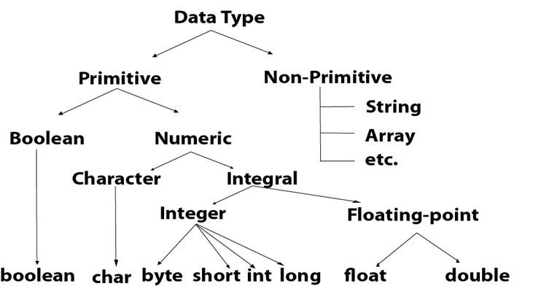

## Java Primitive Data Types

In Java language, primitive data types are the building blocks of data manipulation. These are the most basic data types available in Java language.

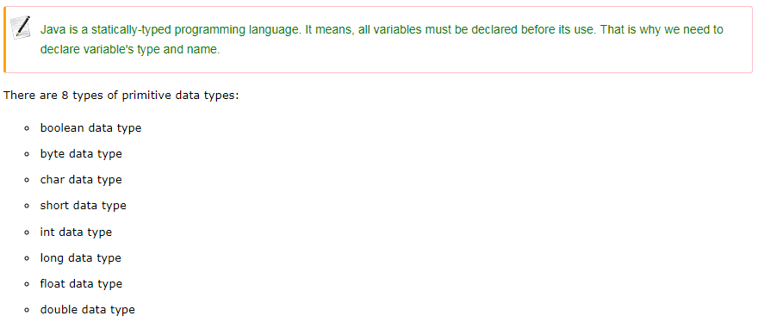

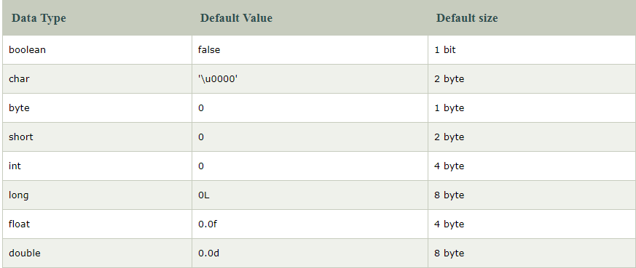

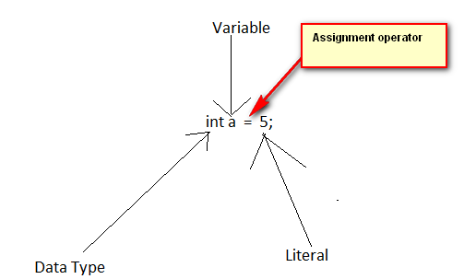

|  |  |  |
| --- | --- | --- |
| Table 1: List of Java's primitive data types | | |
| **Type** | **Size in Bytes** | **Range** |
| byte | 1 byte | -128 to 127 |
| short | 2 bytes | -32,768 to 32,767 |
| int | 4 bytes | -2,147,483,648 to 2,147,483, 647 |
| long | 8 bytes | -9,223,372,036,854,775,808 to  9,223,372,036,854,775,807 |
| float | 4 bytes | approximately ±3.40282347E+38F  (6-7 significant decimal digits)  *Java implements IEEE 754 standard* |
| double | 8 bytes | approximately ±1.79769313486231570E+308 (15 significant decimal digits) |
| char | 2 byte | 0 to 65,536 (unsigned) |
| boolean | 1 bit | true or false |