**INTRODUCTION TO JAVA:-**

**What is JAVA?**

* **it was first released by sun micro system in 1995 & later acquired by Oracle Corporation.**
* **current version of java is java 9(1.9).**
* **Java is High level platform independent programming languages, used to develope windows based applications.**
* **It works on principle of Object Orientation.**
* **A java platform includes on execution engine, a compiler & set of libraries.**

**Creating JAVA Programmes in ECLIPSE:-**

**Whenever we want to create java programme in eclipse, then first we need to create Package(i.e.,optional) & Class under the "src" folder in java project.**

**Hierarchy in Eclipse:-{"Project/package explorer" structure}**

**WorkSpace**

**--> Java Project(s).**

**-->Package(s).**

**-->class(s).**

**-->Methods.**

**PACKAGE:- It is a name space which organise set of related classes.**

**NAVIGATION:-{to create packages}**

**--> select "src" folder under java project in "eclipse".**

**--> right click on mouse.**

**-->goto "NEW".**

**-->select "PACKAGE".**

**-->enter "PackageName".**

**` -->Click on "OK".**

**NOTE:- "PACKAGE NAME" should be in "lowercase".**

**ex:- sample.test, selenium.testcases, org.insightq.**

**CLASS:- class is the actual written place for java programme which is used to define the behaviour of any given class.**

* **class is a combination of VARIABLES & METHODS.**

**NAVIGATION:-{to create class with main method only}**

**-->select "package name" under "src" folder in the java project.**

**-->right click on mouse.**

**--> goto NEW.**

**--> select Class.**

**--> enter class name.**

**--> set "ON" for main method checkbox.**

**-->Click on "OK".**

**NOTE:- class name should be "camelcase".**

**ex:- GoogleSearch, GmailLogin.**

**NOTE:-Method names & Variable names should starts with lowercase then followed with uppercase.**

**ex:- seleniumTest, sampleTestClass, userName.**

**=======================================================================================**

**Class with main method only:-**

**Sysntax:**

**package packageName;**

**public class ClassName**

**{**

**//declaration**

**public static void main(String[] args)**

**{**

**------------**

**------------- //statements**

**}**

**}**

* **whichever statements we write in main method those will be executed first.**

**NOTE:- to increase font size in eclipse: Shift + ctrl + [+].**

**common programme guidelines:-**

**>>> Identifier is a name of the method/class/variables.**

* **java identifier must start with a letter/currency charecter($)/ connecting charecter such as underscore(_).**
* **after first charecter identifiers can contain any combinations of letters, currency chcarecters,connecting charecters and numbers.**

**>>> Identifiers can't start with anumber & can't contain space.**

**Ex:- >> int variable1=10; // This is valid.**

**>> int 4var=10; // This is invalid, identifiers can't start with digit.**

**>>> Identifiers are case-sensitive.**

**Ex:- studentName & StudentName are 2 identifiers.**

**Comments in java:-**

**As per scripting standards we should provide proper comments in java programme to comment single line, prefix that statement with "//"(ctrl+/).**

**Ex:- //to validate login functionality**

**-->to uncomment a line (ctrl+/)**

**-->to comment block of statements we can use: {ctrl+shift+/}.**

**Ex:- /*--------- Ex:-/* to validate**

**---------- login**

**----------*/ functionality*/**

**Shortcut:- *ctrl+shift+/==>for comment block of statements.**

**\*ctrl+shift+\==>for uncomment block of statements.**

*Output functions:-* **to display user messages during runtime we can use following output functions.**

Printing in single: System.out.print("GfG1");

Printing line by line: System.out.println("GfG1");

*Variables in Java*

A variable is a name given to a memory location. It is used to store any kind of value.

Note: we can give any name to a Variable

*Datatypes in Java*

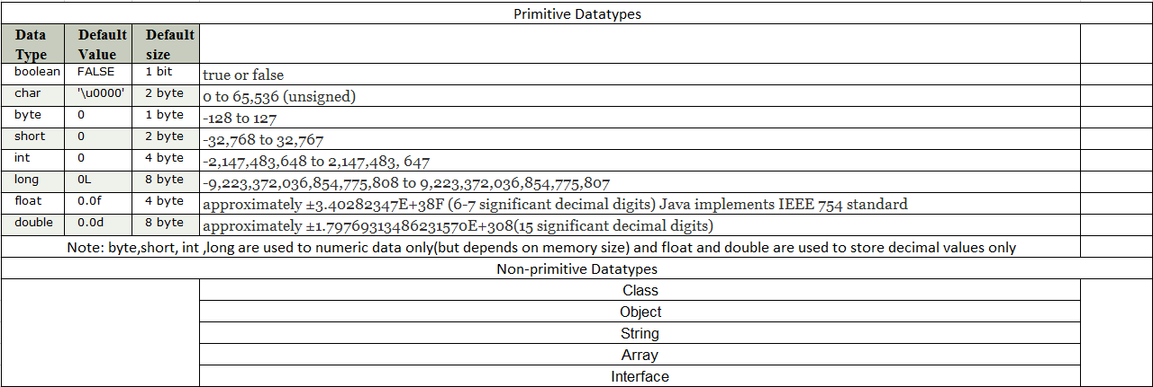

*Assigning values to variables in Java:*

Syntax: datatype variablename=value

(See the below programe)

public class fdfdfd {

public static void main(String[] args) {

// declaring character

char a = 'G';

// Integer data type is generally

// used for numeric values

int i=89;

// use byte and short if memory is a constraint

byte b = 4;

// this will give error as number is

// larger than byte range

// byte b1 = 7888888955;

short s = 56;

// this will give error as number is

// larger than short range

// short s1 = 87878787878;

// by default fraction value is double in java

double d = 4.355453532;

// for float use 'f' as suffix

float f = 4.7333434f;

String course="Selenium";

System.out.println("char: " + a);

System.out.println("integer: " + i);

System.out.println("byte: " + b);

System.out.println("short: " + s);

System.out.println("float: " + f);

System.out.println("double: " + d);

System.out.println("String: " + course);

}

}

*Operators in Java:*

*Java Arithmetic Operators(+,-,*,/,%)*

*[will give any value as a result]*

class OperatorExample{

public static void main(String args[]){

int a=10;

int b=5;

System.out.println(a+b);//15

System.out.println(a-b);//5

System.out.println(a*b);//50

System.out.println(a/b);//2 System.out.println(a%b);//0

}}

Note:🡪/ will give quotient

🡪% will give remainder

*Java Realational Operators(==,!=,>,<,>=,<=)*

*[will give true/false as a result]*

public class fdfdfd {

public static void main(String[] args) {

int a = 10;

int b = 20;

System.out.println("a == b = " + (a == b) );

System.out.println("a != b = " + (a != b) );

System.out.println("a > b = " + (a > b) );

System.out.println("a < b = " + (a < b) );

System.out.println("b >= a = " + (b >= a) );

System.out.println("b <= a = " + (b <= a) );}}

*Java Logical Operators(&&,||)*

*[will give true/false as a result]*

public class fdfdfd {

public static void main(String[] args) {

boolean a = true;

boolean b = false;

System.out.println("a && b = " + (a&&b));

System.out.println("a || b = " + (a||b) );

System.out.println("!(a && b) = " + !(a && b));

}}

Note:&&-AND operator check for both the values/variables are true

||-OR operator check for both the values/variables are true

*Java Assignment Operators()*

public class fdfdfd {

public static void main(String[] args) {

int a = 10;

int b = 20;

int c = 0;

c = a + b;

System.out.println("c = a + b = " + c );//c = a + b = 30

c += a ;//c=c-a

System.out.println("c += a = " + c );//c += a = 40

c -= a ;//c=c-a

System.out.println("c -= a = " + c );//c -= a = 30

c *= a ;//c=c*a

System.out.println("c *= a = " + c );//c *= a = 300

a = 10;

c = 15;

c /= a ;//c=c/a

System.out.println("c /= a = " + c );//c /= a = 1

a = 10;

c = 15;

c %= a ;//c=c%a

System.out.println("c %= a = " + c );//c %= a = 5 }}

*Conditional statements in Java:*

*Java If Statement*

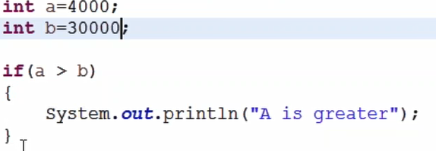

Note: if statement will execute the block of statements when condition is true

deels

de

*Java If else Statement*

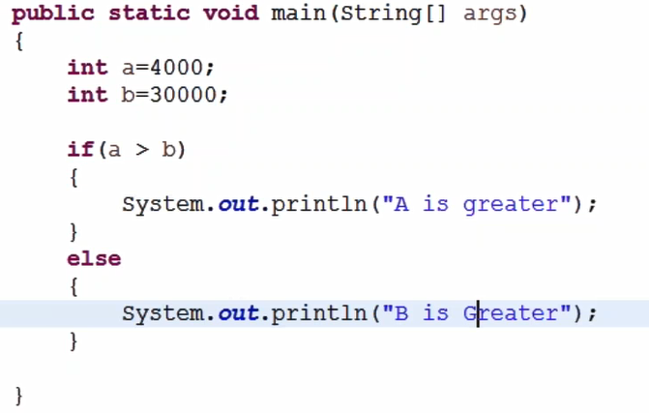

Note: else statement will execute the block of statements when condition is false

*Java If else-if Statement*

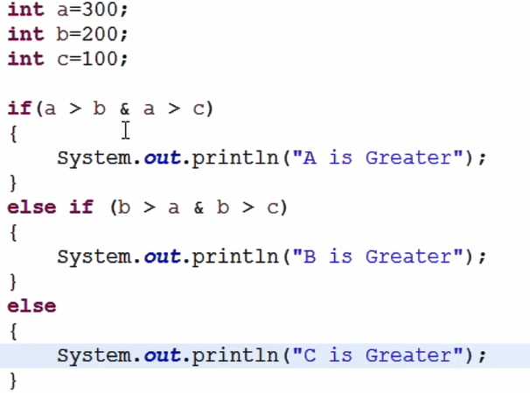

Note: else-if statement will execute the block of statement when the condition is true and upper if condition is false

*Java nested if Statement(if in if)*

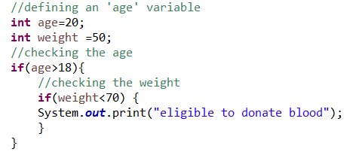

*SwitchCase*

//Switch with string

String course="Automation";

switch(course){

case "Automation":

System.out.println("Your course is Automation");

break;

case "Manual":

System.out.println("Your course is Manual");

break;

}

//Switch with number

int number=0;

switch(number){

case 1:

System.out.println("Your course is Automation");

break;

case 2:

System.out.println("Your course is Manual");

break;

default:

System.out.println("not valid course");}

Note: Switch case will execute the block of statements only if the matched case is found, if not finding match case it executes default case(if there)

Break statement is necessary for every case(if break is not there it executes all the cases)

Default case is optional

*ForLoop(when we know the number of iterations)*

Note: when ever we want to execute the same set of code for number of times

We need to use loops

for(int i=0;i<10;i++) {

System.out.println("Hi");

}

For loop termintation with break;

for(int i=0;i<10;i++) {

System.out.println("Hi");

if(i==5) {

break;

}

}

Note: i++ is the increment operator, i=i+1

i—is the decrement operator=i=i-1;

Example: prininting 1 to 10 in forward order and reverse order

for(int i=1;i<=10;i++) {

System.out.println(i);

}

for(int i=10;i>=1;i--) {

System.out.println(i);

}

*whileLoop(when we don’t know the number of iterations)*

int i=1; //intialising the loop variable

while(i<=10) {

System.out.println(i);

i++;//without incrementing the loop will go infinite iterations

}

*dowhileLoop(when we don’t know the number of iterations)*

int i=1; //intialising the loop variable

do {

System.out.println(i);

i++;

} while (i<=10);

Note: do while loop will execute the statements atleast once without checking the condition, this is the difference between while and do while loop