Scope and life time of variables:

As we know there are three types of variables: 1) instance variables, 2) class variables and 3) local variables, we will look at the scope and lifetime of each of them now.

Instance Variables

A variable which is declared inside a class and outside all the methods and blocks is an instance variable.

General scope of an instance variable is throughout the class except in static methods. Lifetime of an instance variable is until the object stays in memory.

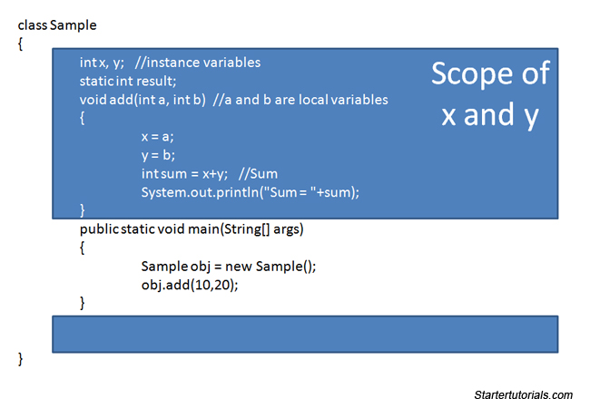

Class Variables

A variable which is declared inside a class, outside all the blocks and is marked *static* is known as a class variable.

General **scope of a class variable** is throughout the class and the **lifetime of a class variable** is until the end of the program or as long as the class is loaded in memory.

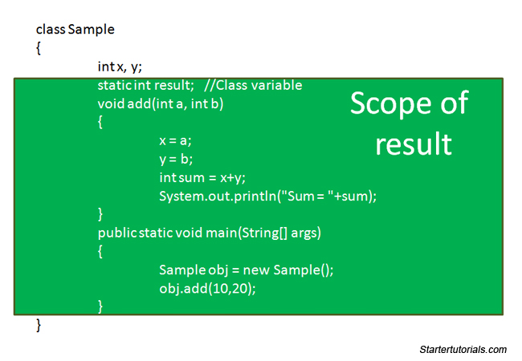

Local Variables

All other variables which are not instance and class variables are treated as local variables including the parameters in a method. Scope of a local variable is within the block in which it is declared and the lifetime of a local variable is until the control leaves the block in which it is declared.

