DATA ANALYTICS AND VISUALIZATION

Web Application User Behavior Analysis Using Excel, SQL, and Power BI

-Naveen M
ABSTRACT

- This project focuses on analyzing user behavior data collected from a web application to derive meaningful insights and support data-driven decision making. The dataset contains information about user interactions such as pages visited, device types, session duration, clicks, scroll percentage, bounce rate, and conversion status. Initially, the raw dataset was imported into Microsoft Excel for preprocessing and data cleaning.
- Various techniques such as removing duplicates, formatting, and filtering were applied to ensure data consistency and accuracy. After cleaning, the dataset was transferred to a MySQL database using phpMyAdmin for further analysis. SQL queries were used to extract useful information, including aggregate functions, logical conditions, comparison operators, and subqueries. These queries helped in identifying patterns such as user engagement levels, high-performing pages, and conversion trends. The processed data was then visualized using Power BI to create interactive dashboards and charts. Visualization techniques such as bar charts, pie charts, and scatter plots were used to represent the data in a clear and understandable manner.
- The dashboard provides insights into user behavior, device usage, and overall performance of the web application. This project demonstrates the importance of data cleaning, analysis, and visualization in transforming raw data into valuable insights. The results obtained can help improve user experience and optimize business strategies. Overall, this project highlights the effective use of Excel, SQL, and Power BI in data analytics.

INTRODUCTION

- In the modern digital era, web applications generate a large amount of user data through daily interactions. Understanding this data is essential for improving user experience, increasing engagement, and enhancing overall application performance. This project focuses on analyzing user behavior data to identify patterns and trends in how users interact with a web application. The dataset includes various attributes such as user activity, session duration, device type, clicks, and conversion status.
- To begin with, the raw data is processed and cleaned using Microsoft Excel to ensure accuracy and consistency. Data cleaning techniques such as removing duplicates, formatting, and filtering are applied to prepare the dataset for analysis. After preprocessing, Structured Query Language (SQL) is used to perform detailed analysis by applying queries, aggregate functions, and conditions to extract meaningful insights.

PROBLEM STATEMENT

Web applications generate large volumes of user data, but extracting useful insights from this data is challenging. The main problem is to:
- Clean and preprocess raw data
- Identify meaningful patterns in user activity
- Analyze user engagement and conversion behavior
- Present insights in a clear and visual format

DATASET DESCRIPTION

The dataset consists of 100 records of web application user activity with the following attributes:
- user_id – Unique identifier for each user
- page – Page visited (Home, Product, Checkout, Signup)
- device – Device type (Desktop, Mobile, Tablet)
- session_duration_sec – Time spent on the session
- clicks – Number of clicks made by the user
- scroll_percent – Percentage of page scrolled
- bounce – Whether the user left immediately (0 or 1)
- conversion – Whether the user completed a goal (0 or 1)

DATA CLEANING USING EXCEL

Data cleaning is an important step to ensure accuracy and consistency. In this project, Microsoft Excel was used to:
- Format the dataset into a structured table
- Apply filters and sorting
- Use conditional formatting for better visualization
- Check for missing or inconsistent values

RAW DATA

The raw dataset was imported into Excel in CSV format. It contained unprocessed user activity data which required cleaning and transformation before analysis.
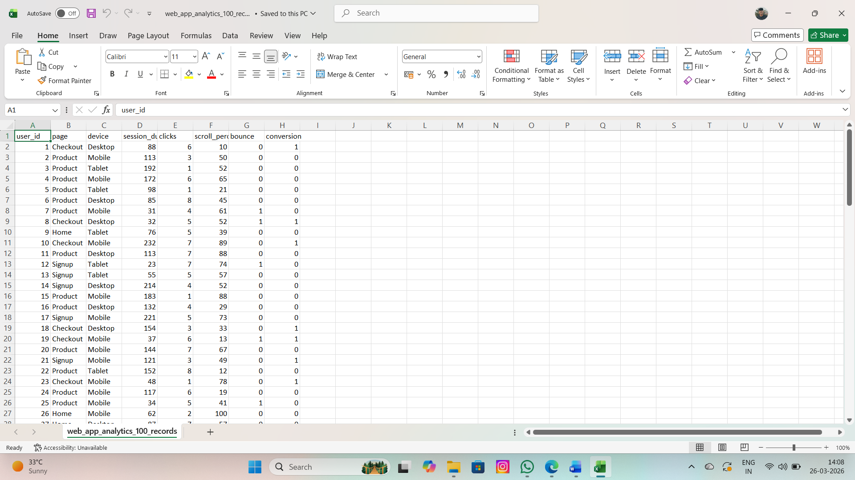

REMOVING DUPLICATE VALUES

Data cleaning is an important step to ensure accuracy and consistency. In this project, Microsoft Excel was used to:
- Format the dataset into a structured table
- Apply filters and sorting
- Use conditional formatting for better visualization
- Check for missing or inconsistent values

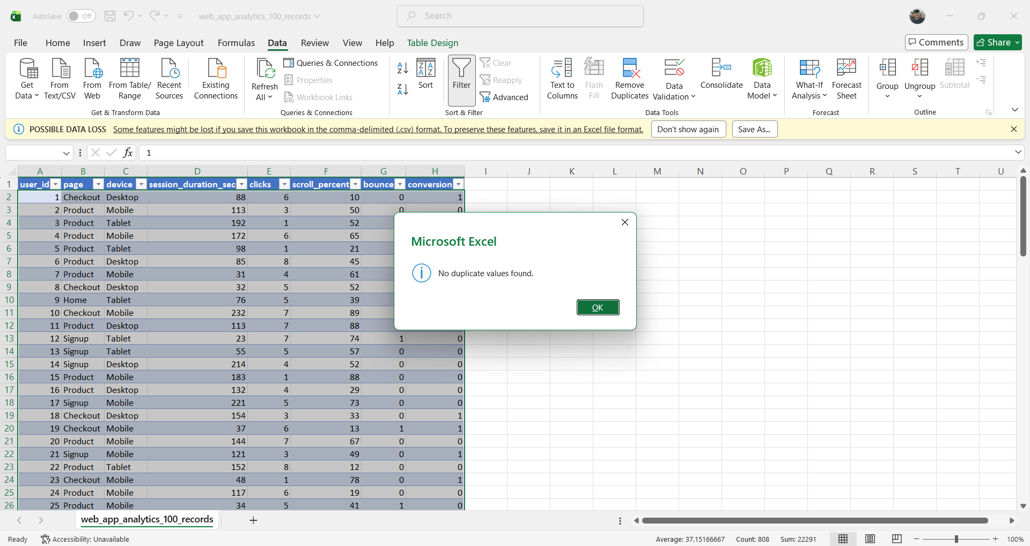

HANDLING MISSING VALUES

- Handling missing values is an important step in data cleaning to ensure accurate analysis. In this project, the dataset was checked in Microsoft Excel to identify blank or incomplete entries. Missing values were detected using filtering and sorting techniques.
- Depending on the situation, some missing values were removed, while others were replaced with suitable values such as averages or default values. This helped in maintaining data consistency and reliability.
- Proper handling of missing data improved the accuracy of analysis and ensured better results in SQL queries and visualizations.

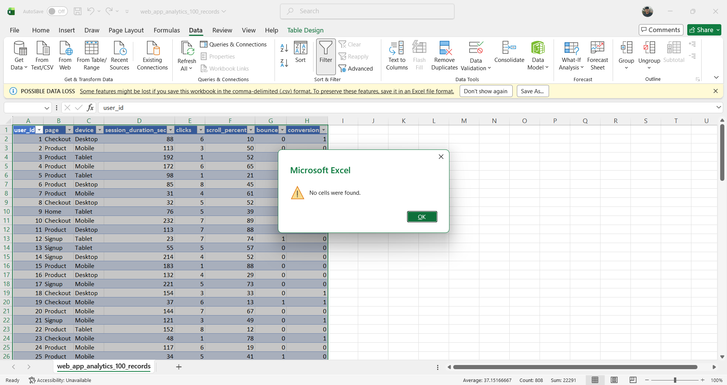

GOOGLE COLAB LINK:

https://colab.research.google.com/drive/1Tx2KtMaP1qrZrROelTHtYHB4hV3kUmP0?usp=sharing

SQL

- Structured Query Language (SQL) was used to analyze the cleaned dataset stored in the MySQL database. The data was imported into phpMyAdmin for efficient querying and management. SQL queries were written to retrieve, filter, and organize the data based on specific conditions.
- Various operations such as selecting data, applying conditions, and sorting were performed. SQL helped in extracting meaningful insights from the dataset quickly and accurately. It also made the analysis process more structured and efficient.
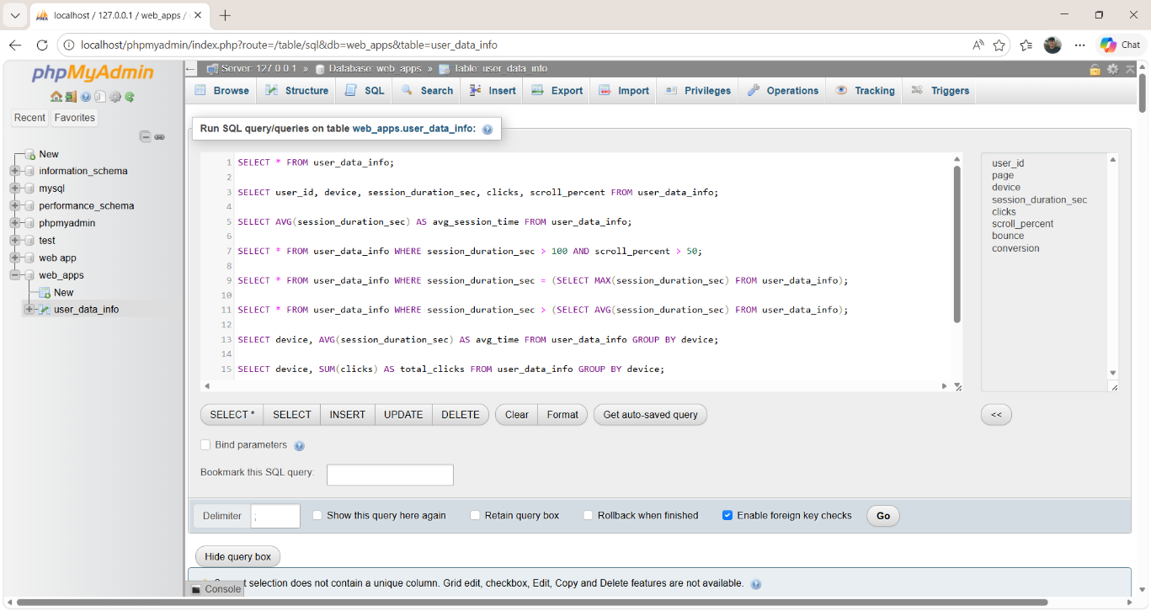

AGGREGATE FUNCTION

Aggregate functions were used to summarize data:
- AVG() – To calculate average session duration
- SUM() – To calculate total clicks
- COUNT() – To count number of users

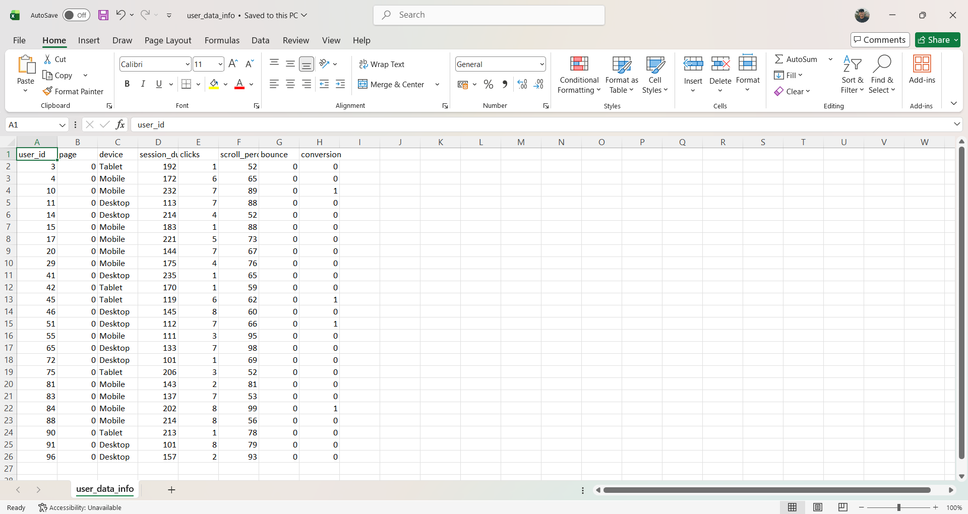

LOGICAL AND COMPARISON OPERATOR

Logical and comparison operators were used to filter data:
- > , < , = – Comparison operators
- AND, OR – Logical operators

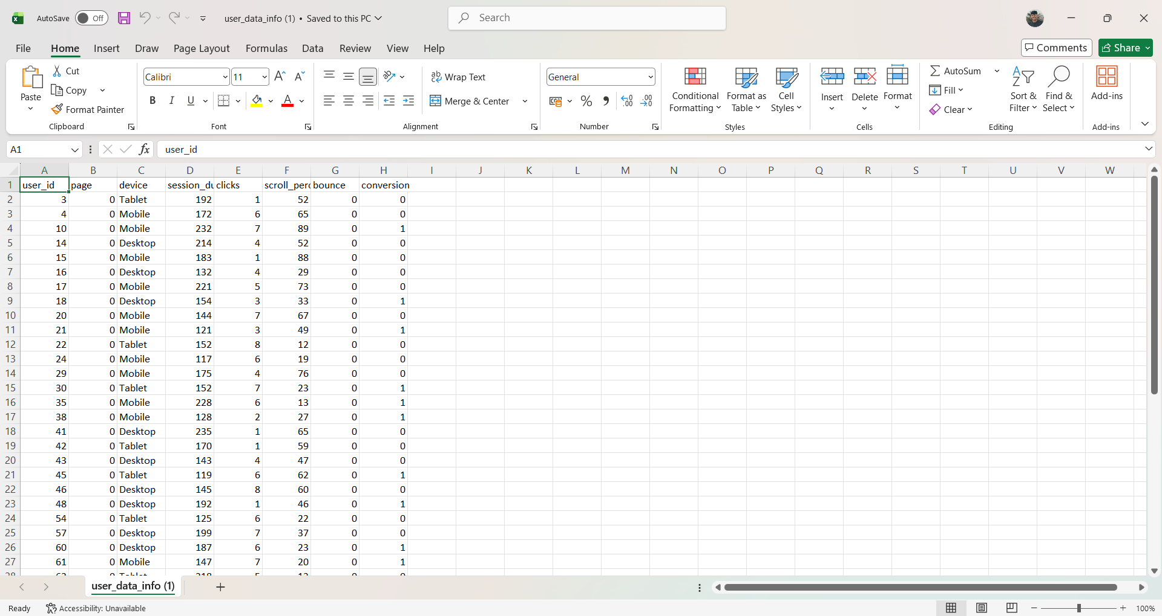

TOOLS USED:
In this project, multiple tools were used for data cleaning, analysis, and visualization to ensure accurate and meaningful results. Each tool played a specific role in different stages of the project.
Microsoft Excel:
Microsoft Excel was used for data preprocessing and cleaning. The raw dataset was imported into Excel, where techniques such as filtering, sorting, formatting, and removing duplicate values were applied. Excel also helped in identifying missing values and organizing the data into a structured format, making it ready for further analysis.
MySQL(phpMyAdmin):
MySQL was used as the database management system to store and analyze the dataset. The cleaned data from Excel was imported into phpMyAdmin, where SQL queries were executed. Various operations such as SELECT statements, filtering using WHERE clauses, aggregate functions, logical and comparison operators, and subqueries were used to extract meaningful insights from the data efficiently.
PowerBI:
Power BI was used for data visualization and dashboard creation. The processed data was imported into Power BI to create interactive visualizations such as bar charts, pie charts, line graphs, and KPI cards. These visualizations helped in understanding user behavior, identifying trends, and presenting the results in a clear and visually appealing manner. The dashboard provides an overall summary of key insights and supports better decision-making.

VISUALIZATIONS

- Data visualization plays a crucial role in transforming complex data into a clear and understandable format. In this project, visualization was performed using Power BI to represent the analyzed data effectively. After processing the dataset using Excel and SQL, the cleaned data was imported into Power BI for creating interactive visual reports.
- Filters and slicers were added to make the dashboard interactive, allowing users to view data based on specific conditions such as device type or page visited. This made the analysis more dynamic and user-friendly.

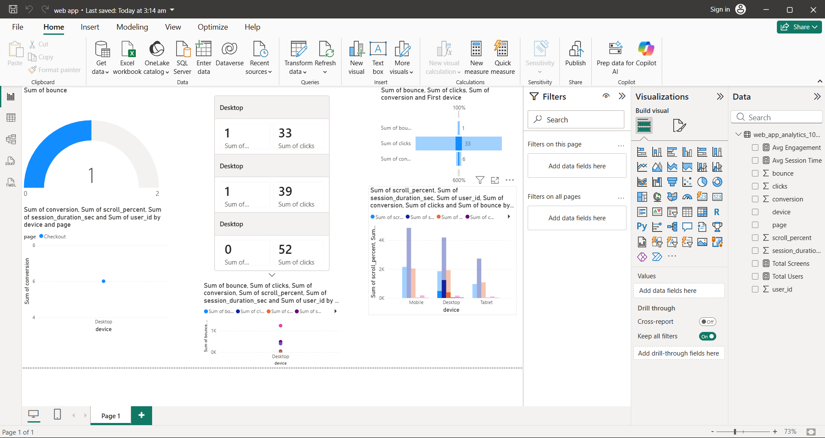

DASHBOARD

- The dashboard is an important component of this project, as it provides a comprehensive and interactive view of the analyzed data. It was created using Power BI to present key insights in a clear and visually appealing manner. The dashboard combines multiple visual elements to give an overall summary of user behavior and application performance.
- The dashboard includes various charts such as bar charts, pie charts, line graphs, and KPI cards. These visuals display important metrics like total users, total clicks, average session duration, bounce rate, and conversion rate. Each visualization is designed to highlight specific aspects of the dataset, making it easier to understand patterns and trends.
- Interactive features such as filters and slicers were added to enhance usability. Users can filter the data based on device type, page visited, or other attributes, allowing them to explore the data in detail. This interactivity helps in making better comparisons and deeper analysis.
- The layout of the dashboard is organized in a structured way so that users can quickly identify key information. It provides a quick overview as well as detailed insights, making it useful for decision-making. Overall, the dashboard effectively communicates the results of the analysis and helps in understanding user behavior more efficiently.

KEY INSIGHTS
● Users show moderate engagement, with an average session duration indicating steady interaction with the web application.
● Pages like Product and Checkout show higher user activity compared to other pages
● User interaction follows a clear pattern (visit → click → scroll → conversion).
● Conversion rates are moderate, indicating opportunities to improve user experience.
● High session duration does not always lead to conversion, showing a gap between engagement and outcomes.
● Users access the application from different devices (desktop, mobile, tablet), indicating flexible usage behavior.

BUSINESS RECOMMENDATIONS

● Improve low-performing pages (e.g., pages with high bounce rates) to increase user engagement.
● Focus on high-traffic pages (such as Product and Checkout) to optimize conversions.
● Enhance UI/UX design to improve user satisfaction and reduce bounce rates.
● Use user behavior patterns to provide personalized recommendations and content.
● Encourage users to complete actions (visit → click → conversion) through better navigation and design strategies.
● Continuously monitor user activity using dashboards to identify trends and improve performance.

CONCLUSION

This project successfully demonstrates how raw data can be transformed into meaningful insights using data analytics tools. By cleaning data in Excel, analyzing it using SQL, and visualizing it in Power BI, valuable patterns in user behavior were identified. The insights gained can help improve user experience, increase engagement, and optimize web application performance.

