Experment-2

Flight Reservation System

Aim :- To design and deploy a simple Flight Reservation System as a Software-as-a-Service (SaaS) application using a Cloud Service Provider for online flight search and booking management.

PROCEDURE :-

- Choose a cloud platform such as AWS / Microsoft Azure / Google Cloud.
- Create and configure a cloud account with hosting services.
- Design the Flight Reservation System modules (login, flight search, booking, payment).
- Develop the web application using HTML/CSS/JavaScript for frontend.
- Implement backend logic using PHP / Python / Node.js.
- Configure a cloud database to store flight schedules and passenger records.
- Deploy and test the SaaS application through web access for multiple users.

OUTPUT :-

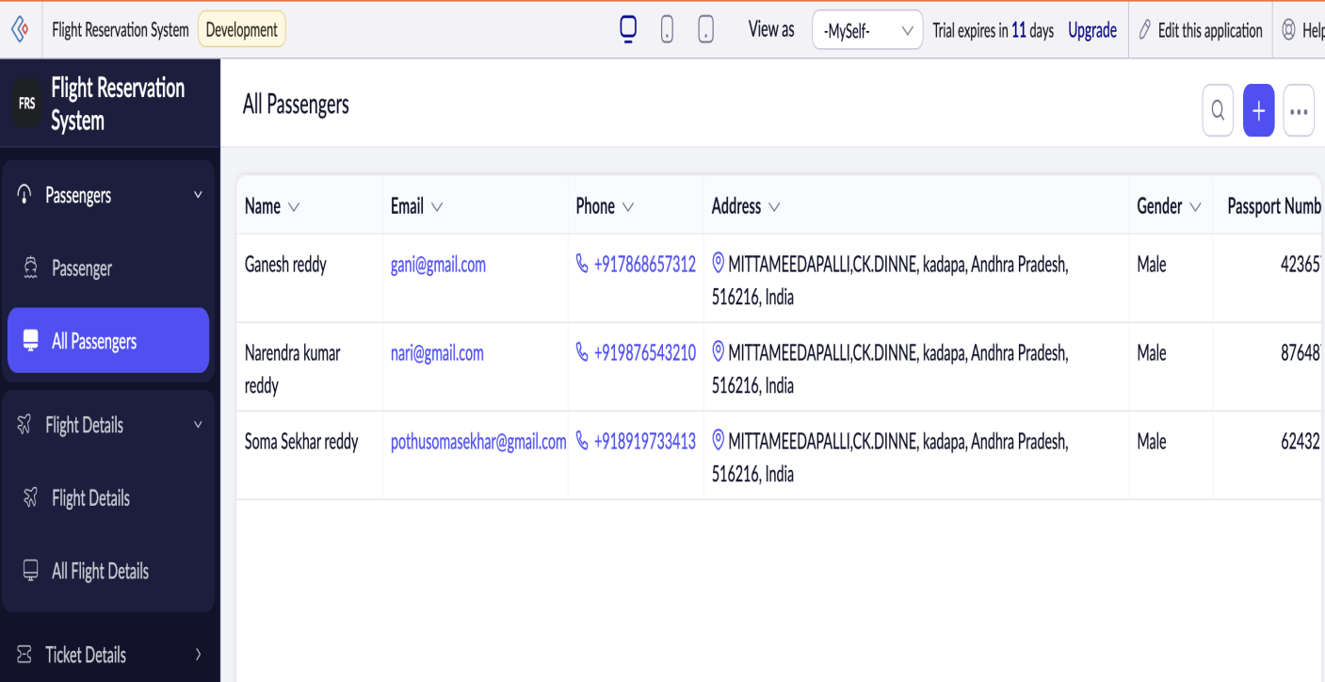

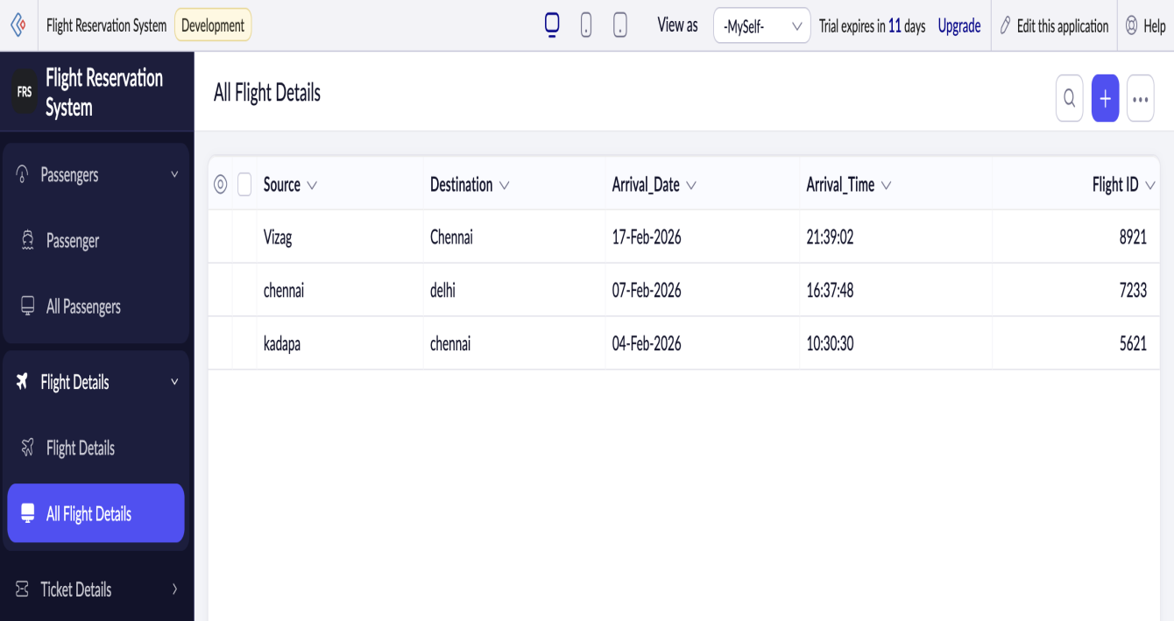

RESULT :-
The Flight Reservation System was successfully deployed on the cloud and accessed via the internet.It demonstrated SaaS features such as online booking, centralized data storage, and scalable user access.

