Date:- Experment-1

Hospital Management System

Aim :- To develop and deploy a simple Hospital Management System (HMS) as a Software-as-a-Service (SaaS) application using a Cloud Service Provider for managing patient, doctor, and appointment records online.

PROCEDURE :-
- Select a cloud service provider such as AWS / Microsoft Azure / Google Cloud.
- Create a cloud account and configure virtual server or app service.
- Design the HMS web application with modules for patients, doctors, and appointments.
- Develop the frontend using HTML/CSS/JavaScript and backend using PHP/Node.js/Python.
- Set up a cloud database service like MySQL / Firebase / Cloud SQL.
- Deploy the application code to the cloud hosting environment.
- Test the SaaS application through a web browser with multiple user logins.

OUTPUT :-
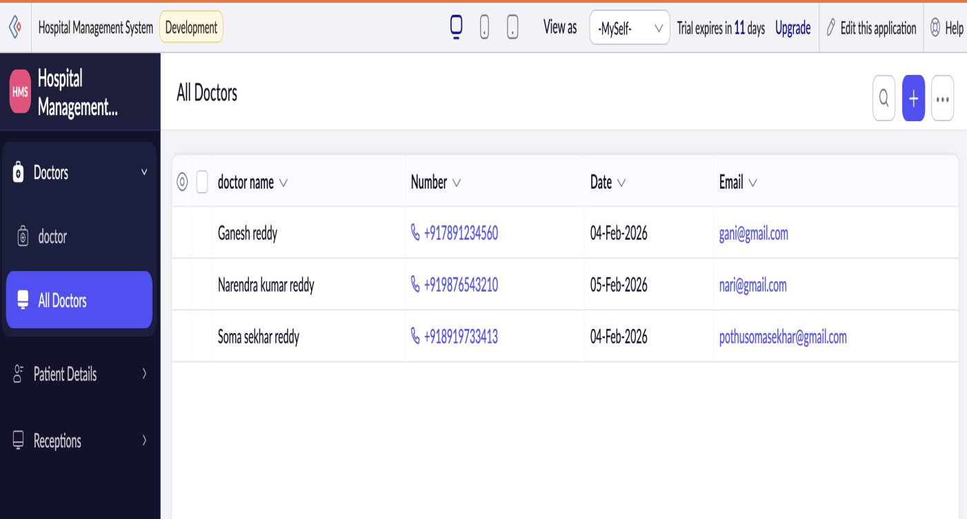

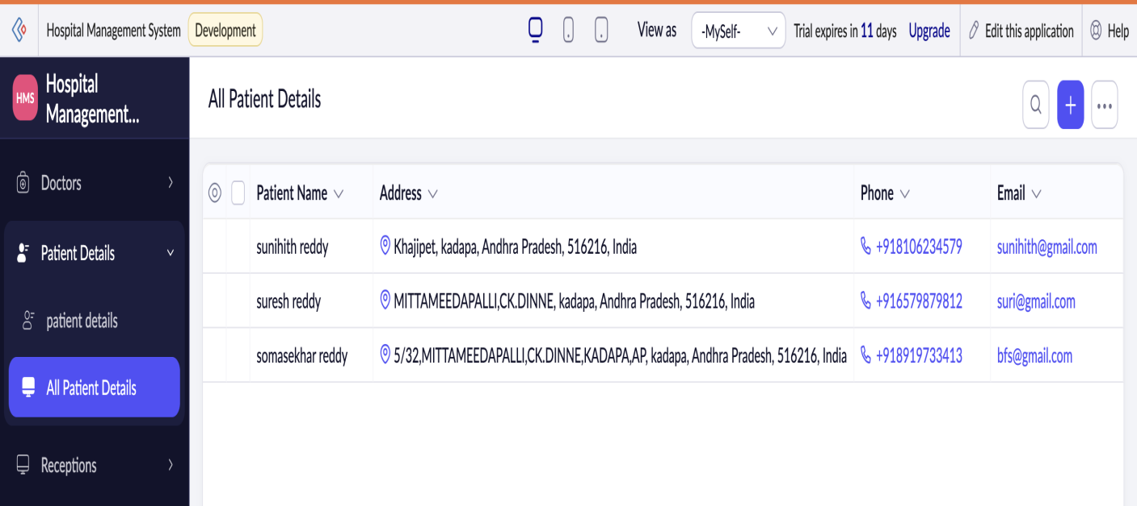

RESULT :-
A simple cloud-based Hospital Management System was successfully deployed and accessed via the internet.The SaaS model enabled centralized data management, remote access, and scalable healthcare services.

