Claude apps gateway on Azure
Network-restricted deployment with Claude models in Microsoft Foundry
Deployment, client connection and capacity planning for Claude Code, the VS Code extension and Claude Desktop
September 29, 2026

Tutorial: Deploy the Claude apps gateway on Azure in a network-restricted environment
A worked example that runs the Claude apps gateway in an internal Azure Container Apps environment, with Claude models in Microsoft Foundry behind a private endpoint, Azure Database for PostgreSQL with private access and Microsoft Entra ID sign-in. Each step is shown in the Azure portal, the Azure CLI and a script.
The Claude apps gateway is a server that ships inside Claude Code. It signs developers in through an OpenID Connect
identity provider, applies per-group model access, and forwards Messages API requests to a model provider, so no model
credential reaches a developer machine (Claude apps gateway).
This tutorial is a worked example of the gateway on Azure, in the form of Anthropic's
AWS example: the gateway has no public endpoint, calls
Claude in Microsoft Foundry through a private endpoint with its managed identity, and signs developers in with
Microsoft Entra ID. Like the AWS example, it is a working example for customer-managed infrastructure, not a supported
production deployment.
Each step is shown three ways:
Tab | Content
Azure portal | The portal path, the settings, and a screenshot of the resource this tutorial deployed on 2026-09-29
Azure CLI | The az commands, in PowerShell 7
Script | The step of infra/azure-private/Deploy-Gateway.ps1, which runs the same az commands (infra/azure-private/Deploy-Gateway.ps1:5-20)

The script reuses existing resources and may reconcile their settings, and -Plan prints the commands it would run
without changing anything (docs/adr/0005-network-restricted-deployment.md:56-60).
In this tutorial, you:
- Create a virtual network, private DNS zones and a Foundry account with Claude deployments behind a private endpoint
- Create PostgreSQL with private access, a registry with the gateway image, and the gateway's managed identity
- Create an internal Container Apps environment, the Entra ID app registration and the gateway
- Check from a machine inside the network that every name resolves to a private address and the gateway is ready

Architecture
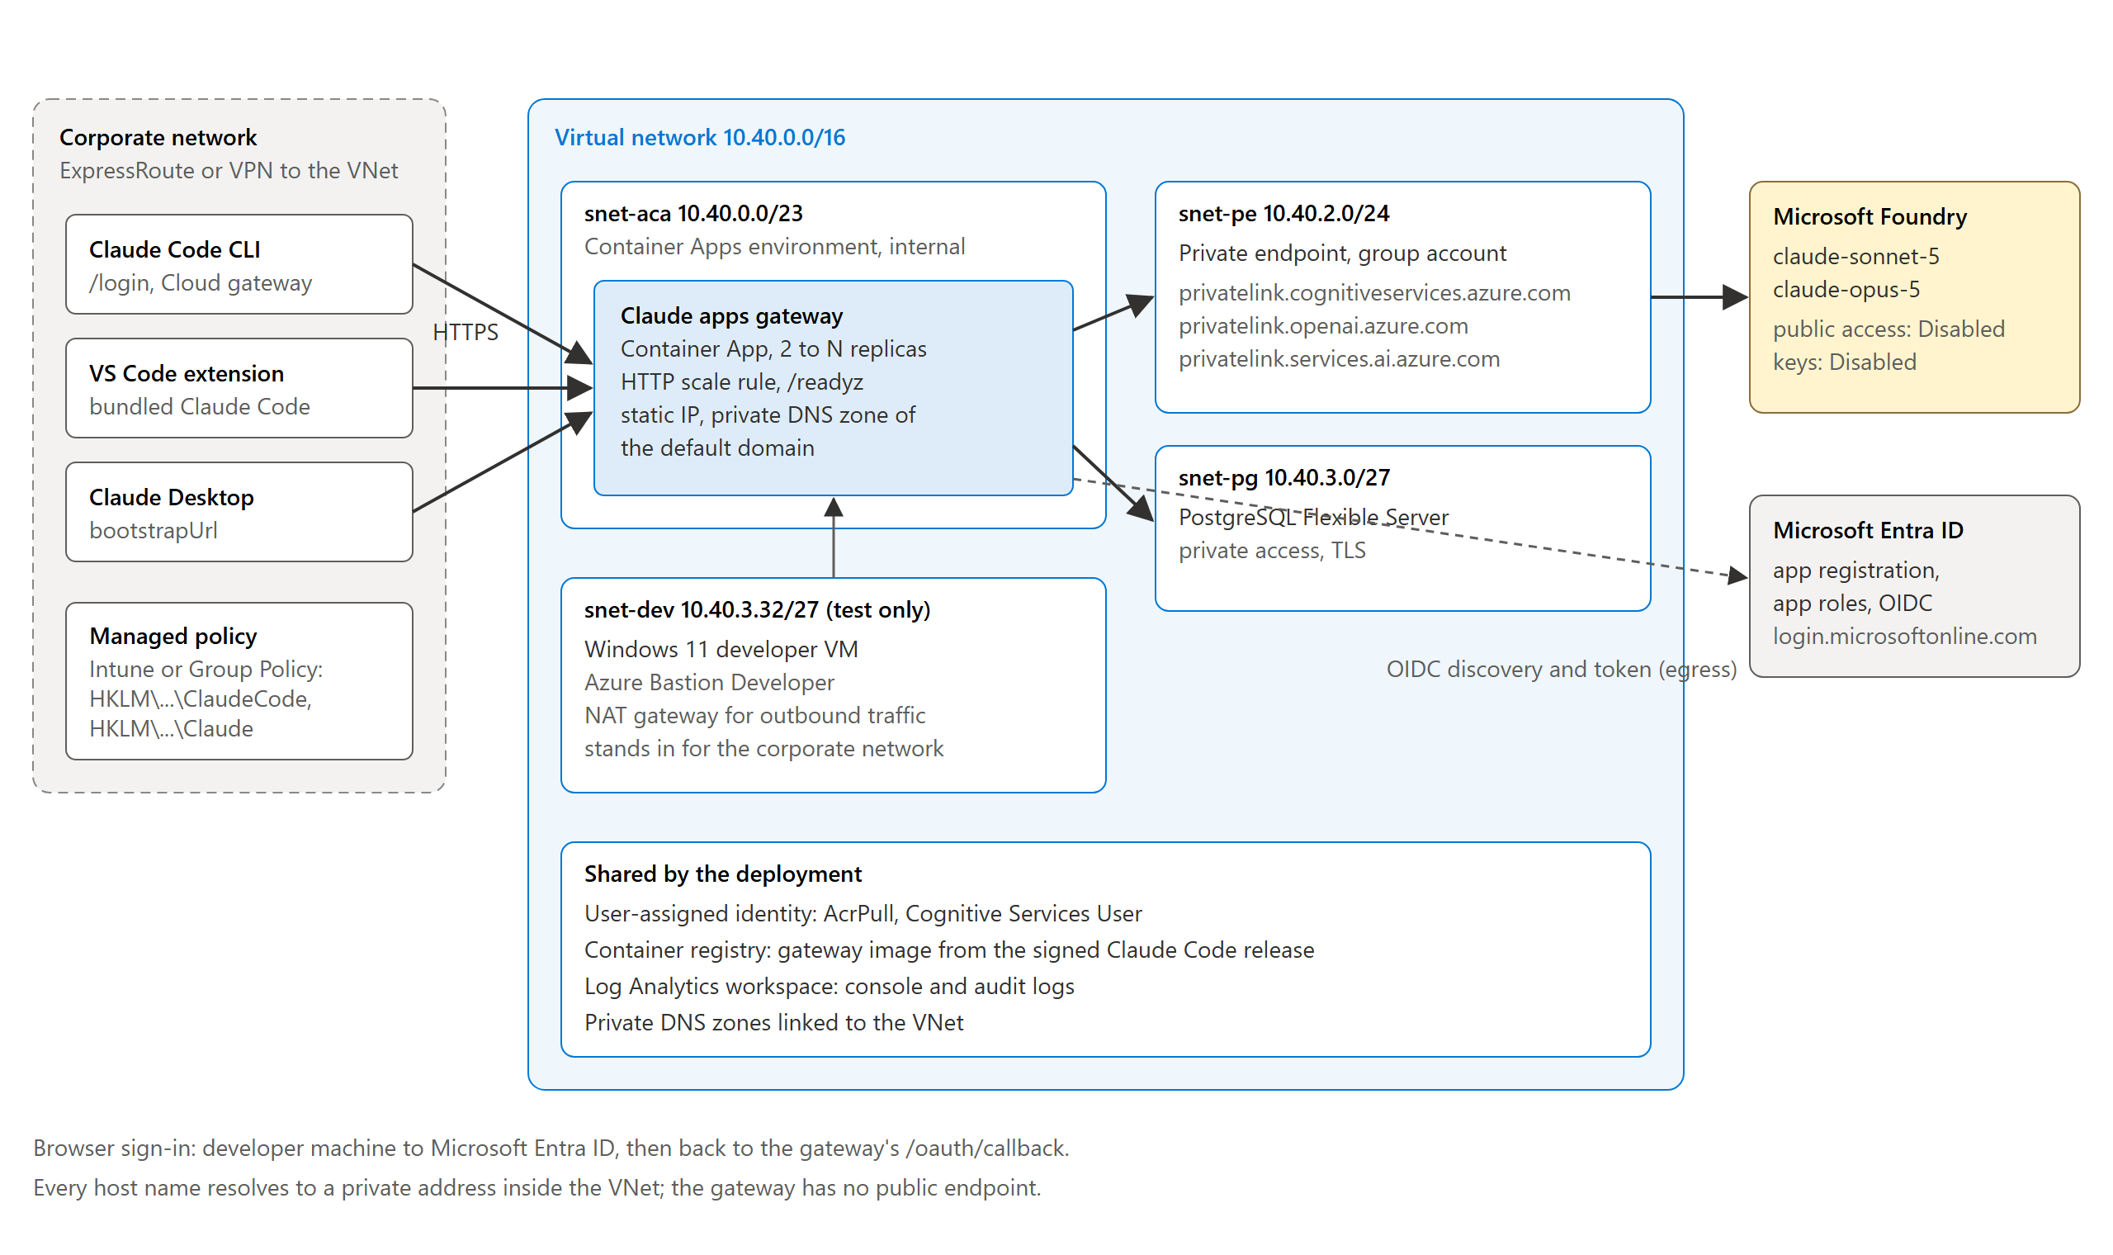
Diagram of the deployment: developer machines on the corporate network reach the gateway's private address over ExpressRoute or VPN; the gateway runs in an internal Container Apps environment in the snet-aca subnet, stores sign-in state in PostgreSQL in snet-pg, and calls Foundry through a private endpoint in snet-pe; browsers sign in to Microsoft Entra ID.
Developers reach the gateway at a host name that resolves to the environment's private static IP. /login in Claude
Code accepts only a gateway whose host name resolves to private addresses
(prerequisites). The deployment creates:
Resource | Name | Purpose
Virtual network | vnet-claude-gw, 10.40.0.0/16 | Subnets snet-aca (/23, delegated to Microsoft.App/environments), snet-pe (/24, private endpoints), snet-pg (/27, delegated to Microsoft.DBforPostgreSQL/flexibleServers) and snet-dev (/27, test machine)
Container Apps environment | cae-claude-gw | Workload profiles, internal: a private static IP and no public endpoint
Container App | ca-claude-gw | The gateway: 2 to 3 replicas by default, with an HTTP scale rule
PostgreSQL flexible server | psql-claude-gw-<suffix> | The gateway's store (sign-in state and rate-limit counters), private access
Foundry account | ai-claude-gw-<suffix> | claude-sonnet-5 and claude-opus-5; public network access and key authentication disabled; private endpoint pe-foundry
Private DNS zones | Three Foundry zones, the environment's default domain, the PostgreSQL zone | Names resolve to private addresses inside the network
Container registry | acrclaudegw<suffix> | The gateway image, built from the signed Claude Code release
Managed identity | id-claude-gw | AcrPull on the registry and Cognitive Services User on Foundry
Log Analytics workspace | log-claude-gw | The gateway's console log, which carries its audit events
App registration | claude-apps-gateway-private-<suffix> | The OpenID Connect client, with app roles Gateway.Standard and Gateway.Premium
Test machine (optional) | vm-dev, bas-claude-gw, ng-dev | A Windows 11 VM reached through Azure Bastion Developer, standing in for a developer machine on the corporate network

The names come from the script (infra/azure-private/Deploy-Gateway.ps1:79-104). The test deployment runs in North
Central US, with the Foundry account in East US 2, where the subscription holds Claude quota (docs/UNKNOWNS.md:74).
Production differences, such as a hub-and-spoke network and a custom domain, are in ADR-0005
(docs/adr/0005-network-restricted-deployment.md:64-73), and sizing for 25,000 developers is in
Plan capacity for 25,000 developers.

Prerequisites
Requirement | Detail | Source
Azure subscription | Owner, or Contributor with User Access Administrator: the steps create role assignments | https://learn.microsoft.com/en-us/azure/role-based-access-control/role-assignments-cli
Microsoft Entra ID | A role that registers applications and assigns app roles, such as Application Administrator or Cloud Application Administrator | https://learn.microsoft.com/en-us/entra/identity/enterprise-apps/assign-user-or-group-access-portal
Claude quota | Quota for each Claude model and deployment type in the Foundry account's region | https://learn.microsoft.com/en-us/azure/foundry/foundry-models/concepts/claude-models-quotas-limits
Claude terms | The organization's legal name, two-letter country code and industry, which each Claude deployment records to accept the Azure Marketplace offer | https://learn.microsoft.com/en-us/azure/developer/ai/how-to/deploy-claude-foundry#terms-of-use
One region for the regional resources | Capacity for a new Container Apps environment, PostgreSQL flexible server and, for the test machine, Bastion Developer | docs/UNKNOWNS.md:74
Tools | Azure CLI with the containerapp extension, PowerShell 7.2 or later, and Node.js 22 or later for the configuration renderer | infra/azure-private/Deploy-Gateway.ps1:1
Companion files | The repository claude-apps-gateway-foundry: the script in infra/azure-private, the gateway configuration in config, the image definition in infra/azure-test/image and the Entra app manifest infra/azure-test/entra-app.json; the commands run from its root | infra/azure-private/Deploy-Gateway.ps1:95-98
Production network | ExpressRoute or VPN from the corporate network to the virtual network, and DNS that resolves the gateway's zone for developer machines | https://learn.microsoft.com/en-us/azure/dns/dns-private-resolver-overview

Get the files, sign in and set the variables
The companion files are in the public GitHub repository naveenneog/claude-apps-gateway-foundry, under the MIT
license. The commands below clone it, and every later command runs from its root:
git clone https://github.com/naveenneog/claude-apps-gateway-foundry.git
Set-Location claude-apps-gateway-foundry
Sign in to the tenant, select the subscription, and add the Container Apps extension of the Azure CLI
(Container Apps CLI):
az login --tenant "<tenant ID>"
az account set --subscription "<subscription ID>"
az extension add --name containerapp --upgrade
Every CLI command in this tutorial reads these variables, and later steps read variables that earlier steps set, in
the same PowerShell session. Secrets and generated files go to a folder in the user's profile under
%LOCALAPPDATA%, outside the repository:
$rg = 'rg-claude-gw-internal'
$location = 'northcentralus' # network, gateway, PostgreSQL and test machine
$foundryLocation = 'eastus2' # Foundry account, where the subscription holds Claude quota
$allowedDomain = 'contoso.com' # the domain of the email claim of the users the gateway admits
$subscriptionId = az account show --query id -o tsv
$tenantId = az account show --query tenantId -o tsv
# Six hexadecimal digits from the subscription and the resource group make the global names unique.
$hash = [Security.Cryptography.SHA256]::HashData([Text.Encoding]::UTF8.GetBytes("$subscriptionId/$rg"))
$suffix = [Convert]::ToHexString($hash).Substring(0, 6).ToLowerInvariant()
$vnet = 'vnet-claude-gw'
$foundry = "ai-claude-gw-$suffix"
$postgres = "psql-claude-gw-$suffix"
$acr = "acrclaudegw$suffix"
$identity = 'id-claude-gw'
$environment = 'cae-claude-gw'
$app = 'ca-claude-gw'
$work = Join-Path $env:LOCALAPPDATA "claude-gateway-deploy-$suffix-$(Get-Date -Format yyyyMMddHHmmss)"
New-Item -ItemType Directory -Path $work -ErrorAction Stop | Out-Null
# A new folder that only the operator's account may open: inherited permissions are removed, and the run stops
# unless exactly one entry, the operator's, remains.
icacls $work /inheritance:r /grant:r "${env:USERDOMAIN}\${env:USERNAME}:(OI)(CI)F" | Out-Null
if ($LASTEXITCODE -ne 0 -or @((Get-Acl $work).Access).Count -ne 1) { throw "The permissions of $work could not be limited to $env:USERNAME." }
$work
The suffix is the one the script derives (infra/azure-private/Deploy-Gateway.ps1:70-71). Each run creates a new
folder, whose name the last line prints; a later PowerShell session sets $work to that name again. icacls removes
the inherited permissions and grants the operator's account full control, and a new folder has no other explicit
entries, so other accounts have none (icacls). The commands pass
each secret to the Azure CLI as an @<file> argument, which the CLI reads from the file, so no secret is on a command
line (Azure CLI quoting;
infra/azure-private/lib/Az.psm1:1-10). The secret files are written with .NET's File.WriteAllText, not a cmdlet,
because PowerShell module logging records the parameters of cmdlets
(about_Logging_Windows;
docs/adr/0004-operator-and-developer-tooling.md:106-112). The folder and its files stay after a failed or interrupted
step until Remove-Item -Recurse -Force $work deletes them, as in Clean up resources.
Each portal resource opens at https://portal.azure.com/#@<tenant ID>/resource<resource ID>; the screenshots in this
tutorial were captured from those links.

Deploy the gateway

Step 1: Create the network
The environment's subnet is delegated to Microsoft.App/environments and is /27 or larger
(custom virtual network); PostgreSQL's subnet is
delegated to Microsoft.DBforPostgreSQL/flexibleServers
(private access). The NAT
gateway gives the test machine outbound access for installers and sign-in; production developer machines use the
corporate network instead.

Azure portal
- Resource groups > Create: name rg-claude-gw-internal, region North Central US.
- Virtual networks > Create: name vnet-claude-gw; IP addresses: address space 10.40.0.0/16.
- For the test machine: NAT gateways > Create: name ng-dev; Outbound IP: a new public IP pip-ng-dev
(NAT gateway quickstart).
- Virtual networks > vnet-claude-gw > Settings > Subnets > + Subnet, once for each subnet in the
table after these steps.
Subnet | Range | Subnet delegation | NAT gateway
snet-aca | 10.40.0.0/23 | Microsoft.App/environments | None
snet-pe | 10.40.2.0/24 | None | None
snet-pg | 10.40.3.0/27 | Microsoft.DBforPostgreSQL/flexibleServers | None
snet-dev | 10.40.3.32/27 | None | ng-dev

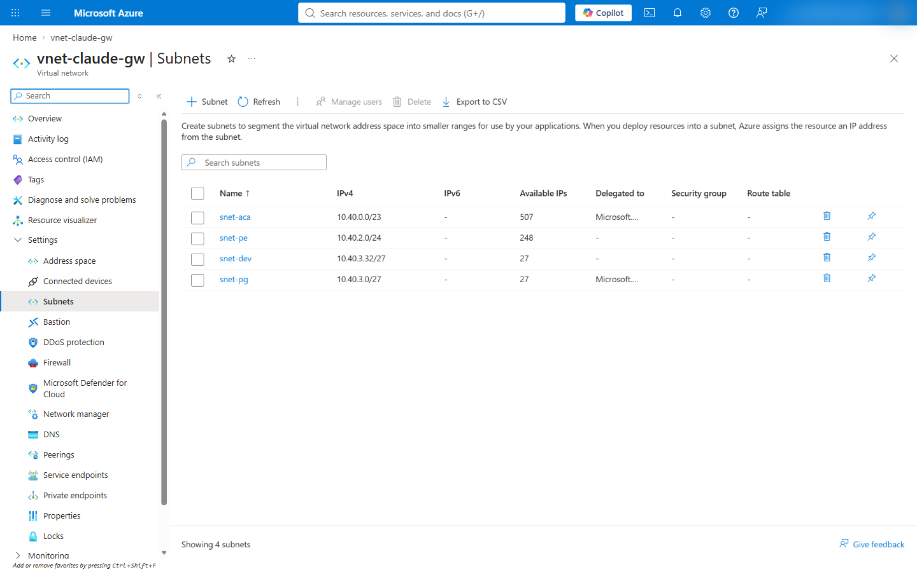
Screenshot of the Subnets page of vnet-claude-gw with snet-aca 10.40.0.0/23 and snet-pg 10.40.3.0/27 delegated, snet-pe 10.40.2.0/24 and snet-dev 10.40.3.32/27.

Azure CLI
az group create --name $rg --location $location
az network vnet create -g $rg -n $vnet --location $location --address-prefixes 10.40.0.0/16
az network public-ip create -g $rg -n pip-ng-dev --location $location --sku Standard
az network nat gateway create -g $rg -n ng-dev --location $location --public-ip-addresses pip-ng-dev
az network vnet subnet create -g $rg --vnet-name $vnet -n snet-aca --address-prefixes 10.40.0.0/23 --delegations Microsoft.App/environments
az network vnet subnet create -g $rg --vnet-name $vnet -n snet-pe --address-prefixes 10.40.2.0/24
az network vnet subnet create -g $rg --vnet-name $vnet -n snet-pg --address-prefixes 10.40.3.0/27 --delegations Microsoft.DBforPostgreSQL/flexibleServers
az network vnet subnet create -g $rg --vnet-name $vnet -n snet-dev --address-prefixes 10.40.3.32/27 --nat-gateway ng-dev

Script
pwsh -File infra/azure-private/Deploy-Gateway.ps1 -Step network
The step is in infra/azure-private/lib/Steps.Base.psm1:6-27.

Step 2: Create the private DNS zones for Foundry
A Foundry account answers on three host names, <account>.cognitiveservices.azure.com, <account>.openai.azure.com
and <account>.services.ai.azure.com, and each family has its own private DNS zone
(private endpoint DNS). Each zone is
linked to the virtual network, so the names resolve to the private endpoint inside it.

Azure portal
- Private DNS zones > Create: name privatelink.cognitiveservices.azure.com, resource group rg-claude-gw-internal.
- The zone > DNS Management > Virtual Network Links > Add: name link-vnet-claude-gw, virtual network
vnet-claude-gw, auto registration off
(private DNS quickstart).
- Repeat for privatelink.openai.azure.com and privatelink.services.ai.azure.com.
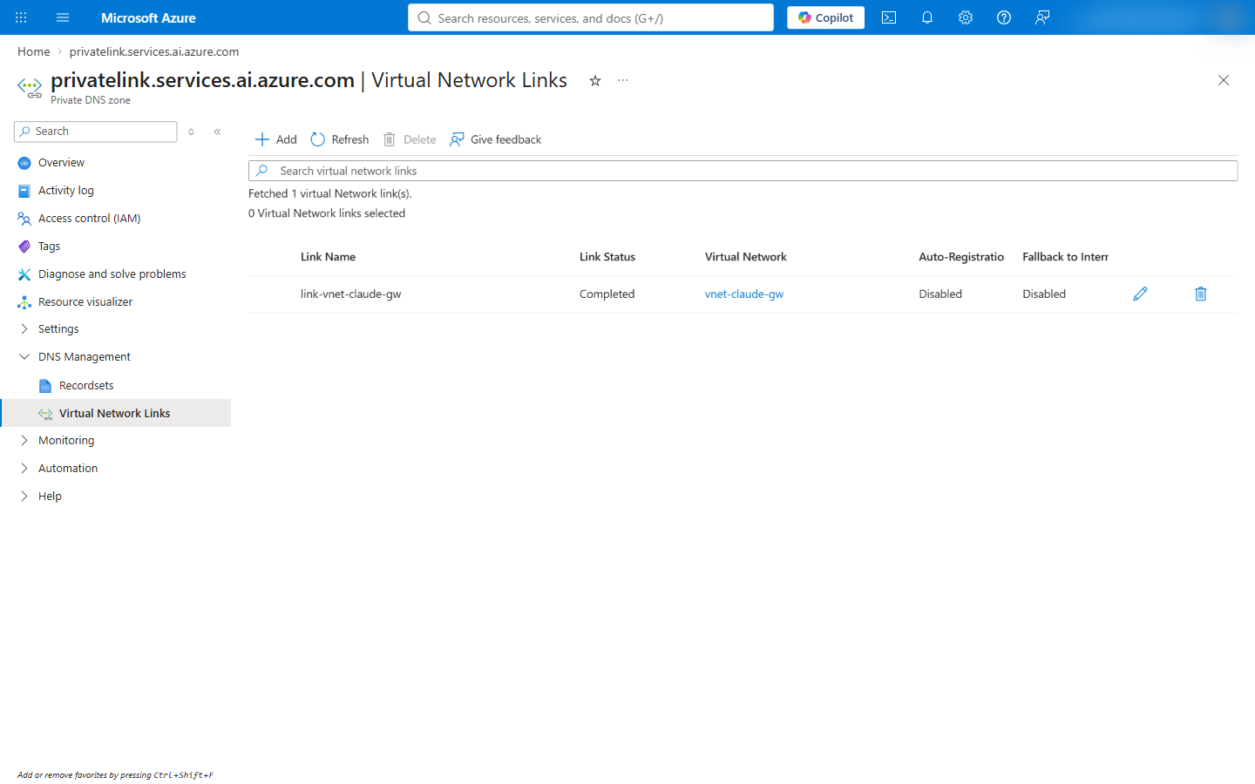
Screenshot of the Virtual Network Links page of privatelink.services.ai.azure.com with the link link-vnet-claude-gw to vnet-claude-gw, status Completed, auto registration Disabled.

Azure CLI
foreach ($zone in 'privatelink.cognitiveservices.azure.com', 'privatelink.openai.azure.com', 'privatelink.services.ai.azure.com') {
az network private-dns zone create -g $rg -n $zone
az network private-dns link vnet create -g $rg -z $zone -n "link-$vnet" -v $vnet -e false
}

Script
pwsh -File infra/azure-private/Deploy-Gateway.ps1 -Step dns
The step is in infra/azure-private/lib/Steps.Base.psm1:30-43.

Step 3: Create the Foundry account, the Claude deployments and the private endpoint
The account's public network access is disabled, so only the private endpoint reaches it, and local (key)
authentication is disabled, so only Entra ID tokens are accepted
(disable local authentication). Each Claude
deployment carries a modelProviderData block with the organization's name, country code and industry, which accepts
the Azure Marketplace offer for Claude
(terms of use). The
Azure CLI's az cognitiveservices account deployment create has no option for that block, so the CLI tab writes the
deployment through Azure Resource Manager with az rest (infra/azure-private/lib/Steps.Base.psm1:57-67).

Azure portal
- Foundry (Azure AI Foundry) > Create a resource: name ai-claude-gw-<suffix>, region East US 2.
- Foundry portal (ai.azure.com), the resource > Models + endpoints > Deploy model: claude-sonnet-5,
deployment type Global Standard; claude-opus-5, Data Zone Standard. The deployment dialog asks for the
organization name, country and industry
(deploy Foundry models).
- The resource > Resource Management > Networking > Private endpoint connections > + Private endpoint:
name pe-foundry, region North Central US, target sub-resource account, virtual network vnet-claude-gw /
snet-pe, private DNS integration with the three zones of step 2
(configure private link).
- Networking > Firewalls and virtual networks > Allow access from: Disabled > Save.
- Key authentication: the disable local authentication
guide sets disableLocalAuth with a template, PowerShell or Azure Policy; the CLI tab's az resource update sets it.
With public network access disabled, the Foundry portal manages the account only from a network with a path to its
private endpoint (configure private link);
the CLI tab creates the deployments through Azure Resource Manager, which does not need that path. The deployment
recorded here created both deployments after public access was disabled.
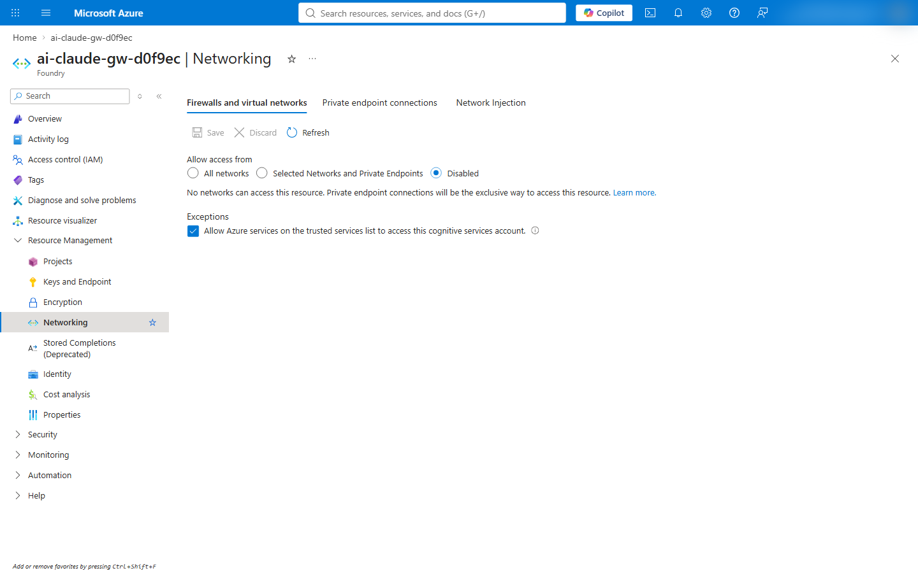
Screenshot of the Networking page of the Foundry account with Allow access from set to Disabled: private endpoint connections are the only way to reach the resource.
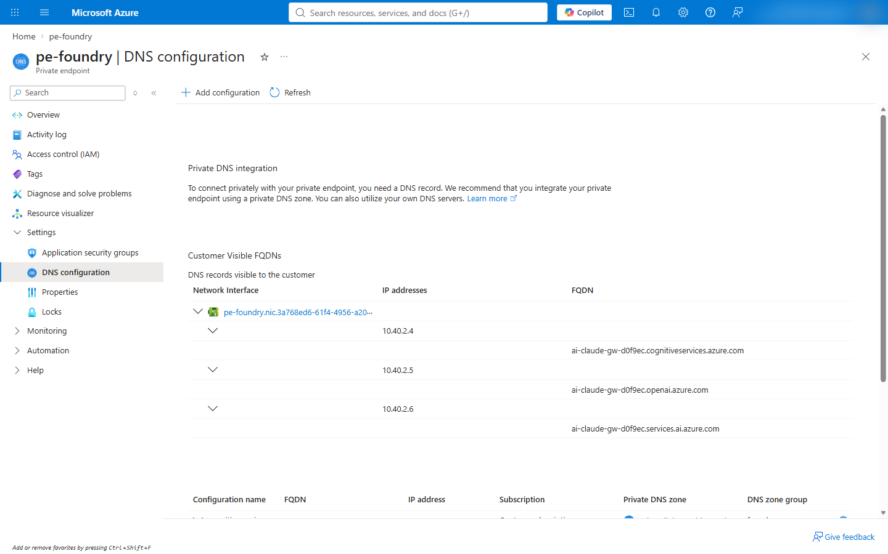
Screenshot of the DNS configuration of pe-foundry: the cognitiveservices, openai and services.ai host names of the account resolve to 10.40.2.4, 10.40.2.5 and 10.40.2.6.

Azure CLI
az cognitiveservices account create -g $rg -n $foundry --location $foundryLocation --kind AIServices --sku S0 --custom-domain $foundry --yes
$foundryId = az cognitiveservices account show -g $rg -n $foundry --query id -o tsv
az resource update --ids $foundryId --set properties.publicNetworkAccess=Disabled properties.disableLocalAuth=true

# One deployment per model; the terms block names your organization.
foreach ($m in @(@{ Name = 'claude-sonnet-5'; Sku = 'GlobalStandard' }, @{ Name = 'claude-opus-5'; Sku = 'DataZoneStandard' })) {
@{ sku = @{ name = $m.Sku; capacity = 10 }
properties = @{ model = @{ format = 'Anthropic'; name = $m.Name; version = '2' }
modelProviderData = @{ organizationName = 'Contoso Ltd'; countryCode = 'US'; industry = 'technology' } } } |
ConvertTo-Json -Depth 5 | Set-Content "deployment-$($m.Name).json"
az rest --method put --url "https://management.azure.com$foundryId/deployments/$($m.Name)?api-version=2025-10-01-preview" --body "@deployment-$($m.Name).json"
}

az network private-endpoint create -g $rg -n pe-foundry --location $location --vnet-name $vnet --subnet snet-pe --private-connection-resource-id $foundryId --group-id account --connection-name foundry
az network private-endpoint dns-zone-group create -g $rg --endpoint-name pe-foundry -n foundry --private-dns-zone privatelink.cognitiveservices.azure.com --zone-name cognitiveservices
az network private-endpoint dns-zone-group add -g $rg --endpoint-name pe-foundry -n foundry --private-dns-zone privatelink.openai.azure.com --zone-name openai
az network private-endpoint dns-zone-group add -g $rg --endpoint-name pe-foundry -n foundry --private-dns-zone privatelink.services.ai.azure.com --zone-name services-ai
The capacity is in the quota units of the model and deployment type; the model versions are the ones this deployment
used (infra/azure-private/Deploy-Gateway.ps1:87-91).

Script
pwsh -File infra/azure-private/Deploy-Gateway.ps1 -Step foundry -ClaudeOrganizationName 'Contoso Ltd' -ClaudeCountryCode US -ClaudeIndustry technology
The step refuses to create a Claude deployment without -ClaudeOrganizationName
(infra/azure-private/lib/Steps.Base.psm1:45-83).

Step 4: Create the PostgreSQL server
The gateway keeps device-flow grants and rate-limit counters in PostgreSQL 14 or later
(store). The server uses private access: it has
no public endpoint, and its name resolves through a private DNS zone linked to the virtual network
(private access).
Burstable B1ms is a test size with 35 user connections; sizing is in
Plan capacity for 25,000 developers.

Azure portal
- Azure Database for PostgreSQL flexible servers > Create: name psql-claude-gw-<suffix>, region
North Central US, PostgreSQL version 16, Compute + storage: Burstable, Standard_B1ms, 32 GiB, high
availability disabled; Authentication: PostgreSQL authentication, administrator gatewayadmin
(create a server).
- Networking: Private access (VNet Integration), virtual network vnet-claude-gw, subnet snet-pg, a new
private DNS zone psql-claude-gw-<suffix>.private.postgres.database.azure.com.
- After creation: the server > Settings > Databases > + Add: gateway.
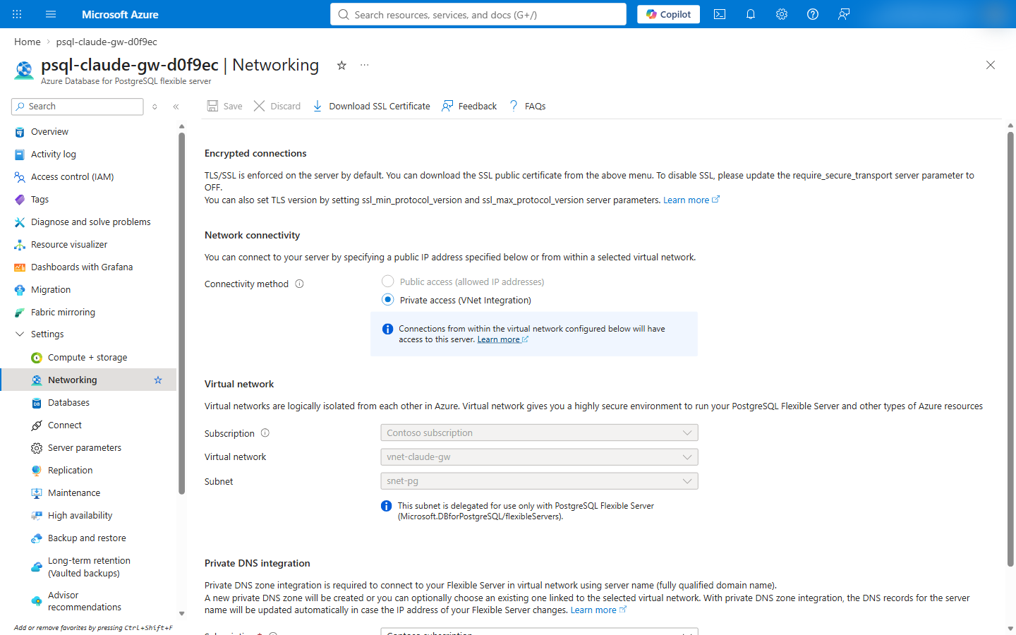
Screenshot of the Networking page of the PostgreSQL server: connectivity method Private access (VNet Integration), virtual network vnet-claude-gw, subnet snet-pg delegated to PostgreSQL flexible servers.

Azure CLI
# A random password in a file; the CLI reads it from the file, and --output none keeps the reply, which repeats the
# password, off the console.
$pgPassword = ([Convert]::ToBase64String([Security.Cryptography.RandomNumberGenerator]::GetBytes(32)) -replace '[+/=]', '') + 'Aa1!'
[IO.File]::WriteAllText("$work\pg-password.txt", $pgPassword)

az postgres flexible-server create -g $rg -n $postgres --location $location --tier Burstable --sku-name Standard_B1ms --version 16 --storage-size 32 --zonal-resiliency Disabled --vnet $vnet --subnet snet-pg --private-dns-zone "$postgres.private.postgres.database.azure.com" --admin-user gatewayadmin --admin-password "@$work\pg-password.txt" --yes --output none
az postgres flexible-server db create -g $rg -s $postgres -d gateway
The reply of az postgres flexible-server create holds the administrator password and a connection string with it
(the command's source).
Step 9 reads pg-password.txt.

Script
pwsh -File infra/azure-private/Deploy-Gateway.ps1 -Step postgres -PostgresSku Standard_B1ms -PostgresTier Burstable
The script keeps the password in memory for the app step and sets a new one when the app step runs alone
(infra/azure-private/lib/Steps.App.psm1:94-100).

Step 5: Create the registry and build the gateway image
The image runs the Claude Code binary as the gateway. Its build downloads the release, checks the release manifest's
signature and the binary's SHA-256 checksum, and fails on a mismatch (docs/adr/0005-network-restricted-deployment.md:71;
infra/azure-test/image/Dockerfile:14-20). az acr build runs the build as an ACR Tasks quick task in Azure
(ACR Tasks quickstart).
For a registry with a private endpoint and public access disabled, ACR Tasks runs the build on a dedicated agent pool in
the virtual network (agent pools).

Azure portal
- Container registries > Create: name acrclaudegw<suffix>, region North Central US, pricing plan
Basic; admin user disabled
(registry quickstart).
- Build the image with the CLI tab's az acr build; the registry > Services > Repositories then lists
claude-gateway.
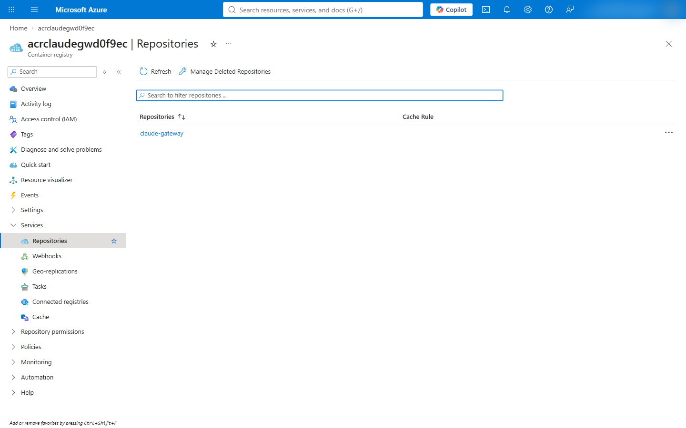
Screenshot of the Repositories page of the container registry listing the claude-gateway repository.

Azure CLI
az acr create -g $rg -n $acr --location $location --sku Basic --admin-enabled false
az acr build --registry $acr --image claude-gateway:2.1.284 --build-arg CLAUDE_VERSION=2.1.284 --build-arg CLAUDE_SHA256=5cd90aabd83f8a15136c35aa37bb1d92b348993573316643dc3fe4e04afbf88f --no-logs infra/azure-test/image
$image = "$acr.azurecr.io/claude-gateway@" + (az acr repository show -n $acr --image claude-gateway:2.1.284 --query digest -o tsv)
--no-logs makes the CLI wait for the build and print the run as JSON, whose status is Succeeded for a good
build; without it, the CLI prints the build log (tests/azure-private/fake-az.mjs:12-16). The checksum is the
linux-x64 value in the release manifest of Claude Code 2.1.284 (infra/azure-private/Deploy-Gateway.ps1:93-94).

Script
pwsh -File infra/azure-private/Deploy-Gateway.ps1 -Step registry
The step stops when the build's status is not Succeeded (infra/azure-private/lib/Steps.Base.psm1:106-125).

Step 6: Create the gateway's identity
The gateway pulls its image and calls Foundry with a user-assigned managed identity. AcrPull lets it pull from the
registry (image pull with managed identity),
and Cognitive Services User lets it call the Foundry account; the gateway's Foundry upstream authenticates through
DefaultAzureCredential (Microsoft Foundry upstream).

Azure portal
- Managed Identities > Create: name id-claude-gw, region North Central US
(user-assigned identities).
- The registry > Access control (IAM) > Add role assignment: role AcrPull, assign access to
Managed identity, member id-claude-gw
(assign roles in the portal).
- The Foundry account > Access control (IAM) > Add role assignment: role Cognitive Services User, member
id-claude-gw.
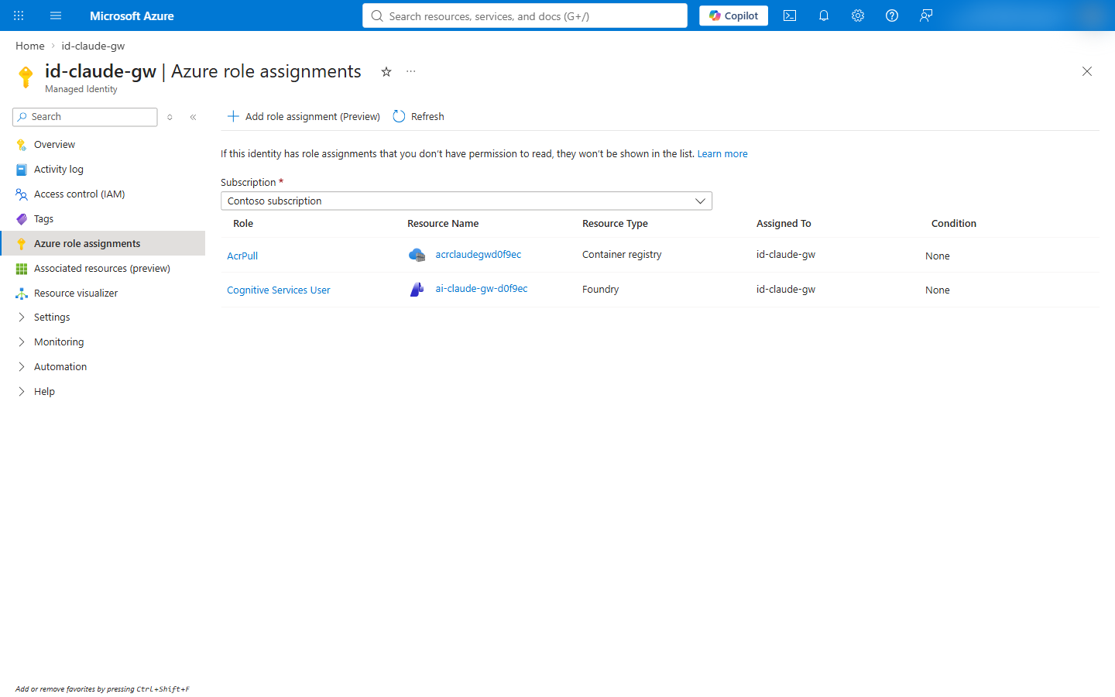
Screenshot of the Azure role assignments of id-claude-gw: AcrPull on the container registry and Cognitive Services User on the Foundry account.

Azure CLI
az identity create -g $rg -n $identity --location $location
$principalId = az identity show -g $rg -n $identity --query principalId -o tsv
$identityClientId = az identity show -g $rg -n $identity --query clientId -o tsv
$identityId = az identity show -g $rg -n $identity --query id -o tsv
$acrId = az acr show -g $rg -n $acr --query id -o tsv
az role assignment create --assignee-object-id $principalId --assignee-principal-type ServicePrincipal --role AcrPull --scope $acrId
az role assignment create --assignee-object-id $principalId --assignee-principal-type ServicePrincipal --role "Cognitive Services User" --scope $foundryId

Script
pwsh -File infra/azure-private/Deploy-Gateway.ps1 -Step identity
The step is in infra/azure-private/lib/Steps.Base.psm1:127-145.

Step 7: Create the internal Container Apps environment
An internal environment has no public endpoint: its apps are reachable from the virtual network at the environment's
static IP (custom virtual network). A private
DNS zone named after the environment's default domain, with a * record for the static IP, resolves the app's host
name inside the network
(private DNS zone for an environment).

Azure portal
- Log Analytics workspaces > Create: name log-claude-gw, region North Central US.
- Container Apps Environments > Create: name cae-claude-gw, region North Central US, environment type
Workload profiles; Monitoring: Log Analytics log-claude-gw; Networking: use your own virtual network
Yes, vnet-claude-gw, infrastructure subnet snet-aca, Virtual IP: Internal.
- The environment > Overview: note the Static IP; the Default domain is in JSON View as
properties.defaultDomain.
- Private DNS zones > Create: the default domain as the zone name. The zone > DNS Management >
Recordsets > + Add: name *, type A, the static IP. Virtual Network Links > Add: vnet-claude-gw.
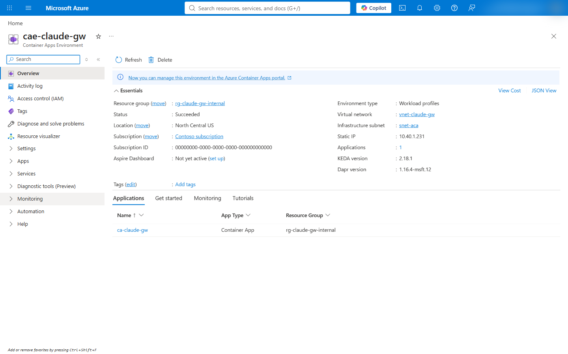
Screenshot of the overview of cae-claude-gw: environment type Workload profiles, virtual network vnet-claude-gw, infrastructure subnet snet-aca, static IP 10.40.1.231, one application ca-claude-gw.
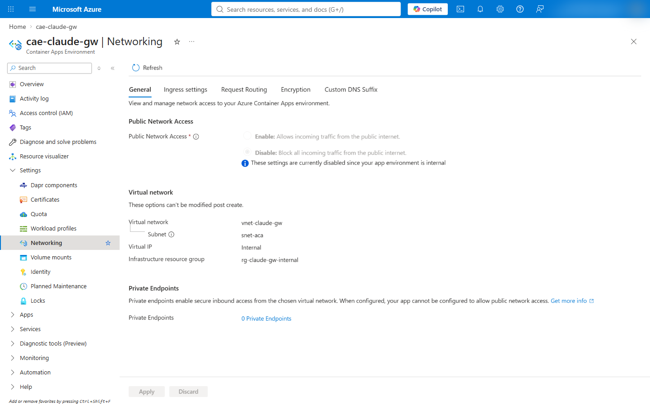
Screenshot of the Networking page of cae-claude-gw: public network access disabled because the environment is internal, virtual network vnet-claude-gw, subnet snet-aca, virtual IP Internal.
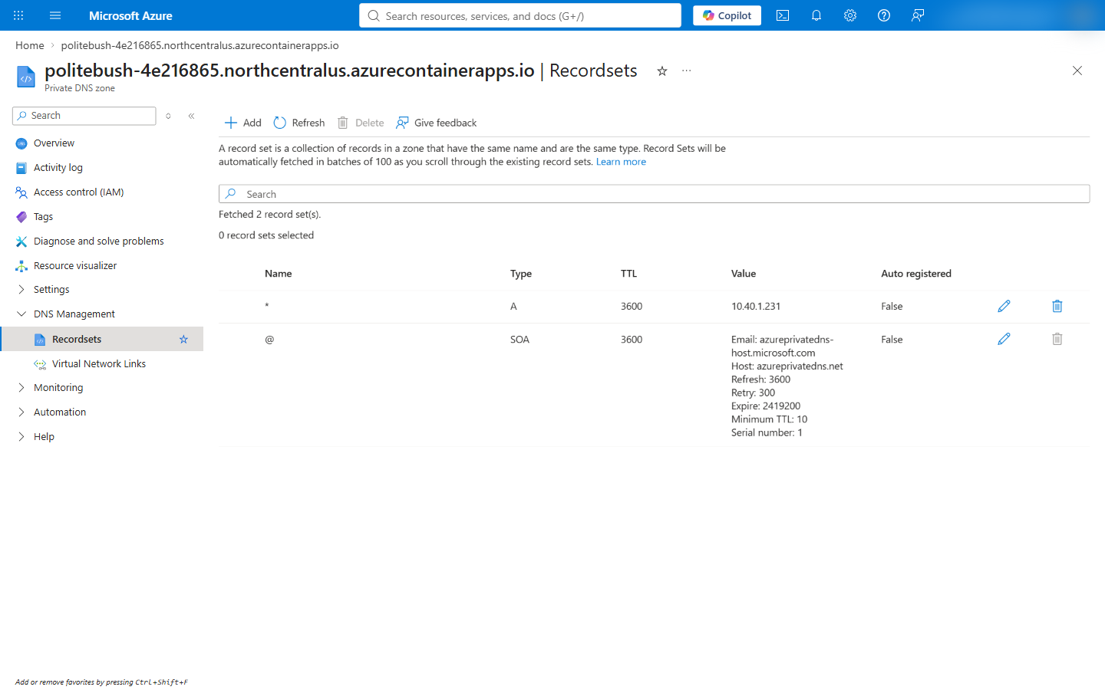
Screenshot of the record sets of the private DNS zone named after the environment's default domain, with a wildcard A record for the environment's static IP.

Azure CLI
az monitor log-analytics workspace create -g $rg -n log-claude-gw --location $location --retention-time 30
$workspaceId = az monitor log-analytics workspace show -g $rg -n log-claude-gw --query customerId -o tsv
$workspaceKey = az monitor log-analytics workspace get-shared-keys -g $rg -n log-claude-gw --query primarySharedKey -o tsv
[IO.File]::WriteAllText("$work\workspace-key.txt", $workspaceKey)
$acaSubnetId = az network vnet subnet show -g $rg --vnet-name $vnet -n snet-aca --query id -o tsv
az containerapp env create -g $rg -n $environment --location $location --enable-workload-profiles true --infrastructure-subnet-resource-id $acaSubnetId --internal-only true --logs-destination log-analytics --logs-workspace-id $workspaceId --logs-workspace-key "@$work\workspace-key.txt"

$domain = az containerapp env show -g $rg -n $environment --query properties.defaultDomain -o tsv
$staticIp = az containerapp env show -g $rg -n $environment --query properties.staticIp -o tsv
az network private-dns zone create -g $rg -n $domain
az network private-dns link vnet create -g $rg -z $domain -n "link-$vnet" -v $vnet -e false
az network private-dns record-set a add-record -g $rg -z $domain -n "*" -a $staticIp
The environment in this tutorial got the default domain politebush-4e216865.northcentralus.azurecontainerapps.io
and the static IP 10.40.1.231.

Script
pwsh -File infra/azure-private/Deploy-Gateway.ps1 -Step environment
The step is in infra/azure-private/lib/Steps.App.psm1:5-38.

Step 8: Register the gateway in Microsoft Entra ID
The gateway is a confidential OpenID Connect client. Its redirect URI is <public URL>/oauth/callback, Entra ID
issues v2.0 tokens, and the gateway admits a user whose token carries one of its app roles in the roles claim
(identity provider setup;
config/gateway.azure-private.yaml:22-23). The app roles, the email optional claim and the delegated permissions
openid, profile, email and offline_access come from infra/azure-test/entra-app.json.

Azure portal
- Microsoft Entra ID > App registrations > New registration: name claude-apps-gateway-private-<suffix>,
single tenant, redirect URI Web https://ca-claude-gw.<default domain>/oauth/callback
(register an application).
- The app > App roles > Create app role: Gateway.Standard and Gateway.Premium, allowed member types
Users/Groups (app roles).
- Token configuration > Add optional claim: ID token, email.
- Manifest: api.requestedAccessTokenVersion = 2
(app manifest).
- Certificates & secrets > New client secret: Expires set to a custom 7 days, or the period the
organization's credential policy sets; the gateway reads the secret as OIDC_CLIENT_SECRET in step 9
(add a client secret).
- Enterprise applications > the app > Users and groups > Add user/group: a user or group, with a role
(assign users and groups).
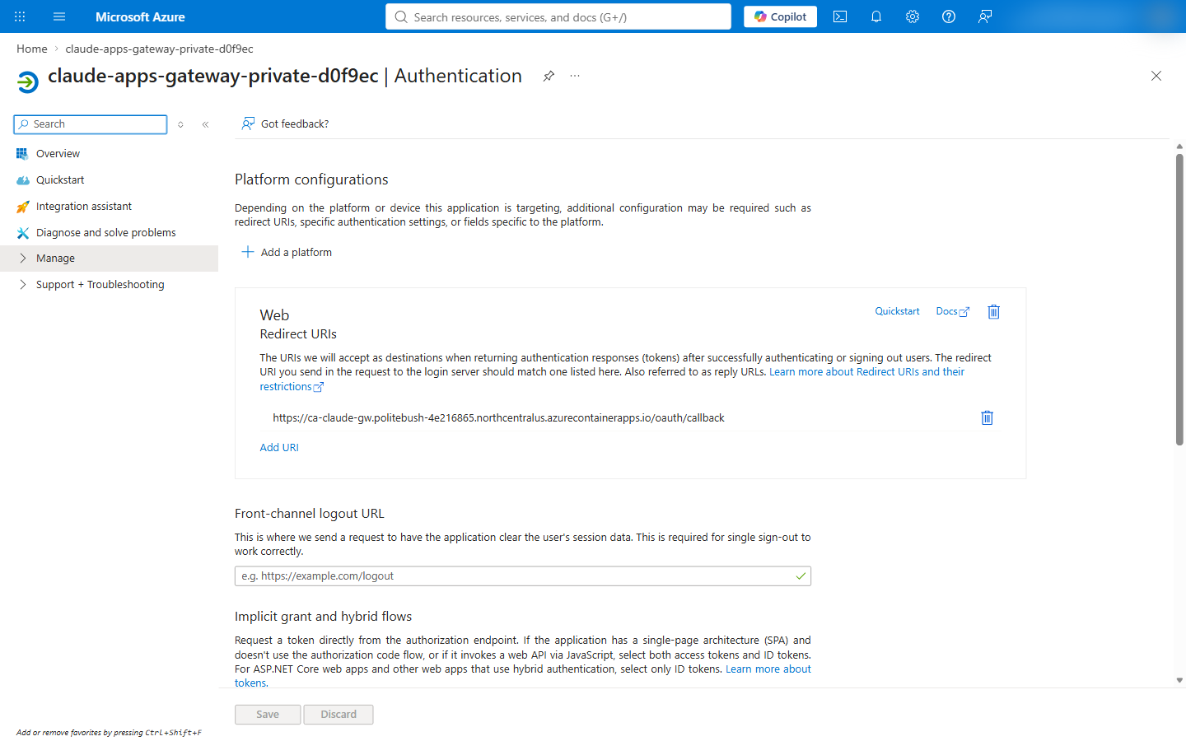
Screenshot of the Authentication page of the app registration with the Web redirect URI https://ca-claude-gw.politebush-4e216865.northcentralus.azurecontainerapps.io/oauth/callback.
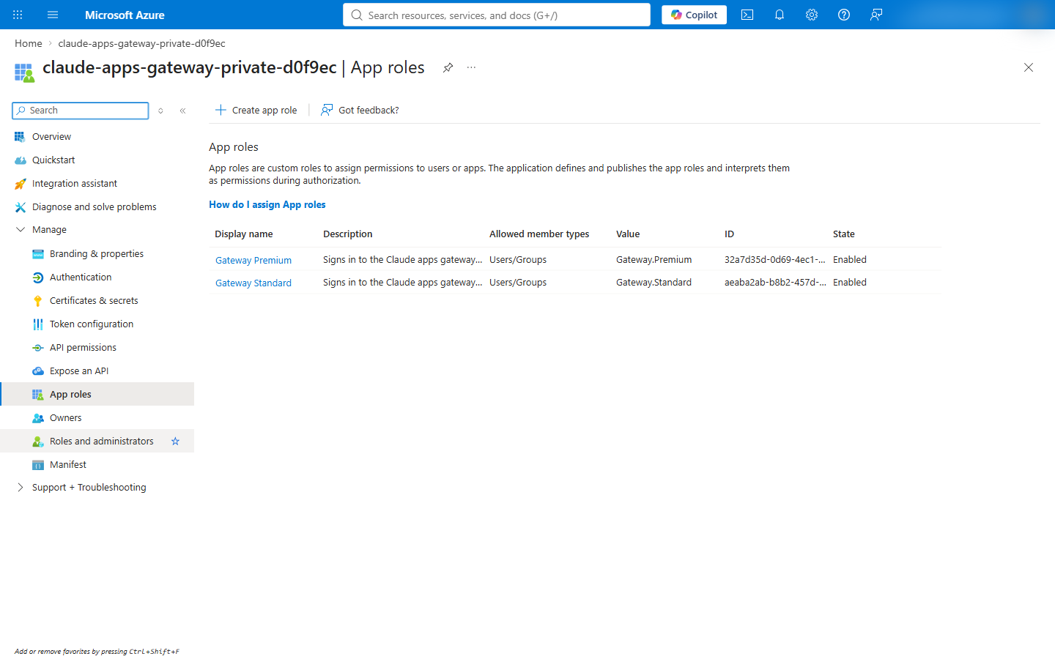
Screenshot of the App roles page of the app registration listing Gateway.Standard and Gateway.Premium.

Azure CLI
$manifest = Get-Content infra/azure-test/entra-app.json -Raw | ConvertFrom-Json
ConvertTo-Json -Depth 10 -InputObject $manifest.appRoles | Set-Content "$work\app-roles.json"
ConvertTo-Json -Depth 10 -InputObject $manifest.optionalClaims | Set-Content "$work\optional-claims.json"
ConvertTo-Json -Depth 10 -InputObject $manifest.requiredResourceAccess | Set-Content "$work\graph-access.json"

$appId = az ad app create --display-name "claude-apps-gateway-private-$suffix" --sign-in-audience AzureADMyOrg --web-redirect-uris "https://$app.$domain/oauth/callback" --app-roles "@$work\app-roles.json" --optional-claims "@$work\optional-claims.json" --required-resource-accesses "@$work\graph-access.json" --query appId -o tsv
az ad app update --id $appId --set api.requestedAccessTokenVersion=2
$spId = az ad sp create --id $appId --query id -o tsv

# Give yourself Gateway.Premium; other users and groups get a role the same way, or in the portal.
$premium = ($manifest.appRoles | Where-Object value -eq 'Gateway.Premium').id
$me = az ad signed-in-user show --query id -o tsv
@{ principalId = $me; resourceId = $spId; appRoleId = $premium } | ConvertTo-Json | Set-Content "$work\role-assignment.json"
az rest --method POST --url "https://graph.microsoft.com/v1.0/servicePrincipals/$spId/appRoleAssignedTo" --body "@$work\role-assignment.json" --headers Content-Type=application/json
A new service principal can take a few seconds to reach Microsoft Graph; the script retries the role assignment
(infra/azure-private/lib/Steps.App.psm1:69-73).

Script
pwsh -File infra/azure-private/Deploy-Gateway.ps1 -Step entra -OperatorRole Gateway.Premium
The script creates the client secret in the app step, valid for -ClientSecretDays days (default 7). With
-RotateClientSecret it adds a new secret and restarts the latest revision, because a changed secret reaches a
revision only when the revision restarts or a new one is deployed
(manage secrets;
infra/azure-private/lib/Steps.App.psm1:118-121). The old secret stays valid until it expires, since --append keeps it.

Step 9: Configure and deploy the gateway
The gateway reads gateway.yaml, rendered from the admin file config/gateway-admin.azure-private.json: the app
roles it admits, the models and their Foundry deployments, a policy per role with its availableModels, the networks
developers connect from, and the sign-in limits (scripts/admin/new-gateway-config.mjs:196-236). Values specific to the
deployment and every secret are ${VAR} references that the Container App sets as environment variables
(secret expansion).
The configuration's network settings for this topology:
listen:
public_url: "${GATEWAY_PUBLIC_URL}"
trusted_proxies: [100.100.0.0/17, 100.100.128.0/19, 100.100.160.0/19, 100.100.192.0/19] # where the ingress connects from
store:
max_connections: 5
readiness_grace_seconds: 300 # keeps /readyz ready through a database failover
upstreams:
- provider: foundry
resource: "${FOUNDRY_RESOURCE}"
auth: { use_azure_ad: true }
access_control:
allow_cidrs: [10.40.0.0/16] # deployment.developerCidrs in the admin file
The full file is config/gateway.azure-private.yaml:8-73. trusted_proxies names the ranges a workload profile
environment reserves, where the Container Apps ingress connects from; the ingress puts the client's address rightmost
in X-Forwarded-For, so the gateway sees each developer's own address, and a developer cannot set X-Forwarded-For
to take another address's sign-in limit (docs/adr/0005-network-restricted-deployment.md:75-88). The gateway container's
secrets and settings:
Setting | Value | Portal location
Image | acrclaudegw<suffix>.azurecr.io/claude-gateway@<digest>, pulled with id-claude-gw | Containers > Edit and deploy
Command and arguments | /usr/local/bin/claude with gateway --config /etc/claude/gateway.yaml | Containers > the container
CPU and memory | 1 vCPU, 2 GiB | Containers > the container
Secrets | gateway-config (the rendered YAML), oidc-client-secret, jwt-secret, pg-password | Security > Secrets
Volume | Secret volume gateway-config with the file gateway.yaml, mounted at /etc/claude | Containers > Volumes
Environment variables | Listed in the CLI tab | Containers > the container > Environment variables
Health probes | Startup and liveness on /healthz, readiness on /readyz, port 8080 | Containers > the container > Health probes
Ingress | Enabled, Limited to VNet, HTTP, target port 8080 | Networking > Ingress
Scale | 2 to 3 replicas, HTTP rule of 150 concurrent requests | App > Scale
Identity | User assigned: id-claude-gw | Security > Identity

The readiness probe on /readyz fails when the store is unreachable
(health).
CLAUDE_GATEWAY_DRAIN_TIMEOUT_MS gives open streams two minutes when a replica stops, and the termination grace
period is 10 seconds longer (upgrades).
BUN_CONFIG_MAX_HTTP_REQUESTS is how many requests a replica sends upstream at once
(concurrent upstream requests).

Azure portal
- Render the configuration with the CLI tab's node scripts/admin/new-gateway-config.mjs --topology private.
- Container Apps > Create: name ca-claude-gw, environment cae-claude-gw; Container: the image from
acrclaudegw<suffix> with managed identity id-claude-gw, CPU and memory from the table; Ingress: enabled,
Limited to VNet, target port 8080 (portal quickstart).
- Security > Secrets > + Add, once for each secret in the table
(manage secrets).
- Containers > Edit and deploy: the command, arguments, environment variables, the secret volume at
/etc/claude (secret volumes)
and the probes (health probes); Scale:
minimum 2, maximum 3, an HTTP rule with 150 concurrent requests
(scale rules) > Create.
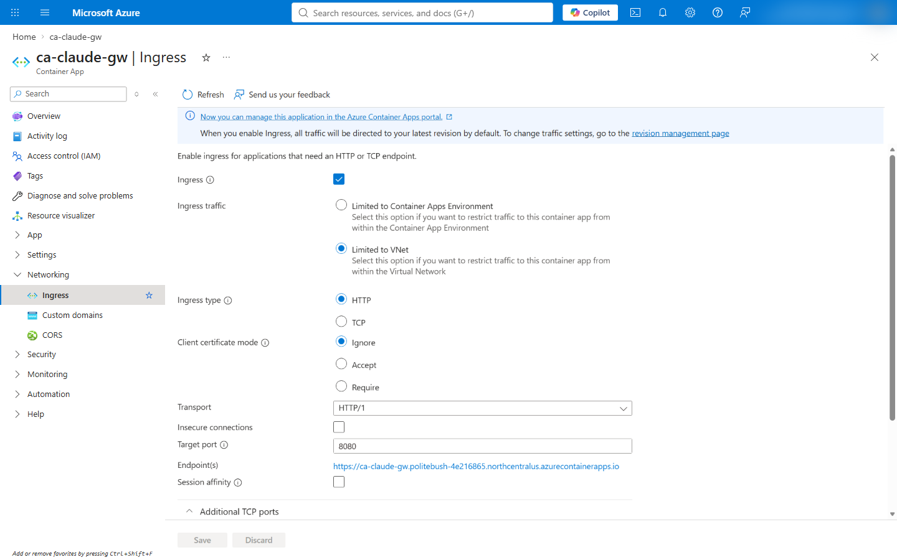
Screenshot of the Ingress page of ca-claude-gw: ingress enabled, traffic limited to the virtual network, HTTP, target port 8080, and the endpoint on the environment's default domain.
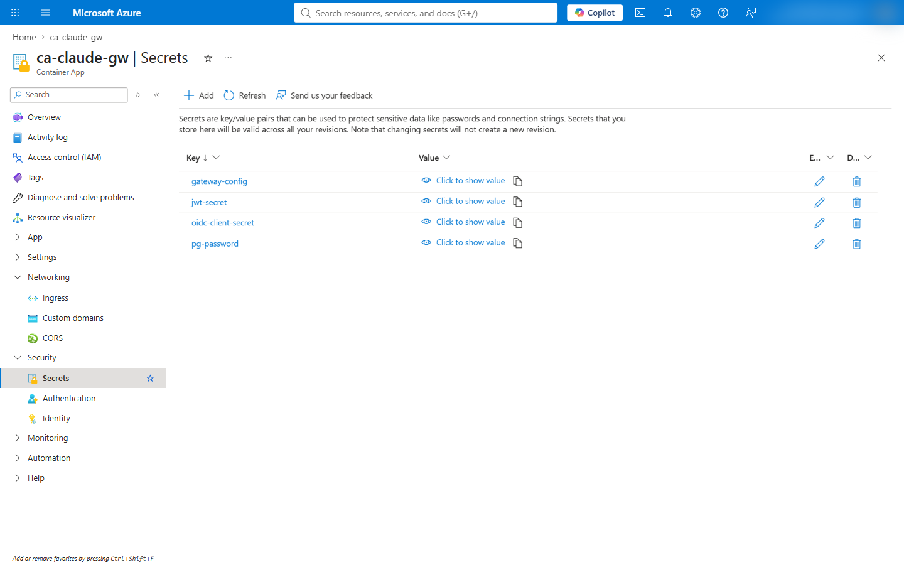
Screenshot of the Secrets page of ca-claude-gw listing gateway-config, jwt-secret, oidc-client-secret and pg-password with hidden values.

Azure CLI
Render the configuration, create the client secret, valid for 7 days like the script's default, and the
session-signing secret, then write the app definition. The organization's credential policy sets the client secret's
lifetime (add a client secret):
node scripts/admin/new-gateway-config.mjs --topology private
$end = [DateTime]::UtcNow.AddDays(7).ToString('yyyy-MM-ddTHH:mm:ssZ')
$oidcSecret = az ad app credential reset --id $appId --append --display-name gateway --end-date $end --query password -o tsv
$jwtSecret = [Convert]::ToBase64String([Security.Cryptography.RandomNumberGenerator]::GetBytes(48))
$environmentId = az containerapp env show -g $rg -n $environment --query id -o tsv
$config = (Get-Content config/gateway.azure-private.yaml | ForEach-Object { " $_" }) -join "`n"

$definition = @"
location: $location
identity:
type: UserAssigned
userAssignedIdentities:
"$identityId": {}
properties:
environmentId: "$environmentId"
workloadProfileName: Consumption
configuration:
activeRevisionsMode: Single
ingress: { external: true, targetPort: 8080, transport: http, allowInsecure: false }
registries:
- { server: "$acr.azurecr.io", identity: "$identityId" }
secrets:
- name: gateway-config
value: |
$config
- { name: oidc-client-secret, value: "$oidcSecret" }
- { name: jwt-secret, value: "$jwtSecret" }
- { name: pg-password, value: "$pgPassword" }
template:
terminationGracePeriodSeconds: 130
containers:
- name: gateway
image: "$image"
command: [/usr/local/bin/claude]
args: [gateway, --config, /etc/claude/gateway.yaml]
resources: { cpu: 1.0, memory: 2Gi }
env:
- { name: CLAUDE_GATEWAY_LOG_LEVEL, value: info }
- { name: AZURE_CLIENT_ID, value: "$identityClientId" }
- { name: GATEWAY_PUBLIC_URL, value: "https://$app.$domain" }
- { name: OIDC_ISSUER, value: "https://login.microsoftonline.com/$tenantId/v2.0" }
- { name: OIDC_CLIENT_ID, value: "$appId" }
- { name: ALLOWED_EMAIL_DOMAIN, value: "$allowedDomain" }
- { name: GATEWAY_PG_USER, value: gatewayadmin }
- { name: GATEWAY_PG_HOST, value: "$postgres.postgres.database.azure.com" }
- { name: FOUNDRY_RESOURCE, value: "$foundry" }
- { name: BUN_CONFIG_MAX_HTTP_REQUESTS, value: "256" }
- { name: CLAUDE_GATEWAY_DRAIN_TIMEOUT_MS, value: "120000" }
- { name: OIDC_CLIENT_SECRET, secretRef: oidc-client-secret }
- { name: GATEWAY_JWT_SECRET, secretRef: jwt-secret }
- { name: GATEWAY_PG_PASSWORD, secretRef: pg-password }
probes:
- { type: Startup, httpGet: { path: /healthz, port: 8080 }, initialDelaySeconds: 5, periodSeconds: 10, timeoutSeconds: 3, failureThreshold: 30 }
- { type: Liveness, httpGet: { path: /healthz, port: 8080 }, periodSeconds: 15, timeoutSeconds: 3, failureThreshold: 3 }
- { type: Readiness, httpGet: { path: /readyz, port: 8080 }, periodSeconds: 10, timeoutSeconds: 3, failureThreshold: 3 }
volumeMounts:
- { volumeName: gateway-config, mountPath: /etc/claude }
volumes:
- { name: gateway-config, storageType: Secret, secrets: [{ secretRef: gateway-config, path: gateway.yaml }] }
scale:
minReplicas: 2
maxReplicas: 3
rules:
- { name: http-concurrency, http: { metadata: { concurrentRequests: "150" } } }
"@
[IO.File]::WriteAllText("$work\containerapp.yaml", $definition)

az containerapp create -g $rg -n $app --yaml "$work\containerapp.yaml" --output none
az containerapp show -g $rg -n $app --query "{latest:properties.latestRevisionName, ready:properties.latestReadyRevisionName, fqdn:properties.configuration.ingress.fqdn}"
The variables $identityId, $identityClientId, $image, $domain, $pgPassword and $appId come from steps 4
to 8, in the same PowerShell session; $work\pg-password.txt holds the PostgreSQL password for a new session. The
gateway admits a user who holds an app role and whose email claim ends with $allowedDomain
(config/gateway.azure-private.yaml:20-23). The app is ready when latest and ready name the same revision. The
definition's schema is the Container Apps ARM specification
(ARM and YAML specification),
and the script builds the same definition (infra/azure-private/lib/AppDefinition.psm1:6-85).

Script
pwsh -File infra/azure-private/Deploy-Gateway.ps1 -Step app -MinReplicas 2 -MaxReplicas 3 -ConcurrentRequests 150
The step checks that config/gateway.azure-private.yaml is the rendering of its admin file, creates the secrets, writes
the definition to a temporary folder, deploys it and waits for the revision to be ready
(infra/azure-private/lib/Steps.App.psm1:81-127).

Step 10: Create a test machine in the network (optional)
A Windows 11 VM in snet-dev stands in for a developer machine on the corporate network. It has no public IP and is
reached through Azure Bastion Developer, which needs no public IP or AzureBastionSubnet and connects to one VM at a
time (Bastion SKUs). Run Command installs
Claude Code, checked against the release checksum, and VS Code, and writes the machine policies that point Claude Code
and Claude Desktop at the gateway (Run Command;
infra/azure-private/lib/Steps.Dev.psm1:9-33).

Azure portal
- Virtual machines > Create: name vm-dev, region North Central US, image Windows 11 Enterprise,
size Standard_D4s_v5; Networking: vnet-claude-gw / snet-dev, public IP None, NIC network security
group None.
- The VM > Connect > Bastion: with the Developer SKU, Bastion deploys on first connect
(Bastion Developer).
- The VM > Operations > Run command > RunPowerShellScript: the setup script of the CLI tab.
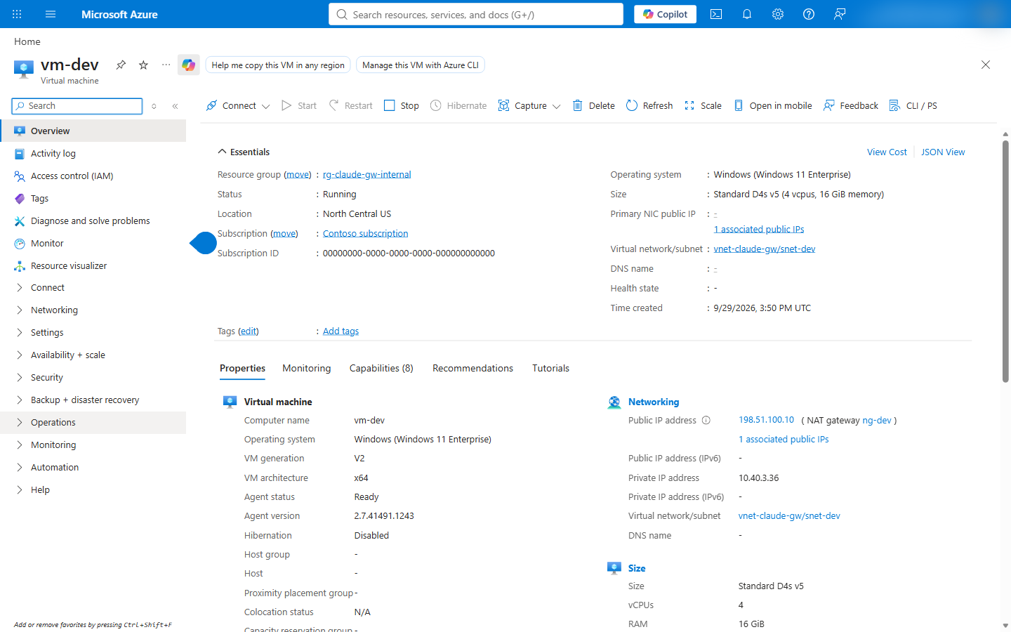
Screenshot of the overview of vm-dev: Windows 11 Enterprise in vnet-claude-gw / snet-dev with private IP address 10.40.3.36, no public IP address on its network interface, and outbound access through NAT gateway ng-dev.
The NAT gateway's public address in this screenshot is replaced with 198.51.100.10, a documentation address
(RFC 5737).

Azure CLI
The machine policies point Claude Code and Claude Desktop at this deployment's gateway; the file below holds them,
with the host name from step 7. Connect Claude Code, VS Code and Claude Desktop
describes both values:
$gatewayUrl = "https://$app.$domain"
$policy = @{ forceLoginMethod = 'gateway'; forceLoginGatewayUrl = $gatewayUrl; parentSettingsBehavior = 'merge' } | ConvertTo-Json -Compress
[IO.File]::WriteAllText("$work\vm-setup.txt", @"
New-Item -Path 'HKLM:\SOFTWARE\Policies\ClaudeCode' -Force | Out-Null
New-ItemProperty -Path 'HKLM:\SOFTWARE\Policies\ClaudeCode' -Name Settings -PropertyType String -Force -Value '$policy' | Out-Null
New-Item -Path 'HKLM:\SOFTWARE\Policies\Claude' -Force | Out-Null
New-ItemProperty -Path 'HKLM:\SOFTWARE\Policies\Claude' -Name bootstrapUrl -PropertyType String -Force -Value '$gatewayUrl/user/bootstrap' | Out-Null
"@)

# The VM's administrator password, for signing in through Bastion; keep it in the organization's credential store.
$vmPassword = ([Convert]::ToBase64String([Security.Cryptography.RandomNumberGenerator]::GetBytes(18)) -replace '[+/=]', '') + 'Aa1!'
[IO.File]::WriteAllText("$work\vm-password.txt", $vmPassword)
Create the VM and Bastion, then run the setup on the VM:
az vm create -g $rg -n vm-dev --location $location --image MicrosoftWindowsDesktop:windows-11:win11-25h2-ent:latest --size Standard_D4s_v5 --license-type Windows_Client --security-type TrustedLaunch --vnet-name $vnet --subnet snet-dev --public-ip-address '""' --nsg '""' --admin-username devadmin --admin-password "@$work\vm-password.txt" --output none
az network bastion create -g $rg -n bas-claude-gw --location $location --sku Developer --vnet-name $vnet
az vm run-command invoke -g $rg -n vm-dev --command-id RunPowerShellScript --scripts "@$work\vm-setup.txt"
In PowerShell, '""' passes an empty value to the Azure CLI, and "@file" is quoted because @ is special in
PowerShell (empty strings).
Run Command runs the file's lines as a PowerShell script on the VM
(Run Command). The script's setup also
installs Claude Code, checked against the release checksum, and VS Code (infra/azure-private/lib/Steps.Dev.psm1:12-29);
on a machine set up by hand, Claude Code installs with Anthropic's installer
(set up Claude Code).

Script
pwsh -File infra/azure-private/Deploy-Gateway.ps1 -Step devvm
pwsh -File infra/azure-private/Deploy-Gateway.ps1 -ShowDevVmPassword
The script saves the VM password for the current Windows user with DPAPI; -ShowDevVmPassword prints the user name
and the password (infra/azure-private/lib/Steps.Dev.psm1:38-50).

Step 11: Verify the deployment
From inside the network, every host name resolves to a private address and the gateway reports ready; from outside,
Foundry refuses a request. The verify step runs these checks on the test machine with Run Command and on the
operator's machine (infra/azure-private/lib/Steps.Dev.psm1:80-121).

Azure portal
- The test machine > Connect > Bastion, then in PowerShell on the VM:
Resolve-DnsName ca-claude-gw.<default domain> and Invoke-WebRequest https://ca-claude-gw.<default domain>/readyz.
- Container Apps > ca-claude-gw > Overview: status Running and the application URL on the default domain.
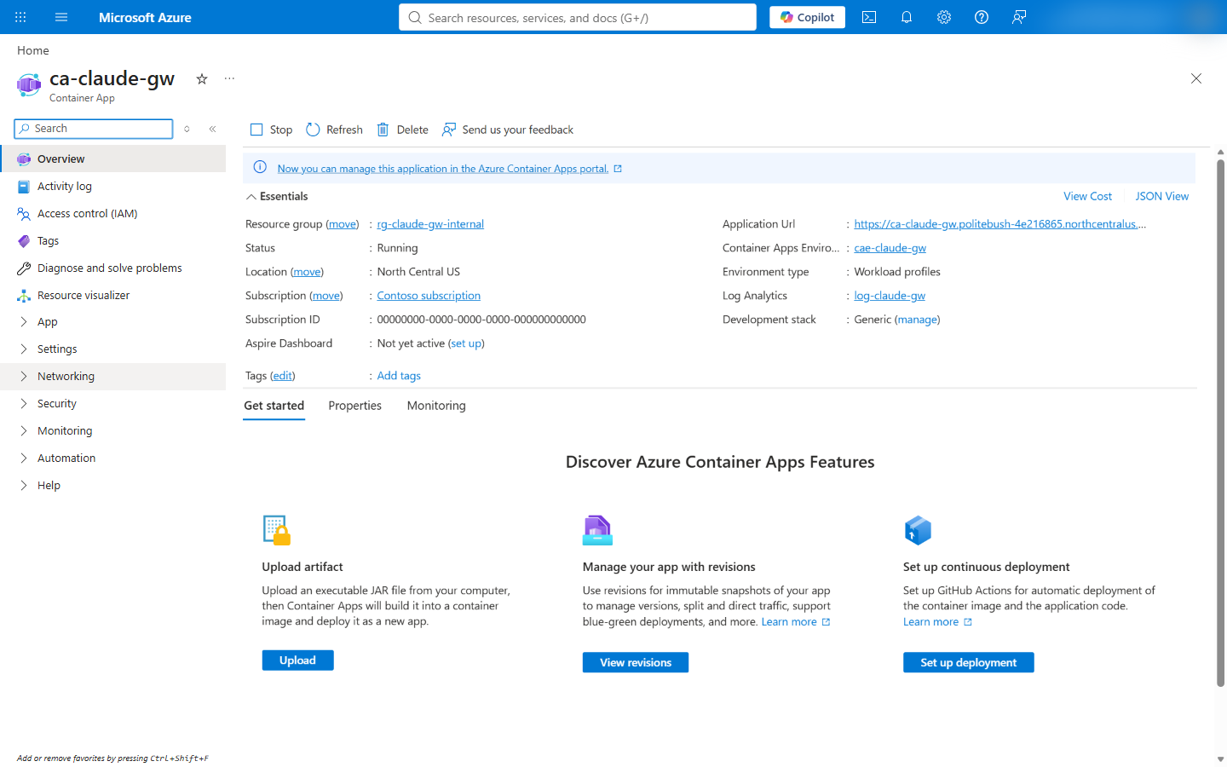
Screenshot of the overview of ca-claude-gw: status Running, location North Central US, environment cae-claude-gw, application URL on the environment's default domain.

Azure CLI
The checks run on the test machine with Run Command, for this deployment's host name; the last command reads
PostgreSQL's public access setting:
[IO.File]::WriteAllText("$work\vm-check.txt", @"
Resolve-DnsName $app.$domain -Type A
(Invoke-WebRequest -UseBasicParsing https://$app.$domain/readyz).StatusCode
"@)
az vm run-command invoke -g $rg -n vm-dev --command-id RunPowerShellScript --scripts "@$work\vm-check.txt"
az postgres flexible-server show -g $rg -n $postgres --query network.publicNetworkAccess -o tsv

Script
pwsh -File infra/azure-private/Deploy-Gateway.ps1 -Step verify
PASS gateway host resolves to private addresses only (T-16)
PASS gateway /readyz answers 200 inside the VNet (T-16)
PASS PostgreSQL resolves to a private address (T-69)
PASS Foundry resolves to the private endpoint (T-68)
PASS Foundry refuses a request from outside the VNet: 403 (T-68)
PASS PostgreSQL public network access is Disabled (T-69)
addresses: gateway 10.40.1.231 postgres 10.40.3.4 foundry 10.40.2.6

Connect developers
Claude Code, the VS Code extension and Claude Desktop read the gateway's address from machine policy, which Intune or
Group Policy delivers; a developer cannot configure the gateway sign-in in their own settings
(set the gateway URL). The client setup,
the sign-in, and the network each developer machine needs are in
Connect Claude Code, VS Code and Claude Desktop.
At the first sign-in, Claude Code shows the first 16 hexadecimal characters of the SHA-256 fingerprint of the
gateway's certificate, and pins the certificate for the host name
(connect developers). The fingerprint the
verify step printed for this deployment starts with 2fbc49857fa6e209.

Run the whole deployment with the script
The script runs every step in order, creating what is missing (infra/azure-private/Deploy-Gateway.ps1:111-131):
# Print the commands without changing anything.
pwsh -File infra/azure-private/Deploy-Gateway.ps1 -Plan -ClaudeOrganizationName 'Contoso Ltd'
# Deploy.
pwsh -File infra/azure-private/Deploy-Gateway.ps1 -ClaudeOrganizationName 'Contoso Ltd'
# Deploy chosen steps; later steps read the names earlier steps created.
pwsh -File infra/azure-private/Deploy-Gateway.ps1 -Step app,verify
Every parameter is in the script reference (docs/learn/reference-scripts.md). A re-run reuses existing
resources and reports each with FOUND. It can also reconcile settings that drifted: Foundry's public access and key
authentication, the DNS records, the role assignments, the Entra app's redirect URI and role assignment. It recovers
secrets it cannot read, such as setting a new PostgreSQL password, runs the test machine's setup again, and updates
the Container App with PATCH semantics (infra/azure-private/lib/Steps.Base.psm1:52-53;
infra/azure-private/lib/Steps.App.psm1:44-48; infra/azure-private/lib/Steps.App.psm1:98-103;
infra/azure-private/lib/Steps.Dev.psm1:73-74). -Plan lists what a re-run would change.

Results of the test deployment
Measured on 2026-09-29 with pwsh -File infra/azure-private/Deploy-Gateway.ps1, gateway image Claude Code 2.1.284.
Verified: network isolation, name resolution, readiness, certificate trust, and Claude in Foundry answering the
gateway's managed identity through the private endpoint from inside the gateway container (docs/UNKNOWNS.md:68). From
the test machine, Claude Code's /login showed the gateway's certificate fingerprint and got its code accepted by the
gateway, which handed the browser to Microsoft Entra ID (docs/TEST-PLAN.md:280-281). Not yet verified: the Entra
sign-in and a signed-in request through the gateway, which waited on the tester's multifactor authentication, and the
VS Code extension and Claude Desktop sign-ins.
Check | Result
Gateway host name inside the network | Resolves to 10.40.1.231 only; /readyz answers 200
PostgreSQL host name inside the network | Resolves to 10.40.3.4; public network access Disabled
Foundry host names inside the network | Resolve to 10.40.2.4, 10.40.2.5 and 10.40.2.6 (the private endpoint)
Foundry from outside the network | 403 with a valid Entra ID token
Foundry from the gateway container, with the gateway's managed identity | claude-sonnet-5 answered 200 through the private endpoint, 10.40.2.6
Gateway certificate | Issuer Microsoft TLS G2 RSA CA OCSP 02, valid 2026-09-28 to 2027-01-06 (100 days), chain trusted by Windows (docs/UNKNOWNS.md:67)
Region | North Central US; Central US refused a new environment with AKSCapacityHeavyUsage (docs/UNKNOWNS.md:74)

The environment's default domain carries a certificate that the platform issues and renews. Each renewal changes the
pinned certificate, and Claude Code shows each developer the trust prompt again
(connect developers), so a production
deployment uses a custom domain with a certificate whose rotation the organization schedules
(docs/adr/0005-network-restricted-deployment.md:68).

Troubleshooting
The gateway's own boot and sign-in errors are in the
gateway troubleshooting table. These are
specific to this deployment on Azure:
Symptom | Cause | Fix | Reference
az containerapp env create fails with AKSCapacityHeavyUsage: "Creating a new cluster is unavailable at this time in region ..." | The region has no capacity for a new environment | Create the network and the environment in another region; the Foundry account can stay where the quota is | docs/UNKNOWNS.md:74
az postgres flexible-server create is refused for the region | The subscription is restricted from PostgreSQL flexible server in that region | Choose a region where az postgres flexible-server list-skus -l <region> lists the tier | docs/UNKNOWNS.md:74
A Claude deployment is refused | The deployment has no modelProviderData block | Include organizationName, countryCode and industry | https://learn.microsoft.com/en-us/azure/developer/ai/how-to/deploy-claude-foundry#terms-of-use
az acr build output does not parse as JSON | Without --no-logs, the CLI prints the build log | Add --no-logs, then read status from the JSON | tests/azure-private.test.mjs:120-130
az network private-endpoint dns-zone-group show returns {} with exit code 0 | The group does not exist; the CLI answers with an empty object | Treat an empty object as missing | infra/azure-private/lib/Az.psm1:85-87
/login: "Gateway hosts must be on your organization's private network; resolves to the public (or unrecognized) address " | The developer's DNS does not resolve the gateway's zone to the private IP | Forward the default domain's zone, or the custom domain's zone, to the private DNS zone through a DNS Private Resolver | https://code.claude.com/docs/en/claude-apps-gateway-on-aws#troubleshooting
/login gets 403; the gateway logs access.denied with reason ip_not_allowlisted and a client_ip in 100.100.0.0/16 | listen.trusted_proxies does not name the addresses the Container Apps ingress connects from, so the gateway checks the ingress's address against access_control.allow_cidrs; /readyz still answers, because health probes are exempt | Name the four ranges a workload profile environment reserves in trusted_proxies, as config/gateway.azure-private.yaml:14 does | docs/adr/0005-network-restricted-deployment.md:79-87
The revision does not become ready | /readyz fails while PostgreSQL is unreachable: a missing zone link, or a wrong password | Read the console log, then check the PostgreSQL zone's link and the pg-password secret | https://code.claude.com/docs/en/claude-apps-gateway-deploy#health
During a rollout the new replicas log remaining connection slots are reserved for roles with the SUPERUSER attribute | The old revision's replicas still hold their connections while the new ones open theirs, and together they exceed the server's user connections | Keep 2 × maximum replicas × store.max_connections within the server's user connections, or choose a larger PostgreSQL size | tests/azure-private.test.mjs:135-138
/login times out; the gateway logs Postgres is not answering, then, after store.readiness_grace_seconds, that /readyz reports not ready | The PostgreSQL server is stopped or unreachable. On 2026-09-29 an automated job of the test subscription stopped it (activity log: "Stops an existing server"); new sign-ins need the store, so the ingress stops routing to replicas that are not ready | Start the server with az postgres flexible-server start, and exclude it from automation that stops idle servers; the gateway reports ready again once PostgreSQL answers | https://code.claude.com/docs/en/claude-apps-gateway-deploy#outage-behavior
Inference fails with 401 or 403 from Foundry | The gateway's identity lacks Cognitive Services User on the account, or the assignment has not propagated | Assign the role on the Foundry account and retry after a few minutes | https://code.claude.com/docs/en/claude-apps-gateway-config#microsoft-foundry

Logs and telemetry
The gateway writes single-line JSON audit events and operational lines to stderr
(logs). Container Apps sends them to the
ContainerAppConsoleLogs_CL table of the environment's Log Analytics workspace
(log monitoring):
az containerapp logs show -g $rg -n $app --type console --tail 50
ContainerAppConsoleLogs_CL
| where ContainerAppName_s == 'ca-claude-gw'
| where Log_s has '"evt":"inference"'
| project TimeGenerated, Log_s
An inference event names the user, the model, the upstream and the response status (tests/live/lib.mjs:177-185).
Client metrics, logs and traces reach a collector through the gateway when telemetry.forward_to names one
(telemetry).

Clean up resources
Deleting the resource group deletes every resource of this tutorial. The app registration is in Entra ID, outside the
resource group, and a deleted Foundry account stays recoverable until it is purged
(purge a deleted resource):
az group delete -n $rg --yes
az ad app delete --id $appId
az cognitiveservices account purge -g $rg -n $foundry -l $foundryLocation
The folder $work holds the secret files of the CLI steps, including after a failed or interrupted step. A deployment
that keeps running needs none of them, since the Container App holds its secrets, so the folder can go as soon as the
gateway is ready and the VM password is in the organization's credential store:
Remove-Item -Recurse -Force $work

Next steps
Connect Claude Code, VS Code and Claude Desktop
- Plan capacity for 25,000 developers
- Configure models, roles and developer access (docs/learn/how-to-admin-configure.md)
- Script reference (docs/learn/reference-scripts.md)

Connect Claude Code, VS Code and Claude Desktop to the gateway
Deploy Windows client policies with Intune or Group Policy and connect Claude Code, its VS Code extension and Claude Desktop through the gateway's interactive sign-in.
This article configures Windows machines for the network-restricted Azure deployment, with Microsoft Entra ID sign-in
and Microsoft Foundry upstreams. Production uses a custom domain with the organization's certificate
(docs/adr/0005-network-restricted-deployment.md:65-74); the example URL is https://claude-gateway.corp.contoso.com.
A custom domain replaces the default host name in four places: a private DNS record, a certificate bound to the
Container App (custom domains and certificates),
GATEWAY_PUBLIC_URL, which is the gateway's listen.public_url, and the Entra redirect URI <origin>/oauth/callback.
Deploy-Gateway.ps1 sets the last two from the default host name (infra/azure-private/lib/AppDefinition.psm1:16;
infra/azure-private/lib/Steps.App.psm1:44). Until that change, the client values use
https://ca-claude-gw.<environment default domain>.
Client | Machine setting | Sign-in | Minimum version | Source
Claude Code CLI | forceLoginMethod, forceLoginGatewayUrl, parentSettingsBehavior in Claude Code managed settings | /login, then gateway device-code approval in a browser | Claude Code 2.1.195 | Prerequisites, login keys
Claude Code extension for VS Code | The same machine-level Claude Code settings | Panel sign-in and browser authorization; gateway-specific screens are not documented | VS Code 1.94.0; no extension-specific gateway minimum is documented | Extension prerequisites, first use, policy surfaces
Claude Desktop | bootstrapUrl under HKLM\SOFTWARE\Policies\Claude; keep the Claude Code merge opt-in too | Its own gateway device-code sign-in; not the CLI session | Desktop 1.10628.0 for bootstrapUrl; gateway 2.1.203 | Bootstrap keys, Desktop connection

Prerequisites
- Complete Deploy the network-restricted gateway; use its HTTPS hostname and a trusted certificate (TLS requirements).
- Connect the machine and sign-in browser to the corporate network or VPN, with private-zone DNS forwarding (DNS Private Resolver).
- Install the listed clients; check the standalone CLI with claude --version. The extension bundles its own CLI (VS Code prerequisites).
- A CLAUDE_CODE_USE_* provider variable, such as CLAUDE_CODE_USE_FOUNDRY, selects that provider directly, without the gateway sign-in (set the gateway URL).
- Have Node.js 22 or later for the generator (docs/learn/reference-scripts.md:13), and administrator rights or device management for HKLM (delivery mechanisms).
- Assign a user, or groups for the 25,000-developer rollout, to Gateway.Standard or Gateway.Premium on the gateway's
enterprise application (config/gateway.azure-private.yaml:22-23). This deployment names its app registration
claude-apps-gateway-private-<suffix> (infra/azure-private/Deploy-Gateway.ps1:84).
In the Microsoft Entra admin center, open Enterprise applications, select that gateway application, then
Users and groups > Add user/group. Select the user or group, choose Select a role, select the gateway role,
and select Assign. Group-based assignment requires Microsoft Entra ID P1 or P2; nested group memberships
do not grant access through the assignment (assign users, groups and roles).

Network requirements for developer machines
The deployment constructs https://ca-claude-gw.<environment default domain> and links a private DNS zone with a
wildcard A record pointing to the environment's static IP (infra/azure-private/lib/Steps.App.psm1:23-31).
Forward that zone from corporate DNS to an Azure DNS Private Resolver inbound endpoint; give a custom hostname private resolution too
(inbound endpoints).
From a developer machine, check resolution and connectivity:
Resolve-DnsName claude-gateway.corp.contoso.com
Test-NetConnection claude-gateway.corp.contoso.com -Port 443
Every address must be RFC 1918, CGNAT 100.64.0.0/10, link-local, IPv6 ULA fc00::/7, or loopback; a public A or AAAA answer fails /login (private-network requirement).
Destination | Port | Used for | Source
Gateway hostname, resolving to its private IP | TCP 443 | CLI and browser sign-in, Desktop bootstrap and model requests | Gateway prerequisites
login.microsoftonline.com and the documented authentication hosts, including *.msauth.net and *.aadcdn.msftauth.net | TCP 443 | Entra browser sign-in and its page resources; use the full authentication list for your environment | Microsoft authentication endpoints
claude.ai | TCP 443 | Downloading the native CLI installation script, if using Anthropic's installer | Install Claude Code
downloads.claude.ai | TCP 443 | CLI native binaries and updates; Desktop session components, model catalog and update binaries | CLI network access, Desktop egress
claude.ai, api.anthropic.com; alternatively releases.claude.com with updateViaUpdatesHost | TCP 443 | Desktop update feeds when auto-updates are enabled | Desktop egress

Export Desktop's Egress list for all enabled telemetry, services and connectors; this table is not a complete feature allowlist (Desktop egress).
The offline installer bundles session components, but its catalog still uses downloads.claude.ai unless disabled or mirrored (MDM egress).
Add the gateway hostname to NO_PROXY, retaining other entries: HTTPS-proxied CLI requests skip certificate pinning (pinning).
Desktop's app follows its own OS or managed proxy configuration, not the CLI shell variable (Desktop proxy).

Generate the policy files
From the repository root, use an empty output directory with the generator in Generate client payloads (docs/learn/how-to-admin-configure.md):
node scripts\admin\new-client-policy.mjs --gateway-url https://claude-gateway.corp.contoso.com --fast-model claude-sonnet-5 --out .\client-policy
Options and outputs: scripts/admin/new-client-policy.mjs:155-179. Windows policy locations define the destinations below.
Output | Purpose
login\managed-settings.json | File-based policy; install as C:\Program Files\ClaudeCode\managed-settings.json
login\ClaudeCode-HKLM.reg | The same JSON as the Settings string value under HKLM\SOFTWARE\Policies\ClaudeCode
login\ClaudeCode.mobileconfig | macOS configuration profile; not used on Windows
developer\ | Alternative apiKeyHelper profile and instructions; do not deploy alongside forced gateway login

The login payload contains these three keys (scripts/admin/new-client-policy.mjs:46):
{
"forceLoginMethod": "gateway",
"forceLoginGatewayUrl": "https://claude-gateway.corp.contoso.com",
"parentSettingsBehavior": "merge"
}
The login keys require an administrator-managed source on the machine, not user/project settings, HKCU or the gateway's managed.policies[].cli
(client-side settings).
--fast-model affects only the alternative developer folder's install command (scripts/admin/new-client-policy.mjs:97-98).
The generator does not write Desktop's policy. Add this separate REG_SZ value (Desktop value types):
reg add "HKLM\SOFTWARE\Policies\Claude" /v bootstrapUrl /t REG_SZ /d "https://claude-gateway.corp.contoso.com/user/bootstrap" /f
Equivalent .reg content:
Windows Registry Editor Version 5.00

[HKEY_LOCAL_MACHINE\SOFTWARE\Policies\Claude]
"bootstrapUrl"="https://claude-gateway.corp.contoso.com/user/bootstrap"
The VM setup downloads claude.exe, checks its release SHA-256, writes both HKLM policies and installs VS Code (infra/azure-private/lib/Steps.Dev.psm1:17-29).

Deliver the policy with Intune or Group Policy
Registry policy replaces the managed settings file by default. Keep all three keys and other required controls in one complete JSON value (source precedence).
Intune
- Use a PowerShell platform script to write both HKLM values, or a system-context Win32 app to import the .reg and set Desktop's value
(Intune Management Extension, Win32 install context).
The packaged installer can run reg import .\client-policy\login\ClaudeCode-HKLM.reg, followed by the Desktop command above.
- For a platform script, open Devices > Scripts and remediations > Platform scripts > Add > Windows 10 and later.
Set Run this script using the logged on credentials to No (system context) and Run script in 64-bit PowerShell host to Yes
(script policy settings).
- Assign to a pilot device group; review Device status before expanding
(monitor run status).
Group Policy
- Edit the device GPO in Group Policy Management. Open Computer Configuration > Preferences > Windows Settings > Registry.
- Add Registry Item entries: action Update, hive HKEY_LOCAL_MACHINE, type REG_SZ.
Set SOFTWARE\Policies\ClaudeCode / Settings to the complete JSON; set SOFTWARE\Policies\Claude / bootstrapUrl to https://claude-gateway.corp.contoso.com/user/bootstrap
(configure a Registry item).
For 25,000 developers, stage assignments with sign-in instructions. NAT/VPN users share per-address sign-in limits
(large rollouts).
The sample sets 1,000 starts and 100 submissions per address per 600 seconds, not fleet-wide capacity (config/gateway.azure-private.yaml:71-73).

Sign in from Claude Code
- Open PowerShell and run claude.
- Enter /login; the Cloud gateway screen has the URL filled in. Press Enter (login screen).
- Compare the first-connect fingerprint with the administrator's published value: the first 16 lowercase hex
characters of the leaf certificate's SHA-256, without colons. Accept only a match (pinning).
- Open the verification link and confirm the code on the gateway's page. Sign in to Entra with the assigned work account;
the browser returns to /oauth/callback (device flow, callback).
- Run /status; Setting sources shows gateway policy as remote managed settings. Use /model for allowed models
(policy check, models).
On the test machine of the tutorial, Claude Code 2.1.284 showed these screens
on 2026-09-29 (docs/TEST-PLAN.md:280-281). After Enter on the Cloud gateway screen, it asks to trust the gateway
and shows the start of the certificate's SHA-256 fingerprint:
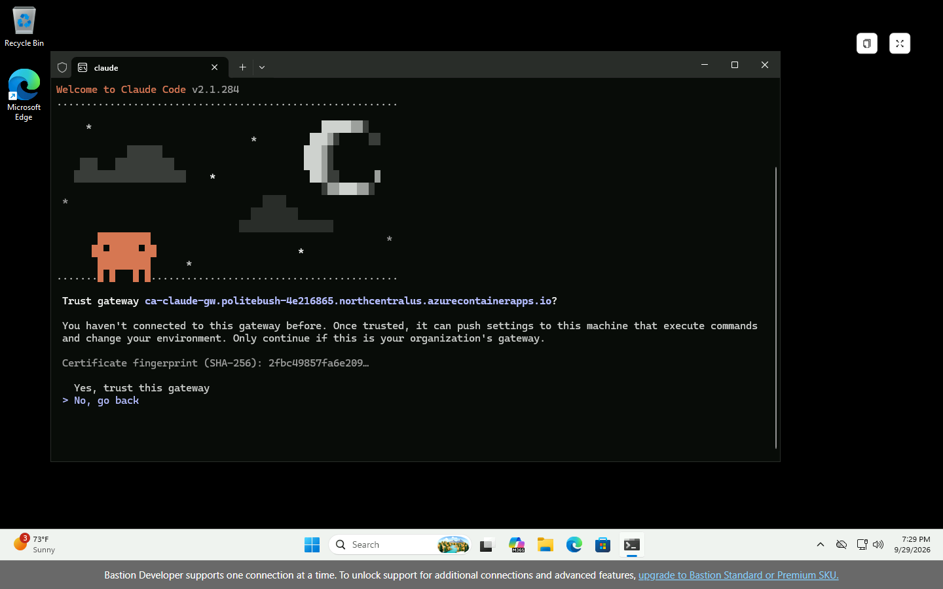
Screenshot of Claude Code asking Trust gateway ca-claude-gw on the environment's default domain, with the certificate fingerprint 2fbc49857fa6e209 and the choices Yes, trust this gateway and No, go back.
After the trust, it opens the browser, shows the code and the gateway's verification address, and waits:
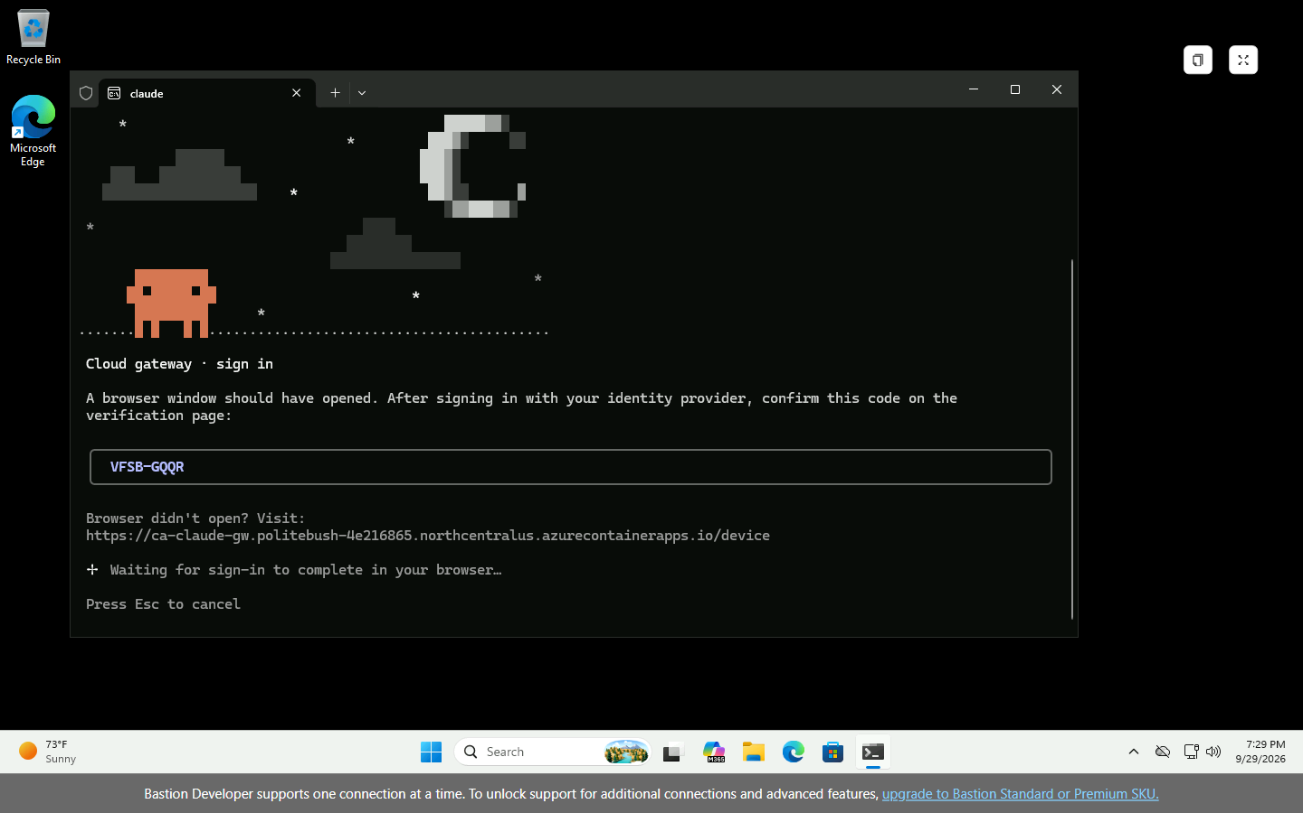
Screenshot of Claude Code's Cloud gateway sign-in screen with a one-time code, the address of the gateway's device page, and Waiting for sign-in to complete in your browser.
The gateway's device page takes the code, then sends the browser to Microsoft Entra ID for the sign-in; a mistyped
code is refused on the page:
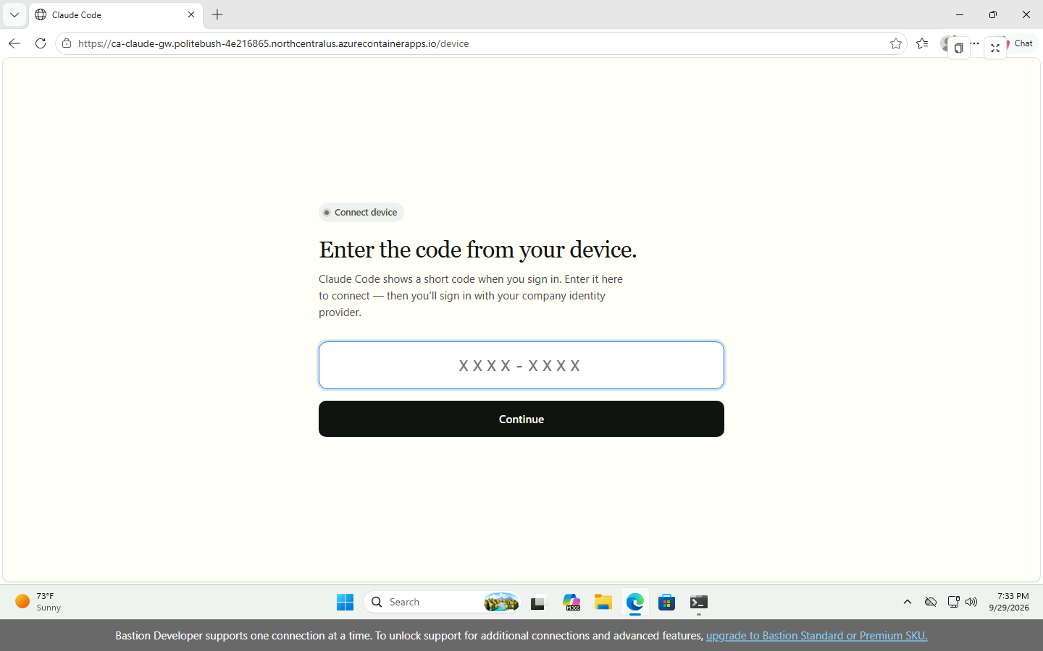
Screenshot of the gateway's device page in Microsoft Edge on the test machine: Enter the code from your device, a code field and a Continue button.
Administrators can publish the fingerprint from the served leaf certificate file with OpenSSL in PowerShell:
$fingerprint = ((openssl x509 -noout -fingerprint -sha256 -in .\cert.pem) -split '=', 2)[1].Replace(':', '').ToLowerInvariant()
$fingerprint
$fingerprint.Substring(0, 16)
This formats Anthropic's OpenSSL command for PowerShell.
The verify step also prints sha256 (infra/azure-private/lib/Steps.Dev.psm1:94).
The CLI pins the leaf per hostname; every rotation prompts every developer again. Publish the replacement fingerprint.
Over SSH, run /login remotely and open the link on a laptop that can reach the gateway (remote machines).
Client 2.1.275 added optional email confirmation, but this gateway returns no email field, so no such confirmation appears
(connection behavior).

Sign in from the VS Code extension
- Deploy the same machine policy; the extension's bundled CLI reads managed sources
(runtime, policy surfaces).
- Open Extensions with Ctrl+Shift+X, install Claude Code, then open its Spark-icon panel
(install, open panel).
- On first use, select Sign in and complete browser authorization (first use).
The guide does not specify gateway-only screens, panel behavior for forceLoginMethod, or CLI credential reuse.
disableLoginPrompt skips prompts for direct third-party provider setups; leave its default false here
(extension settings).
The integrated terminal's claude command needs the standalone CLI, separate from the panel
(extension prerequisites).

Connect Claude Desktop
- Both roles opt in with desktop: {} (config/gateway.azure-private.yaml:55-65); without it, /user/bootstrap returns 404 (Desktop overlay).
- Deploy bootstrapUrl directly under HKLM\SOFTWARE\Policies\Claude. Since Desktop 1.19367.0, HKLM policy excludes
HKCU policy entirely; keep configuration in one hive
(registry precedence).
- Quit and reopen Desktop; configuration is read at launch (how keys are read).
- Complete Desktop's browser sign-in. With only bootstrapUrl, and no bootstrapOidc or header credentials,
Desktop uses device-code mode against the bootstrap server's origin
(bootstrap authentication).
- Cowork and Code send model requests through the gateway; CLI and Desktop sign-ins are separate. Enable Chat with
chatTabEnabled: true in Desktop policy or the desktop overlay (gateway 2.1.227+ for the overlay)
(Desktop tabs).
Retain parentSettingsBehavior: "merge" in the selected Claude Code managed source on Desktop-only machines:
it lets a gateway egress allowlist reach embedded sessions. This repository sets model lists, not an egress allowlist (config/gateway.azure-private.yaml:54-65;
Desktop policy delivery).
The MDM-only trustBootstrapDelivery (Desktop 1.26832.0+) skips consent for bootstrap-delivered sign-in targets, endpoints, helper scripts and connectors, not sign-in
(bootstrap controls).

What the gateway enforces after sign-in
- Models: Standard gets Sonnet 5; Premium adds Opus 5 (config/gateway.azure-private.yaml:55-65).
The picker follows availableModels; other model requests return 400 (model enforcement).
- CLI policy: locked settings cannot be overridden locally; policy loads at startup and refreshes hourly, with some changes deferred.
A signed-in CLI exits at startup after about 10 seconds if the gateway is unreachable (policy and startup).
- Credentials: clear conflicting API credentials; forced gateway sign-in does not use a leftover API key or claude.ai login
(credential errors).
- Lifetime: IdP deprovisioning ends the session within ttl_hours when refresh fails; here it is one hour (config/gateway.azure-private.yaml:27; deprovisioning).
- Sign-out: /logout deletes the local credential. Client 2.1.275 supports revocation, but this server advertises no endpoint: logout is local only (sign-out).
- CI: no unattended service-token flow exists (CI limitations).

Troubleshoot
Symptom | Cause | Fix | Reference
Gateway hosts must be on your organization's private network; <host> resolves to the public (or unrecognized) address <ip> | At least one DNS answer is public | Correct corporate DNS forwarding and A/AAAA records; use the private route | Private-address refusal
No gateway option in /login | Missing login keys, or keys in user settings/HKCU | Deploy all three keys in the selected machine-managed source, then start Claude Code again | Set the gateway URL
The gateway is limiting sign-in attempts right now | Per-address sign-in limit reached; this wording requires client 2.1.274+ | Retry after the window; operators check trusted_proxies before sizing sign-in limits for shared addresses | Large rollouts
Desktop cannot fetch /user/bootstrap (404), or is not configured | Missing matching desktop policy, wrong bootstrapUrl, or unread policy | Check the matching policy's desktop: {}, the HKLM value and gateway URL; quit and reopen Desktop | Desktop overlay, registry delivery
Fingerprint prompt after a certificate change | Leaf certificate no longer matches the pin | Compare the new published fingerprint; for repeated unexpected changes, check ingress certificates and TLS interception | Certificate pinning
Administrator policy requires a Cloud gateway sign-in | API environment variables, an apiKeyHelper, or a saved Console API key conflict with policy | Clear those credentials; use claude auth logout for a saved key, then start claude and run /login | Error reference
Proxy refusal, or certificate pin checks skipped | An HTTPS proxy is on the CLI's gateway route | Add claude-gateway.corp.contoso.com to NO_PROXY and relaunch; retain other bypass entries | Proxy and pinning
Gateway rejects requests from a corporate subnet | The source is outside access_control.allow_cidrs | Have the operator configure the admitted developer networks; the sample admits 10.40.0.0/16 | config/gateway.azure-private.yaml:68

Related content
- Overview (docs/learn/overview.md)
- Configure models, roles and developer access (docs/learn/how-to-admin-configure.md)
- Developer profile quickstart (docs/learn/quickstart-developer.md)
- Troubleshoot the developer profile (docs/learn/troubleshoot.md)
- Deploy the network-restricted gateway
- Plan capacity for 25,000 developers

Plan capacity for 25,000 developers
Size sign-in limits, gateway replicas, PostgreSQL, Foundry quota, identity and private connectivity for a rollout to 25,000 developers.
A rollout has six separate capacity boundaries: sign-in limits, gateway replicas, PostgreSQL connections, Foundry
quota, identity, and network/DNS/certificate management. Developer count alone does not determine inference load.
This article covers the internal Container Apps environment, private PostgreSQL store and private-endpoint Foundry
accounts in docs/adr/0005-network-restricted-deployment.md:55-77. Worked examples are assumptions, not measured capacity.

Limits at a glance
Defaults and repository inputs were checked on September 29, 2026; they are not capacity benchmarks.
Limit | Default | Setting in this repository | Source
Sign-in starts, per client address | 30 per 600 seconds | rate_limits.device_authorization: 1,000 per 600 seconds | HTTP tuning; config/gateway.azure-private.yaml:72
Code submissions, per client address | 10 per 600 seconds | rate_limits.device_verify: 100 per 600 seconds | HTTP tuning; config/gateway.azure-private.yaml:73
Concurrent upstream requests, per replica | 256 | -MaxUpstreamRequests sets BUN_CONFIG_MAX_HTTP_REQUESTS | Upstream concurrency; infra/azure-private/lib/AppDefinition.psm1:25
HTTP scale-out target | 10 concurrent requests | -ConcurrentRequests: 150 | HTTP scaling; infra/azure-private/Deploy-Gateway.ps1:42
PostgreSQL pool, per replica | 5 connections | store.max_connections: 5 | Store; config/gateway.azure-private.yaml:33
Readiness grace after a store outage | 0 seconds | store.readiness_grace_seconds: 300 | Store; config/gateway.azure-private.yaml:35
Gateway session lifetime | 1 hour | session.ttl_hours: 1 | Session; config/gateway.azure-private.yaml:27
Gateway shutdown drain | 25 seconds | 120 seconds; container termination grace 130 seconds | Upgrades; infra/azure-private/lib/AppDefinition.psm1:28; infra/azure-private/lib/AppDefinition.psm1:59

Sign-in rate limits
These limits apply to sign-in, not inference. Without listen.trusted_proxies, the gateway counts the ingress
address rather than developer addresses (large rollouts).
For evenly distributed sign-ins, attempts per address per window = developers / addresses × window / rollout duration.
Set max = round up(estimated attempts × 2): the factor of 2 allows retries and multiple clients.
Calculate starts and browser code submissions separately if their network paths differ.
- Assumption: distinct private addresses. Each of the 25,000 developers keeps an individual private address.
Their CLI, extension, Desktop and browser attempts stay below 30 starts and 10 submissions per 600 seconds.
Defaults suffice; total headcount does not combine their buckets.
- Assumption: shared addresses. Developers share 10 NAT/VPN egress addresses and sign in evenly over 2 hours:
25,000 / 10 = 2,500 developers per address; 120 minutes / 10 minutes = 12 windows; about 208.3 sign-ins per window.
Doubling gives about 416.7; rounding up to 500 for each limit provides an example rollout setting.
Measure the busiest client_ip/window in sign-in audit events.
The repository's 100 code submissions would throttle this example even though its 1,000 starts suffice.
Set deployment.signInsPerAddress and deployment.codeSubmissionsPerAddress to 500 for this example
(config/gateway-admin.azure-private.json:38-39). Windows remain 600 seconds (config/gateway.azure-private.yaml:72-73).
Render, then check, from the repository root:
node scripts\admin\new-gateway-config.mjs --topology private
node scripts\admin\new-gateway-config.mjs --topology private --check
Options are defined at scripts/admin/new-gateway-config.mjs:239-245; rendering does not deploy the change.
device_verify protects against guessing codes: raise it only as needed. Lower limits after rollout if refresh tokens
enable silent renewal; otherwise size for repeated sign-ins
(large rollouts).

Gateway replicas
Use Little's law: average concurrency = requests/second × average seconds open.
Estimate the busiest sustained interval, then test bursts. Count model requests, including tool turns, not user prompts.
Input | Assumption for this example | How to measure
Developers active at peak | 20% of 25,000 = 5,000 | Distinct sub values in inference events during the peak interval
Requests per active developer | 2 per minute | Model request count divided by active developers and interval duration
Average time a request stays open | 30 seconds | Time from request start to stream end in the client/load generator

Audit fields are recorded in docs/UNKNOWNS.md:55; the target is 150, below 256 upstream slots (infra/azure-private/Deploy-Gateway.ps1:42-43).
request rate = 25,000 × 20% × 2 = 10,000 requests/minute
concurrency = (10,000 / 60) × 30 = 5,000 open requests
replicas = ceiling(5,000 / 150) = 34
This is a floor, not a production recommendation. Allow for bursts, uneven routing, overlap and zone loss.
-MinReplicas, -MaxReplicas and -ConcurrentRequests control the range/target (infra/azure-private/lib/AppDefinition.psm1:76-80).
The HTTP target is a scaling signal, not a hard cap
(HTTP scaling).
A stream occupies an upstream slot until it ends; queued bodies also consume memory. -MaxUpstreamRequests sets
BUN_CONFIG_MAX_HTTP_REQUESTS (1–65,535). Measure CPU/memory before raising it, and keep the HTTP target below it
(upstream concurrency).
CPU/memory capacity remains unmeasured (U-58, docs/UNKNOWNS.md:69). -Cpu/-Memory request 1 vCPU/2 GiB (infra/azure-private/Deploy-Gateway.ps1:44-45).
Use load_test_mode on an isolated deployment with its own empty database,
never a gateway developers use. It returns canned replies without Foundry; x-load-test-user simulates distinct users.
The mode needs gateway 2.1.282+; CPU estimates before 2.1.283 are substantially lower. Even newer estimates omit upstream encryption.
Hold one replica fixed; vary duration, body size and concurrency; measure queue onset and CPU/memory growth per open request
with replica metrics. Include planned spend enforcement, then test autoscaling and real Foundry.
Create with -ZoneRedundant where supported; keep at least 2 minimum replicas, more if the peak cannot wait for scaling
(zone distribution).
Azure allows 1,000 replicas per revision.
The Consumption-core quota sums all active replicas' cores across apps; allocations vary.
Read it before selecting -MaxReplicas:
az containerapp env list-usages --resource-group "<resource-group>" --name "<environment>"
Request more through the environment's Quota page. The example needs 34 × 1 = 34 cores before overlap/other apps.
The deployment's allocation remains unchecked (U-60, docs/UNKNOWNS.md:71).
CLAUDE_GATEWAY_DRAIN_TIMEOUT_MS is 120,000 ms; termination grace is 130 seconds (infra/azure-private/lib/AppDefinition.psm1:28; infra/azure-private/lib/AppDefinition.psm1:59).
Keep grace at least 5 seconds beyond drain; unfinished streams are cut (upgrades).
Azure documents a 240-second HTTP ingress timeout.
A 403.5-second stream completed in the test deployment (U-40, docs/UNKNOWNS.md:51), not a guarantee at every load.
Retest long streams on the private deployment, including scale-in and upgrades.

PostgreSQL
Budget for the old and new revisions of a rollout, which hold connections at the same time: 2 × replicas × store.max_connections + other connections ≤ max_connections − reserved connections. On 2026-09-29 a rollout of 2 replicas at 10 connections each, next to the old revision's 2, logged remaining connection slots are reserved for roles with the SUPERUSER attribute on Burstable B1ms (tests/azure-private.test.mjs:135-138).
Pools are per replica, not per developer.
Azure currently reserves 15 connections. Read max_connections, reserved_connections and superuser_reserved_connections;
defaults do not automatically increase after a SKU change (PostgreSQL limits).
SKU | Default maximum connections | Maximum user connections
Burstable B1ms | 50 | 35
Burstable B2s | 429 | 414
General Purpose D2ds_v5 | 859 | 844
General Purpose D4ds_v5 | 1,718 | 1,703
General Purpose D8ds_v5 | 3,437 | 3,422
General Purpose D16ds_v5 | 5,000 | 4,985

The example's 2 × 34 × 10 = 680 connections, a rollout of 34 replicas at 10 connections each, fit D2ds_v5's 844 before other clients, but do not establish CPU/I/O capacity.
Set the pool through deployment.storeConnectionsPerReplica (config/gateway-admin.azure-private.json:40).
The B1ms test ceiling is -MaxReplicas 3 with 5 connections per replica: 2 × 3 × 5 = 30 of 35 maximum user connections (infra/azure-private/Deploy-Gateway.ps1:38-41).
A test checks this default budget (tests/azure-private.test.mjs:132-142). Production guidance is General Purpose with zone-redundant HA
(docs/adr/0005-network-restricted-deployment.md:69; HA support).
-PostgresSku, -PostgresTier and -PostgresZonalResiliency apply to new servers, not upgrades (infra/azure-private/lib/Steps.Base.psm1:92-100).
Built-in PgBouncer uses port 6432
on General Purpose/Memory Optimized tiers. Compatibility is unvalidated here: test pooling mode, sign-in, spend writes
and migrations with their advisory lock before adopting it.
Startup/liveness probe /healthz; readiness probes /readyz (infra/azure-private/lib/AppDefinition.psm1:69-71).
The 300-second grace keeps ready replicas in rotation through short failovers. New sign-ins fail; existing tokens validate locally.
Spend enforcement fails open by default; enforcement.fail_closed_on_error: true blocks inference even while ready
(outage behavior).
Spend limits add database work per inference request and durable counters, caps and audit tables. Back them up and
test restores (store; Postgres).

Foundry quota
The Claude quota reference
defines subscription pools per model/version and deployment type: Global Standard across all regions; Data Zone Standard
within each data zone. Another account/region in the same pool does not multiply quota. RPM, uncached input tokens
per minute (ITPM) and output tokens per minute (OTPM) are separate limits. Cache writes count toward ITPM; cache reads do not.
These published defaults apply to Claude Sonnet 5 and Opus 5, for Global Standard and US Data Zone Standard:
Subscription offer | RPM | ITPM | OTPM
Enterprise / MCA-E | 10,000 | 10,000,000 | 2,000,000
Pay-as-you-go | 40 | 40,000 | 8,000

Assumption: all 10,000 requests/minute target one model, averaging 2,000 uncached input and 500 output tokens/request.
Then ITPM = 10,000 × 2,000 = 20,000,000 and OTPM = 10,000 × 500 = 5,000,000, exceeding enterprise defaults.
Recalculate per model from pilot usage responses; measured inference events contain no token counts (docs/UNKNOWNS.md:63).
Read granted capacity on Foundry's Quota page and submit the increase form;
approval is not guaranteed. The deployment's grant remains to be checked (U-59, docs/UNKNOWNS.md:70).
Foundry returns HTTP 429 at a rate limit. The gateway fails over
in order on 429, 5xx, 401, 403, 404 or timeouts. Every request tries the first upstream; failures are not remembered.
It waits up to one hour for Foundry to start responding: this is not load balancing or guaranteed prompt failover.
Example fragment: separate accounts with deployment mappings. The renderer currently emits a single account
(scripts/admin/new-gateway-config.mjs:150-154); adopting this needs a renderer change, not an edit to generated output.
upstreams:
- name: foundry-primary
provider: foundry
resource: example-primary
auth: { use_azure_ad: true }
- name: foundry-secondary
provider: foundry
resource: example-secondary
auth: { use_azure_ad: true }
auto_include_builtin_models: false
models:
- id: claude-sonnet-5
upstream_model: { foundry-primary: claude-sonnet-5, foundry-secondary: claude-sonnet-5 }
- id: claude-opus-5
upstream_model: { foundry-primary: claude-opus-5, foundry-secondary: claude-opus-5 }
Mappings use upstream name (models).
Each account needs private endpoint/DNS, public access and key auth disabled, and Cognitive Services User for the
gateway's user-assigned identity (Foundry auth;
docs/adr/0005-network-restricted-deployment.md:70-72). Verify quota before relying on fallback.
Sonnet uses Global Standard here (processing in any Azure region); Opus uses Data Zone Standard (processing within its zone).
Preserve this on fallback; private endpoints do not change processing residency.

Identity
Assign Gateway.Standard/Gateway.Premium to developer groups; Entra emits roles.
The gateway uses groups_claim: roles (config/gateway.azure-private.yaml:21-23).
Group assignment requires Entra ID P1/P2 and excludes nested-group members
(assignment requirements).
Using app roles avoids relying on a groups claim that is omitted above 200 group memberships in JWTs
(group overage).
Per-role policies restrict models (config/gateway.azure-private.yaml:54-65); deployment.desktop: true enables Desktop (config/gateway-admin.azure-private.json:41).
Retain offline_access and test silent refresh. Sessions last 1 hour; deprovisioning takes effect at refresh/expiry,
not immediately. There is no individual gateway-token revocation. Rotate signing keys in stages: accept old and new,
sign with new, wait the session lifetime plus a margin, then remove old. Outright replacement signs everyone out
(session; JWT rotation).

Network, DNS and certificate
Developers need ExpressRoute/VPN routes to the environment's static private IP. App ingress is external to the
internal environment, not the internet (ingress visibility).
Conditionally forward the gateway zone to an Azure DNS Private Resolver inbound endpoint.
Link the private zone to its VNet. /login requires private-only gateway resolution.
listen.trusted_proxies names the ranges a workload profile environment reserves, where the Container Apps ingress
connects from, while access_control.allow_cidrs names developer networks from deployment.developerCidrs
(config/gateway.azure-private.yaml:12-14; config/gateway.azure-private.yaml:67-68;
config/gateway-admin.azure-private.json:35-37). Developer subnets are never trusted as proxies
(docs/adr/0005-network-restricted-deployment.md:75-87).
Bind a custom domain to a TLS certificate issued by the organization's CA (Container Apps certificates);
install the CA trust chain on clients. The change to the custom origin also sets GATEWAY_PUBLIC_URL and the Entra
redirect URI <origin>/oauth/callback to it; Deploy-Gateway.ps1 derives both from the default host name
(infra/azure-private/lib/AppDefinition.psm1:16; infra/azure-private/lib/Steps.App.psm1:44).
The CLI pins the leaf certificate per hostname. Publish its SHA-256 fingerprint
and plan rotations: each prompts developers again. Put the hostname in NO_PROXY to avoid proxy bypass of pin checks
(connect developers).
Measured on 2026-09-29: the internal default domain served a publicly trusted, platform-managed certificate from
Microsoft TLS G2 RSA CA OCSP 02, valid 2026-09-28 to 2027-01-06 (100 days); the platform controls rotation (U-56, docs/UNKNOWNS.md:67).

Rollout waves
Load test first, then pilot all clients and corporate/VPN paths against real Foundry. Size waves from sign-in concentration
and inference demand, not invitation count (large rollouts).
Pause expansion when queueing, failures or quota use exceed the pilot's agreed operating bounds.
Component | Signal to watch | Source
Sign-in | sign-in refused, client_ip, rate-limited attempts; Claude Code 2.1.274+ displays The gateway is limiting sign-in attempts right now | Large rollouts
Gateway | client requests are open, latency and drain window over after; replica count, CPU, memory and restarts | Concurrency, upgrades, metrics
PostgreSQL | active_connections includes active and idle connections; compare with usable capacity, failed connections, CPU and storage | PostgreSQL metrics
Foundry | 429 status in inference events; operational logs for upstream 429s hidden by successful fallback; RPM, ITPM and OTPM | Gateway logs, Claude quota
Identity | auth.denied, session.mint and session.refresh outcomes | Gateway logs
Network and TLS | Private DNS answers, connection failures and unexpected fingerprint prompts | Prerequisites, certificate pinning

Related content
- Gateway overview (docs/learn/overview.md)
- Configure models, roles and developer access (docs/learn/how-to-admin-configure.md)
- Run the inference tests (docs/learn/how-to-test-inference.md)
- Script reference (docs/learn/reference-scripts.md)
- Deploy a network-restricted gateway
- Connect Claude Code, VS Code and Claude Desktop

