claude-code-foundry-gateway — Project Summary

Date: 2026-09-10
Version: 1.0
Audience: Engineering Team, Architects, Stakeholders

Table of Contents

claude-code-foundry-gateway — Project Summary

1. Executive Summary
claude-code-foundry-gateway is a governed-access accelerator that lets an organization roll out Claude Code, the VS Code extension, and Claude Desktop against its own Microsoft Foundry Claude deployment — without ever putting a vendor API key on a developer machine. An Azure API Management (APIM) v2 gateway sits between every client and Foundry: it validates each developer's own Microsoft Entra ID token, resolves their tier from Entra group membership, enforces per-developer and organization-wide token budgets, meters usage for chargeback in Application Insights, and only then calls Foundry using its own managed identity. The repository is a PowerShell-and-Bash-first automation suite (one interactive installer, onboarding and workstation setup scripts, governance and budget tooling, and Bicep infrastructure-as-code) rather than a running service — the "product" is a reusable deployment and governance pattern, verified end to end against a live Foundry tenant.

2. Architecture Overview
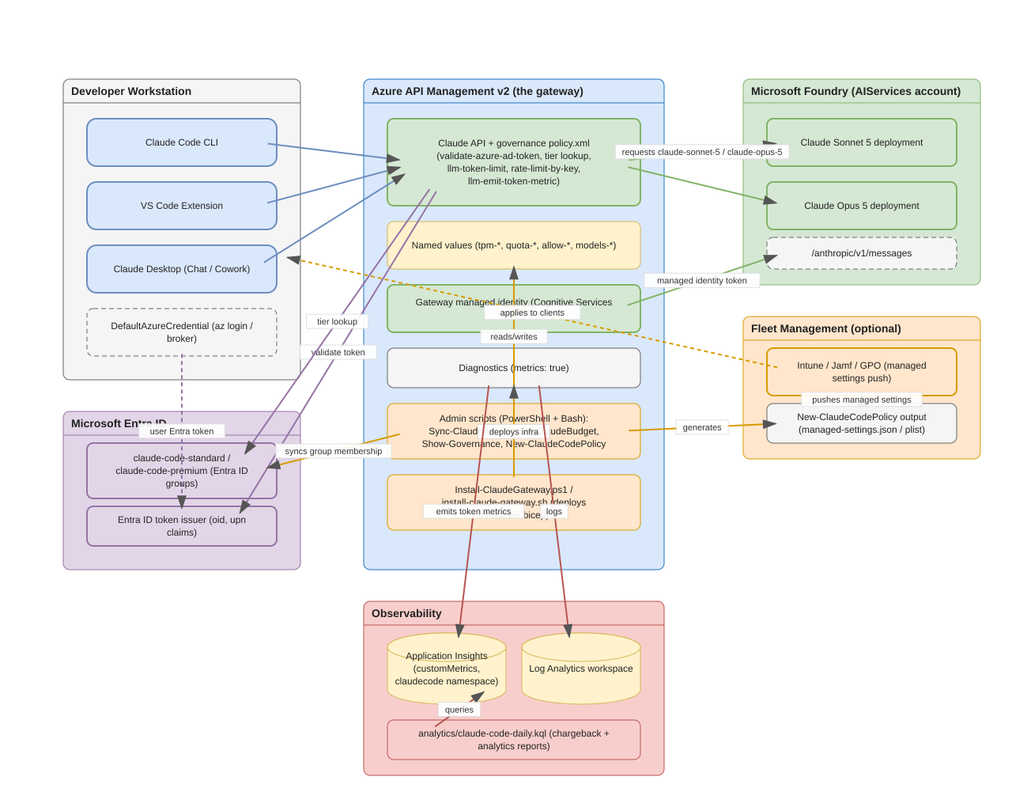
High-Level Architecture
The system has five cooperating parts:
Part | Role
Developer workstations | Run Claude Code CLI, the VS Code extension, and Claude Desktop, all authenticating through DefaultAzureCredential (az login) — no client holds a credential.
Microsoft Entra ID | Source of truth for entitlement. Two groups, claude-code-standard and claude-code-premium, gate access; the developer's oid claim in their Entra token is unforgeable.
Azure API Management v2 (the gateway) | The enforcement point. Hosts the Claude API, the governance policy.xml, named values holding every budget, and the sole managed identity permitted to call Foundry.
Observability | Log Analytics and Application Insights receive gateway diagnostics; llm-emit-token-metric writes per-developer token counts as custom metrics that analytics/claude-code-daily.kql turns into chargeback and usage reports.
Microsoft Foundry | Hosts the actual Claude Sonnet 5 and Claude Opus 5 deployments behind the Anthropic Messages API shape (/anthropic/v1/messages).

An optional sixth part, fleet management (Intune, Jamf, or Group Policy), distributes managed-settings payloads generated by New-ClaudeCodePolicy.ps1 so that client-side capability controls (permission rules, hooks, available Desktop tabs, connectors) roll out centrally. The project's own `docs/ARCHITECTURE.md` is explicit that this layer is a management convenience, not a security boundary — Anthropic's own guidance is that a modified client binary can bypass any client-side control, so entitlement, budgets, and model access are enforced only at the gateway.

Why an APIM v2 SKU is mandatory
The llm-token-limit, llm-emit-token-metric, and related policies parse the Anthropic Messages API shape only on v2 tiers (Basic v2, Standard v2, Premium v2). On a classic tier the same policy applies without error but counts zero tokens, so budgets silently never trigger. The Bicep template (infra/main.bicep) restricts apimSku to the three v2 values for exactly this reason.

Why the identity model is trustworthy
Claude Code's Foundry mode calls Azure's DefaultAzureCredential, which resolves to the developer's own signed-in session. The resulting Entra ID token carries a genuine, signed oid claim that cannot be shared or forged. The gateway validates that token, uses the oid to meter usage and resolve a tier, and then discards the user token entirely, re-issuing the call to Foundry with authentication-managed-identity. Foundry never sees a developer's credential, and removing someone from the Entra group revokes their access immediately — nothing has to be revoked at the Foundry endpoint itself.

3. Processing Pipeline
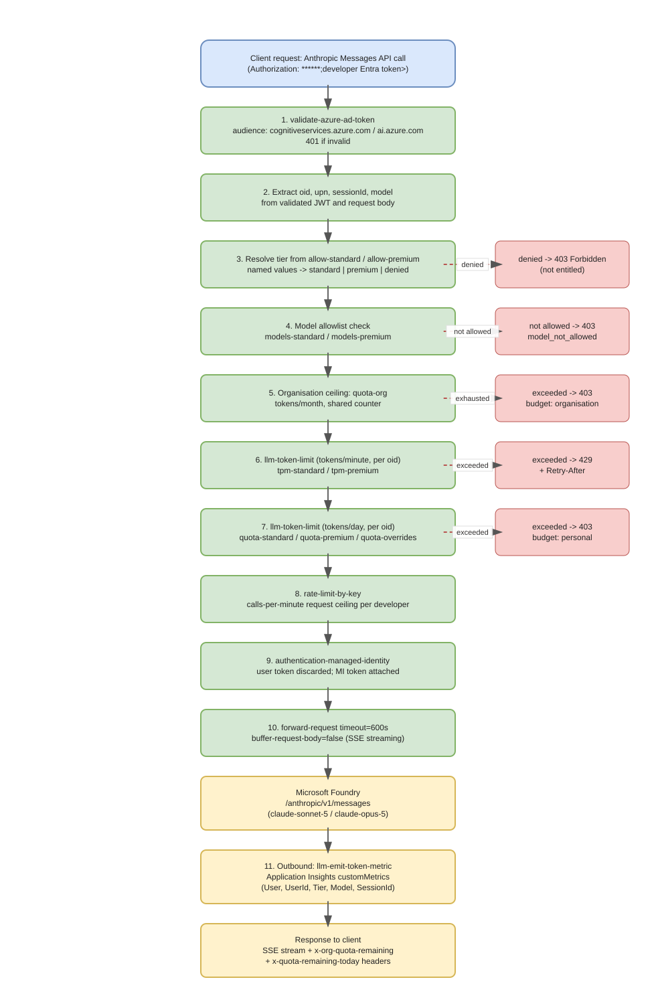
Processing Pipeline
Every request from a client passes through the following ordered stages, all defined in `infra/policy.xml`:
- `validate-azure-ad-token` — checks signature, issuer, expiry, and audience (https://cognitiveservices.azure.com / https://ai.azure.com). An invalid token is rejected with 401.
- Claim extraction — reads oid, upn (falling back to unique_name, preferred_username, or azp), the x-claude-code-session-id header, and the request's model field.
- Tier resolution — checks the oid against the allow-standard / allow-premium named values (sentinel-comma exact match). No match means denied, and the request is refused with an actionable 403.
- Model allowlist — models-standard / models-premium restrict which Claude deployments a tier may call, checked before anything is forwarded so a modified client cannot widen it.
- Organization ceiling — quota-org is a single, shared monthly counter across every developer. It is a soft cap: the underlying llm-token-limit policy can let high-concurrency requests briefly exceed it, and it is enforced per gateway, not aggregated across regions.
- Per-developer rate limit — llm-token-limit on tokens-per-minute (tpm-standard / tpm-premium), keyed on oid. Exceeding it returns 429 with Retry-After.
- Per-developer daily budget — a second llm-token-limit check on tokens-per-day (quota-standard / quota-premium, or a quota-overrides entry for that developer). Exceeding it returns 403 until the period resets.
- Request-rate ceiling — rate-limit-by-key bounds requests-per-minute (calls-per-minute), guarding against a runaway agent loop rather than token spend.
- `authentication-managed-identity` — the validated user token is discarded, and the gateway's own managed-identity token is attached for the outbound call.
- Forwarding — forward-request uses a 600-second timeout (agent turns can run for minutes) and buffer-request-body="false" (tool schemas and file context routinely produce large request bodies), then calls Foundry's /anthropic/v1/messages.
- Metering — llm-emit-token-metric writes token counts to Application Insights as custom metrics dimensioned by User, UserId, Tier, Model, and SessionId. The response also carries x-org-quota-remaining and x-quota-remaining-today headers.
Both budget refusals return 403 with a JSON body naming which budget was exhausted ("budget": "organisation" or "budget": "personal"), so a developer or platform engineer can tell the two apart without inspecting logs.

4. Core Components
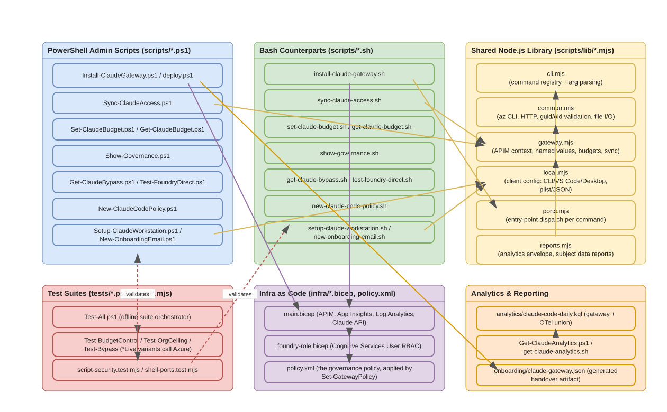
Component Relationships
The repository ships parallel PowerShell and Bash implementations of every administrative command, sharing a common Node.js library so behavior does not drift between platforms.

4.1 Entry points
Component | File(s) | Purpose
Interactive installer | Install-ClaudeGateway.ps1, install-claude-gateway.sh | Discovers Foundry accounts, collects budgets, shows a summary, and deploys the Bicep template. Supports -WhatIf / --what-if previews and unattended flags (-Yes / --yes).
Scriptable deploy | deploy.ps1 | The underlying Bicep wrapper the installer calls; usable directly for automation.
Developer setup | scripts/Setup-ClaudeWorkstation.ps1, scripts/setup-claude-workstation.sh | Installs/configures Claude Code CLI, VS Code extension, and Claude Desktop from a claude-gateway.json handover file; verifies with a real call through the gateway.

4.2 Administrative scripts (PowerShell ↔ Bash pairs)
Function | PowerShell | Bash
Sync Entra group membership to the gateway | Sync-ClaudeAccess.ps1 | sync-claude-access.sh
Read/set per-developer budget overrides | Get-ClaudeBudget.ps1 / Set-ClaudeBudget.ps1 | get-claude-budget.sh / set-claude-budget.sh
Verify all governance controls | Show-Governance.ps1 | show-governance.sh
Audit direct (bypassing) Foundry role holders | Get-ClaudeBypass.ps1 | get-claude-bypass.sh
Verify Foundry with the gateway bypassed | Test-FoundryDirect.ps1 | test-foundry-direct.sh
Generate managed-settings/MDM policy payloads | New-ClaudeCodePolicy.ps1 | new-claude-code-policy.sh
Generate onboarding email | New-OnboardingEmail.ps1 | new-onboarding-email.sh
Discover Foundry deployment values | Get-FoundryValues.ps1 | get-foundry-values.sh
Apply the governance policy on its own | Set-GatewayPolicy.ps1 | set-gateway-policy.sh
End-to-end health check | Debug-ClaudeCode.ps1 | debug-claude-code.sh
Analytics reporting | Get-ClaudeAnalytics.ps1 | get-claude-analytics.sh
Bulk entitlement import from a roster | Import-ClaudeEntitlement.ps1 | import-claude-entitlement.sh
Subject data discovery / removal (privacy) | Find-ClaudeUserData.ps1, Remove-ClaudeUserData.ps1 | find-claude-user-data.sh, remove-claude-user-data.sh
Script encoding repair (BOM for PS 5.1) | Repair-ScriptEncoding.ps1 | repair-script-encoding.sh

docs/SHELL-SCRIPTS.md is the authoritative command-mapping reference, including flag-name differences (PowerShell uses -CamelCase; Bash uses --kebab-case).

4.3 Shared Node.js library (scripts/lib/*.mjs)
Both the Bash scripts and several PowerShell scripts route through common Node.js modules so Azure REST calls, validation, and formatting logic exist once:
Module | Responsibility
cli.mjs | Command registry and parseArgs-based argument parsing for every Bash-invoked command.
common.mjs | Wraps the Azure CLI (az), builds ARM/Graph/Insights HTTP requests, validates GUIDs and object ids, and handles safe file I/O.
gateway.mjs | Resolves APIM context (subscription, resource group, service name), reads/writes named values, and implements sync, budget, and bypass logic.
local.mjs | Configures local client files — Claude Code, VS Code, and Claude Desktop (including plist generation for macOS) — from the onboarding JSON.
ports.mjs | Dispatches each CLI command name to its underlying implementation; the "port" of a .ps1 script's behavior into JavaScript.
reports.mjs | Builds the Claude Code Analytics API-shaped envelope and subject-data reports used by Get-ClaudeAnalytics/Find-ClaudeUserData.

4.4 Infrastructure as code
File | Purpose
infra/main.bicep | Deploys APIM (v2, system-assigned identity), Log Analytics, Application Insights (with CustomMetricsOptedInType: WithDimensions), the Claude API and its operations, and applies the governance policy.
infra/foundry-role.bicep | Grants Cognitive Services User on the Foundry account to the gateway's managed identity only.
infra/policy.xml | The governance policy described in Section 3, applied by Set-GatewayPolicy.ps1 / set-gateway-policy.sh.
infra/azuredeploy.json | Compiled ARM template powering the README's "Deploy to Azure" button.

4.5 Tests
tests/Test-All.ps1 orchestrates an offline suite (encoding checks, shell-script parity, PowerShell 5.1/7 compatibility) plus opt-in live suites (-IncludeAzure) that call real Azure resources: Test-BudgetControlLive.ps1, Test-OrgCeilingLive.ps1, Test-CapabilityScopingLive.ps1. tests/script-security.test.mjs and tests/shell-ports.test.mjs are Node's built-in test runner suites invoked by npm run test:scripts, validating the Bash command surface and hardening against unsafe inputs (documented in docs/SCRIPT-SECURITY-REVIEW.md).

5. API Contracts / Message Schemas

5.1 Governance error responses
Every gateway-side refusal returns a JSON body shaped like the Anthropic Messages API's own error envelope, so clients handle it the same way as a model-side error:
Field | Type | Meaning
type | string | Always "error" at the top level.
error.type | string | permission_error (not entitled), invalid_request_error (model not allowed), or rate_limit_error (budget exhausted).
error.code | string | Present for model restrictions, e.g. model_not_allowed.
error.budget | string | Present only on budget refusals: organisation or personal.
error.message | string | Actionable, human-readable explanation.

5.2 Response headers on success
Header | Meaning
x-org-quota-remaining | Tokens left in the shared organization-wide monthly ceiling.
x-quota-remaining-today | Tokens left in the caller's own daily budget.

5.3 onboarding/claude-gateway.json (generated handover artifact)
Written by the installer at the end of a successful deployment; consumed by the workstation setup scripts so a developer types nothing.
Field | Type | Meaning
gatewayUrl | string | Base URL of the Claude API on the gateway.
tenantId | string | Entra tenant guid the gateway trusts.
apimName, resourceGroup | string | The deployed APIM instance and its resource group.
standardGroup, premiumGroup | string | Entra group names for the two tiers.
tiers.standard / tiers.premium | object | tokensPerMinute and tokensPerDay for each tier, shown to the developer.
desktopInteractive (optional) | object | clientId, authFlow, scopes, sessionLifetimeSec, redirectPort, and related OIDC settings for Claude Desktop's interactive sign-in, instead of the Azure CLI credential helper.
generated | string | Timestamp of generation.

The file contains no secret — access is enforced by Entra group membership, not by anything in this JSON — so it is safe to email or place on an internal share, and is gitignored only because it is environment-specific.

5.4 Named values (governance configuration surface)
Named value | Default | Meaning
tpm-standard | 20,000 | Standard tier tokens/minute per developer.
quota-standard | 500,000 | Standard tier tokens/day per developer.
tpm-premium | 80,000 | Premium tier tokens/minute per developer.
quota-premium | 5,000,000 | Premium tier tokens/day per developer.
quota-org | 100,000,000 | Shared tokens/month ceiling across everyone (soft cap, per gateway).
models-standard / models-premium | empty (all) | Sentinel-comma model allowlist per tier.
calls-per-minute | 120 | Request-rate ceiling per developer.
quota-overrides | none | Per-developer daily budget overrides, independent of tier.

6. Infrastructure & Deployment
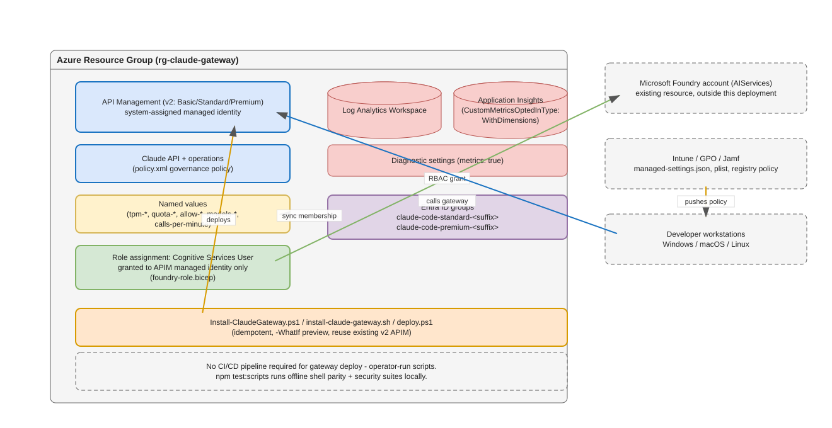
Deployment and Infrastructure
- Compute/runtime: no application server ships in this repository — the "runtime" is Azure API Management itself, configured entirely by Bicep and a policy document. There is no Dockerfile or container image, because the workload is a managed PaaS gateway, not a containerized service.
- Deployment mechanism: Install-ClaudeGateway.ps1 / install-claude-gateway.sh deploy infra/main.bicep idempotently — they detect and offer to reuse an existing v2 APIM instance rather than creating a duplicate, and -WhatIf / --what-if previews changes with no writes. deploy.ps1 exposes the same Bicep deployment non-interactively for scripting. Re-running the installer is also how budgets are changed later.
- Identity and RBAC: infra/foundry-role.bicep grants Cognitive Services User on the Foundry account only to the gateway's system-assigned managed identity. Closing the bypass (removing any direct developer role assignment on the Foundry account) is a documented manual step — until it is done, a developer with a direct role can call Foundry directly and skip all governance.
- Observability wiring: the Bicep template enables APIM diagnostics with metrics: true and sets the Application Insights component's CustomMetricsOptedInType to WithDimensions — both are required, and both fail silently if omitted (no metrics at all, or metrics with no User breakdown, respectively).
- CI/CD: there is no build/release pipeline in this repository (no .github/workflows/). Verification is developer-run: pwsh -NoProfile -File ./tests/Test-All.ps1 (offline) and -IncludeAzure for live checks, plus npm run test:scripts for the Node.js-based Bash test suites. node .ironclad/gate.mjs --stage packet is the project's own definition-of-done gate, described in AGENTS.md.
- Fleet management (optional): New-ClaudeCodePolicy.ps1 / new-claude-code-policy.sh generate managed-settings JSON or a macOS plist, which an administrator pushes through Intune, Jamf, or Group Policy to control client-side capability (permission rules, hooks, Desktop tabs, connectors) fleet-wide.
- Cost model: roughly $250/month for one APIM Basic v2 unit, plus ingestion-based Log Analytics/Application Insights costs, plus unchanged Foundry CCU token billing.

7. Extension Patterns

7.1 Add a new administrative command (Bash + PowerShell parity)
- Implement the PowerShell version first as scripts/Verb-Noun.ps1, following the existing scripts' -WhatIf / dry-run and parameter-validation conventions.
- Register the Bash-visible command shape in scripts/lib/cli.mjs (commands map): give it a description and its flag list.
- Implement the behavior in the appropriate scripts/lib/*.mjs module (gateway.mjs for APIM/Entra operations, local.mjs for client-side file changes, reports.mjs for analytics/reporting shapes).
- Wire the command into scripts/lib/ports.mjs's dispatch table, and add a matching scripts/verb-noun.sh thin wrapper that calls the shared Node.js entry point.
- Add the mapping row to docs/SHELL-SCRIPTS.md, and add both an offline test case (tests/script-security.test.mjs or tests/shell-ports.test.mjs) and, if it touches Azure, a *Live PowerShell Pester-style script under tests/.
- Update CHANGELOG.md in the same change, per the project's AGENTS.md contract.

7.2 Change a governance budget without redeploying
Budgets are APIM named values, not code. Use:
az apim nv update -g <rg> --service-name <apim-name> --named-value-id tpm-standard --value 40000
or the higher-level Set-ClaudeBudget.ps1 -User <email> -Tokens <n> for a single developer's daily override. Changes take effect on the next request — the policy resolves the value per call.

7.3 Add a new governance control to the policy
Edit infra/policy.xml directly (it is heavily commented with the reasoning behind ordering), then apply it in isolation with Set-GatewayPolicy.ps1 / set-gateway-policy.sh rather than a full redeploy. Keep new checks before the authentication-managed-identity step, since anything after that point runs with the gateway's own identity rather than the caller's context.

7.4 Extend the analytics pipeline
analytics/claude-code-daily.kql already unions two sources (gateway metrics and an optional OpenTelemetry export) with isfuzzy=true, so it degrades gracefully if only one source is present. To add a new dimension, extend both the llm-emit-token-metric policy's dimension list (bounded — only 5 custom dimension slots remain out of Azure Monitor's 10-key limit, 5 of which are APIM built-ins) and the corresponding extend/summarize clause in the KQL.

8. Rules & Anti-Patterns
Sourced from AGENTS.md, docs/ARCHITECTURE.md, and the ADRs in docs/adr/:
Do:
- Treat docs/adr/ as binding once accepted; reconcile conflicts with a new ADR rather than silently picking a side (AGENTS.md, "Contract precedence").
- Keep governance checks (entitlement, budgets, model access) at the gateway, never client-side only — docs/adr/0004-policy-out-of-band.md.
- Preserve PowerShell/Bash parity: every new administrative capability needs both a .ps1 and a .sh entry point sharing the Node.js library — docs/adr/0005-shell-parity-security.md.
- Save any PowerShell script containing non-ASCII characters as UTF-8 with a BOM — Windows PowerShell 5.1 reads .ps1 as ANSI otherwise, corrupting characters silently.
- Keep &, ^, <, >, |, and ( ) inside --query out of literal Azure CLI arguments on Windows; az is a .cmd shim and these are interpreted by cmd.exe before az sees them. Filter in PowerShell or call the REST API directly instead.
- Validate every external input at the trust boundary and check authorization per object, not just per user (AGENTS.md non-negotiables).
Don't:
- Don't assume a classic (non-v2) APIM SKU works — the llm-* policies parse the Anthropic shape only on v2 tiers; on classic tiers budgets silently never trigger.
- Don't rely on quota-org as a hard ceiling — it is a soft cap that can be briefly exceeded under high concurrency, and it is enforced per gateway/region, not globally.
- Don't add prompt inspection, content logging, or semantic caching by default — the project deliberately records only token counts and identities, and caching an agent's tool-using turns is considered unsafe (docs/ARCHITECTURE.md, "What this deliberately does not do").
- Don't skip, weaken, or delete a test to reach green; don't disable a detector without an ADR recording why (AGENTS.md non-negotiables).
- Don't commit onboarding/claude-gateway.json or any generated per-deployment artifact — it is environment-specific and gitignored by design, even though it contains no secret.
- Don't leave a direct Cognitive Services User role assignment on a developer identity after standing up the gateway — that is the documented "bypass" that Get-ClaudeBypass.ps1 audits for and the README explicitly instructs closing.

9. Dependencies

9.1 Root tooling (package.json)
Package | Version | Purpose
playwright | ^1.62.1 | Drives the screenshot-capture tooling in guide/ against the Azure portal and clients.
sharp | ^0.34.4 | Image composition for the guide's annotated screenshots.

9.2 Azure / cloud dependencies (via Azure CLI, not npm)
Dependency | Role
Azure API Management (v2 SKU) | The governance gateway itself.
Microsoft Entra ID | Identity, groups, and token issuance.
Microsoft Foundry (AIServices account) | Hosts the Claude model deployments.
Log Analytics + Application Insights | Diagnostics and chargeback metrics.
Azure CLI (az), jq (Bash path) | Required tooling for every administrative script.
PowerShell 5.1+ or PowerShell 7+ | Runtime for the .ps1 scripts; PowerShell 7 (pwsh) additionally needed for the entitlement-sync step on macOS/Linux.
Node.js (built-in fetch) | Runtime for scripts/lib/*.mjs and every Bash script's transport layer.

9.3 Infrastructure as code
File | Technology
infra/main.bicep, infra/foundry-role.bicep | Azure Bicep, compiled to infra/azuredeploy.json (ARM) for the one-click deploy button.
infra/policy.xml | Azure API Management policy XML with embedded C#-like expressions.

9.4 Development / testing
Tool | Purpose
tests/Test-All.ps1 and sibling Test-*.ps1 scripts | PowerShell-based offline and live (-IncludeAzure) regression suites.
tests/*.test.mjs (Node's built-in test runner) | Bash-script parity and security regression tests, run via npm run test:scripts.
.ironclad/gate.mjs | The project's own packet/pre-commit/release gate (see AGENTS.md).

10. Code Structure
claude-code-foundry-gateway/
├── Install-ClaudeGateway.ps1 # Interactive admin setup — start here (Windows)
├── install-claude-gateway.sh # Same wizard, for macOS and Linux
├── deploy.ps1 # Non-interactive Bicep deployment wrapper
├── DEVELOPER.md # The developer's whole side — send them this
├── README.md # Project overview, quickstart, governance reference
├── AGENTS.md # Binding coding-agent contract (ironclad skill)
├── CHANGELOG.md # Keep-a-Changelog formatted history
│
├── infra/ # Infrastructure as code
│ ├── main.bicep # Gateway, observability, API, policy, RBAC
│ ├── foundry-role.bicep # Cognitive Services User grant for the gateway identity
│ ├── policy.xml # The governance policy (Section 3 of this document)
│ └── azuredeploy.json # Compiled ARM, for the "Deploy to Azure" button
│
├── scripts/ # Administrative tooling, PowerShell + Bash pairs
│ ├── Setup-ClaudeWorkstation.ps1 / setup-claude-workstation.sh
│ ├── Sync-ClaudeAccess.ps1 / sync-claude-access.sh
│ ├── Set-ClaudeBudget.ps1 / set-claude-budget.sh, Get-ClaudeBudget.ps1 / get-claude-budget.sh
│ ├── Show-Governance.ps1 / show-governance.sh
│ ├── Get-ClaudeBypass.ps1 / get-claude-bypass.sh, Test-FoundryDirect.ps1 / test-foundry-direct.sh
│ ├── New-ClaudeCodePolicy.ps1 / new-claude-code-policy.sh
│ ├── New-OnboardingEmail.ps1 / new-onboarding-email.sh
│ ├── Get-FoundryValues.ps1 / get-foundry-values.sh
│ ├── Debug-ClaudeCode.ps1 / debug-claude-code.sh
│ ├── Get-ClaudeAnalytics.ps1 / get-claude-analytics.sh
│ ├── Import-ClaudeEntitlement.ps1 / import-claude-entitlement.sh
│ ├── Find-ClaudeUserData.ps1 / Remove-ClaudeUserData.ps1 (+ Bash equivalents)
│ ├── get-foundry-token.ps1 / .sh / .cmd # Credential helper for Claude Desktop
│ ├── inspect-proxy.mjs # Decodes and prints the JWT Claude Code sends
│ └── lib/ # Shared Node.js modules
│ ├── cli.mjs # Command registry + argument parsing
│ ├── common.mjs # az CLI wrapper, HTTP, GUID/oid validation, safe file I/O
│ ├── gateway.mjs # APIM context, named values, budgets, entitlement sync
│ ├── local.mjs # Client config: CLI / VS Code / Desktop, plist/JSON writers
│ ├── ports.mjs # Dispatches each Bash command to its implementation
│ └── reports.mjs # Analytics envelope and subject-data report builders
│
├── docs/ # Reference and explanation documentation
│ ├── SETUP.md # Prerequisites, roles, deployment, closing the bypass
│ ├── ONBOARDING.md # Add/change/revoke access; developer setup
│ ├── MONITORING.md # Metrics, chargeback, KQL, alerts
│ ├── DEBUGGING.md # Isolate a failure layer by layer
│ ├── MIGRATION.md # Moving a population off first-party Claude
│ ├── COMPARISON.md # Foundry vs. Anthropic direct
│ ├── ARCHITECTURE.md # Request path, identity model, design decisions
│ ├── GOVERNANCE-CHECKS.md # Command reference for verifying controls
│ ├── TROUBLESHOOTING.md # Symptom → fix lookup
│ ├── SHELL-SCRIPTS.md # PowerShell ↔ Bash command mapping
│ ├── SCRIPT-SECURITY-REVIEW.md # Security review of the shell/PowerShell scripts
│ ├── ROADMAP.md / STATUS.md / UNKNOWNS.md / CHARTER.md # ironclad project-governance docs
│ ├── adr/ # Accepted architecture decision records
│ └── generated/ # This generated documentation set (see below)
│
├── analytics/
│ └── claude-code-daily.kql # Chargeback + Claude Code Analytics API-shaped query
│
├── onboarding/
│ └── README.md # Explains the generated claude-gateway.json handover file
│
├── guide/ # Playwright-based screenshot tooling for the docs
│ ├── capture.mjs, compose.mjs, auth.mjs
│ └── lib/annotate.mjs
│
└── tests/ # PowerShell and Node.js test suites
├── Test-All.ps1 # Offline suite orchestrator
├── Test-BudgetControl(Live).ps1, Test-OrgCeiling(Live).ps1, Test-Bypass.ps1, ...
└── script-security.test.mjs, shell-ports.test.mjs
This document was generated by an automated documentation agent from the repository's own source files, scripts, infrastructure templates, and existing documentation. It does not modify any file outside `docs/generated/`. Cross-check specific commands and values against the authoritative files referenced throughout before relying on them operationally.

