
MINISTRY FOR EDUCATION AND SCIENCE OF RUSSIA
________________________________

SAINT PETERSBURG ELECTROTECHNICAL UNIVERSITY

«LETI»
________________________________

APPROVED

__________________________
Date, signature

Application for Delivery E-bill

PROJECT MANAGEMENT PLAN

PMP_T04_00.12

Electronic & Paper

17 pages

St. Petersburg / Санкт-Петербург
2021
HISTORY

Version #/ Версия № | Author / Кто разработал | Data / Дата | Short description / Причина
00.10 | Naveen/Навин,  Chubchik  Alexander  Olegovich, | 03.03.21 | The first version
00.20 | Naveen/Навин,  Chubchik  Alexander  Olegovich, | 18.03.21 | Detail requirements
00.30 | Naveen/Навин,  Chubchik  Alexander  Olegovich, | 22.04.21 | Architecture, prepared for review
01.00 | Naveen/Навин,  Chubchik  Alexander  Olegovich, | 29.05.21 | Final version, gant diagram and risks updated

Project team / Список исполнителей

№ | Name / ФИО | Group / Группа | Project role / Обязанности | Contact Information / Контактные данные (email/телефон)
1 | Naveen/навин | 6300 | Programmer, Lead ,Quality Manager ,CM | Naveensheoran1000@gmail.com
2 | Chubchik Alexander  Olegovich | 6300 | Tester, Database ,CM | very_vazhno@mail.ru
Teacher / Преподаватель
Filippov Evgeny Vasilyevich / Филиппов Евгений Васильевич e.philippov.leti@mail.ru
Aleksandr Eroshkin /Александр Ерошкин
a.eroshkin@sigma-it.ru

index
1. BASIS FOR DEVELOPMENT 04
2. DEVELOPMENT GOALS 04
3. Detail requirements 04
4. HIGH-LEVEL DESIGN 08
5. work breakdown structure and efforts estimation 10
6. Key milstones 11
7. Chosen technology and development framework 11
8. configuration and change management 12
9. project specific process 12
10. project risks 13
11. project schedule 13
12. Test plan 13
appendix 1. test cases 13
appendix 2. test results
appendix 3. defects 17

BASIS FOR DEVELOPMENT
Development is carried out on the basis of the requirements for the course work in the discipline "Software Engineering" .
Full name of the project :----
“Application for Delivery E-bill”

Short name of the program (nick-name, 4-5 characters) _____ E-bill

DEVELOPMENT GOALS
The software product is intended to development of android application for the Delivery E-bill. Using this application Delivery boys will not need any bill slip on paper .So we can save our tree as we know papers are prepared with trees.

Detail requirements
System Requirement -
Installation on Windows Machine
Requirements:
- 4 GB RAM minimum, 8 GB RAM recommended
- 2 GB of available disk space minimum, 4 GB Recommended (500 MB for IDE + 1.5 GB for Android SDK and emulator system image)
- 1280 x 800 minimum screen resolution
- Microsoft Windows 7/8/10 (32- or 64-bit). The Android Emulator supports 64-bit Windows only

Use Case
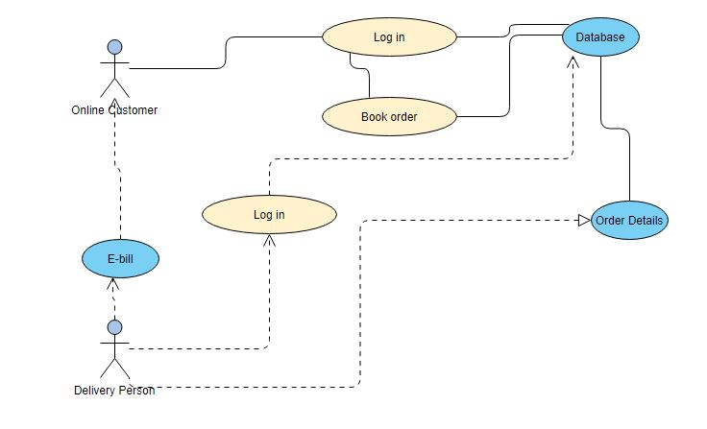

Register Delivery Boy:
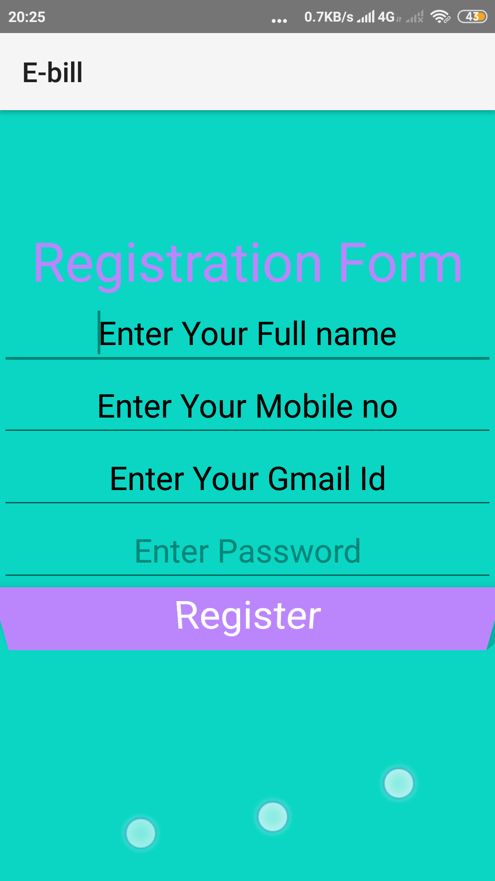
Log in
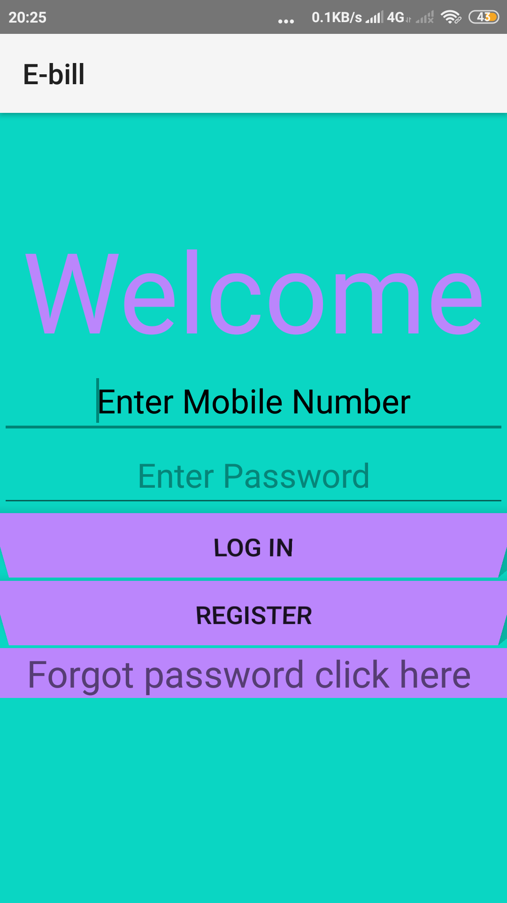

high level design
MVP
Model: the data layer
View: the UI layer, displays data received from Presenter, reacts to user input. On Android, we treat Activities, Fragments, and android.view.View as View from MVP.
Presenter: responds to actions performed on the UI layer, performs tasks on Model objects (using Use Cases), passes results of those tasks to Views
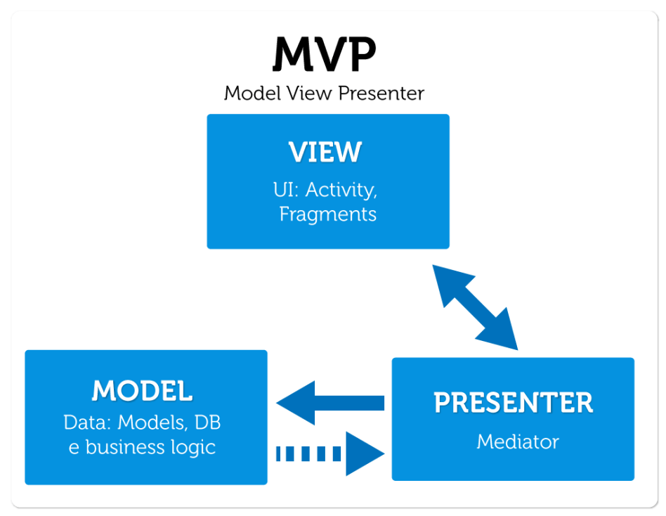

Basic Design

Delivery Boy
Customer
Request

Database

work breakdown structure and efforts estimation

Now:-

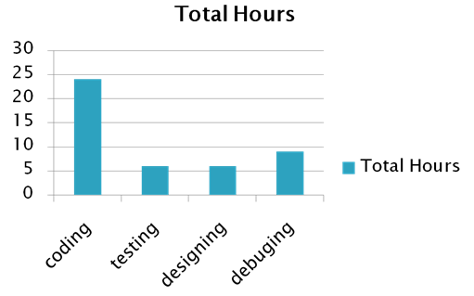

FInal:-

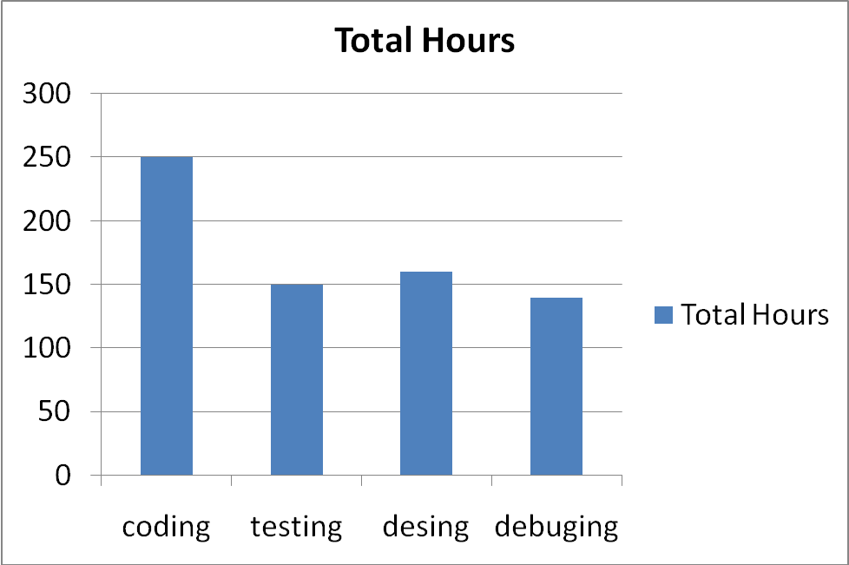

Key milstones
Table 1. Key milstones
№ | Start date / | End date | Description
1 | 05.02.21 | 03.03.21 | SOW developed, reviewed and signed
2 | 03.03.21 | 18.03.21 | Project Management Plan(PMP)
3 | 18.03.21 | 22.04.21 | Project Implementation – Phase 1
 | 31.03.21 | 14.04.21 | Authentication ,Registration
 | 14.04.21 | 22.04.21 | Real time Database
4 | 22.04.21 | 26.05.21 | Project Implementation – Phase 2
 | 23.04.21 | 07.05.21 | Forgot password ,new Design
 | 07.05.21 | 26.05.21 | Getting bill format , Delivery confirmation
5 | 26.05.21 | 02.06.21 | Course project completed, presentation and final report prepared for defense

Chosen technology and development framework

- Android Studio
- Android Software Development Kit (SDK)
- XML
- JAVA
- Firebase

configuration and change management

Version control system:-
For our project we used Github to store the code and other documents.

Branch policy:-
We have three branches for our project.
1 For Coding
2 Testing
3 Debugging
Document Naming:
T04_E-bill_DOC-Type.extension
where,
DOC-Type document abbreviation:
◦ SOW - Statement of Work
◦ PMP - Project Management Plan
◦ WBS - Work Break-down Structure
◦ CMP - Configuration Management Plan
◦ PKM - Protocol of Kick-off Meeting
◦ WR -Weekly Report
◦ METRICS - Project Metrics
◦ TESTS - Test Cases
◦ DEFECTS - Defects
◦ TR - Test Report

project specific process
Development model:-
We will use the following development model “Agile model”.
Using this Model we create 5 sprints .
2 sprints for the Phase 1 implementation of the project (Check point 2)
2 sprints for the Phase 2 implementation of the project (Check point 3) .
1 sprint for the final check point 4.

Reporting rules:-
Weekly report by the project team.
Be punctual all team member.
Strictly follow deadline.

project risks

Our team created a risk register with following details:-
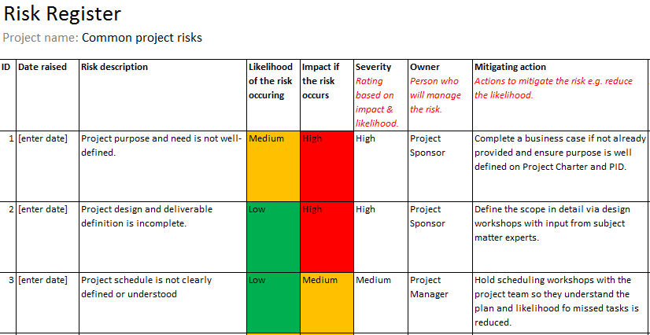

project schedule

REFERENCE :sow_t04_2021

Test plan
Appendix 1
  - Functional testing (13 test cases)
  - Usability testing (15 test cases)
  - Debugging (31 cases)

Appendix 2
Usability testing:
Tests were done using different phones, we used 9 phones to be exact, all functional and usability testing was done through Firebase Test Lab
For usability testing we ran 15 test cases, these test cases are represented in the table below. Point of every test is to understand how well suited for users are our interface features.

Usability:
Tested point of interface | Results
Enter Email Id | This item's height is 45dp. Consider making the height of this touch target 48dp or larger.
Enter Password | This item's height is 45dp. Consider making the height of this touch target 48dp or larger.
Log in | This item's height is 46dp. Consider making the height of this touch target 48dp or larger. A parent container may be clipping the size of this item, which has a drawing area of 1080dp x 144dp. Consider increasing the size of this item's clipping ancestor, or allowing a larger parent container to handle actions on behalf of this item.
Register | This item's height is 46dp. Consider making the height of this touch target 48dp or larger. A parent container may be clipping the size of this item, which has a drawing area of 1080dp x 144dp. Consider increasing the size of this item's clipping ancestor, or allowing a larger parent container to handle actions on behalf of this item.
Forgot password | This item's height is 27dp. Consider making the height of this touch target 48dp or larger.
Enter Full name | This item's height is 45dp. Consider making the height of this touch target 48dp or larger.
Enter mobile no | This item's height is 45dp. Consider making the height of this touch target 48dp or larger.
Enter mail id(register screen) | This item's height is 45dp. Consider making the height of this touch target 48dp or larger.
Enter password(register screen) | No problems found
Register button(register screen) | This item's height is 46dp. Consider making the height of this touch target 48dp or larger. A parent container may be clipping the size of this item, which has a drawing area of 1080dp x 144dp. Consider increasing the size of this item's clipping ancestor, or allowing a larger parent container to handle actions on behalf of this item.
Enter your email id(forgot password screen) | This item's height is 45dp. Consider making the height of this touch target 48dp or larger.
Reset Password | This item's height is 47dp. Consider making the height of this touch target 48dp or larger. A parent container may be clipping the size of this item, which has a drawing area of 491dp x 144dp. Consider increasing the size of this item's clipping ancestor, or allowing a larger parent container to handle actions on behalf of this item.
Starting screen | The text contrast ratio is 1.44. This ratio is based on an estimated foreground color of #BB86FC and an estimated background color of #0AD6C3. Consider increasing this item's text contrast ratio to 3.00 or greater.
Register screen | The text contrast ratio is 1.44. This ratio is based on an estimated foreground color of #BB86FC and an estimated background color of #0AD6C3. Consider increasing this item's text contrast ratio to 3.00 or greater.
Reset password screen | The text contrast ratio is 1.44. This ratio is based on an estimated foreground color of #BB86FC and an estimated background color of #0AD6C3. Consider increasing this item's text contrast ratio to 3.00 or greater.

For functional testing we did 13 tests for each interactable point of the interface + opening of the app interfaces on 9 phones, results of these tests are in the table below.
Functional testing:
Tested point of interface | Results
Enter Email Id | No problems were found, working as intended
Enter Password | On first iterations, user was able to put in password with inappropriate characters (fixed)
Log in | No problems were found, working as intended
Register | No problems were found, working as intended
Forgot password | No problems were found, working as intended
Enter Full name | On first iterations, user was able to put in password with inappropriate characters (fixed)
Enter mobile no | On first iterations, user was able to put in password with inappropriate characters (fixed)
Enter mail id(register screen) | No problems were found, working as intended
Enter password(register screen) | No problems were found, working as intended
Register button(register screen) | No problems were found, working as intended
Enter your email id(forgot password screen) | No problems were found, working as intended
Reset Password | No problems were found, working as intended
Enter Email Id | No problems were found, working as intended
Opening of the app screens | Our app uses 3 non-SDK interfaces, which are incompatible with Android P+

Debugging was done manually through inbuilt functions of Android studio, during this process we’ve tested every feature of our app and found and fixed some bugs, in the table below you can see number of defects found and their status.
Debugging:
Defects :
Week no. | Description | Status*
1 | 5 bugs | 5 closed
2 | 5 bugs | 5 closed
3 | 7 bugs | 7 closed
4 | 9 bugs | 9 closed
5 | 2 bugs | 2 closed
6 | 3 bugs | 2 closed
* ( open ,closed)

Defects statistic on categories :
Defect Categories | Number  Total / open
Critical | 7 / 7
Major | 7 / 7
Regular | 4 / 4
Minor | 5 / 5
Enhancement | 8 / 8

Appendix 3:
Defects statistics on state :
Defects State | Number of bugs
Open | 31
Closed | 30

