Basic Shell Scripts:

Output to screen

#!/bin/bash
# Simple output script

echo "Hello World"
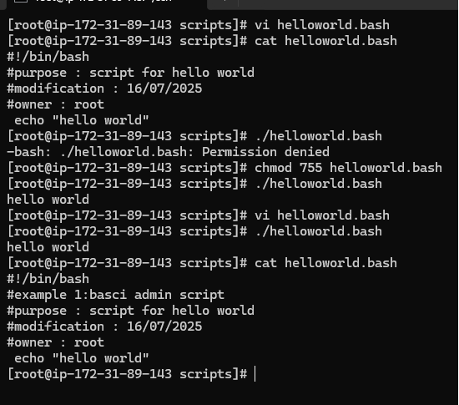

Defining Tasks

#!/bin/bash
# Define small tasks

whoami
echo
pwd
echo
hostname
echo
ls -ltr
echo
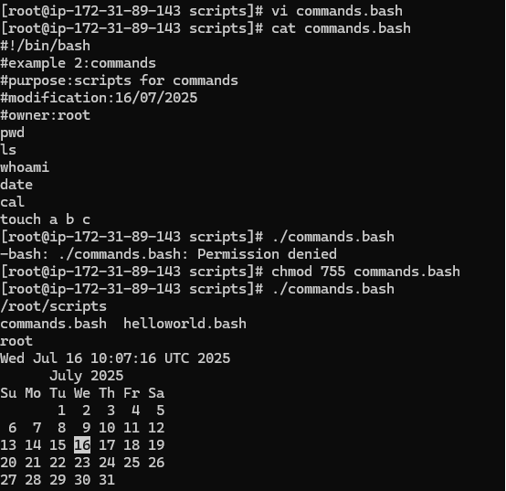

Defining variables

#!/bin/bash
# Example of defining variables

a=Imran
b=Afzal
c=’Linux class’

echo "My first name is $a"
echo "My surname is $b"
echo ‘My surname is $c’

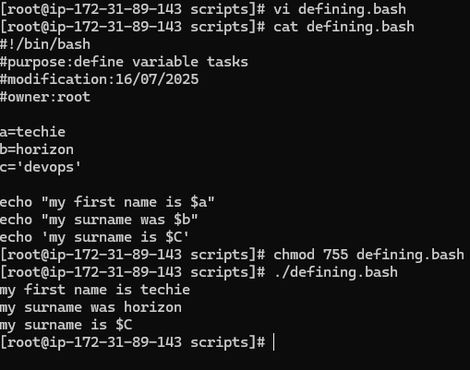

Read Input

#!/bin/bash
# Read user input

echo "What is your first name?"
read a
echo

echo "What is your last name?"
read b
echo

echo Hello $a $b

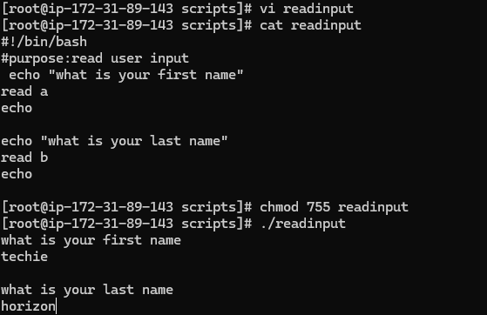

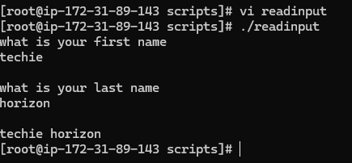

Scripts to run commands within

#!/bin/bash
# Script to run commands within

clear
echo "Hello `whoami`"
echo
echo "Today is `date`"
echo
echo "Number of user login: `who | wc -l `"
echo
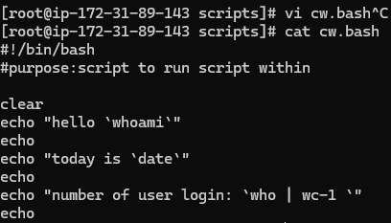

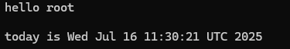

Read input and perform a task

#!/bin/bash
# This script will rename a file

echo Enter the file name to be renamed
read oldfilename

echo Enter the new file name
read newfilename

mv $oldfilename $newfilename
echo The file has been renamed as $newfilename

