case Scripts:

#!/bin/bash

echo
echo Please chose one of the options below
echo
echo 'a = Display Date and Time'
echo 'b = List file and directories'
echo 'c = List users logged in'
echo 'd = Check System uptime'
echo

read choices

case $choices in

a) date;;
b) ls;;
c) who;;
d) uptime;;
*) echo Invalid choice - Bye.

esac
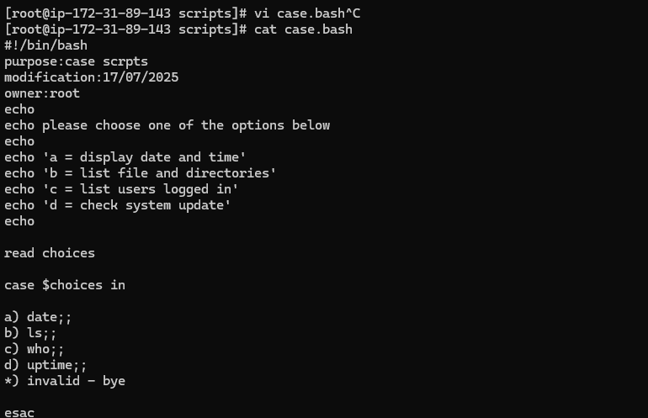
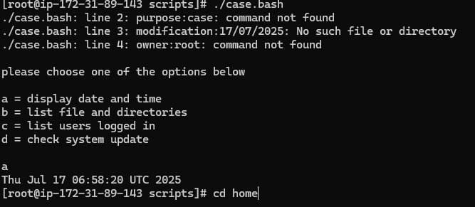

This script will look at your current day and tell you the state of the backup

#!/bin/bash

NOW=$(date +"%a")
case $NOW in
Mon)
echo "Full backup";;
Tue|Wed|Thu|Fri)
echo "Partial backup";;
Sat|Sun)
echo "No backup";;
*) ;;
esac
