React-js

Ser517 Project Technique Study

The reason I learn React.js is that sometimes we don’t actually wanna access the Back-end when we need to check the data. It can be very slow right? Also, I need to learn Front-end techniques to help implement our project.

It can be useful. For example, there is a upload button on the page to give user a way uploading PDF files. However when the user uploads the wrong type of file or even doesn’t upload anything, what is gonna happen? From my point of view, I will parse whatever the user gives me to Back-End and match this data to something in DB. Then I return a result to Front-End.

But this is too slow and not straight-forward. What if I directly raise a notification on the page? React.js does help us to do that. I really wanna learn something. Let’s start!

First we need to install the Node.js:

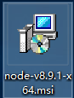

We create a js file named example.js on the desktop

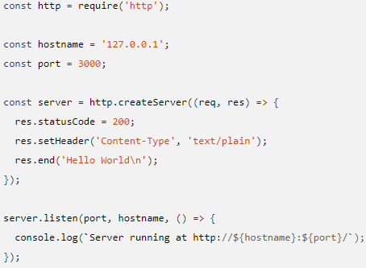

Write those code in that js file and open the CMD terminal:



Then, we wanna install React.js:

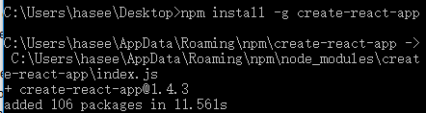

Then, try to create an app:

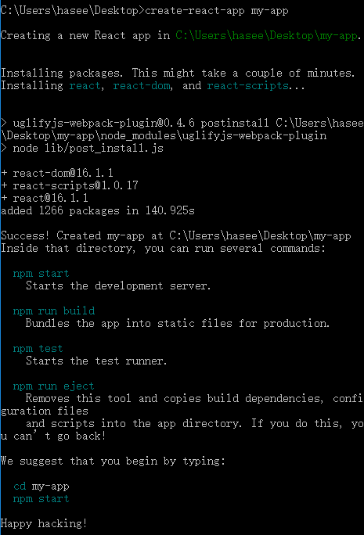

Now we get to that directory and try to run the code:



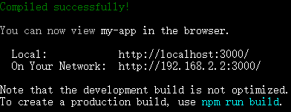

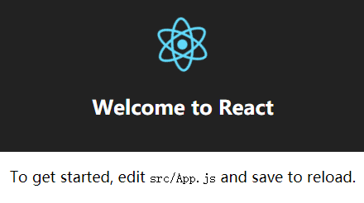

Let’s look into the js file, the code!

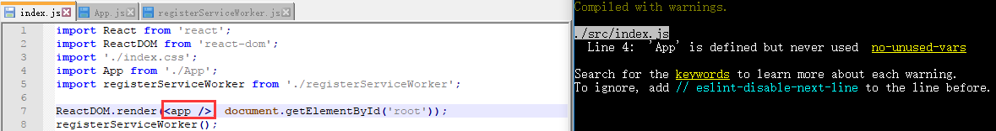

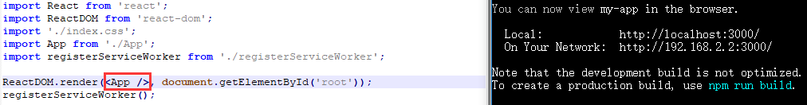

So this code is capital-sensitive!

Challenges:

Now we know how to create a simple React.js App but it is far away from implementation of our Profile Dashboard Module. We may spend more time learning it during the Winter-Break.