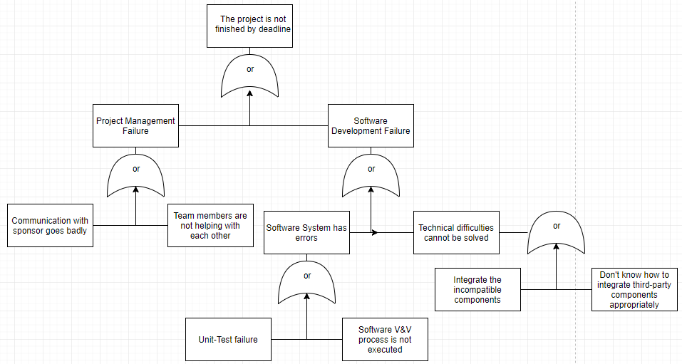

This Fault-Tree is our result of Risk Analysis.

The Fault-Tree lists all the possibilities that can lead to the failure of this whole Software process. Every leaf in this fault tree represents a possible original cause of failure, which should be overcome within our Software process.

Risk Summary

Cause 1: Bad Communication With Sponsor

It has never come out during this semester. Prof.Roman always replies our email timely. For next semester, if necessary, we may change the way of communication.

Cause 2: Team members are not helping each other

It has never come out during this semester. We always give the team our best shot and help each other whenever needed. Next semester we will be even better!

Cause 3: Unit-Test Failure

It has never come out during this semester.

Cause 4: Software V&V is not executed

It has never come out during this semester. In fact we did have some defects in our code but everything turned to a good situation after we applied a throughout test.

Cause 5: Integrate the incompatible components

This one is the most dangerous cause for us. In fact, at the beginning, we planned to use MangoDB as the database engine, but we failed to integrate it into our Django project. Then we hesitated to decide whether we should use relational or non-relational database. Finally, we chose PostgresQL, which was easy to use.

Cause 6: Don’t know how to Integrate third-party components

To be honest, we firmly believe that MangoDB is compatible with Django. It was like, we just didn’t know how to do it appropriately. Anyway, we are fine now.