**Super Admin**

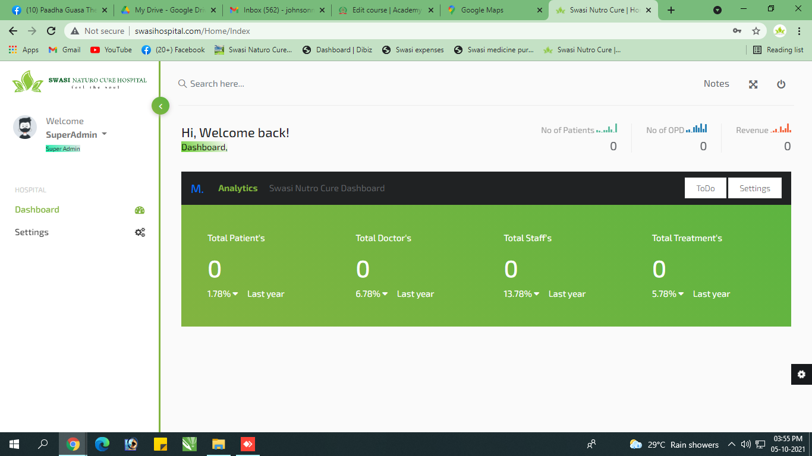

1. Report Panel ah kanom…Super Admin ku Report venum…

Settings – Staff – Inga 4 Staff View aaguthu but ulla ethum show aaga matinguthu…

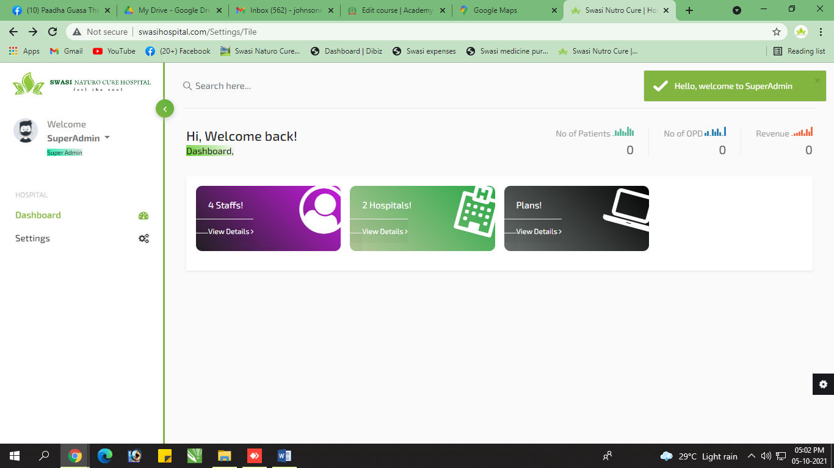

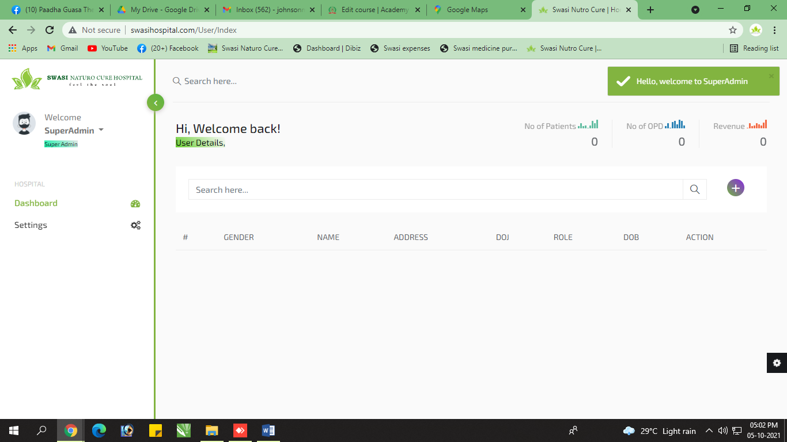

**Admin**

1. **System –** System Name la count increase pananum… detailed ah kuduka mudiyala…

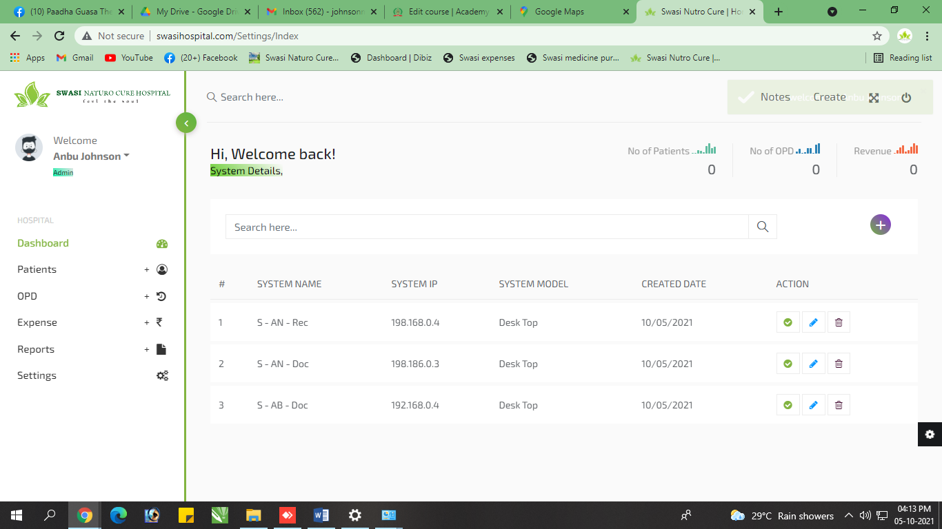

1. **Staff Add Page –** Staff Details kuduthuruken add aaiduchu nu notification vanthuruchu… but data add aagala… 3 times check paniten… 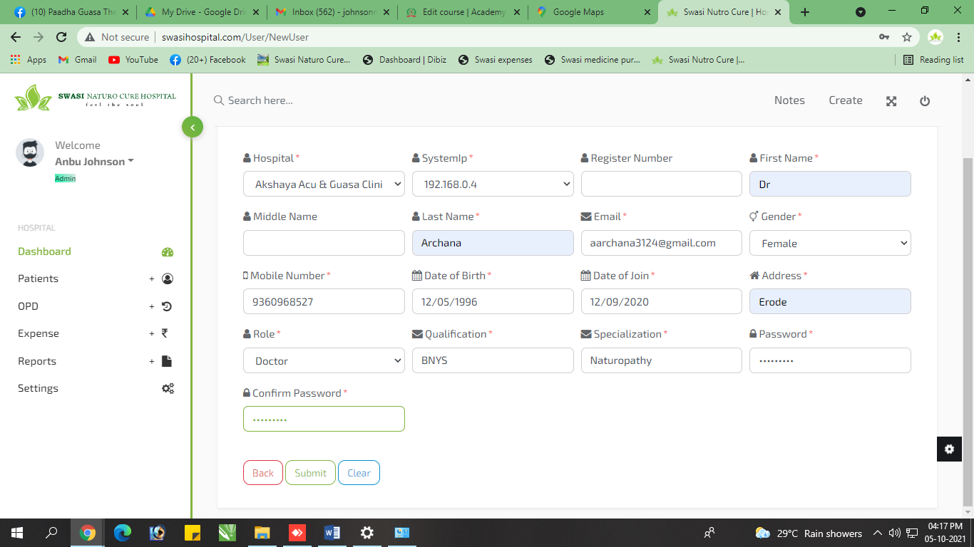

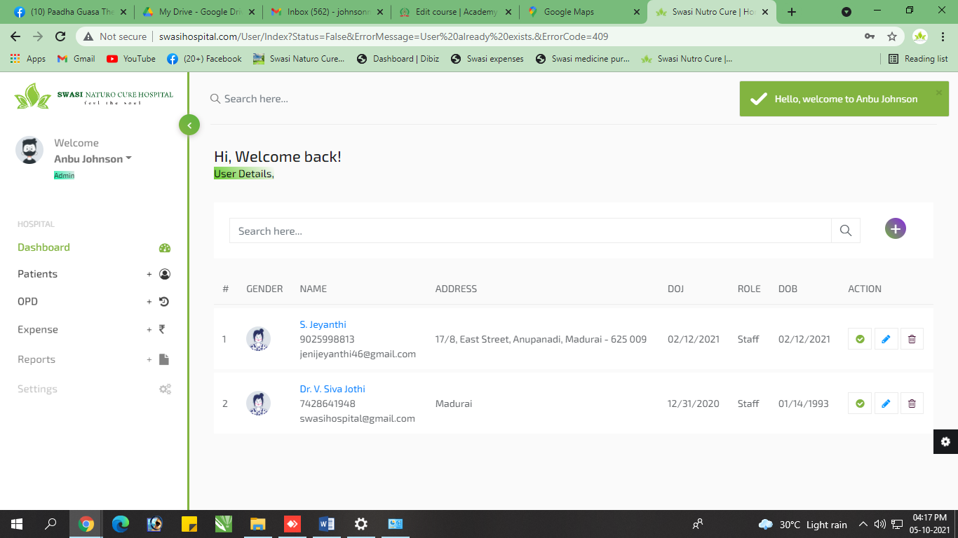

1. **Add Treatment –** 
   1. Duration add panrathu mins & hrs mention pananum… Duration column la Count increase pananum**…**
   2. Duration numeric mattum view aaguthu… athula mins & Hrs view aaganum
   3. Modified Date Add Pananum

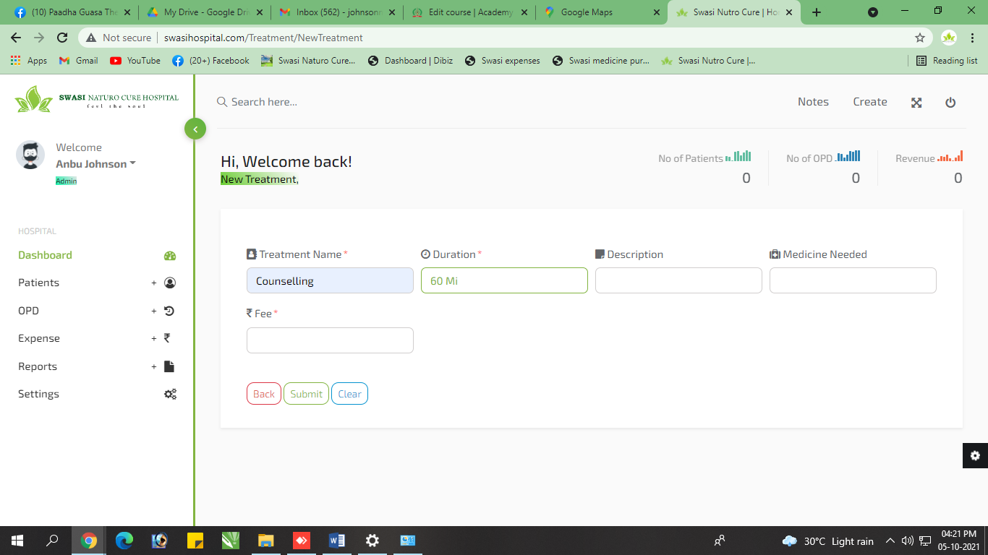

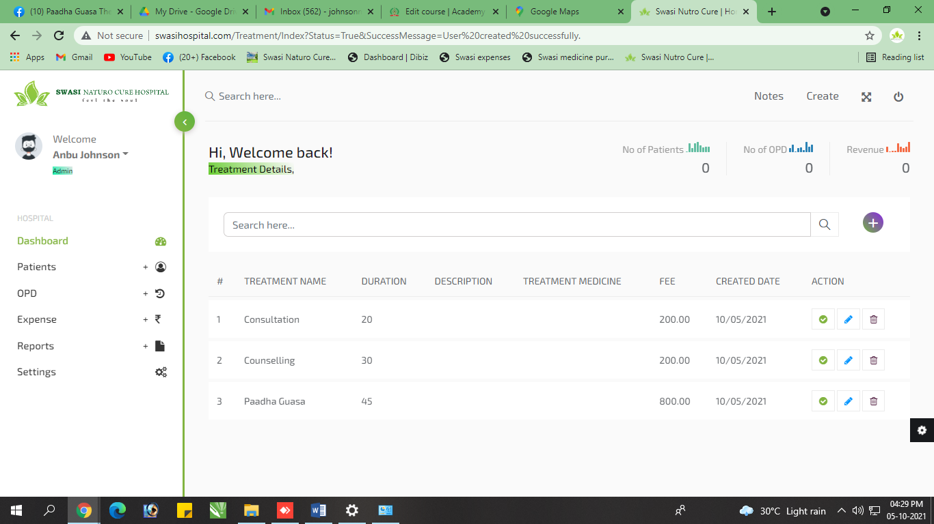

1. **Access Rights –** Ithula onnume ila.. Epdi data add panrathu

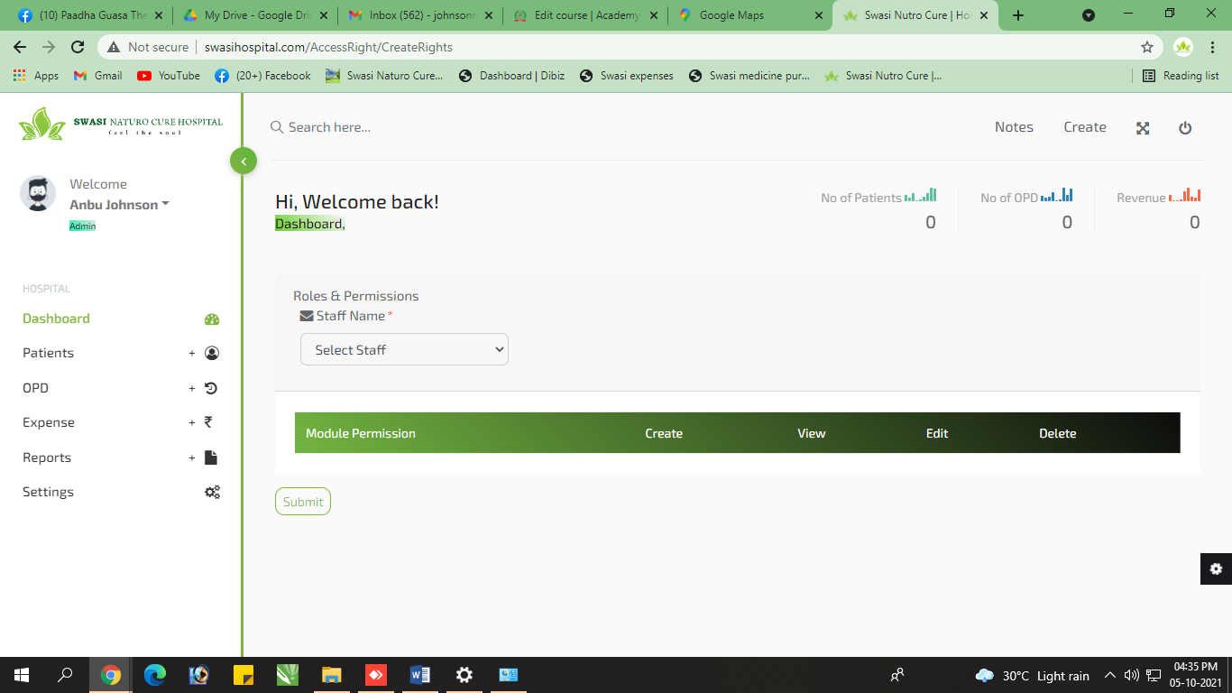

1. **New Medicine –** Intha page la just Medicine mattum than add pana porom… so athuku details iruntha pothu… atha already share paniruken… atha reference ah eduthuko..
   1. Drug Name
   2. Description
   3. Purchase Rate
   4. Sales Rate
   5. Manufacturer

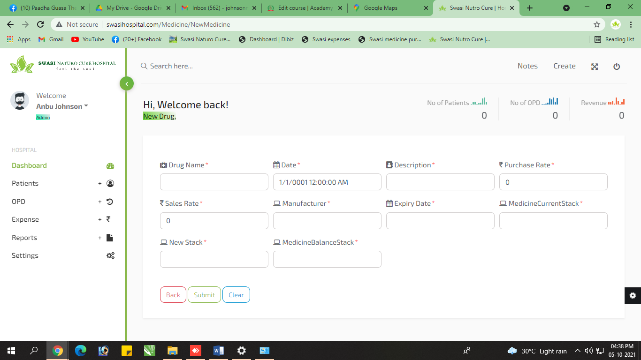

1. Staff Login – Staff ku IP address proper ah kuduthuten.. But open aaga matinguthu..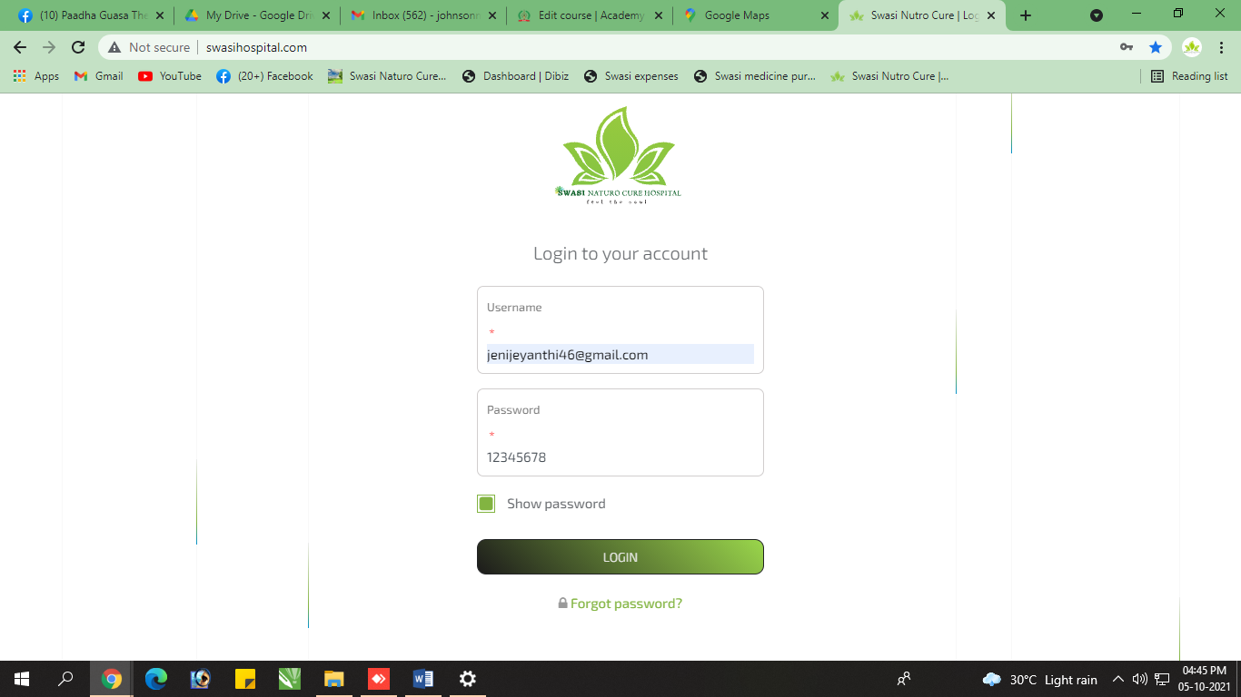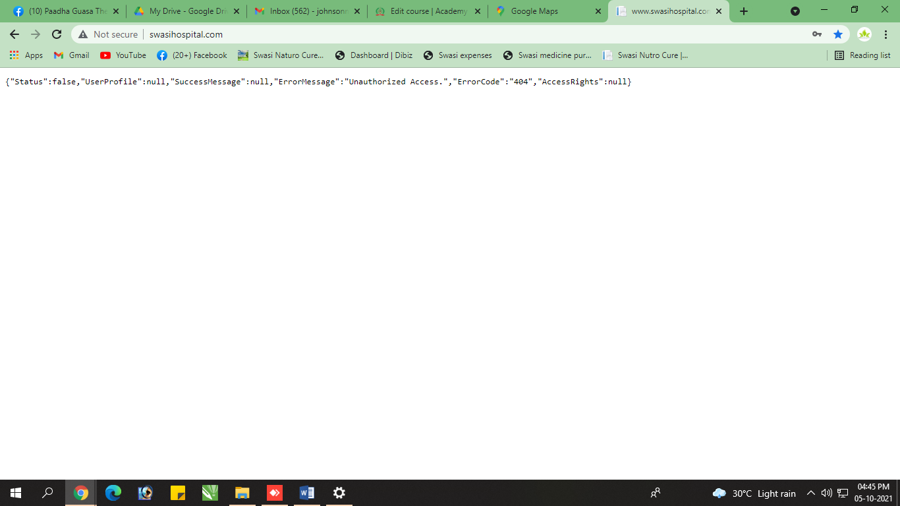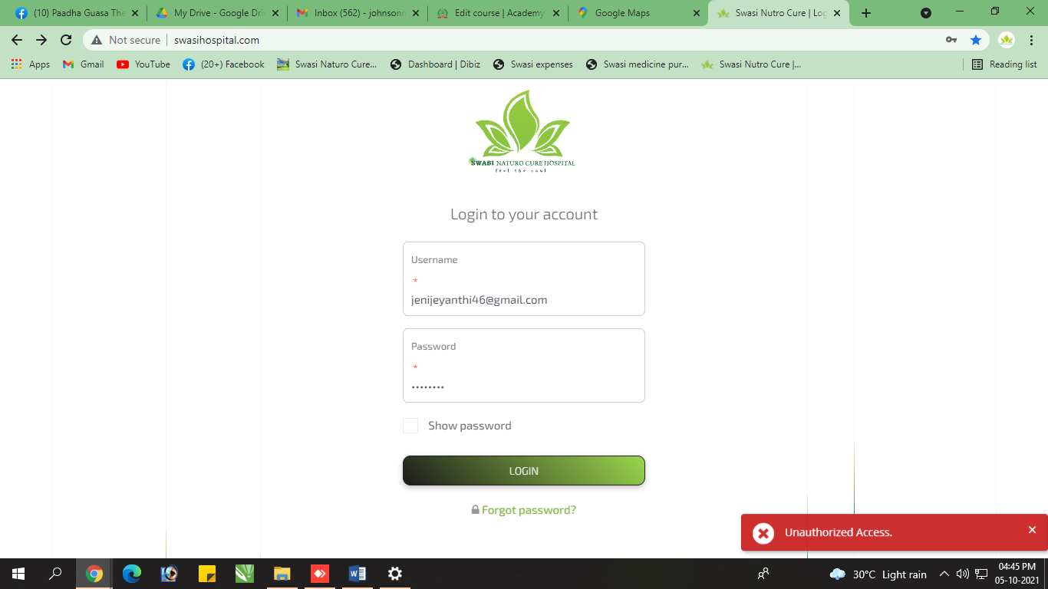

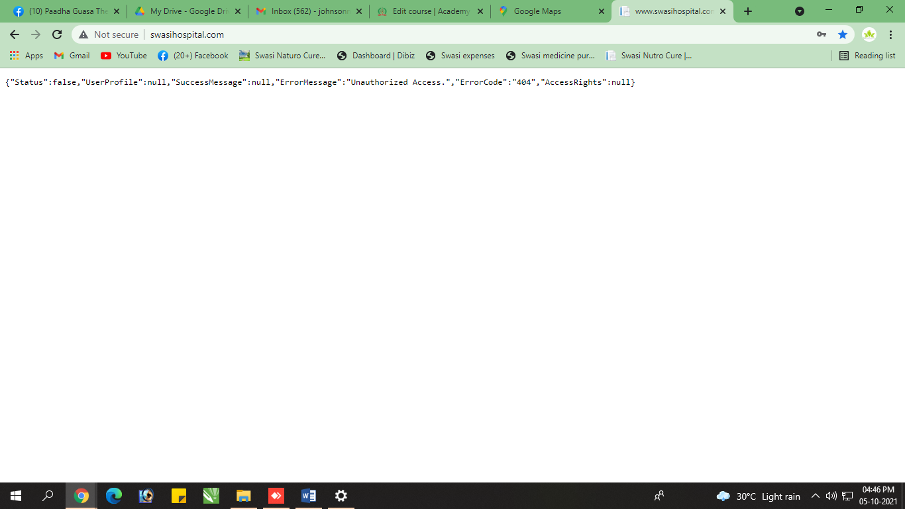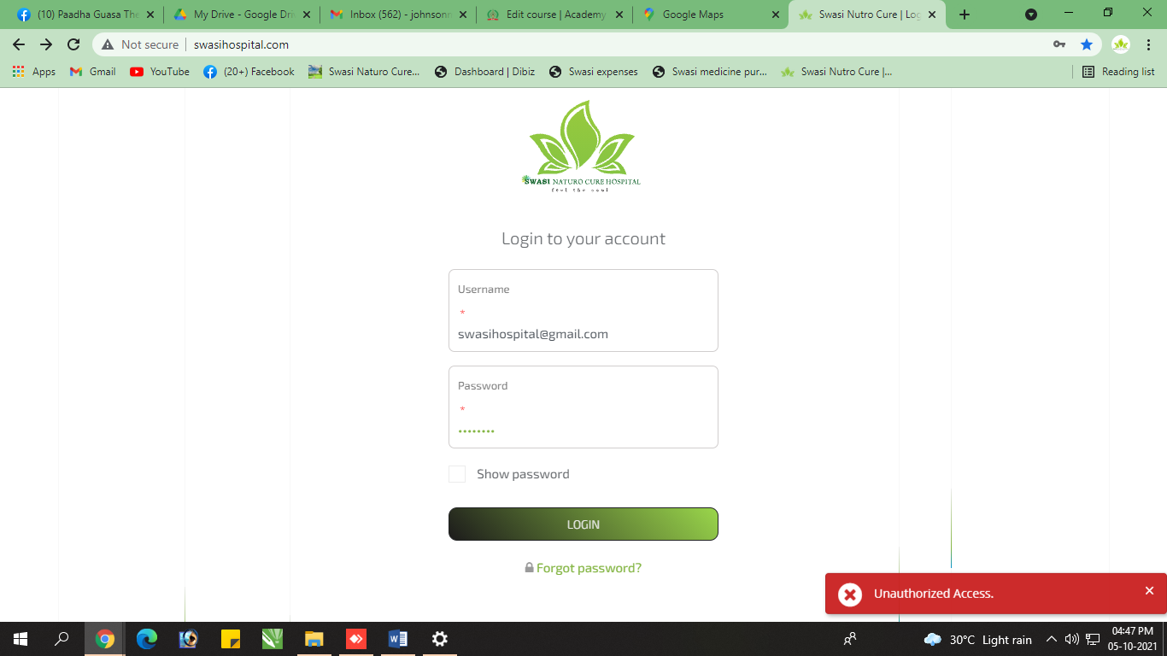

1. Settings – Ivlo neram intha account la than settings la work panitrunthen… ipo logout panitu login panren settings ah kanom….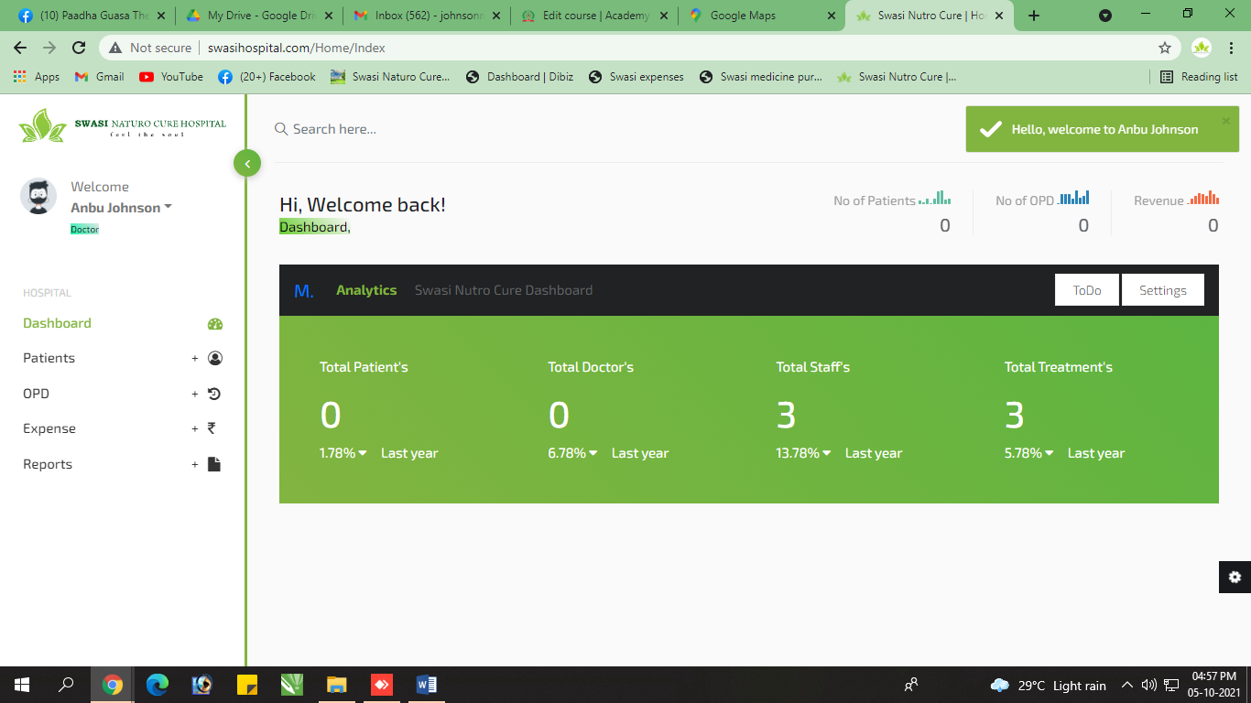
2. Designation – Doctor inga add paniruken… but designation la view aagala…

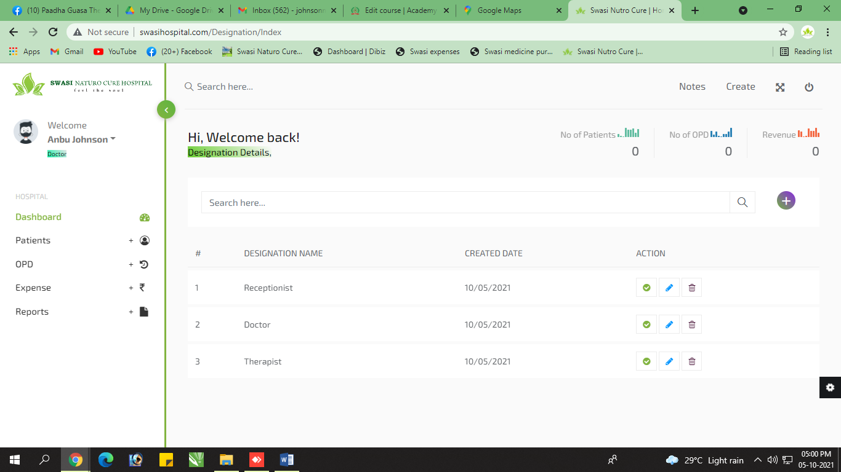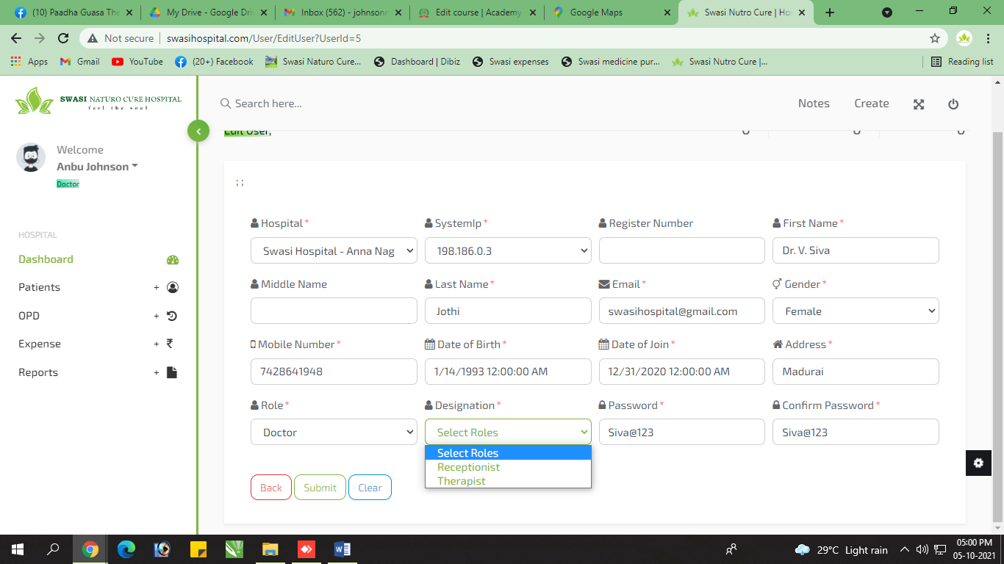

1. Login Error – intha error ella time login panum pothum varuthu…

