1.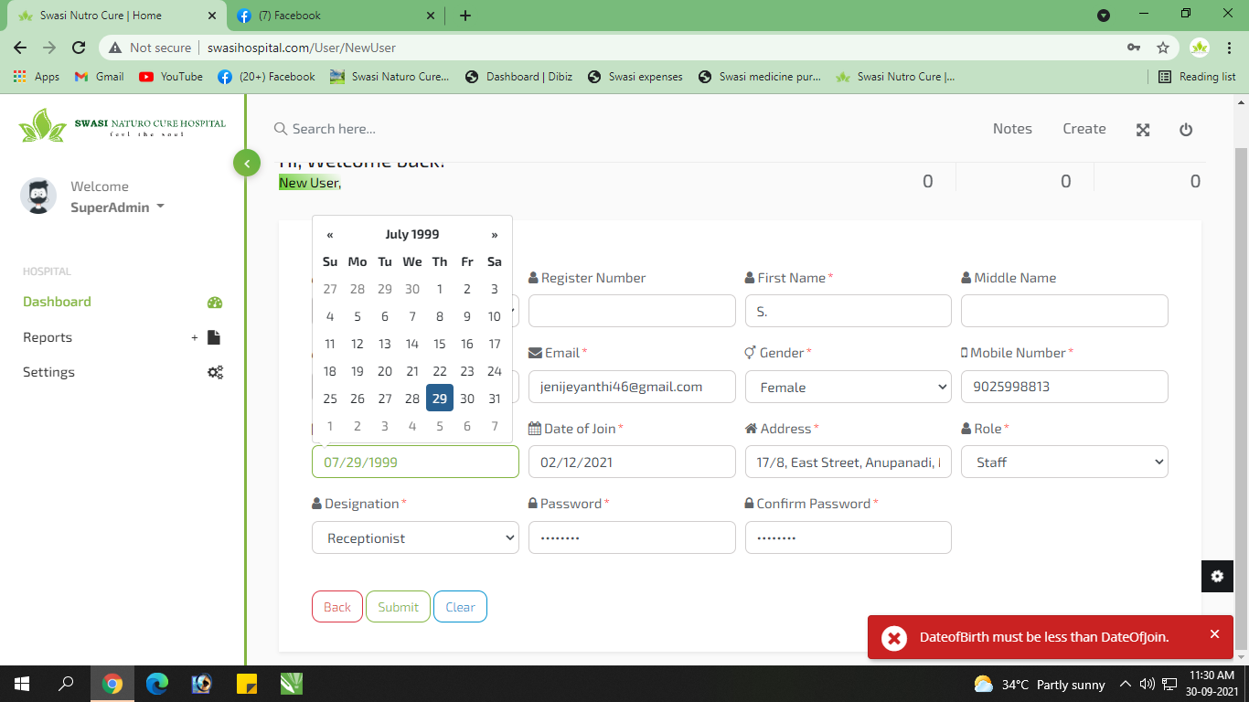

Error kattuthu… (Wrong Error) Fixed

2. Every Login 1st time we got Error Message… 2nd time it will open properly

3. 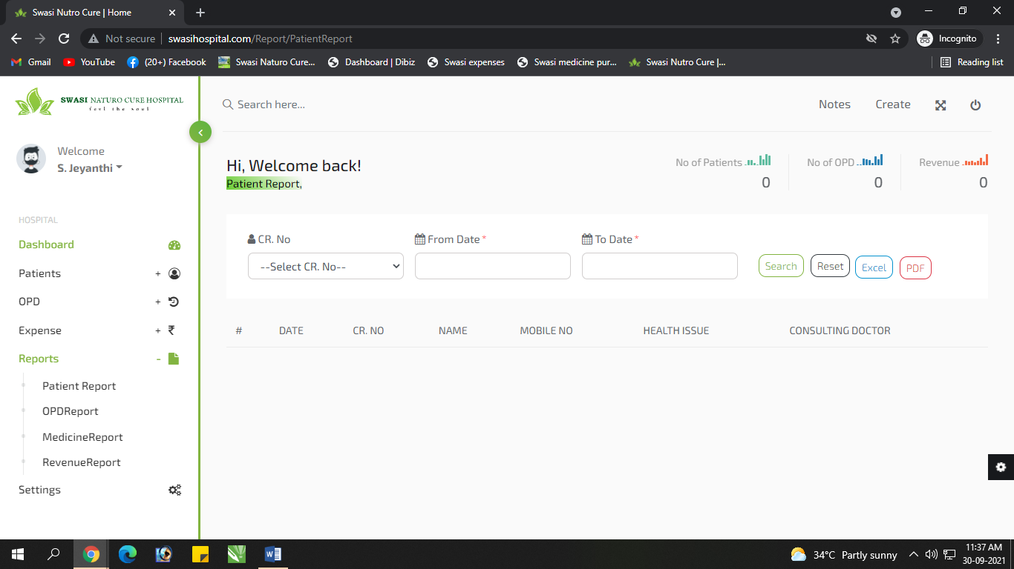

For Staff Login, No need Report Access FIXED

4. 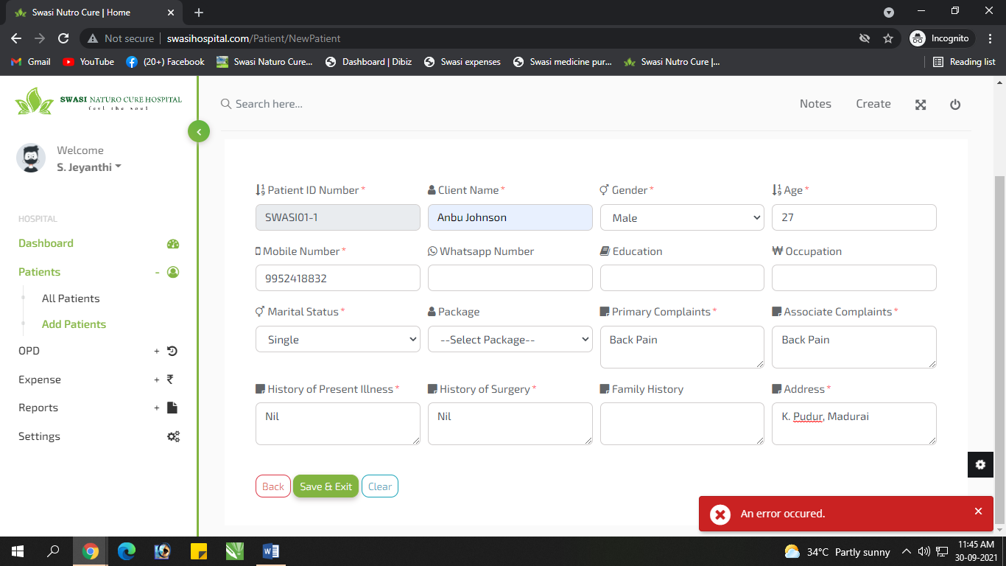

Add Patient la error kattuthu & ena error nu katala

5. 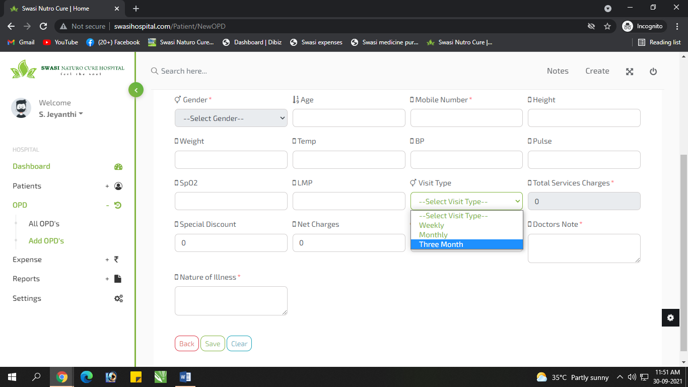

Add OPD – Visit type – Daily, Weekly, Weekly twice, Monthly, Monthly Twice, Once in a 3 month, Once in a 6 months, once in a year. FIXED

6. 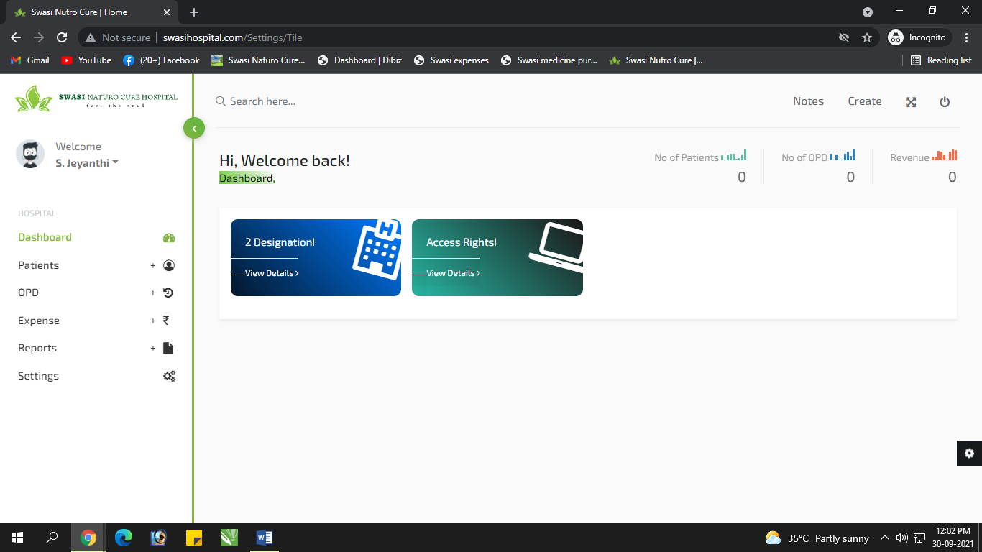

Ithu Staff ku display aaguthu… FIXED

7. 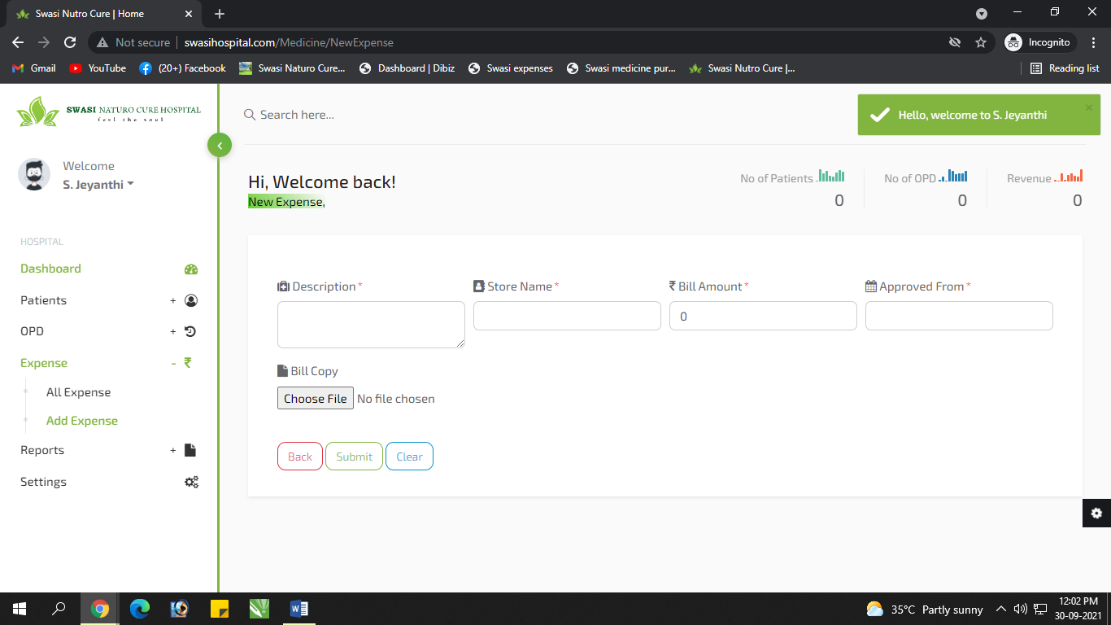

Add Expense – Need Date

8. 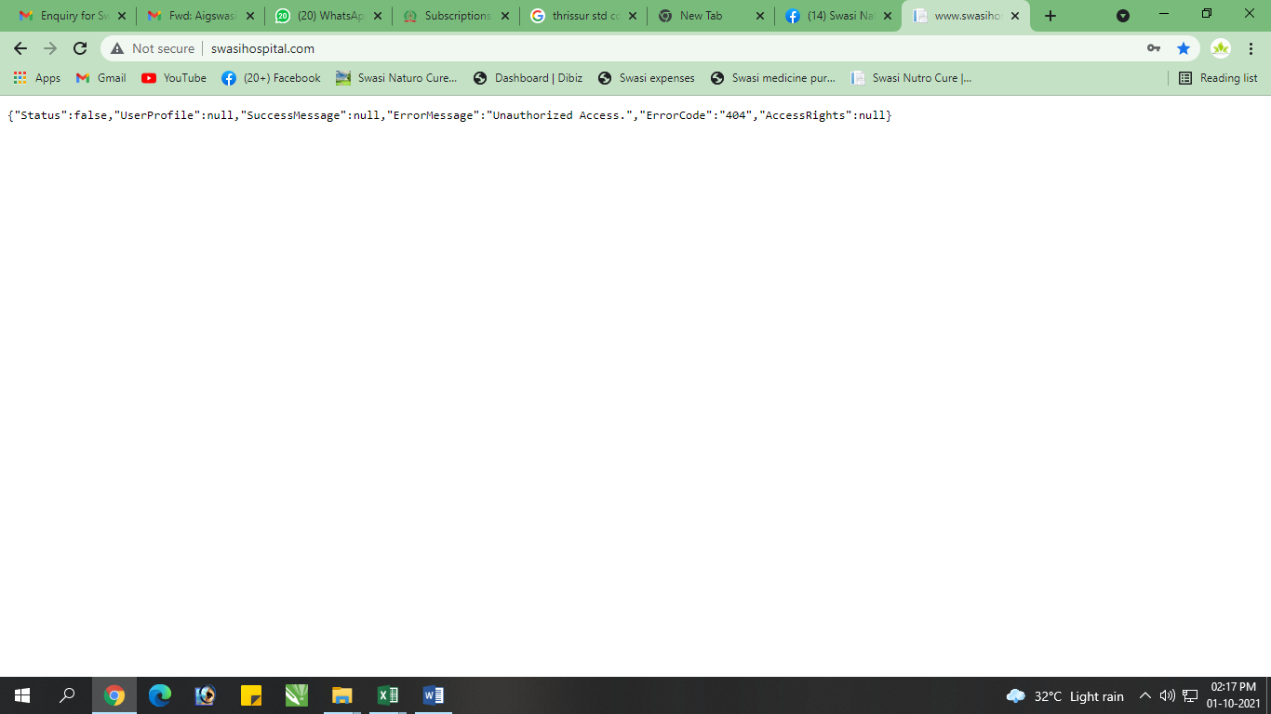 If wrongly entered the password means this error will shows… Kindly check it

9. 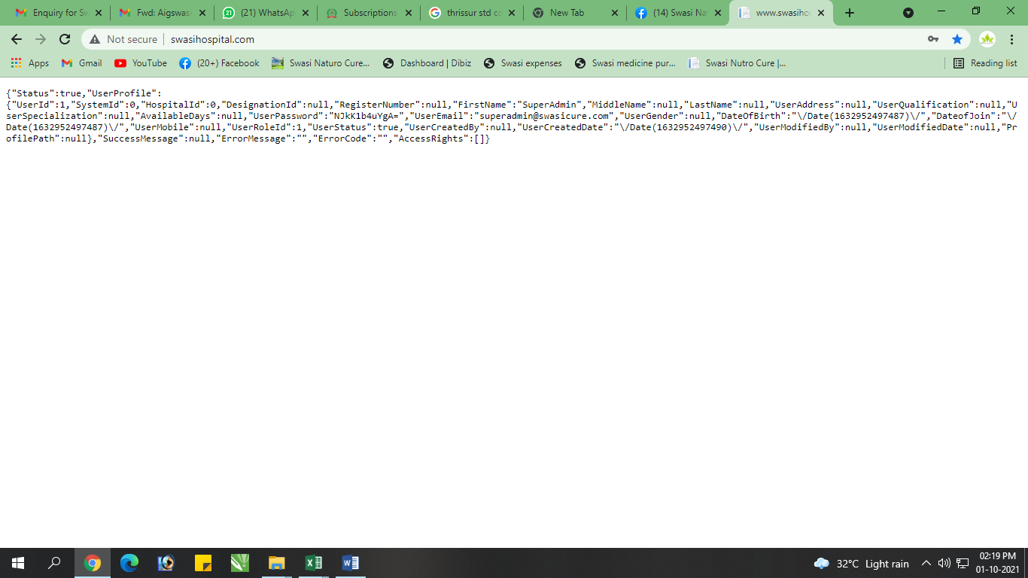

Every 1st time login this error will be come, If I longin 2nd time, then only it will loggedin

10. 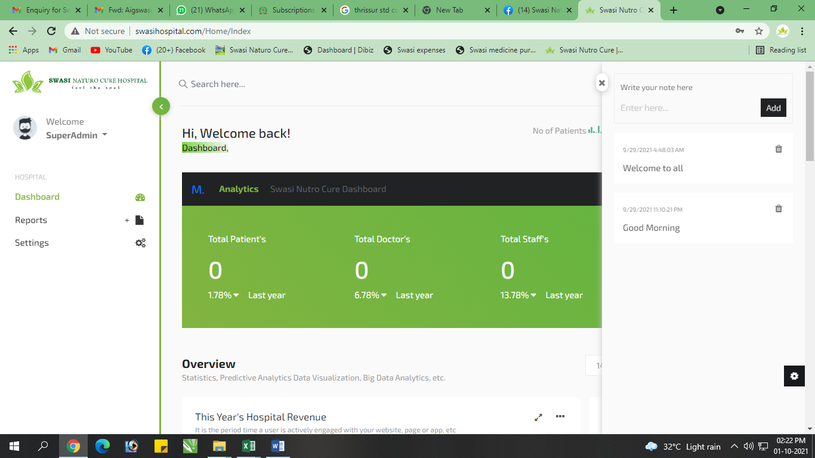

Note option:

1. Yaru Note podurangalo avanga name display aaganum Fixed

2. Yaru mzg anupurangalo avanga mattum than antha particular mzg ah delete pana mudiyanum… (Mathavangaluku View Option mattum than venum) Fixed

11. 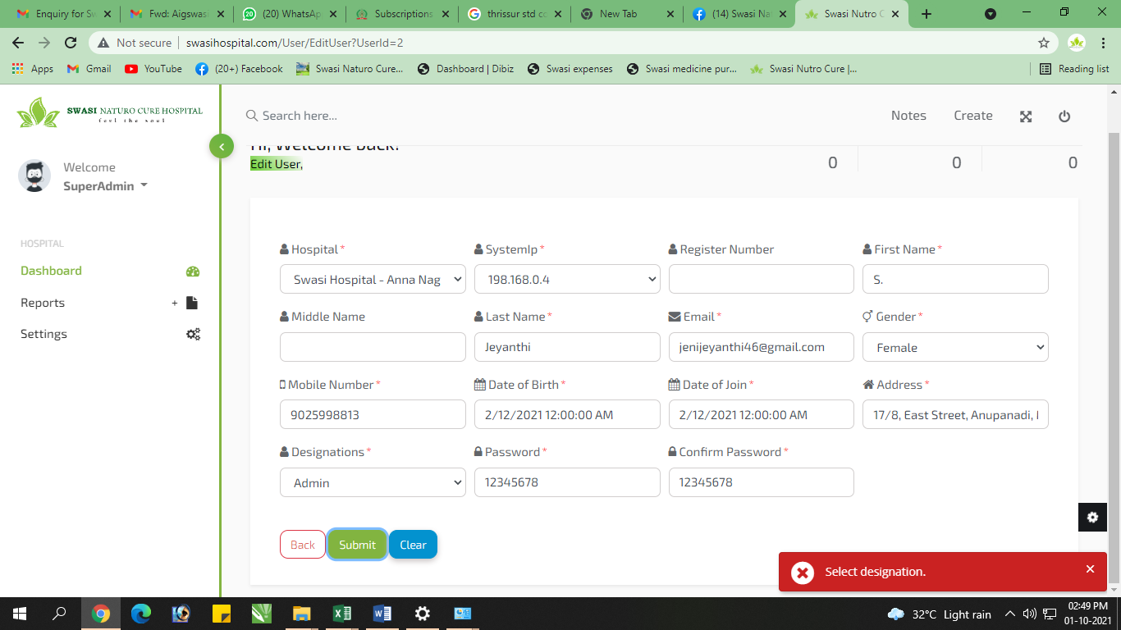

Add Staff la Designation add panathuku apramum, Select Designation nu kattuthu

12. 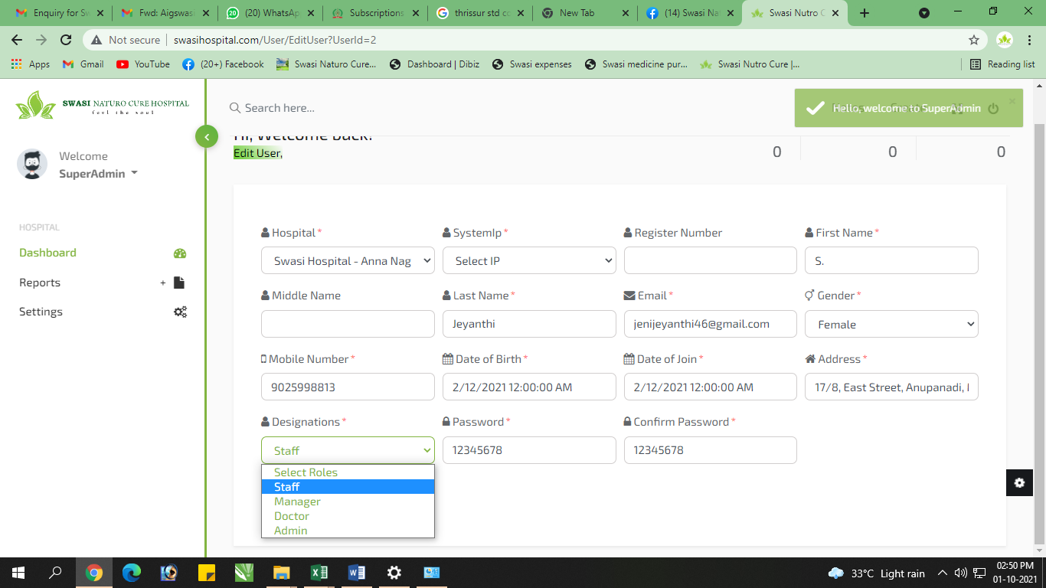

Designations add pana inga view aagala…

13. 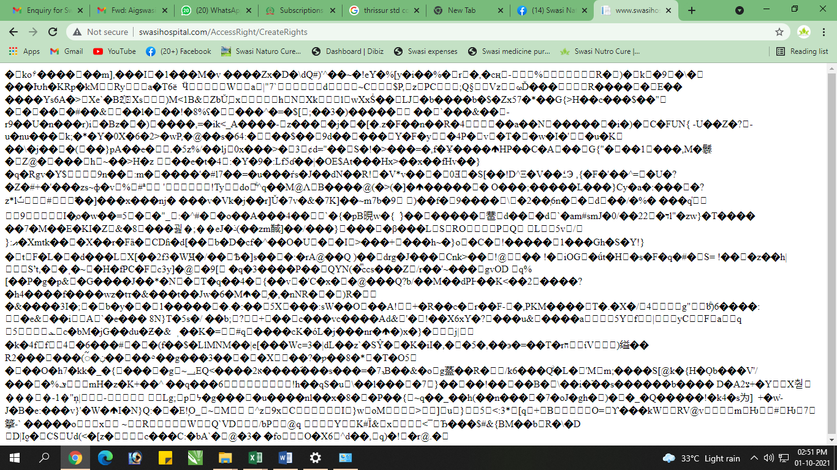

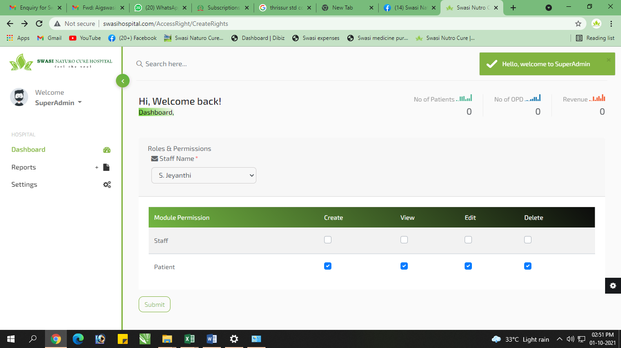

Ithu epdi set panrathu…Need Clarification

14. 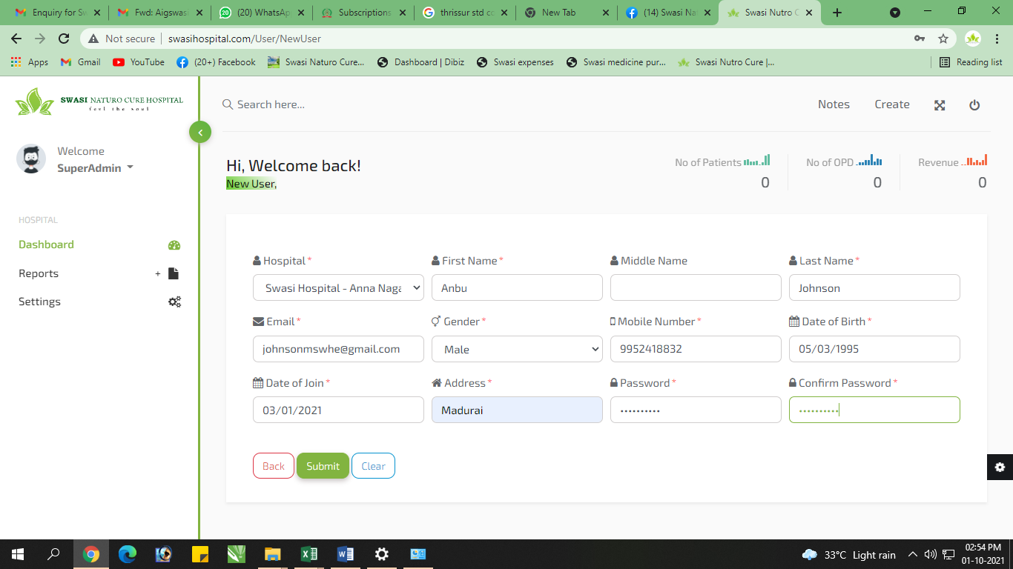

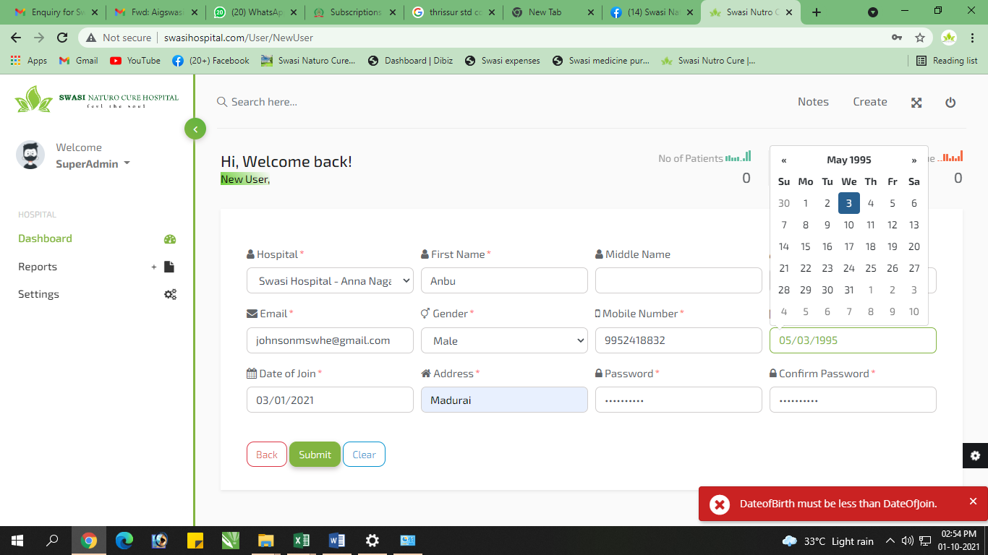

Kindly Check this page… New User la System add pananum la, DOB & DOJ la confusion iruku

15. 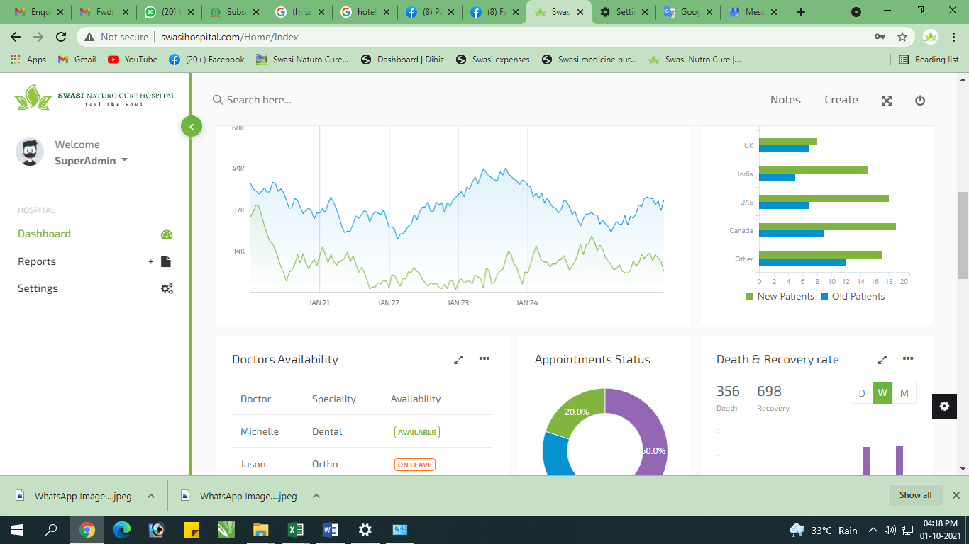

Unwanted Details ah Hide panidu FIXED

16.