Payroll
Integrated Financial Management System
October, 2011

User Manual - English
Version 1.0

October, 2011

Tata Consultancy Services
10th Floor, Air India Building,
Nariman Point, Mumbai - 400058
India

Application : | Pension Payment Application
Author | Sameer Lonkar
Date
Reviewed by
Department

This is a controlled document. Unauthorized access, copying, replication and usage for a purpose other than for which this is intended are prohibited.

DOCUMENT RELEASE NOTICE

Notice No.: IFMS 1.0
Customer: Government of Maharashtra (GoM)
Project: IFMS
Document details: User Manual for Payroll Application

Name | Version No. | Description
User Manual for Payroll Application | 1.0 | This document Explains about the Operations of Payroll Application

Revision details

Action taken | Preceding  Page No. | New  Page No. | Revision  Description

Change Register serial numbers covered:
The documents or revised pages are subject to document control.
Please keep them up-to-date using the release notices from the distributor of the document.
These are confidential documents. Unauthorized access or copying is prohibited.

Approved by: Date:

Authorized by: Date:

DOCUMENT REVISION LIST

Customer: Government of Maharashtra (GoM)
Project: IFMS
Document Name: User Manual for Pension Payment Application

Release Notice Reference (for release): V1.0

Rev.  No | Revision  Date | Revision  Description | Page  No. | Prev  Page No | Action  Taken | Addenda/New page | Release  Notice reference

ABOUT THIS DOCUMENT

Purpose
The purpose of the operating manual document is to assist the users in using the Payroll module of IFMS

Intended Audience
This document is intended for the GoM committee and users of Payroll

Prerequisites
To be able to use this document, the users must have thorough knowledge of the requirements of the Payroll Application

Conventions Used
All procedures are given in a numbered list.
Essential related information is placed in a box as a Note.

House keeping of data
5 Years

1 LOGIN DETAILS 5
1.1 Login Page 6
1.2 Forgot Password 6
1.3 Home Page 7

LOGIN DETAILS

Login Page

Below is the Login Page from which you can loginto the system:-

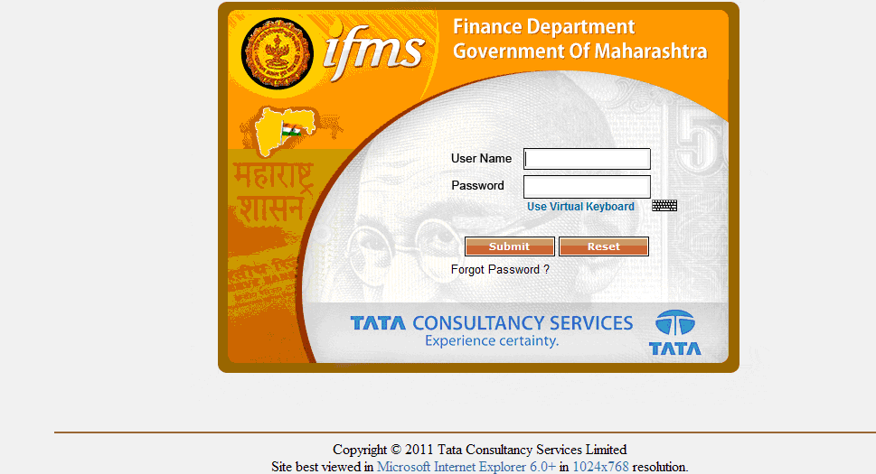
On clicking the keyboard icon, you can enter the password using the Virtual Keyboard.

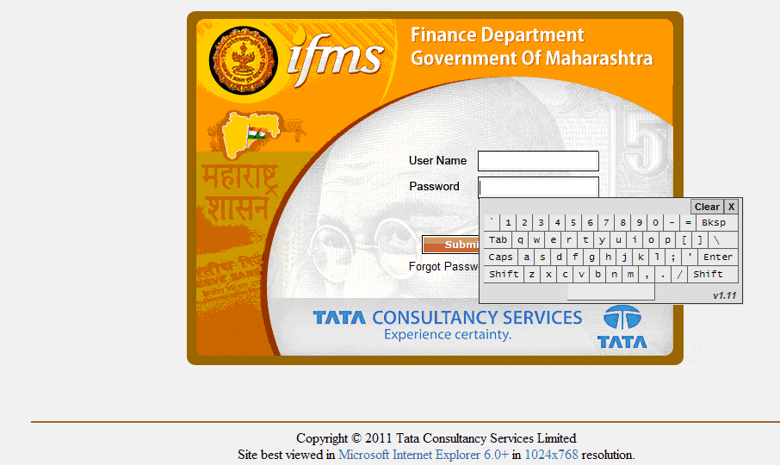
Virtual Keyboard

Forgot Password

By clicking the ‘Forgot Password’, you can change your password from the screen shown below. Type your user name and click on Submit.

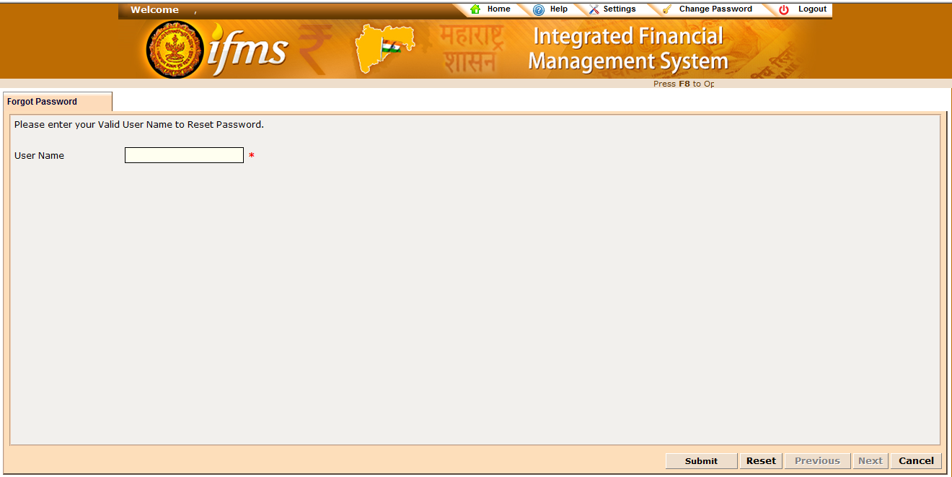

On clicking Submit you will have to fill the required fields mentioned in the screen below.

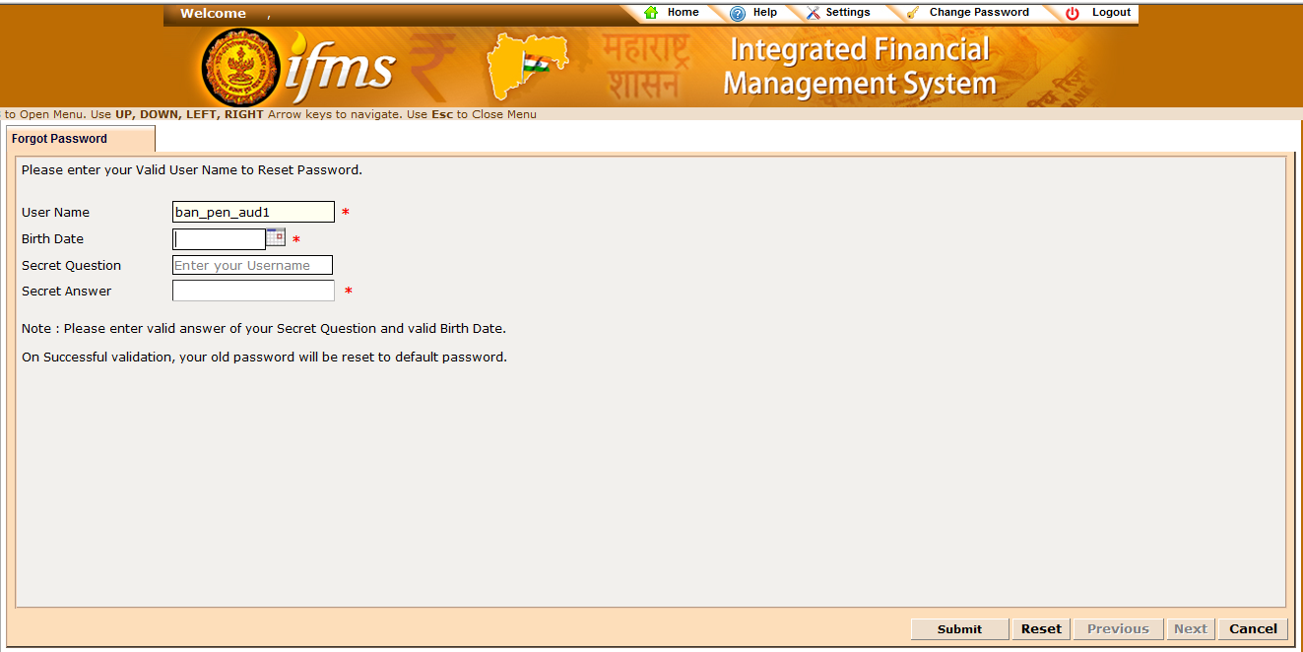
On clicking Submit, the system will validate and the old password will be reset to default password.

Home Page
This is the ‘Home’ screen which will be shown to you after you log in from your ID.

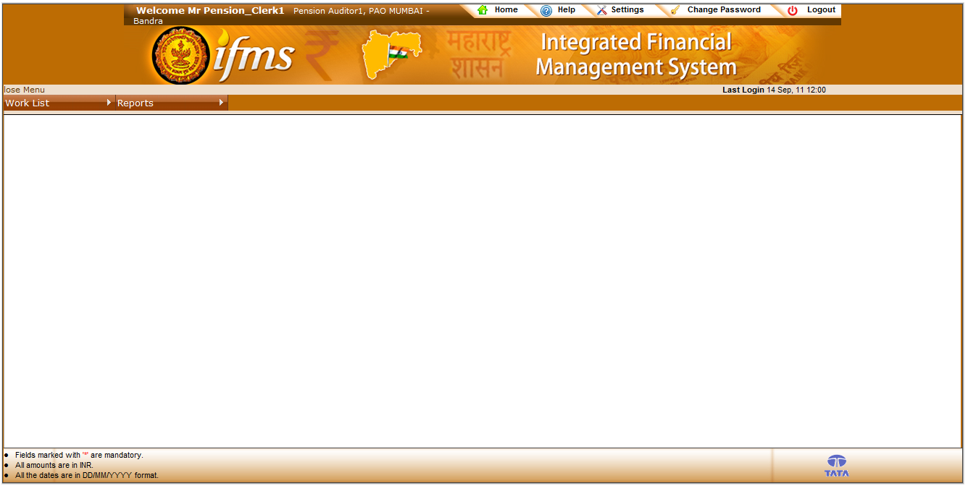

This is the Home screen for you, where your designation along with the office you are from, the Work List, Reports etc. At the top there are following sections -

    - Change Password
By clicking on the “Change Password” you can change your password from the screen shown below:-
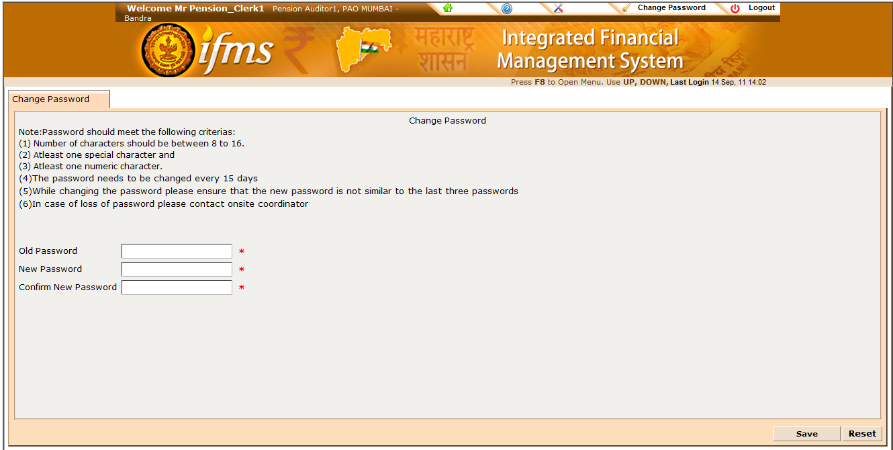
On clicking the Save the new password will be set.

    - Logout
On clicking the “Logout” the system will logout from the current screen and the Login Page will be shown.

New Post Creation
Work list > Payroll > Payroll Admin > New Post Creation

- This functionality is used for creating new permanent or temporary post
- Following screen will get opened after clicking New Post Creation

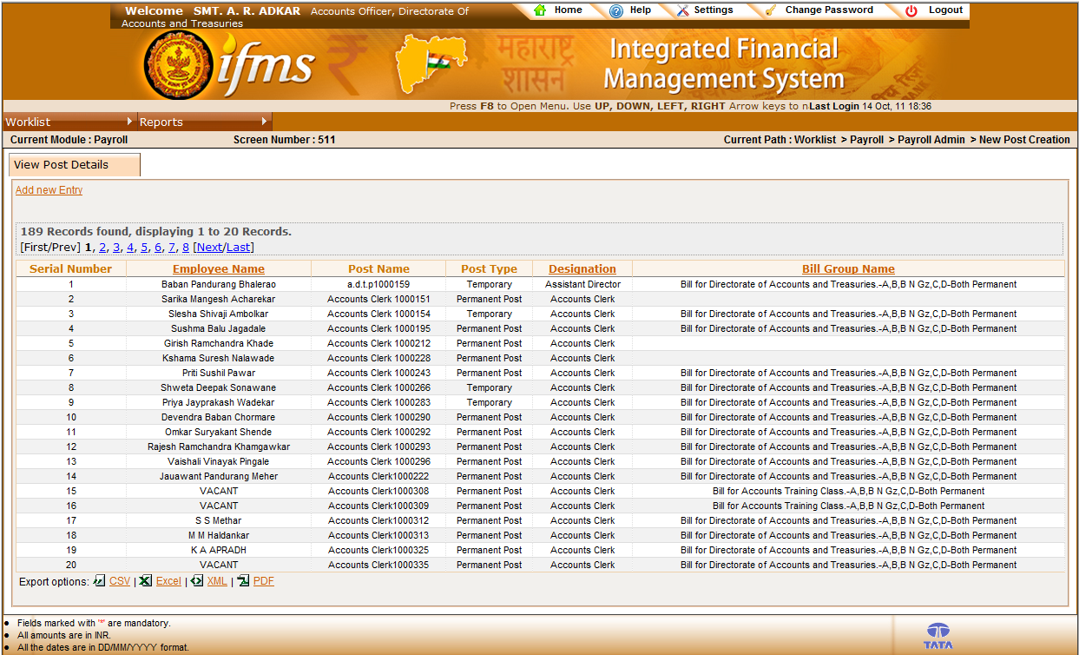

- The above screen reflects new posts already created.
- Hyperlinks are provided at the headings – Employee Name, Designation, Bill Group Name. Click on the hyperlink to sort the list according to the heading.

Add New Entry
- Click on Add New Entry for creating new permanent or temporary post
- Following screen will get appeared

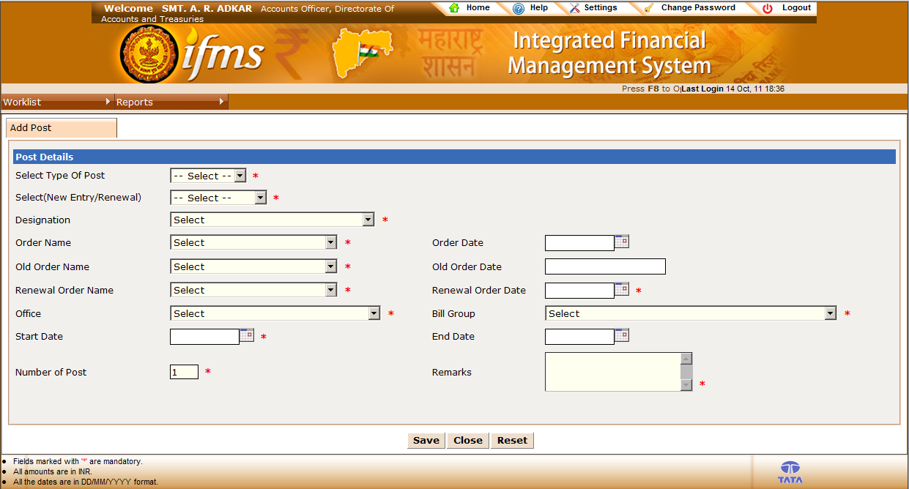

- Select type of post – Permanent or Temporary as required

    - Permanent Post Creation
- After selecting ‘Permanent’, following screen will get appeared –

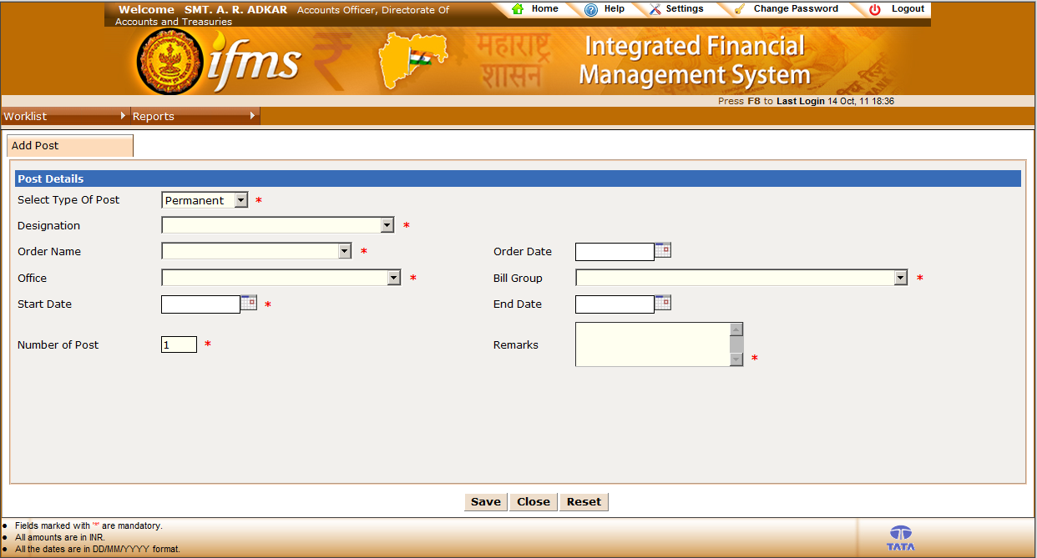

Steps for creating a new Permanent Post –

- Select Designation

- Select Order Name

Order Date will get displayed automatically

- Select Office

- Select Bill Group

- Select Start Date of post

- Select End Date of post (Not Mandatory)

- Enter number of posts to be created

- Enter Remarks

- Click Save to create new posts

- Click Reset to clear the data entered

    - Temporary Post Creation
After selecting ‘Temporary’, following screen will get appeared –

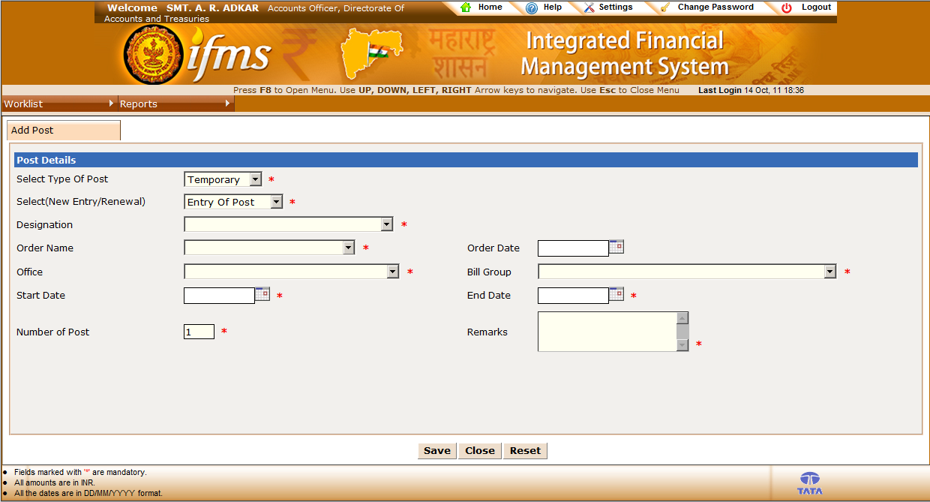

Select New Entry / Renewal

After selecting ‘Entry of Post’, following screen will get appeared –

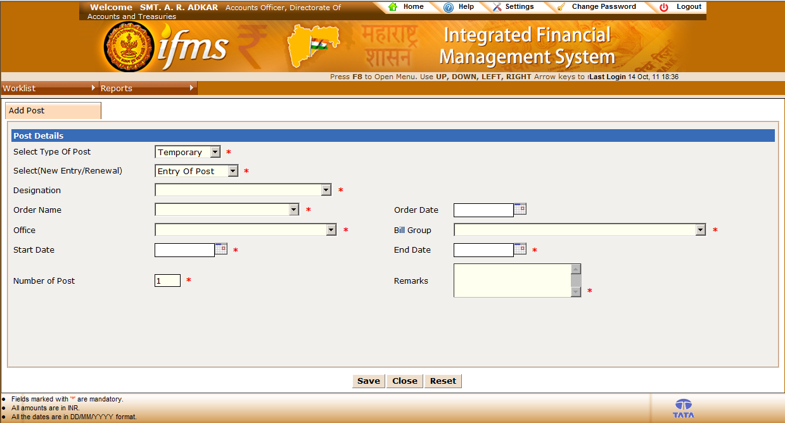

- Select Designation

- Select Order Name

Order Date will get displayed automatically

- Select Office

- Select Bill Group

- Select Start Date of post

- Select End Date of post

- Enter number of posts to be created

- Enter Remarks

- Click Save to create new posts

- Click Reset to clear the data entered

After selecting ‘Renewal of Post’, following screen will get appeared –

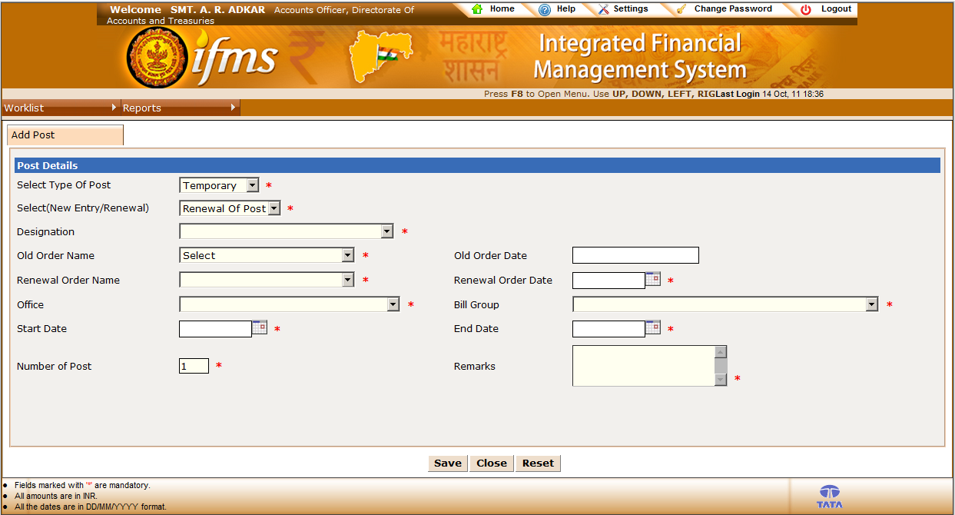

- Select Designation

- Select Order Name

Order Date will get displayed automatically

- Select Renewal Order Name

- Select Renewal Order Date

- Select Office

- Select Bill Group

- Select Start Date of post

- Select End Date of post

- Enter number of posts to be created

- Enter Remarks

- Click Save to create new posts

- Click Reset to clear the data entered

