FLOOD MONITERING ANDEARLYWARNING

PROJECTCODE:223935-TEAM2
NAME : NAVEEN RAO.V
REG NO:610821106061
Abstract:

Floods, being natural disasters, pose significant threats to both human lives and infrastructure. Timelyand accurate flood monitoring is crucial for effective disaster management and response. This paperpresentsaninnovativeIntelligentFloodMonitoringSystem(IFMS)basedonamodularframework.The
proposedsystemutilizesadvancedtechnologiesandmodularcomponentstoenhancetheefficiencyandaccuracyofflooddetectionandprediction.

Modules:

SensorNetworkModule:

Deployinganarrayofsensors,includingwaterlevelsensors,weatherstations,andGPSdevices,tocollect real-time datafromflood-proneareas.

UtilizingIoTtechnologyforseamlesscommunicationbetweensensorsandthecentralmonitoringsystem.

DataProcessingModule

Implementingdatapreprocessingtechniquestofilterandcleantherawsensordata.

Employingmachinelearningalgorithmsfordataanalysis,anomalydetection,andpatternrecognitiontoidentifypotentialfloodindicators.

PredictionandEarlyWarningModule:

Developingpredictivemodelsusinghistoricaldataandmachinelearningalgorithmstoforecastfloodevents.

Implementinganearlywarningsystemthattriggersalertstoauthoritiesandresidentsinat-riskareasbasedonthepredictions.

GISMappingModule:

IntegratingGeographicalInformationSystem(GIS)mappingtovisualizeflood-proneareasandtheirtopographicalfeatures.

Providingdecision-makerswithspatialdatatooptimizeresourceallocationandemergencyresponseplanning.

CommunicationandAlertModule:

Establishingarobustcommunicationsystem,includingSMS,email,andsocialmediaplatforms,todisseminatealertsandwarningstothepublic.

Allowingtwo-waycommunicationforresidentstoreportemergenciesandrequestassistanceduringfloodevents.

RemoteMonitoringandControlModule:

Enablingremotemonitoringofthefloodsituationthroughmobileapplicationsandwebinterfaces.

Implementingcontrolmechanisms,suchasautomatedfloodbarriers,based onreal-timedataandpredictionstomitigate theimpactofflooding.

Conclusion:

TheIntelligentFloodMonitoringSystempresentedinthispaperdemonstratesacomprehensiveandmodularapproachtofloodmonitoring.Byintegratingcutting-edgetechnologies,dataanalysis
techniques,andcommunicationsystems,theproposedsystemprovidesaccurateandtimelyinformationto both authorities and residents. This modular design not only ensures scalability and flexibility but alsoenhancesthesystem’sadaptabilitytodifferentgeographicalregionsandvaryingfloodscenarios.The
implementationofthissystemhasthepotentialtorevolutionizefloodmanagementpractices,significantlyreducing theimpact offloodsonvulnerablecommunities.
FLOOD MONITERNING AND EARLY WARMING
TodeployIoTsensorsformeasuringwaterlevelsinflood-proneareas,followthesegeneralsteps:
**SelectSensors:**

Choosewaterlevelsensorssuitableforyourspecificenvironmentandrequirements.Considerfactorslikeaccuracy,durability,andcommunicationcapabilities.

**ChooseCommunicationProtocol:**
Decideonacommunicationprotocolforthesensors.CommonchoicesincludeMQTT,CoAP,orHTTP.Ensurecompatibilitywithyoursensoranddatacollectionplatform.

**IoTPlatformSelection:**
ChooseanIoTplatformfordatacollectionandmanagement.PopularplatformsincludeAWSIoT,AzureIoT,andGoogleCloudIoT.Set upanaccount andcreateaproject.

**ConfigureIoTDevices:**
ConfigureeachIoTsensortoconnecttoyourchosenIoTplatform.Setupcredentials,communicationprotocols,andensurepropersecuritymeasures are inplace.

**InstallSensors:**
Deploysensorsinflood-proneareas,ensuringtheyaresecurelyplacedtowithstandenvironmentalconditions.Connect sensorstoapowersourceandverifytheirfunctionality.

**TestCommunication:**
ConfirmthatsensorscancommunicatewiththeIoTplatform.Sendtestdataandcheckifit’scorrectlyreceivedandlogged ontheplatform.

**DataProcessingandStorage:**
SetupdataprocessingandstoragemechanismsonyourIoTplatform.Definehowdatashouldbehandled,stored, andanalyzed.

**EarlyWarningSystem:**
Implementanearlywarningsystemthattriggersalertsbasedonthereceivedwaterleveldata.Thiscouldinvolvesettingthresholdsandsendingnotifications whencriticallevelsarereached.

**PowerManagement:**

Implementpowermanagementstrategiesforthesensors,especiallyiftheyareinremoteareas.Considerusing solarpowerorlow-powermodestoextendsensorlifetimes.

**MonitoringandMaintenance:**
Regularlymonitorthesensors’performanceandaddressanyissuespromptly.Planforroutinemaintenancetoensuresensorscontinuetooperateeffectively.

Remembertoadaptthesestepsbasedonthespecificrequirementsofyourprojectandthecharacteristicsoftheflood-proneareaswherethesensorswillbedeployed.
Certainly!Let’sassumeyou’reusingahypotheticalwaterlevelsensorthatcommunicatesoverMQTT.Here’sabasicPythonscriptusingthePahoMQTTlibrarytosendwaterleveldatatoaserver:

```python
Importpaho.mqtt.clientasmqttImport json
Import randomImporttime

#SimulatingwaterleveldatafortestingDefget_water_level():
Returnrandom.uniform(0,100)

#MQTTsettings
Broker_address=“mqtt.eclipse.org”Port = 1883
Topic=“water_level_data”

# Callback when connection is establishedDefon_connect(client,userdata,flags,rc):
Print(“Connectedwithresultcode“+str(rc))
Client.subscribe(topic)

#CallbackwhenamessageisreceivedfromtheserverDefon_message(client,userdata,msg):
Print(f”Receivedmessage:{msg.payload}”)

#CreateMQTTclientClient=mqtt.Client()
Client.on_connect = on_connectClient.on_message=on_message

#Connecttothebroker
Client.connect(broker_address,port,60)

#LooptocontinuouslysendwaterleveldataTry:
WhileTrue:
Water_level=get_water_level()
Payload={“water_level”:water_level}

#ConvertdictionarytoJSON
Payload_json=json.dumps(payload)

#Publishdatatothetopic
Client.publish(topic,payload_json)

Print(f”Sentwaterleveldata:{water_level}”)
Time.sleep(10)#Adjusttheintervalbasedonyourrequirements

ExceptKeyboardInterrupt:
Print(“Scriptterminatedbyuser”)Client.disconnect()
```

Thisscriptgeneratesrandomwaterleveldatafortestingpurposes.Inareal-worldscenario,youwouldreplacethe`get_water_level`functionwiththelogictoreaddatafromyouractualwaterlevelsensor.

Also,makesuretoreplacetheMQTTbrokerdetails(`broker_address`,`port`,`topic`)withthespecificsofyourearly warning platform.

IOT FLOOD MONITOING AND EARLY WARNING

BLOCK DIAGRAM:

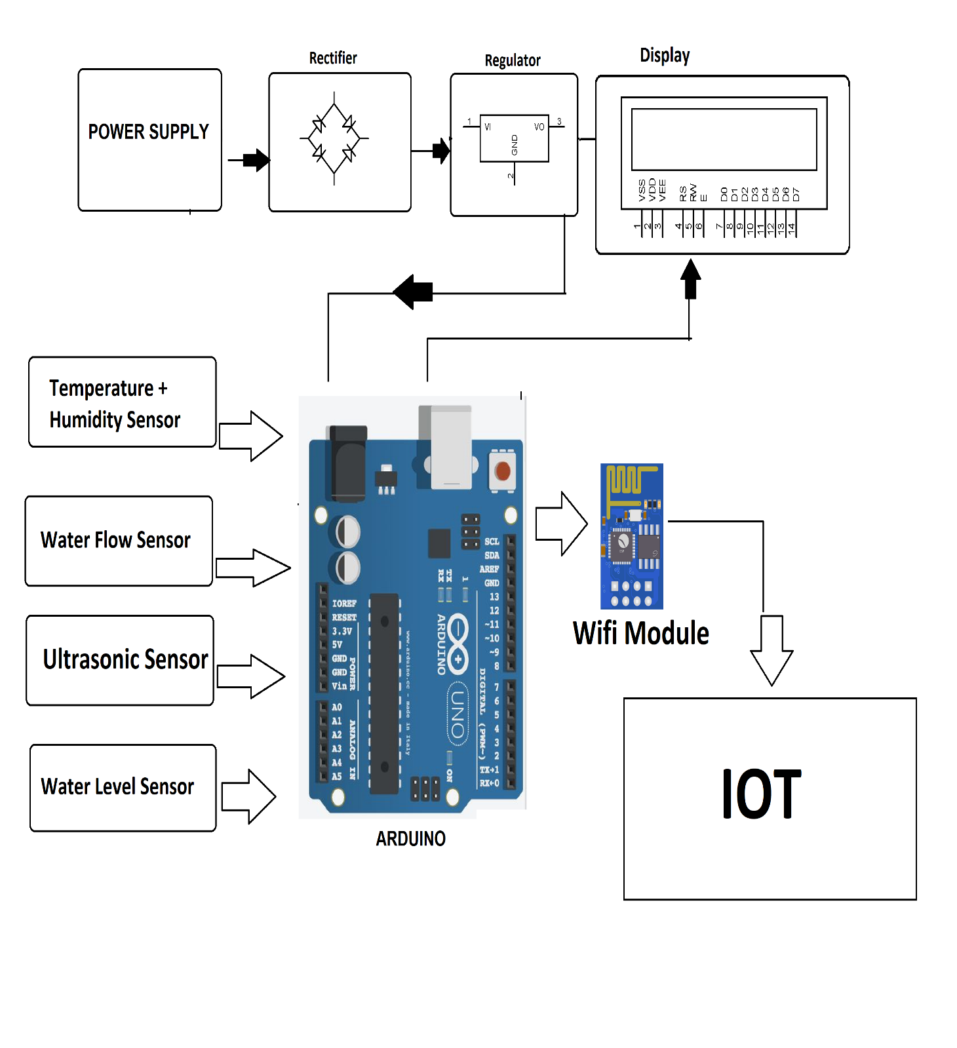

Title:SmartFloodGuardSystem

Concept:

TheSmartFloodGuardSystemutilizesacombinationofcutting-edgetechnologyandcommunityengagementtoprovideaccuratefloodmonitoring andearlywarnings.

Components:

SmartSensor

Deploysmartsensorsinflood-proneareas.Thesesensorsmeasurevariousparameterslikewaterlevel,rainfallintensity,soilmoisture,andriverflow.Theysend real-timedatatoacentralserver.

DataAnalyticsandAI:

ImplementAIalgorithmstoanalyzetheincomingdata.Machinelearningmodelscanpredictpotentialfloodsbasedonhistoricaldatapatterns,rainfallforecasts,andreal-timesensorinputs.

CommunityEngagementApp:

Developauser-friendlymobileappaccessibletothegeneralpublic.Userscanreceivepersonalizedfloodalertsbasedontheirlocation.Theappprovidesreal-timeupdates,evacuationroutes,andsafetytips.

FloodPredictionModels:

Developsophisticatedfloodpredictionmodelsthatcananticipatetheimpactoffloodsonspecificareas.
Thesemodelsconsiderfactorsliketerrain,vegetation,andurbandevelopment.Predictionshelpauthoritiesmake informed decisions.

EarlyWarningSystem:

Implementatieredearlywarningsystem.Forinstance,greenalertsindicatelowrisk,yellowalertssignifymoderate risk, and red alerts indicate imminent danger. Alerts can be sent via SMS, app notifications,andsirens.

CommunityVolunteers:

Recruit and train community volunteers. Equip them with emergency response kits and provide basictraining.Thesevolunteerscanassistduringevacuations,distributeessentialsupplies,andguidepeopletosafe locations.

DroneTechnology:

Utilizedronesequippedwiththermalimagingandhigh-resolutioncameras.Dronescansurveyaffectedareas, assess damage, and identify areas where immediate help is needed. They provide valuable dataforemergency response teams.

PublicAwarenessCampaigns:

Conductregularawarenesscampaignsaboutfloodsafety,preparedness,andtheimportanceofheedingearlywarnings.Usesocialmedia,localworkshops,andeducationalprogramstoreachawideaudience.

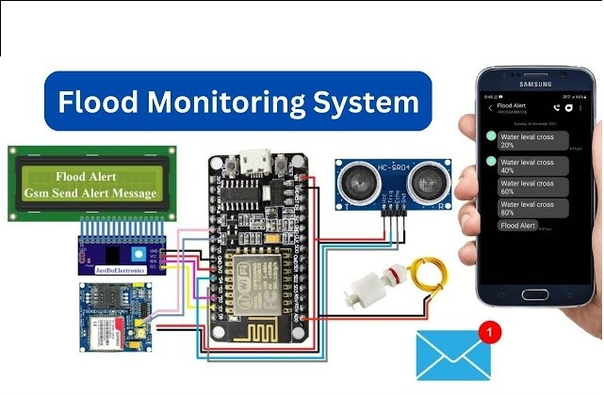

Benefits:

EarlyAlerts:Providestimelywarnings,allowingpeopletoevacuateandtakenecessaryprecautions.

CommunityEngagement:Involvesandempowersthecommunity,enhancingoveralldisasterresilience.

Data-DrivenDecisions:Enablesauthoritiestomakeinformeddecisionsbasedonreal-timedataandpredictiveanalytics.

QuickResponse:Facilitatesrapidresponsethroughefficientuseoftechnologyandcommunityinvolvement.

ImplementingtheSmartFloodGuardSystemnotonlyenhancesfloodpreparednessbutalsofostersasenseofcommunityandcollectiveresponsibilityinthefaceofnaturaldisasters.

