**MOVIE SITE USING HTML, JAVA, CSS**

*Submitted By*

**K.NAVEEN**

**(Registration no-22352222)**

Under the guidance of

**DR.G.KUMARAVELAN**

Associate Professor

Department of Computer Science

***Minor Project report submitted in partial fulfillment of the***

***requirements for the award of the degree of***

**MASTERS IN COMPUTER APPLICATION**



DEPARTMENT OF COMPUTER SCIENCE

SCHOOL OF ENGINEERING

PONDICHERRY UNIVERSITY

KARAIKAL CAMPUS, KARAIKAL

**DEC 2023**

**BONAFIDE CERTIFICATE**

This is to certify that this mini project work entitled as **"MOVIE SITE USING HTML, CSS, JAVA"** is a bonafide record of work done by **K.NAVEEN** in partial fulfillment for the degree of Masters in Computer Application of Pondicherry University.

This work has not been submitted elsewhere for the award of any other degree to the best of our knowledge.

**HEAD OF THE DEPARTMENT**

**Dr. S. BHUVANESHWARI**

Professor and Head

Department of Computer Science

School of Engineering

Pondicherry University

Karaikal Campus

**INTERNAL GUIDE**

Dr. G. Kumaravelan

Associate Professor

Department of Computer Science

School of Engineering

Pondicherry University

Karaikal Campus

Submitted for the Viva-Voce Examination held on

_____________________

**INTERNAL EXAMINER EXTERNAL EXAM**

**DECLARATION**

I declare that this written submission represents my ideas in my own words and where others ideas or words have not been included. I have adequately cited and referenced the original sources. I also declare that I have adhered to all principles of academic honesty and integrity and have not misrepresented or fabricated or falsified any idea/data/fact/source in my submission. I understand that any violation of the above will be cause for disciplinary action by the Institute and can also evoke penal action from the sources which have thus not been properly cited or from whom proper permission has not been properly cited or from whom proper permission has not been taken when needed.

**K.NAVEEN**

**ACKNOWLEDGEMENT**

"No work can be completed successfully without the proper guidance & help of the trainer and other people." This project report is also a manifestation of the invaluable guidance, suggestions, support and encouragement extended by various people.

My sincere thanks to my internal guide Dr. G. Kumaravelan for guiding me and special thanks to my department head Dr. S. Bhuveneswari. Their regular guidance gave me the direction to work during the project.

**K.NAVEEN**

**ABSTRACT**

The chenchu project is a comprehensive web platform designed to cater to the needs of Telugu movie enthusiasts, providing a seamless experience for streaming and downloading high-quality content. With a user-friendly interface, the website offers an extensive collection of Telugu movies, ranging from classics to recent releases.

Key features of the chenchu website include an intuitive navigation system with search functionality, enabling users to easily explore and locate their preferred movies. The movie pages present detailed information such as title, release year, genre, cast, and director, accompanied by trailers and download options for user convenience.

The project emphasizes responsive design, ensuring optimal user experiences across diverse devices, including smartphones, tablets, and PCs. A dedicated download page further enhances user engagement by incorporating a countdown timer for a smooth and secure download process.

Challenges encountered during development included implementing an effective responsive design and ensuring secure handling of the download functionality. Future improvements envision the incorporation of user authentication for personalized recommendations and an expanded movie database for a more diverse selection.

In conclusion, the chenchu project successfully achieves its goal of providing Telugu movie enthusiasts with an engaging and efficient platform to explore, stream, and download their favorite movies. The website stands as a testament to the collaborative efforts of the development team, contributing to the vibrant landscape of online entertainment platforms.

**TABLE OF CONTENTS**

1. Introduction

1.1 Project Overview

1.2 Objectives

2. Technical Details

2.1 Technologies Used

2.2 Key Features

3. Implementation

3.1 Front-End Development

3.2 Movie Pages

3.3 Download Page

4. Challenges Faced

1. Future Improvements
2. Sample Code
3. Sample outputs Screens

8. Conclusion

9. References

**1.INTRODUCTION**

The chenchu project unfolds as a dynamic and user-centric web platform tailored for the ardent Telugu movie enthusiasts seeking a comprehensive and immersive cinematic experience. This initiative arises from the need to provide a centralized hub where users can seamlessly stream and download a diverse array of Telugu movies. Our objective is to transcend traditional viewing boundaries, offering a user-friendly interface that caters to both seasoned cinephiles and newcomers to the Telugu film industry.

The driving force behind the project lies in our commitment to providing users with more than just a viewing platform. chenchu is conceived as a holistic space that not only allows users to explore and enjoy movies but also engage with the cinematic world on a deeper level. Through detailed movie pages, we aim to offer comprehensive information, including release years, genres, cast details, and directorial insights, enriching the overall user experience.

**2.1 Project Overview:**

The chenchu project aims to revolutionize the Telugu movie streaming and downloading experience by providing a dedicated platform for enthusiasts. This endeavor is driven by the desire to offer a centralized space where users can access a diverse and high-quality collection of Telugu movies. The project is meticulously crafted to transcend traditional viewing paradigms, offering a holistic approach that combines a user-friendly interface with a rich cinematic selection.

**2.2 Objectives:**

Development of a User-Friendly Interface: Create an intuitive and responsive platform accessible across various devices, ensuring a seamless experience for users.

Comprehensive Movie Pages: Provide detailed information about each movie, including release years, genres, cast details, and directorial insights, to enhance the overall user experience.

Effective Search Functionality: Implement a robust search feature to enable users to easily discover and locate their preferred movies within the expansive collection.

Secure and Efficient Download Process: Design a download page that ensures the security and efficiency of the download process, enhancing user convenience.

Future Expansion with User Authentication: Plan for the implementation of user authentication to offer personalized recommendations, creating a more tailored user experience.

Diversification of Movie Database: Expand the movie database to encompass a broader selection, capturing the richness of Telugu cinema across different eras.

**3. IMPLEMENTATION**

**3.1 Front-End Development:**

The front-end of chenchu is meticulously crafted using HTML5, CSS3, and JavaScript. The user interface is designed to be intuitive, responsive, and visually appealing across various devices. HTML5 provides the structural foundation, CSS3 styles enhance the aesthetics, and JavaScript facilitates dynamic interactions.

The navigation bar, adorned with a distinctive logo, anchors the user journey. It includes intuitive navigation links with associated icons, offering seamless access to key sections. The search bar, powered by JavaScript, enables users to dynamically filter and display movie cards based on their search queries. The front-end is designed to prioritize user experience, ensuring easy navigation and optimal viewing on smartphones, tablets, and desktops.

**3.2 Movie Pages:**

The movie pages within chenchu are dedicated spaces for each film, offering a comprehensive overview of key details. These details include the movie title, release year, genre, and a captivating image to visually represent the film. The pages are enriched with a star icon, guiding users to clear their browser cache for an optimized experience.

To engage users further, each movie page features a unique green-fancy line, enhancing the visual appeal. This line, strategically placed, complements the overall design and reinforces the platform's commitment to quality and clarity. The use of images, coupled with text content, creates a balanced and informative movie page, catering to diverse user preferences.

**3.3 Download Page:**

The download page of chenchu is designed with a focus on user security and convenience. Users are provided with a dedicated button to initiate the download process. JavaScript is employed to implement a countdown mechanism, ensuring a wait period before users can download, contributing to the overall security of the platform.

The page incorporates a clear call-to-action, guiding users on the download process and emphasizing the importance of patience during the countdown. The implementation aims to strike a balance between user convenience and security, creating a streamlined and secure download experience.

These implementation details collectively contribute to the success of chenchu, providing users with an immersive, secure, and enjoyable platform for exploring and interacting with Telugu cinema. The subsequent sections will delve into challenges faced during implementation and future aspirations for the project.

1. **CHALLENGES FACED**

The development of chenchu was not without its set of challenges, each demanding innovative solutions and strategic problem-solving. Some of the prominent challenges encountered during the implementation include:

**Responsive Design Complexity:** Ensuring a seamless user experience across various devices posed challenges, requiring careful consideration of responsive design principles to accommodate diverse screen sizes.

**Secure Download Functionality**: Implementing a secure download process while maintaining user convenience presented a delicate balance, demanding the integration of robust security measures.

**Countdown Mechanism:** Developing a countdown mechanism on the download page to regulate user access required intricate scripting to balance functionality and user experience.

**Dynamic Search Optimization:** Optimizing the dynamic search functionality for efficiency and accuracy posed challenges, requiring iterative adjustments to enhance user satisfaction.

**Visual Harmony:** Achieving visual harmony throughout the platform, especially on movie pages, demanded meticulous design decisions to create an aesthetically pleasing and informative environment.

**Integration of External Libraries:** While leveraging external libraries like Font Awesome for icons, challenges were encountered in seamless integration, demanding precise implementation and troubleshooting.

**Cross-Browser Compatibility:** Ensuring consistent functionality across different web browsers presented challenges, requiring thorough testing and debugging to enhance cross-browser compatibility.

**User Authentication Planning:** Planning for future user authentication features demanded careful consideration of security protocols and personalized user experiences, adding complexity to the development roadmap.

**Comprehensive Movie Data:** Curating and presenting comprehensive movie data on each page required a thorough data collection process, addressing challenges in data accuracy and completeness.

**Balancing Visual Elements:** Striking a balance between visual elements, such as the green-fancy line, demanded careful consideration of design aesthetics to enhance the overall user interface.

**Educating Users on Optimal Experience:** Communicating to users the importance of clearing browser cache for an optimized experience posed a challenge, necessitating clear and user-friendly instructions.

**Download Page Messaging:** Crafting informative yet concise messaging on the download page presented a challenge in conveying the countdown purpose and ensuring user understanding.

**User Engagement:** Fostering user engagement on the platform required strategies to encourage user interaction, necessitating the implementation of compelling visual elements and intuitive navigation.

**Cross-Device Testing:** Ensuring a consistent user experience across various devices demanded extensive testing, addressing challenges in device-specific optimizations.

**Data Security Measures:** Implementing stringent data security measures to protect user information and ensure secure transactions required meticulous attention to security protocols.

**5. FUTURE IMPROVEMENTS**

The chenchu project is committed to continuous evolution and enhancement, aiming to provide an increasingly enriching experience for Telugu movie enthusiasts. The following future improvements are envisioned:

User Authentication: Implementing user authentication features to offer personalized recommendations, user profiles, and a more tailored viewing experience.

Expanded Movie Database: Continuously expanding the movie database to include a broader selection of Telugu films, spanning various genres and eras to cater to diverse audience preferences.

Enhanced Search Functionality: Further optimizing the dynamic search functionality to provide more accurate and efficient results, including advanced search filters and sorting options.

Interactive Movie Ratings: Introducing user-generated ratings and reviews to foster community engagement and enable users to contribute to the platform's content evaluation.

Mobile App Development: Exploring the development of a dedicated mobile application to extend chenchu's accessibility and convenience for users on smartphones and tablets.

Advanced Download Options: Implementing advanced download options, such as different resolution choices and offline viewing capabilities, to cater to varying user preferences.

Multilingual Support: Introducing support for multiple languages to make the platform more inclusive and accessible to a broader audience beyond Telugu-speaking regions.

Social Media Integration: Integrating social media features to allow users to share their favorite movies, reviews, and recommendations, fostering a sense of community around Telugu cinema.

Data Analytics Implementation: Incorporating data analytics tools to gather insights into user behavior, preferences, and platform usage, enabling data-driven decision-making for future enhancements.

Live Streaming Events: Exploring the possibility of incorporating live streaming events, premieres, and exclusive content releases to create a dynamic and engaging platform.

Improved Visual Elements: Continuously refining and enhancing visual elements across the platform, including graphics, icons, and overall design aesthetics to provide a visually captivating experience.

Educational Content: Introducing educational content related to Telugu cinema, including behind-the-scenes features, interviews with filmmakers, and historical insights to enrich user knowledge.

Accessibility Features: Prioritizing accessibility features to ensure the platform is usable by individuals with disabilities, including considerations for screen readers and keyboard navigation.

Collaborations and Partnerships: Exploring collaborations and partnerships with Telugu film industry stakeholders, such as production houses and filmmakers, to bring exclusive content to the platform.

Notification System: Implementing a notification system to update users about new releases, platform enhancements, and personalized recommendations based on their viewing history.

**6 . SAMPLE OUTPUTS SCREENS**

**Home Page:**

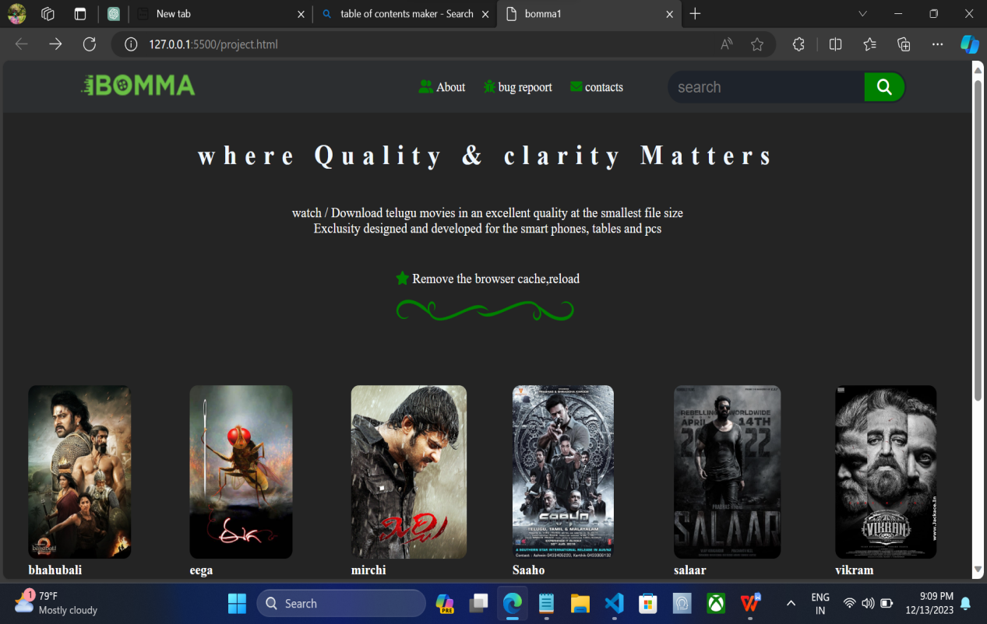

**Search Button:**

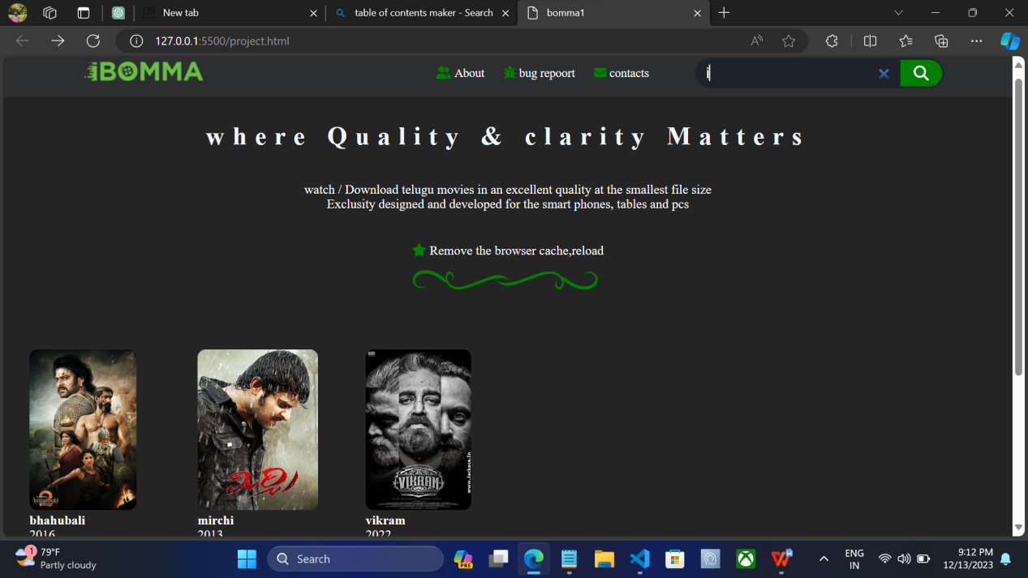

**Movie Page:**

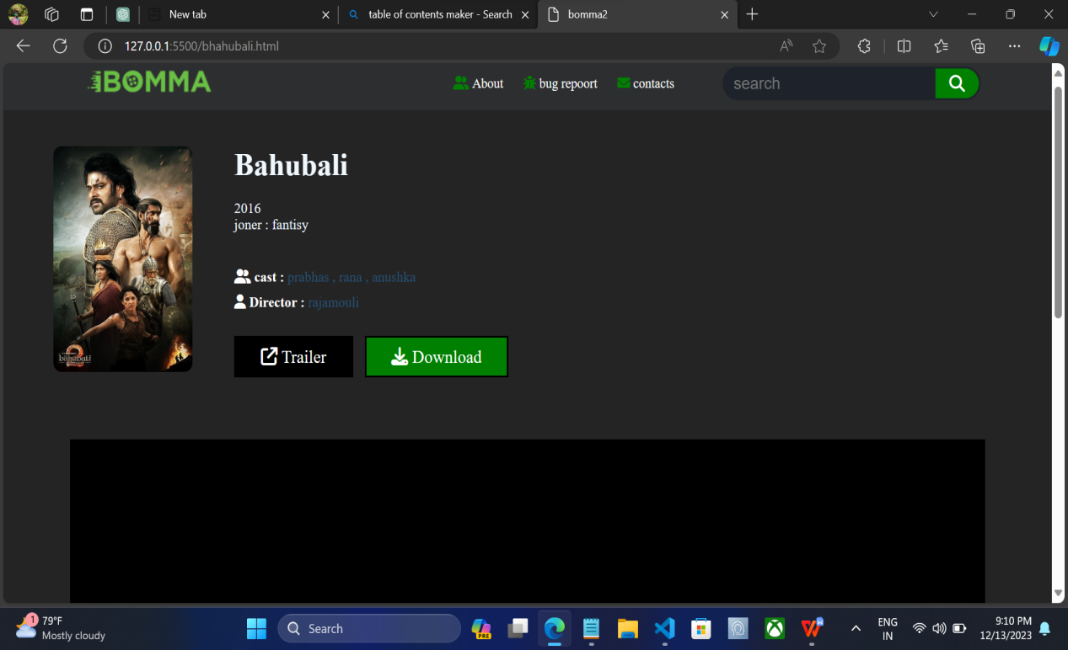

**Online Video watching:**

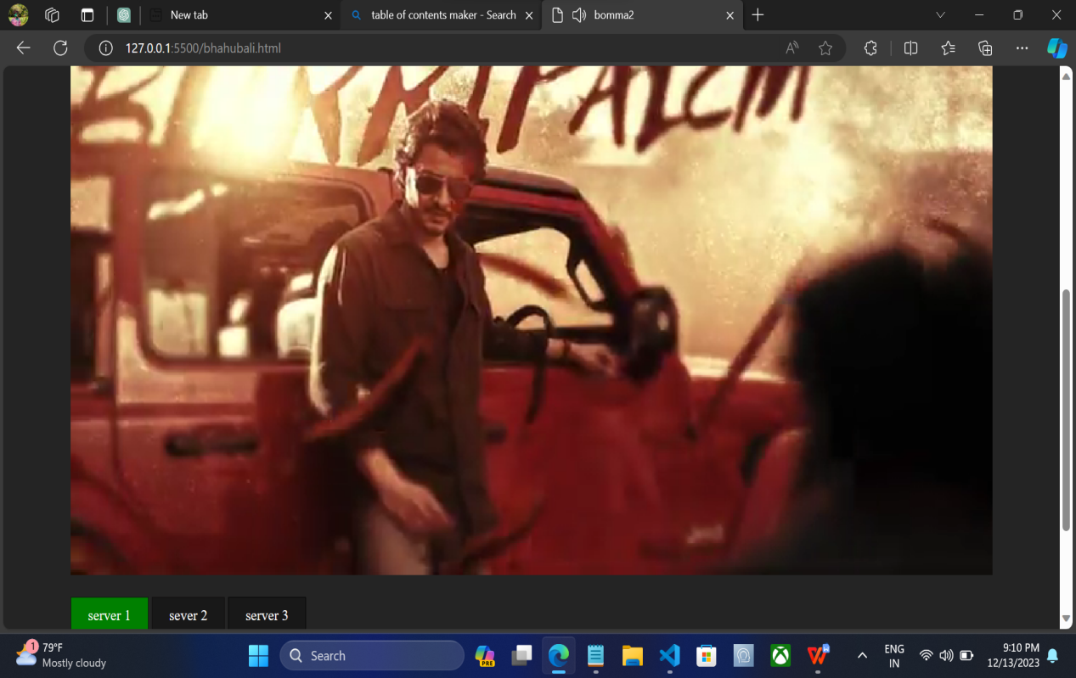

**Trailer:**

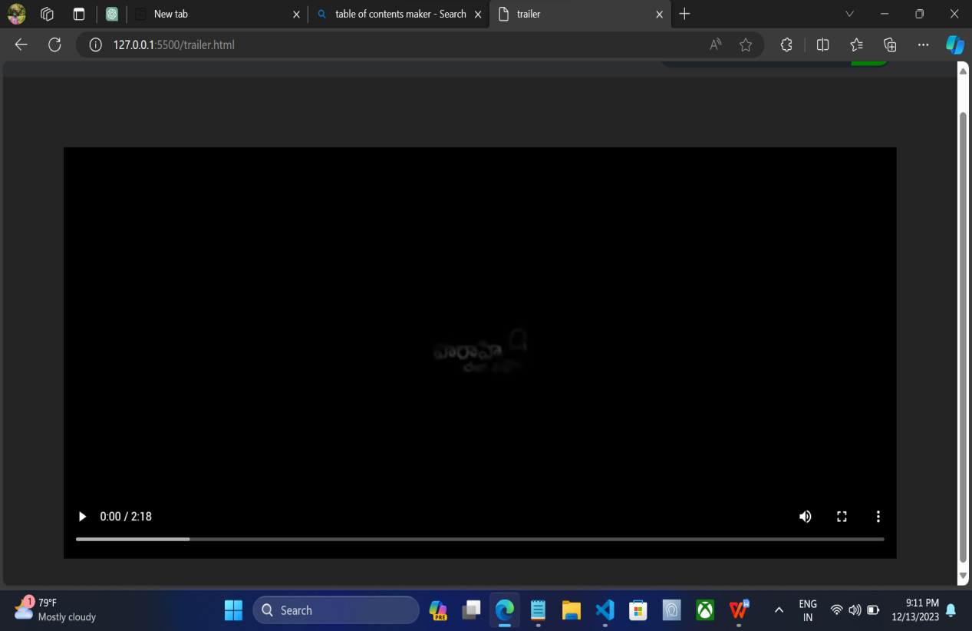

**Download:**

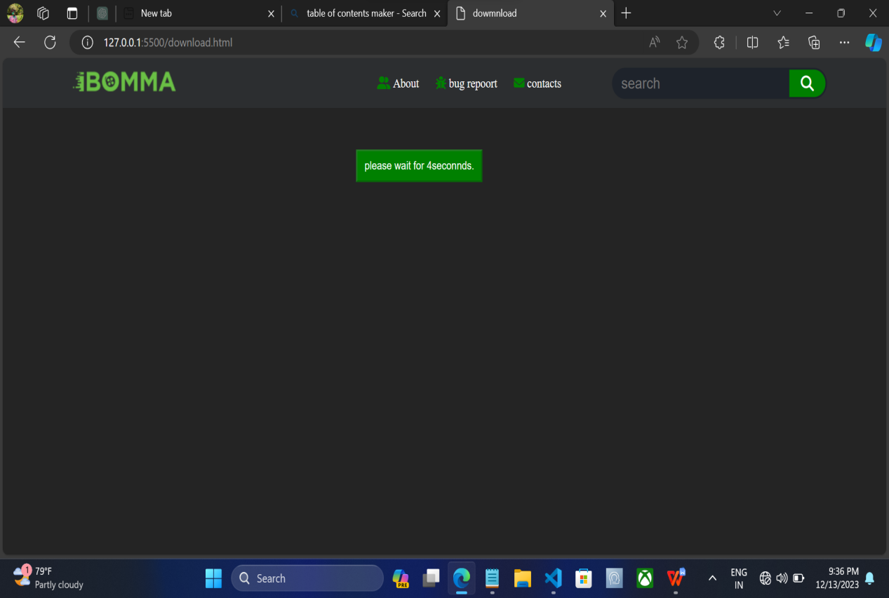

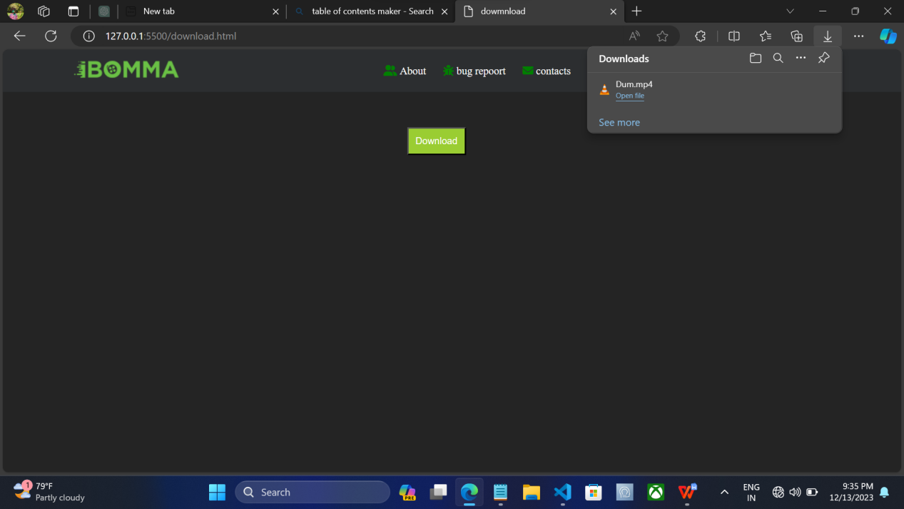

**7. CONCLUSION**

In conclusion, the chenchu project is a testament to the commitment to providing a unique and immersive platform for Telugu movie enthusiasts. The journey from conception to implementation has been marked by a dedication to quality, clarity, and continuous improvement. The platform successfully combines a user-friendly interface with a rich cinematic collection, offering an engaging space for users to explore, stream, and download their favorite Telugu movies.

Throughout the development process, challenges were met with innovative solutions, and each aspect of the platform was carefully crafted to ensure a seamless user experience. From the responsive front-end design to the detailed movie pages and secure download functionality, chenchu reflects a harmonious blend of technology and cinema appreciation.

As the project moves forward, the envisioned future improvements aim to elevate the user experience to new heights. With plans for user authentication, expanded movie databases, and enhanced features, chenchu is poised to become a dynamic hub for Telugu cinema enthusiasts worldwide.

The chenchu team remains committed to the project's vision, embracing the feedback and preferences of its users. The journey doesn't end here; it is a continuous evolution towards creating a platform that not only celebrates the richness of Telugu cinema but also embraces technological advancements to deliver an unparalleled entertainment experience.

**8. REFERENCES**

The development and documentation of the chenchu project drew inspiration and guidance from various resources. Key references include:

1. W3Schools. HTML Tutorial.

<https://www.w3schools.com/html/>

1. W3Schools. CSS Tutorial

<https://www.w3schools.com/css/>

1. MDN Web Docs. JavaScript.

<https://developer.mozilla.org/en-US/docs/Web/JavaScript>

1. Font Awesome. Icons.

<https://fontawesome.com/icons?d=gallery&p=2&m=free>

1. CDNs by jsDelivr. Font Awesome CDN.

<https://www.jsdelivr.com/package/npm/@fortawesome/fontawesome-free>

1. YouTube. Web Development Tutorials.

<https://www.youtube.com/>