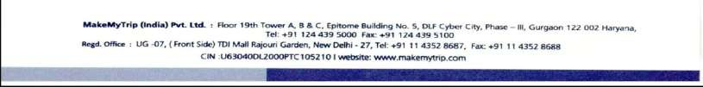


May 22, 2019
Re: Verification of Employment of Naveen Reddy Alka

To Whom It May Concern:

I am the Geetika Gupta for MakeMyTrip. I write to certify that Naveen Reddy Alka worked for MakeMyTrip full-time from September 2016 to January 2018. During that time, he held the position of Sr. Principal Software Engineer.

In this position, Mr. Alka was part of the Payments team that design and develops new features and performance improvements and addresses critical design issues in aging software systems. As part of the process Mr. Alka was crucial in design and implementation of a new payment’s platform for an active multi datacenter architecture. I supervised Mr. Alka in my capacity as Associate Architect

Mr. Alka utilized the following skills while employed at MakeMyTrip:

- Java
- Spring
- Hibernate
- MySQL
- Cassandra
- CouchBase
- Jenkins
- RabitMQ
- Flyway
- Kafka
- Tomcat

If you have any questions, you may contact me.

Very truly yours,

Geetika Gupta
Associate Architect MakeMyTrip
geetika.gupta@makemytrip.com
geetika16@hotmail.com
+91 9886468469

