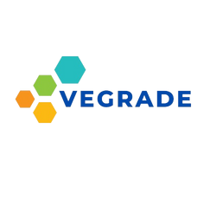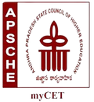

CERTIFICATE OF APPRECIATION

**AWARDED TO**

{{Name}}

For successfully completing the Full stack internship During the period may to sep in the year 2023. He is recognized with a special **Gold** Certificate for his outstanding achievements.

{{id}}

VEGRADE INNOVATIONS (OPc) PRIVATE lIMITED