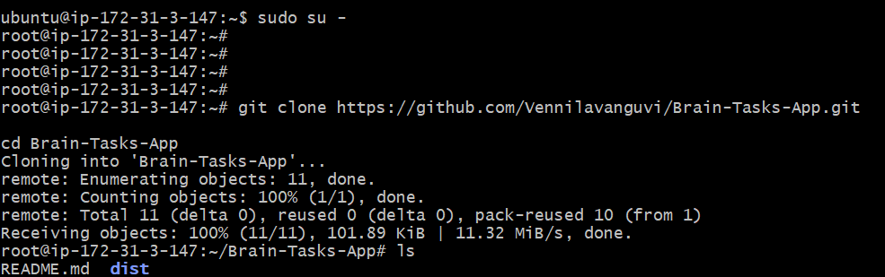
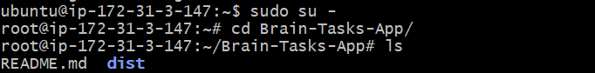
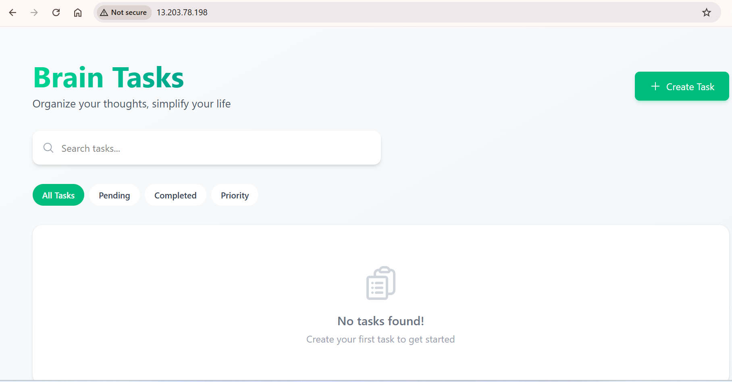
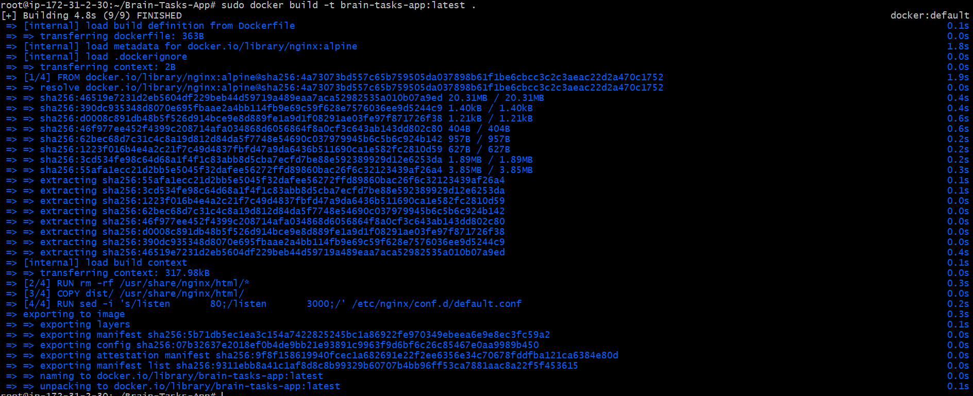
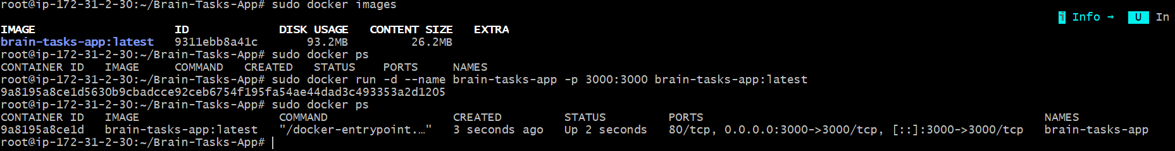

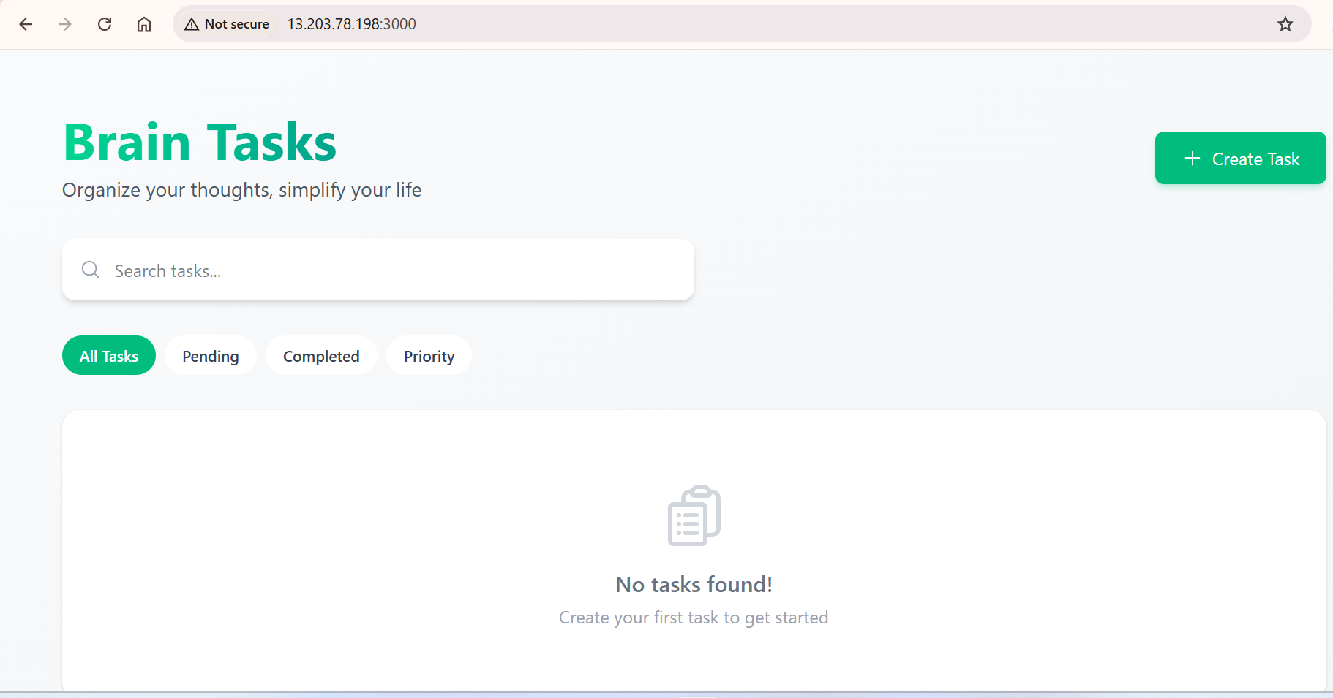
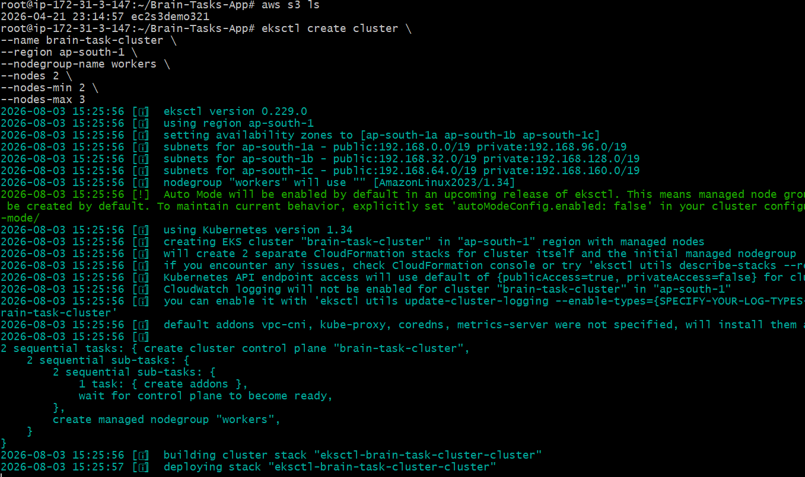
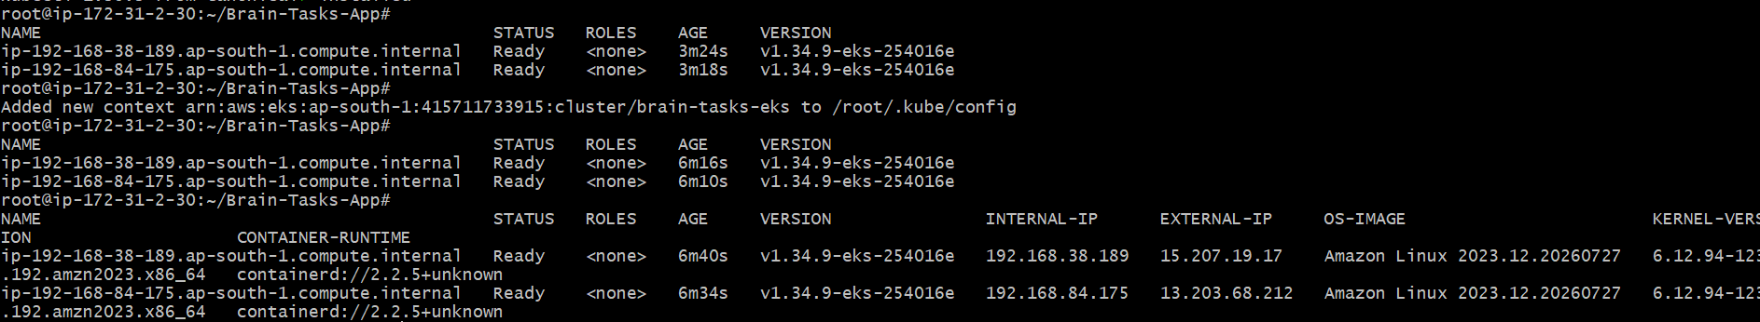
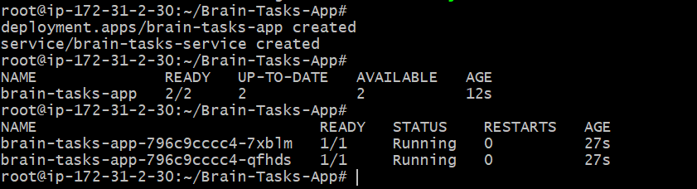

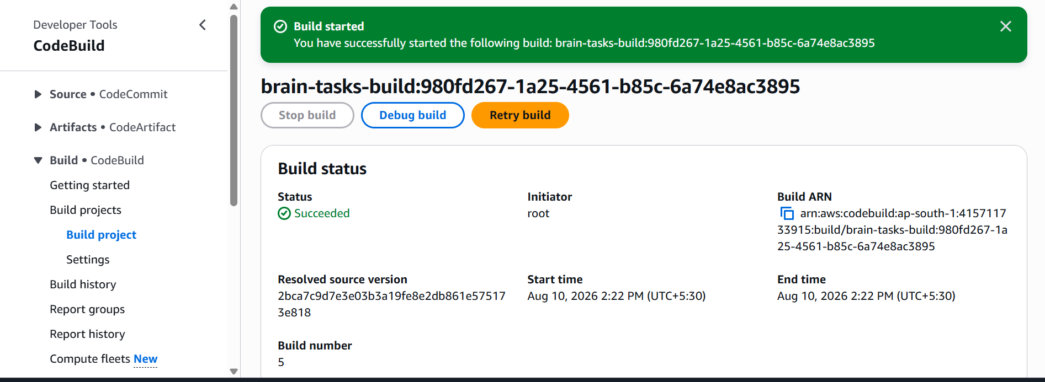
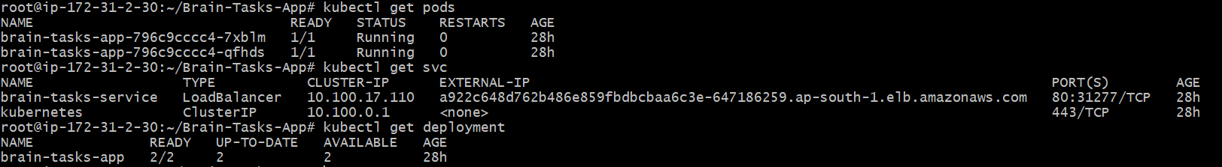
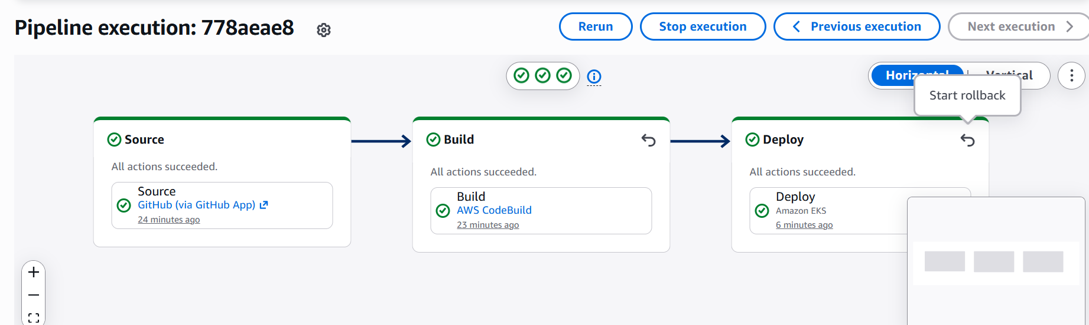
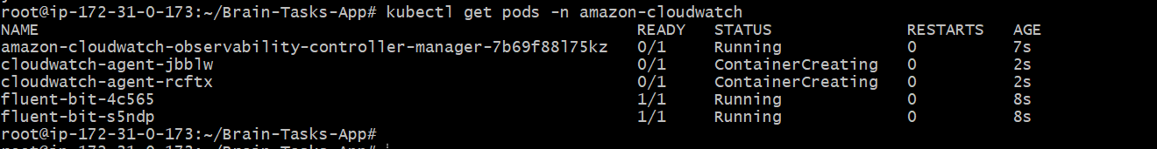
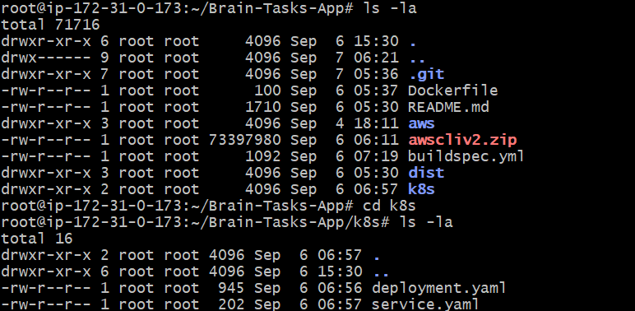

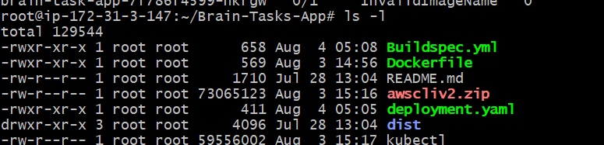
• Developer pushes code to GitHub.
• CodePipeline detects the change.
• CodeBuild installs dependencies, builds the React app, builds the Docker image, and pushes it to Amazon ECR.
• CodeBuild (or a dedicated deploy stage) updates the Kubernetes deployment in Amazon EKS using kubectl.
• The EKS deployment performs a rolling update with the new image.
• CloudWatch collects logs and metrics for the pipeline, build, cluster, and application.

