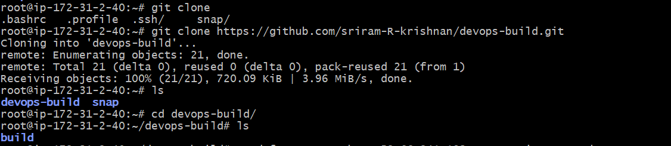
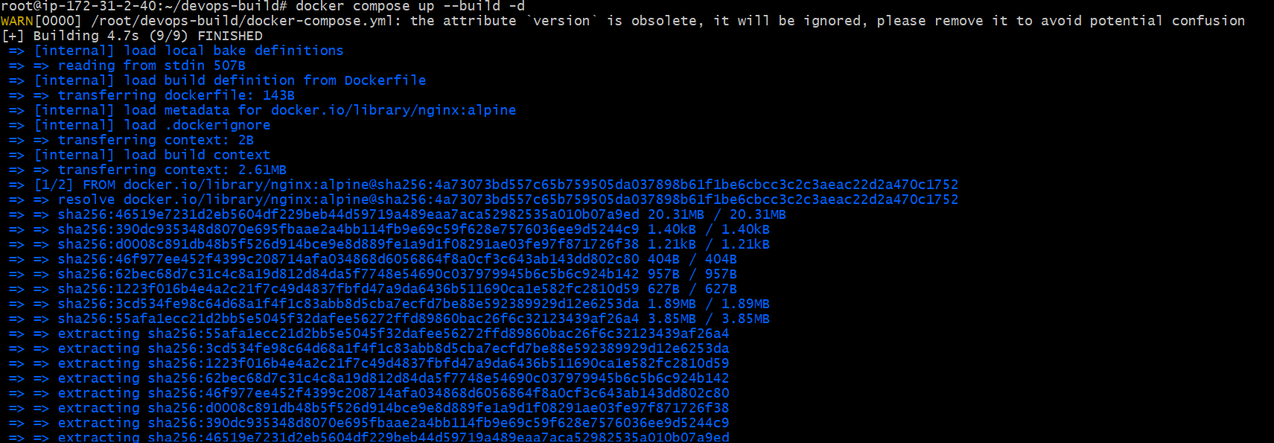
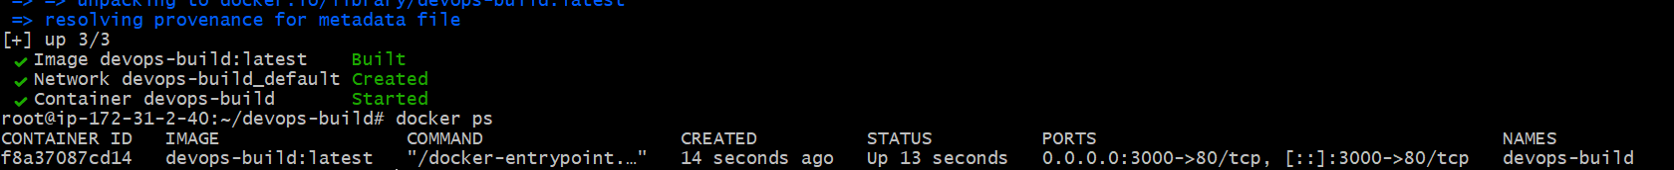
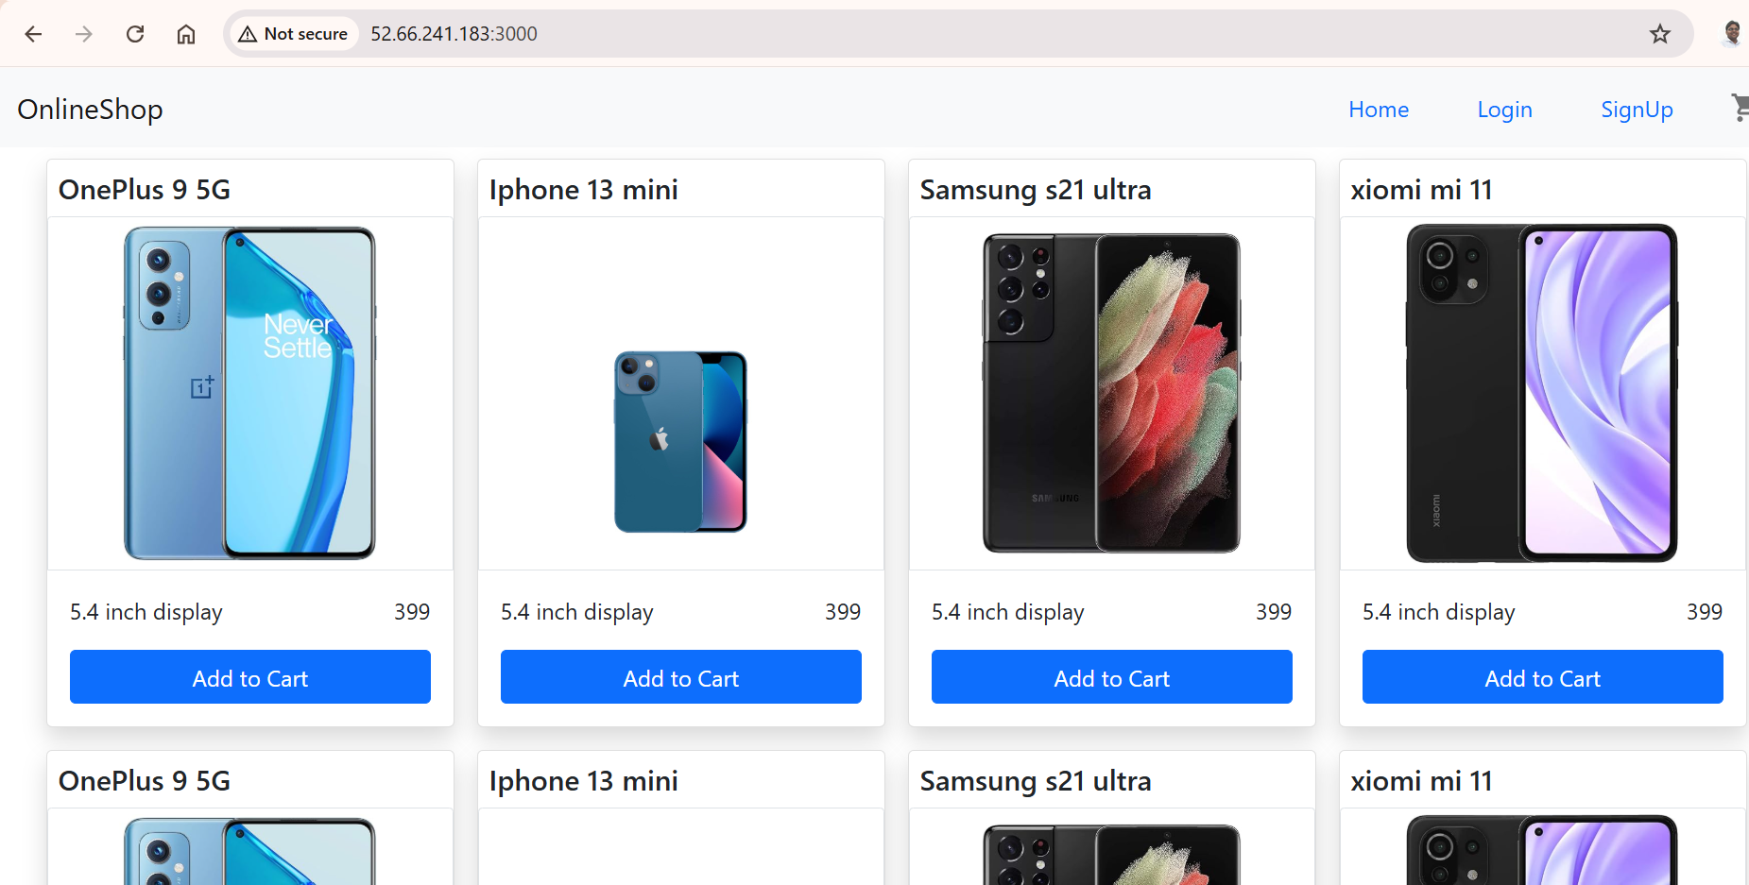

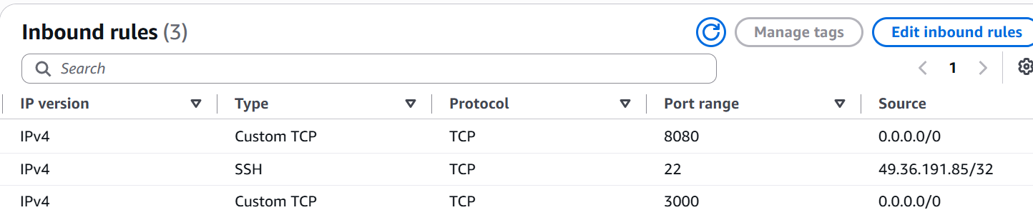

• EC2 t2.micro instance launched
• Ubuntu installed
• Public IP assigned
• Security Group allows:
- SSH (22) only from my current IP
- Application (8080 or 3000) from anywhere (0.0.0.0/0)
• Docker installed
• Docker image pulled from Docker Hub
• Container running
• Application accessible via the EC2 public IP
