**SRI SIVASUBRAMANIYA NADAR**

**COLLEGE OF ENGINEERING**

(AFFILIATED TO ANNA UNIVERSITY, CHENNAI)

RAJIV GANDHI SALAI (OMR), KALAVAKKAM – 603 110

**LABORATORY RECORD**

**CS8662 – MOBILE APPLICATION DEVELOPMENT LABORATORY**

Name : .......S.NAVEEN...................

Reg. No. : .........312217205057..............

Dept. : ...........IT........... Sem. : ........VI........ Sec. : .....A.....



**ANNA UNIVERSITY**

**BONAFIDE CERTIFICATE**

Certified that this is the bonafide record of

the practical work done for the

........CS8662 Mobile Appliction Development.................. lab

by

Name ...............S.Naveen...............................................

Register Number.........................312217205057...................

of Department of ................InformationTechnology...............................................

Sri Sivasubramaniya Nadar College of Engineering,

Kalavakkam, Chennai

during the academic year .......2019-2020............

Staff In-Charge Head

Department of ............IT.............

*Submitted for the University Examination held at*

*Sri Sivasubramaniya Nadar College of Engineering on ....................................*

Internal Examiner External Examiner

|  |  |  |  |  |  |
| --- | --- | --- | --- | --- | --- |
| **INDEX**    Name: ____S.Naveen__ Reg. No. : _______312217205057_________  Sem. : ____VI__________ Sec. : _______A______ | | | | | |
| Ex.No. | Date of Expt. | Title of the Experiment | Page No. | Signature of the Faculty | Remarks |
| 1 | 19-12-2019 | Login Application |  |  |  |
| 2 | 02-01-2020 | GUI, Fonts and Colours |  |  |  |
| 3 | 09-01-2020 | Layout Managers and Event Listeners |  |  |  |
| 4 | 23-01-2020 | Native Calculator |  |  |  |
| 5 | 30-01-2020 | Basic Graphical Primitives |  |  |  |
| 6 | 06-02-2020 | Database Connectivity |  |  |  |
| 7 | 13-02-2020 | Multithreading |  |  |  |
| 8 | 20-02-2020 | GPS Location |  |  |  |
| 9 | 22-02-2020 | Notification Manager |  |  |  |
| 10 | 27-02-2020 | Message Alert |  |  |  |
| 11 | 05-03-2020 | SD Card |  |  |  |
| 12 | 12-03-2020 | RSS Feed |  |  |  |
| 13 | 19-03-2020 | E Mail Application |  |  |  |
| 14 | 26-03-2020 | Mini Project |  |  |  |
|  |  |  |  |  |  |

**Ex.No. 1**

**Login Application**

**Date: 19-12-2019**

**Aim:**

To create an Android application to enable ‘Login’, ‘Registration’ and display the user details.

**Description:**

In this application, three activities are created. In the first activity, the user name and password of the user is fetched as input and upon correct input, it is directed to second activity.

In the second activity, the user details like name, mobile number, department and register number are read as input from the user. After registration it is directed to third activity.

In the third activity, the input that the user gave while registration is displayed with a welcome message.

**Program:**

**XML Codes**

**activity_main.xml**

*<?*xml version="1.0" encoding="utf-8"*?>*<androidx.constraintlayout.widget.ConstraintLayout xmlns:android="http://schemas.android.com/apk/res/android"  
 xmlns:app="http://schemas.android.com/apk/res-auto"  
 xmlns:tools="http://schemas.android.com/tools"  
 android:layout_width="match_parent"  
 android:layout_height="match_parent"  
 android:background="#B2F7EC"  
 tools:context=".MainActivity">  
  
 <EditText  
 android:id="@+id/etname"  
 android:layout_width="229dp"  
 android:layout_height="66dp"  
 android:autofillHints=""  
 android:ems="10"  
 android:hint="Name"  
 android:inputType="textPersonName"  
 app:layout_constraintBottom_toBottomOf="parent"  
 app:layout_constraintEnd_toEndOf="parent"  
 app:layout_constraintHorizontal_bias="0.521"  
 app:layout_constraintStart_toStartOf="parent"  
 app:layout_constraintTop_toTopOf="parent"  
 app:layout_constraintVertical_bias="0.243" />  
  
 <EditText  
 android:id="@+id/etPassword"  
 android:layout_width="233dp"  
 android:layout_height="59dp"  
 android:ems="10"  
 android:hint="Password"  
 android:importantForAutofill="no"  
 android:inputType="textPassword"  
 app:layout_constraintBottom_toBottomOf="parent"  
 app:layout_constraintEnd_toEndOf="parent"  
 app:layout_constraintHorizontal_bias="0.508"  
 app:layout_constraintStart_toStartOf="parent"  
 app:layout_constraintTop_toBottomOf="@+id/etname"  
 app:layout_constraintVertical_bias="0.167" />  
  
 <Button  
 android:id="@+id/btnLogin"  
 android:layout_width="wrap_content"  
 android:layout_height="wrap_content"  
 android:text="login"  
 app:layout_constraintBottom_toBottomOf="parent"  
 app:layout_constraintEnd_toEndOf="parent"  
 app:layout_constraintHorizontal_bias="0.498"  
 app:layout_constraintStart_toStartOf="parent"  
 app:layout_constraintTop_toBottomOf="@+id/etPassword"  
 app:layout_constraintVertical_bias="0.278" />  
  
 <TextView  
 android:id="@+id/tvInfo"  
 android:layout_width="254dp"  
 android:layout_height="59dp"  
 android:textColor="#F0105C"  
 android:textSize="16sp"  
 android:textStyle="bold"  
 app:layout_constraintBottom_toBottomOf="parent"  
 app:layout_constraintEnd_toEndOf="parent"  
 app:layout_constraintHorizontal_bias="0.496"  
 app:layout_constraintStart_toStartOf="parent"  
 app:layout_constraintTop_toBottomOf="@+id/btnLogin"  
 app:layout_constraintVertical_bias="0.292" />  
  
 <TextView  
 android:id="@+id/textView10"  
 android:layout_width="138dp"  
 android:layout_height="37dp"  
 android:layout_marginStart="169dp"  
 android:layout_marginLeft="169dp"  
 android:layout_marginTop="68dp"  
 android:layout_marginEnd="183dp"  
 android:layout_marginRight="183dp"  
 android:layout_marginBottom="117dp"  
 android:text="LOGIN"  
 android:textColor="#EE17D1"  
 android:textSize="20sp"  
 android:textStyle="bold"  
 app:layout_constraintBottom_toTopOf="@+id/etname"  
 app:layout_constraintEnd_toEndOf="parent"  
 app:layout_constraintHorizontal_bias="0.101"  
 app:layout_constraintStart_toStartOf="parent"  
 app:layout_constraintTop_toTopOf="parent"  
 app:layout_constraintVertical_bias="0.0" />  
  
</androidx.constraintlayout.widget.ConstraintLayout>

**activity_second.xml**

*<?*xml version="1.0" encoding="utf-8"*?>*<androidx.constraintlayout.widget.ConstraintLayout xmlns:android="http://schemas.android.com/apk/res/android"  
 xmlns:app="http://schemas.android.com/apk/res-auto"  
 xmlns:tools="http://schemas.android.com/tools"  
 android:layout_width="match_parent"  
 android:layout_height="match_parent"  
 android:background="#F5F0D1"  
 tools:context=".SecondActivity">  
  
 <TextView  
 android:id="@+id/textView2"  
 android:layout_width="109dp"  
 android:layout_height="33dp"  
 android:inputType="textAutoCorrect"  
 android:text="Full Name"  
 android:textColor="#1D3ADD"  
 android:textSize="16sp"  
 android:textStyle="bold"  
 app:layout_constraintBottom_toBottomOf="parent"  
 app:layout_constraintEnd_toEndOf="parent"  
 app:layout_constraintHorizontal_bias="0.122"  
 app:layout_constraintStart_toStartOf="parent"  
 app:layout_constraintTop_toTopOf="parent"  
  
 app:layout_constraintVertical_bias="0.234" />  
  
 <TextView  
 android:id="@+id/textView3"  
 android:layout_width="109dp"  
 android:layout_height="37dp"  
 android:text="Mobile Number"  
 android:textColor="#2946EB"  
 android:textSize="16sp"  
 android:textStyle="bold"  
 app:layout_constraintBottom_toBottomOf="parent"  
 app:layout_constraintEnd_toEndOf="parent"  
 app:layout_constraintHorizontal_bias="0.122"  
 app:layout_constraintStart_toStartOf="parent"  
 app:layout_constraintTop_toBottomOf="@+id/textView2"  
 app:layout_constraintVertical_bias="0.114" />  
  
 <TextView  
 android:id="@+id/textView4"  
 android:layout_width="109dp"  
 android:layout_height="39dp"  
 android:text="Department"  
 android:textColor="#4D62D6"  
 android:textSize="16sp"  
 android:textStyle="bold"  
 app:layout_constraintBottom_toBottomOf="parent"  
 app:layout_constraintEnd_toEndOf="parent"  
 app:layout_constraintHorizontal_bias="0.122"  
 app:layout_constraintStart_toStartOf="parent"  
 app:layout_constraintTop_toBottomOf="@+id/textView3"  
 app:layout_constraintVertical_bias="0.164" />  
  
 <TextView  
 android:id="@+id/textView5"  
 android:layout_width="105dp"  
 android:layout_height="42dp"  
 android:text="Register Number"  
 android:textColor="#334FEB"  
 android:textStyle="bold"  
 app:layout_constraintBottom_toBottomOf="parent"  
 app:layout_constraintEnd_toEndOf="parent"  
 app:layout_constraintHorizontal_bias="0.12"  
 app:layout_constraintStart_toStartOf="parent"  
 app:layout_constraintTop_toBottomOf="@+id/textView4"  
 app:layout_constraintVertical_bias="0.117" />  
  
 <EditText  
 android:id="@+id/etname"  
 android:layout_width="wrap_content"  
 android:layout_height="wrap_content"  
 android:layout_marginTop="116dp"  
 android:ems="10"  
 android:hint="fullname"  
 android:importantForAutofill="no"  
 android:inputType="textPersonName"  
 app:layout_constraintBottom_toBottomOf="parent"  
 app:layout_constraintEnd_toEndOf="parent"  
 app:layout_constraintHorizontal_bias="0.919"  
 app:layout_constraintStart_toStartOf="parent"  
 app:layout_constraintTop_toTopOf="parent"  
 app:layout_constraintVertical_bias="0.021" />  
  
 <EditText  
 android:id="@+id/etMob"  
 android:layout_width="wrap_content"  
 android:layout_height="wrap_content"  
 android:ems="10"  
 android:hint="phone"  
 android:importantForAutofill="no"  
 android:inputType="phone"  
 app:layout_constraintBottom_toBottomOf="parent"  
 app:layout_constraintEnd_toEndOf="parent"  
 app:layout_constraintHorizontal_bias="0.919"  
 app:layout_constraintStart_toStartOf="parent"  
 app:layout_constraintTop_toBottomOf="@+id/etname"  
 app:layout_constraintVertical_bias="0.095" />  
  
 <EditText  
 android:id="@+id/etDept"  
 android:layout_width="wrap_content"  
 android:layout_height="wrap_content"  
 android:ems="10"  
 android:hint="department"  
 android:importantForAutofill="no"  
 android:inputType="textPersonName"  
 app:layout_constraintBottom_toBottomOf="parent"  
 app:layout_constraintEnd_toEndOf="parent"  
 app:layout_constraintHorizontal_bias="0.919"  
 app:layout_constraintStart_toStartOf="parent"  
 app:layout_constraintTop_toBottomOf="@+id/etMob"  
 app:layout_constraintVertical_bias="0.105" />  
  
 <EditText  
 android:id="@+id/etReg"  
 android:layout_width="wrap_content"  
 android:layout_height="wrap_content"  
 android:ems="10"  
 android:hint="reg_no"  
 android:importantForAutofill="no"  
 android:inputType="number"  
 app:layout_constraintBottom_toBottomOf="parent"  
 app:layout_constraintEnd_toEndOf="parent"  
 app:layout_constraintHorizontal_bias="0.919"  
 app:layout_constraintStart_toStartOf="parent"  
 app:layout_constraintTop_toBottomOf="@+id/etDept"  
 app:layout_constraintVertical_bias="0.097" />  
  
 <Button  
 android:id="@+id/btnReg"  
 android:layout_width="156dp"  
 android:layout_height="74dp"  
 android:layout_marginBottom="64dp"  
 android:background="#FFC107"  
 android:text="REGISTER"  
 android:textColor="#3B683D"  
 android:textSize="20sp"  
 android:textStyle="bold"  
 app:layout_constraintBottom_toBottomOf="parent"  
 app:layout_constraintEnd_toEndOf="parent"  
 app:layout_constraintHorizontal_bias="0.498"  
 app:layout_constraintStart_toStartOf="parent" />  
  
 <TextView  
 android:id="@+id/textView6"  
 android:layout_width="129dp"  
 android:layout_height="42dp"  
 android:layout_marginTop="48dp"  
 android:text="REGISTER"  
 android:textColor="#334FEC"  
 android:textSize="18sp"  
 android:textStyle="bold"  
 app:layout_constraintEnd_toEndOf="parent"  
 app:layout_constraintHorizontal_bias="0.45"  
 app:layout_constraintStart_toStartOf="parent"  
 app:layout_constraintTop_toTopOf="parent" />  
  
</androidx.constraintlayout.widget.ConstraintLayout>

**activity_third.xml**

<?xml version="1.0" encoding="utf-8"?>  
<RelativeLayout xmlns:android="http://schemas.android.com/apk/res/android"  
 xmlns:app="http://schemas.android.com/apk/res-auto"  
 xmlns:tools="http://schemas.android.com/tools"  
 android:layout_width="match_parent"  
 android:layout_height="match_parent"  
 android:background="#F0E4F0"  
 tools:context=".ThirdActivity">  
  
 <TextView  
 android:id="@+id/textView17"  
 android:layout_width="144dp"  
 android:layout_height="50dp"  
 android:layout_alignParentTop="true"  
 android:layout_alignParentEnd="true"  
 android:layout_alignParentRight="true"  
 android:layout_marginTop="81dp"  
 android:layout_marginEnd="210dp"  
 android:layout_marginRight="210dp"  
 android:text="Welcome!!!"  
 android:textColor="#E94C40"  
 android:textSize="25sp" />  
  
 <TextView  
 android:id="@+id/t1"  
 android:layout_width="163dp"  
 android:layout_height="36dp"  
 android:layout_alignParentTop="true"  
 android:layout_alignParentEnd="true"  
 android:layout_alignParentRight="true"  
 android:layout_marginTop="87dp"  
 android:layout_marginEnd="20dp"  
 android:layout_marginRight="20dp"  
 android:text="TextView"  
 android:textSize="18sp"  
 android:textStyle="bold" />  
  
 <TextView  
 android:id="@+id/t2"  
 android:layout_width="168dp"  
 android:layout_height="39dp"  
 android:layout_alignParentTop="true"  
 android:layout_centerHorizontal="true"  
 android:layout_marginTop="209dp"  
 android:text="TextView"  
 android:textSize="18sp"  
 android:textStyle="bold" />  
  
 <TextView  
 android:id="@+id/t3"  
 android:layout_width="wrap_content"  
 android:layout_height="45dp"  
 android:layout_alignParentStart="true"  
 android:layout_alignParentLeft="true"  
 android:layout_alignParentEnd="true"  
 android:layout_alignParentBottom="true"  
 android:layout_centerInParent="true"  
 android:layout_marginStart="113dp"  
 android:layout_marginLeft="113dp"  
 android:layout_marginEnd="25dp"  
 android:layout_marginBottom="392dp"  
 android:text="TextView"  
 android:textSize="18sp"  
 android:textStyle="bold" />  
  
 <TextView  
 android:id="@+id/t4"  
 android:layout_width="264dp"  
 android:layout_height="wrap_content"  
 android:layout_alignParentStart="true"  
 android:layout_alignParentLeft="true"  
 android:layout_alignParentBottom="true"  
 android:layout_centerVertical="true"  
 android:layout_marginStart="108dp"  
 android:layout_marginLeft="108dp"  
 android:layout_marginBottom="340dp"  
 android:text="TextView"  
 android:textSize="18sp"  
 android:textStyle="bold" />  
  
 <Button  
 android:id="@+id/back"  
 android:layout_width="155dp"  
 android:layout_height="wrap_content"  
 android:layout_alignParentBottom="true"  
 android:layout_centerHorizontal="true"  
 android:layout_marginBottom="149dp"  
 android:background="#FFEB3B"  
 android:text="Back to Login"  
 android:textSize="18sp" />  
</RelativeLayout>

**Java Codes**

**MainActivity.java**

package com.example.login;  
  
import androidx.appcompat.app.AppCompatActivity;  
import android.content.Intent;  
import android.os.Bundle;  
import android.view.View;  
import android.widget.Button;  
import android.widget.EditText;  
import android.widget.TextView;  
  
public class MainActivity extends AppCompatActivity {  
 private EditText name;  
 private EditText password;  
 private Button Login;  
 private TextView Info;@Override  
 protected void onCreate(Bundle savedInstanceState) {  
 super.onCreate(savedInstanceState);  
 setContentView(R.layout.*activity_main*);  
 name=(EditText)findViewById(R.id.*etname*);  
 password=(EditText)findViewById(R.id.*etPassword*);  
 Info=(TextView)findViewById(R.id.*tvInfo*);  
 Login=(Button)findViewById(R.id.*btnLogin*);  
 name.requestFocus();Login.setOnClickListener(new View.OnClickListener() {  
 @Override  
 public void onClick(View v) {  
 validate(name.getText().toString(),password.getText().toString());  
 name.setText("");  
 password.setText("");  
 }  
 });  
 }  
 private void validate(String userName,String userPassword) {  
 if ((userName.equals("Admin")) && (userPassword.equals("aaaa"))) {  
 Intent intent = new Intent(MainActivity.this, SecondActivity.class);  
 startActivity(intent);  
 } else {  
name.setText("");  
 password.setText("");  
Info.setText("You have entered wrong userName and Password!");  
 name.requestFocus();  
 }  
 }  
 }

**SecondActivity.java**

package com.example.login;  
import androidx.appcompat.app.AppCompatActivity;  
import android.content.Intent;  
import android.os.Bundle;  
import android.os.Parcelable;  
import android.view.View;  
import android.widget.Button;  
import android.widget.EditText;  
  
public class SecondActivity extends AppCompatActivity {  
 private Button Reg;  
 private EditText name;  
 private EditText phone;  
 private EditText dept;  
 private EditText regn;  
 private Button reg;  
 String name1,mob,dep,regno;  
 @Override  
 protected void onCreate(Bundle savedInstanceState) {  
 super.onCreate(savedInstanceState);  
 setContentView(R.layout.*activity_second*);  
 name=(EditText)findViewById(R.id.*etname*);  
 phone=(EditText)findViewById(R.id.*etMob*);  
 dept=(EditText)findViewById(R.id.*etDept*);  
 regn=(EditText)findViewById(R.id.*etReg*);  
 reg=(Button)findViewById(R.id.*btnReg*);  
 name.requestFocus();  
 reg.setOnClickListener(new View.OnClickListener() {  
 @Override  
 public void onClick(View v) {  
 name1=name.getText().toString();  
 mob=phone.getText().toString();  
 dep=dept.getText().toString();  
 regno=regn.getText().toString();  
 Intent i=new Intent(SecondActivity.this,ThirdActivity.class);  
 i.putExtra("name_key",name1);  
 i.putExtra("dept_key",dep);  
 i.putExtra("mob_key",mob);  
 i.putExtra("reg_key",regno);  
 startActivity(i);  
 }  
 });  
 }  
}

**ThirdActivity.java**

package com.example.login;  
import androidx.appcompat.app.AppCompatActivity;  
import android.content.Intent;  
import android.os.Bundle;  
import android.view.View;  
import android.widget.Button;  
import android.widget.TextView;  
  
public class ThirdActivity extends AppCompatActivity {  
 TextView t1,t2,t3,t4;  
 Button back;  
 String name,regno,dept,mob;  
 @Override  
 protected void onCreate(Bundle savedInstanceState) {  
 super.onCreate(savedInstanceState);  
 setContentView(R.layout.*activity_third*);  
 t1=(TextView)findViewById(R.id.*t1*);  
 t2=(TextView)findViewById(R.id.*t2*);  
 t3=(TextView)findViewById(R.id.*t3*);  
 t4=(TextView)findViewById(R.id.*t4*);  
 Intent i=getIntent();  
 name=i.getStringExtra("name_key");  
 dept=i.getStringExtra("dept_key");  
 mob=i.getStringExtra("mob_key");  
 regno=i.getStringExtra("reg_key");  
 back=(Button)findViewById(R.id.*back*);  
 t1.setText(name);  
 t2.setText("Department: "+dept);  
 t3.setText("Mobile Number: "+mob);  
 t4.setText("Register Number: "+regno);  
 back.setOnClickListener(new View.OnClickListener() {  
 @Override  
 public void onClick(View v) {  
 Intent i=new Intent(ThirdActivity.this,MainActivity.class);  
 startActivity(i);  
 }}); }}

**Sample Input/Output**

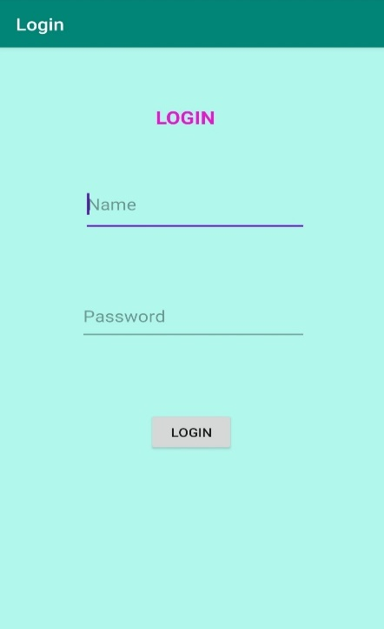 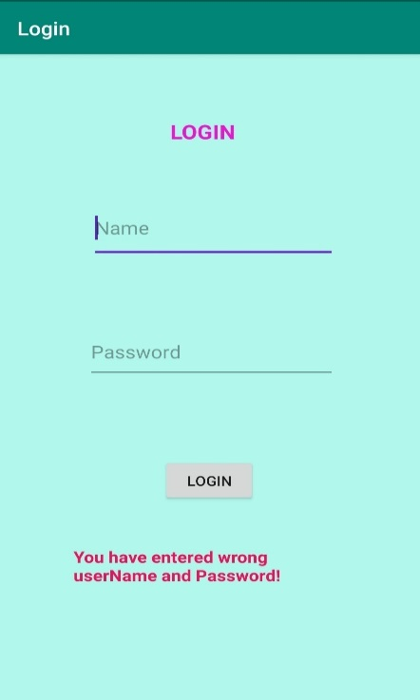

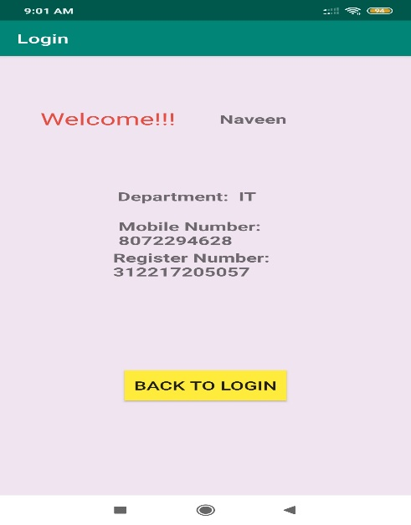 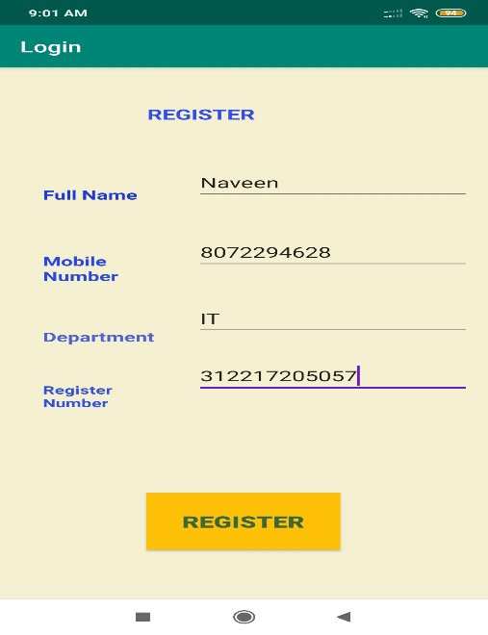

**Result:**

The Android application to implement ‘Login’ and ‘Registration’ is executed successfully.

**Ex. No.2**

**GUI, Fonts and Colours**

**Date: 02-01-2020**

**Aim:**

To create an Android application that uses GUI components, Fonts and Colours.

**Description:**

In this application an empty activity is created. In that, a TextView is placed with some text in it. The font size, colour, type, style and underline effects are done to the text that is provided in the TextView by clicking on buttons. The change of font properties are implemented using switch case.

**Program:**

**XML Code**

**activity_main.xml**

*<?*xml version="1.0" encoding="utf-8"*?>*<LinearLayout xmlns:android="http://schemas.android.com/apk/res/android"  
 android:layout_width="fill_parent"  
 android:layout_height="fill_parent"  
 android:background="#E6F178"  
 android:orientation="vertical">  
 <TextView  
 android:id="@+id/textView1"  
 android:layout_width="match_parent"  
 android:layout_height="wrap_content"  
 android:layout_margin="20sp"  
 android:fontFamily="sans-serif-medium"  
 android:gravity="center"  
 android:text="SSNCE"  
 android:textSize="20sp"  
 android:textStyle="bold" />  
 <Button  
 android:id="@+id/button1"  
 android:layout_width="match_parent"  
 android:layout_height="wrap_content"  
 android:background="#F0D1CF"  
 android:gravity="center"  
 android:text="Change font size"  
 android:textSize="20sp" />  
  
 <Button  
 android:id="@+id/button2"  
 android:layout_width="match_parent"  
 android:layout_height="wrap_content"  
 android:background="#A5DEE6"  
 android:gravity="center"  
 android:text="Change color"  
 android:textSize="20sp" />  
 <Button  
 android:id="@+id/button3"  
 android:layout_width="match_parent"  
 android:layout_height="wrap_content"  
 android:background="#F0C27E"  
 android:gravity="center"  
 android:text="Change font type"  
 android:textSize="20sp" />  
 <Button  
 android:id="@+id/button4"  
 android:layout_width="match_parent"  
 android:layout_height="wrap_content"  
 android:background="#C5BDBD"  
 android:gravity="center"  
 android:text="Change font style (Bold/Italic)"  
 android:textSize="20sp" />  
 <Button  
 android:id="@+id/button5"  
 android:layout_width="match_parent"  
 android:layout_height="wrap_content"  
 android:background="#F07CA3"  
 android:gravity="center"  
 android:text="Underline"  
 android:textSize="20sp" />  
</LinearLayout>

**Java Code**

**MainActivity.java**

package com.example.font;  
import android.app.Activity;  
import android.graphics.*;  
import android.os.Bundle;  
import android.view.View;  
import android.widget.Button;  
import android.widget.TextView;  
  
public class MainActivity extends Activity  
{  
 float font =24;  
 int i=1,j=1,k=1;  
 @Override  
 public void onCreate(Bundle savedInstanceState){  
 super.onCreate(savedInstanceState);  
 setContentView(R.layout.*activity_main*);  
 final TextView t1=(TextView)findViewById(R.id.*textView1*);  
 Button b1 = (Button)findViewById(R.id.*button1*);  
 b1.setOnClickListener(new View.OnClickListener(){  
 public void onClick(View view){  
 t1.setTextSize(font);  
 font=font+4;  
 if(font==40)  
 font=20;  
 }});  
 Button b2 = (Button) findViewById(R.id.*button2*);  
 b2.setOnClickListener(new View.OnClickListener() {  
 public void onClick(View view){  
 switch(i){  
 case 1:  
 t1.setTextColor(Color.*parseColor*("#0000FF"));  
 break;  
 case 2:  
 t1.setTextColor(Color.*parseColor*("#00FF00"));  
 break;  
 case 3:  
 t1.setTextColor(Color.*parseColor*("#FF0000"));  
 break;  
 case 4:  
 t1.setTextColor(Color.*parseColor*("#800000"));  
 break;  
 }  
 i++;  
 if(i==5)  
 i=1;  
 }});Button b3 = (Button) findViewById(R.id.*button3*);  
 b3.setOnClickListener(new View.OnClickListener(){  
 public void onClick(View view){  
 switch(j){  
 case 1:  
 t1.setTypeface(Typeface.*SERIF*);  
 break;  
 case 2:  
 t1.setTypeface(Typeface.*SANS_SERIF*);  
 break;  
 case 3:  
 t1.setTypeface(Typeface.*MONOSPACE*);  
 break; }  
 j++;  
 if(j==4)  
 j=1;  
 }});  
 Button b4 = (Button) findViewById(R.id.*button4*);  
 b4.setOnClickListener(new View.OnClickListener(){  
 public void onClick(View view){  
 switch(k){  
 case 1:  
 t1.setTypeface(null, Typeface.*BOLD_ITALIC*);  
 break;  
 case 2:  
 t1.setTypeface(null, Typeface.*BOLD*);  
 break;  
 case 3:  
 t1.setTypeface(null, Typeface.*ITALIC*);  
 break;  
 case 4:  
 t1.setTypeface(null, Typeface.*NORMAL*);  
 break;  
 }  
 k++;  
 if(k==5)  
 k=1;  
 }});  
 Button b5 = (Button) findViewById(R.id.*button5*);  
 b5.setOnClickListener(new View.OnClickListener(){  
 public void onClick(View view){  
 t1.setPaintFlags(t1.getPaintFlags()^Paint.*UNDERLINE_TEXT_FLAG*);  
 }});}}

**Sample Input/Output:**

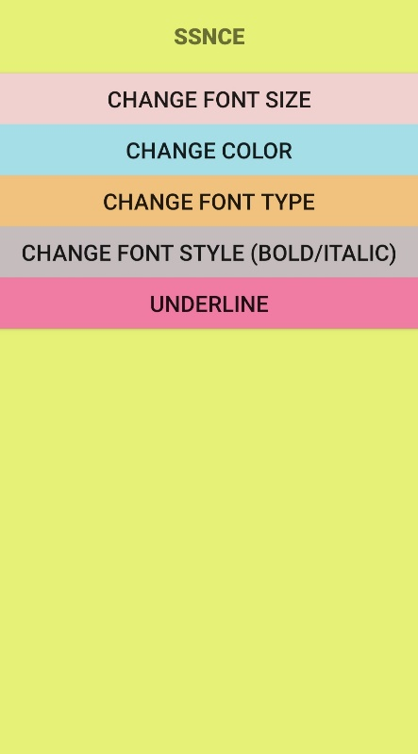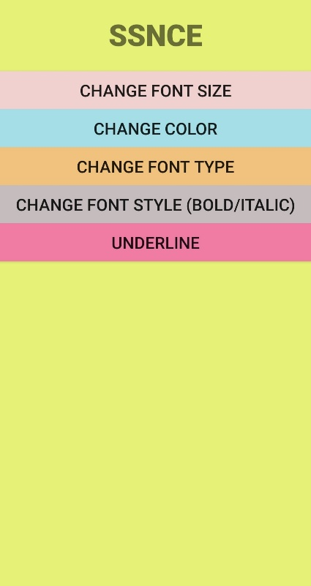

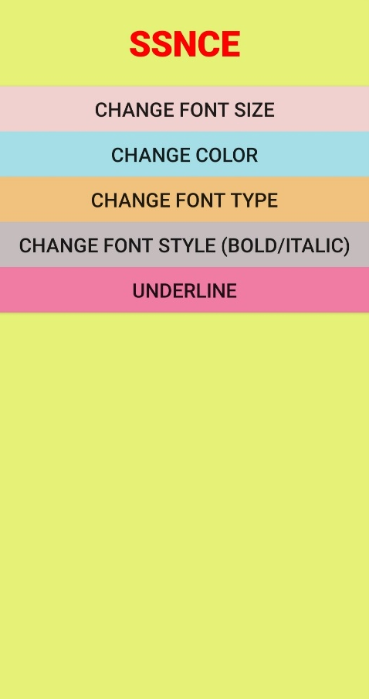 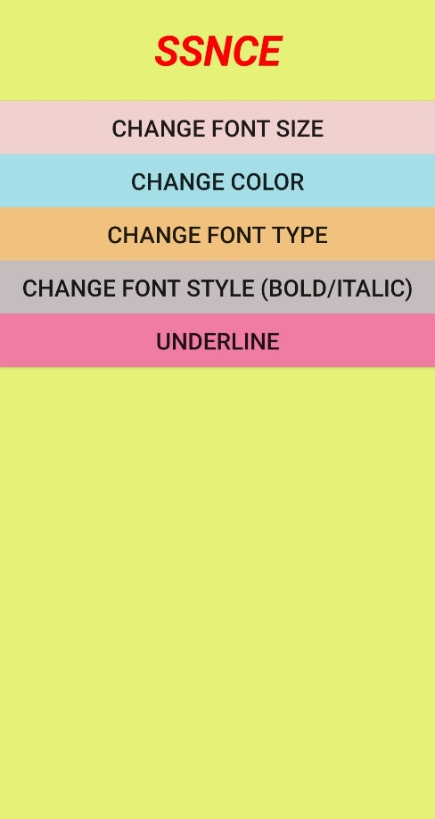

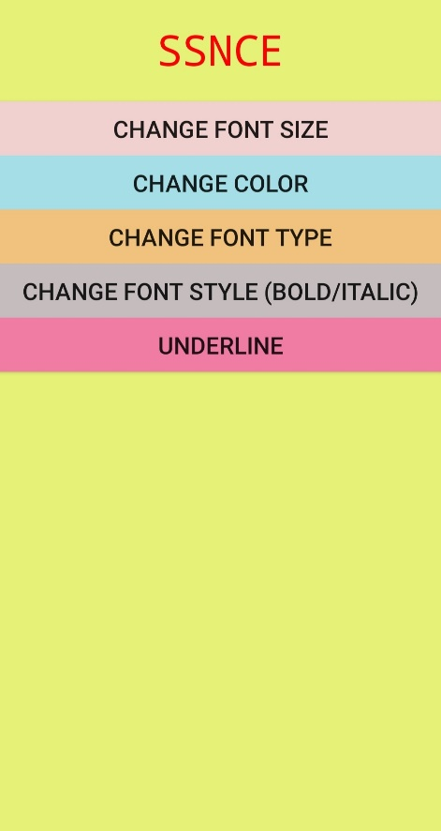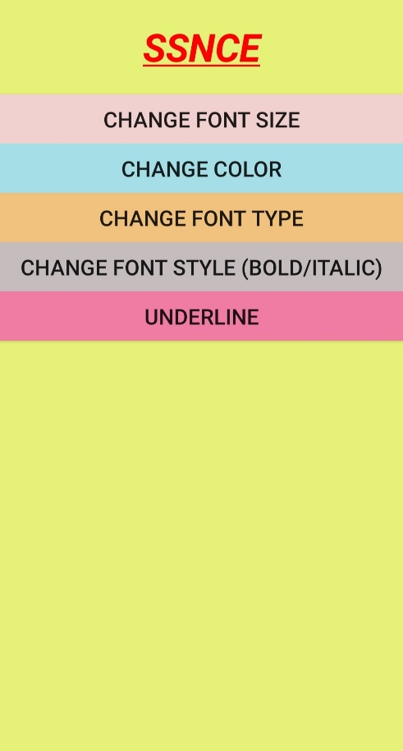

**Result:**

The Android application that uses GUI, fonts and colours has been done successfully.

**Ex.No. 3**

**Layout Managers and Event Listeners**

**Date: 09-01-2020**

**Aim:**

To create an Android application that uses various layouts and event listeners.

**Description:**

In this application, the first activity implements Constraint Layout, second activity implements Linear Layout, third activity implements Relative Layout, fourth activity implements Grid Layout. In this activity, various event listeners like onclick, ondoubleclick, onlongPress, onTouch events are implemented. The fifth activity implements Frame Layout and the sixth activity implements Absolute Layout.

**Program:**

**XML Codes:**

**activity_main.xml**

*<?*xml version="1.0" encoding="utf-8"*?>*<androidx.constraintlayout.widget.ConstraintLayout xmlns:android="http://schemas.android.com/apk/res/android"  
 xmlns:app="http://schemas.android.com/apk/res-auto"  
 xmlns:tools="http://schemas.android.com/tools"  
 android:layout_width="match_parent"  
 android:layout_height="match_parent"  
 android:background="#FAE3EB"  
 tools:context=".MainActivity">  
 <TextView  
 android:id="@+id/textView2"  
 android:layout_width="206dp"  
 android:layout_height="73dp"  
 android:layout_marginBottom="601dp"  
 android:text="Layouts and Event Listeners"  
 android:textColor="#9C27B0"  
 android:textSize="23sp"  
 android:textStyle="bold"  
 app:layout_constraintBottom_toBottomOf="parent"  
 app:layout_constraintEnd_toEndOf="parent"  
 app:layout_constraintHorizontal_bias="0.547"  
 app:layout_constraintStart_toStartOf="parent" />  
 <Button  
 android:id="@+id/linlayout"  
 android:layout_width="177dp"  
 android:layout_height="44dp"  
 android:layout_marginTop="71dp"  
 android:layout_marginBottom="482dp"  
 android:background="#AFDEE4"  
 android:text="Linear Layout"  
 android:textColor="#DB306A"  
 android:textSize="20sp"  
 android:textStyle="bold"  
 app:layout_constraintBottom_toBottomOf="parent"  
 app:layout_constraintEnd_toEndOf="parent"  
 app:layout_constraintStart_toStartOf="parent"  
 app:layout_constraintTop_toBottomOf="@+id/textView2"  
 app:layout_constraintVertical_bias="0.0"/>

<Button  
 android:id="@+id/rel"  
 android:layout_width="wrap_content"  
 android:layout_height="wrap_content"  
 android:layout_marginTop="60dp"  
 android:layout_marginBottom="375dp"  
 android:background="#AFDEE4"  
 android:text="Relative Layout"  
 android:textColor="#E91E63"  
 android:textSize="20sp"  
 android:textStyle="bold"  
 app:layout_constraintBottom_toBottomOf="parent"  
 app:layout_constraintEnd_toEndOf="parent"  
 app:layout_constraintStart_toStartOf="parent"  
 app:layout_constraintTop_toBottomOf="@+id/linlayout" />  
 <Button  
 android:id="@+id/frame"  
 android:layout_width="180dp"  
 android:layout_height="57dp"  
 android:layout_marginTop="55dp"  
 android:layout_marginBottom="271dp"  
 android:background="#AFDEE4"  
 android:text="Frame Layout"  
 android:textColor="#E91E63"  
 android:textSize="20sp"  
 android:textStyle="bold"  
 app:layout_constraintBottom_toBottomOf="parent"  
 app:layout_constraintEnd_toEndOf="parent"  
 app:layout_constraintStart_toStartOf="parent"  
 app:layout_constraintTop_toBottomOf="@+id/rel" />  
 <Button  
 android:id="@+id/grid"  
 android:layout_width="179dp"  
 android:layout_height="48dp"  
 android:layout_marginTop="57dp"  
 android:layout_marginBottom="162dp"  
 android:background="#AFDEE4"  
 android:text="Grid Layout"  
 android:textColor="#E91E63"  
 android:textSize="20sp"  
 android:textStyle="bold"  
 app:layout_constraintBottom_toBottomOf="parent"  
 app:layout_constraintEnd_toEndOf="parent"  
 app:layout_constraintStart_toStartOf="parent"  
 app:layout_constraintTop_toBottomOf="@+id/frame" />  
 <Button  
 android:id="@+id/abs"  
 android:layout_width="wrap_content"  
 android:layout_height="wrap_content"  
 android:layout_marginBottom="59dp"  
 android:background="#AFDEE4"  
 android:text="Absolute Layout"  
 android:textColor="#E91E63"  
 android:textSize="20sp"  
 android:textStyle="bold"  
 app:layout_constraintBottom_toBottomOf="parent"  
 app:layout_constraintEnd_toEndOf="parent"  
 app:layout_constraintStart_toStartOf="parent" />  
</androidx.constraintlayout.widget.ConstraintLayout>

**activity_relative.xml**

<RelativeLayout xmlns:android="http://schemas.android.com/apk/res/android"  
 xmlns:app="http://schemas.android.com/apk/res-auto"  
 xmlns:tools="http://schemas.android.com/tools"  
 android:layout_width="match_parent"  
 android:layout_height="match_parent"  
 android:background="#A6F7DF"  
 tools:context=".Relative">  
 <TextView  
 android:id="@+id/textView"  
 android:layout_width="wrap_content"  
 android:layout_height="wrap_content"  
 android:layout_alignParentStart="true"  
 android:layout_alignParentLeft="true"  
 android:layout_alignParentTop="true"  
 android:layout_marginStart="106dp"  
 android:layout_marginLeft="106dp"  
 android:layout_marginTop="22dp"  
 android:text="Relative Layout"  
 android:textAllCaps="true"  
 android:textColor="#E70551"  
 android:textSize="20sp"  
 android:textStyle="bold" />  
 <Button  
 android:id="@+id/button"  
 android:layout_width="wrap_content"  
 android:layout_height="wrap_content"  
 android:layout_below="@+id/textView"  
 android:layout_alignStart="@+id/textView"  
 android:layout_alignLeft="@+id/textView"  
 android:layout_marginStart="-48dp"  
 android:layout_marginLeft="-48dp"  
 android:layout_marginTop="79dp"  
 android:layout_marginEnd="5dp"  
 android:layout_marginRight="5dp"  
 android:layout_marginBottom="5dp"  
 android:background="#91BDDF"  
 android:text="Aligned to the\nsecond button" />  
 <Button  
 android:id="@+id/button2"  
 android:layout_width="wrap_content"  
 android:layout_height="wrap_content"  
 android:layout_below="@+id/textView"  
 android:layout_alignTop="@id/button"  
 android:layout_marginLeft="32dp"  
 android:layout_marginTop="-1dp"  
 android:layout_marginEnd="21dp"  
 android:layout_marginRight="21dp"  
 android:layout_toRightOf="@id/button"  
 android:background="#73B5E9"  
 android:text="Aligned to the\nfirst button" />  
 <TextView  
 android:id="@+id/textView5"  
 android:layout_width="wrap_content"  
 android:layout_height="wrap_content"  
 android:layout_below="@+id/button"  
 android:layout_alignStart="@+id/button"  
 android:layout_alignLeft="@+id/button"  
 android:layout_marginStart="13dp"  
 android:layout_marginLeft="13dp"  
 android:layout_marginTop="77dp"  
 android:text="align by base\nline "  
 android:textColor="#25c"  
 android:textSize="20sp"  
 android:textStyle="bold|italic" />  
 <TextView  
 android:id="@+id/textView6"  
 android:layout_width="wrap_content"  
 android:layout_height="wrap_content"  
 android:layout_alignBaseline="@id/textView5"  
 android:layout_alignTop="@+id/textView5"  
 android:layout_marginStart="10dp"  
 android:layout_marginLeft="44dp"  
 android:layout_marginTop="0dp"  
 android:layout_marginEnd="10dp"  
 android:layout_marginRight="10dp"  
 android:layout_marginBottom="10dp"  
 android:layout_toRightOf="@id/textView5"  
 android:text="To right of base line textView"  
 android:textColor="#25c"  
 android:textSize="20sp"  
 android:textStyle="bold|italic" />  
 <TextView  
 android:id="@+id/textView4"  
 android:layout_width="wrap_content"  
 android:layout_height="wrap_content"  
 android:layout_alignParentStart="true"  
 android:layout_alignParentLeft="true"  
 android:layout_alignParentRight="true"  
 android:layout_alignParentBottom="true"  
 android:layout_marginStart="10dp"  
 android:layout_marginLeft="10dp"  
 android:layout_marginRight="191dp"  
 android:layout_marginBottom="204dp"  
 android:text="Relative to bottom"  
 android:textAllCaps="true"  
 android:textColor="#D50000"  
 android:textSize="20sp"  
 android:textStyle="bold" />  
</RelativeLayout>

**activity_linear.xml**

<LinearLayout xmlns:android="http://schemas.android.com/apk/res/android"  
 android:layout_width="match_parent"  
 android:layout_height="match_parent"  
 android:weightSum="5"  
 android:orientation="vertical">  
 <TextView  
 android:id="@+id/textView"  
 android:layout_width="199dp"  
 android:layout_height="59dp"  
 android:layout_gravity="center_horizontal"  
 android:layout_weight="0"  
 android:text="Linear Layout"  
 android:textAppearance="?android:attr/textAppearanceLarge"  
 android:textStyle="bold" />  
 <Button  
 android:layout_width="fill_parent"  
 android:layout_height="wrap_content"  
 android:layout_weight="1"  
 android:background="#009300"  
 android:text="Button 1" />  
 <Button  
 android:layout_width="fill_parent"  
 android:layout_height="wrap_content"  
 android:text="Button 2"  
 android:background="#e6cf00"  
 android:layout_weight="1"/>  
 <Button  
 android:layout_width="fill_parent"  
 android:layout_height="wrap_content"  
 android:text="Button 3"  
 android:background="#0472f9"  
 android:layout_weight="1"/>  
 <Button  
 android:layout_width="fill_parent"  
 android:layout_height="wrap_content"  
 android:layout_weight="1"  
 android:background="#e100d5"  
 android:text="Button 4" />  
</LinearLayout>

**activity_grid.xml**

*<?*xml version="1.0" encoding="utf-8"*?>*<RelativeLayout xmlns:android="http://schemas.android.com/apk/res/android"  
 xmlns:app="http://schemas.android.com/apk/res-auto"  
 xmlns:tools="http://schemas.android.com/tools"  
 android:layout_width="match_parent"  
 android:layout_height="match_parent"  
 android:id="@+id/Rlay"  
 android:background="#EEF182"  
 tools:context=".Grid">  
 <GridLayout  
 android:id="@+id/GridLayout1"  
 android:layout_width="wrap_content"  
 android:layout_height="wrap_content"  
 android:background="#5124A2"  
 android:columnCount="3"  
 tools:context=".Grid">  
 <Button  
 android:id="@+id/button3"  
 android:layout_width="119dp"  
 android:layout_height="wrap_content"  
 android:layout_row="0"  
 android:layout_column="0"  
 android:layout_gravity="left|top"  
 android:text="Onclick"  
 android:textSize="20sp" />  
 <Button  
 android:id="@+id/button1"  
 android:layout_row="0"  
 android:layout_column="1"  
 android:layout_gravity="left|top"  
 android:paddingLeft="50dp"  
 android:text="On double click"  
 android:textSize="20sp" />  
 <Button  
 android:id="@+id/button4"  
 android:layout_row="1"  
 android:layout_rowSpan="2"  
 android:layout_column="0"  
 android:layout_gravity="fill_vertical"  
 android:text="ontouch"  
 android:textSize="20sp" />  
 <Button  
 android:id="@+id/button2"  
 android:layout_width="wrap_content"  
 android:layout_height="wrap_content"  
 android:layout_row="1"  
 android:layout_column="1"  
 android:layout_columnSpan="2"  
 android:layout_gravity="fill_horizontal"  
 android:paddingRight="50dp"  
 android:text=" onlong click"  
 android:textSize="20sp" />  
 </GridLayout>  
</RelativeLayout>

**activity_frame.xml**

<FrameLayout xmlns:android="http://schemas.android.com/apk/res/android"  
 android:id="@+id/frameLayout"  
 android:layout_width="fill_parent"  
 android:layout_height="fill_parent">  
 <ImageView  
 android:layout_width="match_parent"  
 android:layout_height="match_parent"  
 android:scaleType="fitXY"  
 android:src="@drawable/img" />  
 <TextView  
 android:layout_width="wrap_content"  
 android:layout_height="wrap_content"  
 android:gravity="center"  
 android:text="SSN COLLEGE OF ENGINEERING"  
 android:textColor="#282927"  
 android:textSize="27sp"  
 android:textStyle="bold" />  
</FrameLayout>

**activity_absolute.xml**

*<?*xml version="1.0" encoding="utf-8"*?>*<AbsoluteLayout xmlns:android="http://schemas.android.com/apk/res/android"  
 android:layout_width="match_parent"  
 android:layout_height="match_parent"  
 android:background="#1BF1C6"  
 android:orientation="vertical">  
 <TextView  
 android:id="@+id/textViewAbsoluteLayout"  
 android:layout_width="wrap_content"  
 android:layout_height="wrap_content"  
 android:layout_x="125dp"  
 android:layout_y="31dp"  
 android:text="AbsoluteLayout"  
 android:textColor="#333"  
 android:textSize="24sp" />  
 <Button  
 android:id="@+id/buttonAbsoluteLayout"  
 android:layout_width="wrap_content"  
 android:layout_height="wrap_content"  
 android:layout_x="90dp"  
 android:layout_y="120dp"  
 android:background="#E0D7F1"  
 android:text="Button in AbsoluteLayout"  
 android:textColor="#14534E"  
 android:textStyle="bold" />  
 <Button  
 android:id="@+id/toggleButtonAbsoluteLayout"  
 android:layout_width="wrap_content"  
 android:layout_height="wrap_content"  
 android:layout_x="38dp"  
 android:layout_y="280dp"  
 android:background="#E0D7F1"  
 android:text="Button 1"  
 android:textColor="#14534E"  
 android:textStyle="bold" />  
 <Button  
 android:id="@+id/toggleButtonAbsoluteLayout1"  
 android:layout_width="wrap_content"  
 android:layout_height="wrap_content"  
 android:layout_x="228dp"  
 android:layout_y="280dp"  
 android:background="#E0D7F1"  
 android:text="Button 2"  
 android:textColor="#14534E"  
 android:textStyle="bold" />  
 <TextView  
 android:layout_width="wrap_content"  
 android:layout_height="wrap_content"  
 android:layout_x="50dp"  
 android:layout_y="440dp"  
 android:text="Layout Manager"  
 android:textSize="30dp"  
 android:textStyle="bold" />  
</AbsoluteLayout>

**Java Codes**

**MainActivity.java**

package com.example.layout;  
import androidx.appcompat.app.AppCompatActivity;  
import android.content.Intent;  
import android.os.Bundle;  
import android.view.View;  
import android.widget.Button;  
  
public class MainActivity extends AppCompatActivity {  
 private Button lin;  
 private Button rel;  
 private Button grid;  
 private Button frame;  
 private Button abs;  
 @Override  
 protected void onCreate(Bundle savedInstanceState) {  
 super.onCreate(savedInstanceState);  
 setContentView(R.layout.*activity_main*);  
 lin=(Button)findViewById(R.id.*linlayout*);  
 rel=(Button)findViewById(R.id.*rel*);  
 grid=(Button)findViewById(R.id.*grid*);  
 frame=(Button)findViewById(R.id.*frame*);  
 abs=(Button)findViewById(R.id.*abs*);  
 lin.setOnClickListener(new View.OnClickListener() {  
 @Override  
 public void onClick(View v) {  
 Intent i=new Intent(MainActivity.this,Linear.class);  
 startActivity(i);  
 }  
 });  
 rel.setOnClickListener(new View.OnClickListener() {  
 @Override  
 public void onClick(View v) {  
 Intent in=new Intent(MainActivity.this,Relative.class);  
 startActivity(in);  
 }  
 });  
 grid.setOnClickListener(new View.OnClickListener() {  
 @Override  
 public void onClick(View v) {  
 Intent g=new Intent(MainActivity.this,Grid.class);  
 startActivity(g);  
 }  
 });  
  
 frame.setOnClickListener(new View.OnClickListener() {  
 @Override  
 public void onClick(View v) {  
 Intent f=new Intent(MainActivity.this,Frame.class);  
 startActivity(f);  
 }  
 });  
 abs.setOnClickListener(new View.OnClickListener() {  
 @Override  
 public void onClick(View v) {  
 Intent a = new Intent(MainActivity.this,absol.class);  
 startActivity(a);  
 }  
 });  
 }}

**Linear.java**

package com.example.layout;  
import androidx.appcompat.app.AppCompatActivity;  
import android.os.Bundle;  
public class Linear extends AppCompatActivity {  
 @Override  
 protected void onCreate(Bundle savedInstanceState) {  
 super.onCreate(savedInstanceState);  
 setContentView(R.layout.*activity_linear*);  
 }  
}

**Relative.java**

package com.example.layout;  
import androidx.appcompat.app.AppCompatActivity;  
import android.os.Bundle;  
public class Relative extends AppCompatActivity {  
 @Override  
 protected void onCreate(Bundle savedInstanceState) {  
 super.onCreate(savedInstanceState);  
 setContentView(R.layout.*activity_relative*);  
 }  
}

**Grid.java**

package com.example.layout;  
import androidx.appcompat.app.AppCompatActivity;  
import android.annotation.SuppressLint;  
import android.os.Bundle;  
import android.os.Handler;  
import android.view.MotionEvent;  
import android.view.View;  
import android.widget.Button;  
import android.widget.RelativeLayout;  
import android.widget.Toast;  
public class Grid extends AppCompatActivity {  
 private Button ocl;  
 private Button odc;  
 private Button olc;  
 private Button otl;  
 private RelativeLayout myLayout=null;  
 int i=0;  
 @SuppressLint("ClickableViewAccessibility")  
 @Override  
 protected void onCreate(Bundle savedInstanceState) {  
 super.onCreate(savedInstanceState);  
 setContentView(R.layout.*activity_grid*);  
 ocl=(Button)findViewById(R.id.*button3*);  
 odc=(Button)findViewById(R.id.*button1*);  
 olc=(Button)findViewById(R.id.*button2*);  
 otl=(Button)findViewById(R.id.*button4*);  
 myLayout=(RelativeLayout)findViewById(R.id.*Rlay*);  
 ocl.setOnClickListener(new View.OnClickListener() {  
 @Override  
 public void onClick(View v) {  
 Toast.*makeText*(getApplicationContext(), "Button is clicked", Toast.*LENGTH_LONG*).show();  
 }  
 });  
 odc.setOnClickListener(new View.OnClickListener() {  
 @Override  
 public void onClick(View v) {  
 i++;  
 Handler handler =new Handler();  
 Runnable runn=new Runnable() {  
 @Override  
 public void run() {  
 i=0;  
 }  
 };  
 if(i==2){  
 Toast.*makeText*(getApplicationContext(),"Button is clicked twice",Toast.*LENGTH_LONG*).show();  
 handler.postDelayed(runn,400);  
 i=0;  
 }  
 }});  
 olc.setOnLongClickListener(new View.OnLongClickListener() {  
 @Override  
 public boolean onLongClick(View v) {  
 Toast.*makeText*(getApplicationContext(),"Button is long clicked",Toast.*LENGTH_LONG*).show();  
 return false;  
 }});  
 otl.setOnTouchListener(new View.OnTouchListener() {  
 @Override  
 public boolean onTouch(View v, MotionEvent event) {  
 switch(event.getAction()){  
 case MotionEvent.*ACTION_DOWN*:  
 Toast.*makeText*(getApplicationContext(),"KEY PRESSED",Toast.*LENGTH_LONG*).show();  
 return true;  
 case MotionEvent.*ACTION_UP*:  
 Toast.*makeText*(getApplicationContext(), "KEY RELEASED", Toast.*LENGTH_LONG*).show();  
 return true;  
 }  
 return false;  
 } });  
 myLayout.setOnTouchListener(new View.OnTouchListener() {  
 @Override  
 public boolean onTouch(View v, MotionEvent event) {  
 Toast.*makeText*(getApplicationContext(),"Screen was touched",Toast.*LENGTH_LONG*).show();  
 return true;}});}}

**Frame.java**

package com.example.layout;  
import androidx.appcompat.app.AppCompatActivity;  
import android.os.Bundle;  
public class Frame extends AppCompatActivity {  
 @Override  
 protected void onCreate(Bundle savedInstanceState) {  
 super.onCreate(savedInstanceState);  
 setContentView(R.layout.*activity_frame*);  
 }}

**Absolute.java**

package com.example.layout;  
import androidx.appcompat.app.AppCompatActivity;  
import android.os.Bundle;  
public class absol extends AppCompatActivity {  
 @Override  
 protected void onCreate(Bundle savedInstanceState) {  
 super.onCreate(savedInstanceState);  
 setContentView(R.layout.activity_absol);  
 }}

**Sample Input/Output**

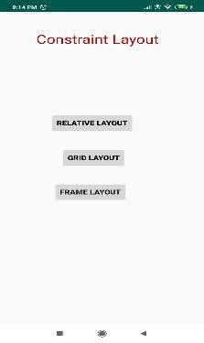 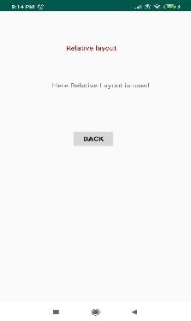 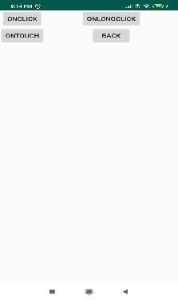

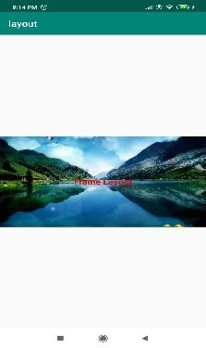 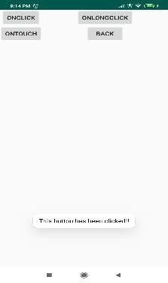 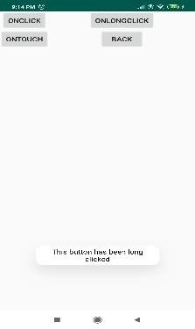

**Result:**

The Android application that implements various layout managers and event listeners has been executed successfully.

**Ex.No. 4**

**Native Calculator**

**Date: 23-01-2020**

**Aim:**

To create an Android application that implements native as well as scientific calculator.

**Description:**

In this application, an empty activity is created. The buttons required to implement the calculator are provided in the xml file. The implementation of functions for the respective button clicks are specified in the java file. When equal button is pressed the function implementation is done.

**Program:**

**activity_main.xml**

*<?*xml version="1.0" encoding="utf-8"*?>*<androidx.constraintlayout.widget.ConstraintLayout xmlns:android="http://schemas.android.com/apk/res/android"  
 xmlns:app="http://schemas.android.com/apk/res-auto"  
 xmlns:tools="http://schemas.android.com/tools"  
 android:layout_width="match_parent"  
 android:layout_height="match_parent"  
 tools:context=".MainActivity">  
 <Button  
 android:id="@+id/logb"  
 android:layout_width="wrap_content"  
 android:layout_height="wrap_content"  
 android:text="log"  
 android:onClick="btn"  
 android:textStyle="bold"  
 app:layout_constraintBottom_toBottomOf="parent"  
 app:layout_constraintEnd_toEndOf="parent"  
 app:layout_constraintHorizontal_bias="0.049"  
 app:layout_constraintStart_toStartOf="parent"  
 app:layout_constraintTop_toTopOf="parent"  
 app:layout_constraintVertical_bias="0.499" />  
 <Button  
 android:id="@+id/sqb"  
 android:layout_width="wrap_content"  
 android:layout_height="wrap_content"  
 android:onClick="btn"  
 android:text="square"  
 android:textStyle="bold"  
 app:layout_constraintBottom_toBottomOf="parent"  
 app:layout_constraintEnd_toEndOf="parent"  
 app:layout_constraintHorizontal_bias="0.049"  
 app:layout_constraintStart_toStartOf="parent"  
 app:layout_constraintTop_toTopOf="parent"  
 app:layout_constraintVertical_bias="0.591" />  
 <Button  
 android:id="@+id/cubeb"  
 android:layout_width="wrap_content"  
 android:layout_height="wrap_content"  
 android:onClick="btn"  
 android:text="cube"  
 android:textStyle="bold"  
 app:layout_constraintBottom_toBottomOf="parent"  
 app:layout_constraintEnd_toEndOf="parent"  
 app:layout_constraintHorizontal_bias="0.346"  
 app:layout_constraintStart_toStartOf="parent"  
 app:layout_constraintTop_toTopOf="parent"  
 app:layout_constraintVertical_bias="0.591" />  
 <Button  
 android:id="@+id/sqrb"  
 android:layout_width="wrap_content"  
 android:layout_height="wrap_content"  
 android:onClick="btn"  
 android:text="√ "  
 android:textStyle="bold"  
 app:layout_constraintBottom_toBottomOf="parent"  
 app:layout_constraintEnd_toEndOf="parent"  
 app:layout_constraintHorizontal_bias="0.95"  
 app:layout_constraintStart_toStartOf="parent"  
 app:layout_constraintTop_toTopOf="parent"  
 app:layout_constraintVertical_bias="0.499" />  
 <Button  
 android:id="@+id/sinb"  
 android:layout_width="wrap_content"  
 android:layout_height="wrap_content"  
 android:onClick="btn"  
 android:text="sin"  
 android:textStyle="bold"  
 app:layout_constraintBottom_toBottomOf="parent"  
 app:layout_constraintEnd_toEndOf="parent"  
 app:layout_constraintHorizontal_bias="0.95"  
 app:layout_constraintStart_toStartOf="parent"  
 app:layout_constraintTop_toTopOf="parent"  
 app:layout_constraintVertical_bias="0.405" />  
 <Button  
 android:id="@+id/cosb"  
 android:layout_width="wrap_content"  
 android:layout_height="wrap_content"  
 android:onClick="btn"  
 android:text="cos"  
 android:textStyle="bold"  
 app:layout_constraintBottom_toBottomOf="parent"  
 app:layout_constraintEnd_toEndOf="parent"  
 app:layout_constraintHorizontal_bias="0.659"  
 app:layout_constraintStart_toStartOf="parent"  
 app:layout_constraintTop_toTopOf="parent"  
 app:layout_constraintVertical_bias="0.405" />  
 <Button  
 android:id="@+id/clearb"  
 android:layout_width="wrap_content"  
 android:layout_height="wrap_content"  
 android:onClick="btn"  
 android:text="DEL"  
 android:textStyle="bold"  
 app:layout_constraintBottom_toBottomOf="parent"  
 app:layout_constraintEnd_toEndOf="parent"  
 app:layout_constraintHorizontal_bias="0.64"  
 app:layout_constraintStart_toStartOf="parent"  
 app:layout_constraintTop_toTopOf="parent"  
 app:layout_constraintVertical_bias="0.591" />  
 <Button  
 android:id="@+id/allcb"  
 android:layout_width="wrap_content"  
 android:layout_height="wrap_content"  
 android:text="AC"  
 android:onClick="btn"  
 android:textStyle="bold"  
 app:layout_constraintBottom_toBottomOf="parent"  
 app:layout_constraintEnd_toEndOf="parent"  
 app:layout_constraintHorizontal_bias="0.931"  
 app:layout_constraintStart_toStartOf="parent"  
 app:layout_constraintTop_toTopOf="parent"  
 app:layout_constraintVertical_bias="0.591" />  
 <Button  
 android:id="@+id/seven"  
 android:layout_width="wrap_content"  
 android:layout_height="wrap_content"  
 android:onClick="btn"  
 android:text="7"  
 android:textStyle="bold"  
 app:layout_constraintBottom_toBottomOf="parent"  
 app:layout_constraintEnd_toEndOf="parent"  
 app:layout_constraintHorizontal_bias="0.049"  
 app:layout_constraintStart_toStartOf="parent"  
 app:layout_constraintTop_toTopOf="parent"  
 app:layout_constraintVertical_bias="0.683" />  
 <Button  
 android:id="@+id/four"  
 android:layout_width="wrap_content"  
 android:layout_height="wrap_content"  
 android:text="4"  
 android:onClick="btn"  
 android:textStyle="bold"  
 app:layout_constraintBottom_toBottomOf="parent"  
 app:layout_constraintEnd_toEndOf="parent"  
 app:layout_constraintHorizontal_bias="0.049"  
 app:layout_constraintStart_toStartOf="parent"  
 app:layout_constraintTop_toTopOf="parent"  
 app:layout_constraintVertical_bias="0.774" />  
 <Button  
 android:id="@+id/one"  
 android:onClick="btn"  
 android:layout_width="wrap_content"  
 android:layout_height="wrap_content"  
 android:text="1"  
 android:textStyle="bold"  
 app:layout_constraintBottom_toBottomOf="parent"  
 app:layout_constraintEnd_toEndOf="parent"  
 app:layout_constraintHorizontal_bias="0.049"  
 app:layout_constraintStart_toStartOf="parent"  
 app:layout_constraintTop_toTopOf="parent"  
 app:layout_constraintVertical_bias="0.862" />  
 <Button  
 android:id="@+id/dot"  
 android:layout_width="wrap_content"  
 android:layout_height="wrap_content"  
 android:text="."  
 android:onClick="btn"  
 android:textStyle="bold"  
 app:layout_constraintBottom_toBottomOf="parent"  
 app:layout_constraintEnd_toEndOf="parent"  
 app:layout_constraintHorizontal_bias="0.049"  
 app:layout_constraintStart_toStartOf="parent"  
 app:layout_constraintTop_toTopOf="parent"  
 app:layout_constraintVertical_bias="0.951" />  
 <Button  
 android:id="@+id/eight"  
 android:layout_width="wrap_content"  
 android:layout_height="wrap_content"  
 android:text="8"  
 android:onClick="btn"  
 android:textStyle="bold"  
 app:layout_constraintBottom_toBottomOf="parent"  
 app:layout_constraintEnd_toEndOf="parent"  
 app:layout_constraintHorizontal_bias="0.346"  
 app:layout_constraintStart_toStartOf="parent"  
 app:layout_constraintTop_toTopOf="parent"  
 app:layout_constraintVertical_bias="0.683" />  
 <Button  
 android:id="@+id/five"  
 android:layout_width="wrap_content"  
 android:layout_height="wrap_content"  
 android:text="5"  
 android:onClick="btn"  
 android:textStyle="bold"  
 app:layout_constraintBottom_toBottomOf="parent"  
 app:layout_constraintEnd_toEndOf="parent"  
 app:layout_constraintHorizontal_bias="0.346"  
 app:layout_constraintStart_toStartOf="parent"  
 app:layout_constraintTop_toTopOf="parent"  
 app:layout_constraintVertical_bias="0.774" />  
 <Button  
 android:id="@+id/two"  
 android:layout_width="wrap_content"  
 android:layout_height="wrap_content"  
 android:text="2"  
 android:onClick="btn"  
 android:textStyle="bold"  
 app:layout_constraintBottom_toBottomOf="parent"  
 app:layout_constraintEnd_toEndOf="parent"  
 app:layout_constraintHorizontal_bias="0.346"  
 app:layout_constraintStart_toStartOf="parent"  
 app:layout_constraintTop_toTopOf="parent"  
 app:layout_constraintVertical_bias="0.862" />  
 <Button  
 android:id="@+id/zero"  
 android:layout_width="wrap_content"  
 android:layout_height="wrap_content"  
 android:text="0"  
 android:onClick="btn"  
 android:textStyle="bold"  
 app:layout_constraintBottom_toBottomOf="parent"  
 app:layout_constraintEnd_toEndOf="parent"  
 app:layout_constraintHorizontal_bias="0.346"  
 app:layout_constraintStart_toStartOf="parent"  
 app:layout_constraintTop_toTopOf="parent"  
 app:layout_constraintVertical_bias="0.951" />  
 <Button  
 android:id="@+id/nine"  
 android:layout_width="wrap_content"  
 android:layout_height="wrap_content"  
 android:text="9"  
 android:onClick="btn"  
 android:textStyle="bold"  
 app:layout_constraintBottom_toBottomOf="parent"  
 app:layout_constraintEnd_toEndOf="parent"  
 app:layout_constraintHorizontal_bias="0.64"  
 app:layout_constraintStart_toStartOf="parent"  
 app:layout_constraintTop_toTopOf="parent"  
 app:layout_constraintVertical_bias="0.683" />  
 <Button  
 android:id="@+id/six"  
 android:layout_width="wrap_content"  
 android:layout_height="wrap_content"  
 android:text="6"  
 android:onClick="btn"  
 android:textStyle="bold"  
 app:layout_constraintBottom_toBottomOf="parent"  
 app:layout_constraintEnd_toEndOf="parent"  
 app:layout_constraintHorizontal_bias="0.64"  
 app:layout_constraintStart_toStartOf="parent"  
 app:layout_constraintTop_toTopOf="parent"  
 app:layout_constraintVertical_bias="0.774" />  
 <Button  
 android:id="@+id/three"  
 android:layout_width="wrap_content"  
 android:layout_height="wrap_content"  
 android:text="3"  
 android:onClick="btn"  
 android:textStyle="bold"  
 app:layout_constraintBottom_toBottomOf="parent"  
 app:layout_constraintEnd_toEndOf="parent"  
 app:layout_constraintHorizontal_bias="0.64"  
 app:layout_constraintStart_toStartOf="parent"  
 app:layout_constraintTop_toTopOf="parent"  
 app:layout_constraintVertical_bias="0.862" />  
 <Button  
 android:id="@+id/div"  
 android:layout_width="wrap_content"  
 android:layout_height="wrap_content"  
 android:text="/"  
 android:onClick="btn"  
 android:textStyle="bold"  
 app:layout_constraintBottom_toBottomOf="parent"  
 app:layout_constraintEnd_toEndOf="parent"  
 app:layout_constraintHorizontal_bias="0.64"  
 app:layout_constraintStart_toStartOf="parent"  
 app:layout_constraintTop_toTopOf="parent"  
 app:layout_constraintVertical_bias="0.951" />  
 <Button  
 android:id="@+id/plus"  
 android:layout_width="wrap_content"  
 android:layout_height="wrap_content"  
 android:text="+"  
 android:onClick="btn"  
 android:textStyle="bold"  
 app:layout_constraintBottom_toBottomOf="parent"  
 app:layout_constraintEnd_toEndOf="parent"  
 app:layout_constraintHorizontal_bias="0.931"  
 app:layout_constraintStart_toStartOf="parent"  
 app:layout_constraintTop_toTopOf="parent"  
 app:layout_constraintVertical_bias="0.683" />  
 <Button  
 android:id="@+id/minus"  
 android:layout_width="wrap_content"  
 android:layout_height="wrap_content"  
 android:text="-"  
 android:onClick="btn"  
 android:textStyle="bold"  
 app:layout_constraintBottom_toBottomOf="parent"  
 app:layout_constraintEnd_toEndOf="parent"  
 app:layout_constraintHorizontal_bias="0.931"  
 app:layout_constraintStart_toStartOf="parent"  
 app:layout_constraintTop_toTopOf="parent"  
 app:layout_constraintVertical_bias="0.774" />  
 <Button  
 android:id="@+id/mul"  
 android:layout_width="wrap_content"  
 android:layout_height="wrap_content"  
 android:text="x"  
 android:onClick="btn"  
 android:textStyle="bold"  
 app:layout_constraintBottom_toBottomOf="parent"  
 app:layout_constraintEnd_toEndOf="parent"  
 app:layout_constraintHorizontal_bias="0.931"  
 app:layout_constraintStart_toStartOf="parent"  
 app:layout_constraintTop_toTopOf="parent"  
 app:layout_constraintVertical_bias="0.862" />  
 <Button  
 android:id="@+id/equal"  
 android:layout_width="wrap_content"  
 android:layout_height="wrap_content"  
 android:text="="  
 android:onClick="btn"  
 android:textStyle="bold"  
 app:layout_constraintBottom_toBottomOf="parent"  
 app:layout_constraintEnd_toEndOf="parent"  
 app:layout_constraintHorizontal_bias="0.931"  
 app:layout_constraintStart_toStartOf="parent"  
 app:layout_constraintTop_toTopOf="parent"  
 app:layout_constraintVertical_bias="0.951" />  
 <EditText  
 android:id="@+id/in"  
 android:layout_width="236dp"  
 android:layout_height="53dp"  
 android:onClick="btn"  
 android:background="@null"  
 android:textSize="20dp"  
 android:textStyle="bold"  
 app:layout_constraintBottom_toBottomOf="parent"  
 app:layout_constraintEnd_toEndOf="parent"  
 app:layout_constraintHorizontal_bias="0.64"  
 app:layout_constraintStart_toStartOf="parent"  
 app:layout_constraintTop_toTopOf="parent"  
 app:layout_constraintVertical_bias="0.05" />  
 <EditText  
 android:id="@+id/sign"  
 android:layout_width="96dp"  
 android:layout_height="49dp"  
 android:background="@null"  
 android:onClick="btn"  
 android:textSize="20dp"  
 app:layout_constraintBottom_toBottomOf="parent"  
 app:layout_constraintEnd_toEndOf="parent"  
 app:layout_constraintHorizontal_bias="0.765"  
 app:layout_constraintStart_toStartOf="parent"  
 app:layout_constraintTop_toTopOf="parent"  
 app:layout_constraintVertical_bias="0.18" />  
 <Button  
 android:id="@+id/ln"  
 android:layout_width="wrap_content"  
 android:layout_height="wrap_content"  
 android:onClick="btn"  
 android:text="ln"  
 android:textStyle="bold"  
 app:layout_constraintBottom_toBottomOf="parent"  
 app:layout_constraintEnd_toEndOf="parent"  
 app:layout_constraintHorizontal_bias="0.049"  
 app:layout_constraintStart_toStartOf="parent"  
 app:layout_constraintTop_toTopOf="parent"  
 app:layout_constraintVertical_bias="0.405" />  
 <Button  
 android:id="@+id/tan"  
 android:layout_width="wrap_content"  
 android:layout_height="wrap_content"  
 android:text="tan"  
 android:textStyle="bold"  
 android:onClick="btn"  
 app:layout_constraintBottom_toBottomOf="parent"  
 app:layout_constraintEnd_toEndOf="parent"  
 app:layout_constraintHorizontal_bias="0.346"  
 app:layout_constraintStart_toStartOf="parent"  
 app:layout_constraintTop_toTopOf="parent"  
 app:layout_constraintVertical_bias="0.405" />  
 <Button  
 android:id="@+id/xn"  
 android:onClick="btn"  
 android:layout_width="wrap_content"  
 android:layout_height="wrap_content"  
 android:text="^"  
 android:textStyle="bold"  
 app:layout_constraintBottom_toBottomOf="parent"  
 app:layout_constraintEnd_toEndOf="parent"  
 app:layout_constraintHorizontal_bias="0.346"  
 app:layout_constraintStart_toStartOf="parent"  
 app:layout_constraintTop_toTopOf="parent"  
 app:layout_constraintVertical_bias="0.499" />  
 <Button  
 android:id="@+id/fact"  
 android:onClick="btn"  
 android:layout_width="wrap_content"  
 android:layout_height="wrap_content"  
 android:text="!"  
 android:textStyle="bold"  
 app:layout_constraintBottom_toBottomOf="parent"  
 app:layout_constraintEnd_toEndOf="parent"  
 app:layout_constraintHorizontal_bias="0.659"  
 app:layout_constraintStart_toStartOf="parent"  
 app:layout_constraintTop_toTopOf="parent"  
 app:layout_constraintVertical_bias="0.499" />  
 <Button  
 android:id="@+id/cr"  
 android:onClick="btn"  
 android:layout_width="wrap_content"  
 android:layout_height="wrap_content"  
 android:text="∛"  
 android:textStyle="bold"  
 app:layout_constraintBottom_toBottomOf="parent"  
 app:layout_constraintEnd_toEndOf="parent"  
 app:layout_constraintHorizontal_bias="0.049"  
 app:layout_constraintStart_toStartOf="parent"  
 app:layout_constraintTop_toTopOf="parent"  
 app:layout_constraintVertical_bias="0.313" />  
</androidx.constraintlayout.widget.ConstraintLayout>

**Java Code**

**MainActivity.java**

package com.example.calapp;  
  
import androidx.appcompat.app.AppCompatActivity;  
import android.os.Bundle;  
import android.view.View;  
import android.widget.TextView;  
import java.text.DecimalFormat;  
public class MainActivity extends AppCompatActivity {  
 TextView signbox, input;  
 String sign, value1, value2, sf;  
 Double num1, num2, result,d;  
 boolean hasdot, sc,sff;  
 public DecimalFormat df = new DecimalFormat("#.########");  
 @Override  
 protected void onCreate(Bundle savedInstanceState) {  
 super.onCreate(savedInstanceState);  
 setContentView(R.layout.*activity_main*);  
 input = findViewById(R.id.*in*);  
 signbox = findViewById(R.id.*sign*);  
 hasdot = false;  
 sc = false;  
 sff=false;  
 sf = null;  
 }  
 public void btn(View view) {  
 switch (view.getId()) {  
 case R.id.*one*:  
 input.setText(input.getText() + "1");  
 break;  
 case R.id.*zero*:  
 input.setText(input.getText() + "0");  
 break;  
 case R.id.*two*:  
 input.setText(input.getText() + "2");  
 break;  
 case R.id.*three*:  
 input.setText(input.getText() + "3");  
 break;  
 case R.id.*four*:  
 input.setText(input.getText() + "4");  
 break;  
 case R.id.*five*:  
 input.setText(input.getText() + "5");  
 break;  
 case R.id.*six*:  
 input.setText(input.getText() + "6");  
 break;  
 case R.id.*seven*:  
 input.setText(input.getText() + "7");  
 break;  
 case R.id.*eight*:  
 input.setText(input.getText() + "8");  
 break;  
 case R.id.*nine*:  
 input.setText(input.getText() + "9");  
 break;  
 case R.id.*plus*:  
 sign = "+";  
 signbox.setText("+");  
 value1 = input.getText().toString();  
 input.setText(null);  
 hasdot = false;  
 break;  
 case R.id.*minus*:  
 if(sff==true){  
 input.setText(input.getText()+"-");  
 sff=false;  
 }  
 else if(input.getText().equals("")){  
 input.setText("-");  
 }  
 else {  
 sign = "-";  
 signbox.setText("-");  
 value1 = input.getText().toString();  
 input.setText(null);  
 hasdot = false;  
 }  
 break;  
 case R.id.*mul*:  
 sign = "*";  
 signbox.setText("x");  
 value1 = input.getText().toString();  
 input.setText(null);  
 hasdot = false;  
 sff=true;  
 break;  
 case R.id.*div*:  
 sign = "/";  
 signbox.setText("/");  
 value1 = input.getText().toString();  
 input.setText(null);  
 hasdot = false;  
 sff=true;  
 break;  
 case R.id.*logb*:  
 sf = "log";  
 signbox.setText("log");  
 input.setText(null);  
 sc = true;  
 hasdot = false;  
 break;  
 case R.id.*ln*:  
 sf="ln";  
 signbox.setText("ln");  
 sc=true;  
 hasdot=false;  
 input.setText(null);  
 break;  
 case R.id.*sqb*:  
 sf = "squ";  
 sc = true;  
 signbox.setText("x^2");  
 value1 = input.getText().toString();  
 input.setText(null);  
 break;  
 case R.id.*cubeb*:  
 sf = "cube";  
 sc = true;  
 signbox.setText("x^3");  
 input.setText(null);  
 break;  
 case R.id.*sinb*:  
 sf = "sin";  
 sc = true;  
 hasdot = false;  
 signbox.setText("sin");  
 input.setText(null);  
 break;  
 case R.id.*cosb*:  
 sf = "cos";  
 sc = true;  
 hasdot = false;  
 signbox.setText("cos");  
 input.setText(null);  
 break;  
 case R.id.*tan*:  
 sf="tan";  
 sc=true;  
 hasdot=false;  
 signbox.setText("tan");  
 input.setText(null);  
 break;  
 case R.id.*fact*:  
 signbox.setText("!");  
 sf="fact";  
 sc=true;  
 hasdot=false;  
 input.setText(null);  
 break;  
 case R.id.*cr*:  
 sf="croot";  
 sc=true;signbox.setText("cube root");  
 input.setText(null);  
 break;  
 case R.id.*xn*:  
 sf= "power";  
 sc=true;  
 signbox.setText("x^n");  
 value1=input.getText().toString();  
 input.setText(null);  
 break;  
 case R.id.*sqrb*:  
 sf = "root";  
 sc = true;signbox.setText("root");  
 input.setText(null);  
 break;  
 case R.id.*equal*:  
 if ((sf == null && sign == null) || input.getText().equals("")) {  
 signbox.setText("Error");  
 } else if (sf != null) {  
 switch (sf) {  
 case "log":  
 value1 = input.getText().toString();  
 num1 = Double.*parseDouble*(value1);  
 input.setText(df.format(Math.*log10*(num1)) + "");  
 sf = null;  
 sc = false;  
 signbox.setText(null);  
 break;  
 case "ln":  
 value1 = input.getText().toString();  
 num1 = Double.*parseDouble*(value1);  
 input.setText(df.format(Math.*log*(num1)) + "");  
 sc = false;  
 sf = null;  
 signbox.setText(null);  
 break;  
 case "sin":  
 value1 = input.getText().toString();  
 num1 = Double.*parseDouble*(value1);  
 double n = Math.*toRadians*(num1);  
 input.setText(df.format(Math.*sin*(n)) + "");  
 sf = null;  
 sc = false;  
 signbox.setText(null);  
 break;  
 case "cos":  
 value1 = input.getText().toString();  
 num1 = Double.*parseDouble*(value1);  
 double n1 = Math.*toRadians*(num1);  
 input.setText(df.format(Math.*cos*(n1)) + "");  
 sc = false;  
 sf = null;  
 signbox.setText(null);  
 break;  
 case "power":num1=Double.*parseDouble*(value1);  
 value2=input.getText().toString();  
 num2=Double.*parseDouble*(value2);  
 input.setText(Math.*pow*(num1,num2)+"");  
 sc=false;  
 sf=null;  
 signbox.setText(null);  
 break;  
 case "tan":  
 value1 = input.getText().toString();  
 num1 = Double.*parseDouble*(value1);  
 double n2 = Math.*toRadians*(num1);  
 d=90.0;  
 if(Double.*compare*(num1,90.0)==0){  
 input.setText("∞");  
 }  
 else {  
 input.setText(df.format(Math.*tan*(n2)) + "");  
 }  
 sc = false;  
 sf = null;  
 signbox.setText(null);  
 break;  
 case "squ":  
 value1=input.getText().toString();  
 num1 = Double.*parseDouble*(value1);  
 input.setText(Math.*pow*(num1, 2) + "");  
 sc = false;  
 sf = null;  
 signbox.setText(null);  
 break;  
 case "cube":  
 value1=input.getText().toString();  
 num1 = Double.*parseDouble*(value1);  
 input.setText(Math.*pow*(num1, 3) + "");  
 sc = false;  
 sf = null;  
 signbox.setText(null);  
 break;  
 case "root":  
 value1 = input.getText().toString();  
 num1 = Double.*parseDouble*(value1);  
 input.setText(df.format(Math.*sqrt*(num1)) + "");  
 sc = false;  
 sf = null;  
 signbox.setText(null);  
 break;  
 case "croot":  
 value1=input.getText().toString();  
 num1=Double.*parseDouble*(value1);  
 input.setText(df.format(Math.*cbrt*(num1))+"");  
 sc=false;  
 sf=null;  
 signbox.setText(null);  
 break;  
 case "fact":  
 value1=input.getText().toString();  
 num1=Double.*parseDouble*(value1);  
 int i=Integer.*parseInt*(value1);  
 if(i==0){  
 input.setText(1+"");  
 }  
 else {  
 i--;  
 while(i>0){  
 num1=num1*i;  
 i--;  
 }  
 input.setText(num1+"");  
 }  
 sc=false;  
 sf=null;  
 signbox.setText(null);  
 break;  
 } else if (sign != null) {  
 value2 = input.getText().toString();  
 num1 = Double.*parseDouble*(value1);  
 num2 = Double.*parseDouble*(value2);  
 input.setText(null);  
 switch (sign) {  
 case "+":  
 result = num1 + num2;  
 input.setText(df.format(result) + "");  
 sign = null;  
 signbox.setText(null);  
 break;  
 case "-":  
 result = num1 - num2;  
 input.setText(df.format(result) + "");  
 sign = null;  
 signbox.setText(null);  
 break;  
 case "*":  
 result = num1 * num2;  
 input.setText(df.format(result) + "");  
 sign = null;  
 signbox.setText(null);  
 break;  
 case "/":  
 result = num1 / num2;  
 input.setText(df.format(result) + "");  
 sign = null;  
 signbox.setText(null);  
 break;  
 }}  
 break;  
 case R.id.*allcb*:  
 input.setText(null);  
 signbox.setText(null);  
 value1 = null;  
 value2 = null;  
 sign = null;  
 hasdot = false;  
 break;  
 case R.id.*clearb*:  
 if (input.getText().equals(""))  
 input.setText(null);  
 else {  
 int length = input.getText().length();  
 String s = input.getText().toString();  
 if (s.charAt(length - 1) == '.') {  
 hasdot = false;  
 input.setText(input.getText().subSequence(0, length - 1));  
 } else  
 input.setText(input.getText().subSequence(0, length - 1));  
 }  
 break;  
 case R.id.*dot*:  
 if (!hasdot) {  
 if (input.getText().equals("")) {  
 hasdot = true;  
 input.setText("0.");  
 } else {  
 hasdot = true;  
 input.setText(input.getText() + ".");  
 }  
 }  
 }}}

**Sample Input/Output**

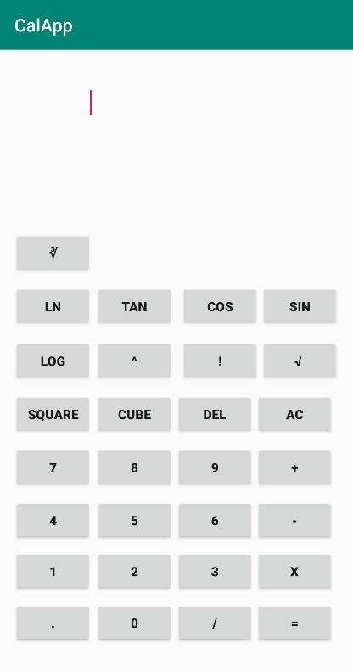 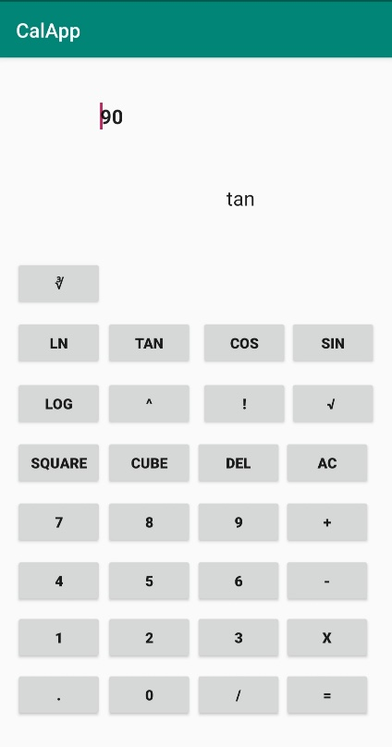 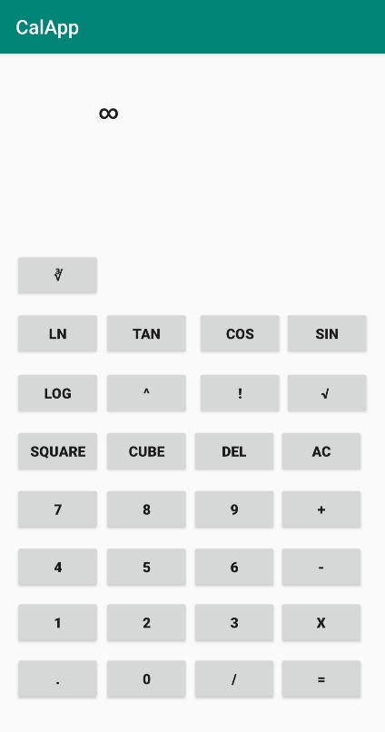

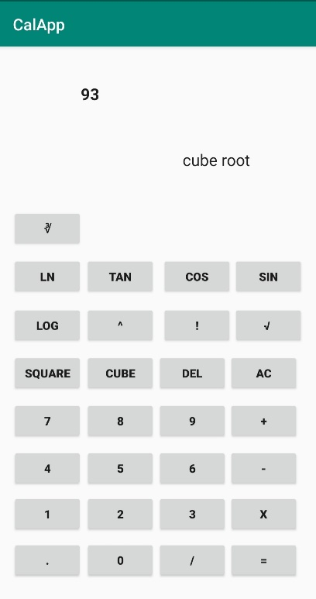 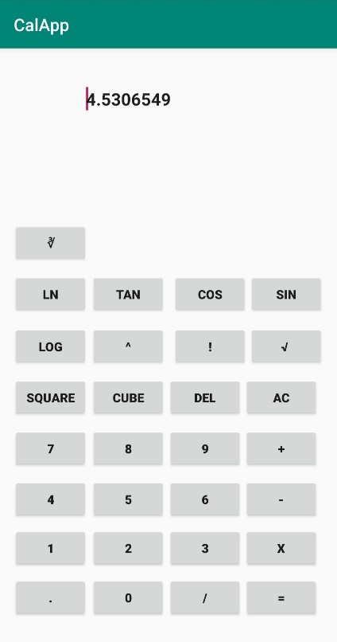

**Result:**

The Android application to implement scientific calculator has been executed successfully.

**Ex.No. 5**

**Basic Graphical Primitives**

**Date: 30-01-2020**

**Aim:**

To create an Android application to implement the Basic Graphical Primitives.

**Description:**

In this application, the graphical primitives are implemented in two activities. The first activity contains the basic as well as derived primitives of square and rectangle such as solid and filled rounded primitives. In the second activity, the graphical primitives for circle, ellipse, triangle and arc are created.

**Program:**

**XML Code:**

**activity_main.xml**

*<?*xml version="1.0" encoding="utf-8"*?>*<androidx.constraintlayout.widget.ConstraintLayout xmlns:android="http://schemas.android.com/apk/res/android"  
 xmlns:app="http://schemas.android.com/apk/res-auto"  
 xmlns:tools="http://schemas.android.com/tools"  
 android:layout_width="match_parent"  
 android:layout_height="match_parent"  
 android:background="#C6D323"  
 tools:context=".MainActivity">

<TextView  
 android:id="@+id/textView"  
 android:layout_width="417dp"  
 android:layout_height="63dp"  
 android:layout_marginStart="160dp"  
 android:layout_marginLeft="160dp"  
 android:layout_marginTop="112dp"  
 android:layout_marginEnd="92dp"  
 android:layout_marginRight="92dp"  
 android:layout_marginBottom="549dp"  
 android:text="GRAPHICAL PRIMITIVES"  
 android:textColor="#83153D"  
 android:textSize="30sp"  
 android:textStyle="bold"  
 app:layout_constraintBottom_toBottomOf="parent"  
 app:layout_constraintEnd_toEndOf="parent"  
 app:layout_constraintHorizontal_bias="0.519"  
 app:layout_constraintStart_toStartOf="parent"  
 app:layout_constraintTop_toTopOf="parent"  
 app:layout_constraintVertical_bias="0.0" />  
  
 <Button  
 android:id="@+id/button"  
 android:layout_width="187dp"  
 android:layout_height="61dp"  
 android:layout_marginTop="101dp"  
 android:layout_marginBottom="407dp"  
 android:background="#D5AFDF"  
 android:text="Basic Shapes"  
 android:textColor="#1A2361"  
 android:textSize="20sp"  
 android:textStyle="bold"  
 app:layout_constraintBottom_toBottomOf="parent"  
 app:layout_constraintEnd_toEndOf="parent"  
 app:layout_constraintStart_toStartOf="parent"  
 app:layout_constraintTop_toBottomOf="@+id/textView" />

<Button  
 android:id="@+id/button3"  
 android:layout_width="181dp"  
 android:layout_height="62dp"  
 android:layout_marginTop="72dp"  
 android:background="#D5AFDF"  
 android:text="Derived Shapes"  
 android:textColor="#1A2361"  
 android:textSize="20sp"  
 android:textStyle="bold"  
 app:layout_constraintEnd_toEndOf="parent"  
 app:layout_constraintStart_toStartOf="parent"  
 app:layout_constraintTop_toBottomOf="@+id/button" />  
</androidx.constraintlayout.widget.ConstraintLayout>

**activity_c1.xml**

*<?*xml version="1.0" encoding="utf-8"*?>*<androidx.constraintlayout.widget.ConstraintLayout xmlns:android="http://schemas.android.com/apk/res/android"  
 xmlns:app="http://schemas.android.com/apk/res-auto"  
 xmlns:tools="http://schemas.android.com/tools"  
 android:layout_width="match_parent"  
 android:layout_height="match_parent"  
 tools:context=".c1">

<TextView  
 android:layout_width="176dp"  
 android:layout_height="29dp"  
 android:text="Basic Primitives"  
 android:textSize="20sp"  
 android:textStyle="bold"  
 app:layout_constraintBottom_toBottomOf="parent"  
 app:layout_constraintHorizontal_bias="0.459"  
 app:layout_constraintLeft_toLeftOf="parent"  
 app:layout_constraintRight_toRightOf="parent"  
 app:layout_constraintTop_toTopOf="parent"  
 app:layout_constraintVertical_bias="0.052" />  
  
</androidx.constraintlayout.widget.ConstraintLayout>

**activity_c2.xml**

*<?*xml version="1.0" encoding="utf-8"*?>*<androidx.constraintlayout.widget.ConstraintLayout xmlns:android="http://schemas.android.com/apk/res/android"  
 xmlns:app="http://schemas.android.com/apk/res-auto"  
 xmlns:tools="http://schemas.android.com/tools"  
 android:layout_width="match_parent"  
 android:layout_height="match_parent"  
 tools:context=".c2">

<TextView  
 android:layout_width="wrap_content"  
 android:layout_height="wrap_content"  
 android:text="GUI"  
 app:layout_constraintBottom_toBottomOf="parent"  
 app:layout_constraintHorizontal_bias="0.47"  
 app:layout_constraintLeft_toLeftOf="parent"  
 app:layout_constraintRight_toRightOf="parent"  
 app:layout_constraintTop_toTopOf="parent"  
 app:layout_constraintVertical_bias="0.106" />  
</androidx.constraintlayout.widget.ConstraintLayout>

**Java Code:**

**MainActivity.java**

package com.example.shapes;  
import androidx.appcompat.app.AppCompatActivity;  
import android.content.Intent;  
import android.os.Bundle;  
import android.view.View;  
import android.widget.Button;  
public class MainActivity extends AppCompatActivity {  
 private Button b1;  
 private Button b2;  
 @Override  
 protected void onCreate(Bundle savedInstanceState)

{  
 super.onCreate(savedInstanceState);  
 setContentView(R.layout.*activity_main*);  
 b1=(Button)findViewById(R.id.*button*);  
 b2=(Button)findViewById(R.id.*button3*);  
 b1.setOnClickListener(new View.OnClickListener() {  
 @Override  
 public void onClick(View v) {  
 Intent i=new Intent(MainActivity.this,c1.class);  
 startActivity(i);  
 }  
 });  
 b2.setOnClickListener(new View.OnClickListener() {  
 @Override  
 public void onClick(View v) {  
 Intent j=new Intent(MainActivity.this,c2.class);  
 startActivity(j);  
 }  
 });  
 }  
}

**c1.java**

package com.example.shapes;  
import androidx.appcompat.app.AppCompatActivity;  
import android.os.Bundle;  
public class c1 extends AppCompatActivity {  
 @Override  
 protected void onCreate(Bundle savedInstanceState) {  
 super.onCreate(savedInstanceState);  
 setContentView(new circle1(this));  
 }  
}

**circle1.java**

package com.example.shapes;  
import android.content.Context;  
import android.graphics.Canvas;  
import android.graphics.Color;  
import android.graphics.Paint;  
import android.graphics.Path;  
import android.graphics.Point;  
import android.graphics.Rect;  
import android.graphics.RectF;  
import android.os.Build;  
import android.view.View;  
public class circle1 extends View

{  
 private Paint paint1,paint2,paint3,paint4,paint5;  
 private Rect rect,rect1;  
 private Rect squ,squ1;  
 public circle1(Context context)

{  
 super(context);  
 paint5=new Paint();  
 paint5.setColor(Color.*BLACK*);  
 paint5.setTextSize(60);  
 paint5.setFakeBoldText(true);  
 paint1=new Paint();  
 paint1.setTextSize(50);  
 paint1.setColor(Color.*MAGENTA*);  
 paint2=new Paint();  
 paint2.setTextSize(50);  
 paint2.setColor(Color.*BLUE*);  
 paint3=new Paint();  
 paint3.setTextSize(50);  
 paint3.setColor(Color.*YELLOW*);  
 paint4=new Paint();  
 paint4.setColor(Color.*RED*);  
 paint4.setStrokeWidth(10);  
 paint4.setTextSize(40);  
 paint4.setStyle(Paint.Style.*STROKE*);  
 rect=new Rect(800,1000,950,1400);  
 squ=new Rect(300,1500,500,1700);  
 rect1=new Rect(200, 400, 50, 800);  
 squ1=new Rect(400,600,600,800);  
 }  
 protected void onDraw(Canvas canvas)

{  
 canvas.drawText("Basic Primitives",350,200,paint5);  
 canvas.drawCircle(500,1200,100,paint3);  
 canvas.drawText("Circle",450,1400,paint1);  
 canvas.drawRect(rect1,paint4);  
 canvas.drawText("Rectangle",25,900,paint1);  
 canvas.drawRect(squ1,paint4);  
 canvas.drawText("Square",425,900,paint1);  
 Point a=new Point(850,500);  
 Point b=new Point(750,800);  
 Point c=new Point(950,800);  
 Path path=new Path();  
 path.moveTo(a.x,a.y);  
 path.lineTo(b.x,b.y);  
 path.lineTo(c.x,c.y);  
 path.lineTo(a.x,a.y);  
 canvas.drawPath(path,paint3);  
 canvas.drawText("Triangle",765,900,paint1);  
 Point a1=new Point(150,1100);  
 Point b1=new Point(50,1150);  
 Point c1=new Point(250,1150);  
 Point a2=new Point(50,1250);  
 Point b2=new Point(250,1250);  
 Point c2=new Point(150,1300);  
 Path path1=new Path();  
 path1.moveTo(a1.x,a1.y);  
 path1.lineTo(b1.x,b1.y);  
 path1.lineTo(a2.x,a2.y);  
 path1.lineTo(c2.x,c2.y);  
 path1.lineTo(b2.x,b2.y);  
 path1.lineTo(c1.x,c1.y);  
 path1.lineTo(a1.x,a1.y);  
 canvas.drawPath(path1,paint2);  
 canvas.drawText("Hexagon",50,1400,paint1);  
 canvas.drawRect(rect,paint1);  
 canvas.drawText("Filled Rectangle",700,1500,paint1);  
 canvas.drawRect(squ,paint2);  
 canvas.drawText("Filled Square",250,1800,paint1);  
  
}}

**c2.java**

package com.example.shapes;  
import androidx.appcompat.app.AppCompatActivity;  
import android.os.Bundle;  
public class c2 extends AppCompatActivity {  
 @Override  
 protected void onCreate(Bundle savedInstanceState) {  
 super.onCreate(savedInstanceState);  
 setContentView(new circle2(this));  
 }}

**circle2.java**

package com.example.shapes;  
import android.content.Context;  
import android.graphics.Canvas;  
import android.graphics.Color;  
import android.graphics.Paint;  
import android.graphics.Path;  
import android.graphics.Point;  
import android.graphics.Rect;  
import android.graphics.RectF;  
import android.os.Build;  
import android.view.View;  
public class circle2 extends View  
{  
 private Paint paint1,paint2,paint3,paint4,paint5,paint6;  
 private Rect rect,rect1;  
 private Rect squ,squ1;  
 public circle2(Context context)  
 {  
 super(context);  
 paint5=new Paint();  
 paint5.setColor(Color.*BLACK*);  
 paint5.setTextSize(60);  
 paint5.setFakeBoldText(true);  
 paint6=new Paint();  
 paint6.setColor(Color.*GREEN*);  
 paint6.setTextSize(50);  
 paint1=new Paint();  
 paint1.setTextSize(50);  
 paint1.setColor(Color.*MAGENTA*);  
 paint2=new Paint();  
 paint2.setTextSize(50);  
 paint2.setColor(Color.*BLUE*);  
 paint3=new Paint();  
 paint3.setTextSize(50);  
 paint3.setColor(Color.*YELLOW*);  
 paint4=new Paint();  
 paint4.setColor(Color.*RED*);  
 paint4.setStrokeWidth(10);  
 paint4.setTextSize(40);  
 paint4.setStyle(Paint.Style.*STROKE*);  
 }  
 protected void onDraw(Canvas canvas)  
 {  
 canvas.drawText("Derived Primitives",300,300,paint5);  
 canvas.drawRoundRect(new RectF(600,1300,800,1700),20,20,paint1);  
 canvas.drawText("Rounded Rectangle",550,1775,paint1);  
 canvas.drawRoundRect(new RectF(150,1400,350,1600),20,20,paint3);  
 canvas.drawText("Rounded square",100,1775,paint1);  
 RectF ellipse=new RectF(100,650,300,1000);  
 canvas.drawOval(ellipse,paint2);  
 canvas.drawText("Ellipse",100,1100,paint1);  
 Point a3=new Point(500,750);  
 Point b3=new Point(600,700);  
 Point c3=new Point(600,800);  
 Point d3=new Point(500,900);  
 Path path2=new Path();  
 path2.moveTo(a3.x,a3.y);  
 path2.lineTo(b3.x,b3.y);  
 path2.lineTo(c3.x,c3.y);  
 path2.lineTo(d3.x,d3.y);  
 path2.lineTo(a3.x,a3.y);  
 canvas.drawPath(path2,paint6);  
 canvas.drawText("Polygon",450,1100,paint1);  
 final RectF oval = new RectF();  
 Paint paint = new Paint();  
 paint.setColor(Color.*BLACK*);  
 paint.setStrokeWidth(10);  
 paint.setStyle(Paint.Style.*STROKE*);  
 oval.set(600, 500, 1000, 950);  
 canvas.drawArc(oval, 0, 120, true, paint);  
 canvas.drawText("ARC",800,1100,paint1);  
 }  
}

**Sample Input/Output:**

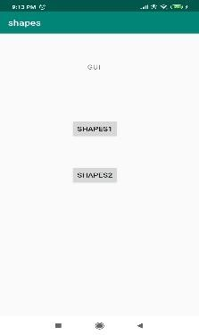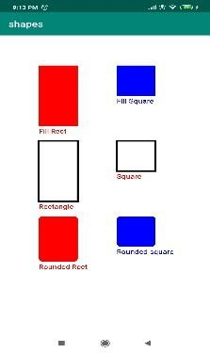

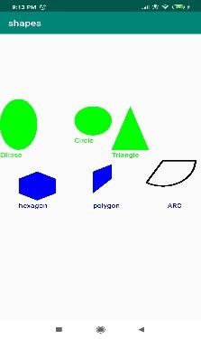

**Result:**

The Android application to implement basic graphical primitives has been executed successfully.

**Ex.No. 6**

**Database Connectivity**

**Date: 06-02-2020**

**Aim:**

To create an Android application that uses SQLite database to insert, view, delete and update the Employee database information.

**Description:**

In this application, the employee database is created in SQLite database. The first activity contains various operations that are to be performed. The second activity is used to insert the employee records. The third activity is used for deletion of records and the fourth activity is used to update the records. The records are viewed based on the ID in the fifth activity and all the records in the database can be viewed using the buffer.

**Program:**

**XML Code:**

**activity_main.xml**

*<?*xml version="1.0" encoding="utf-8"*?>*<androidx.constraintlayout.widget.ConstraintLayout xmlns:android="http://schemas.android.com/apk/res/android"  
 xmlns:app="http://schemas.android.com/apk/res-auto"  
 xmlns:tools="http://schemas.android.com/tools"  
 android:layout_width="match_parent"  
 android:layout_height="match_parent"  
 android:background="#9AF364"  
 tools:context=".MainActivity">  
  
 <TextView  
 android:id="@+id/textView"  
 android:layout_width="279dp"  
 android:layout_height="76dp"  
 android:layout_marginTop="67dp"  
 android:layout_marginBottom="645dp"  
 android:text="EMPLOYEE DATABASE"  
 android:textColor="#CA1054"  
 android:textSize="25sp"  
 android:textStyle="bold"  
 app:layout_constraintBottom_toBottomOf="parent"  
 app:layout_constraintEnd_toEndOf="parent"  
 app:layout_constraintHorizontal_bias="0.568"  
 app:layout_constraintStart_toStartOf="parent"  
 app:layout_constraintTop_toTopOf="parent"  
 app:layout_constraintVertical_bias="0.122" />  
  
 <Button  
 android:id="@+id/insert"  
 android:layout_width="128dp"  
 android:layout_height="56dp"  
 android:layout_marginTop="77dp"  
 android:layout_marginBottom="470dp"  
 android:background="#F1CA1D"  
 android:text="INSERT"  
 android:textColor="#F0120D"  
 android:textSize="20sp"  
 android:textStyle="bold"  
 app:layout_constraintBottom_toBottomOf="parent"  
 app:layout_constraintEnd_toEndOf="parent"  
 app:layout_constraintHorizontal_bias="0.498"  
 app:layout_constraintStart_toStartOf="parent"  
 app:layout_constraintTop_toBottomOf="@+id/textView"  
 app:layout_constraintVertical_bias="1.0" />  
  
 <Button  
 android:id="@+id/update"  
 android:layout_width="130dp"  
 android:layout_height="61dp"  
 android:layout_marginTop="61dp"  
 android:layout_marginBottom="361dp"  
 android:background="#F0C60E"  
 android:text="UPDATE"  
 android:textColor="#E21B17"  
 android:textSize="20sp"  
 android:textStyle="bold"  
 app:layout_constraintBottom_toBottomOf="parent"  
 app:layout_constraintEnd_toEndOf="parent"  
 app:layout_constraintHorizontal_bias="0.494"  
 app:layout_constraintStart_toStartOf="parent"  
 app:layout_constraintTop_toBottomOf="@+id/insert"  
 app:layout_constraintVertical_bias="1.0" />  
  
 <Button  
 android:id="@+id/delete"  
 android:layout_width="119dp"  
 android:layout_height="59dp"  
 android:layout_marginTop="55dp"  
 android:layout_marginBottom="258dp"  
 android:background="#F0C60E"  
 android:text="DELETE"  
 android:textColor="#F0342F"  
 android:textSize="20sp"  
 android:textStyle="bold"  
 app:layout_constraintBottom_toBottomOf="parent"  
 app:layout_constraintEnd_toEndOf="parent"  
 app:layout_constraintHorizontal_bias="0.498"  
 app:layout_constraintStart_toStartOf="parent"  
 app:layout_constraintTop_toBottomOf="@+id/update"  
 app:layout_constraintVertical_bias="1.0" />  
  
 <Button  
 android:id="@+id/view"  
 android:layout_width="126dp"  
 android:layout_height="54dp"  
 android:layout_marginTop="50dp"  
 android:layout_marginBottom="160dp"  
 android:background="#F0C60E"  
 android:text="VIEW"  
 android:textColor="#E53935"  
 android:textSize="20sp"  
 android:textStyle="bold"  
 app:layout_constraintBottom_toBottomOf="parent"  
 app:layout_constraintEnd_toEndOf="parent"  
 app:layout_constraintHorizontal_bias="0.512"  
 app:layout_constraintStart_toStartOf="parent"  
 app:layout_constraintTop_toBottomOf="@+id/delete"  
 app:layout_constraintVertical_bias="1.0" />  
  
 <Button  
 android:id="@+id/viewall"  
 android:layout_width="124dp"  
 android:layout_height="51dp"  
 android:layout_marginTop="56dp"  
 android:layout_marginBottom="50dp"  
 android:background="#F0C60E"  
 android:text="VIEW ALL"  
 android:textColor="#E53935"  
 android:textSize="20sp"  
 android:textStyle="bold"  
 app:layout_constraintBottom_toBottomOf="parent"  
 app:layout_constraintEnd_toEndOf="parent"  
 app:layout_constraintHorizontal_bias="0.523"  
 app:layout_constraintStart_toStartOf="parent"  
 app:layout_constraintTop_toBottomOf="@+id/view"  
 app:layout_constraintVertical_bias="1.0" />  
</androidx.constraintlayout.widget.ConstraintLayout>

**activity_insert.xml**

*<?*xml version=”1.0” encoding=”utf-8”*?>*<AbsoluteLayout xmlns:android=”http://schemas.android.com/apk/res/android”  
 android:layout_width=”match_parent”  
 android:layout_height=”match_parent”  
 android:background=”#9AF364”>  
  
 <TextView  
 android:id=”@+id/textView2”  
 android:layout_width=”wrap_content”  
 android:layout_height=”51dp”  
 android:layout_x=”23dp”  
 android:layout_y=”488dp”  
 android:text=”Enter Department:”  
 android:textColor=”#E53935”  
 android:textSize=”20sp” />  
  
 <TextView  
 android:id=”@+id/textView3”  
 android:layout_width=”wrap_content”  
 android:layout_height=”51dp”  
 android:layout_x=”26dp”  
 android:layout_y=”566dp”  
 android:text=”Enter Designation:”  
 android:textColor=”#E53935”  
 android:textSize=”20sp” />  
  
 <TextView  
 android:layout_width=”wrap_content”  
 android:layout_height=”wrap_content”  
 android:layout_x=”84dp”  
 android:layout_y=”26dp”  
 android:text=”Employee Details”  
 android:textColor=”#E9110C”  
 android:textSize=”30sp”  
 android:textStyle=”bold” />  
  
 <TextView  
 android:layout_width=”wrap_content”  
 android:layout_height=”wrap_content”  
 android:layout_x=”20dp”  
 android:layout_y=”110dp”  
 android:text=”Enter Employee ID:”  
 android:textColor=”#E53935”  
 android:textSize=”20sp” />  
  
 <EditText  
 android:id=”@+id/Empid”  
 android:layout_width=”150dp”  
 android:layout_height=”wrap_content”  
 android:layout_x=”221dp”  
 android:layout_y=”95dp”  
 android:inputType=”number”  
 android:textSize=”20sp” />  
  
 <TextView  
 android:layout_width=”wrap_content”  
 android:layout_height=”39dp”  
 android:layout_x=”20dp”  
 android:layout_y=”187dp”  
 android:text=”Enter Name:”  
 android:textColor=”#E53935”  
 android:textSize=”20sp” />  
  
 <EditText  
 android:id=”@+id/Name”  
 android:layout_width=”150dp”  
 android:layout_height=”wrap_content”  
 android:layout_x=”219dp”  
 android:layout_y=”177dp”  
 android:inputType=”text”  
 android:textSize=”20sp” />  
  
 <TextView  
 android:layout_width=”132dp”  
 android:layout_height=”56dp”  
 android:layout_x=”25dp”  
 android:layout_y=”259dp”  
 android:text=”Enter Salary:”  
 android:textColor=”#E53935”  
 android:textSize=”20sp” />  
  
 <EditText  
 android:id=”@+id/Salary”  
 android:layout_width=”150dp”  
 android:layout_height=”wrap_content”  
 android:layout_x=”219dp”  
 android:layout_y=”260dp”  
 android:inputType=”number”  
 android:textSize=”20sp” />  
  
 <TextView  
 android:layout_width=”178dp”  
 android:layout_height=”55dp”  
 android:layout_x=”18dp”  
 android:layout_y=”332dp”  
 android:text=”Enter Mail ID:”  
 android:textColor=”#E53935”  
 android:textSize=”20sp” />  
  
 <EditText  
 android:id=”@+id/mail”  
 android:layout_width=”150dp”  
 android:layout_height=”wrap_content”  
 android:layout_x=”217dp”  
 android:layout_y=”332dp”  
 android:inputType=”text”  
 android:textSize=”20sp” />  
  
 <TextView  
 android:layout_width=”wrap_content”  
 android:layout_height=”51dp”  
 android:layout_x=”28dp”  
 android:layout_y=”412dp”  
 android:text=”Enter Phone:”  
 android:textColor=”#E53935”  
 android:textSize=”20sp” />  
  
 <EditText  
 android:id=”@+id/designation”  
 android:layout_width=”150dp”  
 android:layout_height=”wrap_content”  
 android:layout_x=”225dp”  
 android:layout_y=”559dp”  
 android:inputType=”text”  
 android:textSize=”20sp” />  
  
 <EditText  
 android:id=”@+id/dept”  
 android:layout_width=”150dp”  
 android:layout_height=”wrap_content”  
 android:layout_x=”225dp”  
 android:layout_y=”490dp”  
 android:inputType=”text”  
 android:textSize=”20sp” />  
  
 <EditText  
 android:id=”@+id/phone”  
 android:layout_width=”150dp”  
 android:layout_height=”wrap_content”  
 android:layout_x=”223dp”  
 android:layout_y=”415dp”  
 android:inputType=”number”  
 android:textSize=”20sp” />  
  
 <Button  
 android:id=”@+id/Insert”  
 android:layout_width=”150dp”  
 android:layout_height=”wrap_content”  
 android:layout_x=”125dp”  
 android:layout_y=”657dp”  
 android:text=”Insert”  
 android:textSize=”30dp” />  
</AbsoluteLayout>

**activity_view.xml**

*<?*xml version="1.0" encoding="utf-8"*?>*<AbsoluteLayout xmlns:android="http://schemas.android.com/apk/res/android"  
 android:layout_width="match_parent"  
 android:layout_height="match_parent"  
 android:background="#9AF364">  
  
 <TextView  
 android:layout_width="wrap_content"  
 android:layout_height="wrap_content"  
 android:layout_x="84dp"  
 android:layout_y="26dp"  
 android:text="Employee Details"  
 android:textColor="#E9110C"  
 android:textSize="30sp"  
 android:textStyle="bold" />  
  
 <TextView  
 android:layout_width="wrap_content"  
 android:layout_height="wrap_content"  
 android:layout_x="20dp"  
 android:layout_y="110dp"  
 android:text="Enter Employee ID:"  
 android:textColor="#E53935"  
 android:textSize="20sp" />  
  
 <EditText  
 android:id="@+id/Empid"  
 android:layout_width="150dp"  
 android:layout_height="wrap_content"  
 android:layout_x="221dp"  
 android:layout_y="95dp"  
 android:inputType="number"  
 android:textSize="20sp" />  
  
 <Button  
 android:id="@+id/View"  
 android:layout_width="150dp"  
 android:layout_height="wrap_content"  
 android:layout_x="107dp"  
 android:layout_y="550dp"  
 android:text="View"  
 android:textSize="30dp" />  
</AbsoluteLayout>

**activity_del.xml**

*<?*xml version="1.0" encoding="utf-8"*?>*<AbsoluteLayout xmlns:android="http://schemas.android.com/apk/res/android"  
 android:layout_width="match_parent"  
 android:layout_height="match_parent"  
 android:background="#9AF364">  
  
 <TextView  
 android:layout_width="wrap_content"  
 android:layout_height="wrap_content"  
 android:layout_x="84dp"  
 android:layout_y="26dp"  
 android:text="Employee Details"  
 android:textColor="#E9110C"  
 android:textSize="30sp"  
 android:textStyle="bold" />  
  
 <TextView  
 android:layout_width="wrap_content"  
 android:layout_height="wrap_content"  
 android:layout_x="20dp"  
 android:layout_y="110dp"  
 android:text="Enter Employee ID:"  
 android:textColor="#E53935"  
 android:textSize="20sp" />  
  
 <EditText  
 android:id="@+id/Empid"  
 android:layout_width="150dp"  
 android:layout_height="wrap_content"  
 android:layout_x="221dp"  
 android:layout_y="95dp"  
 android:inputType="number"  
 android:textSize="20sp" />  
  
 <Button  
 android:id="@+id/Delete"  
 android:layout_width="150dp"  
 android:layout_height="wrap_content"  
 android:layout_x="107dp"  
 android:layout_y="550dp"  
 android:text="Delete"  
 android:textSize="30dp" />  
</AbsoluteLayout>

**activity_update.xml**

*<?*xml version="1.0" encoding="utf-8"*?>*<AbsoluteLayout xmlns:android="http://schemas.android.com/apk/res/android"  
 android:layout_width="match_parent"  
 android:layout_height="match_parent"  
 android:background="#9AF364">  
  
 <TextView  
 android:layout_width="wrap_content"  
 android:layout_height="wrap_content"  
 android:layout_x="84dp"  
 android:layout_y="26dp"  
 android:text="Employee Details"  
 android:textColor="#E9110C"  
 android:textSize="30sp"  
 android:textStyle="bold" />  
  
 <TextView  
 android:layout_width="wrap_content"  
 android:layout_height="wrap_content"  
 android:layout_x="20dp"  
 android:layout_y="110dp"  
 android:text="Enter Employee ID:"  
 android:textColor="#E53935"  
 android:textSize="20sp" />  
  
 <EditText  
 android:id="@+id/Empid"  
 android:layout_width="150dp"  
 android:layout_height="wrap_content"  
 android:layout_x="221dp"  
 android:layout_y="95dp"  
 android:inputType="number"  
 android:textSize="20sp" />  
  
 <Button  
 android:id="@+id/Update"  
 android:layout_width="150dp"  
 android:layout_height="wrap_content"  
 android:layout_x="107dp"  
 android:layout_y="550dp"  
 android:text="Update"  
 android:textSize="30dp" />  
</AbsoluteLayout>

**activity_update1.xml**

*<?*xml version="1.0" encoding="utf-8"*?>*<AbsoluteLayout xmlns:android="http://schemas.android.com/apk/res/android"  
 android:layout_width="match_parent"  
 android:layout_height="match_parent"  
 android:background="#9AF364">  
  
 <TextView  
 android:layout_width="wrap_content"  
 android:layout_height="wrap_content"  
 android:layout_x="82dp"  
 android:layout_y="64dp"  
 android:text="Employee Details"  
 android:textColor="#E9110C"  
 android:textSize="30sp"  
 android:textStyle="bold" />  
  
 <TextView  
 android:layout_width="wrap_content"  
 android:layout_height="39dp"  
 android:layout_x="20dp"  
 android:layout_y="187dp"  
 android:text="Enter Name:"  
 android:textColor="#E53935"  
 android:textSize="20sp" />  
  
 <EditText  
 android:id="@+id/Name"  
 android:layout_width="150dp"  
 android:layout_height="wrap_content"  
 android:layout_x="219dp"  
 android:layout_y="177dp"  
 android:inputType="text"  
 android:textSize="20sp" />  
  
 <TextView  
 android:layout_width="132dp"  
 android:layout_height="56dp"  
 android:layout_x="25dp"  
 android:layout_y="259dp"  
 android:text="Enter Salary:"  
 android:textColor="#E53935"  
 android:textSize="20sp" />  
  
 <EditText  
 android:id="@+id/Salary"  
 android:layout_width="150dp"  
 android:layout_height="wrap_content"  
 android:layout_x="219dp"  
 android:layout_y="260dp"  
 android:inputType="number"  
 android:textSize="20sp" />  
  
 <TextView  
 android:layout_width="178dp"  
 android:layout_height="55dp"  
 android:layout_x="18dp"  
 android:layout_y="332dp"  
 android:text="Enter Mail ID:"  
 android:textColor="#E53935"  
 android:textSize="20sp" />  
  
 <EditText  
 android:id="@+id/mail"  
 android:layout_width="150dp"  
 android:layout_height="wrap_content"  
 android:layout_x="217dp"  
 android:layout_y="332dp"  
 android:inputType="text"  
 android:textSize="20sp" />  
  
 <TextView  
 android:layout_width="wrap_content"  
 android:layout_height="51dp"  
 android:layout_x="28dp"  
 android:layout_y="412dp"  
 android:text="Enter Phone:"  
 android:textColor="#E53935"  
 android:textSize="20sp" />  
  
 <TextView  
 android:id="@+id/textView4"  
 android:layout_width="wrap_content"  
 android:layout_height="51dp"  
 android:layout_x="26dp"  
 android:layout_y="557dp"  
 android:text="Enter Department"  
 android:textColor="#E53935"  
 android:textSize="20sp" />  
  
 <TextView  
 android:id="@+id/textView5"  
 android:layout_width="wrap_content"  
 android:layout_height="51dp"  
 android:layout_x="22dp"  
 android:layout_y="489dp"  
 android:text="Enter Designation"  
 android:textColor="#E53935"  
 android:textSize="20sp" />  
  
 <EditText  
 android:id="@+id/designation"  
 android:layout_width="150dp"  
 android:layout_height="wrap_content"  
 android:layout_x="225dp"  
 android:layout_y="559dp"  
 android:inputType="text"  
 android:textSize="20sp" />  
  
 <EditText  
 android:id="@+id/dept"  
 android:layout_width="150dp"  
 android:layout_height="wrap_content"  
 android:layout_x="225dp"  
 android:layout_y="490dp"  
 android:inputType="text"  
 android:textSize="20sp" />  
  
 <EditText  
 android:id="@+id/phone"  
 android:layout_width="150dp"  
 android:layout_height="wrap_content"  
 android:layout_x="223dp"  
 android:layout_y="415dp"  
 android:inputType="number"  
 android:textSize="20sp" />  
  
 <Button  
 android:id="@+id/Update"  
 android:layout_width="150dp"  
 android:layout_height="wrap_content"  
 android:layout_x="125dp"  
 android:layout_y="657dp"  
 android:text="Update"  
 android:textSize="30dp" />  
</AbsoluteLayout>

**Java Codes**

**MainActivity.java**

package com.example.employee;  
import android.app.Activity;  
import android.app.AlertDialog.Builder;  
import android.content.Context;  
import android.content.Intent;  
import android.database.Cursor;  
import android.database.sqlite.SQLiteDatabase;  
import android.os.Bundle;  
import android.view.View;  
import android.view.View.OnClickListener;  
import android.widget.Button;  
import android.widget.EditText;  
import androidx.appcompat.app.AppCompatActivity;  
public class MainActivity extends AppCompatActivity {  
 private Button insert;  
 private Button update;  
 private Button delete;  
 private Button view;  
 private Button viewall;  
 SQLiteDatabase db;  
 @Override  
 protected void onCreate(Bundle savedInstanceState) {  
 super.onCreate(savedInstanceState);  
 setContentView(R.layout.*activity_main*);  
 insert=(Button)findViewById(R.id.*insert*);  
 update=(Button)findViewById(R.id.*update*);  
 delete=(Button)findViewById(R.id.*delete*);  
 view=(Button)findViewById(R.id.*view*);  
 viewall=(Button)findViewById(R.id.*viewall*);  
 db = openOrCreateDatabase("EmplyeeDB", Context.*MODE_PRIVATE*, null);  
 db.execSQL("CREATE TABLE IF NOT EXISTS employee1(empid VARCHAR PRIMARY KEY,name VARCHAR,salary VARCHAR,phone VARCHAR,mail VARCHAR,design VARCHAR,dept VARCHAR);");  
 insert.setOnClickListener(new View.OnClickListener() {  
 @Override  
 public void onClick(View v) {  
 Intent i=new Intent(MainActivity.this,insert.class);  
 startActivity(i);  
 }});  
 update.setOnClickListener(new View.OnClickListener(){  
 @Override  
 public void onClick(View v){  
 Intent u=new Intent(MainActivity.this,upd.class);  
 startActivity(u);  
 }});  
 view.setOnClickListener(new View.OnClickListener() {  
 @Override  
 public void onClick(View v) {  
 Intent j= new Intent(MainActivity.this,View1.class);  
 startActivity(j);  
 }});  
 delete.setOnClickListener(new OnClickListener() {  
 @Override  
 public void onClick(View v) {  
 Intent d=new Intent(MainActivity.this,Del1.class);  
 startActivity(d);  
 }});  
 viewall.setOnClickListener(new View.OnClickListener() {  
 @Override  
 public void onClick(View v) {  
 Cursor c=db.rawQuery("SELECT * FROM employee1", null);  
 if(c.getCount()==0){  
 showMessage("Error", "No records found");  
 return;}  
 StringBuffer buffer=new StringBuffer();  
 while(c.moveToNext()){  
 buffer.append("EmpID: "+c.getString(0)+"\n");  
 buffer.append("Name: "+c.getString(1)+"\n");  
 buffer.append("Salary: "+c.getString(2)+"\n\n");  
 buffer.append("Phone: "+c.getString(3)+"\n\n");  
 buffer.append("Mail: "+c.getString(4)+"\n\n");  
 buffer.append("Designation: "+c.getString(5)+"\n\n");  
 buffer.append("Department: "+c.getString(6)+"\n\n");  
 }  
 showMessage("Employee Details", buffer.toString());  
 }  
 });}  
 public void showMessage(String title,String message){  
 Builder builder=new Builder(this);  
 builder.setCancelable(true);  
 builder.setTitle(title);  
 builder.setMessage(message);  
 builder.show();  
 }}

**Insert.java**

package com.example.employee;  
import android.app.Activity;  
import android.app.AlertDialog.Builder;  
import android.content.Context;  
import android.database.Cursor;  
import android.database.sqlite.SQLiteDatabase;  
import android.os.Bundle;  
import android.view.View;  
import android.view.View.OnClickListener;  
import android.widget.Button;  
import android.widget.EditText;  
public class insert extends Activity implements OnClickListener {  
 private EditText EmpID, Name, Salary, des, dep,phone,mail;  
 private Button Insert;  
 SQLiteDatabase db;  
 String emailPattern="[a-zA-Z0-9._-]+@[a-z]+\\.+[a-z]+";  
@Override  
 public void onCreate(Bundle savedInstanceState) {  
 super.onCreate(savedInstanceState);  
 setContentView(R.layout.*activity_insert*);  
 EmpID = (EditText) findViewById(R.id.*Empid*);  
 Name = (EditText) findViewById(R.id.*Name*);  
 Salary = (EditText) findViewById(R.id.*Salary*);  
 phone=(EditText)findViewById(R.id.*phone*);  
 mail=(EditText)findViewById(R.id.*mail*);  
 des = (EditText) findViewById(R.id.*designation*);  
 dep = (EditText) findViewById(R.id.*dept*);  
 Insert = (Button) findViewById(R.id.*Insert*);  
 Insert.setOnClickListener(this);db = openOrCreateDatabase("EmplyeeDB", Context.*MODE_PRIVATE*, null);  
 db.execSQL("CREATE TABLE IF NOT EXISTS employee1(empid VARCHAR PRIMARY KEY, name VARCHAR,salary VARCHAR,phone VARCHAR,mail VARCHAR,design VARCHAR,dept VARCHAR);");  
 }  
  
 public void onClick(View view) {  
 try {  
 if (view == Insert) {

if (EmpID.getText().toString().trim().length() == 0 ||  
 Name.getText().toString().trim().length() == 0 ||  
 Salary.getText().toString().trim().length() == 0 || des.getText().toString().trim().length() == 0 ||dep.getText().toString().length() == 0 || phone.getText().toString().trim().length() == 0 || mail.getText().toString().trim().length() == 0) {  
 showMessage("Error", "Please enter all values");  
 return;  
 }  
 if (!(Name.getText().toString()).matches("[A-Za-z]+")) {  
 showMessage("Error", "Enter only the text for Name!!");  
 return;  
 }  
 if (!(des.getText().toString()).matches("[A-Za-z]+")) {  
 showMessage("Error", "Enter only the text for Designation!!");  
 return;  
 }  
 if (!(dep.getText().toString()).matches("[A-Za-z]+")) {  
 showMessage("Error", "Enter only the text for Department!!");  
 return;  
 }  
 if (!(mail.getText().toString()).matches(emailPattern)) {  
 showMessage("Error", "Enter a valid email Id!!");  
 return;  
 }  
 if ((phone.getText().toString()).length() < 10 || (phone.getText().toString()).length() > 10) {  
 showMessage("Error", "Enter a valid phone number!!");  
 return;}  
 db.execSQL("INSERT INTO employee1 VALUES('" + EmpID.getText() + "','" + Name.getText() +"','" + Salary.getText() + "','" + phone.getText() + "','" + mail.getText() + "','" + des.getText() + "','" + dep.getText() + "');");  
 showMessage("Success", "Record added");  
 clearText();  
 }  
 }catch(Exception e){  
 showMessage("Error!","Duplicate Entry!");  
 clearText();  
 }}  
 public void showMessage(String title,String message){  
 Builder builder=new Builder(this);  
 builder.setCancelable(true);  
 builder.setTitle(title);  
 builder.setMessage(message);  
 builder.show();  
 }  
 public void clearText(){  
 EmpID.setText("");  
 Name.setText("");  
 Salary.setText("");  
 des.setText("");  
 phone.setText("");  
 mail.setText("");  
 dep.setText("");  
 EmpID.requestFocus();}}

**Delete.java**

package com.example.employee;  
import android.app.Activity;  
import android.app.AlertDialog.Builder;  
import android.content.Context;  
import android.database.Cursor;  
import android.database.sqlite.SQLiteDatabase;  
import android.os.Bundle;  
import android.view.View;  
import android.view.View.OnClickListener;  
import android.widget.Button;  
import android.widget.EditText;  
public class Del1 extends Activity implements OnClickListener{  
 EditText EmpID;  
 Button Delete;  
 SQLiteDatabase db;@Override  
 public void onCreate(Bundle savedInstanceState){  
 super.onCreate(savedInstanceState);  
 setContentView(R.layout.*activity_del1*);  
 EmpID=(EditText)findViewById(R.id.*Empid*);  
 Delete=(Button)findViewById(R.id.*Delete*);  
 Delete.setOnClickListener(this);  
 db = openOrCreateDatabase("EmplyeeDB", Context.*MODE_PRIVATE*, null);  
 db.execSQL("CREATE TABLE IF NOT EXISTS employee1(empid VARCHAR PRIMARY KEY,name VARCHAR,salary VARCHAR,phone VARCHAR,mail VARCHAR,design VARCHAR,dept VARCHAR);");  
 }  
 public void onClick(View view) {  
 if (view == Delete) {if (EmpID.getText().toString().trim().length() == 0) {  
 showMessage("Error", "Please enter EmpID");  
 return;}  
 Cursor c = db.rawQuery("SELECT * FROM employee1 WHERE empid='" + EmpID.getText() + "'", null);  
 if (c.moveToFirst()) {  
 db.execSQL("DELETE FROM employee1 WHERE empid='" + EmpID.getText() + "'");  
 showMessage("Success", "Record Deleted");  
 } else {  
 showMessage("Error", "Invalid EmpID");  
 }  
 clearText();  
 }}  
 public void showMessage(String title,String message){  
 Builder builder=new Builder(this);  
 builder.setCancelable(true);  
 builder.setTitle(title);  
 builder.setMessage(message);  
 builder.show();  
 }  
 public void clearText() {  
 EmpID.setText("");  
 EmpID.requestFocus();  
 }}

**View.java**

package com.example.employee;  
import android.app.Activity;  
import android.app.AlertDialog.Builder;  
import android.content.Context;  
import android.database.Cursor;  
import android.database.sqlite.SQLiteDatabase;  
import android.os.Bundle;  
import android.view.View;  
import android.view.View.OnClickListener;  
import android.widget.Button;  
import android.widget.EditText;  
  
public class View1 extends Activity implements OnClickListener  
{  
 EditText EmpID;  
 Button View;  
 SQLiteDatabase db;

@Override  
 public void onCreate(Bundle savedInstanceState)  
 {  
 super.onCreate(savedInstanceState);  
 setContentView(R.layout.*activity_view1*);  
  
 EmpID=(EditText)findViewById(R.id.*Empid*);  
 View=(Button)findViewById(R.id.*View*);  
 View.setOnClickListener(this);  
db = openOrCreateDatabase("EmplyeeDB", Context.*MODE_PRIVATE*, null);  
 db.execSQL("CREATE TABLE IF NOT EXISTS employee1(empid VARCHAR PRIMARY KEY,name VARCHAR,salary VARCHAR,phone VARCHAR,mail VARCHAR,design VARCHAR,dept VARCHAR);");  
 }  
 public void onClick(View view)  
 {  
 if(view==View)  
 {if(EmpID.getText().toString().trim().length()==0)  
 {  
 showMessage("Error", "Please enter EmpID");  
 return;  
 }  
 StringBuffer buffer=new StringBuffer();  
 Cursor c=db.rawQuery("SELECT * FROM employee1 WHERE empid='"+EmpID.getText()+"'", null);  
 if(c.moveToFirst())  
 {  
 buffer.append("EmpID: "+c.getString(0)+"\n");  
 buffer.append("Name: "+c.getString(1)+"\n");  
 buffer.append("Salary: "+c.getString(2)+"\n\n");  
 buffer.append("Phone: "+c.getString(3)+"\n\n");  
 buffer.append("Mail: "+c.getString(4)+"\n\n");  
 buffer.append("Designation: "+c.getString(5)+"\n\n");  
 buffer.append("Department: "+c.getString(6)+"\n\n");  
 }  
 else  
 {  
 showMessage("Error", "Invalid Emp ID");  
 clearText();  
 }  
 showMessage("Employee Details", buffer.toString());  
 clearText();  
 }}  
 public void showMessage(String title,String message)  
 {  
 Builder builder=new Builder(this);  
 builder.setCancelable(true);  
 builder.setTitle(title);  
 builder.setMessage(message);  
 builder.show();  
 }  
 public void clearText()  
 {  
 EmpID.setText("");  
 EmpID.requestFocus();  
 }  
}

**update.java**

package com.example.employee;  
  
import androidx.appcompat.app.AppCompatActivity;  
  
import android.app.AlertDialog;  
import android.content.Context;  
import android.content.Intent;  
import android.database.Cursor;  
import android.database.sqlite.SQLiteDatabase;  
import android.os.Bundle;  
import android.view.View;  
import android.widget.Button;  
import android.widget.EditText;  
import android.widget.Toast;  
  
public class upd extends AppCompatActivity {  
 private EditText empId;  
 private Button upd;  
 SQLiteDatabase db;  
 String id1;  
 @Override  
 protected void onCreate(Bundle savedInstanceState) {  
 super.onCreate(savedInstanceState);  
 setContentView(R.layout.*activity_upd*);  
 upd=(Button)findViewById(R.id.*Update*);  
 empId=(EditText)findViewById(R.id.*Empid*);  
  
 db = openOrCreateDatabase("EmplyeeDB", Context.*MODE_PRIVATE*, null);  
 db.execSQL("CREATE TABLE IF NOT EXISTS employee1(empid VARCHAR PRIMARY KEY,name VARCHAR,salary VARCHAR,phone VARCHAR,mail VARCHAR,design VARCHAR,dept VARCHAR);");  
 upd.setOnClickListener(new View.OnClickListener() {  
 @Override  
 public void onClick(View v) {  
 if (empId.getText().toString().trim().length() == 0) {  
 showMessage("Error", "Please enter EmpID");  
 return;  
 }  
 id1=empId.getText().toString();String Query = "Select * from employee1 where empid = '"+id1+"'";  
 Cursor cursor = db.rawQuery(Query, null);  
 if(cursor.getCount() <= 0) {  
 cursor.close();  
 showMessage("Error", "Please enter valid EmpID");  
 clearText();  
 return;  
 }  
 Intent i=new Intent(upd.this,upd1.class);  
 i.putExtra("id_key",id1);  
 startActivity(i);  
 }  
 });}  
 public void showMessage(String title,String message){  
 AlertDialog.Builder builder=new AlertDialog.Builder(this);  
 builder.setCancelable(true);  
 builder.setTitle(title);  
 builder.setMessage(message);  
 builder.show();  
 }  
 public void clearText(){  
 empId.setText("");  
 empId.requestFocus();  
 }  
}

**update1.java**

package com.example.employee;  
import android.app.Activity;  
import android.app.AlertDialog.Builder;  
import android.content.Context;  
import android.content.Intent;  
import android.database.Cursor;  
import android.database.sqlite.SQLiteDatabase;  
import android.os.Bundle;  
import android.view.View;  
import android.view.View.OnClickListener;  
import android.widget.Button;  
import android.widget.EditText;  
import android.widget.Toast;  
public class upd1 extends Activity implements OnClickListener  
{  
 EditText Name,Salary,desgn,dept,phone,mail;  
 Button Update;  
 String id;  
 String emailPattern="[a-zA-Z0-9._-]+@[a-z]+\\.+[a-z]+";  
 SQLiteDatabase db;  
@Override  
 public void onCreate(Bundle savedInstanceState)  
 {  
 super.onCreate(savedInstanceState);  
 setContentView(R.layout.*activity_upd1*);  
 Name=(EditText)findViewById(R.id.*Name*);  
 phone=(EditText)findViewById(R.id.*phone*);  
 mail=(EditText)findViewById(R.id.*mail*);  
 desgn=(EditText)findViewById(R.id.*designation*);  
 dept=(EditText)findViewById(R.id.*dept*);  
 Salary=(EditText)findViewById(R.id.*Salary*);  
 Update=(Button)findViewById(R.id.*Update*);  
  
 Update.setOnClickListener(this);  
db = openOrCreateDatabase("EmplyeeDB", Context.*MODE_PRIVATE*, null);  
 db.execSQL("CREATE TABLE IF NOT EXISTS employee1(empid VARCHAR PRIMARY KEY,name VARCHAR,salary VARCHAR,phone VARCHAR,mail VARCHAR,design VARCHAR,dept VARCHAR);");  
 }  
 public void onClick(View view) {  
 if (view == Update) {  
 if (Name.getText().toString().trim().length() == 0 ||  
 desgn.getText().toString().trim().length() == 0 || Salary.getText().toString().trim().length() == 0 || phone.getText().toString().trim().length() == 0 || mail.getText().toString().trim().length() == 0 || dept.getText().toString().trim().length() == 0) {  
 showMessage("Error", "Please enter all values");  
 return;  
 }  
 if(!(Name.getText().toString()).matches("[A-Za-z]+")){  
 showMessage("Error","Enter only the text for Name!!");  
 return;  
 }  
 if(!(desgn.getText().toString()).matches("[A-Za-z]+")){  
 showMessage("Error","Enter only the text for Designation!!");  
 return;  
 }  
 if(!(dept.getText().toString()).matches("[A-Za-z]+")){  
 showMessage("Error","Enter only the text for Department!!");  
 return;  
 }  
 if(!(mail.getText().toString()).matches(emailPattern)){  
 showMessage("Error","Enter a valid emai Id!!");  
 return;  
 }  
 if((phone.getText().toString()).length()<10 || (phone.getText().toString()).length()>10){  
 showMessage("Error","Enter a valid phone number!!");  
 return;  
 }  
 Intent i = getIntent();  
 id = i.getStringExtra("id_key");  
 if (view == Update) {  
 Cursor c = db.rawQuery("SELECT * FROM employee1 WHERE empid='" + id + "'", null);  
  
 if (c.moveToFirst()) {  
 db.execSQL("UPDATE employee1 SET name='" + Name.getText() + "',salary='" + Salary.getText() + "',phone='" + phone.getText() + "',mail='" + mail.getText() + "',design='" + desgn.getText() + "',dept='" + dept.getText() + "' WHERE empid='" + id + "'");  
 showMessage("Success", "Record Modified");  
 Intent intent=new Intent(upd1.this,MainActivity.class);  
 clearText();  
 startActivity(intent);  
  
 } else {  
 showMessage("Error", "Invalid Details");  
 }  
 clearText();  
 }}}  
 public void showMessage(String title,String message)  
 {  
 Builder builder=new Builder(this);  
 builder.setCancelable(true);  
 builder.setTitle(title);  
 builder.setMessage(message);  
 builder.show();  
 }  
 public void clearText()  
 {  
 Name.setText("");  
 Salary.setText("");  
 desgn.setText("");  
 phone.setText("");  
 mail.setText("");  
 dept.setText("");  
 Name.requestFocus();}}

**Sample Input/Output**

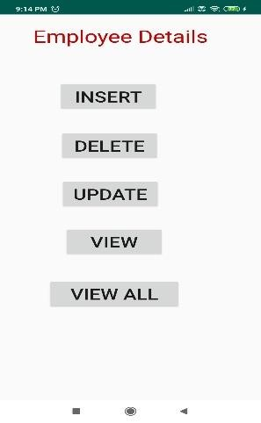 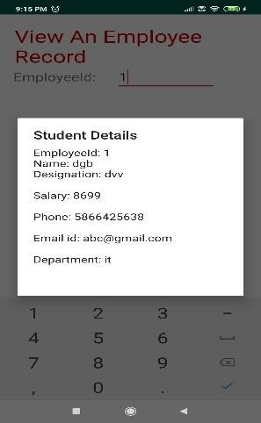

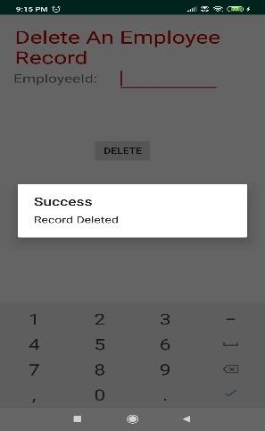 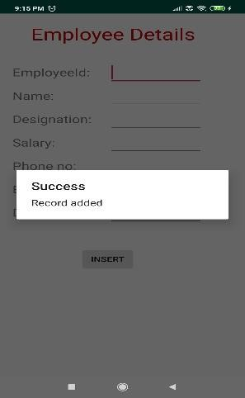

**Result:**

The Android application to implement the employee database using SQLite Database has been done successfully.

**Ex.No. 7**

**Multithreading**

**Date: 13-02-2020**

**Aim:**

To create an Android application that implements Multithreading.

**Description:**

In this application, an empty activity is created in which two ImageView is placed. The image is made visible through the start of the thread from a button click. Another button is provided to stop the thread and the image is set to invisible. This is done by interrupting the threads.

**Program:**

**XML Code:**

**activity_main.xml**

*<?*xml version="1.0" encoding="utf-8"*?>*<AbsoluteLayout xmlns:android="http://schemas.android.com/apk/res/android"  
 xmlns:app="http://schemas.android.com/apk/res-auto"  
 xmlns:tools="http://schemas.android.com/tools"  
 android:layout_width="match_parent"  
 android:layout_height="match_parent"  
 android:background="#E6CEEC"  
 android:orientation="vertical">  
  
 <ImageView  
 android:id="@+id/india1"  
 android:layout_width="151dp"  
 android:layout_height="192dp"  
 android:layout_gravity="center"  
 android:layout_margin="50dp"  
 android:layout_x="29dp"  
 android:layout_y="128dp" />  
  
 <Button  
 android:id="@+id/button"  
 android:layout_width="wrap_content"  
 android:layout_height="wrap_content"  
 android:layout_gravity="center"  
 android:layout_margin="10dp"  
 android:layout_x="51dp"  
 android:layout_y="439dp"  
 android:background="#F3C869"  
 android:text="Load Image "  
 android:textColor="#921714"  
 android:textSize="20sp"  
 android:textStyle="bold" />  
  
 <ImageView  
 android:id="@+id/india2"  
 android:layout_width="151dp"  
 android:layout_height="192dp"  
 android:layout_x="222dp"  
 android:layout_y="129dp"  
 app:srcCompat="@drawable/img" />  
  
 <Button  
 android:id="@+id/bt2"  
 android:layout_width="wrap_content"  
 android:layout_height="wrap_content"  
 android:layout_x="224dp"  
 android:layout_y="437dp"  
 android:background="#F3C869"  
 android:text="Stop thread"  
 android:textColor="#921714"  
 android:textSize="20sp"  
 android:textStyle="bold" />  
  
 <TextView  
 android:id="@+id/textView"  
 android:layout_width="wrap_content"  
 android:layout_height="49dp"  
 android:layout_x="113dp"  
 android:layout_y="41dp"  
 android:text="Multithreading"  
 android:textColor="#D81B60"  
 android:textSize="29sp"  
 android:textStyle="bold" />  
</AbsoluteLayout>

**Java Code**

**MainActivity.java**

package com.example.multithreading;  
import android.os.Bundle;  
import androidx.appcompat.app.AppCompatActivity;  
import android.view.View;  
import android.widget.Button;  
import android.widget.ImageView;  
import android.widget.TextView;  
import android.widget.Toast;  
public class MainActivity extends AppCompatActivity{  
 Thread t1,t2;  
 TextView tv,tv1;  
 ImageView img,img1;  
 Button bt1,bt2;  
 public void cool(final int ab){  
 runOnUiThread(new Runnable() {  
 @Override  
 public void run() {  
 try {  
 Thread.*sleep*(ab);  
 } catch (Exception e) {  
 }  
 }});}  
 protected void onCreate(Bundle savedInstanceState) {  
 super.onCreate(savedInstanceState);  
 setContentView(R.layout.*activity_main*);  
 bt1= (Button) findViewById(R.id.*button*);  
 bt2=(Button)findViewById(R.id.*bt2*);  
 img = (ImageView)findViewById(R.id.*india1*);  
 img1 = (ImageView)findViewById(R.id.*india2*);  
 bt1.setOnClickListener(new View.OnClickListener() {  
 @Override  
 public void onClick(View v) {  
 try {  
 img.setVisibility(View.*VISIBLE*);  
 img1.setVisibility(View.*VISIBLE*);  
 img.post(new Runnable() {  
 @Override  
 public void run() {  
 t1 = new Thread(this,"First");  
 cool(100);  
 img.setImageResource(R.drawable.*img1*);  
 }  
 });  
 img1.post(new Runnable() {  
 @Override  
 public void run() {  
 t2 = new Thread(this,"Second");  
 cool(200);  
 img1.setImageResource(R.drawable.*img2*);  
 }  
 });  
 Toast.*makeText*(MainActivity.this,"Threads Started", Toast.*LENGTH_LONG*).show();  
 t1.start();  
 t2.start();  
 }  
 catch (Exception e)  
 {  
 }  
 }  
 });  
 bt2.setOnClickListener(new View.OnClickListener() {  
 @Override  
 public void onClick(View v) {  
 t1.interrupt();  
 img.setVisibility(View.*INVISIBLE*);  
 t2.interrupt();  
 img1.setVisibility(View.*INVISIBLE*);  
 Toast.*makeText*(MainActivity.this,"Threads Stopped", Toast.*LENGTH_LONG*).show();  
 }  
 });}}

**Sample Input/Output:**

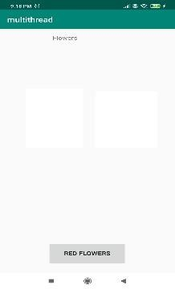 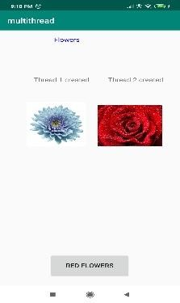

**Result:**

The Android application to implement Multithreading has been implemented successfully.

**Ex.No. 8**

**GPS Location**

**Date: 20-02-2020**

**Aim:**

To create an Android application that makes use of GPS location information.

**Description:**

In this application, an empty activity is created. The LocationServices class is imported and is used to get the longitude and latitude of the current location. The current and previous location information are used to calculate the distance travelled. The location permission is included in the manifest file. The current location button that is provided redirects to the Google Maps application, pointing to the current GPS location.

**Program:**

**XML Code:**

**activity_main.xml**

*<?*xml version="1.0" encoding="utf-8"*?>*<LinearLayout xmlns:android="http://schemas.android.com/apk/res/android"  
 xmlns:app="http://schemas.android.com/apk/res-auto"  
 xmlns:tools="http://schemas.android.com/tools"  
 android:layout_width="match_parent"  
 android:layout_height="match_parent"  
 tools:context=".MainActivity"  
 android:orientation="vertical">  
  
 <TextView  
 android:layout_width="wrap_content"  
 android:layout_height="wrap_content"  
 android:text="Movement Monitor "  
 android:textSize="30dp"  
 android:layout_marginLeft="20sp"  
 android:layout_gravity="center"  
 android:layout_marginTop="50dp"  
 android:textColor="#000000">

</TextView>  
  
 <LinearLayout  
 android:layout_width="wrap_content"  
 android:layout_height="wrap_content"  
 android:orientation="horizontal">  
  
 <TextView  
 android:layout_width="wrap_content"  
 android:layout_height="wrap_content"  
 android:text="Current Latitude : "  
 android:textSize="20dp"  
 android:layout_marginLeft="20sp"  
 android:layout_marginTop="50dp"></TextView>  
  
 <EditText  
 android:layout_width="200dp"  
 android:layout_height="50dp"  
 android:layout_marginTop="50dp"  
 android:id="@+id/lat1"/>  
  
 </LinearLayout>  
 <LinearLayout  
 android:layout_width="wrap_content"  
 android:layout_height="wrap_content"  
 android:orientation="horizontal">  
 <TextView  
 android:layout_width="wrap_content"  
 android:layout_height="wrap_content"  
 android:text="Previous Latitude : "  
 android:textSize="20dp"  
 android:layout_marginLeft="20sp"  
 android:layout_marginTop="50dp"></TextView>  
  
 <EditText  
 android:layout_width="200dp"  
 android:layout_height="50dp"  
 android:layout_marginTop="50dp"  
 android:id="@+id/lat2"/>  
 </LinearLayout>  
 <LinearLayout  
 android:layout_width="wrap_content"  
 android:layout_height="wrap_content"  
 android:orientation="horizontal">  
  
 <TextView  
 android:layout_width="wrap_content"  
 android:layout_height="wrap_content"  
 android:text="Current Longitude : "  
 android:textSize="20dp"  
 android:layout_marginLeft="20sp"  
 android:layout_marginTop="50dp"></TextView>  
  
 <EditText  
 android:layout_width="200dp"  
 android:layout_height="50dp"  
 android:layout_marginTop="50dp"  
 android:id="@+id/lon1"/>  
 </LinearLayout>  
  
 <LinearLayout  
 android:layout_width="wrap_content"  
 android:layout_height="wrap_content"  
 android:orientation="horizontal">  
 <TextView  
 android:layout_width="wrap_content"  
 android:layout_height="wrap_content"  
 android:text="Previous Longitude : "  
 android:textSize="20dp"  
 android:layout_marginLeft="20sp"  
 android:layout_marginTop="50dp"></TextView>  
 <EditText  
 android:layout_width="200dp"  
 android:layout_height="50dp"  
 android:layout_marginTop="50dp"  
 android:id="@+id/lon2"/>  
 </LinearLayout>  
  
 <LinearLayout  
 android:layout_width="wrap_content"  
 android:layout_height="wrap_content"  
 android:orientation="horizontal">   
 <TextView  
 android:layout_width="wrap_content"  
 android:layout_height="wrap_content"  
 android:text="Distance Travelled : "  
 android:textSize="20dp"  
 android:layout_marginLeft="20sp"  
 android:layout_marginTop="50dp"></TextView>  
 <EditText  
 android:layout_width="200dp"  
 android:layout_height="50dp"  
 android:layout_marginTop="50dp"  
 android:id="@+id/dist"/>  
 </LinearLayout>  
 <Button  
 android:id="@+id/monitor"  
 android:layout_width="wrap_content"  
 android:layout_height="wrap_content"  
 android:layout_gravity="center"  
 android:layout_marginTop="5dp"  
 android:text="Start Monitoring" />  
  
 <Button  
 android:id="@+id/loc"  
 android:layout_width="wrap_content"  
 android:layout_height="48dp"  
 android:layout_gravity="center"  
 android:layout_marginTop="5dp"  
 android:text="Search Current Location" />  
  
</LinearLayout>

**AndroidManifest.xml**

*<?*xml version="1.0" encoding="utf-8"*?>*<manifest xmlns:android="http://schemas.android.com/apk/res/android"  
 package="com.example.location">  
 <uses-permission android:name="android.permission.ACCESS_COARSE_LOCATION"/>  
 <uses-permission android:name="android.permission.ACCESS_FINE_LOCATION"/>  
 <uses-permission android:name="android.permission.INTERNET"/>  
 <application  
 android:allowBackup="true"  
 android:icon="@mipmap/ic_launcher"  
 android:label="@string/app_name"  
 android:roundIcon="@mipmap/ic_launcher_round"  
 android:supportsRtl="true"  
 android:theme="@style/AppTheme">  
 <activity android:name=".MainActivity">  
 <intent-filter>  
 <action android:name="android.intent.action.MAIN" />  
 <category android:name="android.intent.category.LAUNCHER" />  
 </intent-filter>  
 </activity>  
 </application>  
  
</manifest>

**build.gradle**

apply plugin: 'com.android.application'  
android {  
 compileSdkVersion 29  
 buildToolsVersion "29.0.2"  
 defaultConfig {  
 applicationId "com.example.location"  
 minSdkVersion 14  
 targetSdkVersion 29  
 versionCode 1  
 versionName "1.0"  
 testInstrumentationRunner "androidx.test.runner.AndroidJUnitRunner"  
 }  
 buildTypes {  
 release {  
 minifyEnabled false  
 proguardFiles getDefaultProguardFile('proguard-android-optimize.txt'), 'proguard-rules.pro'  
 }}}  
dependencies {  
 implementation fileTree(dir: 'libs', include: ['*.jar'])  
 implementation 'androidx.appcompat:appcompat:1.0.2'  
 implementation 'androidx.constraintlayout:constraintlayout:1.1.3'  
 testImplementation 'junit:junit:4.12'  
 androidTestImplementation 'androidx.test.ext:junit:1.1.0'  
 androidTestImplementation 'androidx.test.espresso:espresso-core:3.1.1'  
 implementation 'com.google.android.gms:play-services-location:17.0.0'  
}

**Java Code:**

**MainActivity.java**

package com.example.location;  
import android.content.Intent;  
import android.location.Location;  
import android.net.Uri;  
import android.os.Bundle;  
import android.view.View;  
import android.widget.Button;  
import android.widget.EditText;  
import android.widget.TextView;  
import android.widget.Toast;  
import androidx.appcompat.app.AppCompatActivity;  
import com.google.android.gms.location.FusedLocationProviderClient;  
import com.google.android.gms.location.LocationServices;  
import com.google.android.gms.tasks.OnSuccessListener;  
import java.sql.Time;  
import static java.lang.Thread.*sleep*;  
public class MainActivity extends AppCompatActivity {  
 String s1="0",s2="0";  
 int i=0;  
 private FusedLocationProviderClient client;  
 @Override  
 protected void onCreate(Bundle savedInstanceState) {  
 super.onCreate(savedInstanceState);  
 setContentView(R.layout.*activity_main*);  
 final Button monitor =findViewById(R.id.*monitor*);  
 Button loc = findViewById(R.id.*loc*);  
 client = LocationServices.*getFusedLocationProviderClient*(this);  
 monitor.setOnClickListener(new View.OnClickListener() {  
 @Override  
 public void onClick(View v) {  
 monitor.setText("Refresh");  
 client.getLastLocation().addOnSuccessListener(MainActivity.this, new OnSuccessListener<Location>() {  
 String prev_lati=s1,prev_longi=s2;  
 @Override  
 public void onSuccess(Location location) {  
 EditText t1,t2,t3,t4;  
 t1=findViewById(R.id.*lat1*);  
 t2=findViewById(R.id.*lat2*);  
 t3=findViewById(R.id.*lon1*);  
 t4=findViewById(R.id.*lon2*);  
 EditText disti =findViewById(R.id.*dist*);  
 if (location != null) {  
 String info = location.toString();  
 String lattitude = info.substring(15, 24);  
 String longitude = info.substring(25, 34);  
 Double lat1=Double.*parseDouble*(lattitude);  
 Double lat2=Double.*parseDouble*(prev_lati);  
 Double lon1=Double.*parseDouble*(longitude);  
 Double lon2=Double.*parseDouble*(prev_longi);  
 lon1 = Math.*toRadians*(lon1);  
 lon2 = Math.*toRadians*(lon2);  
 lat1 = Math.*toRadians*(lat1);  
 lat2 = Math.*toRadians*(lat2);  
 double dlon = lon2 - lon1;  
 double dlat = lat2 - lat1;  
 double a = Math.*pow*(Math.*sin*(dlat / 2), 2)  
 + Math.*cos*(lat1) * Math.*cos*(lat2)  
 * Math.*pow*(Math.*sin*(dlon / 2), 2);  
 double c = 2 * Math.*asin*(Math.*sqrt*(a));  
 double r = 6371;  
 double ans = c*r;  
 t1.setText(lattitude);  
 t3.setText(longitude);  
 if(i==0) {  
 t4.setText("Not Known");  
 disti.setText("Not Known");  
 t2.setText("Not Known");  
 }  
 else{  
 t4.setText(prev_longi);  
 disti.setText(Double.*toString*(ans));  
 t2.setText(prev_lati);  
 }  
 s1=lattitude;  
 s2=longitude;  
 i++;  
 }}});}});  
 loc.setOnClickListener(new View.OnClickListener() {  
 @Override  
 public void onClick(View v) {  
 client.getLastLocation().addOnSuccessListener(MainActivity.this, new OnSuccessListener<Location>() {  
 @Override  
 public void onSuccess(Location location) {  
 if (location != null) {  
 String info = location.toString();  
 String lattitude = info.substring(15, 24);  
 String longitude = info.substring(25, 34);  
 Uri gmmIntentUri = Uri.*parse*("geo:"+lattitude+","+longitude+"?z=21");  
 Intent mapIntent = new Intent(Intent.*ACTION_VIEW*, gmmIntentUri);  
 mapIntent.setPackage("com.google.android.apps.maps");  
 if (mapIntent.resolveActivity(getPackageManager()) != null) {  
 startActivity(mapIntent);

}}});}});}}}

**Sample Input/Output:**

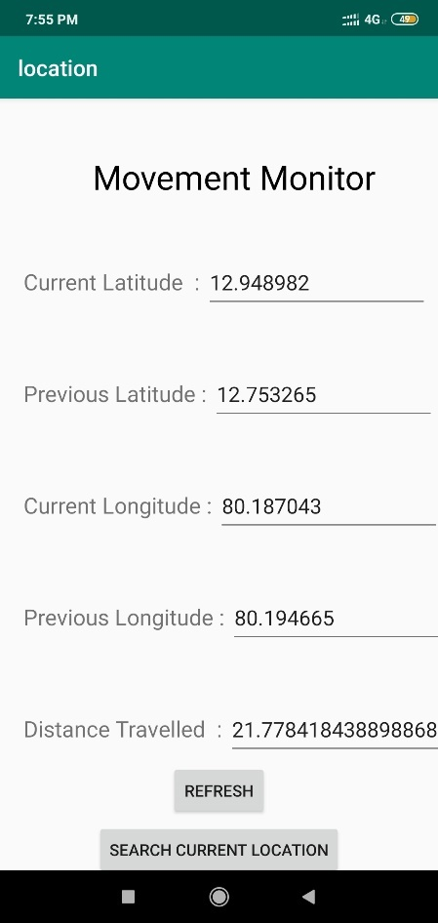 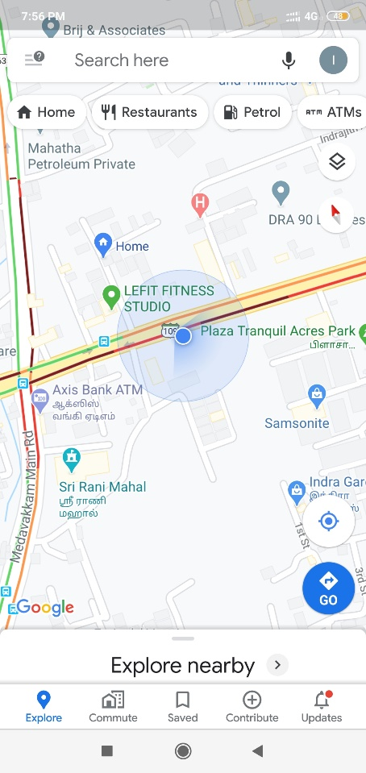

**Result:**

The Android application to track the GPS location data has been implemented successfully.

**Ex.No. 9**

**Notification Manager**

**Date: 22-02-2020**

**Aim:**

To create an Android application, that makes use of notification manager.

**Description:**

In this application, an activity is created, in which the text that is to be notified is taken as input. The NotificationManagerCompat class is used to send the simple notification of the text that was given as input. The notification is triggered through a button press.

**Program:**

**XML Code**

**activity_main.xml**

*<?*xml version="1.0" encoding="utf-8"*?>*<androidx.constraintlayout.widget.ConstraintLayout xmlns:android="http://schemas.android.com/apk/res/android"  
 xmlns:app="http://schemas.android.com/apk/res-auto"  
 xmlns:tools="http://schemas.android.com/tools"  
 android:layout_width="match_parent"  
 android:layout_height="match_parent"  
 android:layout_margin="10dp"  
 android:background="#CEC2E6"  
 android:orientation="vertical">  
  
 <TextView  
 android:id="@+id/textView"  
 android:layout_width="wrap_content"  
 android:layout_height="wrap_content"  
 android:layout_marginStart="122dp"  
 android:layout_marginLeft="122dp"  
 android:layout_marginEnd="146dp"  
 android:layout_marginRight="146dp"  
 android:text="Message"  
 android:textColor="#192A96"  
 android:textSize="30sp"  
 android:textStyle="bold"  
 app:layout_constraintBottom_toBottomOf="parent"  
 app:layout_constraintEnd_toEndOf="parent"  
 app:layout_constraintStart_toStartOf="parent"  
 app:layout_constraintTop_toTopOf="parent"  
 app:layout_constraintVertical_bias="0.053" />  
  
 <EditText  
 android:id="@+id/editText"  
 android:layout_width="match_parent"  
 android:layout_height="wrap_content"  
 android:singleLine="true"  
 android:textSize="30sp"  
 app:layout_constraintBottom_toBottomOf="parent"  
 app:layout_constraintEnd_toEndOf="parent"  
 app:layout_constraintHorizontal_bias="0.0"  
 app:layout_constraintStart_toStartOf="parent"  
 app:layout_constraintTop_toTopOf="parent"  
 app:layout_constraintVertical_bias="0.22" />  
  
 <Button  
 android:id="@+id/button"  
 android:layout_width="wrap_content"  
 android:layout_height="wrap_content"  
 android:layout_gravity="center"  
 android:layout_margin="30dp"  
 android:background="#FDD835"  
 android:text="Notify"  
 android:textColor="#DB5A32"  
 android:textSize="30sp"  
 android:textStyle="bold"  
 app:layout_constraintBottom_toBottomOf="parent"  
 app:layout_constraintEnd_toEndOf="parent"  
 app:layout_constraintStart_toStartOf="parent"  
 app:layout_constraintTop_toTopOf="parent"  
 app:layout_constraintVertical_bias="0.453" />  
  
</androidx.constraintlayout.widget.ConstraintLayout>

**Java Code**

**MainActivity.java**

package com.example.notification;  
import androidx.appcompat.app.AppCompatActivity;  
import androidx.core.app.NotificationCompat;  
import androidx.core.app.NotificationManagerCompat;  
import android.app.NotificationChannel;  
import android.app.NotificationManager;  
import android.os.Build;  
import android.os.Bundle;  
import android.view.View;  
import android.widget.Button;  
import android.widget.EditText;  
import android.widget.Toast;  
  
public class MainActivity extends AppCompatActivity {  
 private final String CHANNEL_ID ="personal_notification";  
 public String ab;  
 EditText et;  
 @Override  
 protected void onCreate(Bundle savedInstanceState) {  
 super.onCreate(savedInstanceState);  
 setContentView(R.layout.*activity_main*);  
 Button btn =(Button)findViewById(R.id.*button*);  
 et=(EditText)findViewById(R.id.*editText*);  
 btn.setOnClickListener(new View.OnClickListener() {  
 @Override  
 public void onClick(View v) {  
 ab=et.getText().toString();  
 notify1(ab);  
 }});}  
 public void notify1(String ab){  
 createNotificationChannel();  
 NotificationCompat.Builder notificationBuilder = (NotificationCompat.Builder) new NotificationCompat.Builder(this,CHANNEL_ID);  
 notificationBuilder.setSmallIcon(R.drawable.*ic_launcher_background*);  
 notificationBuilder.setContentTitle("Simple notification");  
 Toast.*makeText*(MainActivity.this,ab, Toast.*LENGTH_SHORT*).show();  
 notificationBuilder.setContentText(ab);  
 notificationBuilder.setPriority(NotificationCompat.*PRIORITY_DEFAULT*);  
 NotificationManagerCompat notificationmanagercompat=NotificationManagerCompat.*from*(this);  
 notificationmanagercompat.notify(000,notificationBuilder.build());  
 }  
 private void createNotificationChannel() {  
 if(Build.VERSION.*SDK_INT*>= Build.VERSION_CODES.*O*){  
 CharSequence name="Personal notification";  
 String description="Include all";  
 int importance= NotificationManager.*IMPORTANCE_DEFAULT*;  
 NotificationChannel notificationchannel=new NotificationChannel(CHANNEL_ID,name,importance);  
 notificationchannel.setDescription(description);  
 NotificationManager notificationManager=(NotificationManager) getSystemService(*NOTIFICATION_SERVICE*);  
 notificationManager.createNotificationChannel(notificationchannel);  
  
 }}}

**Sample Input/Output**

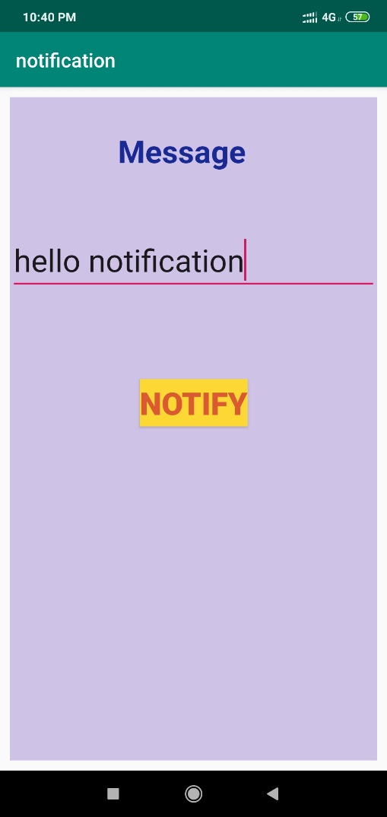 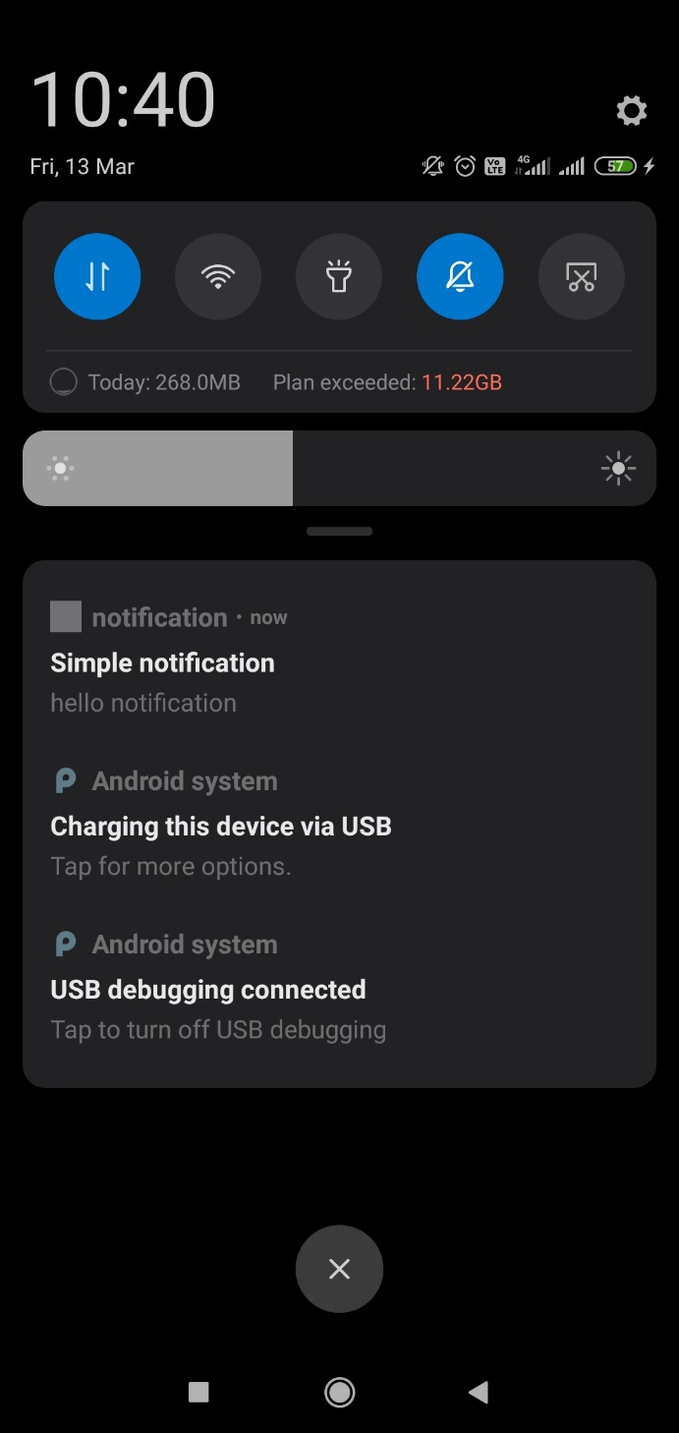

**Result:**

The Android application that makes use of Notification Manager to send notification has been executed successfully.

**Ex.No. 10**

**Message Alert**

**Date: 27-02-2020**

**Aim:**

To implement an Android application that creates an alert upon receiving a message (SMS).

**Description:**

In this application, a java class is created that makes use of BroadCastReceiver and SmsManager to get the sender number of the SMS along with the text that was sent. These details are given as a toast message alert when the SMS is received by the device. This application uses the SMS permission to SEND, RECEIVE and READ SMS.

**Program:**

**XML Code**

**activity_main.xml**

*<?*xml version="1.0" encoding="utf-8"*?>*<androidx.constraintlayout.widget.ConstraintLayout xmlns:android="http://schemas.android.com/apk/res/android"  
 xmlns:app="http://schemas.android.com/apk/res-auto"  
 xmlns:tools="http://schemas.android.com/tools"  
 android:layout_width="match_parent"  
 android:layout_height="match_parent"  
 tools:context=".MainActivity">  
 <TextView  
 android:layout_width="wrap_content"  
 android:layout_height="wrap_content"  
 android:text="Message"  
 app:layout_constraintBottom_toBottomOf="parent"  
 app:layout_constraintLeft_toLeftOf="parent"  
 app:layout_constraintRight_toRightOf="parent"  
 android:textSize="25dp"  
 app:layout_constraintTop_toTopOf="parent" />  
</androidx.constraintlayout.widget.ConstraintLayout>

**AndroidManifest.xml**

*<?*xml version="1.0" encoding="utf-8"*?>*<manifest xmlns:android="http://schemas.android.com/apk/res/android"  
 package="com.example.message">  
 android:versionCode="1"  
 android:versionName="1.0"  
 <application  
 android:allowBackup="true"  
 android:icon="@mipmap/ic_launcher"  
 android:label="@string/app_name"  
 android:roundIcon="@mipmap/ic_launcher_round"  
 android:supportsRtl="true"  
 android:theme="@style/AppTheme">  
 <activity android:name=".MainActivity"  
 android:label="@string/app_name">  
 <intent-filter>  
 <action android:name="android.intent.action.MAIN" />  
 <category android:name="android.intent.category.LAUNCHER" />  
 </intent-filter>  
 </activity>  
 <receiver android:name="com.example.message.IncomingSms">  
 <intent-filter><action android:name="android.provider.Telephony.SMS_RECEIVED"/>  
 </intent-filter>  
 </receiver>  
 </application>  
 <uses-sdk  
 android:minSdkVersion="8"  
 android:targetSdkVersion="17"/>  
 <uses-permission android:name="android.permission.RECEIVE_SMS"></uses-permission>  
 <uses-permission android:name="android.permission.READ_SMS"></uses-permission>  
 <uses-permission android:name="android.permission.SEND_SMS"></uses-permission>  
</manifest>

**Java Code**

**IncomingSms.java**

package com.example.message;  
import android.content.BroadcastReceiver;  
import android.content.*;  
import android.os.Bundle;  
import android.telephony.SmsManager;  
import android.telephony.SmsMessage;  
import android.util.Log;  
import android.widget.Toast;  
public class IncomingSms extends BroadcastReceiver{  
 *// Get the object of SmsManager* final SmsManager sms = SmsManager.*getDefault*();  
 public void onReceive(Context context, Intent intent) {  
*// Retrieves a map of extended data from the intent.* final Bundle bundle = intent.getExtras();  
 try {  
 if (bundle != null) {  
 final Object[] pdusObj = (Object[]) bundle.get("pdus");  
 for (int i = 0; i < pdusObj.length; i++) {  
 SmsMessage currentMessage = SmsMessage.*createFromPdu*((byte[]) pdusObj[i]);  
 String phoneNumber = currentMessage.getDisplayOriginatingAddress();  
 String senderNum = phoneNumber;  
 String message = currentMessage.getDisplayMessageBody();  
 Log.*i*("SmsReceiver", "senderNum: "+ senderNum + "; message: " + message);  
 int duration = Toast.*LENGTH_LONG*;  
 Toast toast = Toast.*makeText*(context, "senderNum: "+ senderNum + ", message: " + message, duration);  
 toast.show();  
 } } *// bundle is null* } catch (Exception e){  
 Log.*e*("SmsReceiver", "Exception smsReceiver" +e);  
 }}}

**Sample Input/Output**

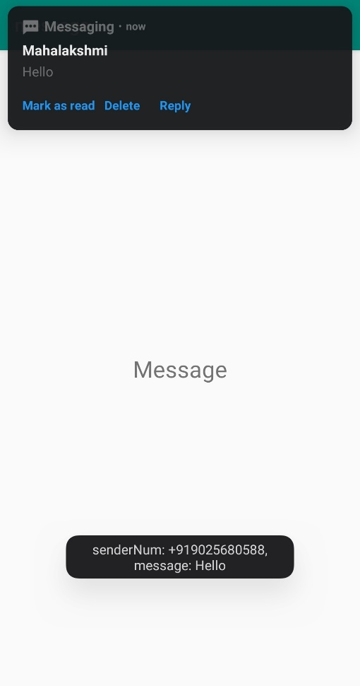

**Result:**

The Android application to alert when a message is received is executed successfully.

**Ex.No. 11**

**SD Card**

**Date: 05-03-2020**

**Aim:**

To create an Android application that writes data into SD Card.

**Description:**

In this application, an activity is created, that takes the file name and data to be written to SD Card as input. The save button, writes data to the file in SD Card. The data in any particular file can be read using the read button. This application uses the external storage permission. The data is appended to the already existing data in the file.

**Program:**

**XML Code**

**activity_main.xml**

*<?*xml version="1.0" encoding="utf-8"*?>*<RelativeLayout xmlns:android="http://schemas.android.com/apk/res/android"  
 xmlns:app="http://schemas.android.com/apk/res-auto"  
 xmlns:tools="http://schemas.android.com/tools"  
 android:layout_width="match_parent"  
 android:layout_height="match_parent"  
 tools:context=".MainActivity">  
 <EditText  
 android:id="@+id/editText1"  
 android:layout_width="wrap_content"  
 android:layout_height="wrap_content"  
 android:layout_alignParentRight="true"  
 android:layout_alignParentTop="true"  
 android:layout_marginRight="20dp"  
 android:layout_marginTop="24dp"  
 android:ems="10" >  
 <requestFocus />  
 </EditText>  
 <EditText  
 android:id="@+id/editText2"  
 android:layout_width="wrap_content"  
 android:layout_height="wrap_content"  
 android:layout_alignRight="@+id/editText1"  
 android:layout_below="@+id/editText1"  
 android:layout_marginTop="24dp"  
 android:ems="10" />  
 <TextView  
 android:id="@+id/textView1"  
 android:layout_width="wrap_content"  
 android:layout_height="wrap_content"  
 android:layout_alignBaseline="@+id/editText1"  
 android:layout_alignBottom="@+id/editText1"  
 android:layout_alignParentLeft="true"  
 android:text="File Name:" />  
 <TextView  
 android:id="@+id/textView2"  
 android:layout_width="wrap_content"  
 android:layout_height="wrap_content"  
 android:layout_alignBaseline="@+id/editText2"  
 android:layout_alignBottom="@+id/editText2"  
 android:layout_alignParentLeft="true"  
 android:text="Data:" />  
 <Button  
 android:id="@+id/button1"  
 android:layout_width="wrap_content"  
 android:layout_height="wrap_content"  
 android:layout_alignLeft="@+id/editText2"  
 android:layout_below="@+id/editText2"  
 android:layout_marginLeft="70dp"  
 android:layout_marginTop="16dp"  
 android:text="save" />  
 <Button  
 android:id="@+id/button2"  
 android:layout_width="wrap_content"  
 android:layout_height="wrap_content"  
 android:layout_alignBaseline="@+id/button1"  
 android:layout_alignBottom="@+id/button1"  
 android:layout_toRightOf="@+id/button1"  
 android:text="read" />  
</RelativeLayout>

**AndroidManifest.xml**

*<?*xml version="1.0" encoding="utf-8"*?>*<manifest xmlns:android="http://schemas.android.com/apk/res/android"  
 package="com.example.sdcard">  
 <uses-permission android:name="android.permission.WRITE_EXTERNAL_STORAGE"/>  
 <application  
 android:allowBackup="true"  
 android:icon="@mipmap/ic_launcher"  
 android:label="@string/app_name"  
 android:roundIcon="@mipmap/ic_launcher_round"  
 android:supportsRtl="true"  
 android:theme="@style/AppTheme">  
 <activity android:name=".MainActivity">  
 <intent-filter>  
 <action android:name="android.intent.action.MAIN" />  
 <category android:name="android.intent.category.LAUNCHER" />  
 </intent-filter>  
 </activity>  
 </application>  
</manifest>

**Java Code**

**MainActivity.java**

package com.example.sdcard;  
  
import android.os.Bundle;  
import android.view.View;  
import android.widget.Button;  
import android.widget.EditText;  
import android.widget.Toast;  
import androidx.appcompat.app.AppCompatActivity;  
import java.io.BufferedReader;  
import java.io.File;  
import java.io.FileInputStream;  
import java.io.FileNotFoundException;  
import java.io.FileOutputStream;  
import java.io.IOException;  
import java.io.InputStreamReader;  
import java.io.OutputStreamWriter;  
public class MainActivity extends AppCompatActivity {  
 EditText editTextFileName,editTextData;  
 Button saveButton,readButton;  
 @Override  
 protected void onCreate(Bundle savedInstanceState) {  
 super.onCreate(savedInstanceState);  
 setContentView(R.layout.*activity_main*);  
 editTextFileName=findViewById(R.id.*editText1*);  
 editTextData=findViewById(R.id.*editText2*);  
 saveButton=findViewById(R.id.*button1*);  
 readButton=findViewById(R.id.*button2*);  
 *//Performing action on save button* saveButton.setOnClickListener(new View.OnClickListener(){  
 @Override  
 public void onClick(View arg0) {  
 String filename=editTextFileName.getText().toString();  
 String data=editTextData.getText().toString();  
 FileOutputStream fos;  
 try {  
 File myFile = new File("/sdcard/"+filename);  
 myFile.createNewFile();  
 FileOutputStream fOut = new FileOutputStream(myFile,true);  
 OutputStreamWriter myOutWriter = new OutputStreamWriter(fOut);  
 myOutWriter.append(data +"\n");  
 myOutWriter.close();  
 fOut.close();  
 Toast.*makeText*(getApplicationContext(),filename + " saved",Toast.*LENGTH_LONG*).show();  
 } catch (FileNotFoundException e) {e.printStackTrace();}  
 catch (IOException e) {e.printStackTrace();}  
 }});readButton.setOnClickListener(new View.OnClickListener(){  
 @Override  
 public void onClick(View arg0) {  
 String filename=editTextFileName.getText().toString();  
 StringBuffer stringBuffer = new StringBuffer();  
 String aDataRow = "";  
 String aBuffer = "";  
 try {  
 File myFile = new File("/sdcard/"+filename);  
 FileInputStream fIn = new FileInputStream(myFile);  
 BufferedReader myReader = new BufferedReader(new InputStreamReader(fIn));  
 while ((aDataRow = myReader.readLine()) != null) {  
 aBuffer += aDataRow + "\n";  
 }  
 myReader.close();  
 } catch (IOException e) {  
 e.printStackTrace();  
 }  
 Toast.*makeText*(getApplicationContext(),aBuffer+" ",Toast.*LENGTH_LONG*).show();  
 }});}}

**Sample Input/Output:**

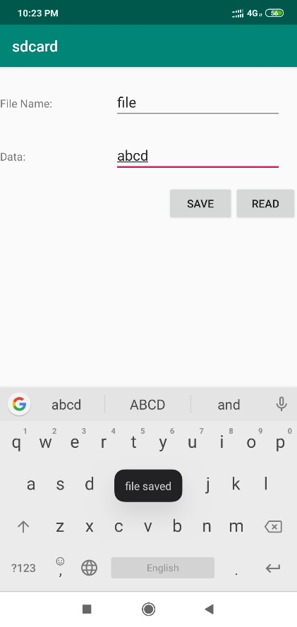 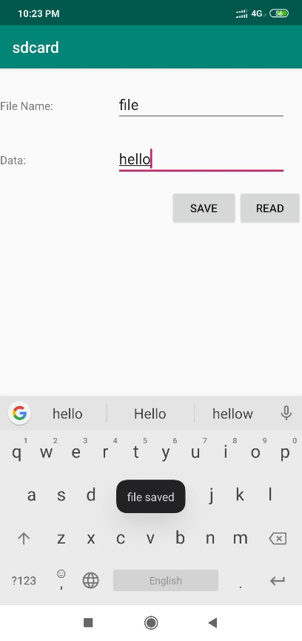 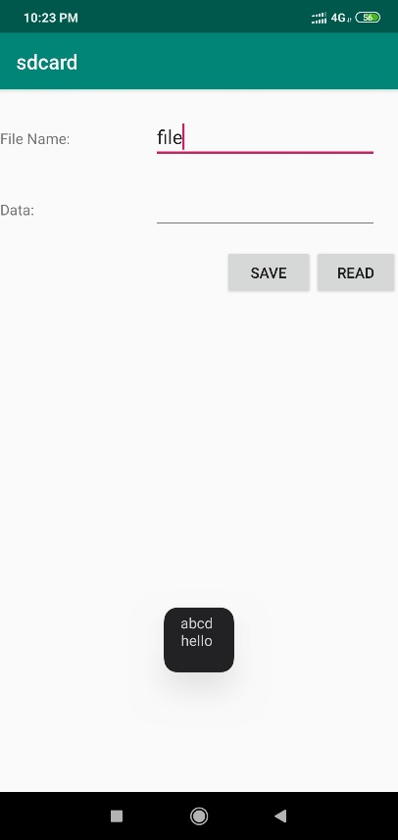

**Result:**

The Android application to write data to SD Card has been implemented successfully.

**Ex.No. 12**

**RSS Feed**

**Date: 12-03-2020**

**Aim:**

To develop an Android application for RSS Feed using Android Studio.

**Description:**

RSS stands for Really Simple Syndication. It is a document that is created by the website with .xml extension. In this application, an activity is created, where the java file makes use of XMLPullParser that parses through the RSS XML file. It is an easy way to share website updates and content so that the users need not have to visit the site daily.

**Program:**

**XML Code**

**activity_main.xml**

*<?*xml version="1.0" encoding="utf-8"*?>*<LinearLayout xmlns:android="http://schemas.android.com/apk/res/android"  
 android:layout_width="fill_parent"  
 android:layout_height="fill_parent"  
 android:orientation="vertical" >  
  
 <ListView  
 android:id="@+id/listView"  
 android:layout_width="match_parent"  
 android:layout_height="wrap_content" />  
  
</LinearLayout>

**AndroidManifest.xml**

*<?*xml version="1.0" encoding="utf-8"*?>*<manifest xmlns:android="http://schemas.android.com/apk/res/android"  
 package="com.example.rssfeed" >  
 <uses-permission android:name="android.permission.INTERNET"/>  
 <application  
 android:allowBackup="true"  
 android:icon="@mipmap/ic_launcher"  
 android:label="@string/app_name"  
 android:supportsRtl="true"  
 android:theme="@style/AppTheme" >  
 <activity android:name=".MainActivity" >  
 <intent-filter>  
 <action android:name="android.intent.action.MAIN" />  
 <category android:name="android.intent.category.LAUNCHER" />  
 </intent-filter>  
 </activity>  
 </application>  
</manifest>

**Java Code**

package com.example.rssfeed;  
import android.app.ListActivity;  
import android.content.Intent;  
import android.net.Uri;  
import android.os.AsyncTask;  
import android.os.Bundle;  
import android.view.View;  
import android.widget.ArrayAdapter;  
import android.widget.ListView;  
import org.xmlpull.v1.XmlPullParser;  
import org.xmlpull.v1.XmlPullParserException;  
import org.xmlpull.v1.XmlPullParserFactory;  
import java.io.IOException;  
import java.io.InputStream;  
import java.net.MalformedURLException;  
import java.net.URL;  
import java.util.ArrayList;  
import java.util.List;  
  
public class MainActivity extends ListActivity  
{  
 List headlines;  
 List links;  
 @Override  
 protected void onCreate(Bundle savedInstanceState)  
 {  
 super.onCreate(savedInstanceState);  
 new MyAsyncTask().execute();  
 }  
  
 class MyAsyncTask extends AsyncTask<Object,Void,ArrayAdapter>{  
 @Override  
 protected ArrayAdapter doInBackground(Object[] params)  
 {  
 headlines = new ArrayList();  
 links = new ArrayList();  
 try {  
 URL url = new URL("https://www.thehindu.com/news/feeder/default.rss");  
 XmlPullParserFactory factory = XmlPullParserFactory.*newInstance*();  
 factory.setNamespaceAware(false);  
 XmlPullParser xpp = factory.newPullParser();  
  
 *// We will get the XML from an input stream* xpp.setInput(getInputStream(url), "UTF_8");  
 boolean insideItem = false;  
  
 *// Returns the type of current event: START_TAG, END_TAG, etc..* int eventType = xpp.getEventType();  
 while (eventType != XmlPullParser.*END_DOCUMENT*){  
 if (eventType == XmlPullParser.*START_TAG*)  
 {  
 if (xpp.getName().equalsIgnoreCase("item")){  
 insideItem = true;  
 }  
 else if (xpp.getName().equalsIgnoreCase("title"))  
 {  
 if (insideItem)  
 headlines.add(xpp.nextText()); *//extract the headline* }  
 else if (xpp.getName().equalsIgnoreCase("link"))  
 {  
 if (insideItem)  
 links.add(xpp.nextText()); *//extract the link of article* }  
 }  
 else if(eventType==XmlPullParser.*END_TAG* && xpp.getName().equalsIgnoreCase("item"))  
 {  
 insideItem=false;  
 }  
 eventType = xpp.next(); *//move to next element* }  
  
 } catch (MalformedURLException e)  
 {  
 e.printStackTrace();  
 }catch (XmlPullParserException e){  
 e.printStackTrace();  
 }catch (IOException e){  
 e.printStackTrace();  
 }  
 return null;  
 }  
 protected void onPostExecute(ArrayAdapter adapter) {  
 adapter = new ArrayAdapter(MainActivity.this, android.R.layout.*simple_list_item_1*, headlines);  
 setListAdapter(adapter);  
 }  
 }  
 @Override  
 protected void onListItemClick(ListView l, View v, int position, long id){  
 Uri uri = Uri.*parse*((links.get(position)).toString());  
 Intent intent = new Intent(Intent.*ACTION_VIEW*, uri);  
 startActivity(intent);  
 }  
 public InputStream getInputStream(URL url){  
 try{  
 return url.openConnection().getInputStream();  
 }  
 catch (IOException e){  
 return null;  
 }  
 }  
}

**Sample Input/Output**

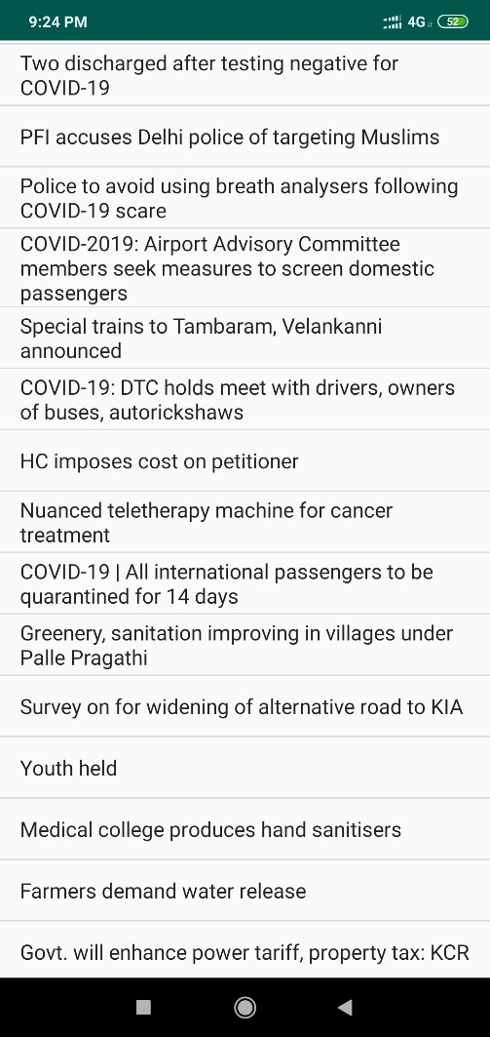 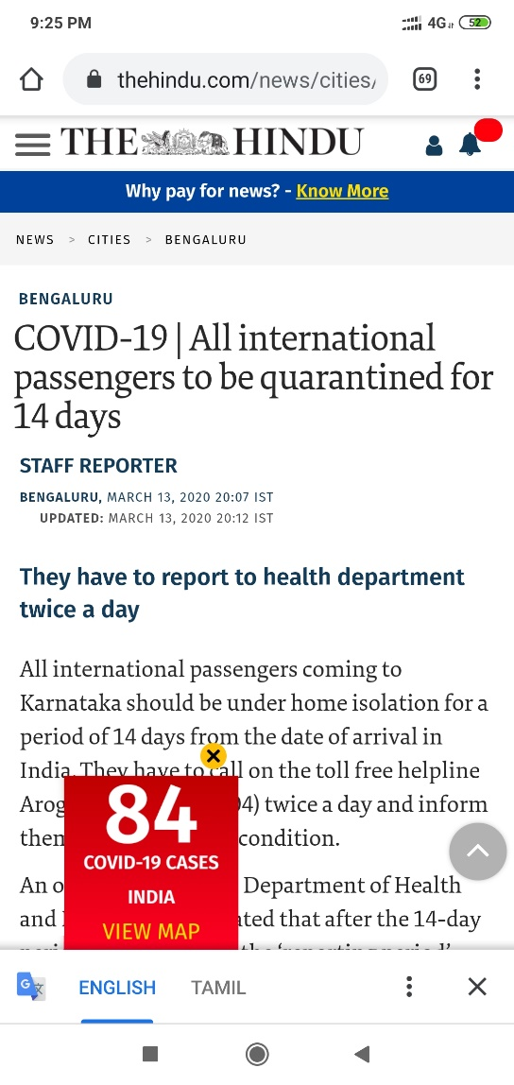

**Result:**

The Android application to implement RSS Feed has been executed successfully.

**Ex.No. 13**

**E-Mail Application**

**Date: 19-03-2020**

**Aim:**

To implement an Android application that is used to send E-Mail.

**Description:**

In this application, an empty activity is created. The Recipient Mail ID, Subject and Message Body are read as input from the user. Upon the button click of send message, the PUT property is used that makes use of smtp protocol. The password of the sender is authenticated and the mail delivered to the recipient. This application makes use of INTERNET permission.

**Program:**

**XML Code**

*<?*xml version="1.0" encoding="utf-8"*?>*<LinearLayout xmlns:android="http://schemas.android.com/apk/res/android"  
 xmlns:tools="http://schemas.android.com/tools"  
 android:layout_width="match_parent"  
 android:layout_height="match_parent"  
 android:paddingBottom="@dimen/activity_vertical_margin"  
 android:paddingLeft="@dimen/activity_horizontal_margin"  
 android:paddingRight="@dimen/activity_horizontal_margin"  
 android:paddingTop="@dimen/activity_vertical_margin"  
 android:orientation="vertical"  
 tools:context=".MainActivity">  
  
 <TextView  
 android:layout_width="385dp"  
 android:layout_height="70dp"  
 android:text="E Mail Application"  
 android:textAlignment="center"  
 android:textSize="25sp"  
 android:textStyle="bold" />  
  
 <TextView  
 android:layout_width="366dp"  
 android:layout_height="47dp"  
 android:text="Recipient Email"  
 android:textSize="20sp" />  
 <EditText  
 android:layout_width="match_parent"  
 android:layout_height="wrap_content"  
 android:id="@+id/editTextEmail" />  
  
 <TextView  
 android:layout_width="366dp"  
 android:layout_height="44dp"  
 android:text="Subject"  
 android:textSize="20sp" />  
 <EditText  
 android:layout_width="match_parent"  
 android:layout_height="wrap_content"  
 android:id="@+id/editTextSubject" />  
  
 <TextView  
 android:layout_width="347dp"  
 android:layout_height="60dp"  
 android:text="Message"  
 android:textSize="20sp" />  
  
 <EditText  
 android:id="@+id/editTextMessage"  
 android:layout_width="match_parent"  
 android:layout_height="83dp"  
 android:lines="4" />  
  
 <Button  
 android:id="@+id/buttonSend"  
 android:layout_width="298dp"  
 android:layout_height="66dp"  
 android:text="Send" />  
</LinearLayout>

**AndroidManifest.xml**

*<?*xml version="1.0" encoding="utf-8"*?>*<manifest xmlns:android="http://schemas.android.com/apk/res/android"  
 package="com.example.mail">  
 <uses-permission android:name="android.permission.INTERNET"/>  
 <application  
 android:allowBackup="true"  
 android:icon="@mipmap/ic_launcher"  
 android:label="@string/app_name"  
 android:supportsRtl="true"  
 android:theme="@style/AppTheme">  
 <activity android:name=".MainActivity">  
 <intent-filter>  
 <action android:name="android.intent.action.MAIN" />  
 <category android:name="android.intent.category.LAUNCHER" />  
 </intent-filter>  
 </activity>  
 </application>  
</manifest>

**Java Code**

**MainActivity.java**

package com.example.mail;  
  
import android.os.Bundle;  
import android.view.View;  
import android.widget.Button;  
import android.widget.EditText;  
  
import androidx.appcompat.app.AppCompatActivity;  
  
public class MainActivity extends AppCompatActivity implements View.OnClickListener {  
  
 *//Declaring EditText* private EditText editTextEmail;  
 private EditText editTextSubject;  
 private EditText editTextMessage;  
  
 *//Send button* private Button buttonSend;  
  
 @Override  
 protected void onCreate(Bundle savedInstanceState) {  
 super.onCreate(savedInstanceState);  
 setContentView(R.layout.*activity_main*);  
  
 *//Initializing the views* editTextEmail = (EditText) findViewById(R.id.*editTextEmail*);  
 editTextSubject = (EditText) findViewById(R.id.*editTextSubject*);  
 editTextMessage = (EditText) findViewById(R.id.*editTextMessage*);  
  
 buttonSend = (Button) findViewById(R.id.*buttonSend*);  
  
 *//Adding click listener* buttonSend.setOnClickListener(this);  
 }  
  
  
 private void sendEmail() {  
 *//Getting content for email* String email = editTextEmail.getText().toString().trim();  
 String subject = editTextSubject.getText().toString().trim();  
 String message = editTextMessage.getText().toString().trim();  
  
 *//Creating SendMail object* SendMail sm = new SendMail(this, email, subject, message);  
  
 *//Executing sendmail to send email* sm.execute();  
 }  
  
 @Override  
 public void onClick(View v) {  
 sendEmail();  
 }  
}

**SendMail.java**

package com.example.mail;  
import javax.mail.Session;  
import android.app.ProgressDialog;  
import android.content.Context;  
import android.os.AsyncTask;  
import android.widget.Toast;  
import java.util.Properties;  
import javax.mail.Message;  
import javax.mail.MessagingException;  
import javax.mail.PasswordAuthentication;  
import javax.mail.Transport;  
import javax.mail.internet.InternetAddress;  
import javax.mail.internet.MimeMessage;  
*//Class is extending AsyncTask because this class is going to perform a networking operation*public class SendMail extends AsyncTask<Void,Void,Void> {  
 *//Declaring Variables* private Context context;  
 private Session session;  
 *//Information to send email* private String email;  
 private String subject;  
 private String message;  
 *//Progressdialog to show while sending email* private ProgressDialog progressDialog;  
 *//Class Constructor* public SendMail(Context context, String email, String subject, String message){  
 *//Initializing variables* this.context = context;  
 this.email = email;  
 this.subject = subject;  
 this.message = message;  
 }  
 @Override  
 protected void onPreExecute() {  
 super.onPreExecute();  
 *//Showing progress dialog while sending email* progressDialog = ProgressDialog.*show*(context,"Sending message","Please wait...",false,false);  
 }  
 @Override  
 protected void onPostExecute(Void aVoid) {  
 super.onPostExecute(aVoid);  
 *//Dismissing the progress dialog* progressDialog.dismiss();  
 *//Showing a success message* Toast.*makeText*(context,"Message Sent",Toast.*LENGTH_LONG*).show();  
 }  
 @Override  
 protected Void doInBackground(Void... params) {  
 *//Creating properties* Properties props = new Properties();  
 *//Configuring properties for gmail  
 //If you are not using gmail you may need to change the values* props.put("mail.smtp.host", "smtp.gmail.com");  
 props.put("mail.smtp.socketFactory.port", "465");  
 props.put("mail.smtp.socketFactory.class", "javax.net.ssl.SSLSocketFactory");  
 props.put("mail.smtp.auth", "true");  
 props.put("mail.smtp.port", "465");  
 *//Creating a new session* session = Session.*getDefaultInstance*(props,  
 new javax.mail.Authenticator() {  
 *//Authenticating the password* protected PasswordAuthentication getPasswordAuthentication() {  
 return new PasswordAuthentication(Config.*EMAIL*, Config.*PASSWORD*);  
 }  
 });  
 try {  
 *//Creating MimeMessage object* MimeMessage mm = new MimeMessage(session);  
 *//Setting sender address* mm.setFrom(new InternetAddress(Config.*EMAIL*));  
 *//Adding receiver* mm.addRecipient(Message.RecipientType.*TO*, new InternetAddress(email));  
 *//Adding subject* mm.setSubject(subject);  
 *//Adding message* mm.setText(message);  
 *//Sending email* Transport.*send*(mm);  
 } catch (MessagingException e) {  
 e.printStackTrace();  
 }  
 return null;  
 }}

**Config.java**

package com.example.mail;  
public class Config {  
 public static final String *EMAIL* ="ishwarya2805@gmail.com"; *//your-gmail-username* public static final String *PASSWORD* =""; *//your-gmail-password*}

**Sample Input/Output**

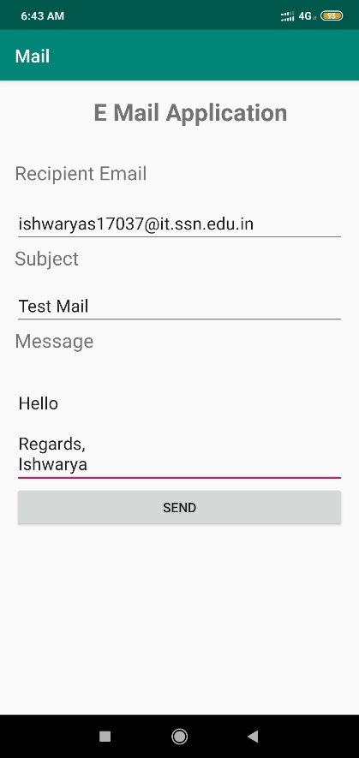 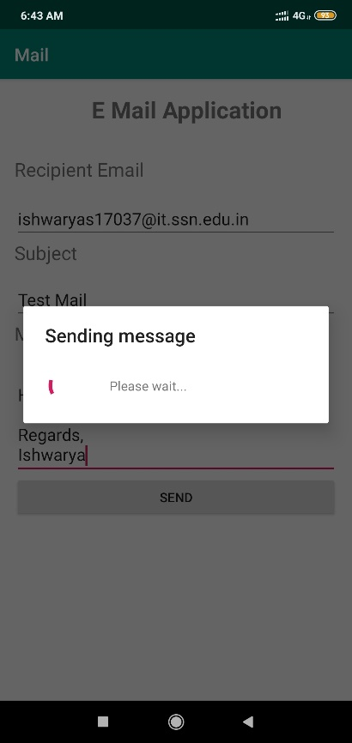

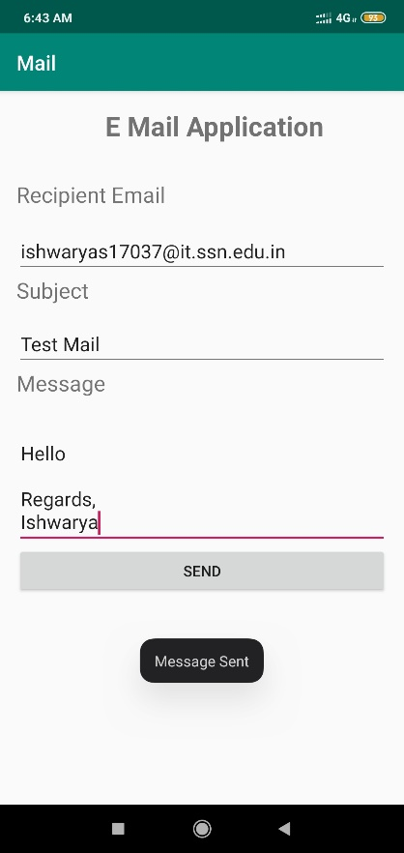 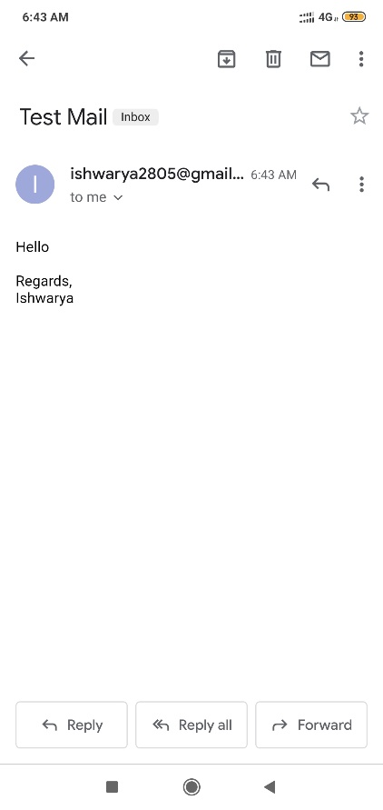

**Result:**

The Android application to send E-Mail has been implemented successfully.