Fallow the below steps:

1. Create a S3 bucket.
2. Create an IAM User , Access Key  and assign a Managed Policy to Read/Write to the specific folder.
3. Install S3 Plugin on Jenkins
4. Configure the S3 profile
5. Configure a Post-Build Step to upload output to S3 bucket.

Create S3 Backet:

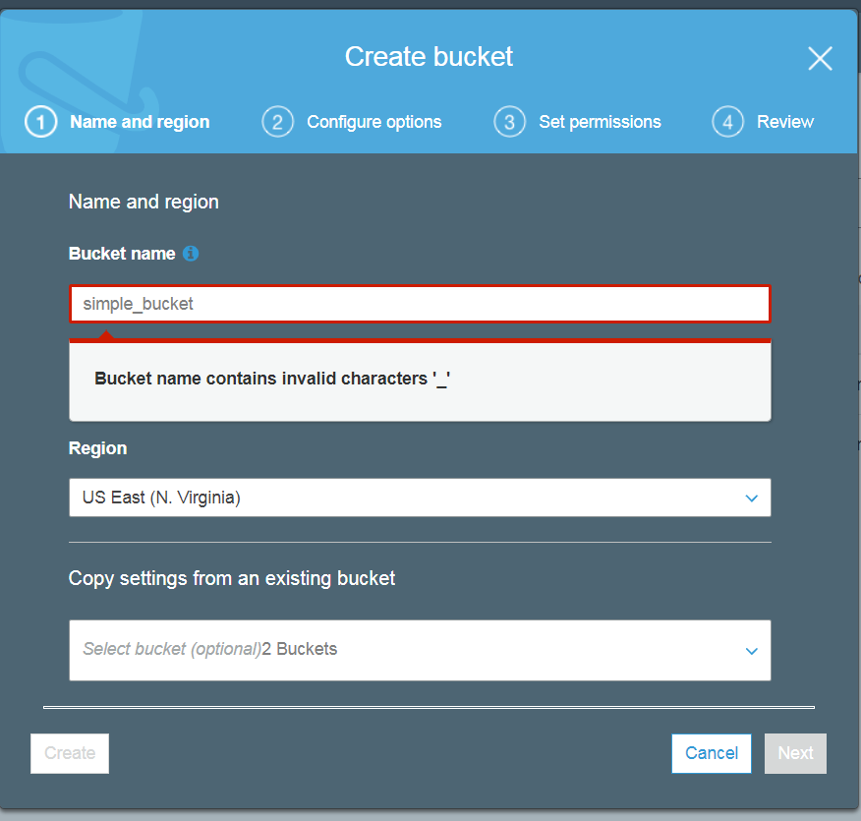

My bucket name :: cap123

Login to IAM user console:

Users🡪 add user

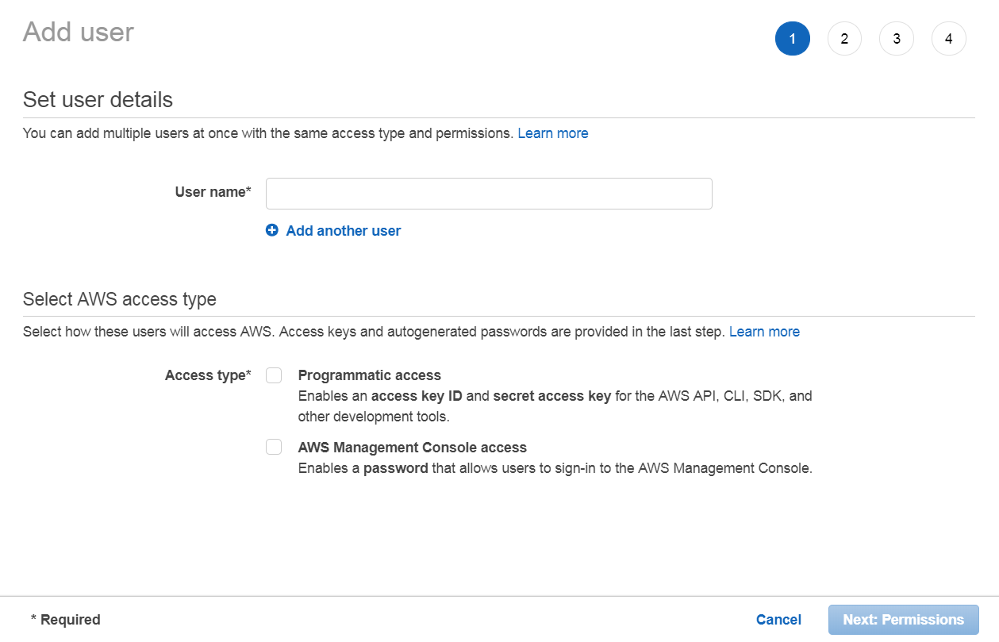

Set the permissions:

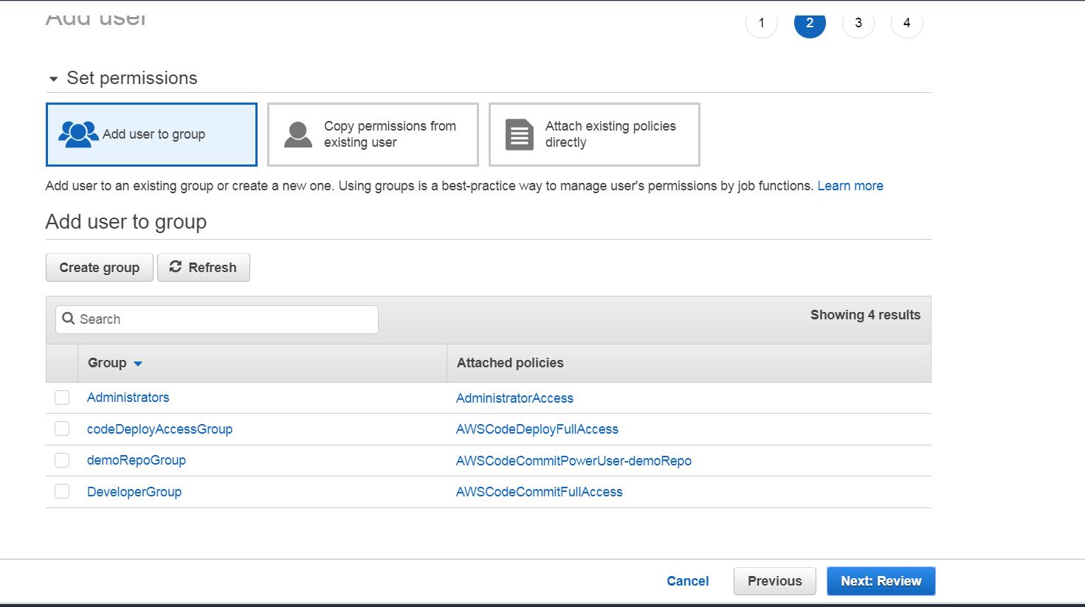

Review and carte the user:

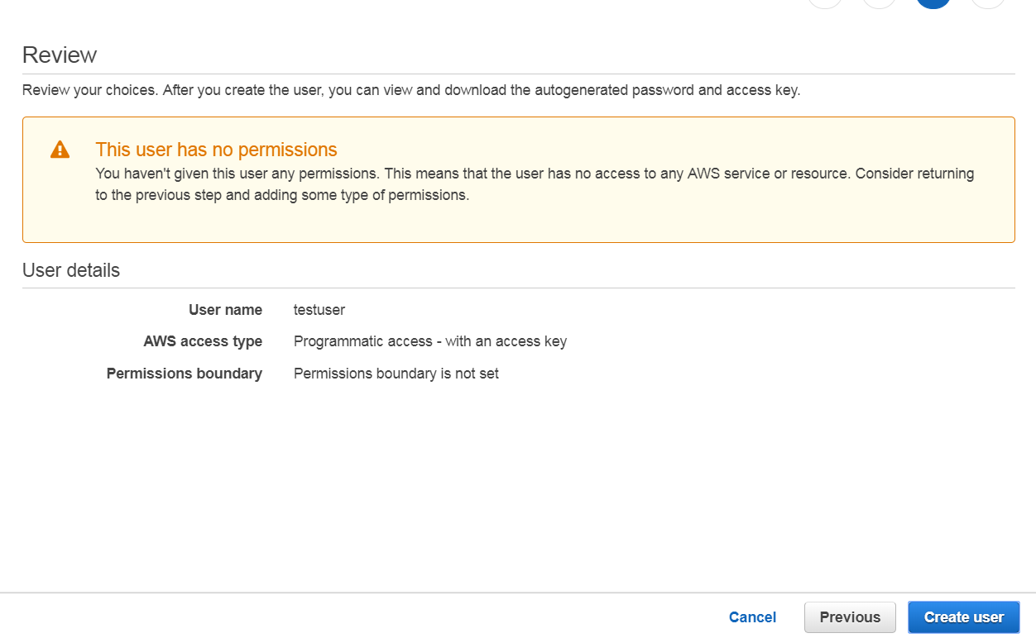

Note :

Please copy the access and secrate key: if u wont copy the secrate key now it wont get later

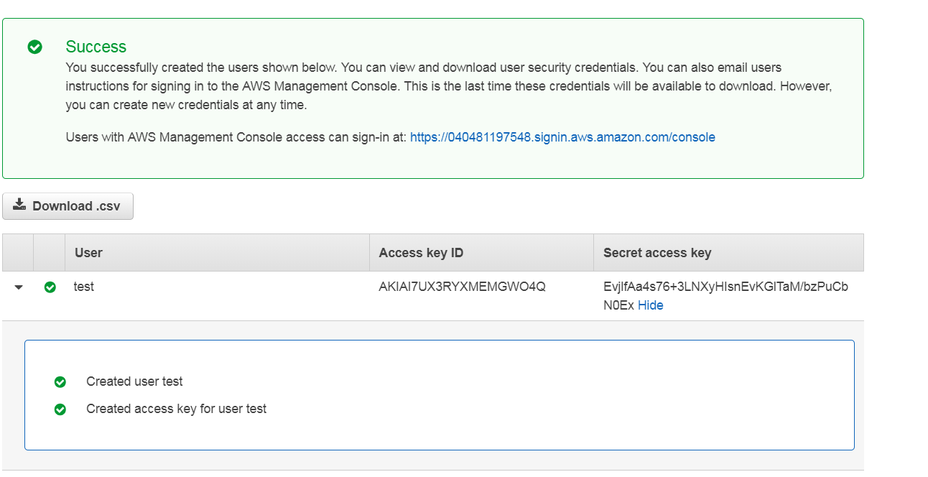

Jenkins plugins:

