TESTING ASSIGNMENT
IDBI Bank – Online Account / Callback Application Form
Test Scenarios | Test Cases | Defect Reports

Application under test: apps.idbibank.in/apply-now-inc.asp
Date: 02-07-2026

Requirement Overview
The IDBI Bank application under test allows a visitor to request a callback / apply for a product online by submitting personal and contact details. The form captures customer status, title, name, age, mobile/phone number, email ID, preferred contact time, nearest branch (state/city/branch), product required, and a CAPTCHA verification code, and requires NDNC authorization consent before submission.
This document contains the three deliverables required for the assignment:
- Deliverable 1 – Test Scenarios covering the application's fields and behaviour.
- Deliverable 2 – Detailed Test Cases written using standard testing techniques (Equivalence Partitioning, Boundary Value Analysis, and Error Guessing).
- Deliverable 3 – Defect Reports, including the defects specified in the assignment requirement as well as additional defects actually identified while testing the live application, supported by screenshot evidence.

Deliverable 1: Test Scenarios
Scenario ID | Test Scenario
TS_01 | Verify Title dropdown displays valid options and is mandatory
TS_02 | Verify First Name field accepts only alphabetic characters
TS_03 | Verify Last Name field accepts only alphabetic characters
TS_04 | Verify Name field(s) reject numeric and special characters
TS_05 | Verify Age dropdown displays correct age-range values and is mandatory
TS_06 | Verify Mobile Number field accepts only 10-digit numeric values
TS_07 | Verify Mobile Number field rejects alphabetic and special characters (e.g. comma, dot)
TS_08 | Verify Mobile Number field rejects values with less/more than 10 digits
TS_09 | Verify optional STD/Phone Number field behaviour when left blank
TS_10 | Verify Email ID field accepts a valid email format
TS_11 | Verify Email ID field rejects an invalid email format
TS_12 | Verify Preferred Contact Time dropdown is mandatory and shows correct slots
TS_13 | Verify Nearest IDBI Bank Branch (State/City/Branch) cascading dropdowns are mandatory
TS_14 | Verify form behaviour when Branch details are left unselected and Submit is clicked
TS_15 | Verify Product Required list box allows multiple selection using Ctrl key
TS_16 | Verify Product Required list box is mandatory
TS_17 | Verify CAPTCHA image can be refreshed using the 'Change Image' link
TS_18 | Verify CAPTCHA textbox validates the entered code against the displayed image
TS_19 | Verify form shows an error when an incorrect CAPTCHA is submitted
TS_20 | Verify NDNC authorization checkbox can be checked/unchecked and is mandatory
TS_21 | Verify Submit button validates all mandatory fields before submission
TS_22 | Verify data entered is retained if validation fails on Submit
TS_23 | Verify successful submission with all valid data and correct CAPTCHA
TS_24 | Verify Reset button clears all entered data

Deliverable 2: Test Cases
Test cases below are derived using Equivalence Partitioning (EP), Boundary Value Analysis (BVA) and Error Guessing, focusing on the Mobile Number, Branch selection and CAPTCHA fields where actual defects were later found during exploratory testing, along with core mandatory-field coverage.
TC ID | Scenario Ref. | Technique | Test Steps | Test Data | Expected Result | Status
TC_01 | TS_02 | EP – Valid Class | Enter value in First Name field | "Naveen" | Value is accepted; only alphabets allowed | Pass
TC_02 | TS_04 | EP – Invalid Class | Enter numeric value in First Name field | "Naveen123" | System should reject numbers / show validation error | Fail (accepted)
TC_03 | TS_06 | BVA – Valid Boundary | Enter a 10-digit mobile number | "7007751458" | Value is accepted | Pass
TC_04 | TS_08 | BVA – Invalid Boundary | Enter a 9-digit mobile number | "700775145" | System should reject / show validation error | Not Verified
TC_05 | TS_08 | BVA – Invalid Boundary | Enter an 11-digit mobile number | "70077514589" | System should reject / show validation error | Not Verified
TC_06 | TS_07 | Error Guessing | Enter special characters in Mobile Number field | "89,,384951" | Field should accept only digits 0–9; comma/dot should be blocked | Fail (Defect BUG-001)
TC_07 | TS_07 | Error Guessing | Enter a value with a dot in Mobile Number field | "98.76543210" | Field should accept only digits 0–9; dot should be blocked | Fail (Defect BUG-001)
TC_08 | TS_10 | EP – Valid Class | Enter a valid email address | "naveenppandey8080@gmail.com" | Value is accepted | Pass
TC_09 | TS_11 | EP – Invalid Class | Enter an email address without '@' symbol | "testgmail.com" | System should reject / show validation error | Not Verified
TC_10 | TS_14 | Error Guessing | Fill all mandatory fields except State/City/Branch and click Submit | See Fig. 2 (blank branch fields) | Validation message such as 'Please Select State/City/Branch' should be shown; page should not refresh; data should be retained | Fail (Defect BUG-002 / BUG-003)
TC_11 | TS_16 | EP – Valid Class | Select a single item from Product Required list box | "Education Loan" | Item is selected and highlighted | Pass
TC_12 | TS_15 | EP – Valid Class | Select multiple items using Ctrl + click | "Credit Card" + "Education Loan" | Both items are selected simultaneously | Not Verified
TC_13 | TS_17 | Functional | Click the 'Change Image' hyperlink next to CAPTCHA | N/A | A new CAPTCHA image/code is displayed | Pass
TC_14 | TS_19 | Error Guessing | Enter an incorrect CAPTCHA code and click Submit | Displayed code: "K6D428"; Entered: "K6D42" | Application should show an appropriate CAPTCHA error message, not proceed as successful | Not Verified
TC_15 | TS_20 | Functional | Leave NDNC authorization checkbox unchecked and click Submit | N/A | Validation message should prompt user to authorize contact | Not Verified
TC_16 | TS_23 | Functional – Positive | Fill all fields correctly with valid data and correct CAPTCHA, click Submit | Valid data set | 'Submission Successful' message is displayed on next page | Not Verified

Deliverable 3: Defect Reports

3.1 Defect Descriptions – As Specified in the Assignment Requirement
The assignment requirement asks for the defect description to be logged for the following three given cases. These are documented below in standard defect-report format so that a developer can understand and reproduce each issue.
Defect ID: DEF-A01 — Services Required list box: no selection accepted without error
Module: Application Form – Services/Product Required Section
Severity: High
Priority: High
Environment: Browser: Google Chrome | OS: Windows 11
Precondition: User is on the application form with the Services/Product Required field visible
Steps to Reproduce: 1) Open the application form. 2) Fill all other mandatory fields with valid data. 3) Do not select any item in the 'Services Required' list box. 4) Click the Submit button.
Expected Result: Since 'Services Required' is a mandatory field, the application should display an appropriate error message (e.g. 'Please select a service') and prevent submission.
Actual Result: The application does not display any error message when no item is selected in the 'Services Required' list box, and the form proceeds without validating this mandatory field.
Severity Justification: A mandatory field can be bypassed, allowing incomplete/invalid data to be submitted; this affects data integrity for the business.
Status: Open
Defect ID: DEF-A02 — Incorrect CAPTCHA accepted; 'Submission Successful' shown
Module: Application Form – CAPTCHA Verification
Severity: Critical
Priority: High
Environment: Browser: Google Chrome | OS: Windows 11
Precondition: User is on the application form with a CAPTCHA image displayed
Steps to Reproduce: 1) Open the application form. 2) Fill all mandatory fields with valid data. 3) In the 'Enter the code exactly as displayed' textbox, enter characters that do NOT match the displayed CAPTCHA image. 4) Click the Submit button.
Expected Result: The application should validate the CAPTCHA input against the displayed image and reject the submission with an error message such as 'Incorrect code entered, please try again' if the values do not match.
Actual Result: The application accepts the incorrect CAPTCHA value and displays the 'Submission Successful' message on the next page, indicating that CAPTCHA validation is not being enforced.
Severity Justification: This is a security control failure — CAPTCHA exists specifically to block automated/bot submissions; if it is not enforced, the form is vulnerable to spam and automated abuse.
Status: Open
Defect ID: DEF-A03 — No response after submitting valid details
Module: Application Form – Submit Action
Severity: Critical
Priority: High
Environment: Browser: Google Chrome | OS: Windows 11
Precondition: User has filled the application form correctly
Steps to Reproduce: 1) Open the application form. 2) Enter all valid details in every field, including a correctly entered CAPTCHA code. 3) Click the Submit button.
Expected Result: On submitting valid details, the application should process the request and display the 'Submission Successful' confirmation message on the next page.
Actual Result: After clicking Submit, the application does not respond — no confirmation message, error message, or page navigation occurs, leaving the user unsure whether the request was received.
Severity Justification: A core business transaction (lead/callback submission) silently fails, resulting in lost leads and a broken user journey with no feedback to the customer.
Status: Open

3.2 Additional Defects Identified During Live Testing
While exploring the live application at apps.idbibank.in/apply-now-inc.asp, the following three defects were actually observed and reproduced. Screenshots are attached as evidence for each.
Bug ID: BUG-001 — Mobile Number field accepts special characters (comma and dot)
Title: Mobile Number field accepts special characters (comma and dot)
Module: Callback Application Form
Severity: Medium
Priority: Medium
Environment: OS: Windows 11 | Browser: Google Chrome
Precondition: Open the IDBI Bank callback application form
Steps to Reproduce: 1) Open the application form. 2) Navigate to the Mobile Number field. 3) Enter '89,,384951' or '98.76543210'. 4) Move to another field or attempt to submit the form.
Expected Result: The Mobile Number field should accept only numeric digits (0–9). Special characters such as comma (,) or dot (.) should either be blocked while typing or trigger a validation error.
Actual Result: The Mobile Number field accepts special characters such as comma (,) and dot (.).
Status: Bug Identified
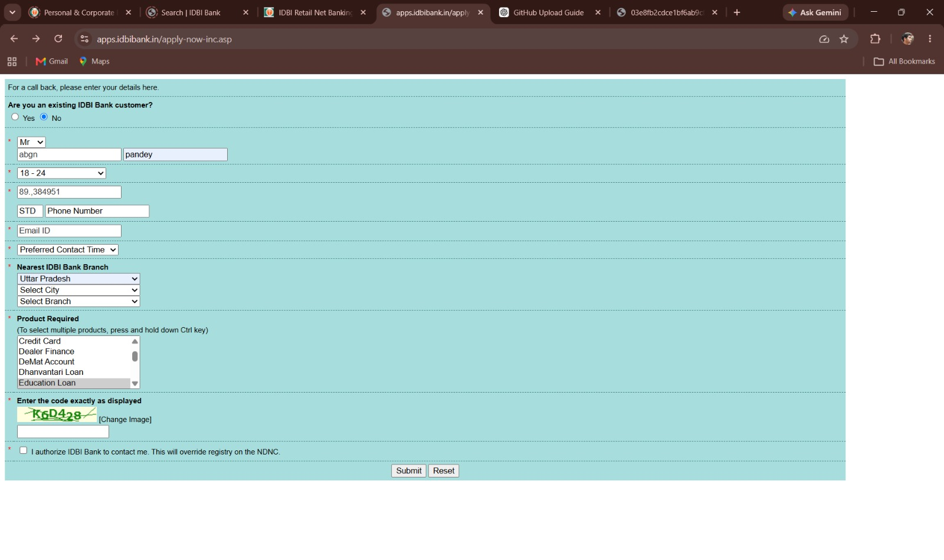
Figure 1: Mobile Number field accepts "89,,384951" as input, which should not be allowed.
Bug ID: BUG-002 — Form refreshes instead of displaying validation message when Branch details are not selected
Title: Form refreshes instead of displaying validation message when Branch details are not selected
Module: Callback Request Form
Severity: Medium
Priority: Medium
Environment: Browser: Google Chrome | OS: Windows 11
Precondition: Open the IDBI Bank callback request form
Steps to Reproduce: 1) Open the application form. 2) Fill the following fields: Existing Customer, Title, First Name, Last Name, Age, Mobile Number, Email ID, Preferred Contact Time. 3) Leave the Nearest IDBI Bank Branch fields (State/City/Branch) unselected. 4) Click Submit.
Expected Result: The application should display a validation message such as 'Please Select State', 'Please Select City', or 'Please Select Branch'. The page should not refresh until the mandatory fields are completed.
Actual Result: The page refreshes without displaying a validation message for the missing branch information.
Status: Open
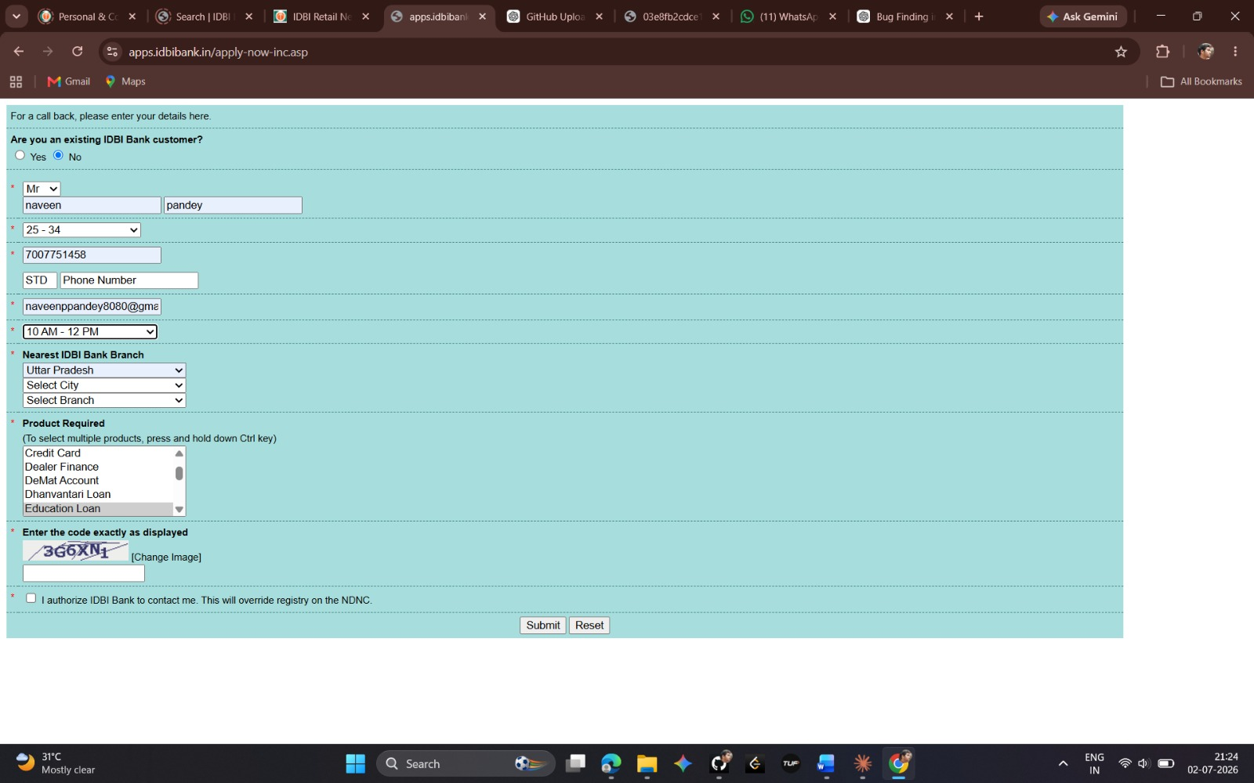
Figure 2: Form filled with all fields except Branch details; no validation message is shown on Submit.
Bug ID: BUG-003 — Form refreshes and clears all entered data instead of displaying validation message when Branch details are not selected
Title: Form refreshes and clears all entered data instead of displaying validation message when Branch details are not selected
Module: Callback Request Form
Severity: High
Priority: High
Environment: Application: IDBI Bank Callback Form | Browser: Google Chrome | OS: Windows 11
Precondition: User is on the Callback Request Form
Steps to Reproduce: 1) Open the Callback Request Form. 2) Fill all mandatory fields up to Preferred Contact Time. 3) Leave the Nearest IDBI Bank Branch fields (State, City, and Branch) empty. 4) Fill the CAPTCHA and any other required fields. 5) Click the Submit button.
Expected Result: The application should display a validation message such as 'Please Select State', 'Please Select City', or 'Please Select Branch'. The page should not refresh, and all previously entered data should be retained.
Actual Result: The page refreshes instead of displaying a validation message. All previously entered user data is cleared, and the user must fill the entire form again.
Severity Justification: This issue causes data loss and a poor user experience because users have to re-enter all information after the page refreshes.
Status: Open
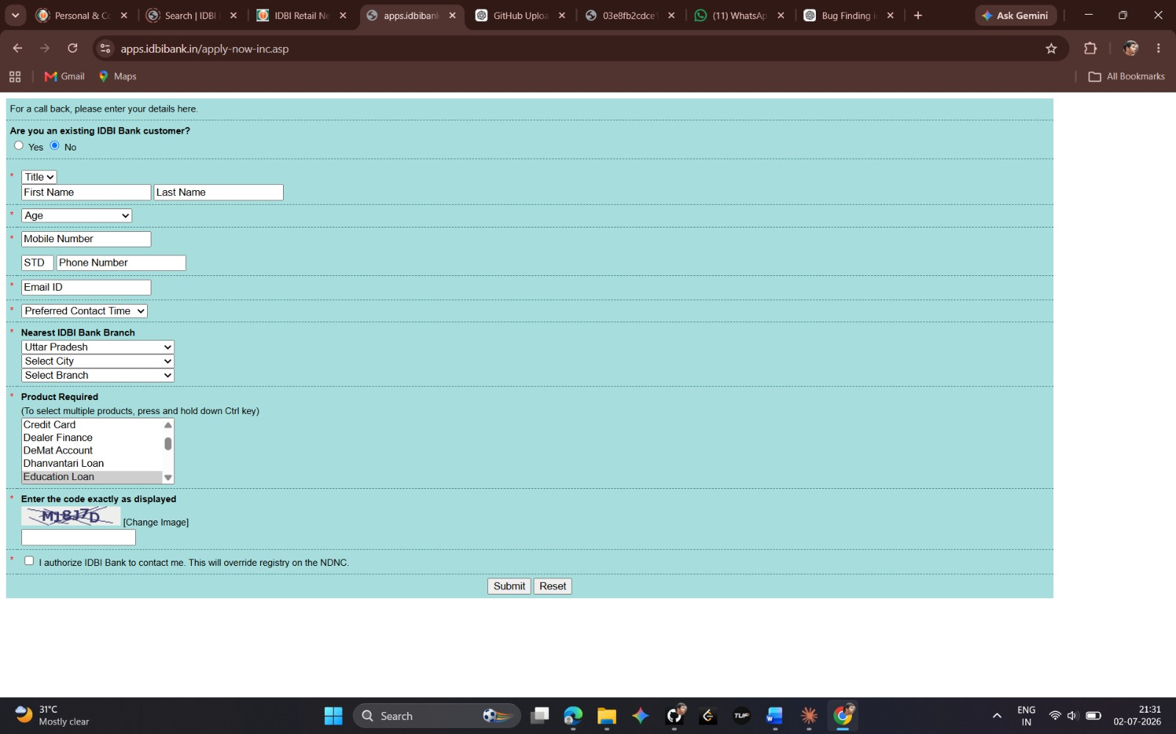
Figure 3: After the page refresh caused by missing Branch selection, all previously entered form data has been cleared.

3.3 Defect Summary
Defect ID | Description | Severity | Status
DEF-A01 | Services Required list box accepts no selection without error | High | Open
DEF-A02 | Incorrect CAPTCHA accepted; 'Submission Successful' shown | Critical | Open
DEF-A03 | No response after submitting valid details | Critical | Open
BUG-001 | Mobile Number field accepts special characters (comma/dot) | Medium | Bug Identified
BUG-002 | Form refreshes without validation message when Branch not selected | Medium | Open
BUG-003 | Form refreshes and clears all data when Branch not selected | High | Open

