Quicksort

Original Hoare partition scheme for quicksort.
(this is the Hoare-style / two-pointer Quick Sort with pivot = first element).

✅ 🔹 Algorithm: QUICK SORT
Algorithm: QUICKSORT(A, low, high)
Step 1: If low < high, then
a. pos = PARTITION(A, low, high)
b. QUICKSORT(A, low, pos - 1)
c. QUICKSORT(A, pos + 1, high)
Step 2: Exit

✅ 🔹 Algorithm: PARTITION
Algorithm: PARTITION(A, low, high)
Step 1:
pivot = low (first element as pivot)
left = low
right = high

Step 2: Repeat while left < right
(a) Move LEFT pointer
- Increase left until
A[left] > A[pivot]
or left > high

(b) Move RIGHT pointer
- Decrease right until
A[right] <= A[pivot]
or right < low

(c) Swap condition
- If left < right
Swap A[left] and A[right]

Step 3:
Swap A[pivot] and A[right]

Step 4:
Return right (final pivot position)

Key Idea
👉 Left finds greater element
👉 Right finds smaller element
👉 Swap them
👉 Finally place pivot at correct position

👉 Quick Sort partitions the array by placing the pivot at its correct position using two pointers, and recursively sorts the left and right subarrays.

First Example

0 | 1 | 2 | 3 | Array Index
23 | 12 | 25 | 5 | Remarks
Pivot Left |  |  | Right | Increase Left until we find a number greater than Pivot or Left reaches extreme right.  Decrease Right until we find number less than or equal to Pivot
 |  | Left | Right | Since Left < Right Swap Left and Right
23 | 12 | 5 | 25
 |  | Right | Left | Since Left >= Right Swap Pivot and Right
(5 | 12) | (23) | (25)
Pivot Left | Right
Right | Left |  |  |  | Since Left >= Right Swap Pivot and Right
(5) | (12) | (23) | (25)
 | Pivot Left  Right |  |  | Since Left >= Right Swap Pivot and Right
(5) | (12) | (23) | (25)
 |  |  | Pivot Left  Right | Since Left >= Right Swap Pivot and Right
(5) | (12) | (23) | (25) | Sorted Data

Second Example

0 | 1 | 2 | 3 | Array Index
27 | 23 | 8 | 8 | Remarks
Pivot Left |  |  | Right | Increase Left until we find a number greater than Pivot or Left reaches extreme right.  Decrease Right until we find number less than or equal to Pivot
 |  |  | Left Right | Since Left >= Right Swap Pivot and Right
( 8 | 23 | 8 ) | (27)
Pivot Left |  | Right
 | Left | Right |  | Since Left < Right  Swap Left and Right
8 | 8 | 23 | (27)
 | Right | Left |  | Since Left >= Right Swap Pivot and Right
(8) | (8) | (23 ) | (27)
Pivot  Left Right |  |  |  | Since Left >= Right Swap Pivot and Right
(8) | (8) | (23 ) | (27)
 |  | Pivot  Left Right |  | Since Left >= Right Swap Pivot and Right
(8) | (8) | (23 ) | (27) | Sorted Data

Case | Time Complexity
Worst-case performance | O(n2)
Best-case performance | O(n log n)
Average-case performance | O(n log n)

Quicksort Program

#include <stdio.h>
void quicksort (int [], int, int); int main()
{
int array[25]; int size, i;

printf("Enter the number of elements: "); scanf("%d", &size);
printf("Enter the elements to be sorted:\n"); for (i = 0; i < size; i++)
{
scanf("%d", &array[i]);
}
quicksort(array, 0, size - 1);
printf("Ascending order list after applying quick sort:\n"); for (i = 0; i < size; i++)
{
printf("%d ", array[i]);
}
printf("\n");

return 0;
}
void quicksort(int array[], int low, int high)
{
int pivot, left, right, temp; if (low < high)
{
pivot = low; left = low; right = high;

while (left < right)
{
/*Increase left until an element greater than pivot is found*/ while (array[left] <= array[pivot] && left <= high)
{
left++;
}

/*Decrease right until an element less than or equal to pivot is found*/ while (array[right] > array[pivot] && right >= low)
{
right--;
}

/*
if left<right, then swap array[left] and array[right]
*/
if (left < right)
{
temp = array[left]; array[left] = array[right]; array[right] = temp;
}
}
/*
if left==right or left>right than swap array[right] and array[pivot]
*/
temp = array[right]; array[right] = array[pivot]; array[pivot] = temp;
quicksort(array, low, right - 1); // Apply quicksort on the left side of pivot quicksort(array, right + 1, high); // Apply quicksort on the right side of pivot
}
}

Another technique of implementing Quicksort algorithm. Any element can be chosen pivot either the leftmost or the rightmost. The given program implements Quick Sort using a modified Hoare partition scheme. It uses two pointers (left and right) and a pivot that moves during swapping.


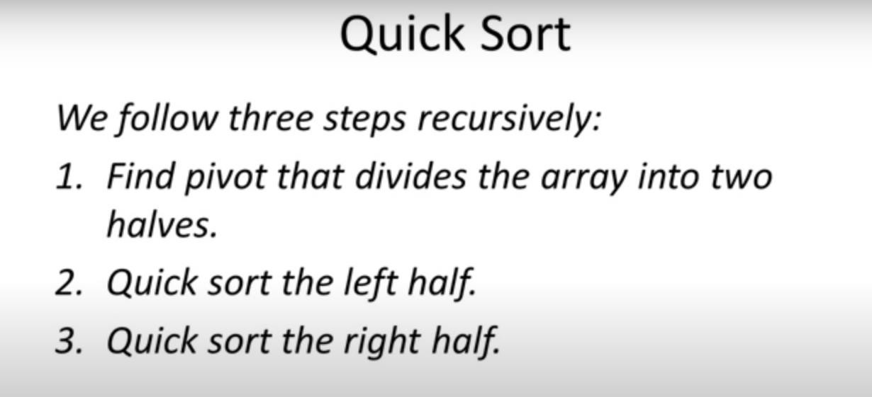
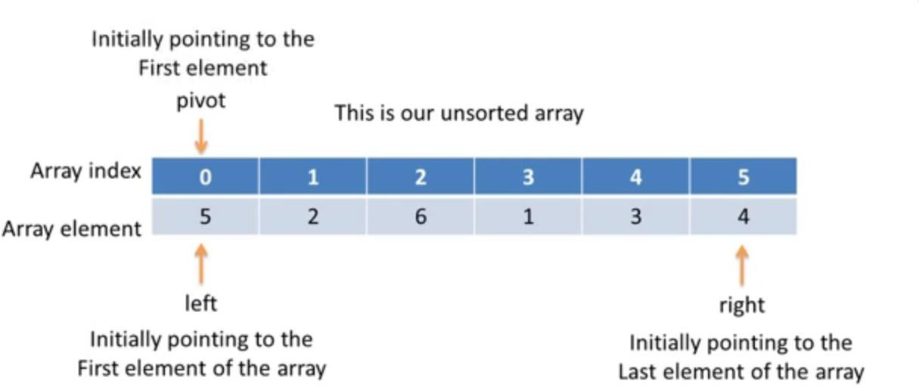

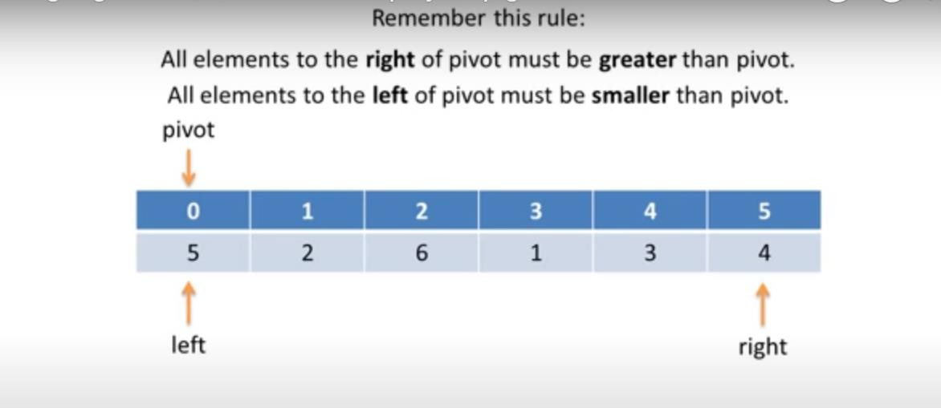
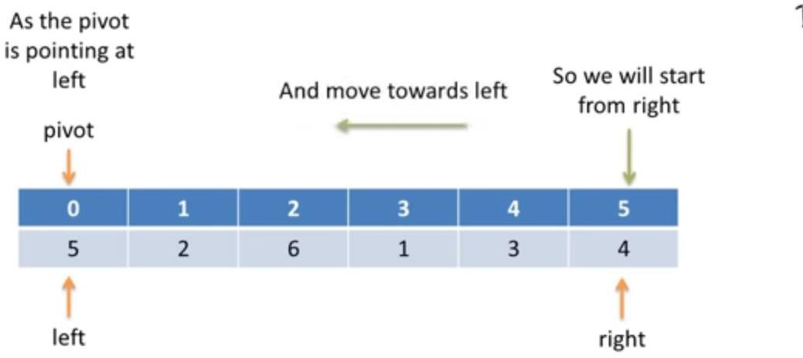

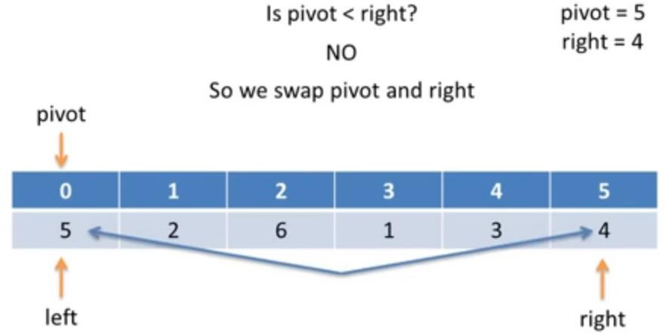

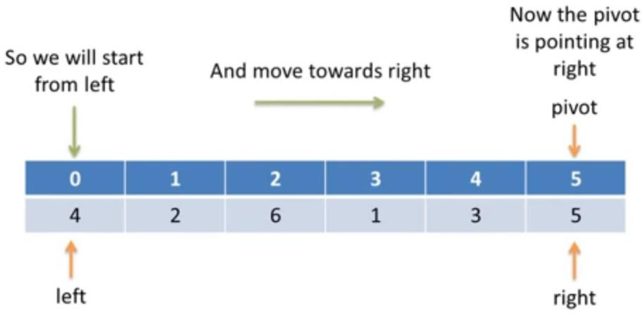

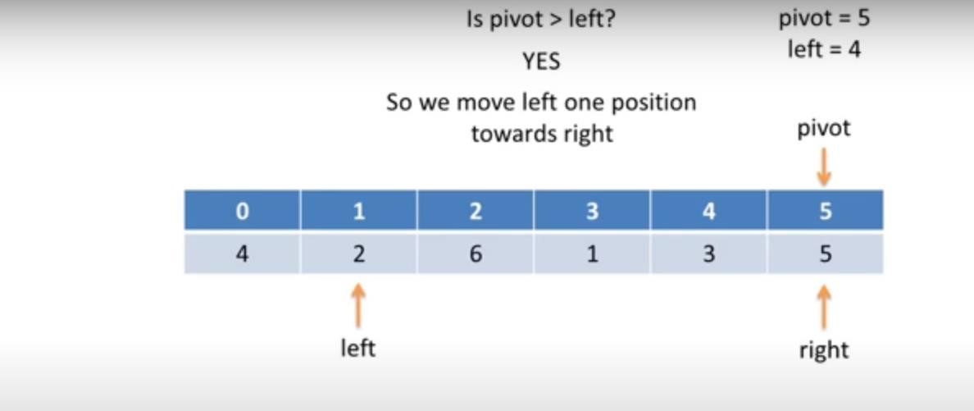
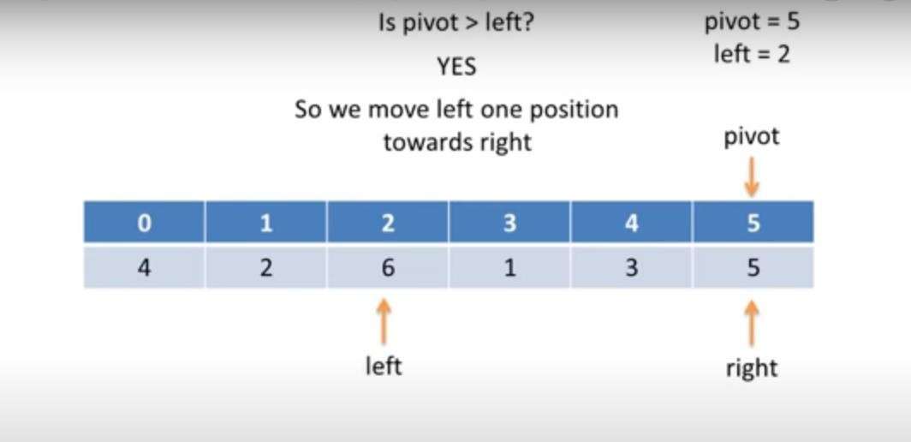

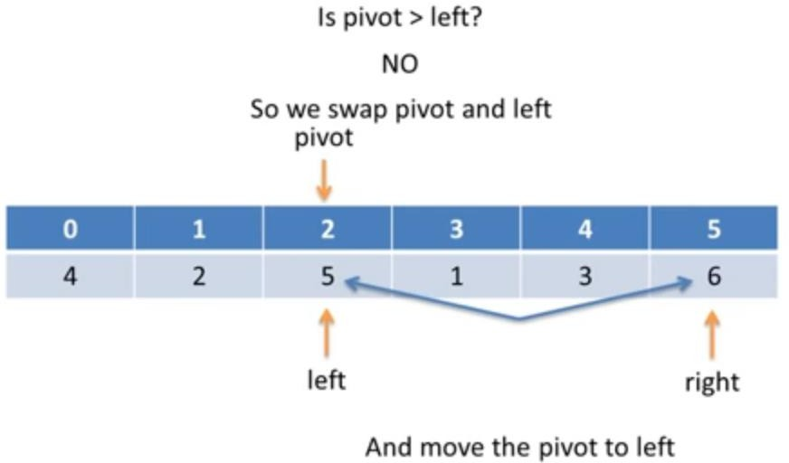

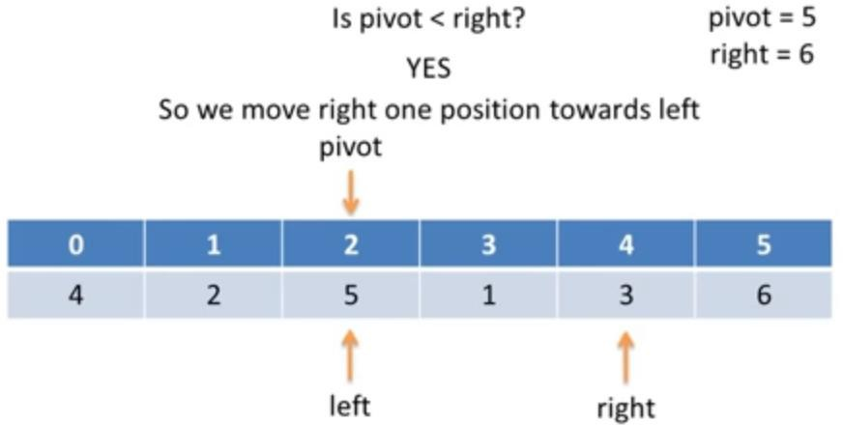

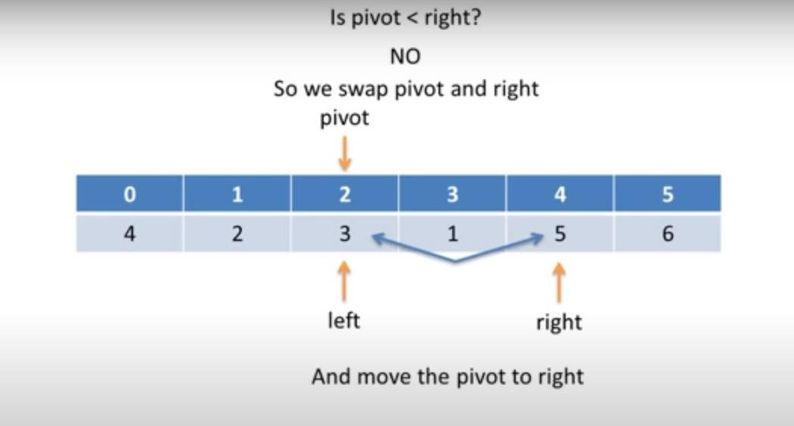

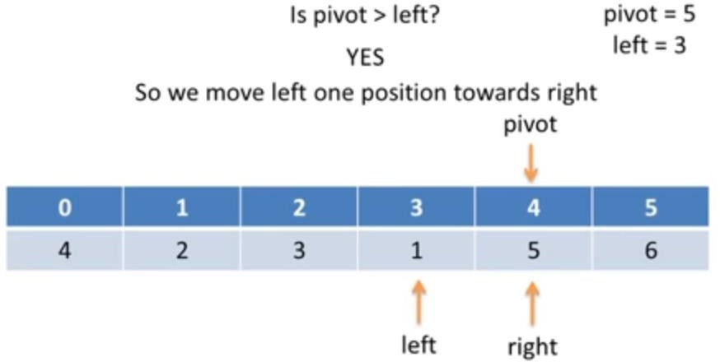

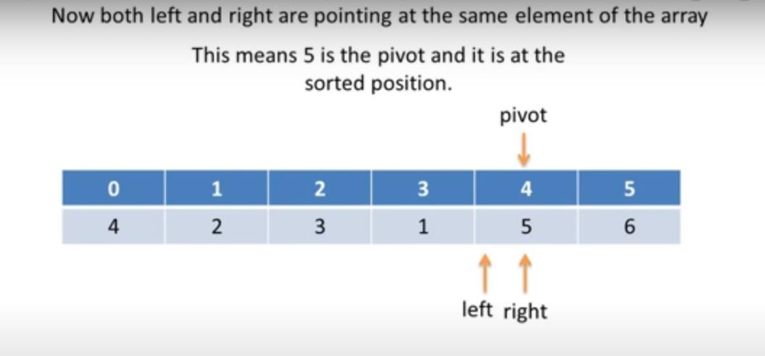
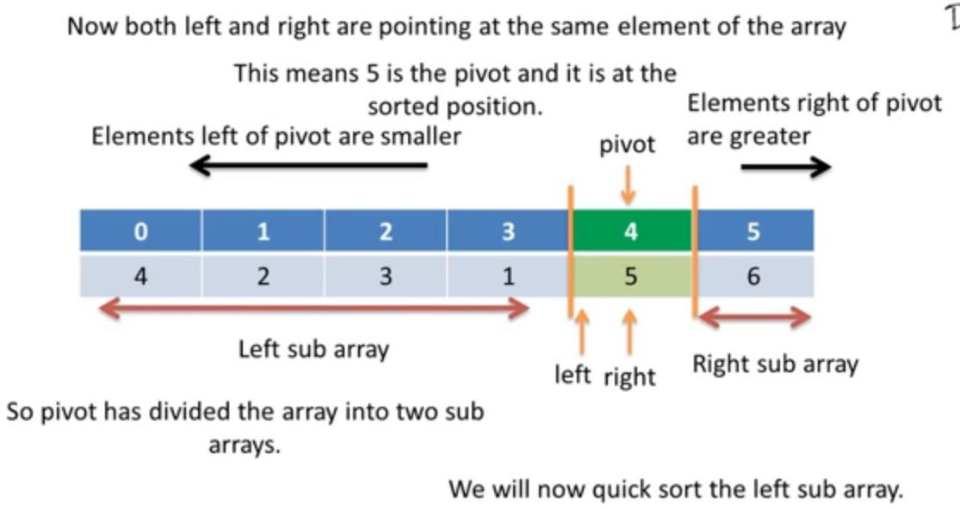

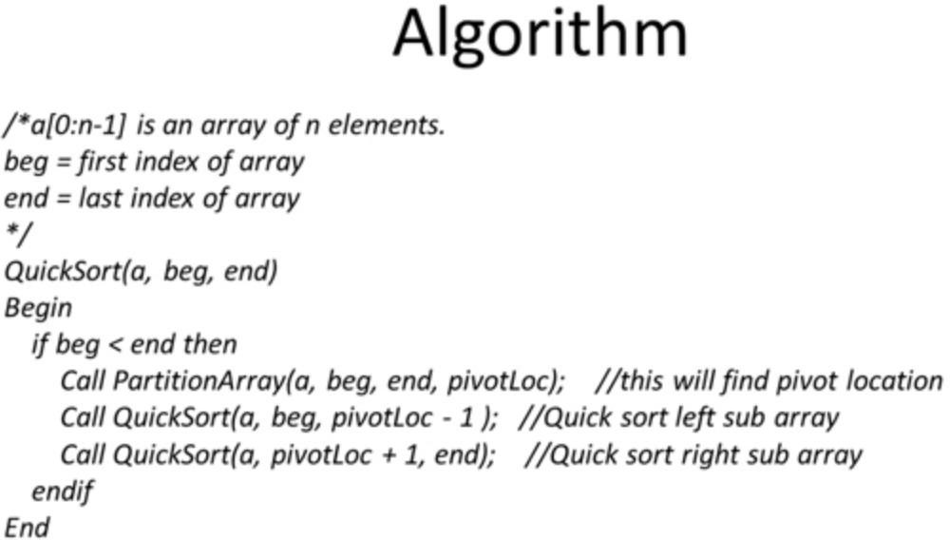

// Quick Sort in C
#include <stdio.h>
// Function declarations
/*
a → passed as pointer so the original array can be modified (in-place sorting)
pivotLoc → passed as pointer so the function can return the pivot index
(C allows returning multiple values using pointers / call-by-reference)
*/
void partitionArray(int *a, int beg, int end, int *pivotLoc);
void quickSort(int *a, int beg, int end);
int main()
{
// Unsorted array
int a[] = {5, 2, 6, 1, 3, 4, 2, 5, 7};
// Calculate number of elements
int n = sizeof(a) / sizeof(a[0]);
int i;
// Call quickSort on entire array
quickSort(a, 0, n - 1);
// Print sorted array
printf("Sorted Array:\n");
for(i = 0; i < n; i++)
{
printf("%d\t", a[i]);
}
return 0;
}//end of main()

// Quick Sort Function
void quickSort(int *a, int beg, int end)
{
int pivotLoc;
// Base condition: stop when subarray has 0 or 1 element
if(beg < end)
{
// Partition array and get correct pivot position
partitionArray(a, beg, end, &pivotLoc);
// Sort left subarray
quickSort(a, beg, pivotLoc - 1);
// Sort right subarray
quickSort(a, pivotLoc + 1, end);
}
} //end of quicksort() function

// Partition Function
void partitionArray(int *a, int beg, int end, int *pivotLoc)
{
int left = beg; // Left pointer starts from beginning
int right = end; // Right pointer starts from end
*pivotLoc = left; // Choose first element as pivot
int tmp; // Temporary variable for swapping
while(1)
{
// Move RIGHT pointer towards left
// Stop when element smaller than pivot is found
while(a[*pivotLoc] <= a[right] && *pivotLoc != right)
{
right--;
}

// If pivot reaches right, partition is complete
if(*pivotLoc == right)
{
break;
}
// Swap pivot with smaller element
else if(a[*pivotLoc] > a[right])
{
tmp = a[right];
a[right] = a[*pivotLoc];
a[*pivotLoc] = tmp;

// Pivot shifts to right
*pivotLoc = right;
}
// Move LEFT pointer towards right
// Stop when element greater than pivot is found
while(a[*pivotLoc] >= a[left] && *pivotLoc != left)
{
left++;
}
// If pivot reaches left, partition is complete
if(*pivotLoc == left)
{
break;
}
// Swap pivot with larger element
else if(a[*pivotLoc] < a[left])
{
tmp = a[left];
a[left] = a[*pivotLoc];
a[*pivotLoc] = tmp;

// Pivot shifts to left
*pivotLoc = left;
}
}//end of while(1) loop
// At this point:
// - Pivot is at correct sorted position
// - Left side contains smaller elements
// - Right side contains larger elements
}//end of partitionArray() function

