Assignment 1:

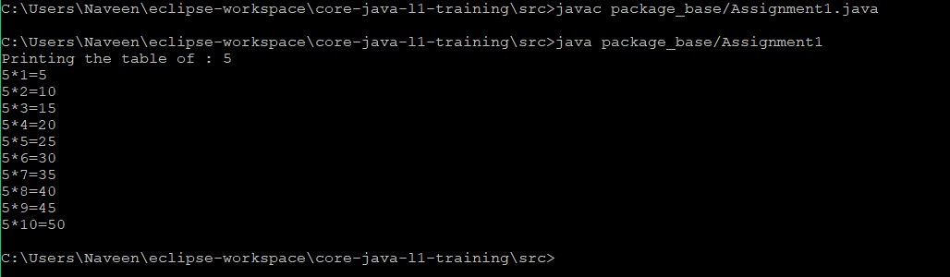

Assignment 2:

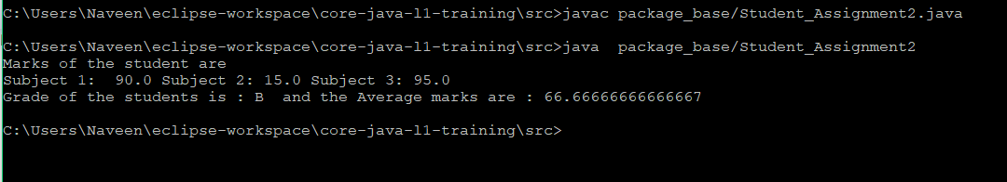

Assignment 3:

