## Patient Name Age/Gender Sample Type Sample ID Ref. Doctor

**IMMUNOLOGY / SEROLOGY**

**TEST DESCRIPTION**

**RESULT**

**UNITS**

**BIOLOGICAL REFERENCE RANGES**

: **B.GOPI**

## : 42 Year(s) / Male

: SERUM

: 20109228

:

Sample Drawn Date Sample Regd Date Sample Auth Date

: 2020-09-01 19:15

: 2020-09-02 11:47

: 2020-09-02 12:19

VISAKHAPATNAM, Andhra Pradesh

**MEDID : 6412999**

█▐ ▌▐▌▐█ ▌▌▐█▐▌▐ █▌▐▌▌▐█▐▌▐█ ▌█ █ █▌▐▐▌▐█ ▌█▌▌▐▌▐█▌▌ ▌█ ▐█▐▐▌

█▐ ▌▐▌▐█ ▌▌▐█▐▌▐ █▌▐▌▌▐█▐▌▐█ ▌█ █ █▌▐▐▌▐█ ▌█▌▌▐▌▐█▌▌ ▌█ ▐█▐▐▌

█▐ ▌▐▌▐█ ▌▌▐█▐▌▐ █▌▐▌▌▐█▐▌▐█ ▌█ █ █▌▐▐▌▐█ ▌█▌▌▐▌▐█▌▌ ▌█ ▐█▐▐▌

█▐ ▌▐▌▐█ ▌▌▐█▐▌▐ █▌▐▌▌▐█▐▌▐█ ▌█ █ █▌▐▐▌▐█ ▌█▌▌▐▌▐█▌▌ ▌█ ▐█▐▐▌

█▐ ▌▐▌▐█ ▌▌▐█▐▌▐ █▌▐▌▌▐█▐▌▐█ ▌█ █ █▌▐▐▌▐█ ▌█▌▌▐▌▐█▌▌ ▌█ ▐█▐▐▌

█▐ ▌▐▌▐█ ▌▌▐█▐▌▐ █▌▐▌▌▐█▐▌▐█ ▌█ █ █▌▐▐▌▐█ ▌█▌▌▐▌▐█▌▌ ▌█ ▐█▐▐▌

█▐ ▌▐▌▐█ ▌▌▐█▐▌▐ █▌▐▌▌▐█▐▌▐█ ▌█ █ █▌▐▐▌▐█ ▌█▌▌▐▌▐█▌▌ ▌█ ▐█▐▐▌

█▐ ▌▐▌▐█ ▌▌▐█▐▌▐ █▌▐▌▌▐█▐▌▐█ ▌█ █ █▌▐▐▌▐█ ▌█▌▌▐▌▐█▌▌ ▌█ ▐█▐▐▌

**SARS CoV 2 (COVID 19) ANTIBODIES**

*(Method: Roche,Electrochemiluminescence(Total), Immunochromatographic(IgG))*

# SARS CoV-2 (COVID-19) Antibody Total

65.31

## COI

< 1.0 : NEGATIVE

> 1.0 : POSITIVE

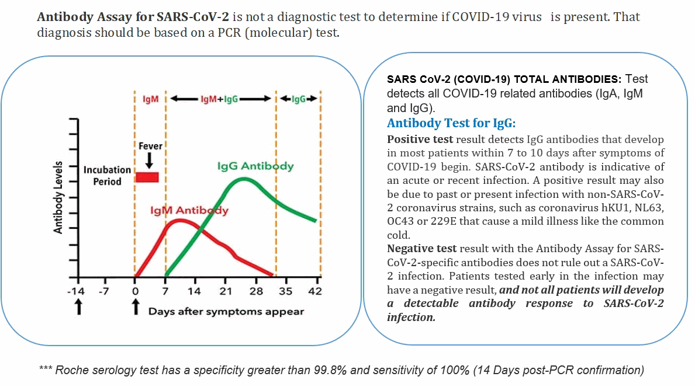SARS CoV-2 (COVID-19) Antibody IgG POSITIVE

 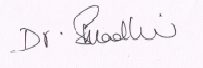

### Dr.ASHITA SINGH MD MICROBIOLOGY

DR.S.MADHURI MD MICROBIOLOGIST

*This is an electronically authenticated report. Report Printed Date : 02/09/2020 12:33:33*

#### NOTE : Assay results should be correlated clinically with other clinical findings and the total clinical status of the patient. Indicates NABL MC-2872 Accredited parameter when processed in HQ ,Hyderabad.

Page 1 of 1