Assignment 1

Use mongo­_practice – to create mongo­_practice database

db.createCollection(“movies”) – to create collection movies

Insert documents

Query/Find documents (1-6)

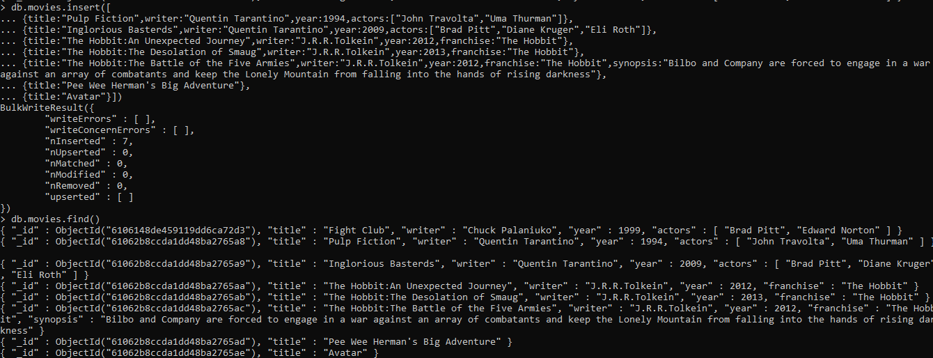

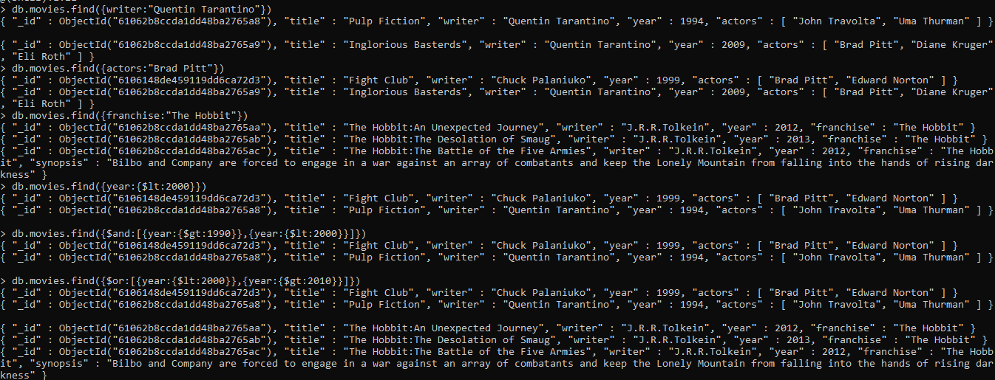

Update documents

1.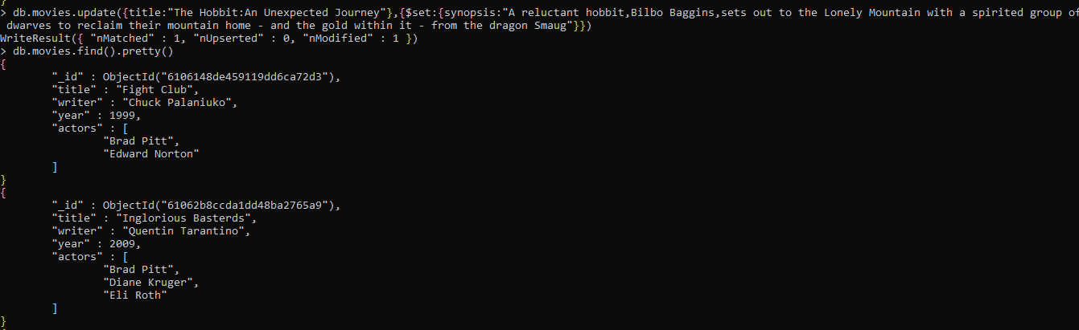

Result

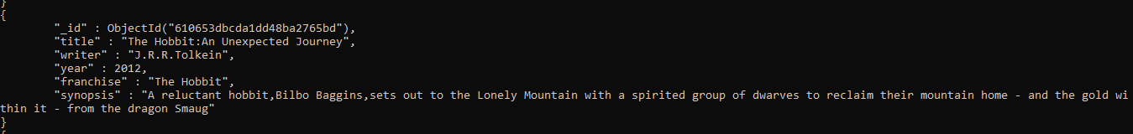

2.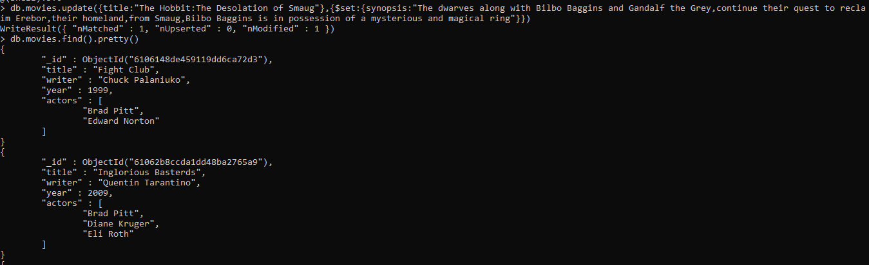

Result

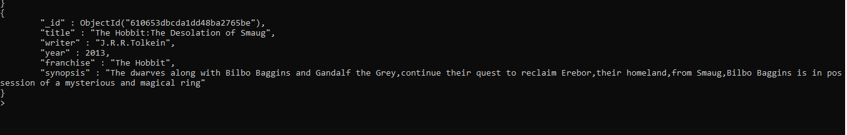

3.

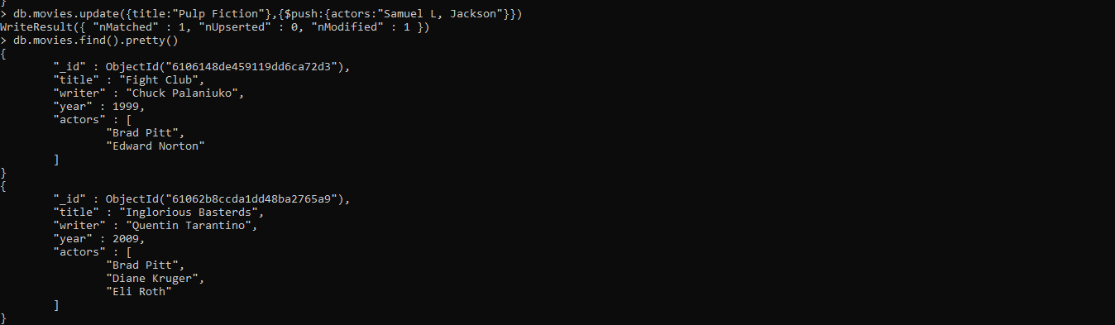

Result

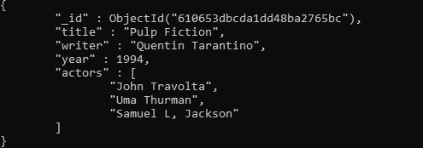

Text Search

Create index

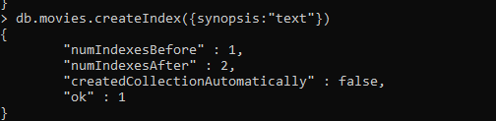

1. and 2.

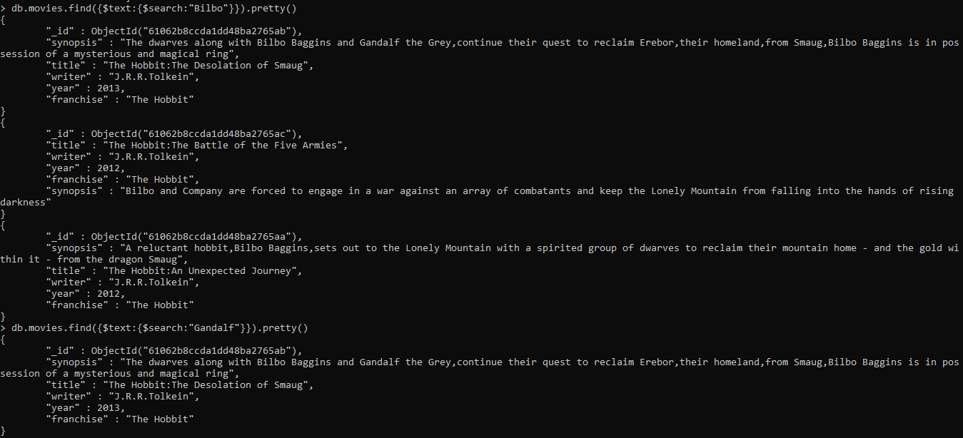

3. and 5.

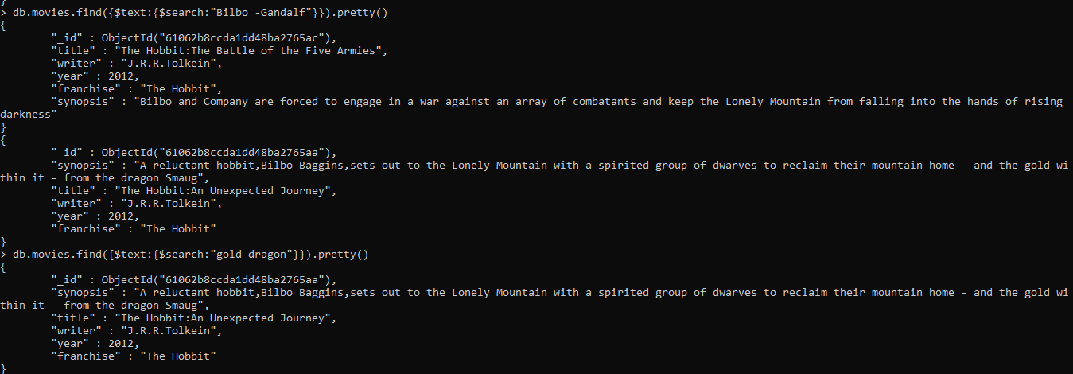

4.

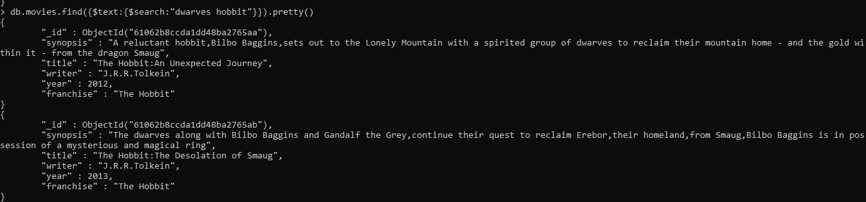

Delete documents

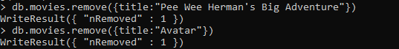

Relationships

db.createCollection(“users”) – to create collection users

db.createCollection(“posts”) – to create collection posts

db.createCollection(“comments”) – to create collection comments

1.

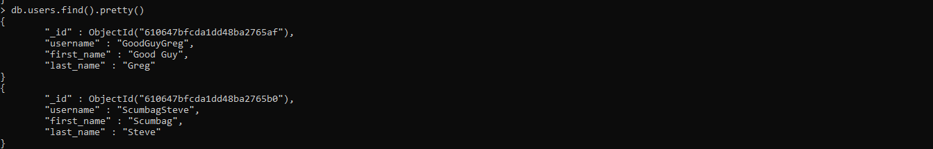

2.

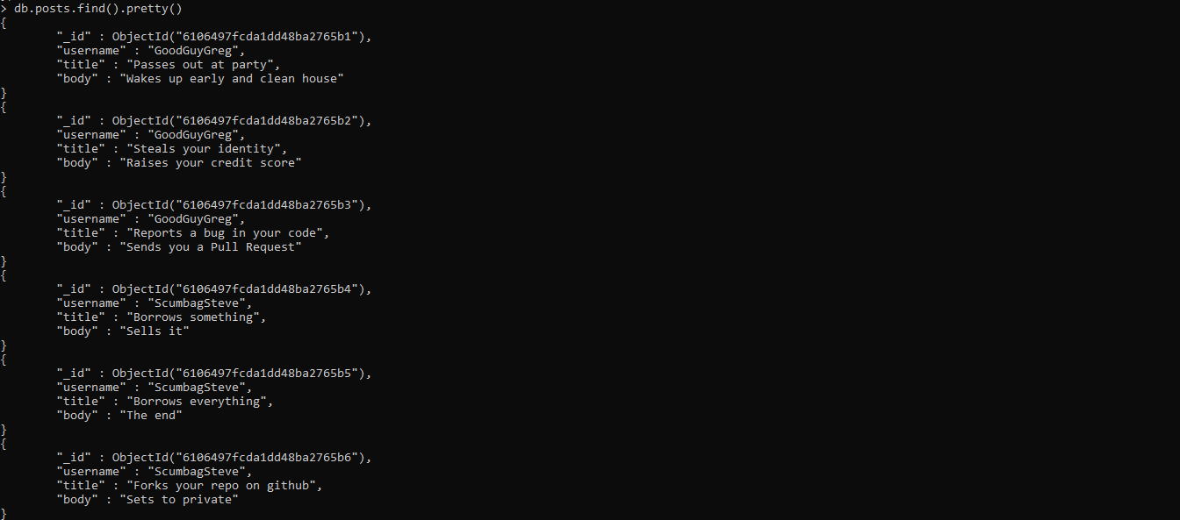

3. and 4.

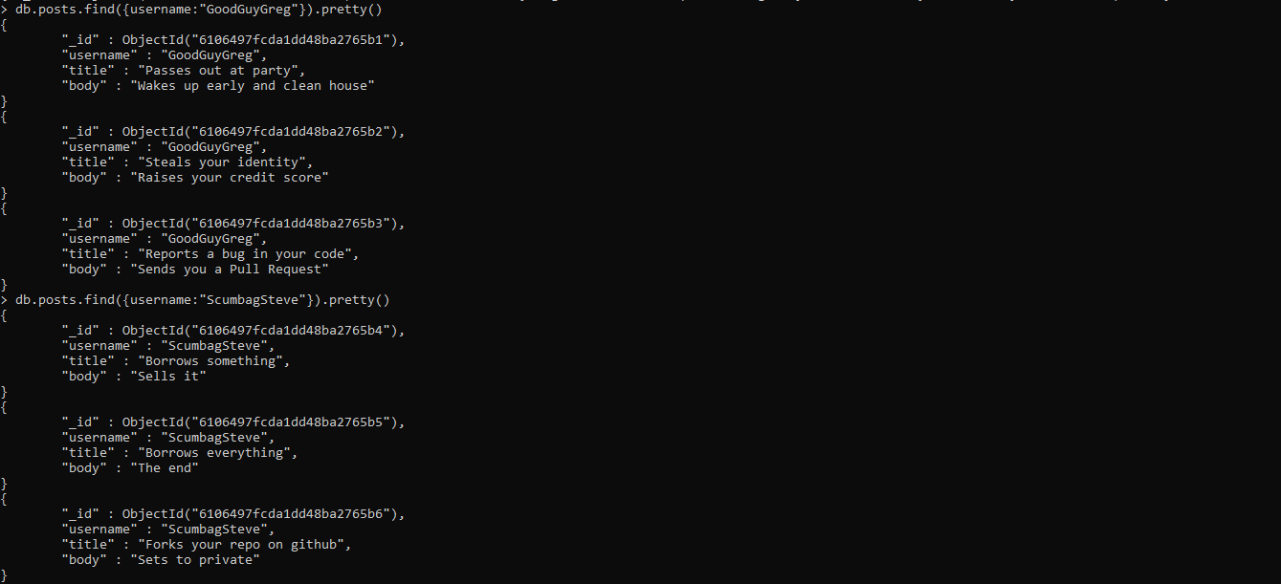

5.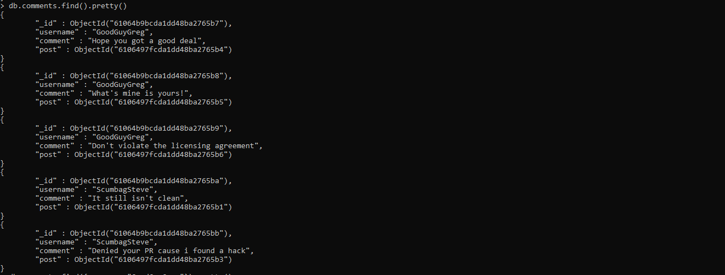

6. and 7.

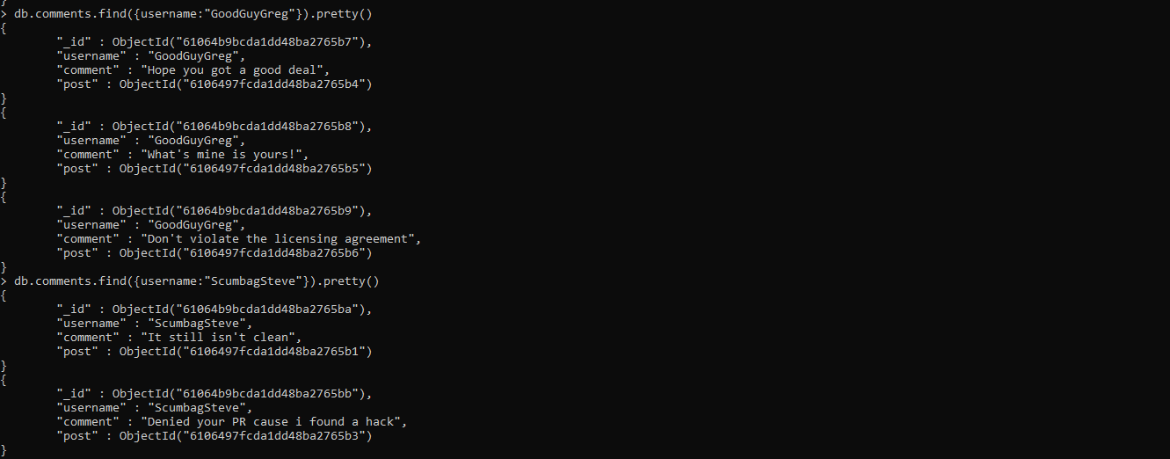

8.

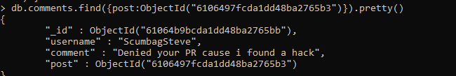

Assignment 2

Download the zip.json file and import into mongodb

use population – to create database population

db.createCollection(“zipcodes”) – to create collection zipcodes

mongoimport - -db population - -collection zipcodes - -file path where zip.json file exists – to import zip.json file into mongodb

Atlanta Population

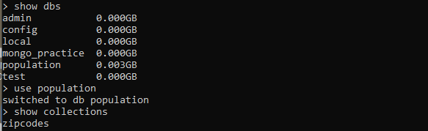

1.

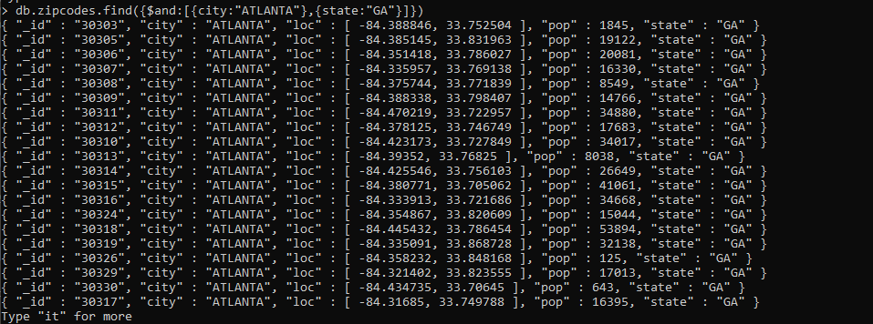

2.

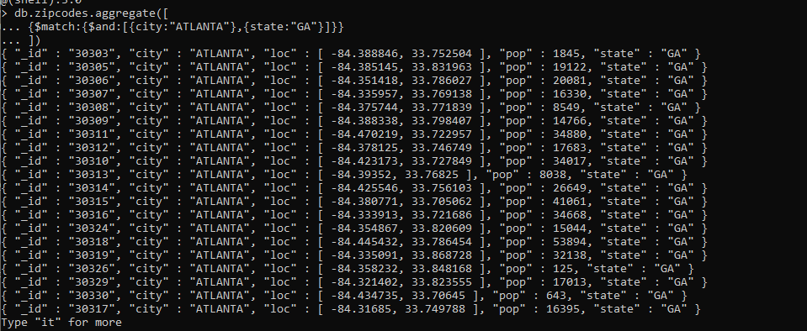

3.



4.

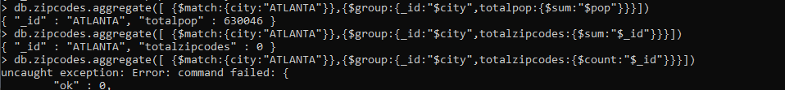

Population by State

1.

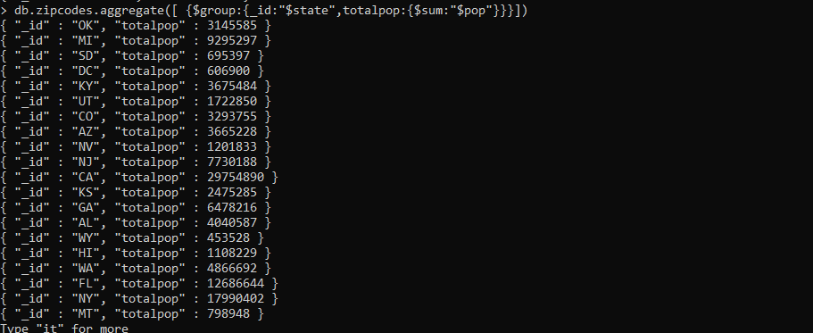

2. and 3.

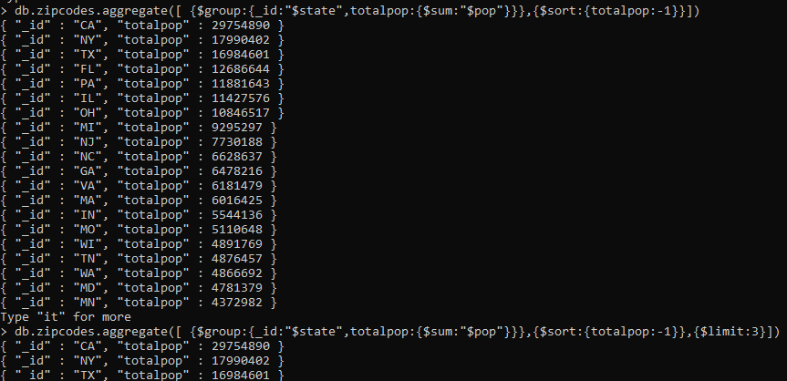

Population by City

1.

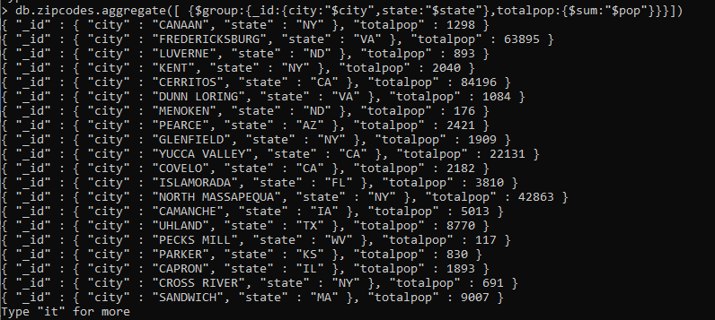

2.

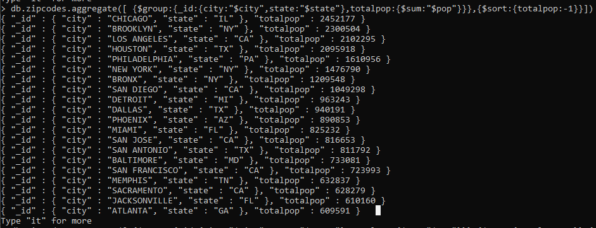

3.



4.



Bonus

1.

db.zipcodes.aggregate([{$group:{ _id:{city:”$city”,state:”$state”},avgpop:{$avg:”$pop”}}}]}

2.

db.zipcodes.aggregate([{$group:{ _id:{city:”$city”,state:”$state”},avgpop:{$avg:”$pop”}}},

{limit:3} ]}

Assignment 3

Download the restaurants.json file and import into mongodb

use restaurants – to create database restaurants

db.createCollection(“addresses”) – to create collection addresses

mongoimport - -db restaurants - -collection addresses - -file path where restaurants.json file exists – to import restaurants.json file into mongodb

1.

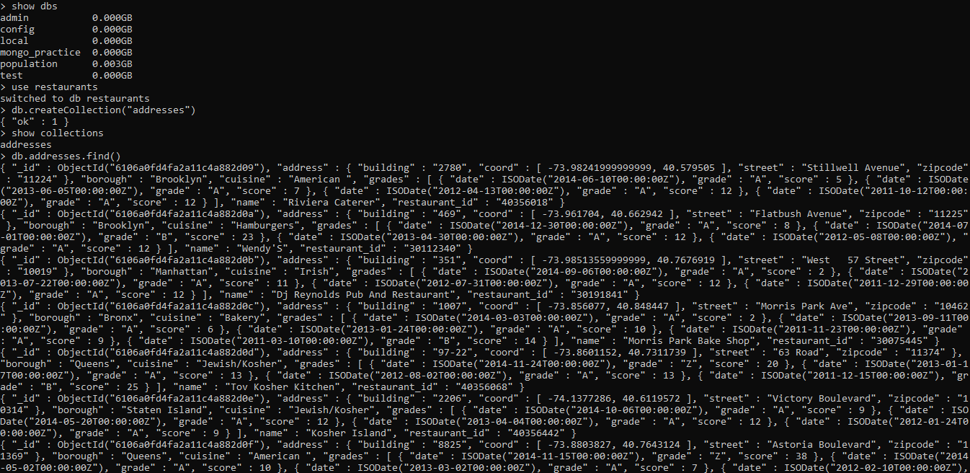

2.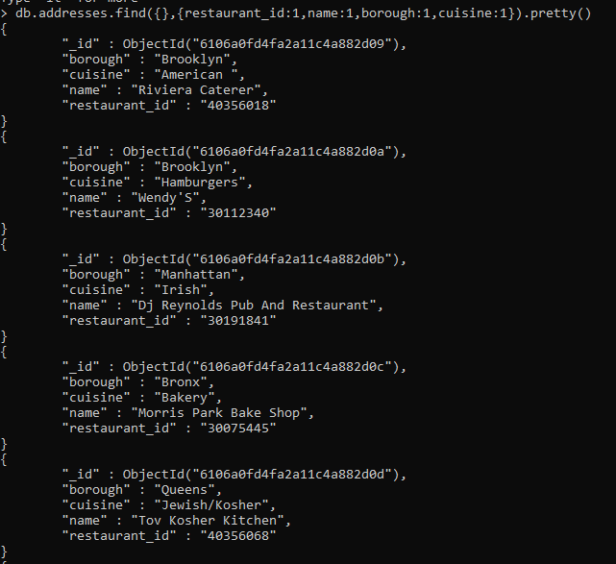

3.

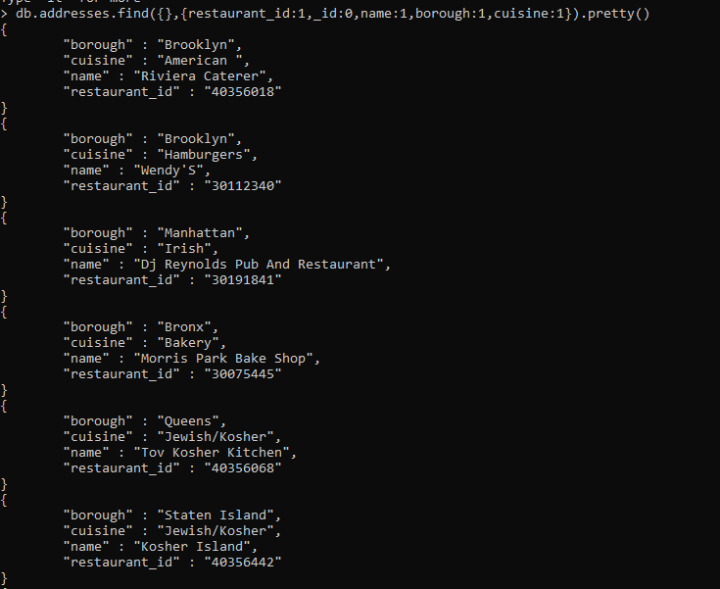

4.

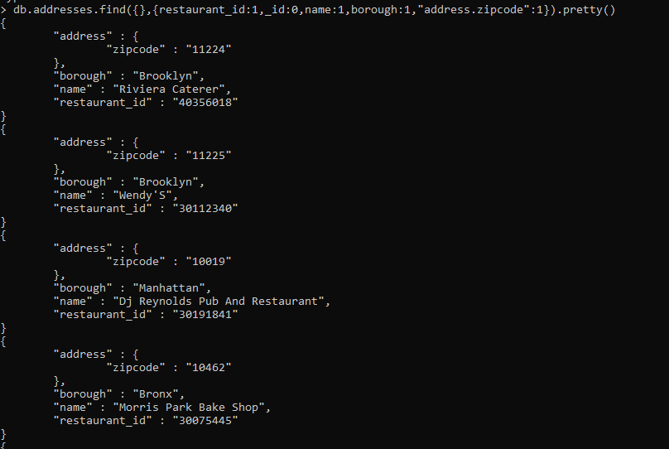

5. and 7.

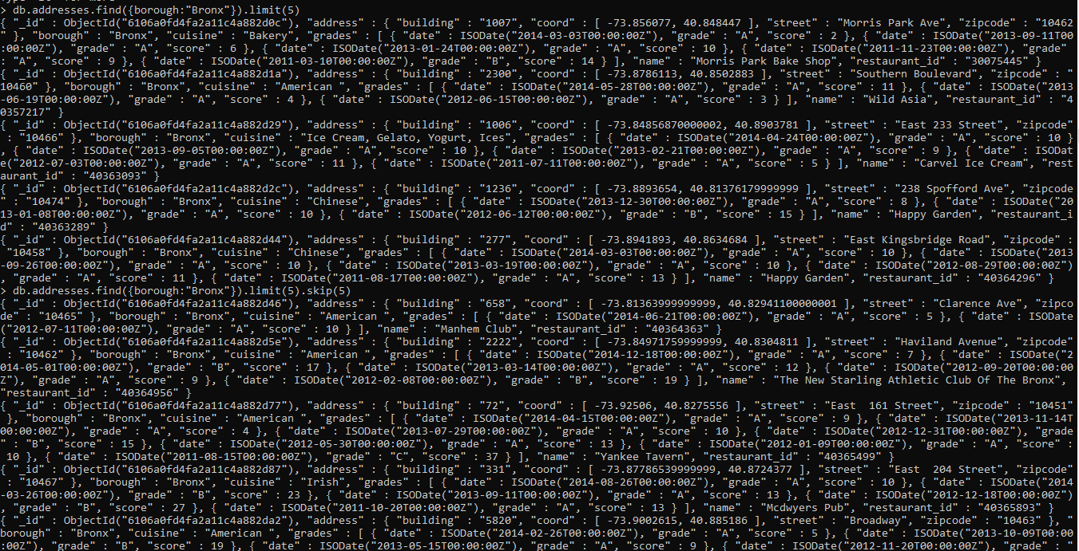

6.

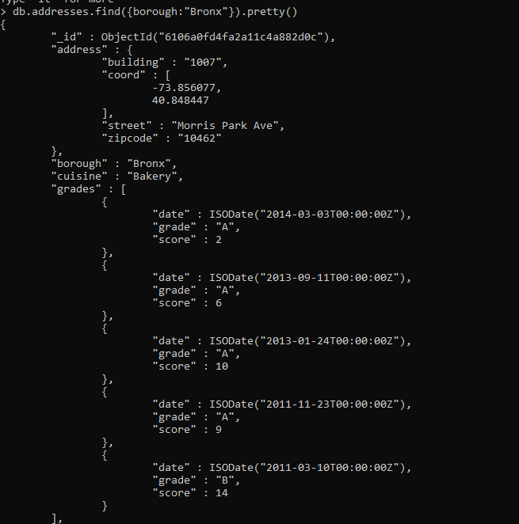

8. and 9.

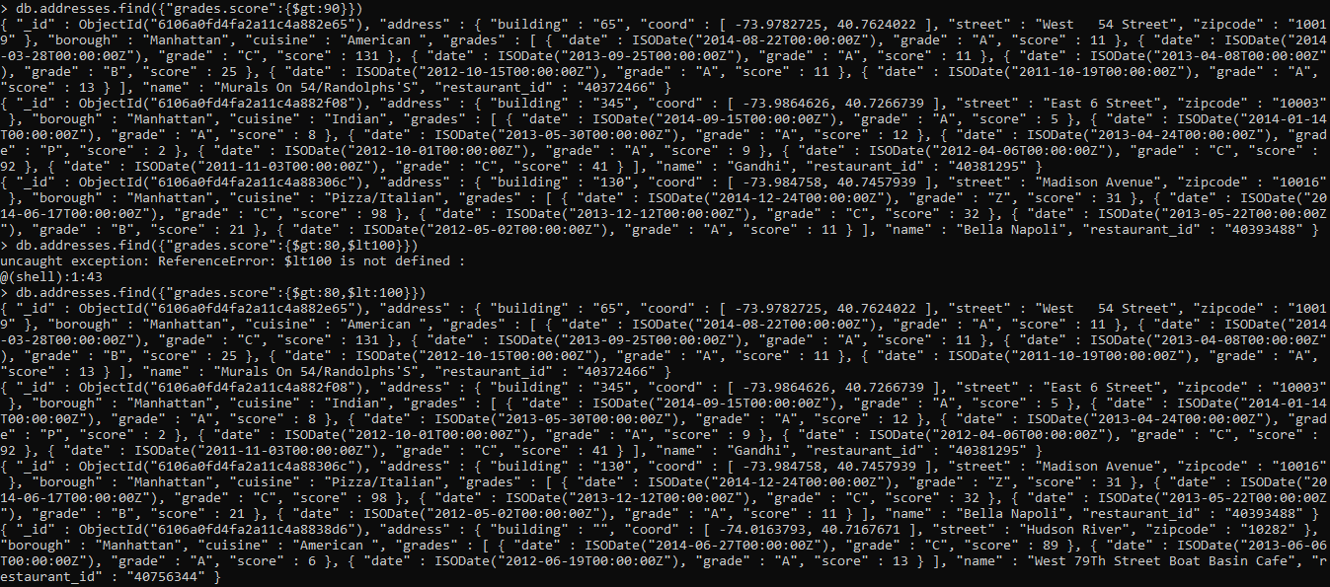

10. and 11.

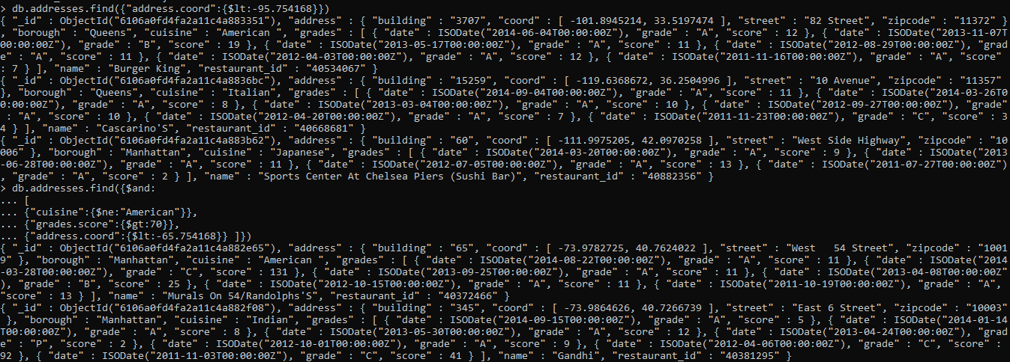

12.

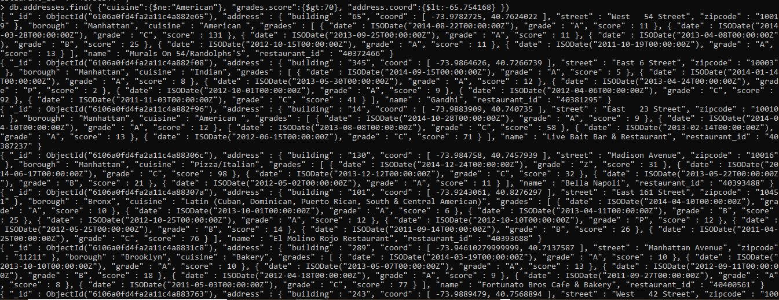

13.

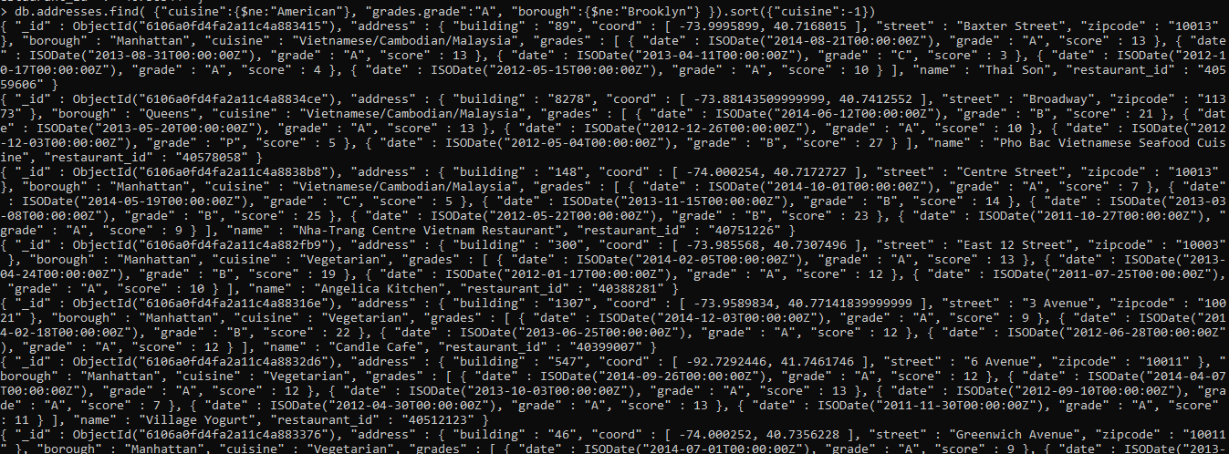

14.



15.

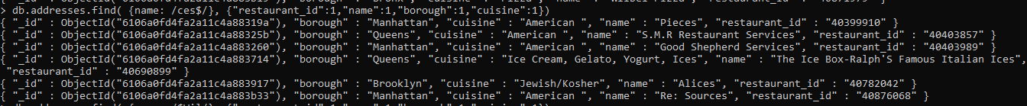

16.



17.

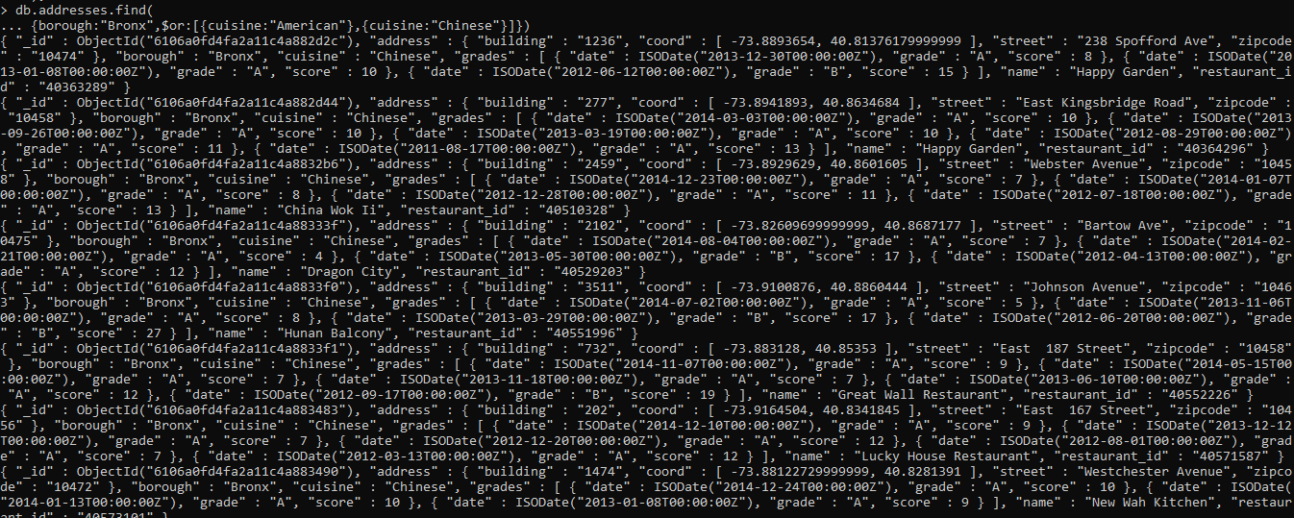

18. and 19.

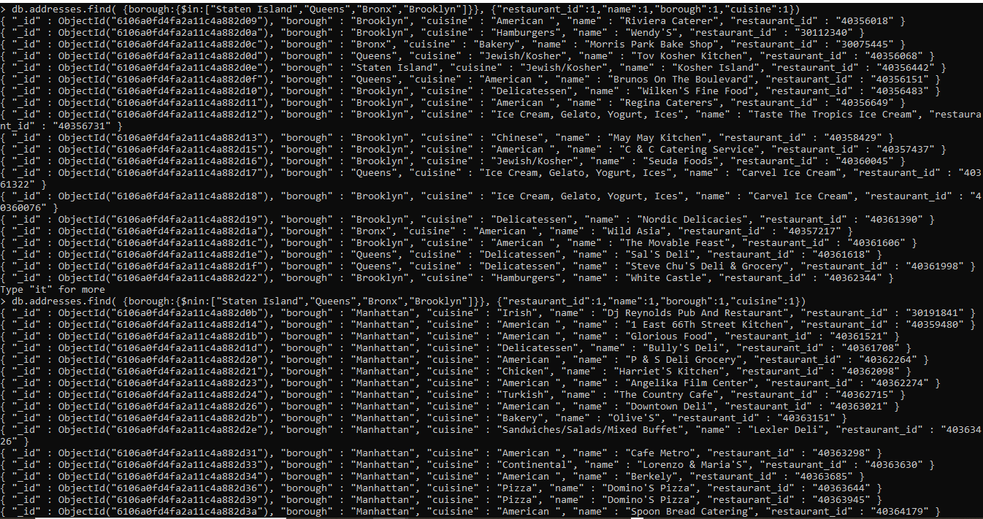

20. and 21.

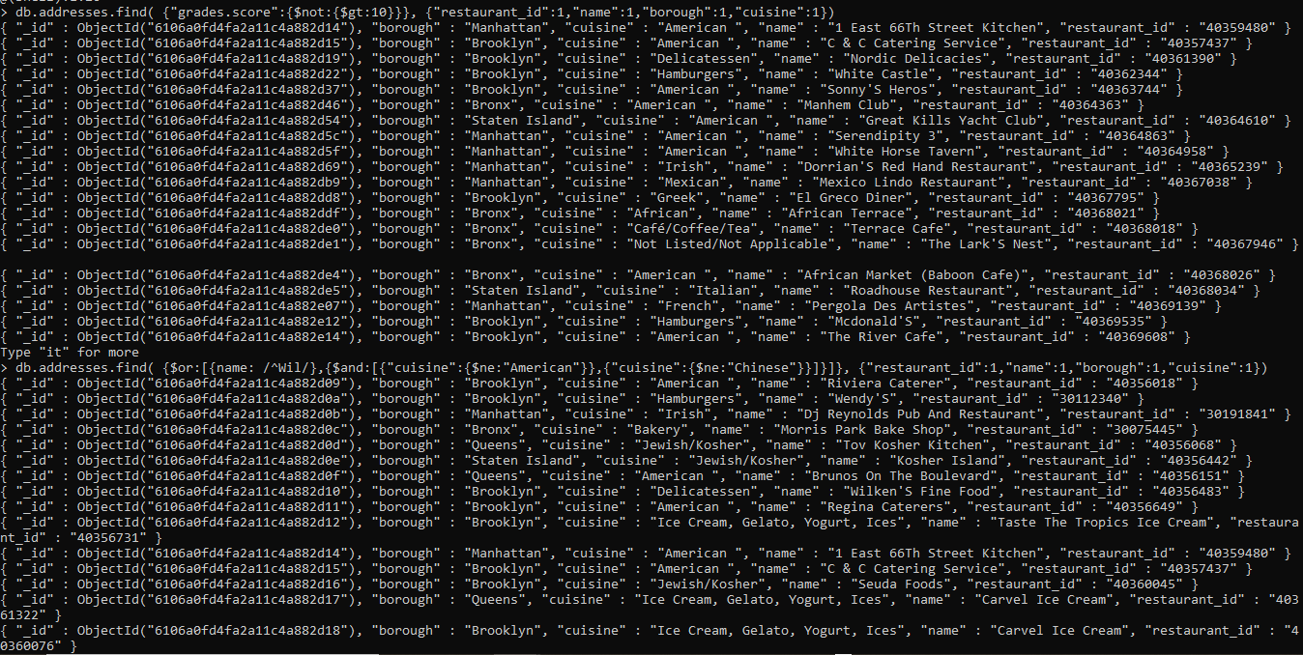

22.

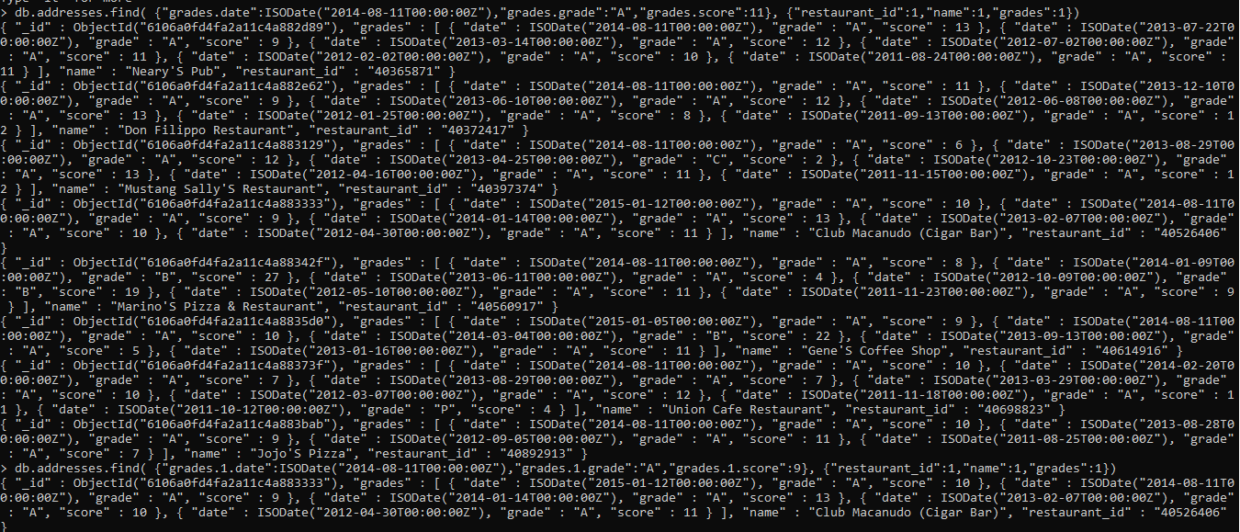

23. , 24.and 25.

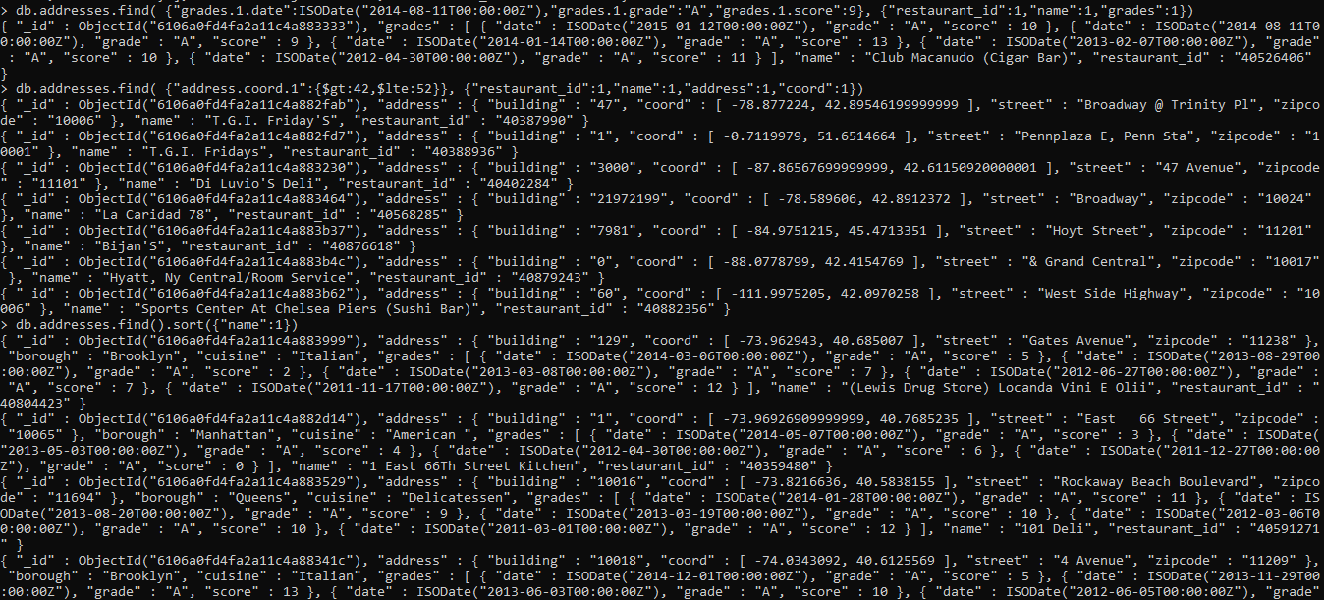

26.

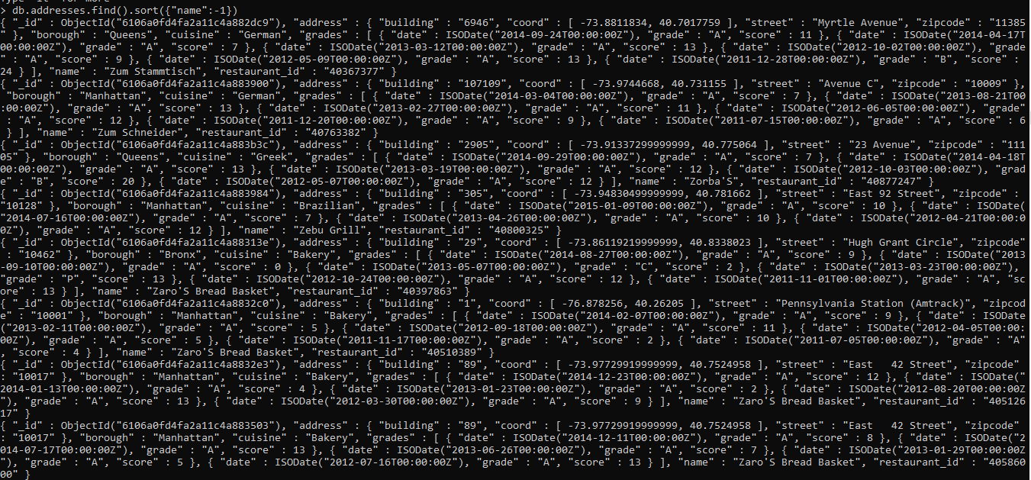

27.

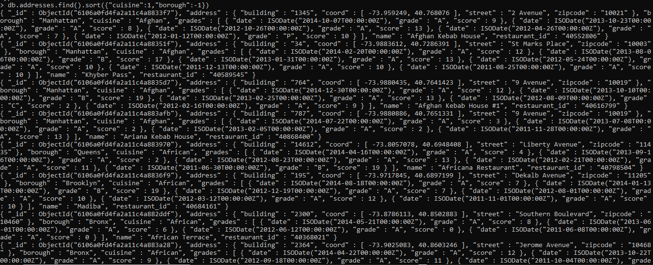

28.

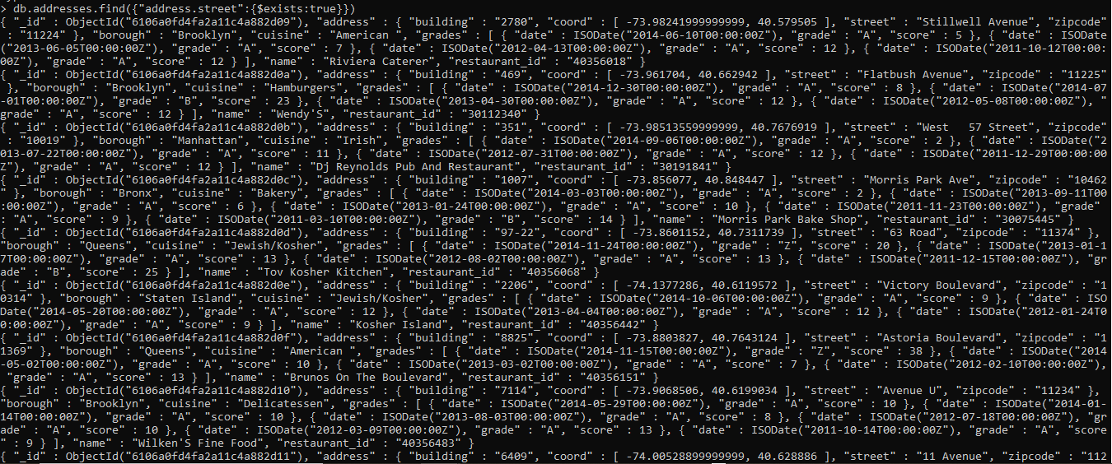

29.

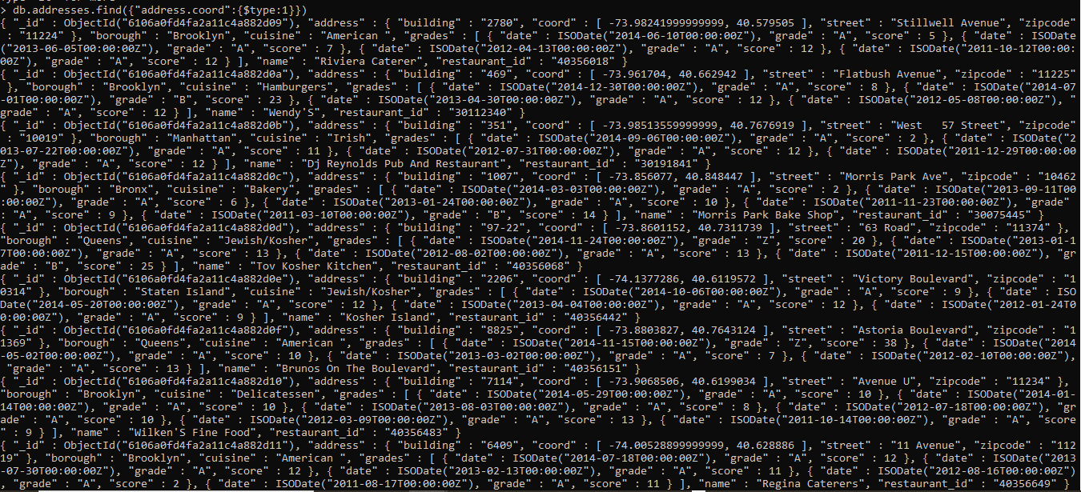

30.

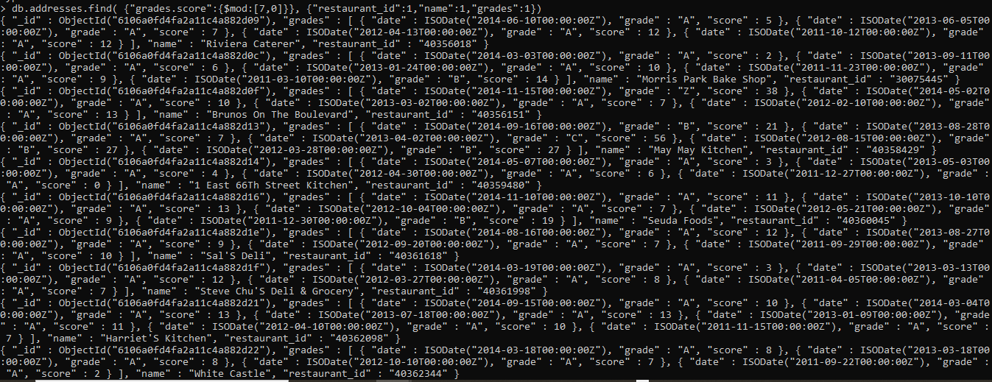

31.

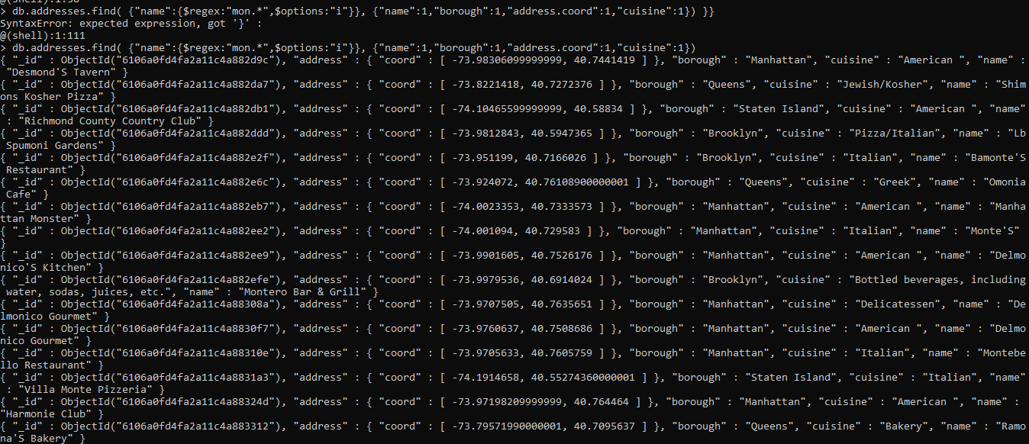

32.

