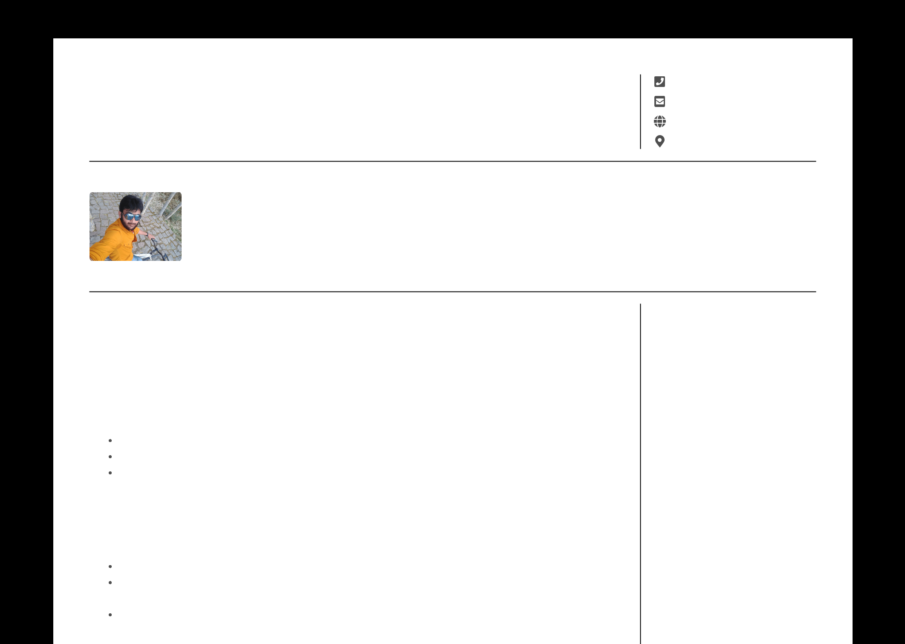

**NAVEEN YALLA**

Senior Software Engineer

[+91 9642396614](tel:)

[naveenyalla22@gmail.com](mailto:)

[www.nyalla.github.io](https://nyalla.github.io/)

Hyderabad, IN

Over 5 plus years of experience in Software development of Enterprise Applications using JAVA and J2EE Technologies in SCM/ITSM/Banking domains.Crafted complex design systems and handled different system integrations.Designed multi level micro service architecture products using Netflix OSS components.Currently being working on Microservice oriented adaption of the existing Monolithic application using Spring boot services. Exploring MEAN stack and programming knowledge into promise/functional paradigm.

 **WORK EXPERIENCES**

**Senior Software Engineer** Techwave | 2020 - Present

Has to design complex Data validation techniques in different stages of Payment processig. Need to maintain strict message formats PACS 008 and other bank partner message formats. Code should be very modularised and has to be plug and play.

Had to handle the team of 4-5 developers and been a POC to Product owners and Senior architects.

Heavy conversion from JSON to XMLs.Parallel prcoessing of multiple requests.

Desinging Endpoints at different levels of architecture.

**Analyst** Netenrich | 2018 - 2020

Been active team memeber in analysing and applying solutions for the product which solves the ITSM communication problems. Handled complex problems with industry standard best practices ans tools.

Good knowledge on Netflix OSS components and integrated with the product.

Analyzed multiple factors affecting the incident to incident relations where we can correlate and infer context from that.

Implemented REST end points which are integrated into the product.

 **SKILLS**

**Technical**

Java/Java8

Spring Framework/Spring Boot

Javascript/Jquery/Node/NPM

SQL/MySQL

Elastic Search/Redis/Kafka

Object-oriented design

Lead and deliver complex

software systems

**Professional**

Effective communication

Team player

Strong problem solver

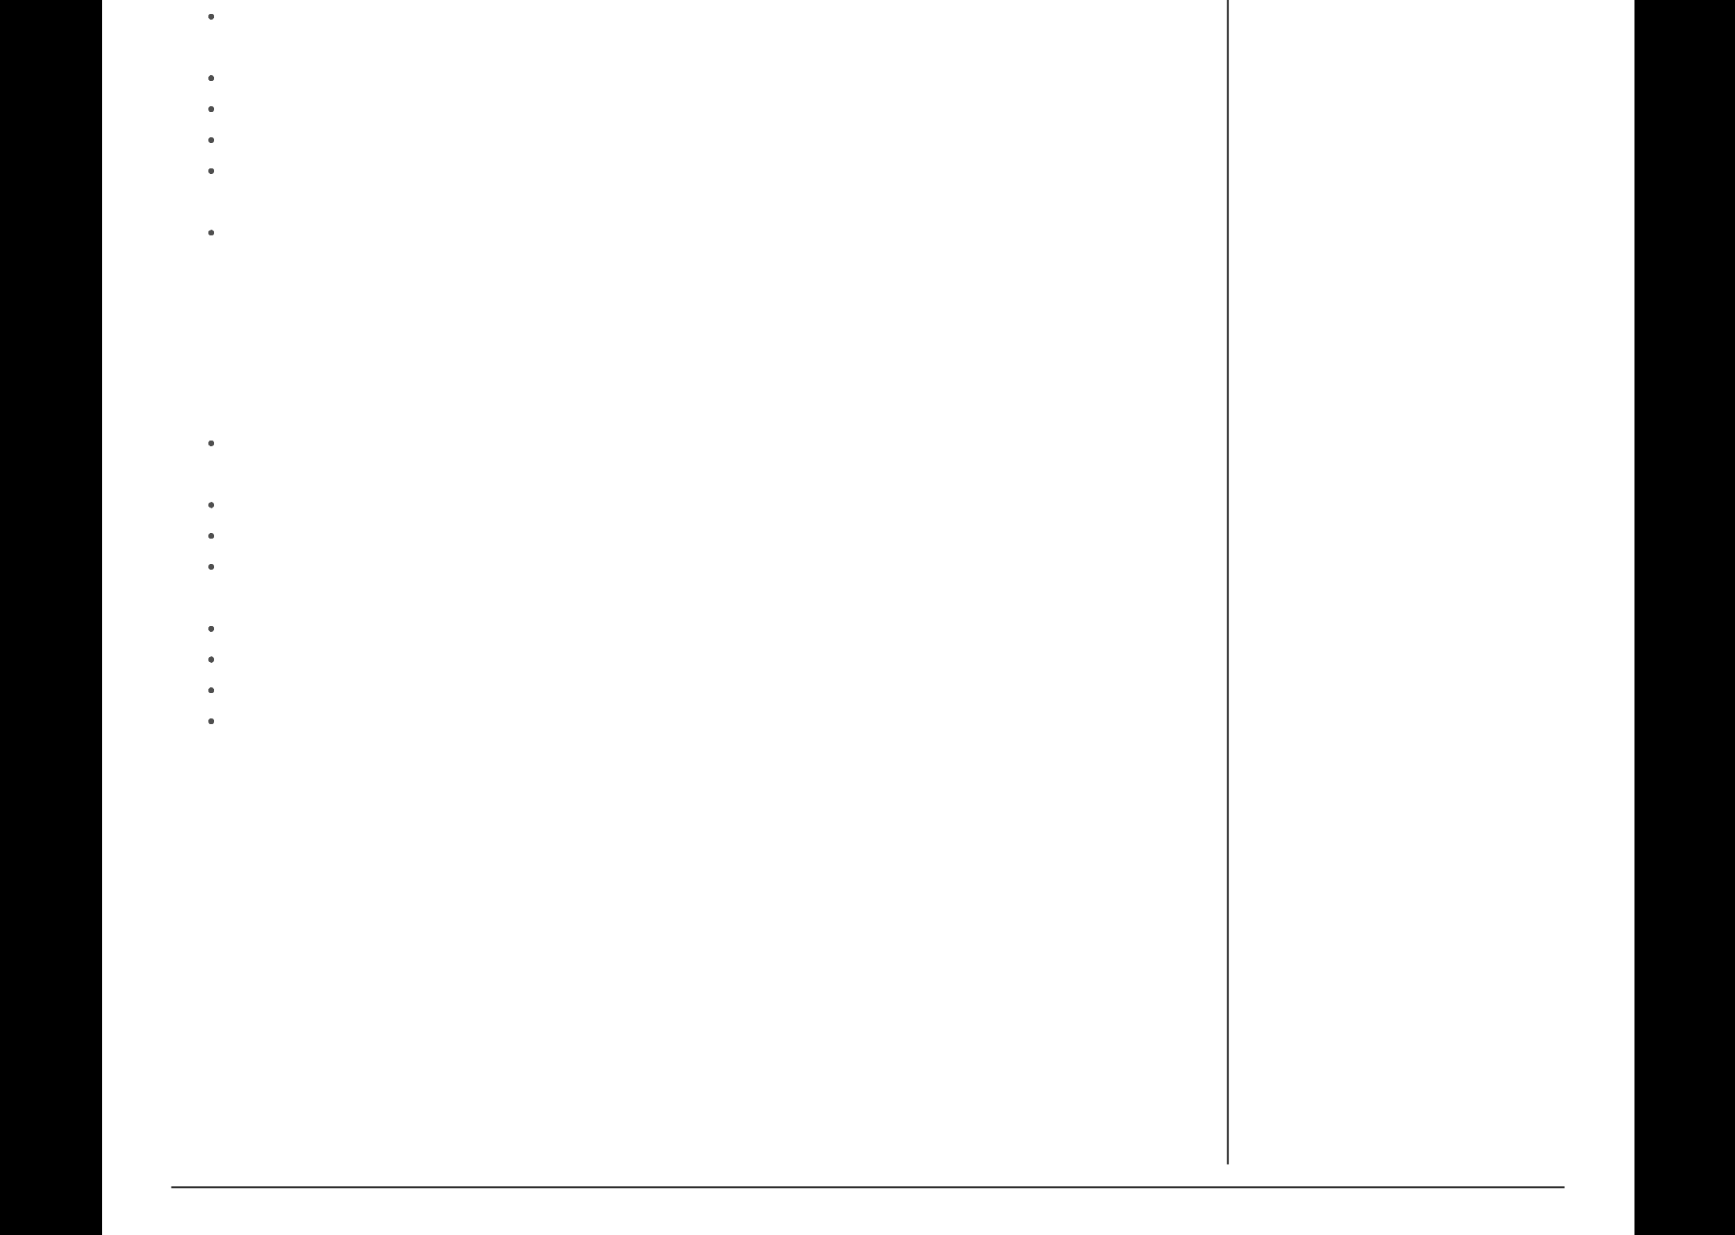Implemented 3 bucket storing of data in in memory (Redis), Mysql (been as source) and Elastic search (for fast reading).

Implemented KAFKA as a broker to communicate between different microservices.

Implemented Spring Micro service metric reports based on actuator.

Metrics are integrated with Prometheus DB and later displayed in Grafana Dashboards. Designed framework to get Azure metrics from azure monitors and store it in elastic search and Prometheus.

Worked on Node Js to integrate with different external systems

**Software Engineer** Steelwedge Techn. | 2014 - 2018

Started carrer as trainee and adopted industry level professional work culture in short span. Handled different in-house tools in the beginning. Implemented S&OP and SCM algorithms in JAVA. Learnt domain level knowledge in SCM and applied the knowledge in solving problems in the product.

Been part of complete SDLC software development life cycle of the application from requirement analysis to testing.

Designed modules based on struts MVC Architecture

Designed and developed the UI using IceFaces,JavaScript, JSP, HTML and complex user interface. Designed and developed business logic using Servlets, JAVA enterprise beans and deployed them on JBOSS server.

Implemented MVC struts framework for application design.

Desingned and developed complex SQL Queries for back end.

Prepared the Functional, Design and Test case specifications.

Provided Technical support for production environments resolving the issues, analyzing the defects, providing and implementing the solution defects

Good time management

 **EDUCATION**

**P.G. Diploma in**

**Entrepreneurship**

Annamalai University, India

2018 - 2019

**B.Tech Computer Sceince**

JNTU, Hyderabad IN

2009 - 2013

 **RECOGNISATIONS**

**Steel performer Award**

Steelwedge Inc. (Now E2Open)

(2016)

 **LANGUAGES**

Telugu (Native)

English (Professional)

 **INTERESTS**

Racing

Movie geek

Photograph

[PDFmyURL.com](https://pdfmyurl.com/?src=pdf) - convert URLs, web pages or even full websites to PDF online. Easy API for developers!