The input is read from the C17 file which is a Netlist, from the input adjacency matrix is computed which represent the graph, from adjacency matrix initial partitions are done as even nodes in one partition and odd nodes in another partition and then KL algorithm is applied which gives minimum cut set cost.

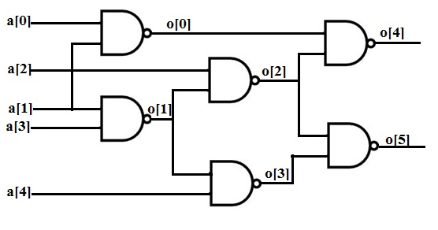

No of nodes =6 (0,1,2,3,4,5)

Initial partitions (0,2,4),(1,3,5)

Final partitions (5,2,4),(1,3,0)

NAVEETH MEERAN N (172VL015)