# Project: Locked Me

**Please find below details my project:**

## Project Description

A Java based application that can be a virtual repository for credentials. The application can create user defined files, retrieve filenames in ascending order, delete file names and locate the file in directory . The credentials will be stored in a file format. The application registers a new user by taking username and password as input. The existing users can login to the application and store their credentials. The provided credentials are stored in a file that have the username, site, username in the site and password for that specific username. The application can also fetch the credentials of a particular user if asked.

### 1.1.2 Technology Stack

* Data structures
* Searching Algorithm
* Sorting Algorithm
* File Handling Operations
* Exception Handling
* Java
* Github

# Architecture/Flow Chart

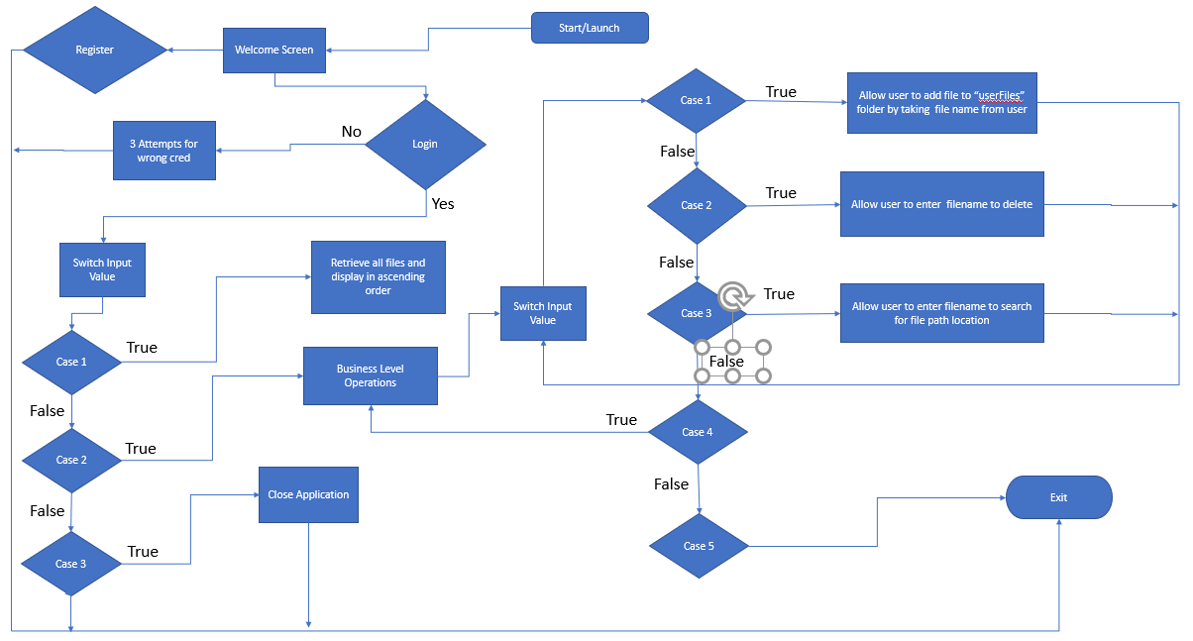

# Project Users Stories

1. As a user, I want Welcome screen with login and registration option.

2. As a user, I want to register in LockMe.com App.

3. As a user I want login into app by entering valid credentials and user will be provided

3 attempts to enter correct credentials.

4. As a developer, I want to display below options in console for User Interaction:

* Retrieve all files in Ascending Order
* Business level Operations
* Exit from Application

.

5. As a user, I want to retrieve all files in Ascending Order.

6. As a developer, I want to display below business level operations for user interaction

* Add user specified file in LockMe app application.
* Delete existing file from LockMe application.
* search a user specified file from the application
* Navigation to previous menu / main context.
* Exit from Application.

7. As a user, I want to add user defined file in an Application

8. As a user, I want to delete existing file from an Application.

9. As a user, I want to search a file and fetch its path location

10. As a user, I want to navigate to previous menu.

**Sprint 1 (Week 1)**

1. As a user, I want Welcome screen with login and registration option.

2. As a user, I want to register in LockMe.com App.

3. As a user I want login into app by entering valid credentials and user will be provided

3 attempts to enter correct credentials.

4. As a developer, I want to display below options in console for User Interaction:

* Retrieve all files in Ascending Order
* Business level Operations
* Exit from Application

5. As a user, I want to retrieve all files in Ascending Order.

**Sprint 2 (Week 2)**

6. As a developer, I want to display below business level operations for user interaction

* Add user specified file in LockMe app application.
* Delete existing file from LockMe application.
* search a user specified file from the application
* Navigation to previous menu / main context.
* Exit from Application.

7. As a user, I want to add user defined file in an Application

8. As a user, I want to delete existing file from an Application.

9. As a user, I want to search a file and fetch its path location

10. As a user, I want to navigate to previous menu.

# 4. Project git Repositories

1. Link to the repository:

htps://github.com/naveevnr/Phase1_Lockme_JavaFSD/tree/master/Lockme_JavaFSD1-main/Lockme_JavaFSD1

2. Clone: git clone https://github.com/naveevnr/ Phase1_Lockme_JavaFSD.git

3. Screenshot:

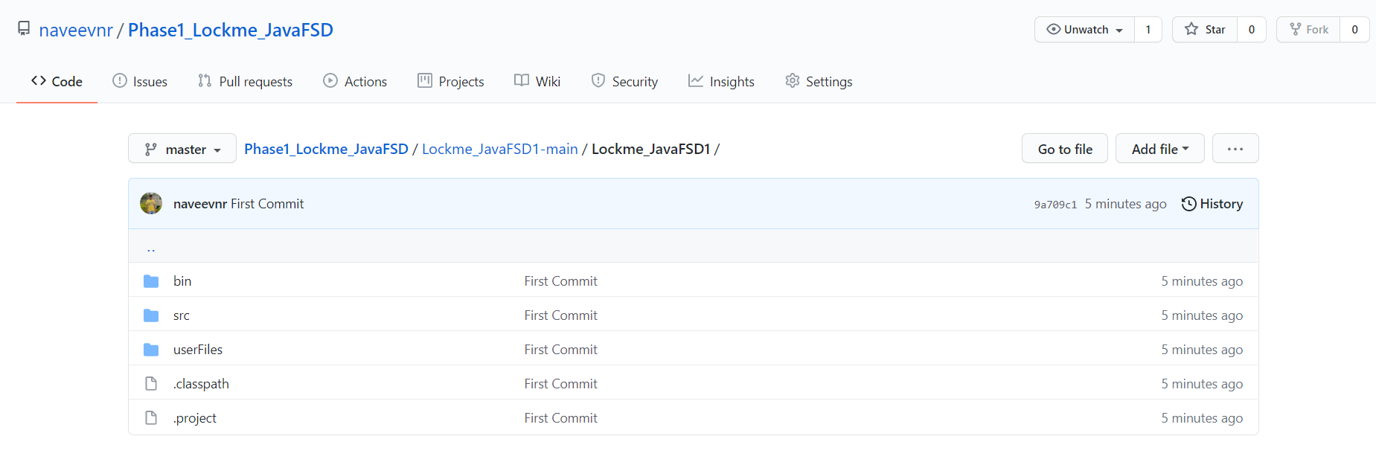

# 5. How to run project:

1. Clone the project: git clone https://github.com/naveevnr/ Phase1_Lockme_JavaFSD.git
2. Open the project in Eclipse : Welcome.java🡪 and Run as Java application

# 6. Directory Structure/ Package:

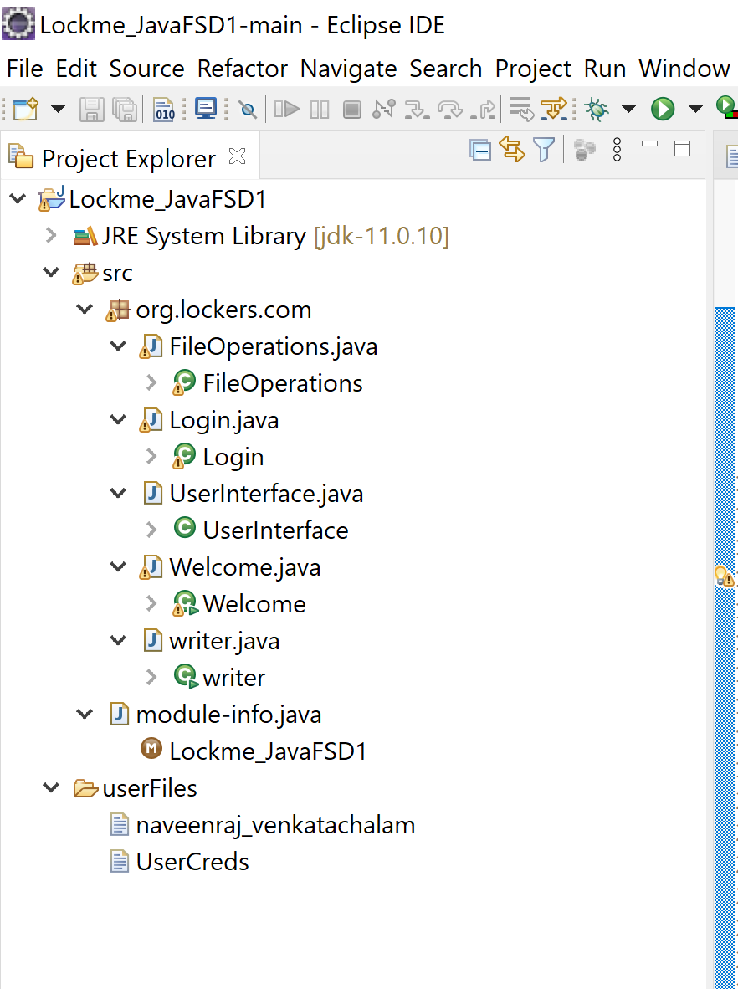

# 7. Source Code Files:

* Welcome.java
* Login.java
* UserInterface.java
* FileOperations.Java
* writer.java

# 8. Output Screenshots:

1. Welcome Screen

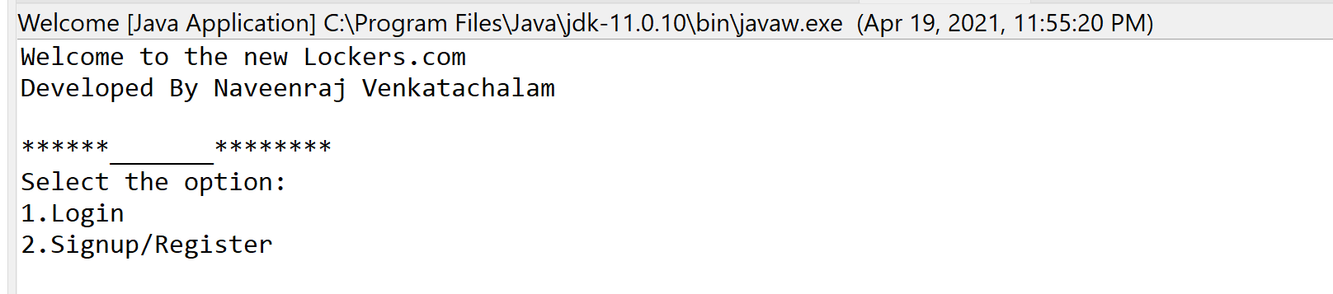

1. New User Registration

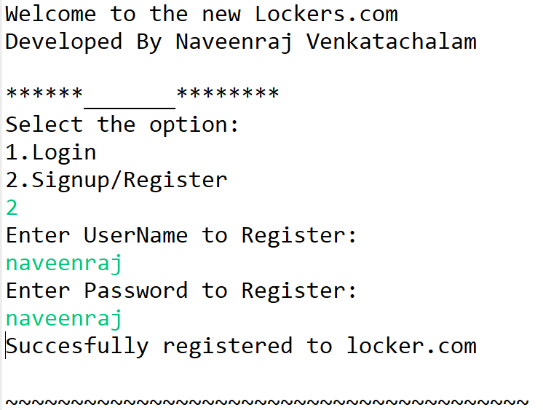

1. Invalid Login credentials:

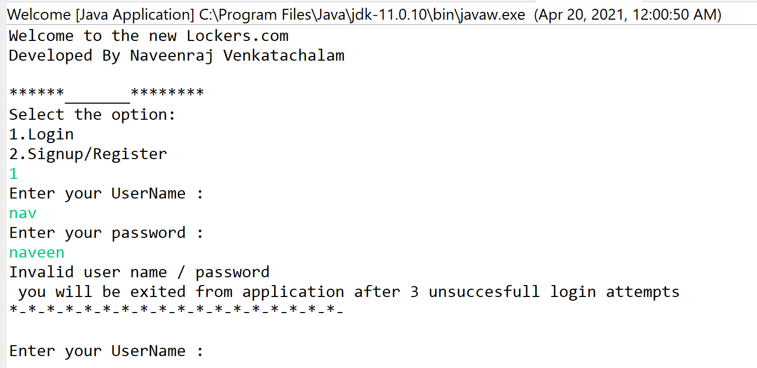

1. Login Page

* 1. Business Level Operations:

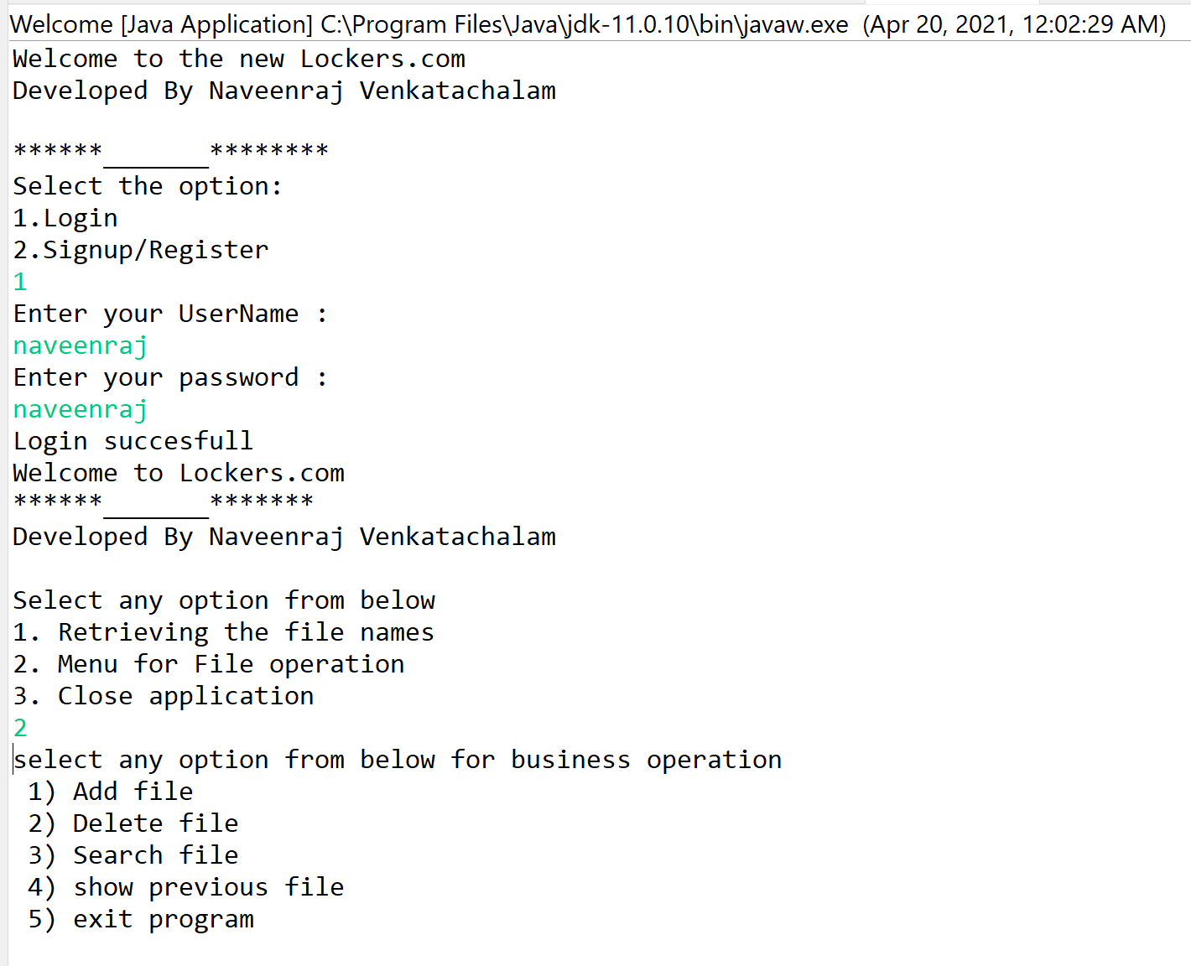

4.2.1 Add a file to the application:

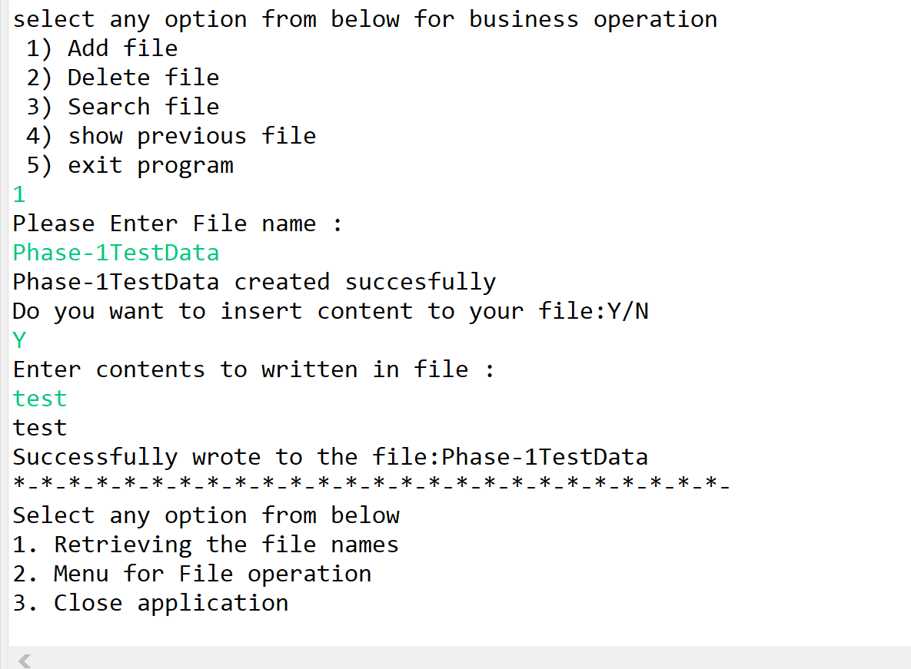

4.2.2 Delete an existing file from application:

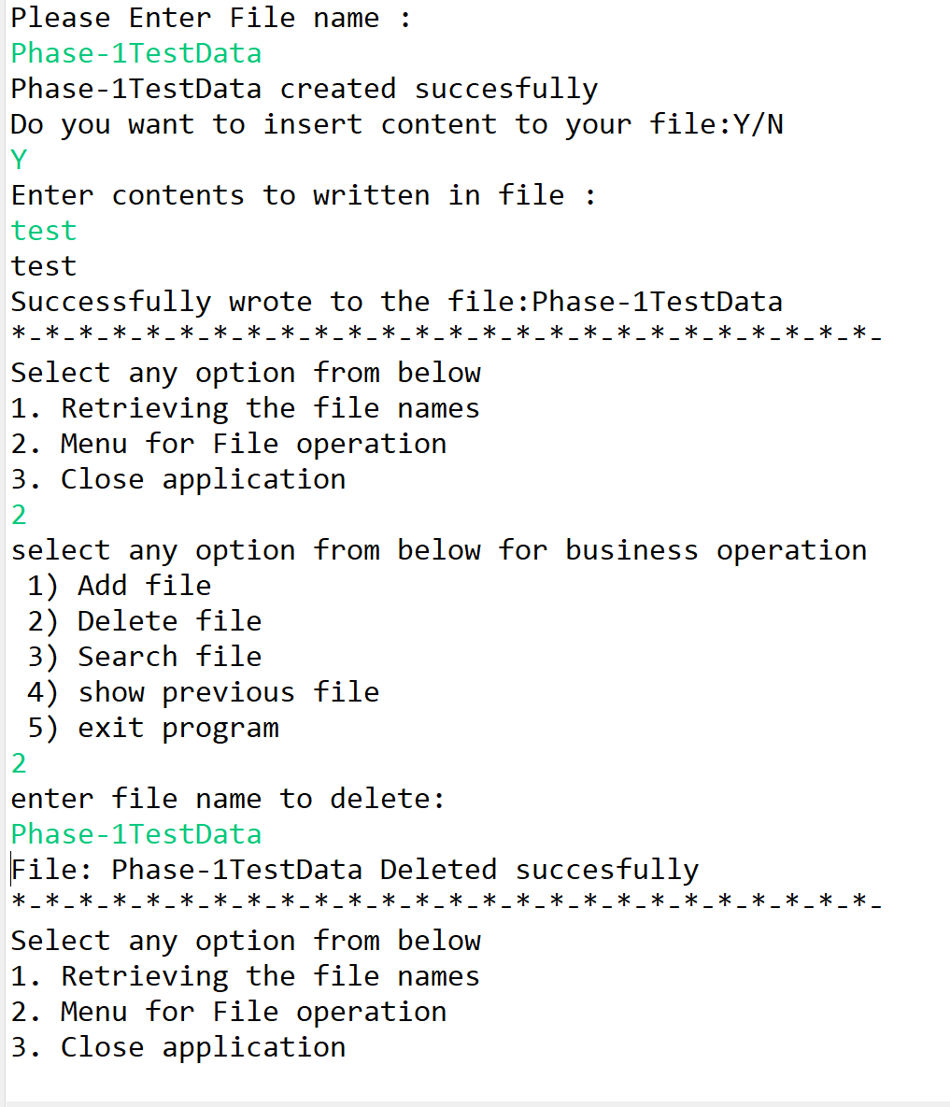

4.2.3 Search a file from an application:

Result upon un-successful operation

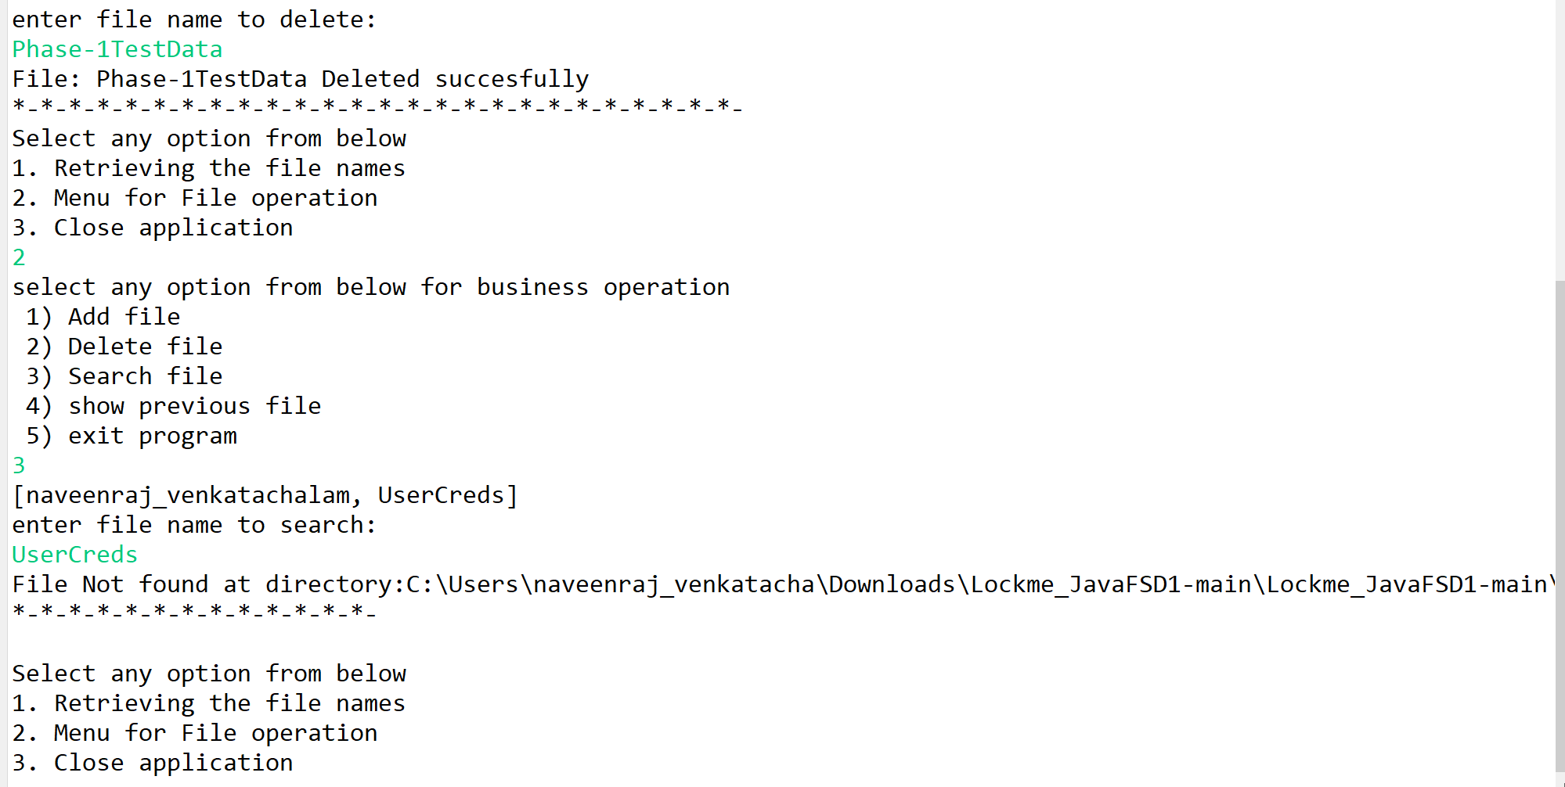

1. Close the Application:

