Sealoc Control Protocols

To interface with the Sealoc ProLoc or EcoView series of commercial/residential LCD Outdoor monitors with an RS232 enabled control device, connect to your monitor as shown in figure 3-6. Use a straight thru cable.

Figure 3-6
DB-9 Connector
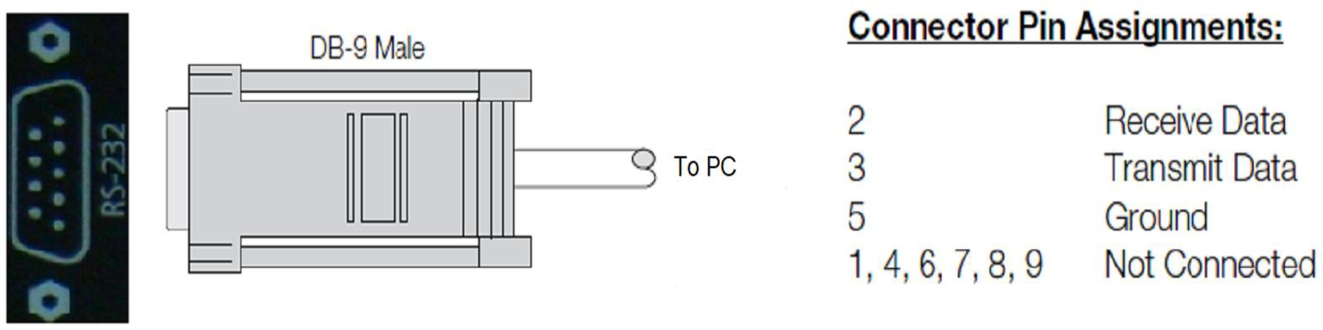

Configure the RS-232 controller or PC serial port as follows:

- No Parity
- 8 Data Bits
- 1 Stop Bit
- No Flow Control
- Baud Rate 9600

Commands are in four-byte raw HEX format in the form of: Command + Data 1 + ID + Data2
- The Command Byte is always 0x69
- Data byte 1 defines which Command is to be executed e.g. 0xD1 (Power ON)
- ID byte is always 0x00, unless you have multiple displays and have assigned unique IDs
  - e.g. Display assigned ID is 1, ID byte is 0x01
- Data byte 2 is always 0x00 (this byte may be optional to include based on which control system you are using)

Command | Data 1 | ID | Data 2
0x69 | ex:0xD1 (Power On) | 0x00 | 0x00

To send a command from a PC running terminal emulation software, create either a separate script file for each command or a single script file containing all the commands along with logic to determine which command is to be sent.

When you send a valid command, the monitor executes it and acknowledges it with “OK”
EF 59 12 01 00
(0xEF 0x59 0x12 0x01 0x00).

Possible response:
0xEF 0x59 0x10 0x01 0x00 = ID 1, DONE
0xEF 0x59 0x11 0x01 0x00 = ID 1, BUSY
0xEF 0x59 0x12 0x01 0x00 = ID 1, OK
0xEF 0x59 0x13 0x01 0x00 = ID1, NG (no good)

Depending upon the command it may also return additional strings having to do with execution of that command.

When you send an invalid or unrecognized command the monitor ignores it and returns the NG response:
EF 59 13 01 00 (0xEF 0x59 0x13 0x01 0x00)

Serial Commands

Command | Data 1 | ID | Data 2
0x69 | 0x97: Menu | 0x00 | 0x00
0x69 | 0xA7: Left | 0x00 | 0x00
0x69 | 0xB7: Right | 0x00 | 0x00
0x69 | 0xC0: Mute Off | 0x00 | 0x00
0x69 | 0xC1: Mute On | 0x00 | 0x00
0x69 | 0xC2: Vol + | 0x00 | 0x00
0x69 | 0xC3: Vol - | 0x00 | 0x00
0x69 | 0xC7: Down | 0x00 | 0x00
0x69 | 0xD0: Power Off | 0x00 | 0x00
0x69 | 0xD1: Power On | 0x00 | 0x00
0x69 | 0xF7: Toggle Power | 0x00 | 0x00
0x69 | 0xD6: OK | 0x00 | 0x00
0x69 | 0xD7: Up | 0x00 | 0x00
0x69 | 0x67: HDMI 1 | 0x00 | 0x00
0x69 | 0xDA: HDMI 2 | 0x00 | 0x00
0x69 | 0xDB: HDMI 3 | 0x00 | 0x00
0x69 | 0x96: Auto Dim Toggle | 0x00 | 0x00

RS 232 AND IR KEY CODES

