GUAYAQUIL

Day 3

Experiences

Guayaquil Test Experiences 1
Family Well coordinated family and group activities where your skills will be delighted and you will discover your greatest potential as a human being
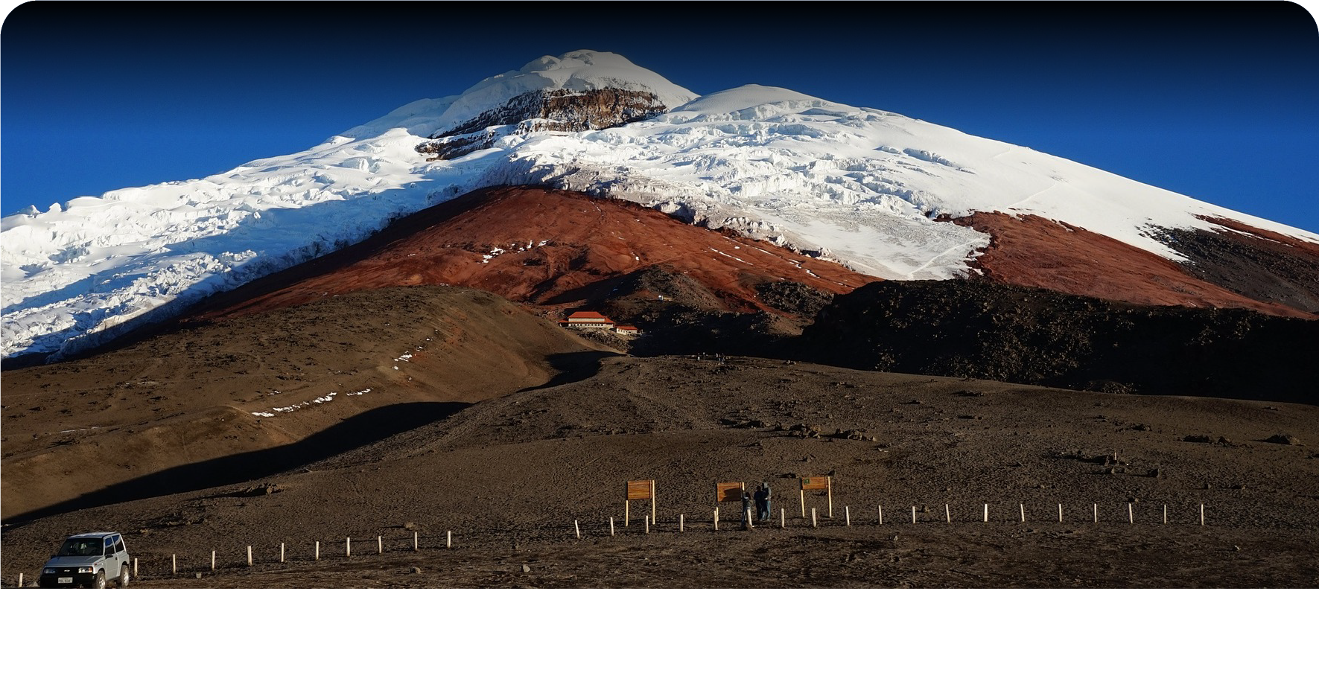
Next we're going to get, Special Coaching training with the owner of the Hotel where you will be finding a deeper family connection, wild and relaxing experiences, or for some life empowerment

Guayaquil Test Experiences 2
Family Well coordinated family and group activities where your skills will be delighted and you will discover your greatest potential as a human being
Next we're going back to hotel to rest and take a meal
B/L/D/O

Departure

Experiences

Guayaquil Test Experiences 1
Family Well coordinated family and group activities where your skills will be delighted and you will discover your greatest potential as a human being
Next we're going to get, Special Coaching training with the owner of the Hotel where you will be finding a deeper family connection, wild and relaxing experiences, or for some life empowerment

Guayaquil Test Experiences 2
Family Well coordinated family and group activities where your skills will be delighted and you will discover your greatest potential as a human being
Take any photos to go back to Home
B/L

