

ENCHANTING ECUADOR

JOSE CUEVAS x 10

4 Days / 3 Nights

Valid until 2022-03-09

FOR JOSE CUEVAS WE CREATED THIS TAILOR-MADE TOUR WITH A FOCUS ON TRANSFORMATIONAL AND SUSTAINABLE TRAVEL. THIS PACKAGE IS BASED ON TITLE

Shall we begin….

QUITO

Arrival

Experiences

Horsebackriding 2 horas-Adventure-Nature-7
Family Well coordinated family and group activities where your skills will be delighted and you will discover your greatest potential as a human being
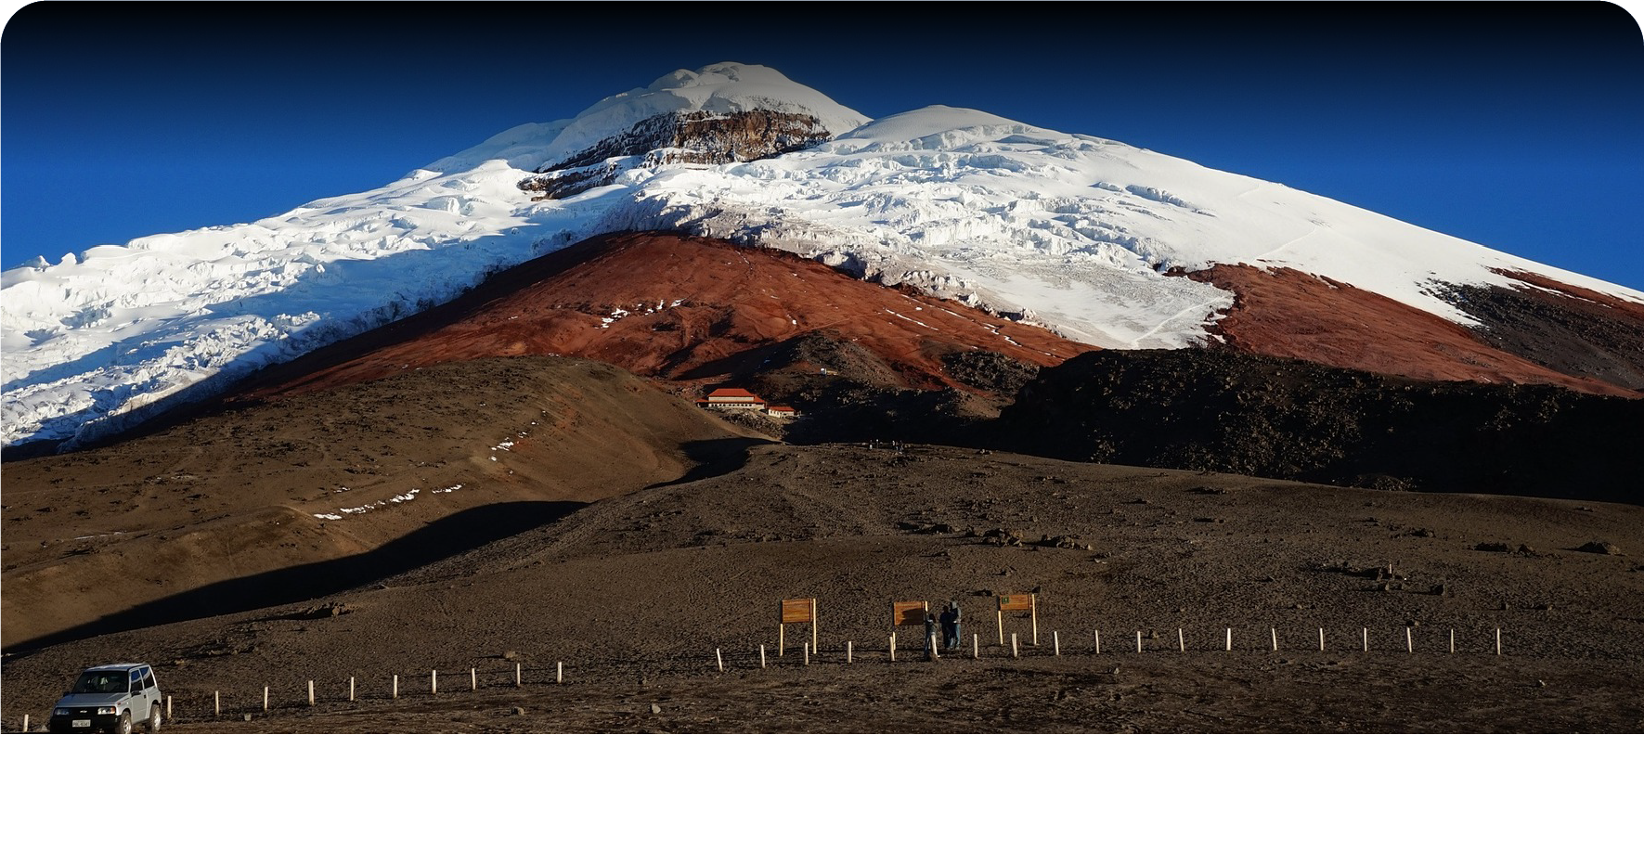
Next we're going to get, Special Coaching training with the owner of the Hotel where you will be finding a deeper family connection, wild and relaxing experiences, or for some life empowerment

Horsebackriding 2 horas-Adventure-Nature-8
Family Well coordinated family and group activities where your skills will be delighted and you will discover your greatest potential as a human being
Next we're going back to hotel to rest and take a meal
D/O

Day 1

Experiences

Temazcal-Wellness-Culture - History - Education-19
Family Well coordinated family and group activities where your skills will be delighted and you will discover your greatest potential as a human being
Next we're going to get, Special Coaching training with the owner of the Hotel where you will be finding a deeper family connection, wild and relaxing experiences, or for some life empowerment

Temazcal-Wellness-Culture - History - Education-9
Family Well coordinated family and group activities where your skills will be delighted and you will discover your greatest potential as a human being
Next we're going back to hotel to rest and take a meal
B/L/D/O

Day 2

Experiences

High and Low Ropes Course-Adventure-Surprise-11
Family Well coordinated family and group activities where your skills will be delighted and you will discover your greatest potential as a human being
Next we're going to get, Special Coaching training with the owner of the Hotel where you will be finding a deeper family connection, wild and relaxing experiences, or for some life empowerment

High and Low Ropes Course-Adventure-Surprise-10
Family Well coordinated family and group activities where your skills will be delighted and you will discover your greatest potential as a human being
Next we're going back to hotel to rest and take a meal
B/L/D/O

GUAYAQUIL

Day 3

Experiences

Guayaquil Test Experiences 1
Family Well coordinated family and group activities where your skills will be delighted and you will discover your greatest potential as a human being
Next we're going to get, Special Coaching training with the owner of the Hotel where you will be finding a deeper family connection, wild and relaxing experiences, or for some life empowerment

Guayaquil Test Experiences 2
Family Well coordinated family and group activities where your skills will be delighted and you will discover your greatest potential as a human being
Next we're going back to hotel to rest and take a meal
B/L/D/O

