GUAYAQUIL

# Day 3

## Experiences

### Guayaquil Test Experiences 1

Family Well coordinated family and group activities where your skills will be delighted and you will discover your greatest potential as a human being

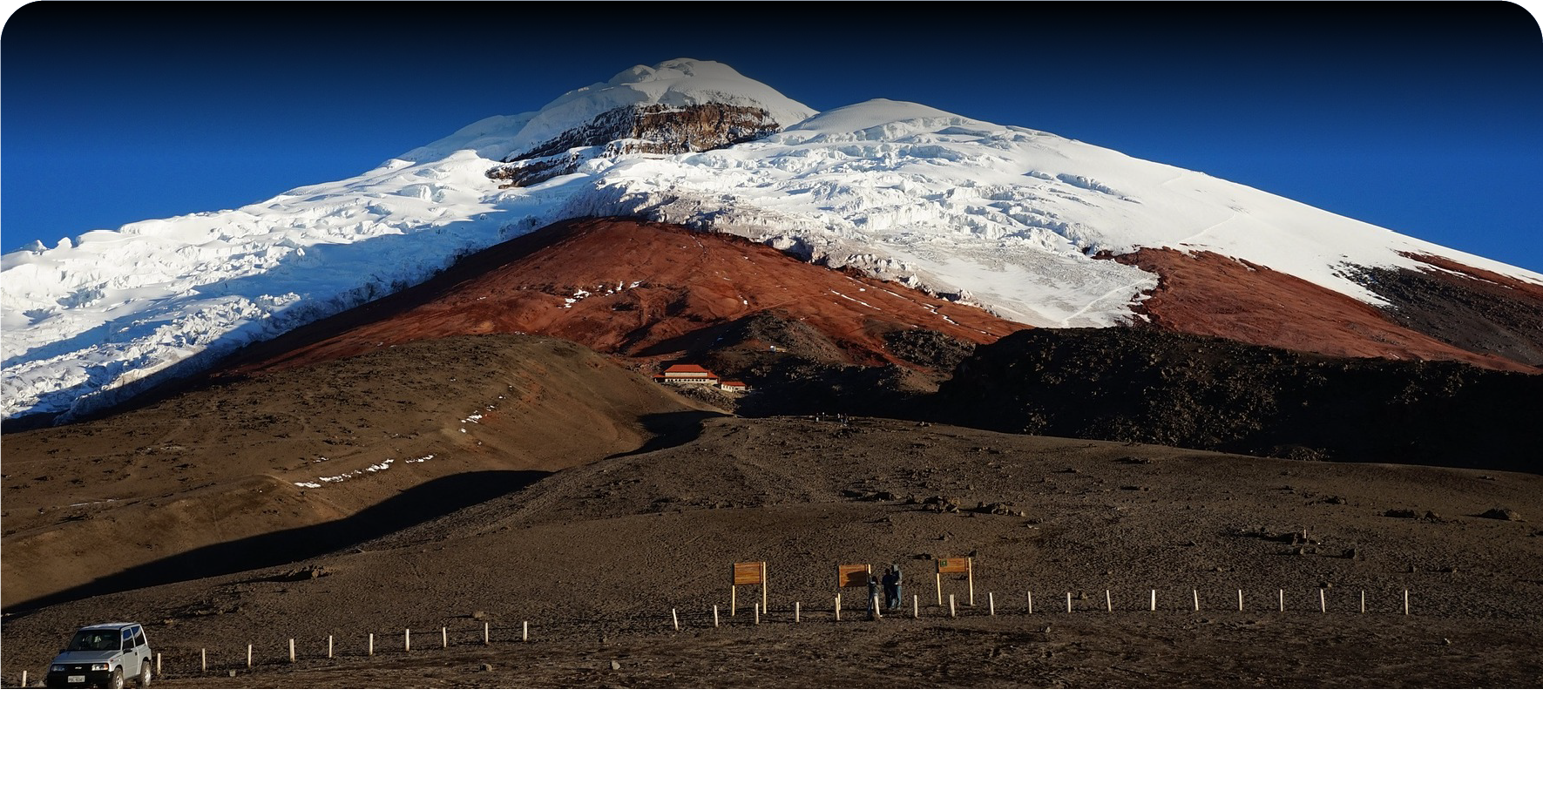

Next we're going to get, Special Coaching training with the owner of the Hotel where you will be finding a deeper family connection, wild and relaxing experiences, or for some life empowerment

### Guayaquil Test Experiences 2

Family Well coordinated family and group activities where your skills will be delighted and you will discover your greatest potential as a human being



Next we're going back to hotel to rest and take a meal

B/L/D/O