## 

**ENCHANTING ECUADOR**

**Kirby x 4  
8 Days / 7 Nights**

**TOUR CREATED FOR CNH TOURS WITH UNIQUE AND TRANSFORMATIONAL EXPERIENCES IN ECUADOR**

**Valid until December 31st, 2022**

**DAY 1 Trf In Guayaquil – Guayaquil City Tour**

**Thursday 17TH Mar 2022**

Your arrival, welcome to Ecuador Continental Part from an amazing Galapagos Trip!!

Are you ready to experience a tour that will create inspirational moments. Let´s start!!!!

Once you arrive at the José Joaquin de Olmedo airport , our local guide would take you to the hotel

where you will stay during your time in Guayaquil

In few minutes our local guide will be waiting for you on the hotel lobby in order to start the

Guayaquil City Tour.

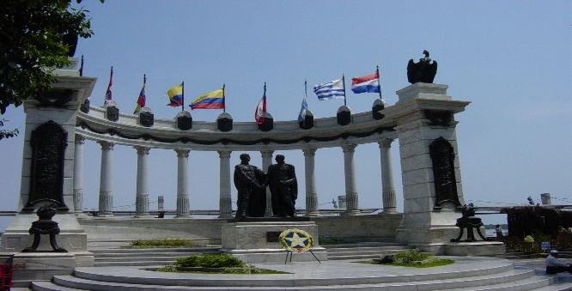 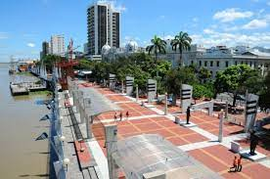

We would start the tour with the main tourist attractions from Guayaquil´s harbor, the main trade business part of the city, the Centennial Park, which has a monument in memory of the heroes of Guayaquil´s independence, Plaza de la Administration, the buildings of the city hall and the governance, the watch´s Morisca Towel, Sucre´s monument, and Bolivar´s Park where there is a statue of Simon Bolivar the main liberator of South America.

This park is also known as the Iguanas´ park due to the presence of iguanas hanging from the green leaps of the trees. On a side of the park there is the Neo-gothic style Metropolitan cathedral. Then we will go to the Chrystal Palace, Plaza de la Integration, Plaza de las Banderas and Plaza Olmedo, which are next to each other on the south side of the city and through the marvelous Malecon 2000.

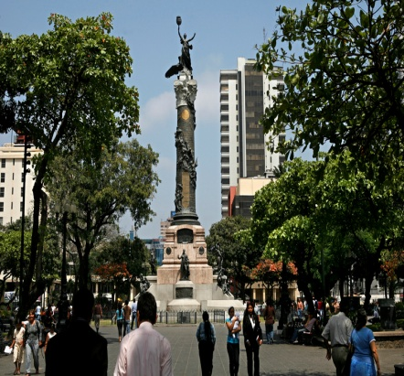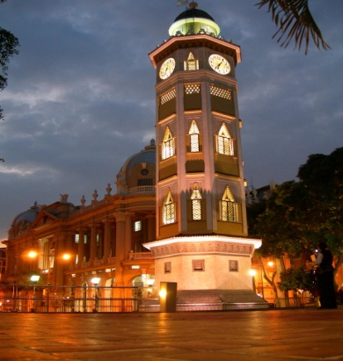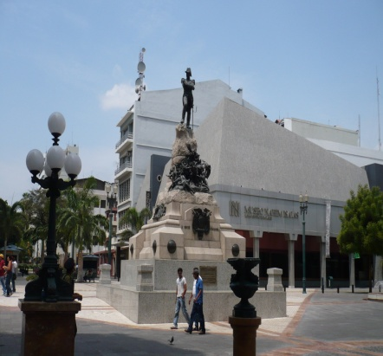

Up north is the Cerro Santa Ana, which has the oldest neighborhood in the city of Guayaquil calling Las Peñas. Las Peñas has been successfully renewed and built in wooden constructions painted on shiny colors, where some art galleries are operating for the public. A view from the Guayaquil´s cementery allows watching the extraordinary marble scultures made by Italian artists. The tour also includes the visit to the Malecon Del Salado.

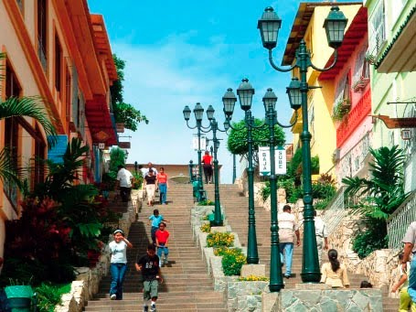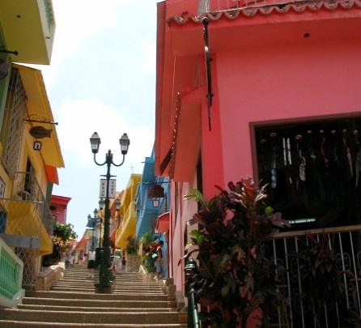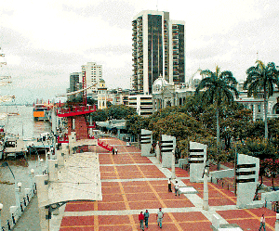

At the end of the Guayaquil tour, we will have the opportunity to go to a restaurant located at the Malecon in order to Experience an optional unforgettable dinner along with some traditional music such as the Pasillos, which derivate from the Vienna Waltz developed by Europeans in the Andean region of the Gran Colombia in the XVIII century- all this while you enjoy the view of the city during the evening. Dinner is not included

After this first important impression we invite you to relax and enjoy the city at night!!!

Accommodation: Hotel Whyndham DBL Standard Room

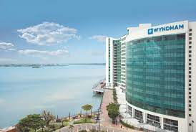 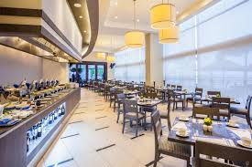

B/-/-/O

**DAY 2 Guayaquil – Cuenca (Cajas National Park – Cuenca City Tour)**

**Friday 18TH Mar 2022**

Immediately after a nice recovery and a healthy breakfast, we head northwest toward the Cajas

National Park. After a short drive,

we can make some quick stops at the Park to take some pictures of the beautiful lakes and lagoons

from this region

We visit the Interpretation Centre located on Lake La Toreadora (the largest and most important in

the entire complex). Here we see pictures and interpretations of the park.

Let´s make a nice stop at a beautiful place where we are going to have our lunch. We will stop at

Hostería Dos Chorreras. You will be surprised all the beauty of this place and the delicious food.

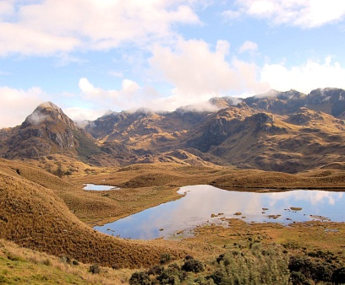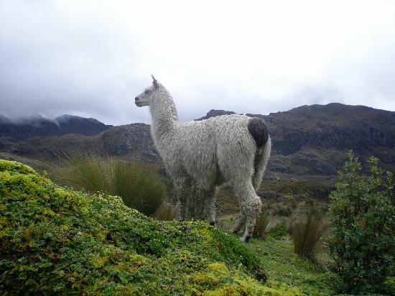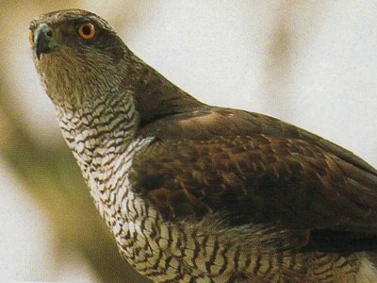

After a quick visit to this beautiful National Park we continue our trip to the emblematic city of Cuenca. We will start the colonial city tour of the colonial section of Cuenca. Cuenca is the cultural capital of Ecuador and the center of art and craft. The cozy and nostalgic atmosphere is enhanced by the cobblestone sidewalks, flower-filled squares and noble facades with their ornate iron balconies.

After discovering unique and secret places we will enjoy a free evening for an special optional dinner.

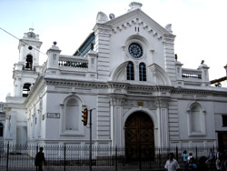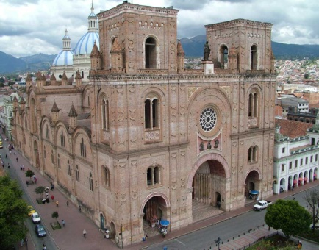 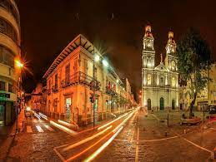

In the evening we will transfer you to the emblematic Hotel Cruz del Vado.

Located in the Historical Downtown of the cultural capital of Ecuador, Cuenca. Hotel Cruz del Vado takes us into one of the most important colonial houses of this city. Its pink marble façade is an example of the luxurious lifestyle enjoyed in the republican era. Located near La Cruz del Vado, hence its name, the hotel is in the oldest neighborhood of beautiful Cuenca which also carries the Cultural Heritage of Humanity title by UNESCO.

Overnight in Hotel Cruz del Vado ROH Double Room

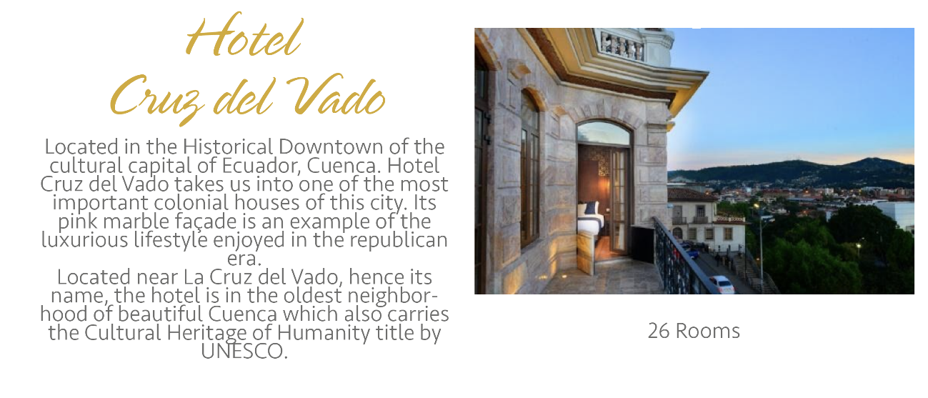

B/L/-/O

**DAY 3 CUENCA (Transformational Tours)**

**Saturday 19TH Mar 2022**

After an Ecuadorian heathy breakfast, with a one of a kind view, you are going to be surprised by our exclusive tour in the city. Starting or ending in the oldest neighborhood right outside of the Hotel, you will explore what we like to call The Culture of El Vado. Cuenca is also known as the Cultural Capital of Ecuador, and “cuencanos” take this seriously. Explore with us the meticulous work made by skillful artisans.

**The Blacksmith**

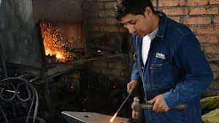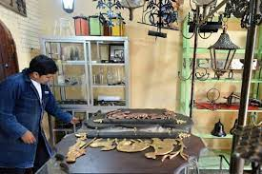

The small traditional street that crosses “Las Herrerías” neighborhood, houses the workshop of Don Sergio Guerra, who, for more than 25 years, has been working in the traditional craft of the arts of fire. In his workshop, he shapes various pieces by hammer and anvil. The “Herrero” manufactures anything from antique style door locks to the coronation roosters of the traditional houses of Cuenca. Accompany him during his workday and he’ll even allow you to forge your own figure. Natural forms, padlocks, horseshoes and various handcrafted pieces take shape in his workshop, which is surely a place to be visited.

We will pause and eat in an emblematic traditional restaurant in the city to have energy for our next visit.

**The Woodworker**

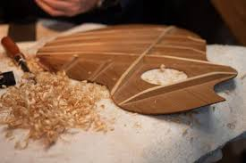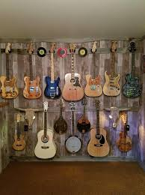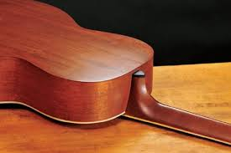

At the entrance to this workshop, in the traditional neighborhood of Vado, you can find a unique aroma of wood. Here some of the most famous guitars in the country are manufactured. This craftsman tells us about his process, how he treats and works the wood to give it the shape of a guitar, charango or even a cuatro. The tuning is everything, some of their pieces take up to 6 months to complete, national and international artists commission the development of their instruments to this skillful instrument maker who embeds pieces of ivory and marble customized according to the taste of the artist who commissioned its development. Admiring this fine work and then listening to a melody from one of his creations is undoubtedly a sight worthy of applause.

Now some down time, exploring antiques of all sorts.

**The Antique Gallery**

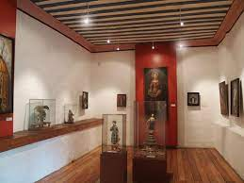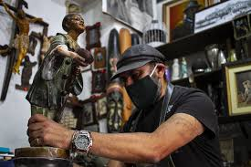

On La Condamine Street there is a private gallery, where you can recall history through the pieces on exhibit. The show is infinite: toys, cameras, saints and religious figures, instruments and many items that define eras and represent the way of life of the aristocracy of Cuenca in past times.

With energy recharged, we want you to use your hands and imagination for the next stop.

**The Potter**

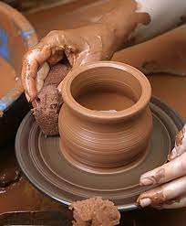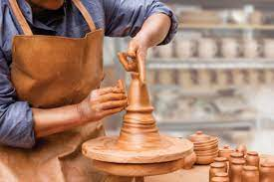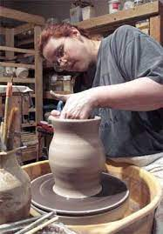

For this family pottery is a way of life that has been passed down from generation to generation. Warmly opening the doors to their home-workshop, Don Juan tells you the story of how he has been practicing with clay since he was a child and that after more than 40 years he is just now perfecting his skills. In the workshop, located in La Convención district, unique pieces of clay are formed and then baked at thousands of degrees to obtain a unique black finish. The potter teaches you how to work the clay in his lathe to make all types of pots and the various pieces that are manufactured there.

Be prepared for an exclusive optional dinner in Cuenca to discover the unique flavors of the local cuisine.

Prepare for a nice rest. After a busy day you are going to need it.

Overnight in Hotel Cruz del Vado ROH Double Room

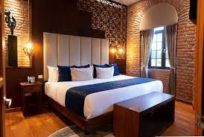 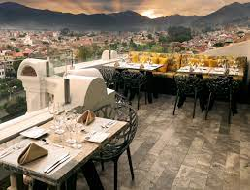

B/L/-/O

**DAY 4 Cuenca – Riobamba (Ingapirca Ruins – Alausi – Guamote – Balbanera – Colta)**

**Sunday 20th Mar 2022**

After an early breakfast the tour begins departing Cuenca to Riobamba into the north direction, our

first stop will be at the the Ingapirca fortress, located at 3100m above sea level. These ancient ruins

are the most important in the country. Their true history is still a mystery, as studies state they could

have been a fortress, an observatory or a temple. We will stop at Posada Ingapirca for a unique

Ecuadorian lunch.

After visiting the Inca Ruins we will make several stops, visiting Alausi, the indigenous town of

Guamote (Note, Thursday is market day). the Balbanera Church, Colta Lake

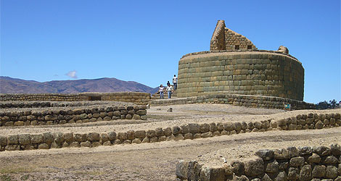 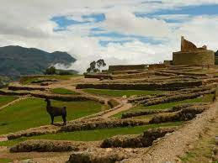 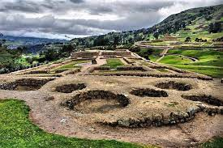

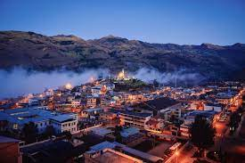 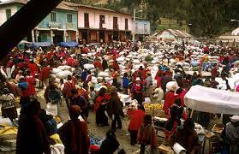 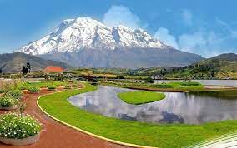

After these visits we finish our day at Riobamba. I hope you had a great day visiting this amazing places. The adventure is not over yet.

Optional Dinner at the hotel.

Accommodation in Abraspungo Hotel DBL Standard.

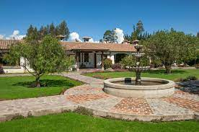 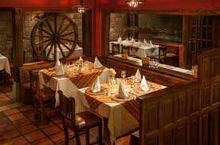

B/L/-/O

**DAY 5 Riobamba –** **Cotopaxi (Quilotoa – San José de Sigchos)**

**Monday 21st Mar 2022**

Today it is going to be cold but the beauty of the landscapes will warm your heart. We will have

breakfast before our departure heading west into the heartlands of Ecuador.

We will take the Panamaericana avenue until we arrive to the route called Pujilí’s Way, passing

through Quilotoa, stopping at Pujili’s Market (only Wednesdays and Sundays), the little village of

Tigua with its artesian paintings and finally, the colorful market of Zumbahua (only Saturdays). This

route has some of the most spectacular landscapes of Ecuador. Arriving at Quilotoa’s crater we will

get a chance to visit the green-blue colored lake inside from two different viewpoints. Shalala

Viewpoint and the regular viewpoint in Quilotoa.. Attendees will be allowed to walk down to the lake

Border and return up again by mule. Lunch at a traditional resrtaurant with a nice view of the

Lagoon Chuquirahua Restaurant.

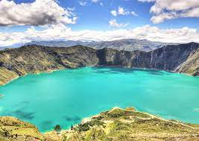 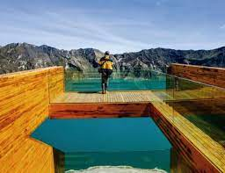 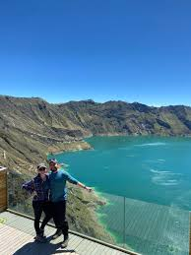

In the afternoon we will continue our trip to our Hostería In Sigchos called San José de Sigchos

where we are going to enjoy the rest of the evening and our accommodation.

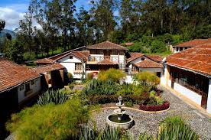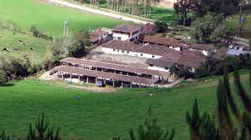

Safe your energy for the next days, You are going to need it.

Optional Dinner at the hotel.

Accommodation at San José de Sigchos Junior Suite Double Room

B/L/-/O

**DAY 6 Cotopaxi – Quito (Parque Nacional Cotopaxi)**

**Tuesday 22nd Mar 2022**

After breakfast we will be ready for the start of our trip to Cotopaxi National Park, which is located at

59.54 km from the city of Quito.

The Cotopaxi volcano is one of the most important points of reference because it is the second

highest active volcano in the world.

Its lush endemic flora and fauna will allow us to see the representative species as Chuquiragua (also

known as the flower of the mountaineer), wild horses, deer, llamas and more. While we are there,

you can explore the lagoon Limpiopungo, located near the volcano Rumiñahui (149.96 meters), or

can hike to observe birds.

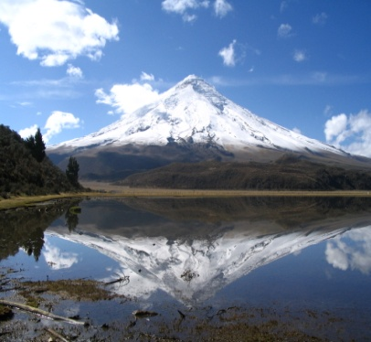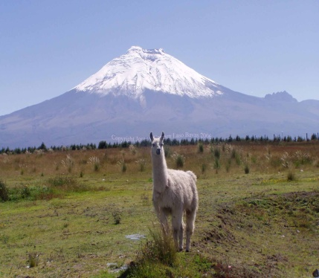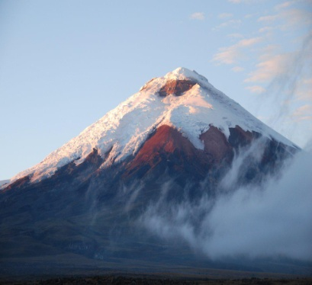

After this visit we will stop on the way at one restaurant with a nice view of the volcanoes which is called Mirador de los Volcanoes on the way to Quito.

In the evening we will transfer you to the emblematic and historical Mama Cuchara Hotel.

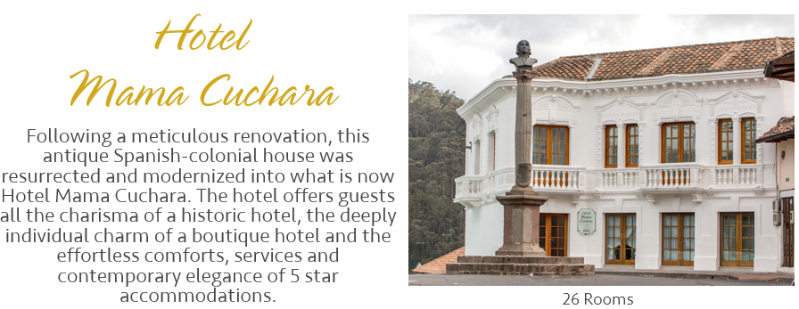

Hotel Mama Cuchara in Quito’s old town will be waiting for you. Set in the traditional and one of the last living neighborhoods, La Loma Grande (“The Big Hill”), many generations of neighbors still live there, withholding hidden yet enchanting places you will enjoy.

Free evening for an optional dinner at our splendid rooftop of our hotel,

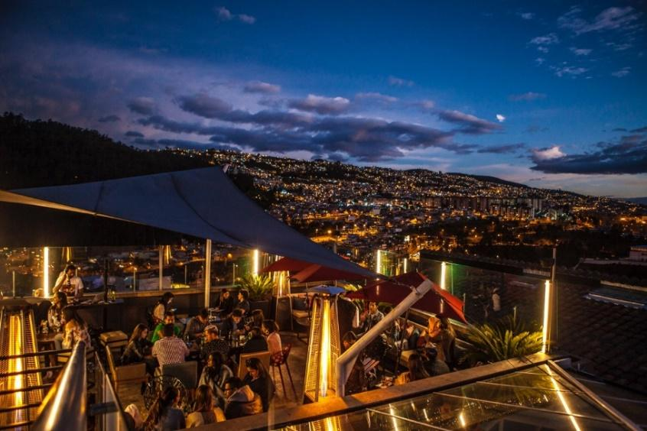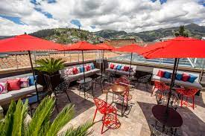

Overnight at Mama Cuchara Hotel ROH Double Room

B/L/-/O

**DAY 7 Quito (Transformational Tours and Old town City Tour)**

**Wednesday 23th Mar 2022**

After a tasty and healthy breakfast at our beautiful La Plaza Restaurant we invite you to take of part of

an exclusive tour in Quito

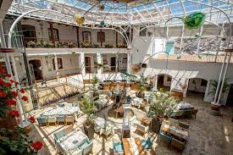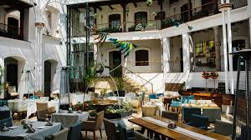

On this day, you will walk through our Enchanted Hill, visiting each corner that offers us wonderful surprises.

The privileged location of Hotel Mama Cuchara gives the opportunity to explore the emblematic neighborhood of the city of Quito, the Loma Grande. Traditions, artisans, and delicacies are now part of our offer to our guests. We invite you to discover every corner with us.

**The Domes of Santo Domingo Church and Chapel of the Rosary**

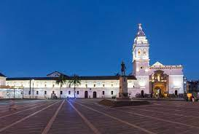 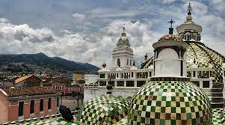

Located between the streets of Guayaquil and Rocafuerte the 16th century Church of Santo Domingo is a site that you should not miss.

It was initially built by Dominican Priests, with contributions by various notable artists from Quito such as, Bernardo Legarda, Miguel de Santiago and Fray Pedro Bedón. Due to this fusion, the church has a large amount of Baroque as well as Neoclassical details, and a variety of artwork including sculptures and paintings which leave visitors in awe.

The late 17th century Chapel of La Virgen del Rosario is located on one side of the church's central nave. Thus creating the famous arch of the Church of Santo Domingo, which supports the Chapel over Rocafuerte Street.

In the chapel you can see the sculpture of the Virgin of the Rosary that was a gift from King Charles V of Spain to Quito. The decoration of this chapel conserves the pure essence of Baroque Quito – golden paintings and carvings on a red backdrop earn its consideration as one of the architectural gems of the historic center of Quito.

Visiting the domes of this church is a worthy memory to take from your visit to Quito and the neighborhood of La Loma Grande. Be sure to bring your camera as you explore one of the best views of the old town!

Library of Santo Domingo

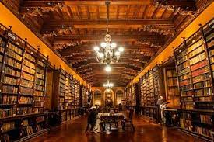 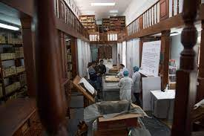

In the convent where the "San Fernando" school was founded, the Fray Pedro Bedón Museum carefully guards several treasures from the Dominican epoch. Their legacy includes more than 30,000 ancient books which emphasize different subjects such as philosophy, theology, social sciences, architecture, and medicine.

It is possible to visit this place and to learn some of its treasures is possible from the hand of its custodian.

After seeing such an incredible place, we have to meet an incredible human being, his passion will enchant you.

El Caretero

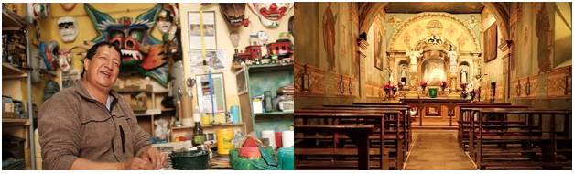

In La Loma Grande neighborhood discover a place as magical as the people who live and work in it. For more than two decades, El Caretero has been making beautiful handmade paper and cardboard masks which are representations of Ecuadorian popular culture.

They are made with the same techniques of yesteryear, in clay molds and paste, which are then painted completely by hand. In addition, El Caretero of la Loma Grande exhibits a demonstration of skill when creating unique pieces by hand and invites you to participate in its creation. Discover and learn how his process is and let yourself be charmed by its art and tradition.

We will pause our tour in a traditional restaurant in the old town to taste our quiteña typical cuisine.

In the afternoon we will be visiting the main churches and plazas in the old town. Enjoy an eloquent description of each site and its history.

I hope you discovered the magical history of the city. Be prepared to enjoy a wonderful dinner. We recommend you some emblematic restaurants in the city.

Free evening for dinner.

After a long day prepare for a nice rest. Overnight in Hotel Mama Cuchara

Overnight at Mama Cuchara Hotel ROH Double Room

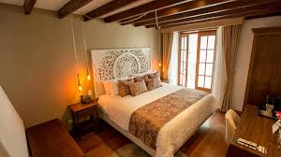 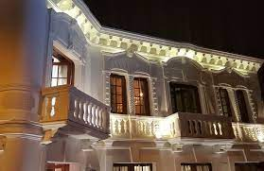

B/L/-/O

**DAY 8 Quito (Trf Out)**

**Thursday 24th Mar 2022**

I hope you really enjoy this adventure called Ecuador. We hope you never forget this trip..

Take one last picture of Quito while having breakfast, because you are going home.

Transfer out to the Airport and final connection with international flight.

B/

*}*

*END OF SERVICES*

**Meals**

**B = Breakfast**

**L= Lunch**

**LB= Lunch Box**

**D = Dinner**

**O = Overnight**

**NET RATES**

In USD, per person, including taxes.

|  |  |
| --- | --- |
| **ROOM TYPE** | **4 GUESTS 2 double Room p/P** |
| **See the Itinerary** | $ 3290 |

**INCLUDED**

* Meals described in the tour
* Guidance
* Transportation
* 2 Double Rooms
* Entrance Fees to churches and museums
* Activities with local entrepreneurs

**NOT INCLUDED**

* International and National Air tickets
* Alcoholic beverages
* Dinner (Each day)
* Gratuity/Tips
* Personal expenses (late check-out, gifts, etc.)
* Meals not described in the program