X100: HVLP and system set parameters to improve pump behavior and stability

Table des matières
1 Tools 2
2 Recording with DVT 2
3 Connect to inverter through DVT and update parameters. 4
4 System level evolution 6

Tools
Parameters are updated both at system level and at HVLP parameters level.
- For system level, A software 35.39 or later must be insalled.
  - If already installed, all the parameters can be adjusted from interface
  - If not installed we’ll need to update the software: locally, IXXAT+IQAN Run, or remotely IQANGo + good internet connection.
  - For HVLP level, we need locally to connect to HVLP through the software DVT, supplied by BorgWarner. (See Appendix for installation)

Recording with DVT
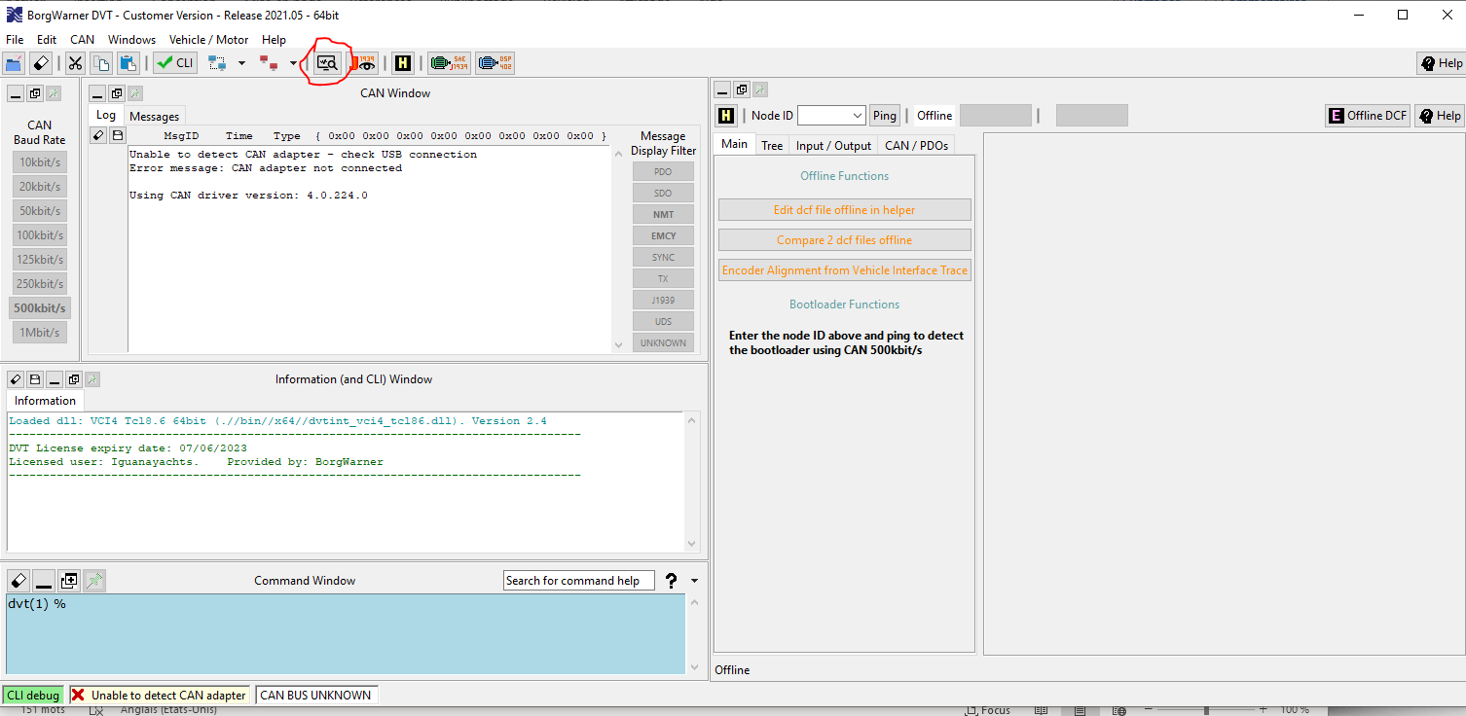
To record a CAN Trace press the button above
A windows pops showing all the current parameters of the HVLP, with:
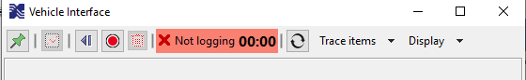
On top, the go / stop / pause / reset button for recording
Trace Items menu allows to adapt the values that will be raised, and Display give some options (display units, values, etc…)

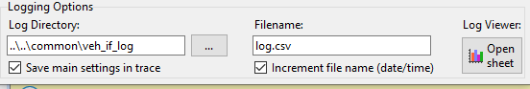
On bottom, The logging option to setup the file.
The log viewer button opens an excell spreadsheet including VBA Macro to clean and present the CAN Trace in lists and curves.
This Macro must be corrected at the first use, as below:
An error will be raised at the first use:
Open the debug tool
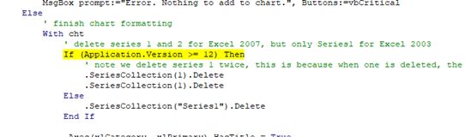
Correct with Val(Application.version), as below
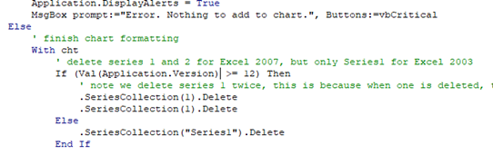
Save the file and close the debug.

IMPORTANT:
- All CanTrace are time based, and this time base is used throughout all the recording unless it is restted to 0. It can be easier to reset it regurlarly.
- Try to limit recoding size as VBA macro is not very fast.

The typical cycle to test the pump stability is the tensionning:
- Go to Maintenance / Untighten, lauch recording, and go back to Auto.

Once it seems to work properly, record a complete up/down of the tracks.

Connect to inverter through DVT and update parameters.

Connect the IXXAT to the CAN that includes the HVLP (J1939, for a X100)
Mind that the HVLP must be powered. Start the IMS or use Menu/Special Feature / Power Controller Force to power the HVLP.
The first time you connect to an inverter from a newly insalled software, it can ask to rebuild a file to acess the full capability of the tool: Press yes.
To change parameters, go to H menu.
Tree View is the most user friendly:
Go to Torque conditionner. Set Torque rate to 200 Nm/s both direction
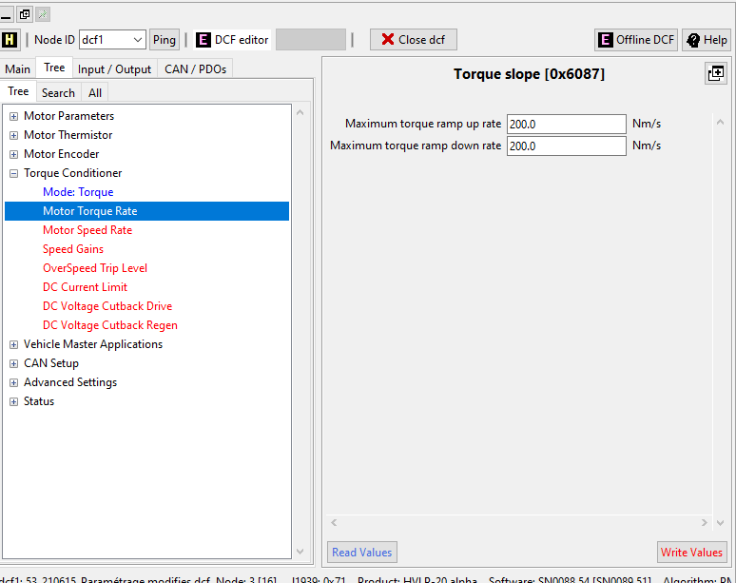

Go to Motor speed Rate, and set as below:
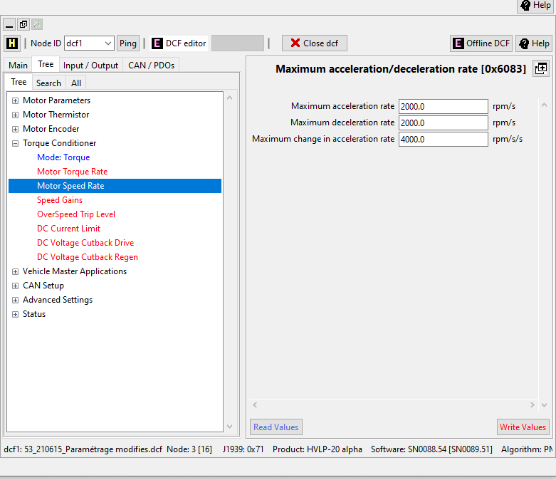

System level evolution
- Time to tension: increase the minimum running time of the pump when tensionning
  - The parameter is in Master tracks menu, default value is 150ms.
  - Increasing the parameter will reduce the niumber of dummy tensionning phases
  - The parameter could affect the tensionning pressure final value: check each change with a untightent / auto cycle
  - A good set up could be 300 to 500ms
- EV Bloc delay:
  - It delays the opening of the valve of the blocker
  - A good value is 300ms.

