

NavGurukul Foundation For Social Welfare

Date: 10-11-2022

**Dear**

**Congratulations!**

On behalf of the NavGurukul Admissions Team, we are delighted to offer you admission to the **NavGurukul Software Engineering Scholarship**.

Your hard work and persistence during the selection process convinced us that you have the right energy and talent to make great use of this opportunity. We are thrilled to welcome you to the **NavGurukul family**.

NavGurukul was started with a vision to enable each and every student to have access to a meaningful and high-growth career. We believe that everyone, irrespective of their social standing and resources has the potential for growth and excellence. Our focus is to empower you to have a choice and a voice - to bring good to you, your family and the community alike.

This scholarship is going to involve **exceptional hard work**, dedication and community work from your end. While you work on your skills that will help you get a job and thrive at it, the program will also take you through a journey of self-inquiry through various experiences that will contribute to a fulfilling life ahead.

You have earned your way into the program, and we are excited to work with you in the year ahead. You have to confirm your joining date within a week of receipt of this admissions letter. To ensure the sanctity of the admission, we will conduct another test once you reach the campus. In case you are unable to clear the test on campus, your admission will be considered **invalid** and you will be asked to go home and reattempt.

Please find the **contact details below** for any help you need to plan your travel and arrival at our campus. Hoping to see you soon.

Warmly,

Ram Ashish Chauhan

Community Manager

www.navgurukul.org hi@navgurukul.org Ward number 202, Sukkhad (Garh, Dharamshala, Himachal Pradesh 176057



NavGurukul Foundation For Social Welfare

**Date: {DATED}**

**Dear {USERNAME}**

**Congratulations!**

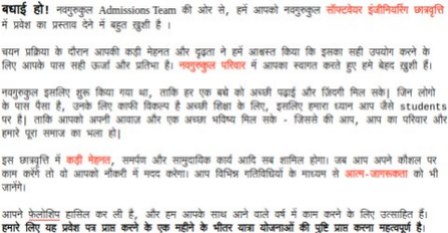

Warmly,

Ram Ashish Chauhan

Community Manager

www.navgurukul.org hi@navgurukul.org Ward number 202, Sukkhad (Garh, Dharamshala, Himachal Pradesh 176057