**Big Data Frameworks CSE3120**

Lab – 3 Hadoop introduction and HDFS commands

**Name:** Naveen Nidadavolu

**Roll No:** 22MIA1049

**1.Command: jps**

**Aim**: To verify Hadoop services using the jps command.

**Algorithm/Procedure**

1. Open the Hadoop terminal.
2. Run the jps command to list the Java processes running on your Hadoop cluster.
3. Confirm that the necessary services (NameNode, DataNode, ResourceManager, etc.) are running.

**Program/Output**

**Result**: Successfully verified the Hadoop services using the jps command.

**2.Command: mkdir**

**Aim**: To create a directory in HDFS using the mkdir command.

**Algorithm/Procedure**

1. Open your Hadoop terminal.
2. Use the hdfs dfs -mkdir /path/to/directory command to create a directory.
3. Confirm the directory's creation with the hdfs dfs -ls /path/to/ command.

**Program/Output**

**Result:** Successfully created the directory in HDFS using the mkdir command.

**3.Command: ls**

**Aim**: To list the contents of a directory in HDFS using the ls command.

**Algorithm/Procedure**

1. Open the Hadoop terminal.
2. Use the hdfs dfs -ls /path/to/directory command to list the contents of the specified directory.
3. Observe the listed files and directories with their details (e.g., permissions, owner, size).

**

**Result:** Successfully listed the contents of directory using the ls command.

**4.Command: touchz**

**Aim:** To create an empty file in HDFS using the touchz command.

**Algorithm/Procedure**

1. Open the Hadoop terminal.
2. Use the hdfs dfs -touchz /path/to/filename command to create an empty file.
3. Verify the file creation with hdfs dfs -ls /path/to/.

**Program/Output**

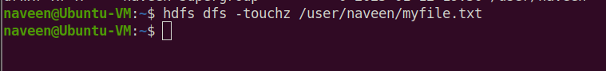

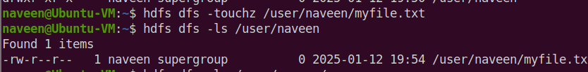

**Result**: Successfully created an empty file in HDFS using the touch command.

**5.Command: cat**

**Aim**: To display the contents of a file in HDFS using the cat command.

**Algorithm/Procedure**

1. Open the Hadoop terminal.
2. Use the hdfs dfs -cat /path/to/filename command to display file contents.
3. Observe the file's content in the terminal output.

**Program/Output**





**Result:** Successfully displayed the contents of /myfile.txt in HDFS.

**6.Command: cp**

**Aim:** To copy files within HDFS using the cp command.

**Algorithm/Procedure**

1. Open the Hadoop terminal.
2. Use the hdfs dfs -cp /source/path /destination/path command to copy a file or directory.
3. Verify the copied file's existence in the destination directory with hdfs dfs -ls.

**Result:** Successfully copied files using the cp command