Big Data Frameworks CSE3120
Lab – 1 Java Programs Experiment
Name: Naveen Nidadavolu
Roll No: 22MIA1049

1. Display odd numbers between 1 -100
Aim: To write a Java program that displays all odd numbers between 1 and 100.
Algorithm
- Start.
- Set the range limit n = 100.
- Use a for loop to iterate through numbers from 1 to n.
- Inside the loop, check if a number is odd using the condition i % 2 != 0:
  - If true, print the number.
- Stop.

Program:
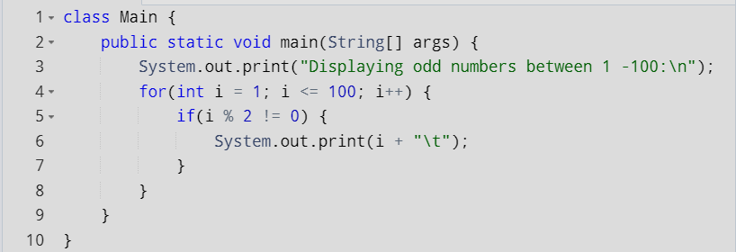

Output
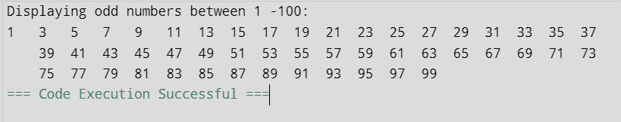
Result: The program successfully displays all odd numbers between 1 and 100.

2. Sum of odd numbers between 1 -100
Aim: To write a Java program that displays sum of odd numbers between 1 and 100.
Algorithm/Procedure
- Start.
- Initialize a variable sum = 0 to store the sum of odd numbers.
- Loop through numbers from i = 1 to i = 100 using a for loop:
- For each i, check if it is an odd number using i % 2 != 0.
- If true (the number is odd), add i to sum.
- After the loop ends, print the value of sum.
- Stop.
Program

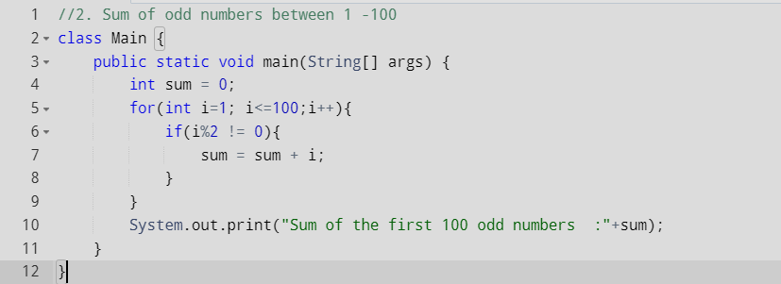

Output
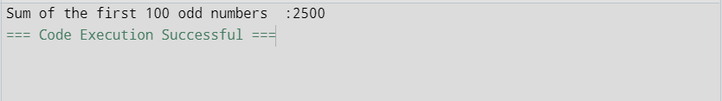

Result: The sum of all odd numbers between 1 and 100 is 2500. The code execution is successful.

3. Program to check the given number is Palindrome or not
Aim: To write a Java program to check whether a given number is a palindrome or not.
Algorithm/Procedure
- Start.
- Import the Scanner class for user input.
- Initialize two variables:
  - reversen = 0 (to store the reversed number).
  - remainder (to store each digit of the number).
- Accept an integer input n from the user.
- Store the original value of n in a new variable originalnum.
- Use a while loop to reverse the number:
  - Extract the last digit using remainder = n % 10.
  - Append the digit to the reversed number using reversen = (reversen * 10) + remainder.
  - Remove the last digit from n using n = n / 10.
- Compare originalnum and reversen:
  - If they are equal, print that the number is a palindrome.
  - Otherwise, print that the number is not a palindrome.
- Stop.

Program
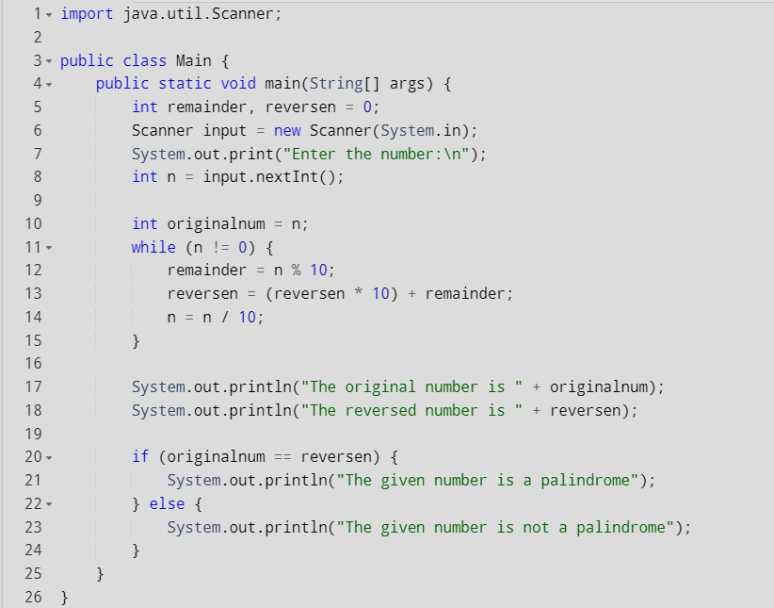

Output
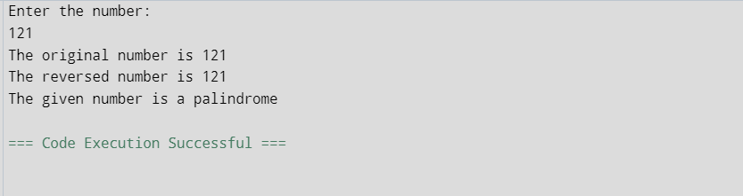
Result: The program successfully checks whether the given number is a palindrome or not.

Q4. Program to print patterns of numbers and stars
*
* *
* * *
* * * *

Aim: To write a Java program that prints a right-angled triangle pattern of stars.
Algorithm/Procedure
- Start.
- Declare an integer n for the number of rows.
- Use two nested for loops:
  - The outer loop runs from i = 0 to i < n (controls the rows).
  - The inner loop runs from j = 0 to j <= i (controls the columns and prints stars).
- In each iteration of the inner loop, print a star (*).
- Move to the next line after completing a row.
- Stop.

Program:
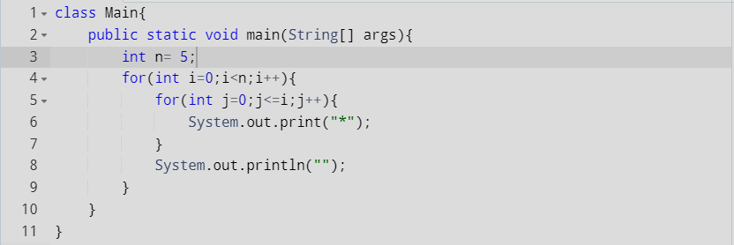

Output:
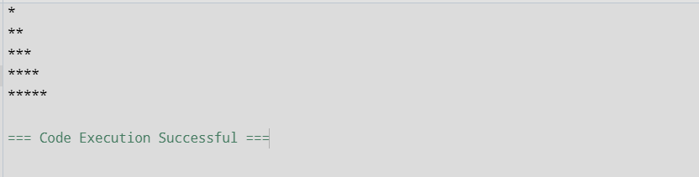

Result: The program successfully prints the right-angled triangle pattern of stars.

5. Print numbers in triangle and pyramid vice
1
121
12321
1234321
123454321

Aim: To write a Java program that prints a numerical pattern in a triangular and pyramid structure.
Algorithm
- Start
- Take an integer input n from the user (number of rows).
- For each row i from 1 to n (outer loop):
  - Print numbers in increasing order from 1 to i (first inner loop).
  - Print numbers in decreasing order from i-1 back to 1 (second inner loop).
  - Move to the next line after completing the row.
- Stop

Program
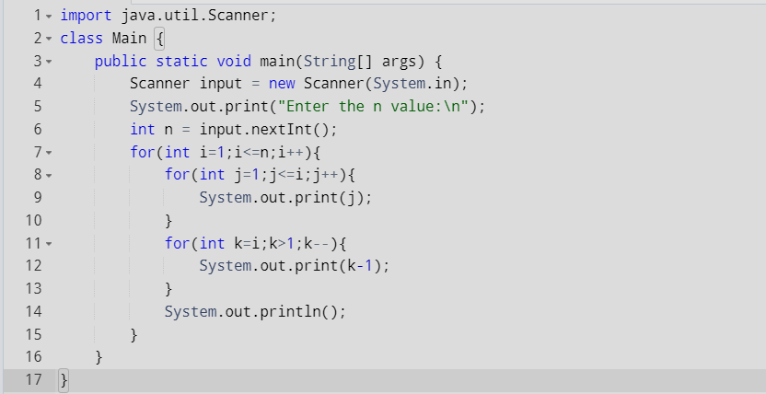

Output:
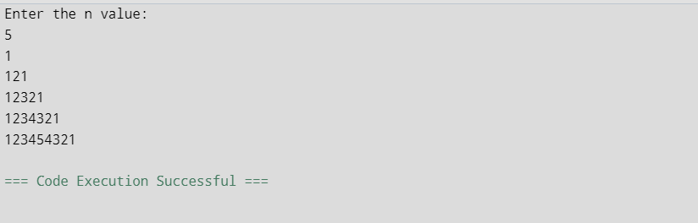

Result: The program successfully prints the triangular pyramid structure with numbers as expected.

6. Find largest and smallest number in an array in java
Aim: To write a Java program that finds the largest and smallest numbers in a given array.
Algorithm
- Start.
- Take input for the size of the array n from the user.
- Declare an integer array arr of size n.
- Use a loop to input n elements into the array from the user.
- Initialize two variables:
  - max to the smallest possible value (Integer.MIN_VALUE).
  - min to the largest possible value (Integer.MAX_VALUE).
- Use a loop to iterate through each element of the array:
  - If the current element is greater than max, update max to the current element.
  - If the current element is smaller than min, update min to the current element.
- After the loop, print the values of min (smallest) and max (largest).
- Stop.

Program
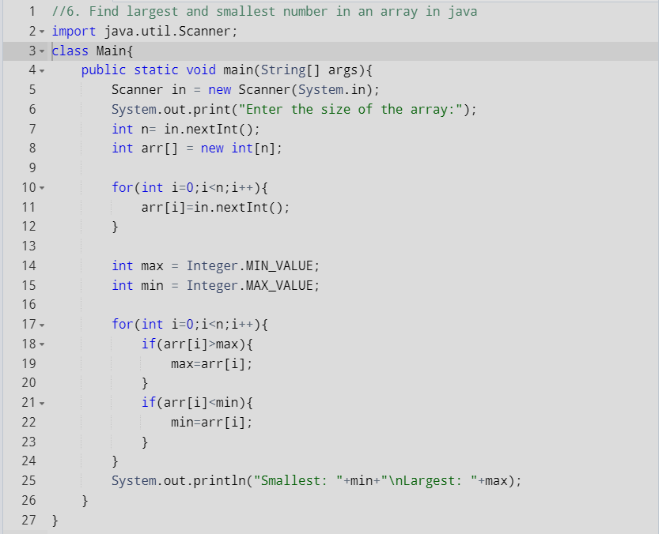
Output
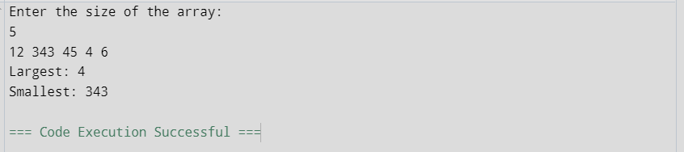

Result: The program successfully finds the largest and smallest numbers in the array.

